Language Skills:
Four core skills: Listening, Speaking, Reading, Writing (LSRW)
- Oracy = Listening + Speaking
- Literacy = Reading + Writing

- Receptive Skills: Listening, Reading
- Productive Skills: Speaking, Writing

Language Skill is the ‘ability to comprehend receptive language and use expressive language to communicate.

Listen (use the target language, to a song, to one another in a pair activity)

Speak (pronunciation practice, greetings, dialogue creation or recitation, songs, substitution drills, oral speed reading, role play)

Read (instructions, written grammar drills, cards for playing games, flashcards)

Write (fill-in-the- blank sheets, sentences that describe a feeling, sight or experience, a dialogue script, a journal entry).

These four skills, as they are referred to, are interrelated because using a language generally requires using more than one skill at a time. However, learners can be more competent in one skill than another.
Listening skills in communication are the ability to accurately receive, interpret, and understand what another person is saying

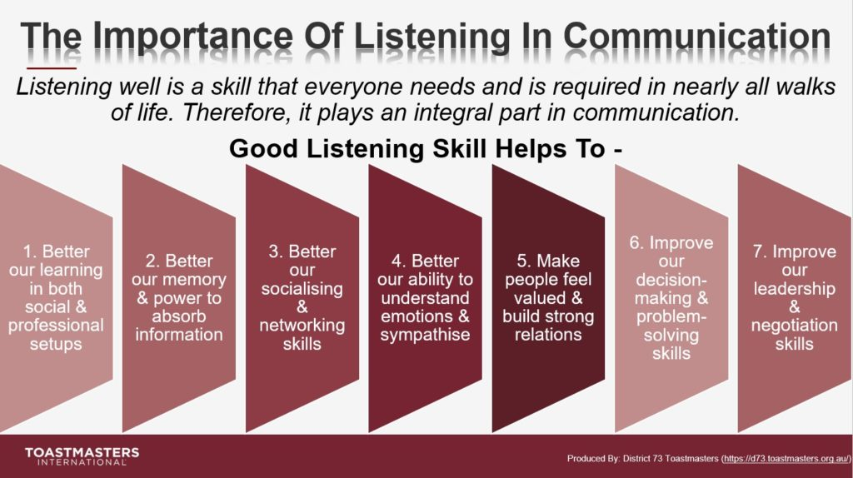
The Process of Listening:
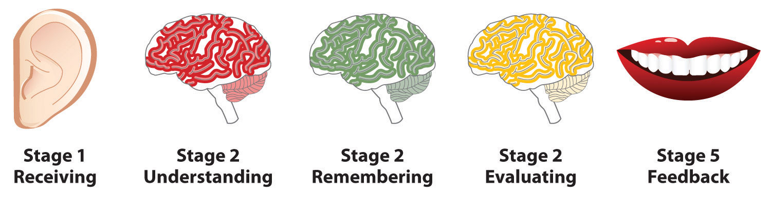

Types of Listening:
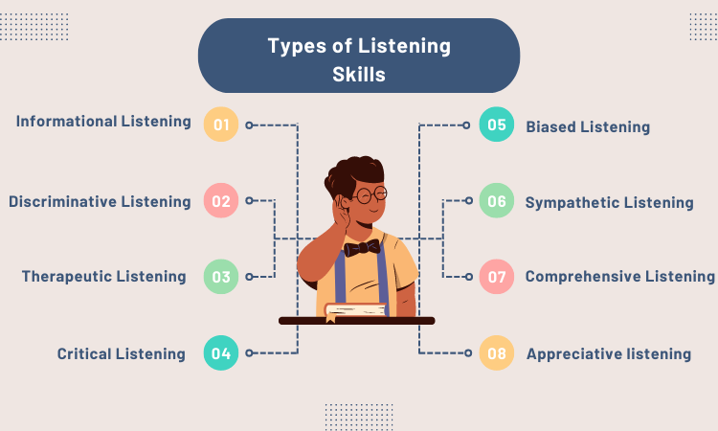
Passive/ignoring: physically present mentally absent
Marginal/superficial: too much overload of information
Projective/selective: Projective listening is a biased form of selective hearing where a listener intentionally disregards the speaker's views or information that contradicts their own firm beliefs, instead focusing only on what aligns with their pre-existing opinions or agenda.
Sensitive/emphatic:
Active/attentive:
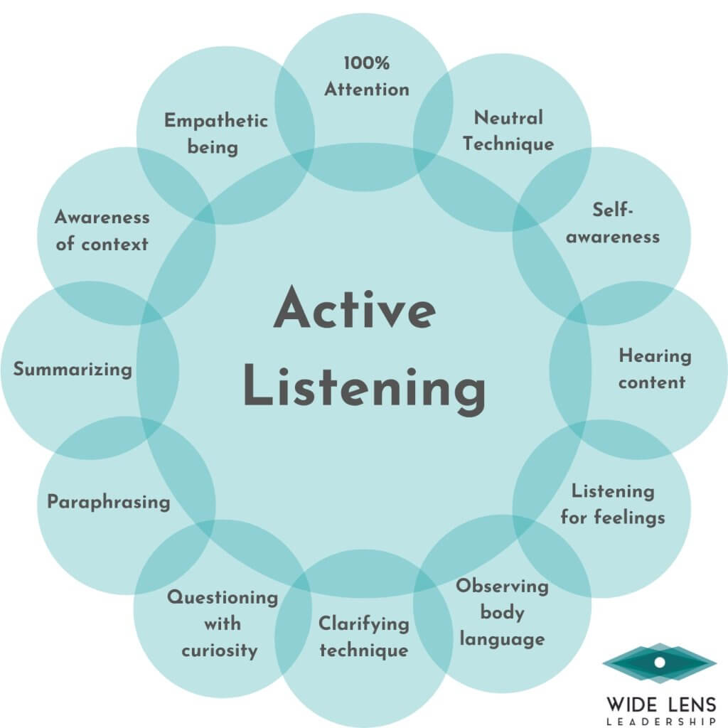

Difference between Listening and Hearing:
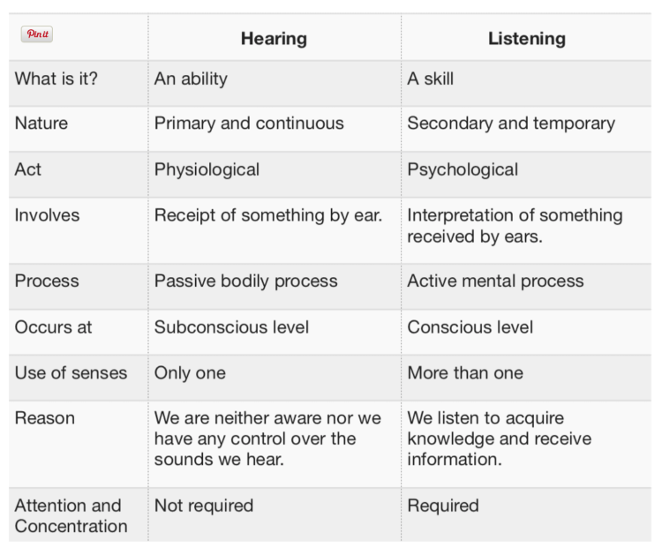
Barriers of Effective Communication:
- Physical Barriers:
- Noise
- Distance
- Loud Talking
- Visual Barrires
- Organizational Barrier
- Lack of Training
- Ego
- Involved with Self
- language and Semantic Barriers
- Use of difficult Words and Jargons
- Speaker’s Style of Speaking
- Lag time
- Mispronounced Words
- Psychological Barrirers
- Lack of Interest
- Difference in background
- Ego
- Prejudice/Hasty evaluation
- Socio-Cultural Bacrriers
- Different Cultural Background
- Personal Space and Public Space
- Sense of Time
- Physiological Barriers
- Hearing Impairment
- Hunger and Tiredness
- Pain

Speaking Skills:

Importance of Speaking Skills:

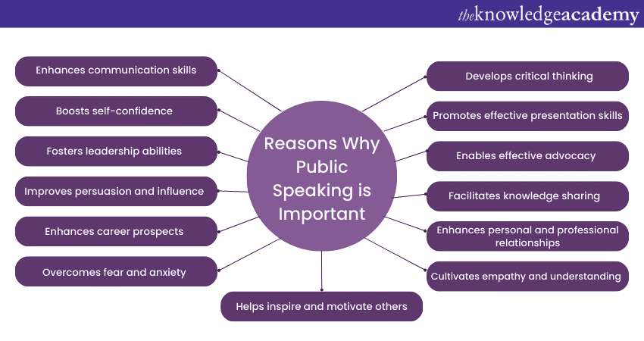
Types of Speaking:
1. Informative speaking

- Persuasive speaking

- Motivational speaking

- Demonstrative speaking

- Entertaining speaking

- Keynote speaking

- Commemorative Speaking

- Ceremonial speaking

Barriers of Speaking:

Psychological Barriers:
- Emotions and Bias: Personal feelings like stress, anger, or anxiety can hinder the ability to listen and understand.
- Attitude: A listener's attitude toward the speaker, or their general outlook, can influence how they interpret the message.
- Selective Perception: People often filter information based on their own biases, interests, and existing beliefs, leading to misinterpretation.
- Lack of Active Listening: Focusing on formulating a response rather than truly absorbing the sender's message leads to a superficial understanding.

Semantic & Language Barriers:
- Ambiguous Language: Words and phrases can have different meanings for different people.
- Jargon and Technical Terms: Specialized language can be a barrier if the listener doesn't understand the terminology.
- Accent Difficulties: Accents can make it harder to understand spoken words.

Physical Barriers:
- Noise: Loud background noise can interfere with the ability to hear and comprehend a message.

- Distance: Geographic distance or being in separate rooms can make communication difficult.

- Poor Technology: Faulty phone lines, bad internet connections, or outdated software can disrupt communication.

Cultural & Social Barriers:
- Cultural Differences: Differences in values, beliefs, and communication styles between cultures can lead to misunderstandings.
- Perceptual Differences: Different viewpoints on a topic can lead to incorrect assumptions.

- Stereotyping: Preconceived notions about people from certain groups can hinder open communication.

Organizational Barriers:
- Hierarchical Structures: Rigid organizational hierarchies can create filters that distort or block information flow between levels.
- Complex Structures: Overly complex organizational charts can make it difficult for information to reach the right people.
- Fear-Driven Culture: A culture where people fear repercussions for speaking up can suppress open communication.
Other Barriers:
- Information Overload: Receiving too much information at once can make it difficult to process and retain.
- Poor Listening Skills: Inadequate attention from the receiver leads to information being missed or misunderstood.

- Lack of Trust: A lack of trust between individuals or groups can make people hesitant to communicate openly.

- Gender & Generational Differences: These can sometimes create different communication styles or expectations.

Reading Skills:

