Lubricant and Lubrication
A substance that is introduced between two relatively moving surfaces for reducing friction and wear is called lubricants. The main purpose of a lubricant is to keep the moving/sliding surfaces apart, so that friction and consequent destruction of material are minimized.
The process of reducing frictional resistance between moving surfaces by the application of lubricants is called lubrication.
Lubrication is the process or technique of using a lubricant to reduce friction and wear and tear in contact between two surfaces. The study of lubrication may be a discipline within the field of tribology.
Application (Functions) of Lubricants:
- Lubricants are primarily used to reduce the friction between two moving surfaces.
- It reduces the loss of energy in the form of heat.
- It increases the efficiency of machines.
- It increases the smooth motion of the moving parts.
- It reduces the surface deformation, wears and tear
- It protects the materials from corrosion.
- Used in the soap and paint industries.
- Used as anti-wear, antioxidants, and antifoaming agents.
Properties or Characteristics:
Good lubricating oil should have:
- High boiling point
- Low freezing point
- High viscosity index
- Good thermal stability
- Hydraulic stability
- Corrosion prevention
- High resistance to oxidation

Mechanism of Lubrication
The phenomenon of lubrication is often explained with the assistance of the subsequent mechanism;
Thick Film or Fluid Film or Hydrodynamic Lubrication
It is administered with the assistance of liquid lubricants. In this mechanism, two moving and sliding surfaces are separated by a thick film of lubricant fluid of about 1000A°, applied to stop direct surface-to-surface contact and consequently reduce wearing and tearing of metals. Therefore it is known as a thick film or fluid film lubrication or hydrodynamic (hydro meaning liquid and dynamic meaning relative motion) lubrication. In this case, fluid is formed by mixing hydrocarbon oils and anti-oxidants with long-chain polymer so as to maintain viscosity. Fluid film lubrication is useful in delicate and light machines like watches, clocks, guns, scientific equipment.
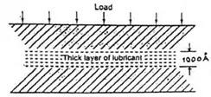
Thick Film
Thin Film or Boundary Lubrication
It is carried out with semi-solid (grease) and solid (graphite and molybdenum disulfide) lubricants. Boundary lubrication is a condition in which the lubricant film becomes too thin to provide total separation. In this type of lubrication, a thin film of lubricant is adsorbed on the surface by weak Vander Waals forces. Thin-film lubrication is operating at relatively low speed and heavy loading (pressure)

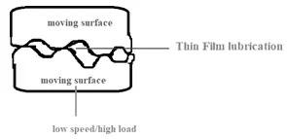
Extreme Pressure (or Temperature) Lubrication
In this mechanism, moving or sliding surfaces are under high and speed, therefore this is often referred to as extreme pressure lubrication. In such a case high temperatures generated due to friction, under these conditions liquid lubricants fail to stick and decompose or vaporize. These problems are minimized by special additives are added to mineral oils. These additives form durable films on metal surfaces that can withstand high loads and high temperatures. Important additives are organic compounds having groups like chloride, sulfur, phosphorus, etc. They react with the metallic surface to form metallic compounds (possess high melting points and serve as good lubricants under extreme temperatures and pressures) like chlorides, sulfides, phosphate as a more durable film.
Classification of Lubricants
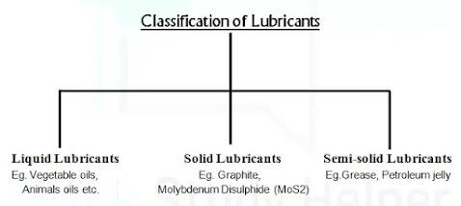
1. Liquid lubricants or Lubricating oils:
Lubricating oils are also known as liquid lubricants. Liquid lubricants are used extensively in applications that are high in terms of speed and load size. Liquid lubricants are the most dominant type of lubricant in the market. Liquid lubricants are the foremost dominant sort of lubricant within the market. Liquid lubricants are comprised of base oil and some additives.
(i) Animal and Vegetable oils,
(ii) Mineral or Petroleum oils and,
(iii) Blended oils
2. Solid Lubricants:
Graphite, molybdenum disulfide(MoS2), boron nitride (BN)x is predominantly used as a solid lubricant. They are used under high temperature and high load (pressure)
∙ Graphite: It is most widely used as a solid lubricant. Graphite has a layered structure. Layers are held together with the help of weak Vander Waals’ forces that facilitate the easy sliding of one layer on the other layer. It is very soapy to touch, non-inflammable. It is used at a higher temperature (around 450oC) condition. They are either used as powder form or mixed with oil or water.
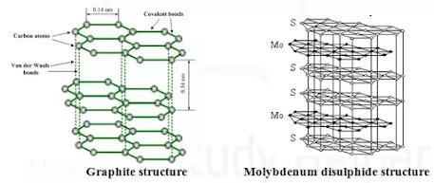
∙ Molybdenum disulfide (MoS2): It is a sandwich-like structure in which a hexagonal layer of molybdenum (Mo) lies between two hexagonal layers of sulfur (S) atom. Like graphite, each layer is held together with weak Vander Waals’ forces. It is stable up to 400oC. It is different from graphite because it is used in a high vacuum unlike graphite (graphite is mixed with water or oil). It adheres even more strongly to the metal or other surface.
3.Semi-solid Lubricants (Grease):
Semi-solid Lubricants are formed by emulsifying oil and fat with thickening agents like soap of sodium, calcium, lithium, aluminum at higher temperatures.
Classification
- Soda-based: In this case, sodium soaps are used as a thickening agent in mineral or petroleum oil. They are slightly soluble in water. They can be used up to 175oC.
- Lithium-based: In this case, lithium soaps are emulsifying with petroleum oil. They are water-resistant and used up to 15oC.
- Calcium-based: During this case, calcium soaps are emulsifying with petroleum oil. They are also water-resistant and used up to 80oC. At higher temperature soap and petroleum oil are separate from each other
Properties of Lubricants
- Viscosity and Viscosity index
- Flash Point and Fire Point
- Cloud Point and Pour Point
- Aniline Point
- Acid number
- Saponification Number
- Steam Emulsion Number
Viscosity and Viscosity index:
Viscosity is the property of a fluid that determines its resistance to flow. It is an indicator of the flowability of lubricating oil. The lower viscosity greater will be the flowability. If the temperature increases the viscosity of the lubricating oil decreases and pressure increase viscosity of lubricating oil increases. In short, we can say that good lubricating oil is that whose viscosity does not change with temperature. It is defined as the rate of change of viscosity with respect to temperature. i.e.The rate at which the viscosity of lubricating oil changes with temperature is measured by an arbitrary scale, known as the Viscosity Index (V. I). A relative chicken feed in viscosity with temperature is indicated by high viscosity index whereas, a coffee viscosity index shows a comparatively large change in viscosity with temperature.
Significance:
∙ It’s the foremost important property that determines the performance of lubricating oils under operating conditions.
∙ Lubricating oil should have sufficient viscosity to enable it in position.
∙ Viscosity helps in the selection of good Lubricating oil. For instance, Light oils have low densities and easy flowability
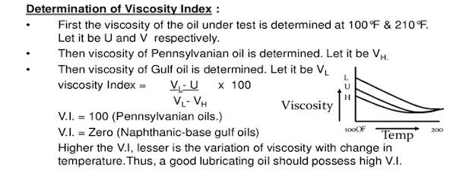
Flash Point and Fire Point:
Flashpoint is the lowest temperature at which the lubricant oil gives off enough vapors that ignite for a moment when a tiny flame is brought near it; while The fire point is the lowest temperature at which the vapors of the lubricant oil burn continuously for at least five seconds when a tiny flame is brought near it. In most cases, the fire points are 5° C to 40° C higher than the flashpoints. The flash and fire do not have any bearing with the lubricating property of the oil, but these are important when oil is exposed to high. Flash and Fire points should be high for a good lubricant. Flash and fire point additives are used to increase the performance of a lubricant. CTFE is added to extend flash and fire points because it increases the vaporization point of lubricants.

Significance
∙ A lubricant should have a flashpoint that is reasonably above its working temperature. This ensures safety against fire hazards during storage, transport, and use.
∙ A good lubricating oil should not under working condition and even if volatilizes, the vapors formed should not catch fire under the working temperature conditions.
Cloud Point and Pour Point: :
When the lubricant oil is cooled slowly, the temperature at which it becomes cloudy or hazy in appearance is called its cloud point; while The lowest temperature at which the lubricant oil becomes semi-solid and ceases to flow is called the pour point. Cloud and pour points indicate the suitability of lubricant oil in cold conditions. Lubricant oil used in a machine working at low temperatures should possess a low pour point; otherwise, the solidification of lubricant oil will cause jamming of the machine. It has been found that the presence of waxes in the lubricant oil raises the pour point. Good lubricant should possess a low pour point.
Significance:
- The cloud point is an index of the lowest temperature of its utility for certain applications.
∙ It is an index of the lowest temperature limit for utility as lubricating oil.
∙ It also indicates dissolved wax concentration of lubricating oil.

Aniline Point:
The aniline point of the lubricant oil is defined as the minimum equilibrium solution temperature for equal volumes of aniline and lubricant oil samples. It gives an indication of the possible deterioration of the lubricant oil in contact with rubber sealing; packing, etc
Significance:
∙ It gives an idea about the presence of aromatic hydrocarbon in a lubricant.
Determination of Aniline Point
Aniline point is determined by mixing mechanically equal volumes of the lubricant oil samples and aniline in a test tube. The mixture is heated, till a homogenous solution is obtained.
Then, the tube is allowed to cool at a controlled rate. The temperature at which the two phases (the lubricant oil and aniline) separate out is recorded at the aniline point.
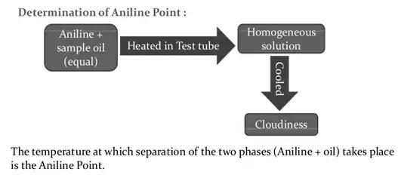
Acid number:
Acid value (or neutralization number or acid number or acidity
Lubricating Oil’s acidity or alkalinity is determined in terms of neutralization number. Neutralization the number represents either the Total Acid Number (TAN).”The number of milligrams of potassium hydroxide (KOH) needed to neutralize any acid in one a gram of oil” or the Total Base Number (TBN). The number of milligrams of hydrochloric acid (HCI) needed to neutralize any base in one gram of oil.
As neutralization point of oil increase, age of oil decrease
Significance:
∙ As antioxidants are consumed during use, generated acids won’t be neutralized and can start to extend in concentration. By monitoring acid number results, a component of the lubricant health can be ascertained.
Saponification Number:
Saponification number is defined as “The number of milligrams of potassium hydroxide required to saponify the fatty material present in one gram of the oil”
Determination:
Saponification the number is determined by refluxing a known quantity of oil with a known excess of potassium hydroxide solution and titrating the unused alkali against an acid.
Steam Emulsion Number:
The time in second during which oil and water emulsion separate out into distinct layers is named ‘steam emulsion the number’ (SEN) or ’emulsification number’.
The time in seconds during which a given volume of oil and water separates out into distinct layers is named the steam demulsification number.
Good grease should have a lower demulsification number. It means the quicker the oil separates out from the emulsion formed, the higher is that the grease.
Significance:
- Good grease features a low steam emulsification number; in order that when it comes in touch with water it doesn’t form an emulsion.
- Oil has a high steam emulsification number is preferred for the preparation of lubrication emulsification like cutting fluids.

SYNTHETIC LUBRICANTS
Synthetic lubricants are a mixture of synthetic base oil plus thickeners and additives which will give the grease or oil lubricant a variety of performance advantages over conventional mineral-based lubricants.
Synthetic oil may be a lubricant consisting of chemical compounds that are artificially made (synthesized).
Advantages
The technical advantages of synthetic motor oils include:
⮚Better low- and high-temperature viscosity performance at service temperature extremes
⮚Better (higher) Viscosity Index (VI)
⮚Better chemical and shear stability
⮚Decreased evaporative loss
⮚ Possibly an extended engine life
Disadvantages
The disadvantages of synthetic motor oils include:
⮚Substantially costlier (per volume) than mineral oils.
⮚Potential decomposition problems in certain chemical environments

