**ETN 22 Gear Sample**

1. Materials chemical composition:

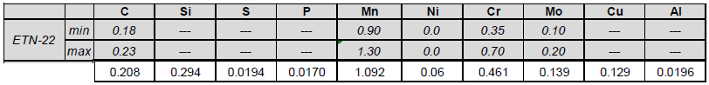

1. Material micro-structure: 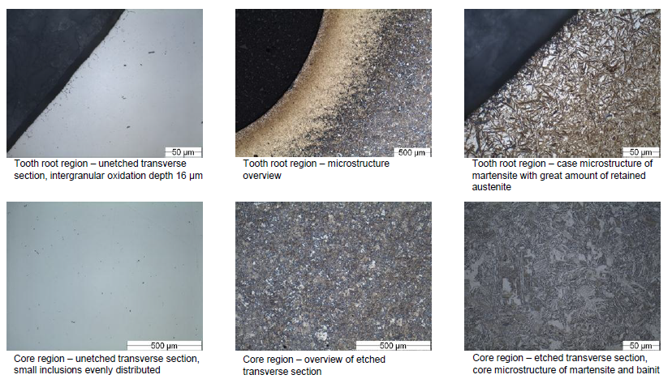
2. Micro-hardness profile: (see CX-4512)

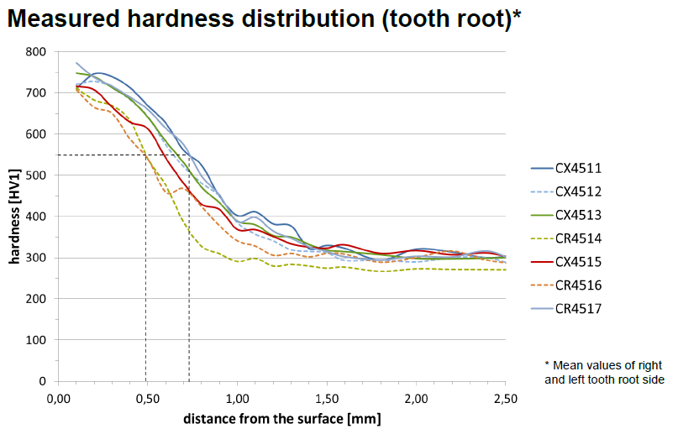

USE CURVE OF CX-4512 FOR ETN22

(DOTTED LINE IN LIGHT BLUE)