**VEXTEC VLM® Project Proposal for Eaton – Vehicle Group**

**May 13, 2016**

# Background

This proposal has been prepared by VEXTEC Corporation (“VEXTEC”) for Eaton – Vehicle Group (“Eaton”). The proposal is prepared for evaluating bending fatigue for an Eaton Gear. This is one of two projects that Eaton is considering, the other project will concentrate on bearings and the goal there will be to compare the products from two different suppliers. Eaton’s goal in the present effort revolves around replicating physical testing virtually. Specifically, Eaton is interested in virtually determining the bending fatigue curve (S-N) of the gear for three different steels. The resulting framework is expected to probabilistically estimate / calculate the fatigue behavior of a broad range of Eaton gears and other products. VEXTEC proposes applying VEXTEC’s VPS-MICRO® software to complete this gear bending project. VPS-MICRO is based on VEXTEC’s patented Virtual Life Management® (VLM®) technology which includes computational microstructural level material models to simulate the fatigue performance and calculate the lifetime of various product configurations.

# Program Objective

The objective of this project is to apply VEXTEC’s VPS-MICRO software (based on VEXTEC’s VLM technology) to evaluate the fatigue performance of Eaton gears subject to bending loading. Eaton has a ‘Single Tooth Bending Fatigue Test Fixture’ set up for experimentally generating the fatigue data (Figure 1) and a virtual (FEA) model representation to calculate the traditional element level stress data (Figure 2).

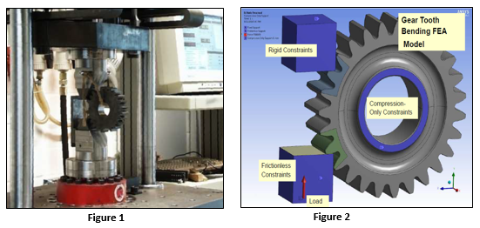

A sample of the output stress results is shown in Figure 3.

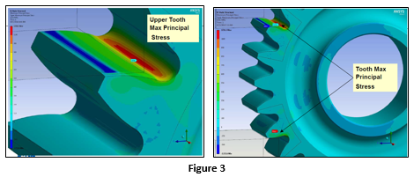

The above test and FEA data will be leveraged to determine the fatigue performance for two different steels (listed in Table 1 below)

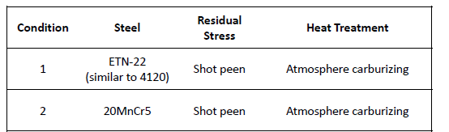

Table 1

# Scope of Work and Deliverables

VEXTEC has the framework to set up and perform VLM (Virtual Life Management) simulations by using VEXTEC’s VPS-MICRO software for analyzing Eaton gears with gear teeth subject to bending loads. The framework includes the development of the material model and its calibration to test data provided by Eaton, data from public domain literature and from additional material characterization performed by VEXTEC. The calibrated material model along with the structural model of the component will be used to simulate the probability of crack initiation, propagation and failure at predetermined load amplitude levels specified by Eaton. Simulations results will then be compared with test data.

The framework is pictorially represented in Figures 4 and 5. Figure 4 shows the flow of information in the VLM process – a) input to VPS-MICRO includes formatted output from the commercially FEA software and the material model, b) output from VPS-MICRO can be visualized and analyzed within VPS-MICRO itself or with the commercial FEA visualizer. Figure 5 outlines the validation work flow that compares results from the experimental and virtual loops and once validated, becomes a predictive and design evaluation framework.

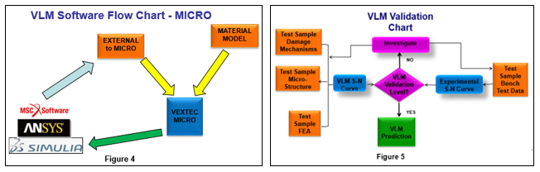

The effort is proposed as a Turnkey effort. The Turnkey phase focuses on the short term task of completing the explicitly defined SOW that is summarized in the previous section. Experimental data for the two materials in Table 1 exists and shows number of load cycles ranging from 1000 cycles at the highest load to runouts / suspensions at 6 million load cycles. For one of the two materials, (20MnCr5), the turnkey effort will include a two factor DOE: Intergranular oxidation depth and tooth core hardness. VEXTEC wants to underscore that material / metallurgical analysis is included for two materials in the proposal, one instance each for the materials listed in Table 1. Essentially, each item of the DOE matrix implies a new material microstructure (or a total of 20 new microstructures for the combinations in Table 2. VEXTEC, however, assumes that, for the VLM simulations associated with the DOE matrix, the material microstructure details for each item in Table 2 will be extrapolated in discussion with the Eaton team without performing any additional metallographic analysis. The details of the DOE are given in Phase 2 description of the Turkey effort (see below). At the conclusion of the Turnkey phase, Eaton will provide VEXTEC with feedback and reference for the work completed, with the intention of including in VEXTEC marketing efforts. In addition, at the conclusion of the Turnkey phase, VEXTEC will extend a complimentary Pilot phase that includes training, limited time node-locked license and technical support to run simulations during the limited time license period. VEXTEC will also appreciate feedback on the software tool, its usability and capability. At the end of the Turnkey / Pilot phase, VEXTEC is suggesting annual software licensing for continued implementation of VLM technology at Eaton. The Software Licensing phase will include Training to additional practitioners, as well as, full technical support and product updates during the license period.

* + Turnkey Phase – This phase starts with a clearly defined and mutually agreed to SOW and concludes with the submission of a final report. Specifically, the turnkey effort consists of application of VPS-MICRO software to analyze an Eaton gear subject to bending loads for two different steel materials. Tasks during this effort will include translating the geometry and FEA results data to VPS-MICRO format, developing microstructural material model for Eaton’s three specified materials, understanding the damage / failure mechanisms for the gear, setting up the model in VPS-MICRO, debugging / running simulations, post processing / interpretation of the results and final technical report. Metallurgical services (microstructural and residual stress measurement) as required are also included in this phase.

Work Summary: 12 weeks

* Phase 1: Virtual Life Management (VLM) model development (per flow chart in Figure 4)
  + Develop model and predict the lives of one (1) gear geometry for each of two (2) different steel materials.
  + Prediction is driven by gear geometry, gear materials and metallurgical characteristics, each subject to specific test conditions. (See schematics and photograph of the test setup in Figure 1)
  + Prediction is also governed by the stresses obtained from the FEA output results. (Model shown in Figure 2 and Stress Plots in Figure 3)
* Phase 2: Verification, validation, correlation and prediction study
  + Verification and validation will be completed using component test results (for 1 material) and published literature data [see Figure 5]
  + Broader correlation of data will be completed with sensitivity and trade-off run from virtual tests with comprehensively known test data. Eaton to provide physical test results as necessary.
  + Model / Framework will be used to calibrate and predict data for Material 2.
  + Run a DOE of two factor: Intergranular oxidation depth and tooth core hardness for two stress levels at the low cycle fatigue region, and two stress levels at the high cycle fatigue region (greater than 3 million cycles, for instance) for the material 20MnCr5 only (See Table 2 below).

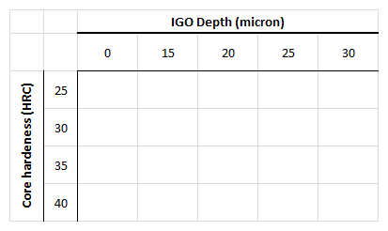

Table 2

* Metallurgical characteristics to include:
  + Inclusions: size, type, density
  + Carbide banding, stringers, etc.
  + Grain size and transition zone
  + Case to core transition zone
  + Residual stress distribution
  + Percent retained austenite
  + Austenitic pools
  + Surface and core hardness, hardness gradient
  + Other features as required
* Report to include:
  + Predicted life and operating stress levels of gear for each material.
  + Material Model details and metallurgical characteristics assessed.

At the conclusion, of the Turnkey phase, VEXTEC will offer a complimentary Pilot to Eaton – and this will include a single (1) node locked license for a period of 4 months (a $10,000 value) and full three (3) day hands on training to Eaton practitioners (a $15,000 value). This license will start with the delivery of the final technical report to Eaton.

The Turnkey phase is estimated to last for **12 weeks** from the time of receiving of all data and project kickoff and the project cost is **$64,000.**

* + Software Licensing – This extension phase includes continued use of the VPS-MICRO software within the Eaton organization internally on multiple other products. This optional includes one (1) License that kicks off at a mutually agreed upon time and initially extends for a period of one year. The license includes full software usage, training, technical support and software updates during that period. It also includes updates to the Eaton customized VPS-MICRO interface. It does not include developing new material models or any consulting support. (*VEXTEC has a cascading licensing scheme – 1st license is $30K per year, license 2, 3 and 4 are each additional $15K per year and license 5 and above are each additional $8K per year*).

This phase extends for a period of **12 months** and costs **$30,000**

## Tasks and Services:

This section explicitly lists the various tasks that VEXTEC expects to complete as a part of the Turnkey phase. The actual services and the sequence of performing these will depend on the final and mutually agreed to SOW.

* + Review Eaton provided information pertaining to the product, the material, the fatigue (bench) test and operational details. This review will include geometry, residual stress, loading conditions, material specification, fracture surface and damage mechanism, microstructure characteristics, and other relevant factors.
  + Review material characterization findings along with calibration data chosen for the material model.
  + Although metallography and fractography data are available from Eaton and in the public domain for VEXTEC to create and calibrate a VLM simulation model, this project proposal considers the possibility of requiring additional Metallurgical Analysis Services. Some level of metallurgical testing from VEXTEC is a good practice for method V&V process.
  + Metallurgical Analysis Services details - This effort is to supplement metallography and fractography data available from Eaton and in the public domain for VEXTEC to create and calibrate a VLM VT model. This assumption is based on in-depth discussions with Eaton and a preliminary survey of the public domain. VEXTEC will perform additional metallurgical analysis if it is determined the available information does not meet the project needs and a reasonable amount effort towards this task is included in this proposal. VEXTEC metallurgical analysis services typically include: 1) Prepare specimens and conduct a metallurgical analysis of pristine and failed specimens provided by the client. This analysis will involve optical microscopy (OM) and SEM, metallography, and fractography, 2) Determine the residual stresses based on the processing.
  + Setup, checkout and calibrate the VLM model.
  + Simulate & predict the probability of crack initiation at predetermined amplitude levels specified by Eaton for one (1) gear geometry for each of two (2) different steel materials.
  + Statistically compare simulation predictions for the different gear products with Eaton provided experimental test data. This comparison will include cycles to failure data.
  + Verification and validation completed for component tests for Material 1
  + Model / Framework will be used to calibrate and predict data for Material 2 (provide confirmation)
  + Provide the crack initiation type (grain or inclusion), initiation cycles, short crack cycles, long crack cycles and total life for each simulated instance.
  + Perform a sensitivity study to include material variability will be performed for estimating fatigue life statistics.

## Data & Information Requirements

VEXTEC requires the following data and information from Eaton:

* + Specimen/component/product geometry and processing details.
  + Mechanical properties and stress-strain data.
  + Material specification and metallography and fractography reports (if available).
  + Additional material information if available – such as, grain size and texture, inclusion size and population.
  + Fatigue bench test protocol and loading conditions.
  + Finite element model data – including the model information and the results database. Also, included should be information on V&V (Ref. ASME V&V 40)

## Deliverables

VEXTEC will provide the deliverables for the Turnkey phase to Eaton as listed below.

1. VLM simulation setup, checkout, and calibration process.
2. Final summary report of the findings and recommendations.
3. VLM simulation outputs will be provided in a spreadsheet format to facilitate further data analysis.
4. VPS-MICRO installation and support during the Turnkey phase.

# Schedule & Pricing

Turnkey Phase - **12 weeks** from receiving of all data at VEXTEC and will cost **$64,000**

Payment –

* + $32,000 – Invoiced at receipt of purchase order
  + $32,000 – After final report.

Software Licensing – **1 VPS-MICRO node locked license** for a **period of 12 months** and will cost **$30,000**Payment –

* + $30,000 – Invoiced at Receipt of Purchase Order for software license