Part Number: CX-4520 (Material DIN 20MnCr5 from India)
Part Name: Gear
Analysis Objective: Metallurgical Analysis

Introduction

It was sent one part, as described above, to the heat treatment laboratory for metallurgical analysis (finish part: after grinding operations).

Result Analysis

Characteristic | Specified | Results
Surface Hardness | 58 – 63 HRC | 62 HRC
Hardness Pitch | 30 – 45 HRC | 36 HRC
Hardness Root | 25 HRC mín. | 31 HRC
Case Depth (CZ2) | Pitch: 0,688 mm min (after grinding)  Root: 0,59 mm min  Diameter: 0,66 mm min (after grinding) | Pitch: 0,84 mm  Root: 0,77 mm  Diameter: 0,57 mm
Superficial Microstructure | Tempered Martensite with Retained Austenite 10-30% | Tempered Martensite with Retained Austenite 20%
Core  Microstructure | Martensite | Ferrite with low-carbon martensite
Intergranular Oxidation | 0,020 max. | Pitch: ------------  Root: 0,016 mm
Nonmartensitic Products | 0,020 max. | Pitch:-------------  Root: 0,030 mm
1ª Bainite | Pitch 0,250 mm mín.  Root 0,100 mm mín. | Pitch: 0,45 mm  Root: 0,40 mm

Microhardness Gradient

Case Depth mm | 0,08 | 0,10 | 0,20 | 0,30 | 0,40 | 0,50 | 0,60 | 0,70 | 0,80 | 0,90
Pitch | 729 | 728 | 740 | 729 | 704 | 671 | 529 | 587 | 535 | 474
Root | 735 | 722 | 731 | 750 | 715 | 677 | 629 | 556 | 492 | ---
Diameter | 719 | 718 | 727 | 704 | 649 | 547 | 499 | --- | --- | ---

Residual Stress (Shot peening per TES-020-3: -100 Ksi min sub-surface)

Root 0° position | Surface: - 68,98 KSI  Subsurface: -154,11 KSI
Root 120° position | Surface: - 66,11 KSI  Subsurface: -141,02 KSI
Root 240° position | Surface: - 66,24 KSI  Subsurface: -145,83 KSI

Inclusions

Internal Cleanliness Per ASTM E 45, Method A, Plate I and III

 | Type A | Type B | Type C | Type D
 | Sulfides | Aluminates | Silicates | Globular Oxides
Thin | 3.0 | 2.5 | 2.5 | 2.0
Thick | 3.0 | 1.5 | 1.5 | ----

Figures:
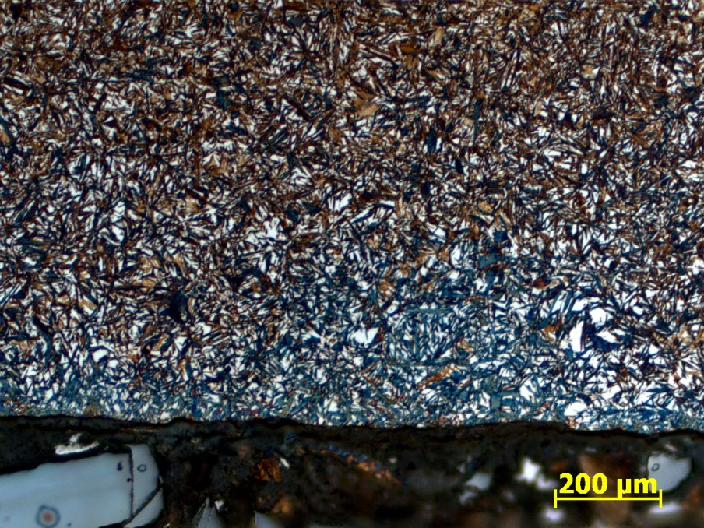

Figure 1: Shows the region of the pitch diameter consisting of tempered martensite and retained austenite 20%.

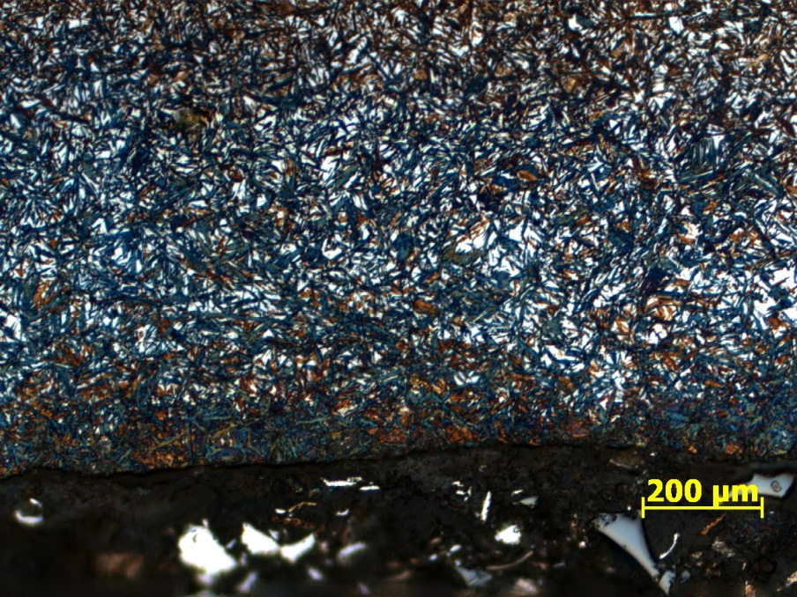

Figure 2: Shows the region of the root diameter consisting of tempered martensite and retained austenite 20%.

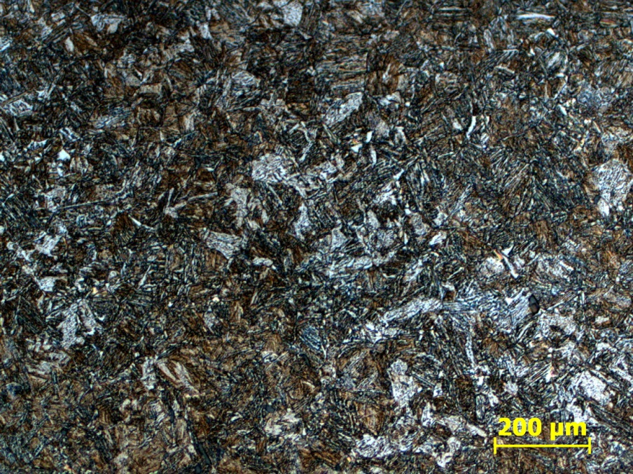

Figure 3: Shows the core region consisting of martensite, bainite and ferrite.

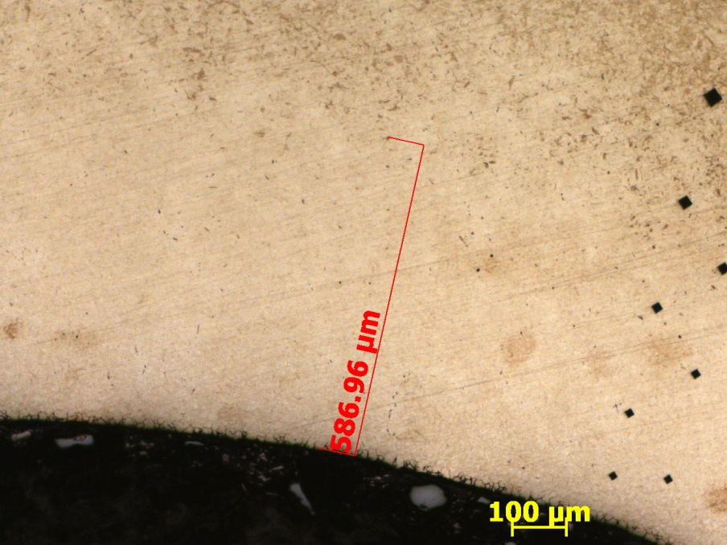

Figure 4: It shows the root region showing the first bainite.

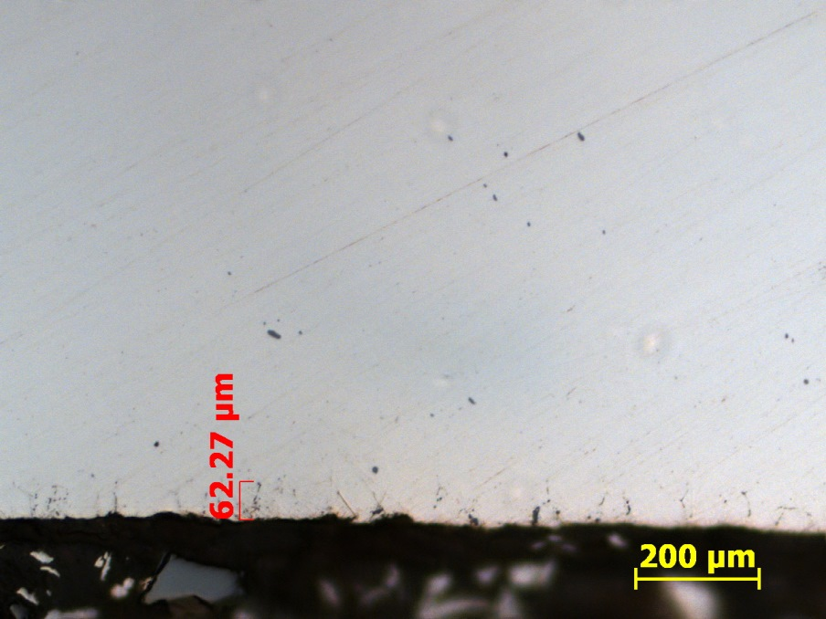

Figure 5: It shows the root region showing the intergranular oxidation.

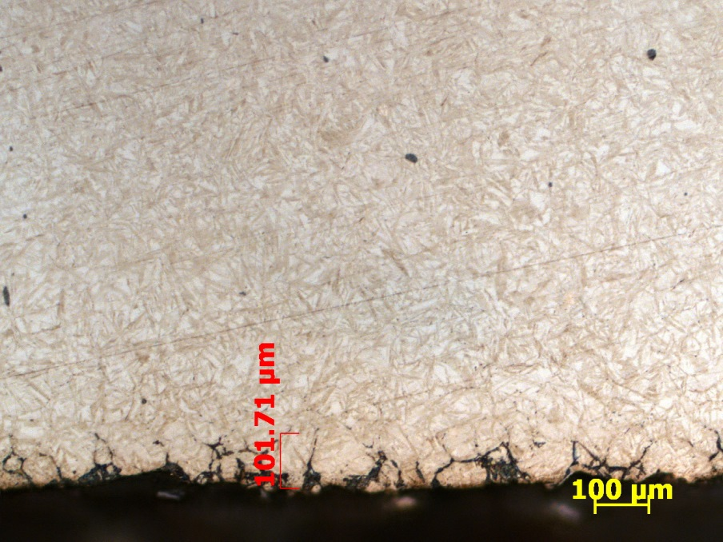

Figure 6: It shows the root region showing the nonmartensitic products.

Comments:

1) Basically the part met the metallurgical specification. The microstructure and hardness are according to the metallurgical design specifications / standard. Regarding the depth of a hardened layer only in the inner diameter region lying below the specified drawing.

2) Case Depth is according the specification considering the grinding operations. Case depth on internal diameter a little lower of specification is not a problem for STBF tests and or same to use in production, because the micro-hardness gradient in this region is Ok.

3) Case and Core microstructure are Ok, besides the non-martensitic products at root are above the specification. The intergranular oxidation in this area is according to the specification.

4) Residual stress measured in 3 teeth are according to the shot peening applied according to TES-020-3.

5) The level of non-metallic inclusions are presented with the maximum levels specified as shown in TES-047. Although not consider that steel is rejected in this requirement, high levels of inclusions can affect the result of bending fatigue.

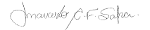
Marcelo C.F. Safra (Analista Qualidade)



Report approved by: Antonio C. Zambon – CoE Materials Engineering

