Overview
Installation Manager is used to install the interim fix for JR51784 but this is only part of what needs to be done. You must create a JMS Queue Connection Factory at the cell scope, create a JMS Queue using that connection factory, and ensure that the queue connection factory uses an authorization alias. It is recommended to simply use the existing BPM authorization alias for the BPM Bus within your deployment environment (DE).

Create a JMS Queue Connection Factory
Use the WebSphere administrative console to create a cell scoped queue connection factory. The JNDI Name specified in WebSphere will be used in the sample jython script so make note of the name now.
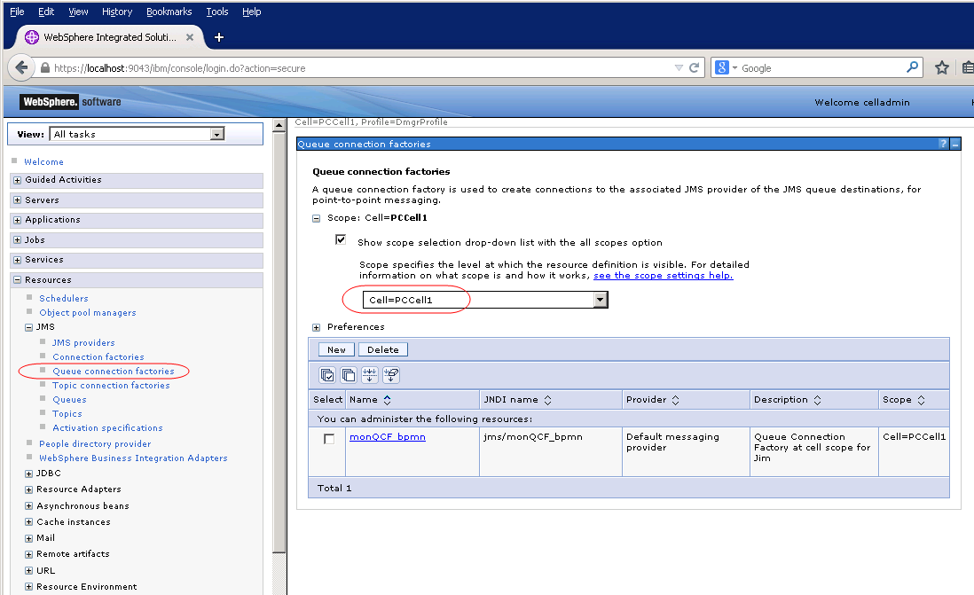

Create a JMS Queue on that bus
Use the WebSphere administrative console to create a cell scoped JMS queue. The JNDI Name specified in WebSphere will be used in the sample jython script so make note of the name now.

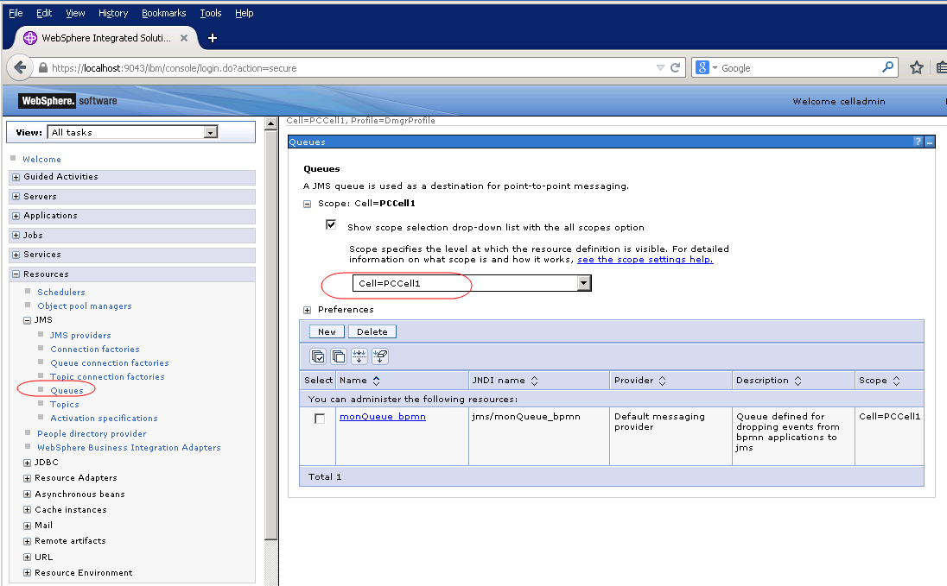

Editing the Sample Jython Script
Use the Sample Jython script (SampleConfigureEventsToJMS.py) to create your Dynamic Event Framework (DEF) configuration on your BPM. The sample script is flexible enough to allow you some freedom to create either one JMS queue to listen to for all events from numerous process applications or you could tailor it to have multiple queues. It is however recommended to listen on a single JMS queue.

Edit the script and provide values for the following fields in the sample script:
1) defListenerId = ‘myListener1’ (This is a simple string identifier to be used to identify the listener who is reading events from a JMS queue. )
2) eventQueueJndiName = 'jms/monQueue_bpmn' (This is the JNDI name of the JMS queue that is a cell scoped resource that you must create prior to executing this sample script.)
3) eventQueueCFJndiName = 'jms/monQCF_bpmn' (This is the JNDI name of the JMS queue connection factory resource that was created at the cell scope. This resource must exist prior to executing this sample script.)

4) eventQueueCF_AuthorizationAlias = 'DeAdminAlias' (This is the authorization alias that will allow secured writes to the JMS queue. It is recommended to simply use the default that BPM provides for the bus, which is DeAdminAlias.)
5) The subscriptions array list is simply a list of the event point keys that you wish to receive. There are many different ways that you can tailor this in your environment. To receive all events emitted from any BPM process application or BPEL application, use the single wildcard value of ‘*/*/*/*/*/*/*’. This way, all events will be sent to the JMS queue.
subscriptions = [
'*/*/*/*/*/*/*'
]
To receive all events from any BPM process application only, use the single wildcard value of ‘*/*/BPD/*/*/*/*’.
subscriptions = [
'*/*/BPD/*/*/*/*'
]
To receive all events from a particular process application, use the single wildcard value of ‘HSS/*/BPD/*/*/*/*’. (HSS is the name of the Hiring Sample process application as an example)
subscriptions = [
'HSS/*/BPD/*/*/*/*'
]

As you can see, you can tailor this in many ways but if you wish to minimize the need to re-run this script as more process applications are rolled out, it is recommended that you use the simple wildcard pattern for all events.

Executing the Sample Scripts

At the BPM Deployment manager, run the sample jython scripts.
- Open up a command line window
- Go to the <deployment manager profile home>\bin directory
- To create the Dynamic Event framework configuration, type “wsadmin –lang jython –user <celladmin> –password <celladmin> –f \tmp\SampleConfigureEventsToJMS.py (use credentials for the cell administrator in lieu of celladmin)
- Synchronize all nodes with the deployment manager so that the Dynamic Event Framework configuration is propagated to all nodes.
- Next reload the Dynamic Event Framework. In a multi-cluster network deployment environment, ensure that the Support cluster is started before performing this step. If the Support cluster is not started at this point, then the operation of starting the Support cluster will reload the Dynamic Event Framework, so explicitly running SampleReloadDEF.py is not necessary in this case. Type the “wsadmin –lang jython –user <celladmin> –password <celladmin> –f \tmp\SampleReloadDEF.py” command (use credentials for the cell administrator in lieu of celladmin). Note that the SampleReloadDEF.py command does not need to be modified.
- Synchronize all nodes with the deployment manager.

