**OAC-DR-Sync Utility**

Raj Verma

Tuesday, March 26, 2019

Contents

Purpose 3

Prerequisites 3

Directory Structure 3

Utils 3

Scripts 3

Cfg 4

Files 4

Logs 4

Lib 5

bin 5

How to run Utility 5

Command Interface version of Sync utility 5

# Purpose

This utility is mainly designed to Sync two environments of Oracle Analytics Cloud(OAC) Essbase including applications and securities.

OAC-DR-SYNC also can be used for following activity using manual interaction command interface.

# Prerequisites

This utility can be run on any Linux machine. ***Recommended to run it from DR server***. System must meet following condition.

1. Python should be installed (2.6 or higher)
2. Directory path of OAC-DR-SYNC must be set in user profile.

e.g. OAC-DR-SYNC is copied under home directory of user

/home/user/**OAC-DR-SYNC**

**Provide permission to OAC-DR-SYNC directory**

***Chmod -R 755 OAC-DR-SYNC***

Now add following lines to user profile (/home/ucd ser/.bash_profile)

**OAC_UTIL_PATH=home/<user>/OAC-DR-SYNC/utils**

**export OAC_UTIL_PATH/cli**

save and execute the profile from home directory of user

. .bash_profile

1. Upgrade latest version of CLI under utils directory

# Directory Structure

OAC-DR-SYNC has directory structure as follows. *Here <Oracle> is the user.*

/home/<oracle>/OAC-DR-SYNC/  
 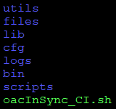

## Utils

Utils directory contains all required utilities to run OAC-DR-SYNC, like cli, Maxl, migrationTool and EssbaseLCMUtility.

## Scripts

This folder contains all scripts required for automation of Sync two OAC environments.

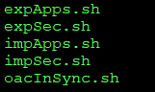

## Cfg

This directory contains configuration file which need to edit and configure before run silent sync.

/home/oracle/OAC-DR-SYNC/cfg/**oacsyncconfig.cfg**

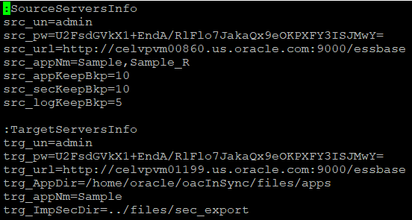

## Files

In this folder all applications and security exported as follows;

1. Applications Export/Import default path (/home/oracle/OAC-DR-SYNC/files/apps)
2. Security export/import (users/groups)default path (/home/oracle/OAC-DR-SYNC/files/sec_export)

## Logs

This directory contains all the logs of application and security export/import and report for full sync between two OAC instance.

1. Application export default log path (/home/oracle/OAC-DR-SYNC/logs/export/appl)
2. Application import default log path (/home/oracle/OAC-DR-SYNC/logs/import/appl)
3. Users export log path (/home/oracle/OAC-DR-SYNC/logs/export/users)
4. Users import log path (/home/oracle/OAC-DR-SYNC/logs/import/users)
5. Groups export log path (/home/oracle/OAC-DR-SYNC/logs/export/groups)
6. Groups import log path (/home/oracle/OAC-DR-SYNC/logs/import/groups)
7. Master log of entire sync process (/home/oracle/OAC-DR-SYNC/logs/ OAC-DR-SYNC_dd-mmm-yyyy_hhmm.log
8. Report of entire sync process (/home/oracle/OAC-DR-SYNC/logs/reports/OAC-DR-SYNC.txt)

## Lib

This directory contains all the required functions for OAC-DR-SYNC utility as follows.

1. font_style.sh
2. functions.sh
3. oacsyncfunc.sh (contains functions of CLI and rest which can be also used for custom automaton)

## bin

This directory contains supportive code to read configuration file, generate report for sync and encrypt password.

/home/oracle/OAC-DR-SYNC/bin



1. createReport.py : to create master report of entire sync between to environment.
2. readConfig.py : to read configuration file and generate compatible info file for OAC-DR-SYNC utility.
3. **password.sh : to generate encrypted password for configuration file.**

Follow below steps to encrypt password:

1. **Password.sh** password
2. Above statement will generate encrypted password in password.txt.
3. Copy encrypted password string from password.txt and paste in to **oacsyncconfig.cfg** file.

# How to run Utility

To run the sync in silent mode, need to execute or schedule ***/home/oracle/OAC-DR-SYNC/scripts/OAC-DR-SYNC.sh*** which will sync target instance from source instance, read all the information from **oacsyncconfig.cfg** file and performs the sync accordingly.

# Command Interface version of Sync utility

OAC-DR-SYNC can be run in interactive mode by executing ***OAC-DR-SYNC_CI.sh***

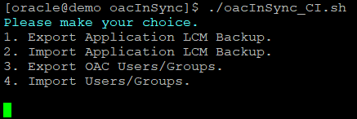

This can be operated by numeric inputs