Design Data Extraction Manager for Mobile Social Ecosystem
(Project Description)

Submitted by
Nishant Kumar
(Roll number: 07000015)
B.Tech Part III
Dept. of Computer Engineering
IT-BHU, Varanasi(U.P.)
India

Under the supervision of

Dr. Alessandra Toninelli
ERCIM Post-doctoral Fellow
ARLES Project-Team
Paris-Rocquencourt
FRANCE

and

Dr. Animesh Pathak
Research Scientist
ARLES Project-Team
Paris-Rocquencourt
FRANCE

CONTENTS

Chapter 1 | Introduction |  | 4-7
 | 1.1 | Overview …………………………………...... | 5
 | 1.2 | Definitions and Teminologies………………... | 5
 | 1.3 | Yarta………………………………………...... | 6
 | 1.4 | Data Extraction Manager (DEM)…………...... | 7
Chapter 2 | Theory |  | 8-16
 | 2.1 | Extraction of Data from Android phone | 9
 |  | 2.1.1 Android phone…………………......... | 9
 |  | 2.1.2 Android ContentProvider…………… | 9
 |  | 2.1.3 Contact ContentProvider……………. | 9
 |  | 2.1.4 CallLog ContentProvider….………… | 10
 |  | 2.1.5 SMS ContentProvider……………….. | 10
 | 2.2 | Extraction of Data from Social Network
 |  | 2.2.1 Social Network……………………… | 10
 |  | 2.2.2 Authentication………………………. | 10
 |  | 2.2.3 OAuth Authentication………………. | 11
 |  | 2.2.4 LinkedIn Data Extraction…………… | 12
 |  | 2.2.5 Facebook Data Extraction…………… | 14
Chapter 3 | Implementation |  | 17-21
 | 3.1 | Architecture Diagram……………………....... | 18
 | 3.2 | Source code description…..………………..... | 19
 | 3.3 | Class Diagram……………………………….. | 22
 | 3.4 | Flow of Execution………………………........ | 23
 | 3.5 | Features……………………………………..... | 25
 | 3.6 | Use………………………………………........ | 26
Chapter 4 | Conclusion |  | 27
Chapter 5 | Future Work |  | 29

Chapter 1
Introduction

1.1 Overview

In the current internet era, the interest has grown rapidly towards social networking.
There exists a wide area of social networks with millions of user. Owing to the large variety of
platforms available for social networking, as well as the different ways the information is represented, it is natural to think of middleware solutions that can bring the users and application developer of the social networks to a common platform.

In this project, I discuss the component of the middleware designed for a common solution for extraction of data from the different social data sources. It includes a common layer of data extraction so that the social networking can be brought to a single window. The data source may be a user smart phone, or a social networking data source containing data of millons of users.

1.2 Definitions and Terminologies:
a.) Mobile community : A group of people united by shared interests
b.) Social network : A social structure made up of individuals or organizations
connected by specific types of interdependency
c.) Mobile Social Ecosystem (MSE) : The rich social interactions seen in current
mobile environments.
e.) MSE Management Middleware : A layer of middleware, responsible for storing,
managing and allowing access to MSE data
f.) Data Extraction Manager : The component of MSE Management layer that is
responsible for extraction of data from various social data
sources.

1.3 YARTA: The MSE Management Middleware:
It is the middleware designed for mobile social ecosystems (MSE). It takes into account the intrinsic distributed nature of mobile social applications, as well as users' security concerns
Yarta is responsible for collecting, maintaining and processing social data, as well as allowing access to those data via extensible interfaces, thus enabling different applications to exploit information provided by the mobile social ecosystem.
The middleware architecture provides mobile social application developers with a set of functionalities that allow them to easily create, manage and securely exchange MSE data.
The middleware consists of two layers:
- MSE Management Middleware : Responsible for storing, managing and allowing access
to MSE data
ii. Mobile Middleware layer : Low level communication/coordination issues, such as
message exchange or device discovery.

The architecture of the Yarta middleware is shown in the figure below:

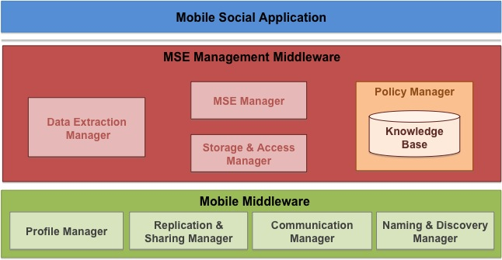

1.4 Data Extraction Manager
The Data Extraction Manager is a component of the MSE Management Layer of the Yarta middleware.
It extracts data from different sources to insert them in the information store of the middleware. Examples of data source include smart phones, existing user applications, such as software for managing pictures, or social platforms like Facebook etc.
The Data Extraction Manager has a modular structure.It interacts with multiple data sources, with each module taking care of a specific source of information.
This component is discussed in detail later.

Chapter 2

Theory

2.1 Introduction
This chapter deals with the basic theory of data extraction from the various data source. These data source provides the information for a user in social network.
The data source can be situated remotely on any server e.g. Facebook,Orkut
or placed at the nodes of social network e.g. smart phones.
The current implementation deals with the extraction of data from an Android phone as well as social networking websites such as LinkedIn, Facebook.

2.2 Extraction of Data from Android Phone

2.2.1 Android:
Android is Google's operating system for mobile devices. It is available as
open source. It consists of Java applications running on a Java based object oriented application framework on top of Java core libraries.

2.2.2 Android ContentProvider:
Android has Content providers that stores and retrieve data and make it accessible to all applications. It is the only way to share data across applications. There is no common storage area that all Android packages can access. Android ships a number of content providers for common data types (audio, video, images, personal contact information, and so on).
All content providers implement a common interface for querying the provider and returning results. Each contentprovider is identified by a unique content uri. The data is stored in specific columns in a contentprovider.

2.2.3 Contact ContentProvider:
The contacts of a user of Android phone is stored in contact content provider.
All information regarding a contact are categorized and stored in respective content provider.

The following are the main content provider and their columns that are used in the project:
Contact: ContactsContract.Contacts
Email: ContactsContract.CommonDataKinds.Email
Phone: ContactsContract.CommonDataKinds.Phone

2.2.4 CallLog Content provider
The Call Log of an Android phone is stored in CallLog.Calls ContetProvider.
There necessary informations for a call history are stored in the different columns of this content provider.

2.2.5 SMS ContentProvider
The SMS of the android mobile phone user are stored in the SMS Content Provider.
The necessary details of a message are stored in different columns of the SMS Content Provider.
ContentProvider for all sms : content://sms
ContentProvider for inbox sms: content://sms//inbox
ContentProvider for sent sms: content://sms//sent

2.3 Data Extraction from social networks:

2.3.1 Social Network: A social network is a social structure made up of individuals or organizations connected by specific types of interdependency, such as friendship, common interest , shared professional activities etc.

2.3.2 Authentication: The user of a social network is associated with information.
These information may be any activity, private messages, information etc. As social networks deals with sharing of data, there need to be a proper authorization and authentication system for accessing the information related to user.
Every social network has an authorization and authentication method to protect the information from unauthorized access. Facebook and LinkedIn API uses the OAuth Authentication flow to let the application access the information from the social network.
This project uses the required OAuth flow for data extraction from Social Network. It is discussed in the next section.

2.3.3 OAuth Authentication

OAuth is an open protocol to allow secure API authorization in a simple and standard method from desktop and web applications.

It has the following basic components
- Service Provider: The Service Provider is the term used to describe the website or
web-service where the restricted resources are located. It can be a photo sharing site where users keep albums, or any other service where information is stored.
In the current scenario, LinkedIn and Facebook API are the service provider.
- User: The users have information they don’t want to make public on the service
provider, but they do want to share it with another site. In OAuth, the protocol stops
without manual interaction with the user at least once to receive permission to grant
access.
In the current scenario, user is the profile owner , whose information will be extracted by
the Data Extraction Manager
c.) Consumer: It is the application that is trying to access the user’s resources. This can be
a website, a desktop program, a mobile device etc. The consumer is the one getting
permission to access resources.
In the current scenario, it is the Data Extraction Manager Application that is accessing
a users profile for extraction of data.
d.) Protected Resources: It is the information that is accessed and protected by OAuth.
This can be data (photos, documents, contacts), activities (posting blog item) .
In the current scenario, it is the profile information of a user, e.g. Name, Email etc.
e.) Tokens – It is used to access user resources. A token is a random string of letters and
numbers (but not limited to) that is unique, hard to guess, and paired with a secret to
protect the token from being abused. OAuth defines two different types of Tokens:
Request and AccessToken .
Request Tokens are used for obtaining user approval, while Access Tokens are used to
access Protected Resources

2.3.4 LinkedIn Data Extraction :
i) Introduction
LinkedIn is a business-oriented social networking site. (http://www.linkedin.com)
It is mainly used for professional networking.
ii) Authenitication
The LinkedIn API utilizes OAuth as its authentication method. Linkedin has a privacy practice that ensures that an end user grants access to the application to use their LinkedIn account. It makes end user to be in control of their information and their LinkedIn accounts. Only an individual user can grant access to the application to make API calls on their behalf.
iii) Steps for Data Extraction
- Register the application on Linkedin website ( http://)
and obtain the API key and API secret key for the application.

Establish a requestToken for the current session:
The first step for authorization is requesting a requestToken.
This request token is obtained by making a call to the server of Linkedin with the API
key and secret key as parameters. The url for request token is
https://api.linkedin.com/uas/oauth/requestToken

3. Redirect the User to Authorization Server
The requestToken obtained is used to forward the user to Linkedin authorization server.
The user will authorize the application.
The following urls can be used for authorization with a oauth_token as a parameter and
request token as its value.
https://www.linkedin.com/uas/oauth/authorize?oauth_token=requestToken
https://www.linkedin.com/uas/oauth/authenticate?oauth_token=requestToken
There is the following difference between above mentioned two authorization server
urls. The second url will automatically redirect the user to a webpage containing the PIN
number, if the following conditions statisfies:
a. The current user is logged into LinkedIn.
b. The current user has already granted an access token to your application.
c. The access token has not expired.
This provides a great user experience - just a one click login! If any of the above conditions are not true, the member will see the normal signin window.

4. Obtain the Access Token
This is the last step where the application obtains an access token that actually gives the agency to make requests on behalf of the LinkedIn member.
The following Url is used to receive the access token for the current user: https://api.linkedin.com/uas/oauth/accessToken

5. Make request for profile information
The application can now make requests to Linkedin to execute its statements.
For e.g. The call to the following url will fetch the profile for the user who
authorized this application
https://api.linkedin.com/v1/people/~
Result:
<?xml version="1.0" encoding="UTF-8" standalone="yes"?>
<person>
<first-name>Nishant</first-name>
<last-name>Kumar</last-name>
</person>

The above mentioned steps are used to extrac data from the Linkedin Profile.
In short, the following steps are used by the application to extract the data from a linkedin profile:
- Register the Application on Linkedin Developer website and get an API key and API
Secret key.
- Develop and application and distribute it to users.
- User clicks on your UI to use the features of your application.
- The application makes a call to LinkedIn for authentication.
This is called getting a Request Token.
- LinkedIn replies to the application with an Request token indicating that the user can use
the authentication system.
- Application redirects user to a LinkedIn url. The url includes the request token .
The user grants access to your application by signing into the authentication page.
- Upon successful authorization, LinkedIn will return a PIN number to the user
- The user submits the PIN number to the application.
- The application makes a call to LinkedIn to get an Access Token.
- LinkedIn replies with an Access Token for the user.
- The Access Token is used for any API calls to LinkedIn to identify the user on whose
behalf the application is making the call.
2.3.5 Data Extraction from Facebook:

i.) Introduction :
Facebook is a social networking website. Users can add people as friends and send them
messages, update their personal profiles etc.
The Facebook Platform provide support to read and write data to Facebook.
ii.) Authentication
Facebook authentication enables your application to interact with the API on behalf of
Facebook users. It uses OAuth standard authentication flow for authorization.
OAuth authentication is used to otbain an access token for a Facebook user. After the access
token is obtained, the application can perform authorized requests on behalf of the user who
has granted the permission to the application. The requests are made by including the access
token in API requests.
iii.) Data Extraction from Facebook
The following steps are followed to extract information from facebook profile:
- Register the application at http://developers.facebook.com/setup/ to get an application ID and application secret. The application ID is termed as client_id
and application secret is termed as client_secret.
- Develop the application that redirects the user to the facebook authorization page. The application id , application secret and redirect uri are passed as parameters in
the url. The following url is used for authorization of the application:
https://graph.facebook.com/oauth/authorize?
client_id=applicationID
&redirect_uri= http://www.facebook.com/connect/login_success.html

- After authorization, the facebook redirects the user to the redirect url with the request
token appended in the url. This request token is denoted by code. The following url is the redirected url by facebook after authorization:
http://www.facebook.com/connect/login_success.html?code=requestToken
- The request token obtained is used to get the access token.
The following url is used to get the access token:
https://graph.facebook.com/oauth/access_token?
client_id=applicationID
&client_secret=applicationSecret
&redirect_uri=http://www.example.com/oauth_redirect&
&code=requestToken
5. The access token is returned by the server as a response. This access token is used to extract the data from the facebook profile of the user.
6. The following url is used to obtain the profile information:
https://graph.facebook.com/me?access_token=accessToken
Result: A sample result obtained after making call to facebook api is as shown below
{
"id": "220439",
"name": "Nishant Kumar",
"first_name": "Nishant",
"last_name": "Kumar",
}

Hence, the above mentioned steps can be used to extract information from a
facebook profile of user.
In short , the following steps can be used to extract data from the facebook profile of a user:
- Redirect the user to https://graph.facebook.com/oauth/authorize with your client_id and the redirect_uri.
- Obtain the code after the authentication
- Redirect the user to https://graph.facebook.com/oauth/access_token with required parameters and code obtained.
- Use the access token obtained to extract data from a user profile.

2.4 Summary:

The wide spread social networks has millions of user. Each user is associated with some information. These information can be extracted by using the required tools and technologies. The extraction of data from a social network was analysed. The social network also includes the individual nodes as smart phone. The contribution of smart phone in social network is analysed.
The extraction of data from the social network is presents in a stepwise method.

Chapter 3

Implementation

3.1 Architecture diagram
USER (Yarta Middleware)

DEM Module 1
DEM Module 2
Social Data Inference
Raw Data Extractor

Social Data Inference
Data Mapping Layer
……………
Data Mapping Layer
Raw Data Extractor

Social Data Source

Description:
a. Social Data Source : The data source from where the data extraction manager will extract
data.
b. DEM Module : The functional unit of data extraction manager. The module is
developed to extract data from a specific data source.
c. Raw Data Extractor : The part of the DEM Module that connects to the social data source
and extract the required data. It may take various information in
its input and returns the extracted data.
d. Data Mapping Layer : It is used to process the extracted data by raw data extractor and
extract useful information from it. It is used to provide useful
information to the end user.
e. Social Data Inference : It is used to make necessary conclusion for social friendship by using
any criteria of friendship with the extracted information.
3.2 Source code description
The basic design of the Data Extraction Manager source code is following:
Common Operations: It consists of those functions that are intensively used for data extraction from a specific data source or platform.They are developed to be used by the DEM modules to extract data. For e.g. a set of functions that performs basic operations for data extraction from a mobile phone, social networking platforms etc.
The current implementation consists of the following :
Phone processor ( common operations of data extraction from Android phone) ,
IDataExtraction ( interface implemented by Web Social Data Extraction modules).

Core Modules: The module developed to extract data from a specific data source and process the result to return it to the user. It communicates with functions in the common operation criteria to form a functional unit. The core modules are used by the user to extract data.
The current implementation consists of the following:
Contact Processor, CallLog Processor , SMS Processor (all designed for Android phones)
Facebook processor (data extraction from Facebook profile of a user)
LinkedIn processor (data extraction from Linkedin profile of a user)

3.2.1 Phone Processor
The phone processor component of the Data Extraction Manager is responsible for making communication with the smart phone social data. This component makes query to the smart phone and returns the extracted information. It also extracts the common information required by almost every modules for phone data extraction , for e.g. contact name by number, contact ID by phone number etc.
Currently, the phone processor is implemented to work with Android phones. It extracts the following information from an Android phone:
- Make a query to Android Content Provider and return the result.
2. Extract a Contact ID for a contact stored in contact list. The contact Id can be searched
according to different criteria such as Name, Number , Email.
3. Extract Name, PhoneNumber, Email for a given ContactID of a contact in contact list.
4. Extract the email address from name or mobilenumber
5. Extract the mobile number from a given name or email
6. Extract the name for a given mobile number or email address
3.2.2 IDataExtraction
It is an interface that should be implemented by any module that is designed to extract information from web social network. This interface extracts information from the module that connects to social profiles and extract information from it. The functions of this interface can be used by any component to obtain the information extracted from a social networking profile.
The current interface provides the following information for a social network profile:
1. First Name
2. Last Name
3. Full Name
4. Email Address
5. Web Profile Url
6. Friends List
6.1 Friend Name
6.2 FriendProfile Url

3.2.3 DEM Modules:
It is a modules, written by application developers, to extract data from a specific social data store. These modules, combined with the Data Extraction Service Layer , forms the functional unit that communicates with a particular social data store and extracts the required information from it.
Currently, there are five data extraction modules implemented to work on an Android phone.
Each module is implemented to extra data from a specific source.
These modules are discussed below:
- Contact Manager: This module is designed to extract the information from contact list of the user. It extends the Phone Processor component of the common Layer to form a functional unit.
- Call Log Manager: This module is designed to extract information from the Call History of the android phone user. It extends the Phone Processor of the Data Extraction Common Layer to form a functional unit.
- SMS Manager: It is designed for extraction of data from the messages received and sent by the user. It uses the Phone processor component to form a functional unit.
- LinkedIn Manager : This module is designed to extract information from a LinkedIn profile of a user. It implements the IDataInterface of the Common Layer to form a functional unit. This module connects to the LinkedIn account of a user and extract data from it. The extracted data are then processed by the IDataextraction interface. The processed data is then available for use.
- Facebook Manager: The module is designed to connect to a facebook profile of user and extract data from it. It implements the IDataExtraction Interface of the Common layer to form a functional unit. The interface process the result extracted from the facebook profile and makes it available for use.

3.3 CLASS DIAGRAM

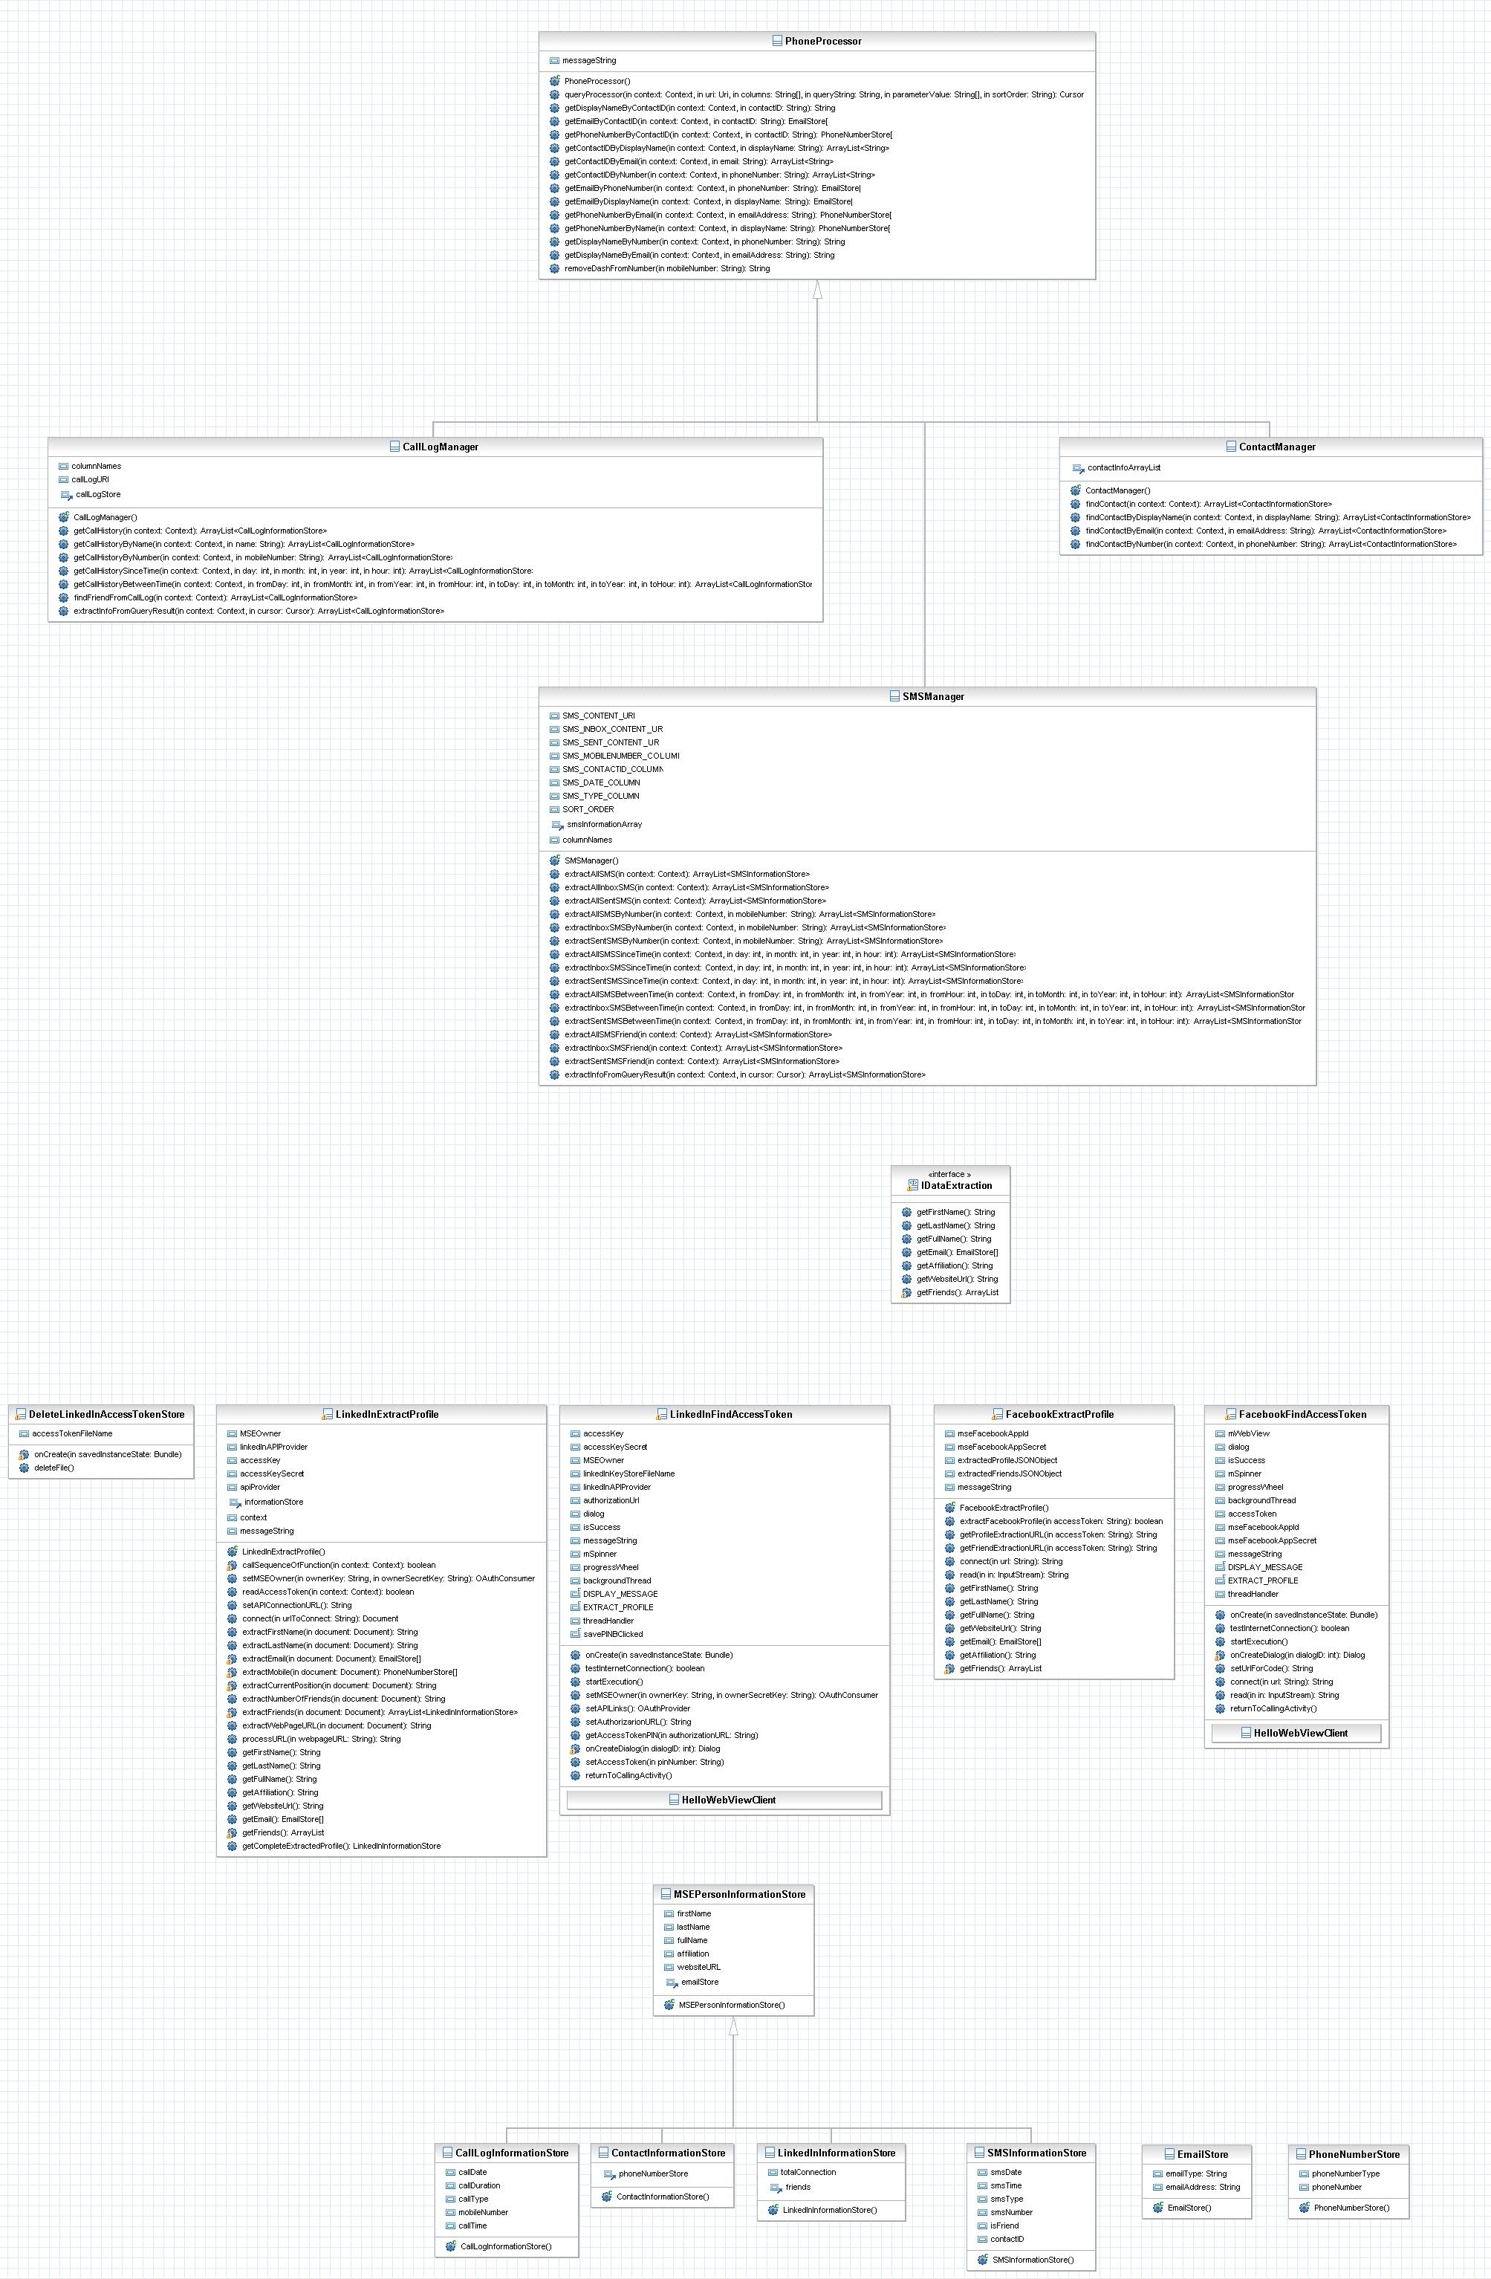

3.4 Execution Control Flow
The execution control flow for few modules are described in this section.
3.4.1 Execution control flow of data extraction from Facebook
- User selects Facebook Manager from the homescreen.
- FacebookManagerHome.java activity starts.
- The FacebookFindAccessToken.java activity is started by the FacebookManagerHome activity.
- A thread is created and startExecution method is called.
- Dialog box for displaying webview is formed and the base url is loaded in it.
- The user authenticate the application.
- The redirected url is extracted in the onPageFinish function of the
WebViewClient and the code is extracted.
- The extracted code is used to make a connection to facebook api url for acccesstoken.
- The access token is obtained by passing the various parameters to the facebook api
url for access token.
- The access token response is received and access token is extracted from it.
- The access token is passed as a result to the calling activity, i.e. FacebookManagerHome.java
- The FacebookManagerHome.java get the access token and calls the extractFacebookProfile method of FacebookExtractProfile.java class and passes access token to it.
- The extractFacebookProfile method calls a set of functions for connecting facebook and extracts data from the user profile.
- The extracted data are processed by the overridden functions of the implemented interface.
- The control returns back to the calling activity and the result is displayed.

3.4.2 Execution control flow of data extraction from LinkedIn
- The LinkedIn processor is selected from the DEM home screen.
- The LinkedInManagerHome.java activity is started to display the list of options related to data extraction from LinkedIn.
- The test access token and delete access token are selected to call TestLinkedInAccessToke.java and DeleteLinkedInAccessToken.java respectively.
- The FirstTime LinkedIn Connection is selected to connect to the LinkedIn profile for getting accesstoken. It calls LinkedInFindAccessToken.java activity.
- The startExecution method calls a set of function to get access token. The dialog is displayed and a webview is loaded to get the PIN number for the access token.
- The access token received is stored in a “LinkedIn” file in the Android internal memory.
- The control id transferred to the DefaultLinkedInConnect.java class.
- The access token stored in the Android internal memory is read and it is used to connect to the LinkedIn profile of a user.
- The extracted result is displayed.

3.5 Features
- Modular structure, therefore extensible to other modules for Anndroid and Social Networking.
- Determine a list of friends from Contact list , Call log and SMS.
- Separate threads for data extraction , therefore reducing load of main thread.
- Save the access token obtained after authorization in the internal memory of Android.
- Log report generation, to track any error during data extraction.
- Specific modules targeted for a specif data source
- GUI for easy communication with Data Extraction Manager.
- List of Options for extraction of data from specific data source.
- The automatic redirection to authorization webpage by browser.
- The progress report of data extraction are displayed while in application is in use.

3.6 Use
3.6.1 Social Networking under one window:
By using Data Extraction Manager, different social networking websites
can be organized in a single window. The user needs to communicate with a central
server.This central server has all the information for the user from different social
networks.
3.6.2. Application developer Common target
The application developer targets to develop applications for a specific social network.
By integration of all social networking in a single window, the application developer
will be able to develop the applications for different social networks by using a
common protocol.
    - Friendship in Social Network
The friendship relation of the user can be determined. The implemented system
determined friends by matching the different information from the contact list. Hence
the social friendship of the user can be determined.

Chapter 4

Conclusion

Conclusion
- The Data Extraction Manager was implemented to extract social information.

- Provided a modular structure to Data Extraction manager

- Any application for data extraction from Android phone and Social networking can be plugin into the system.

- The extraction of data from the contact list, call log was implemented and extraction of data from SMS was plugged in into the system.

- The extraction of data from the Linkedin was implemented and data extraction from facebook profile was plugged in to the system.

Chapter 5

Future Work

Future Work
Few of the future works includes the following:
- Integration of Data Storage for the extracted Information.
- Code generation for the new Plugin for the system.
3. Addition of a Pre-processor for filtering the extracted result.
4. Improve the efficiency of data extraction with respect to time and memory.

