
PIZZA SALES SQL QUERIES
KPI Metrics :-

1. Total Revenue:
SELECT
CAST(SUM(total_price) AS DECIMAL (10,2)) AS Total_Revenue
FROM pizza_sales;

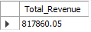

2. Average Order Value
SELECT
CAST(SUM(total_price) / COUNT(DISTINCT order_id) AS DECIMAL (5,2))
AS Avg_Order_Value,
MAX(total_price) AS Maximum_Order_Value,
MIN(total_price) AS Minimum_Order_Value
FROM pizza_sales;

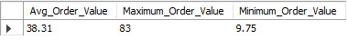

3. Total Pizzas Sold
SELECT SUM(quantity) AS Total_Pizzas_Sold FROM pizza_sales;

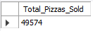

4. Total Orders
SELECT COUNT(DISTINCT(order_id)) AS Total_Orders FROM pizza_sales;

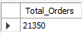

5. Average Pizzas Per Order
SELECT
CAST(SUM(quantity) / COUNT(DISTINCT(order_id)) AS DECIMAL (10,2))
AS Average_Pizzas_per_Order
FROM pizza_sales;

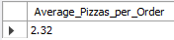
Trends for Total Orders :-

6. Hourly Trend for Total Pizzas Sold:
SELECT order_hour, SUM(quantity) AS Total_Pizzas_Sold
FROM pizza_sales
GROUP BY order_hour
ORDER BY order_hour;

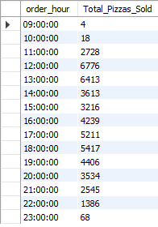

7. Weekly Trend for Orders:
SELECT
order_weeknum AS Week_Number_of_2015,
COUNT(DISTINCT(order_id)) AS Total_Orders
FROM pizza_sales
GROUP BY order_weeknum
ORDER BY order_weeknum;

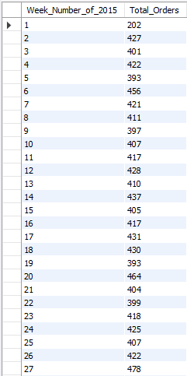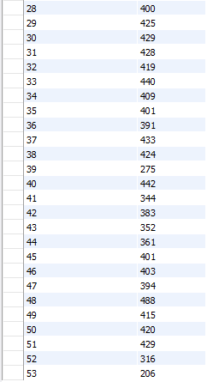
Percentage of Sales :-

8. Percentage of Sales by Pizza Category:
SELECT
pizza_category,
CAST(SUM(total_price) / 100000 AS DECIMAL(10,2)) AS Total_Revenue_in_Lakh,
CAST(SUM(total_price) * 100 / (SELECT SUM(total_price) FROM pizza_sales) AS DECIMAL(10,2)) AS PCT
FROM pizza_sales
GROUP BY pizza_category
ORDER BY Total_Revenue_in_Lakh DESC;

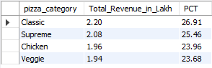

9. Percentage of Sales by Pizza Size:
SELECT
pizza_size,
CAST(SUM(total_price) / 100000 AS DECIMAL(10,2)) AS Total_Revenue_in_Lakh,
CAST(SUM(total_price) * 100 / (SELECT SUM(total_price) FROM pizza_sales) AS DECIMAL(10,2)) AS PCT
FROM pizza_sales
GROUP BY pizza_size
ORDER BY Total_Revenue_in_Lakh DESC;
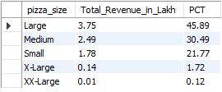

10. Total Pizzas Sold by Pizza Category:
SELECT
pizza_category,
SUM(quantity) AS Total_Quantity_Sold
FROM pizza_sales
GROUP BY pizza_category
ORDER BY Total_Quantity_Sold DESC;
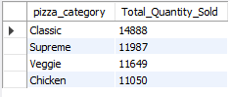
Best and Worst Sellers :-

11. Top 5 Pizzas by Revenue:
SELECT
pizza_name,
CAST(SUM(total_price) AS DECIMAL (10,2)) AS Total_Revenue
FROM pizza_sales
GROUP BY pizza_name
ORDER BY Total_Revenue DESC
LIMIT 5;

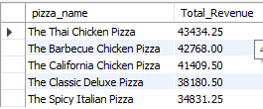

12. Bottom 5 Pizzas by Revenue:
SELECT
pizza_name,
CAST(SUM(total_price) AS DECIMAL (10,2)) AS Total_Revenue
FROM pizza_sales
GROUP BY pizza_name
ORDER BY Total_Revenue ASC
LIMIT 5;

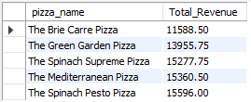

13. Top 5 Pizzas by Quantity:
SELECT
pizza_name,
SUM(quantity) AS Total_Pizzas_Sold
FROM pizza_sales
GROUP BY pizza_name
ORDER BY Total_Pizzas_Sold DESC
LIMIT 5;

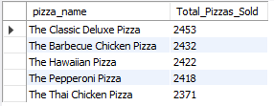

14. Bottom 5 Pizzas by Quantity:
SELECT
pizza_name,
SUM(quantity) AS Total_Pizzas_Sold
FROM pizza_sales
GROUP BY pizza_name
ORDER BY Total_Pizzas_Sold ASC
LIMIT 5;

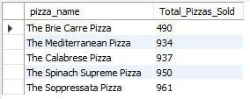

15. Top 5 Pizzas by Total Orders:
SELECT
pizza_name,
COUNT(DISTINCT(order_id)) AS Total_Orders
FROM pizza_sales
GROUP BY pizza_name
ORDER BY Total_Orders DESC
LIMIT 5;

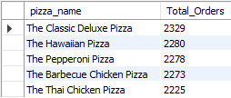

16. Bottom 5 Pizzas by Total Orders:
SELECT
pizza_name,
COUNT(DISTINCT(order_id)) AS Total_Orders
FROM pizza_sales
GROUP BY pizza_name
ORDER BY Total_Orders ASC
LIMIT 5;

