**Key Value Proposition**

**Shade App**: *Know your mood and improve it!*

Social media sits at the epicenter of the lives of most people. Your emotions are more evident from your activity on various platforms such as Facebook, Twitter, Instagram, etc. than perhaps, from your daily activities. Whether they’re feeling low or enthusiastic, people take to social media to vent their emotions. We hope to put that work to good use. What if your social media activity could help improve your mood? We bring you an application that produces a ready-made playlist designed for you, simply by analyzing your tweets. All you need to do is enter your Twitter handle and we take care of the rest. Our desktop application presents a unique and quick way to raise your spirits. A good vibe is just a click away!

Key Features:

1. Desktop Application
2. Interactive UI
3. Minimal user input with no violation of security
4. Quick and efficient response
5. Collection of playlists designed to improve the user’s mood

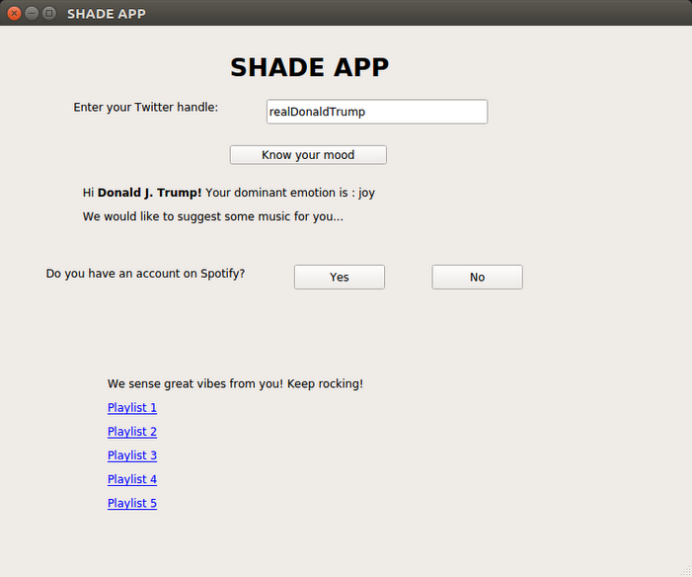

**Our UI**



**Spotify Playlist**



**YouTube Playlist**