Student Support Systems for Online Education available in NKI’s Integrated Systems for Internet Based E-learning
Morten Flate Paulsen, Truls Fagerberg & Torstein Rekkedal

The first part of this chapter presents the systems NKI Distance Education apply to facilitate student support services for online education. The second part discuss the services with regard to the grid of student support services developed by Student Support Services in e-Learning (http://learning.ericsson.net/socrates/), a project supported by the European Socrates program.

NKI’s Integrated Systems

NKI has a number of self-developed and commercial applications that together make up a comprehensive system for student support services. The integration of the systems is extremely important for the total functionality, effectiveness, and quality of the student support services. As shown in Figure 1, STAS is the pivotal master system that holds the core data that many of the other systems depend on.

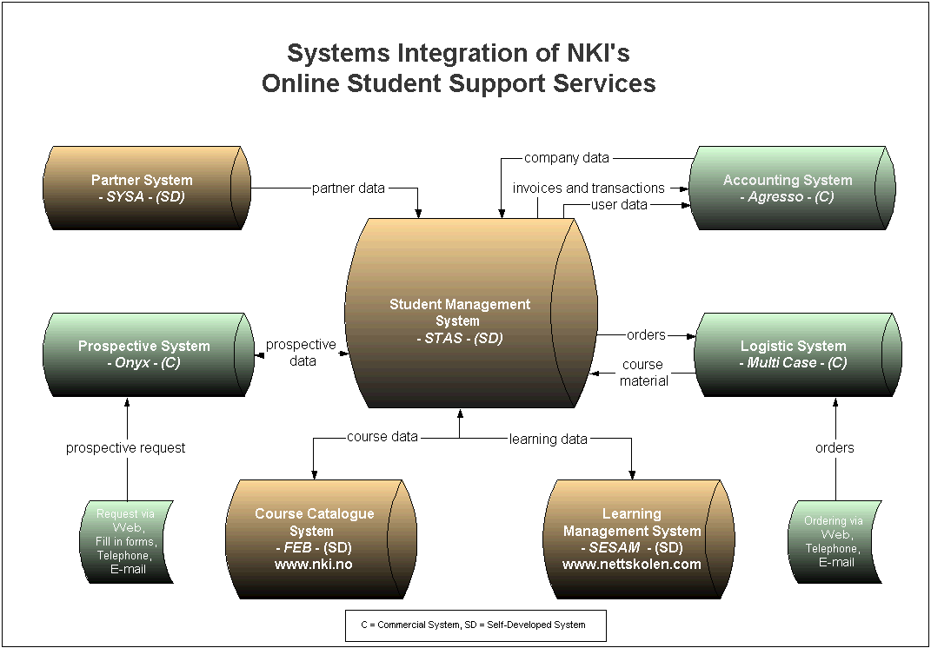

Figure 1. NKI’s integrated systems for online student support

STAS: A Self-developed Student Management System

STAS is NKI’s system for administration of distance students and it is developed by NKI. STAS holds all relevant data about our students, teachers, courses and study programs. One of the largest advantages with STAS is that it is developed to handle students with free starting time and progression. This system also contains very good tools for generating various reports and statistics.

STAS is to consider as NKI master system and is tightly integrating other essential systems such as accounting, logistic, prospective and partner systems. STAS is also the master system for NKI’s Learning Management System (LMS) SESAM, www.nettskolen.com, and NKI’s business portal, www.nki.no.

Agresso: A commercial accounting system

Agresso (www.agresso.com) is a commercial accounting system that handless tuition fees, invoices, wages etc.. When a course enrollment is registered in STAS, the corresponding student account is debited in Agresso. When tutors register grades in SESAM, they are transferred to STAS and the remuneration is added to their accounts in Agresso.

SYSA: A self-developed partner system

SYSA is a system NKI has developed to present information about the local partners that organize face-to-face classes based on NKI’s distance education courses. It provides contact information about the local partners and the classes they offer for NKI courses. SYSA supports the local partners’ marketing and student recruitment. The partners’ contact information is forwarded to STAS.

Onyx: A commercial prospective system

Onyx is a commercial system that is purchased to handle marketing activities and requests from prospective students. Each advertisement, brochure, TV commercial, web-campaign etc. is identified with a unique media code. The advertisements result in thousands of requests that are registered with contact information and media code. The requests may come via NKI’s website, telephone, e-mail etc. from people who consider to enroll in a course. Onyx is also used to follow up prospective students who have showed their interest, but never enrolled in a course. Onyx has access to STAS data so that it knows which prospective students that actually enroll in a course. As a result of this, Onyx provides a number of reports and follow-up services for the marketing department.

Multi-Case: A commercial logistic system

Multi-Case is a commercial logistics system for administration of purchases and shipments of textbooks and miscellaneous physical course material. When course enrollments are registered in STAS, Multi-Case automatically initiate shipment of the corresponding course material. Multi-Case also provides a number of reports about royalties, material on stock etc.

SESAM: a self-developed learning management system

SESAM is NKI’s self-developed learning management system. It is developed to support the services that are important to NKI, and it is therefore well adapted to NKI’s special needs. SESAM is excellent for handling continuous student enrollment 365 days a year. The major, additional advantages it has compared to commercial LMS systems, is its focus on cost-effectiveness and the necessary integration with all the critical student support systems.

SESAM provides a number of services for students. Among them are:

- Access control
- Personalized user-interfaces
- Access to course content and assignments
- Discussion forums
- Class lists
- Student presentations
- Information about grades

The teachers have access to additional services such as:

- Online registration of grades
- Tutor support services
- Wage and payment data

NKI employees also have access to a number of additional reports and statistics on information about course enrolments, user statistics, etc.

SESAM is developed for large-scale online education and it applies state-of-the-art web technologies including Java, XML, XSL, Oracle 9i database and Apache web server.

FEB: A self-developed business portal

FEB is NKI’s self-developed business portal. It is the main portal for the NKI online course catalog. This online catalog presents all courses and programs offered by NKI. This includes information about course content, necessary prerequisites, credits, exams, tuition fees, etc. Prospective students may register or apply to courses directly via FEB. In addition to course information FEB also include a comprehensive database of article with news, frequently asked questions, and more general information about distance and online education. A number of research articles and reports are also available in FEB.

FEB also provides a search engine covering the course catalog, www.nki.no and www.nettskolen.com. FEB is built on current web technologies including Java, XML, XSL, Oracle 9i database and Apache web server.

In February 2003, FEB for the first time automatically provided the course information used in the printed course catalog.

The Grid of Student Support Services

The project Student Support Services in e-Learning has developed a grid of student support services. The following, second part of this article, discusses NKI online student support systems according to the following elements of the grid:

- The information phase
- The guidance phase
- The registration phase
- The help desk
- The learning phase
- The final results phase

The Information Phase
The NKI Marketing department is responsible for the activities related to the information phase. The pivotal systems the department uses to handle this are FEB, Onyx, and SYSA.

FEB presents information about the courses and program for potential students. It also includes additional information about NKI and the services that are available for students. Ideally, FEB should provide the information students need before they decide to enroll in a course. The online information presented via FEB is available at www.nki.no.

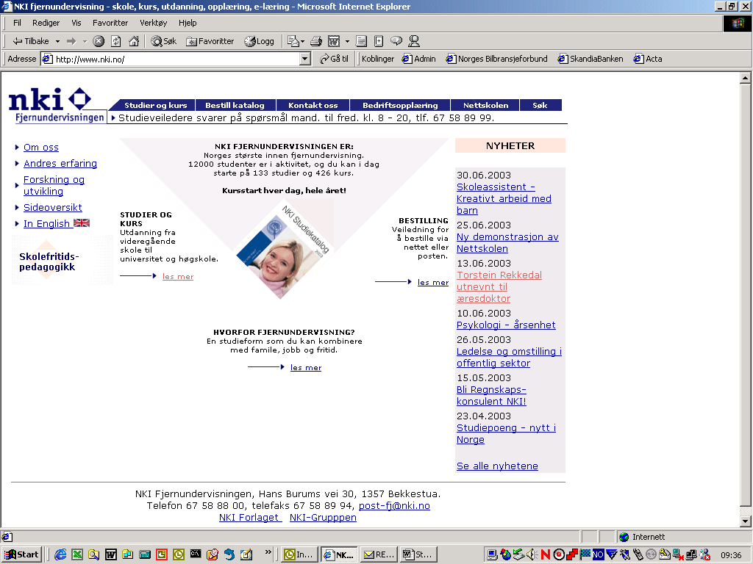

Figure 2. Front page of the NKI marketing/information site.

The front page of the information/marketing site is developed with the main goal of supplying information about NKI courses and programmes in a way that is easy to understand and access. The front page has links “studies and courses”, “corporate training” and to the “NKI Internet College” (i.e. to SESAM and the course pages). In addition the front page links to news and other information about NKI aiming to create contact and credibility. FEB includes both a free text search function and a function for searching for courses and study programmes.
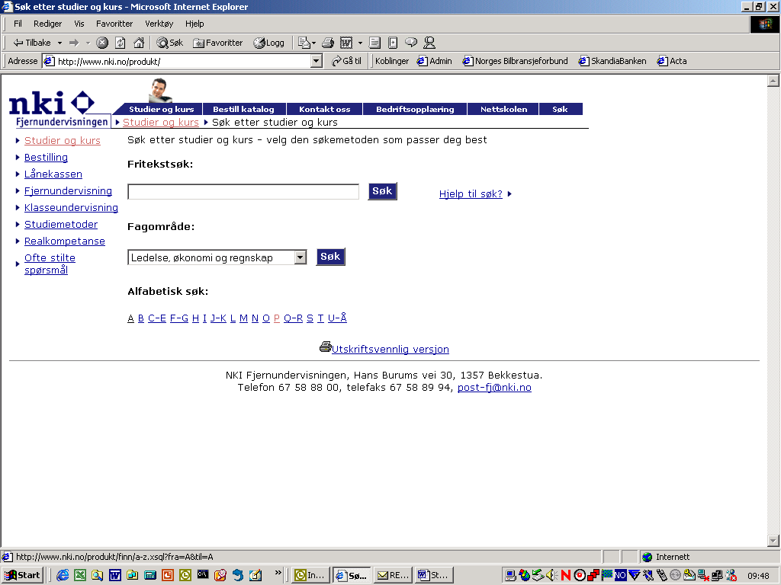

Figure 3. Courses and programmes search page.

The search page contains in addition to the search function information about how to order more information or enrolling, information about possibilities for loans and study grants and more information about study forms and methods (i.e. correspondence education, on line learning, combined education) and where in Norway on can participate in local face-to-face support in different programmes. The page also contains a FAQ unit.

When searching whether NKI offers a programme in psychology, one may search for psychology in free text or click on P in the alphabetical search. A click on P gives a page with 50 different options of courses and programmes delivered either as correspondence education or as online education, while a click on psychology gives you all courses and programmes where the word “psychology” is included in the description.

Clicking Psychology leads you directly to the course page of the Psychology programme delivered as correspondence study, while clicking Psychology leads you to the page informing about the Psychology programme delivered as e-learning on the Internet.

This course page gives complete information about the programme with links to course descriptions, prices, prerequisites, expected study time, exams etc.
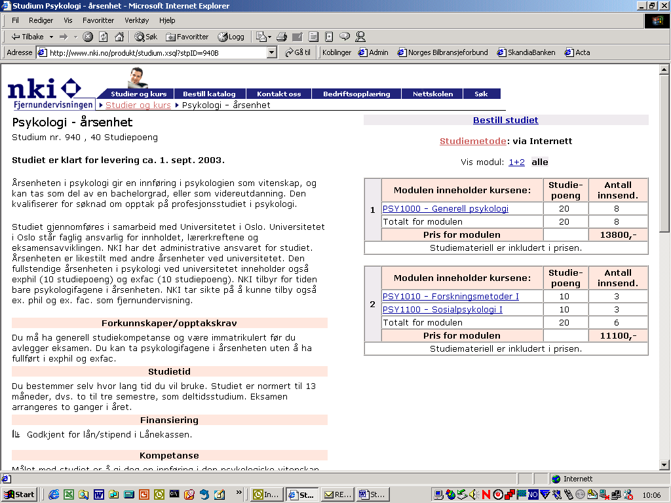

Figure 4. The information page for the Psychology programme.

The marketing department advertises NKI courses in newspapers, magazines, brochures, catalogues, radio commercials, TV commercials etc. The commercials refer to NKI’s addresses, telephone numbers, e-mail addresses, and web-addresses. These may vary according to product and campaign. As a result of these marketing efforts, thousands of prospective students contact NKI to get additional information. This is entered into Onyx so that NKI can provide prospective students with the information they request. Onyx also provides statistics and opportunities to follow up prospective students later.

NKI collaborates with local partners throughout the country. They offer face-to-face classes based on NKI’s distance education courses. SYSA holds information about the partners and the NKI courses they plan to provide. This information is forwarded to FEB so that prospective students can find information about local classes in their region.

The Guidance Phase

For many prospective students, it is a major decision to enroll in a course or program that could take many months to complete and could cost a substantial amount of money. They often want some individual and personal guidance. Hence, the most important tools in the guidance phase are telephone calls, e-mail messages, and student fairs. This personal guidance is very time consuming, but hard to automate.

NKI has not implemented any computer systems to support the guidance phase. But it could be worth wile to consider using support software such as for example Rightnow.com to organize and reduce inbound guidance loads.

The Registration Phase

On registration, student information is entered into STAS and forwarded to SESAM, Agresso and Multi-Case.

When students enroll, information about the enrolment is entered into STAS. This includes information about their names, addresses, and e-mail addresses. Each student is assigned to a course, a class, a tutor and a payment scheme. An e-mail is automatically issued to each student providing an individual password and information shipment of textbooks.

STAS also forwards information to SESAM about the new students and the courses and services they should have access to. STAS forwards account and payment information to Agresso. Similarly, STAS forwards information to Multi-Case about shipment of textbooks and other physical material.

The Help Desk

Students may need help and guidance with regard to technical problems, financial requests, local exams, etc. These requests are time consuming and could be reduced by providing comprehensive, well-organized and searchable web-services. Still, it is important to allow student to contact people who can help them via telephone, e-mail or other services. Since distance students often study during weekends and in the evening, the services should be available after the ordinary office hours.

NKI has not implemented any computer systems to support these individual requests. But it could be worth wile to consider using support software such as for example Rightnow.com to organize and reduce inbound guidance loads.

The Learning Phase

SESAM is NKI’s self-developed learning management system that is developed to handle the learning phase. As soon as a student is enrolled, she receives a personal password that provides access to all course material and services. This includes access to a personal tutor, one ore more discussion for a, a class list etc.

In SESAM each student and tutor have their personal page with information about which Courses they have access to, News from NKI, link to a page for Settings, where they can change settings (password, e-mail address, personal presentation and how frequent they wish to receive e-mail about new entries the their course forums (immediately, once a day, once a week or never (!))). The personal page for students also contains links to Resources (such as FAQs, search engines, archive of previous exams, and form for registration to exams, software, instructions for tutors). There is also a link to registered information about study progression and grades in all courses.

A tutor’s personal page includes in addition a System for registration of grades, overview of assignments commented and graded, overview of salary earned, practical advice for tutors, access to a senior tutor for personal guidance.

The student and tutor pages also include a quick menu for direct access to all pages and information in SESAM to which the person has access rights. All pages have a printer friendly version.
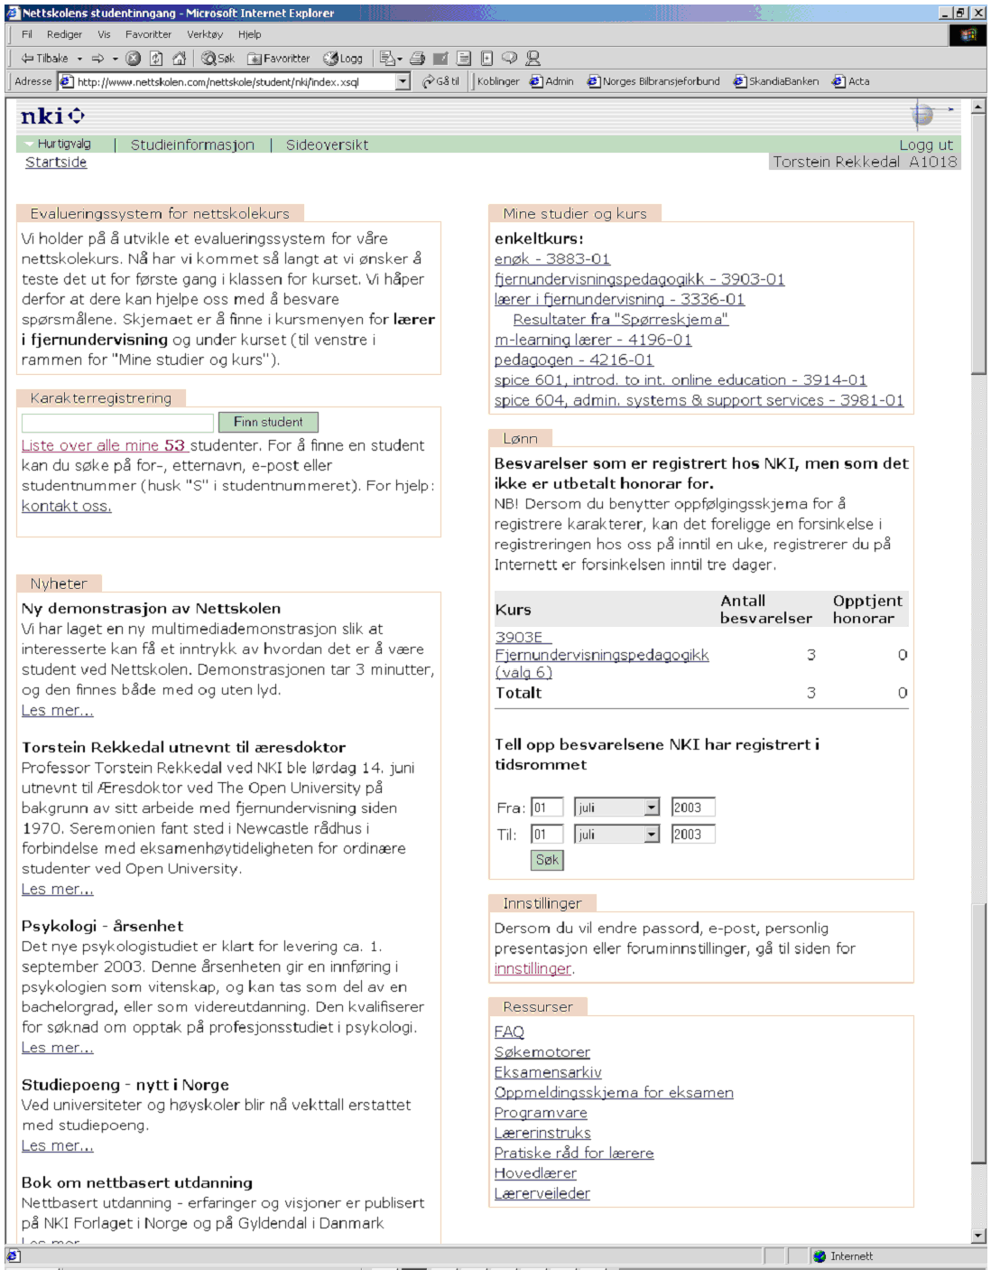

Figure 5. Personal page of a tutor.

Student follow-up
The support functions in SESAM were described by Sjaastad, Akre and Rekkedal (2003). Through the SESAM system for registration of graded assignments, information about study progress is transferred to the STAS system that follows up students continuously according to their plans and real progression schedules.

Course content

The course content in NKI Internet based e-learning courses is delivered both as printed materials (textbooks) and as web materials. In some courses, as the one presented below in figure 6, all course content is delivered on the web. Whether to study on the screen, on line or off line may be dependent on the preferences of each individual student and/or type of course content, interactive, with links or long texts. All course materials are presented in forms meant to be studied on the screen and in printer friendly versions. Preferences concerning studying on the screen or on paper have been examined in different evaluation studies. It seems clear that students generally prefer reading from paper when the materials do not include interactive elements (se e.g. Rekkedal 1998). See also discussion in Ströhlein & Fritsch 2003.

Course content may include text, pictures, graphics, multi media, interactive assignments, multiple-choice assignments or essay assignments. All courses will include obligatory assignments to be submitted to the personal tutor for comments and evaluation.

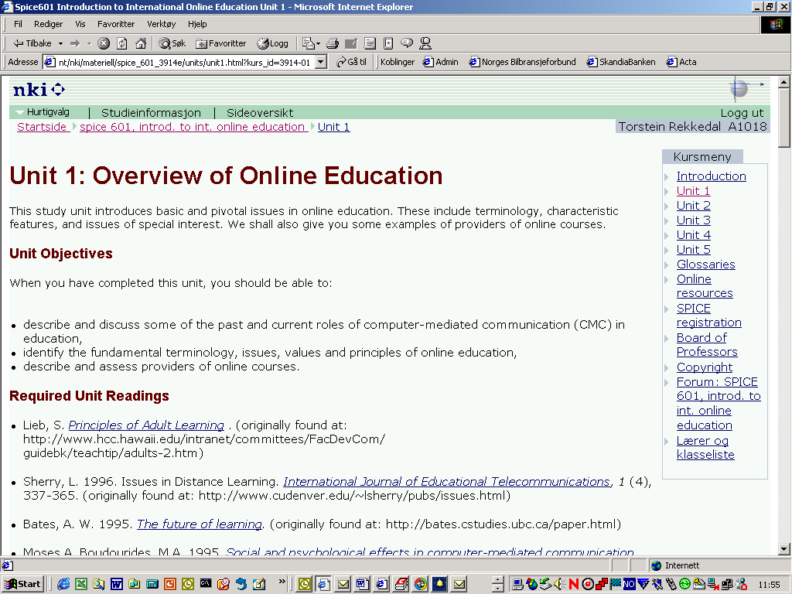

Figure 5. Course page of the course, Introduction to international online education.

The Final Results Phase

The students may register for exams via SESAM. When course completion and exam grades are registered in STAS, course certificates or program diplomas are printed and mailed to the students.

References

Rekkedal, T. (1998): Courses on the WWW - Student Experiences and Attitudes Towards WWW Courses. An Evaluation Report Written for the Leonardo Online Training Project - http://www.nki.no/eeileo/

Sjaastad, J., Akre, A.-K. L. & Rekkedal, T. (2003): NKI Distance Education – Case Study Student Support Systems in E-learning. http://learning.ericsson.net/socrates/doc/norwayp2.doc

Ströhlein, G. & Fritsch, H. (2003): Student support services provision of the eLearning platform LVU at the FernUniversität in Hagen. http://learning.ericsson.net/socrates/doc/germanyp3.doc

