**ABSTRACT**

This abstract introduces JobGrids, an advanced employee recruitment system developed using Django, JavaScript, and HTML. The system incorporates three primary models: job seekers, providers, and admin. Job seekers can effortlessly search for job opportunities, while providers have the ability to post job listings. The admin role involves verifying new providers' licenses and effectively managing the entire system. JobGrids offers a user-friendly interface and robust functionality, seamlessly connecting job seekers with providers and providing efficient administrative control.

1. **Admin :**

* System Management: The admin module enables efficient management of the entire system. Admins have the authority to set user permissions, configure system settings, and monitor system activities. This allows them to maintain system integrity, handle any technical issues that arise, and ensure a seamless user experience for both job seekers and providers.
* Oversight and Compliance: The admin module ensures compliance with regulatory and organizational requirements. Admins can enforce policies, guidelines, and standards, ensuring that job postings adhere to ethical, legal, and quality standards. They also have the ability to conduct audits and address any non-compliance issues promptly.
* License Verification: The admin module ensures the authenticity of new providers by meticulously verifying their licenses. This process adds an extra layer of trust and credibility to the system, safeguarding job seekers from potential fraud and ensuring that only legitimate providers can post job listings.

**2.Job Seekers:**

The job seekers module in JobGrids provides the following key functionalities:

1. Job Search: Job seekers can easily navigate the system to search for relevant job openings. They can utilize various filters such as location, industry, experience level, and job type to refine their search and discover the most suitable job opportunities. This functionality allows job seekers to efficiently explore a wide range of options and find jobs that meet their specific requirements.
2. Application Submission: Once job seekers identify a desirable job listing, they can submit their applications through the system. The module allows job seekers to upload their resumes, cover letters, and other required documents, ensuring a streamlined and organized application process. By providing this functionality, JobGrids simplifies the job application process for job seekers, enabling them to apply for multiple positions effortlessly.
3. Application Tracking: The job seekers module also includes features that enable job seekers to track the status of their applications. They can monitor the progress of their applications, receive notifications on application updates, and view their application history. This functionality provides transparency and allows job seekers to stay informed about the progress of their job applications within the system.

The job seekers module in JobGrids offers a user-friendly and efficient platform for individuals to search for job opportunities, submit applications, and track their progress. With its intuitive interface and robust functionality, the module enhances the overall job search experience, helping job seekers find their desired positions more effectively.

Top of Form

Bottom of Form

**3. Job Providers**:

The providers module in JobGrids provides the following key functionalities:

1. Job Posting: Providers have the ability to create and post job listings within the system. They can enter comprehensive details about the job, including job title, description, requirements, and desired qualifications. This functionality ensures that job listings are accurately presented to attract suitable candidates.
2. Application Management: Once job listings are posted, providers can manage the applications received from job seekers. The module allows providers to review and evaluate applications, shortlist candidates, and communicate with them within the system. This functionality streamlines the application management process, enabling providers to efficiently track and handle candidate responses.
3. Employer Branding: JobGrids also offers features that allow providers to showcase their organization's branding and culture. Providers can include their company logo, mission statement, and other relevant information to create a compelling employer profile. This functionality helps providers establish their brand identity and attract high-quality candidates who align with their organizational values

**PROJECT REQUIREMENTS**

1. **User Registration and Login for Both Job Seekers and Job Providers (Companies):**

* Job seekers and job providers (companies) will have separate registration processes tailored to their specific requirements.
* The login functionality will allow users to securely access their accounts and access the features available to them.

**2. Registration Form for Job Seekers to Submit Their Personal and Academic Information**

**3. Feature to Add New Job Openings for Companies:**

* Companies registered on the platform will have the ability to post new job openings.
* They can provide detailed job descriptions, including job title, responsibilities, qualifications, salary range, location, and application deadlines.

**4. Feature to Approve New Company Registrations into the System by Verifying Uploaded Documents**

**5. Feature for Job Seekers to Search Jobs as per Their Requirements**

**6. Feature for Applying to Jobs:**

* Job seekers can apply to job openings directly through the system.
* They can submit their application, which may include uploading their resume other supporting documents.

**7. Feature for Companies to View Job Applications:**

* Companies will have access to a dashboard or interface where they can view and manage the job applications they receive.
* They can review applicants' details, such as their resumes, cover letters, and other submitted documents.

**8. Security and Privacy:**

* The system should implement appropriate security measures, including data encryption, to protect user information and ensure privacy.
* Access control and authorization mechanisms should be implemented to restrict access to sensitive functionalities and data.

**9. Ability to Select/Reject Candidates:**

* Companies can make decisions on selecting or rejecting candidates based on their job applications.

**. Feature for Adding Reviews About the System:**

* Users, both job seekers and job providers, will have the option to provide feedback and reviews about their experience with the system.

**FEATURES AND HIGHLIGHTS OF THE PROJECT**

The features and highlights of the JobGrids project in Python Django, which contains employee recruitment, job searching and edition, three modules (Admin, Job Seeker, Job Provider), include the following:

**1. User Registration and Authentication:**

- Users can register as admin, instructor, or student.

- User authentication and login system to access different functionalities.

**2. Admin Module:**

- Admin can manage and maintain the system.

- Admin can view and manage all user profiles.

- Admin can verify job providers by checking their license.

- Admin can view interesting insights about the system

-Admin can view trending jobs in the system

**3. Job Seeker Module:**

**-** Job Seekers can view all jobs that available in the system

- Job Seekers can filter out jobs by different category

- Job Seekers can search jobs with the job title, preffred location, and qualification.

- Job Seekers can apply for the job as per their requirement

- Job Seekers can view and edit their profile details.

- Job Seekers can Change their Password

**4. Job Provider Module:**

- Job Providers can view their profile information.

- Job Providers can add new job postings.

- Job Providers can delete their job postings.

- Job Providers can view applications of their job postings

- Job Providers can select/reject applications

- Job Providers can view and edit their profile details.

- Job Providers can Change their Password

**TECHNICAL ASPECTS**

-**Architecture of the project**

**-Class Diagram**

**Django Framework**:

Django is the primary framework used for building the LMS project. It provides a robust foundation for developing web applications, offering features such as URL routing, database connectivity, authentication, and templating.

**Python:**

The LMS project is written in Python, a versatile and powerful programming language known for its simplicity and readability. Python is used to implement the backend logic, handle data processing, and perform various system-level operations.

**HTML/CSS/JavaScript**:

The project utilizes front-end technologies such as HTML, CSS, and JavaScript to develop the user interface and enhance user interactions. These technologies are essential for creating responsive and visually appealing web pages.

**Database Management System (DBMS):**

The project utilizes a DBMS to store and manage data related to users, courses, content, assessments, and grades. Popular choices for DBMS in Django projects include PostgreSQL, MySQL, and SQLite.

**THIRD PARTY LIBRARIES**

**Django REST Framework:**

This library is used to build APIs for the LMS project, enabling seamless communication between the front-end and backend.

**jQuery:**

jQuery is a JavaScript library used to simplify DOM manipulation and handle AJAX requests within the project's front-end components.

**Bootstrap:**

Bootstrap is a popular CSS framework used for responsive web design and UI components, making it easier to create visually appealing and mobile-friendly interfaces.

**Pillow**

A powerful library for image processing and manipulation.

**Admin Volt**

By using the "adminvolt" package, developers can potentially add additional features, modify the layout and design, or enhance the user interface of the Django admin panel. It might provide templates, widgets, or other components that allow for easier customization and styling of the admin interface.

**CLASS DIAGRAM**

**CHALLENGES FACED DURING THE DEVELOPMENT**

**1.User Authentication and Security:**

**Challenge:** Ensuring secure user authentication and protecting sensitive user information.

**Solution:** Implement robust authentication mechanisms, such as password hashing and encryption, along with user role-based access control. Utilize Django's built-in authentication system and security best practices to safeguard user data.

**2.Scalability and Performance:**

**Challenge:** Handling a large number of users, job postings, and concurrent activities without compromising system performance.

**Solution:** Optimize database queries, use caching mechanisms, and employ load balancing techniques to distribute the workload across multiple servers. Implement pagination for job listings and employ asynchronous processing for time-consuming tasks.

**3.Search Functionality:**

**Challenge:** Providing efficient and accurate search functionality for job seekers to find relevant job postings.

**Solution:** Utilize indexing and search technologies like Elasticsearch or Django's built-in search capabilities to enable fast and comprehensive search across job titles, descriptions, and other relevant attributes. Implement advanced search filters to narrow down results based on location, experience level, or industry.

**4.Reviews and Feedback:**

**Challenge:** Allowing job seekers and providers to add reviews and feedback for each other in a fair and reliable manner.

**Solution**: Implement a rating and review system with moderation functionality to ensure the authenticity and fairness of reviews. Use Django's form validation and data validation techniques to prevent abuse or fake reviews. Allow users to report inappropriate content, and implement a moderation process to review and handle such reports.

**5.Template Integration:**

**Challenge:** Integrating multiple templates into a cohesive and consistent user interface.

**Solution**: Ensure that the templates have a consistent structure, naming conventions, and use the same CSS and JavaScript libraries where possible. Create a modular approach by breaking down the templates into reusable components to maintain consistency throughout the application.

**6.Style Clashes:**

**Challenge:** Dealing with conflicting CSS styles when combining templates from different sources.

**Solution:** Identify conflicting styles by inspecting the elements using browser developer tools. Use CSS methodologies like BEM (Block, Element, Modifier) or utility classes to encapsulate styles and minimize clashes. Prioritize styles based on specificity and override conflicting styles as needed

**IMPORTANT SCREENSHOTS WITH EXPLANATION**

**HOME PAGE:**

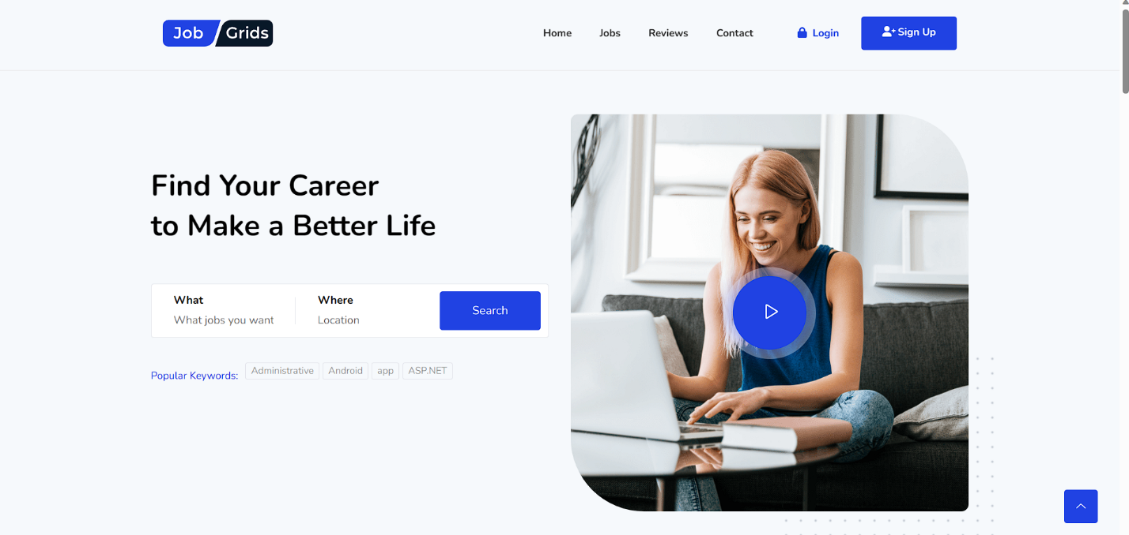

**JOB SEEKER’S HOME PAGE:**

**JOB PROVIDER’S HOME PAGE:**

**JOB APPLYING**

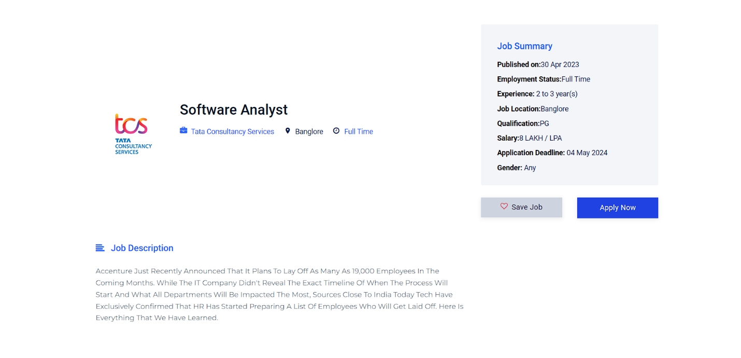

**FEATURED TESTIMONIALS**

**FUTURE ENHANCEMENTS**

There are several future enhancements can consider for the jobgrids project in Python Django. Here are some:

1. **Social Media Integration**

Allow users to sign up or log in using their social media accounts, and provide options for sharing job postings or reviews on popular social media platforms.

1. **Advanced Job Matching Algorithm:**

Develop a sophisticated matching algorithm that analyzes job seeker profiles and job requirements to provide more accurate and personalized job recommendations.

1. **Automated Job Alerts:**

Implement a system that sends email or push notifications to users based on their preferences and criteria, notifying them about new job postings or relevant updates.

1. **Skill Assessment and Testing:**

Integrate skill assessment or testing features into the platform to evaluate job seekers' abilities and provide insights to both job seekers and employers.

1. **Application Tracking System:**

Enhance the job application process by incorporating an application tracking system, allowing job seekers to track the status of their applications and receive updates.

1. **Interview Scheduling and Video Interviews:**

Integrate a scheduling system for interviews, allowing employers and job seekers to schedule interviews directly within the platform. Consider adding video interview capabilities to facilitate remote hiring.

1. **Employer Branding Pages:**

Provide dedicated pages for employers to showcase their company culture, benefits, and achievements to attract top talent.

1. **Machine Learning for Resume Parsing:**

Utilize machine learning techniques to extract relevant information from uploaded resumes and automatically populate job seeker profiles, saving time and improving data accuracy.

1. **Gamification Elements:**

Introduce gamification elements to enhance user engagement, such as badges, achievements, or leaderboards, encouraging job seekers to actively participate and increase their chances of being noticed by employers.

**CONCLUSION**

In conclusion, "JobGrids" has emerged as a comprehensive and feature-rich online recruitment system, leveraging the power of Django framework. Throughout the development process, we have successfully implemented essential functionalities such as job postings, job application management, deadline tracking, and a captivating front-end interface. These core features cater to the needs of both job seekers and job providers, fostering a seamless and efficient recruitment experience.

Looking ahead, there is a plethora of exciting opportunities for enhancing "JobGrids" even further. By incorporating social media integration, we can enable users to seamlessly log in and share job postings, expanding the platform's reach and engagement. Advanced job matching algorithms hold the potential to revolutionize the system, providing highly accurate and personalized job recommendations based on job seekers' profiles and employers' requirements.

To augment user engagement, automated job alerts can be introduced to notify job seekers about new opportunities that match their preferences. Additionally, the integration of skill assessment and testing features will empower employers to gauge the capabilities of applicants accurately. Meanwhile, video interviews and an application tracking system will streamline the recruitment process, ensuring a seamless experience for all stakeholders.

Moreover, prioritizing employer branding pages will enable companies to showcase their unique culture and benefits, attracting top talent. Implementing machine learning techniques for resume parsing will automate data extraction, optimizing the platform's efficiency. By incorporating gamification elements and robust analytics and reporting features, we can drive user engagement, provide valuable insights, and support data-driven decision-making.

Overall, "JobGrids" has established itself as a robust online recruitment system. However, by continuously seeking enhancements and staying attuned to industry trends and user feedback, we can ensure its sustained growth and relevance in an ever-evolving job market. By embracing these future advancements, we will reinforce "JobGrids" as a go-to platform for both job seekers and employers, revolutionizing the recruitment landscape.

**REFERENCES**

* [**https://www.linkedin.com/jobs/?originalSubdomain=in**](https://www.linkedin.com/jobs/?originalSubdomain=in)
* [**https://www.naukri.com/registration/createAccount?othersrcp=22636**](https://www.naukri.com/registration/createAccount?othersrcp=22636)
* [**https://preview.graygrids.com/item/jobgrids-job-board-and-job-portal-web-template/**](https://preview.graygrids.com/item/jobgrids-job-board-and-job-portal-web-template/)
* [**https://github.com/animeshthomas/Job-Grids**](https://github.com/animeshthomas/Job-Grids)