HW3

Anish Mohan

February 23, 2016

1. Q1

* 1a.
  + $g_{1}$ has a 3rd derivative as penalty hence it will tend to favor quadratic functions as the penalty function for a quadratic polynomial will be smallest. $g_{2}$ has a 4th derivative of function as penalty and hence it will till tend to favor cubic functions.
  + Give the above statent as $λ−>∞$, $g_{2}$ will have a smaller training error as it is a higher order polynomial.
* 1b.
  + Give the above statent as $λ−>∞$, the question is if a quadratic or a cubic polynomial fit the test data better. This depends on the true function and the distribution of data, hence we cannot reliably answer which model will have lower test error without assumptions.
  + if the true function is quadratic with noise, then $g_{1}$ will fit better as $g_{2}$ will fit to noise. Thus $g_{1}$ will have lower test error.
  + If the true function is cubic, then $g_{2}$ should fit better and should have lower test error. However, in this case if the bias due to using $g_{1}$ is lower than the variance due to noise in data, then $g_{1}$ could have lower test error as well
* 1c.
  + With $λ=0$, both functions are same and will have same test and training error

1. Q2

* 2a.
* library(ISLR)  
   library(MASS)  
   attach(Boston)  
    
   # Obtain the limits of the distances  
   dislims=range(dis)  
    
   #create grid with range of distance values  
   dis.grid=seq(from=dislims[1],to=dislims[2])  
    
   #fit the cubic polynomial  
   poly.fit=lm(nox~poly(dis,3),data=Boston)  
    
   #fit output  
   summary(poly.fit)
* ##   
  ## Call:  
  ## lm(formula = nox ~ poly(dis, 3), data = Boston)  
  ##   
  ## Residuals:  
  ## Min 1Q Median 3Q Max   
  ## -0.121130 -0.040619 -0.009738 0.023385 0.194904   
  ##   
  ## Coefficients:  
  ## Estimate Std. Error t value Pr(>|t|)   
  ## (Intercept) 0.554695 0.002759 201.021 < 2e-16 \*\*\*  
  ## poly(dis, 3)1 -2.003096 0.062071 -32.271 < 2e-16 \*\*\*  
  ## poly(dis, 3)2 0.856330 0.062071 13.796 < 2e-16 \*\*\*  
  ## poly(dis, 3)3 -0.318049 0.062071 -5.124 4.27e-07 \*\*\*  
  ## ---  
  ## Signif. codes: 0 '\*\*\*' 0.001 '\*\*' 0.01 '\*' 0.05 '.' 0.1 ' ' 1  
  ##   
  ## Residual standard error: 0.06207 on 502 degrees of freedom  
  ## Multiple R-squared: 0.7148, Adjusted R-squared: 0.7131   
  ## F-statistic: 419.3 on 3 and 502 DF, p-value: < 2.2e-16
* #prediction and plotting  
   poly.pred=predict(poly.fit,newdata=list(dis=dis.grid),se=T)  
   plot(dis,nox,xlim=dislims,cex=0.5, col="darkgrey")  
   title("Cubic Polynomial Fit")  
   lines(dis.grid,poly.pred$fit,lwd=2, col="blue")
* 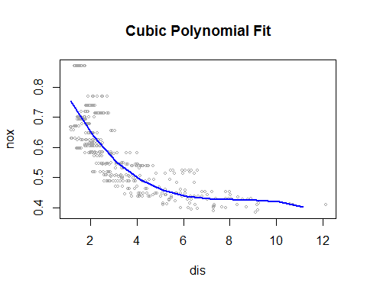
* 2b.
* par(mfrow=c(1,2))  
  rss=rep(NA,10)  
    
  for(i in 1:10){  
   poly.fit=lm(nox~poly(dis,i),data=Boston)   
   rss[i]=sum(poly.fit$residuals^2)  
   poly.pred=predict(poly.fit,newdata=list(dis=dis.grid),se=T)  
   plot(dis,nox,xlim=dislims,cex=0.5, col="darkgrey", main=paste0("Polynomial Fit: Degree ", i))  
   #Title("Polynomial Fit")  
   lines(dis.grid,poly.pred$fit,lwd=2, col="blue")  
  }
* 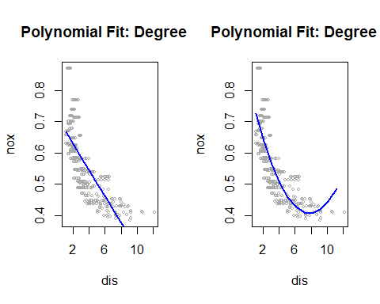 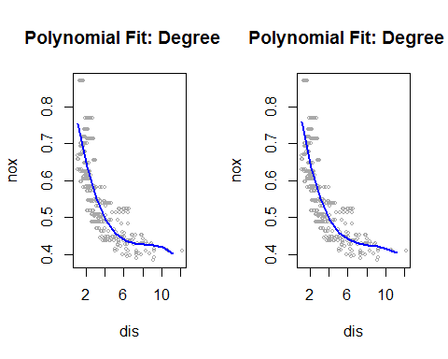 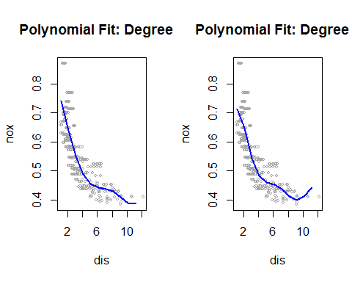 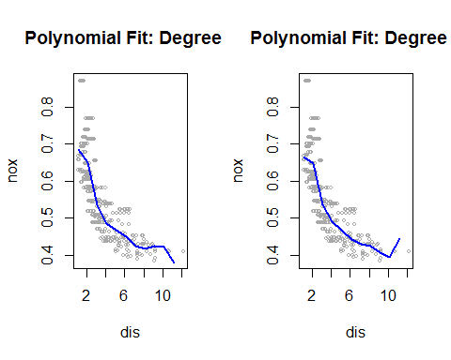 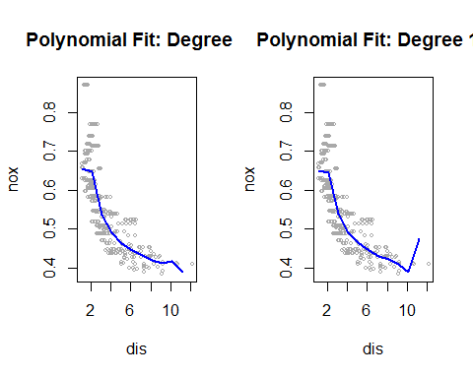
* par(mfrow=c(1,1))  
  plot(rss, xlab="Degree of Polynomial", ylab="RSS Error", main=" Error Plot")
* 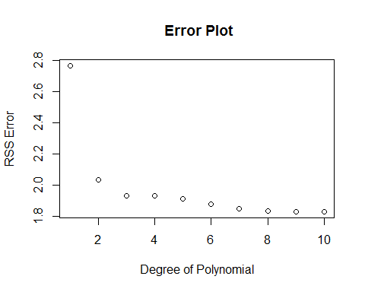
* 2c.
* poly.fit.1=lm(nox~poly(dis,1),data=Boston)   
  poly.fit.2=lm(nox~poly(dis,2),data=Boston)   
  poly.fit.3=lm(nox~poly(dis,3),data=Boston)   
  poly.fit.4=lm(nox~poly(dis,4),data=Boston)   
  poly.fit.5=lm(nox~poly(dis,5),data=Boston)   
  poly.fit.6=lm(nox~poly(dis,6),data=Boston)   
  poly.fit.7=lm(nox~poly(dis,7),data=Boston)   
  poly.fit.8=lm(nox~poly(dis,8),data=Boston)   
  poly.fit.9=lm(nox~poly(dis,9),data=Boston)   
  poly.fit.10=lm(nox~poly(dis,10),data=Boston)   
  anova(poly.fit.1,poly.fit.2,poly.fit.3,poly.fit.4,poly.fit.5,poly.fit.6,poly.fit.7,poly.fit.8,poly.fit.9,poly.fit.10)
* ## Analysis of Variance Table  
  ##   
  ## Model 1: nox ~ poly(dis, 1)  
  ## Model 2: nox ~ poly(dis, 2)  
  ## Model 3: nox ~ poly(dis, 3)  
  ## Model 4: nox ~ poly(dis, 4)  
  ## Model 5: nox ~ poly(dis, 5)  
  ## Model 6: nox ~ poly(dis, 6)  
  ## Model 7: nox ~ poly(dis, 7)  
  ## Model 8: nox ~ poly(dis, 8)  
  ## Model 9: nox ~ poly(dis, 9)  
  ## Model 10: nox ~ poly(dis, 10)  
  ## Res.Df RSS Df Sum of Sq F Pr(>F)   
  ## 1 504 2.7686   
  ## 2 503 2.0353 1 0.73330 198.1169 < 2.2e-16 \*\*\*  
  ## 3 502 1.9341 1 0.10116 27.3292 2.535e-07 \*\*\*  
  ## 4 501 1.9330 1 0.00113 0.3040 0.581606   
  ## 5 500 1.9153 1 0.01769 4.7797 0.029265 \*   
  ## 6 499 1.8783 1 0.03703 10.0052 0.001657 \*\*   
  ## 7 498 1.8495 1 0.02877 7.7738 0.005505 \*\*   
  ## 8 497 1.8356 1 0.01385 3.7429 0.053601 .   
  ## 9 496 1.8333 1 0.00230 0.6211 0.431019   
  ## 10 495 1.8322 1 0.00116 0.3133 0.575908   
  ## ---  
  ## Signif. codes: 0 '\*\*\*' 0.001 '\*\*' 0.01 '\*' 0.05 '.' 0.1 ' ' 1
  + We use ANOVA to analyze the fits and get the best degree of freedom for the polynomial fit. The p-value when comparing a linear model to quadratic is very low ($2.2*{10}^{−16}$), hence it is a not a sufficient fit. The p-value comparing a quadratic and cubic model is very low as well. The p-value comparing cubic and quartic model is high implying that a higher degree polynomial ie. degree-4 polynomial fit is unecessary. A cubic polynomial i.e degree-3 polynomial is a good fit.
* 2d.
* par(mfrow=c(1,1))  
  library(splines)  
  sp.fit=lm(nox~bs(dis,df=4),data=Boston)  
  sp.pred=predict(sp.fit,newdata=list(dis=dis.grid),se=T)  
  plot(dis,nox,col="grey",main="Regression spline fit")  
  lines(dis.grid,sp.pred$fit,col="blue",lwd=2)
* 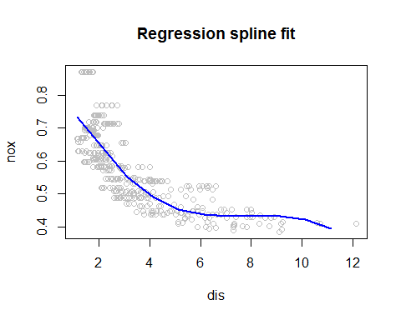
  + Equi-spaced knots were chose by the function when we just specified the degree of freedom in the equation.
* 2e.
* rss=rep(NA,8)  
  par(mfrow=c(1,2))  
  for(i in 3:10){  
   bs.fit=lm(nox~bs(dis,df=i),data=Boston)   
   rss[i]=sum(bs.fit$residuals^2)  
   bs.pred=predict(bs.fit,newdata=list(dis=dis.grid),se=T)  
   plot(dis,nox,xlim=dislims,cex=0.5, col="darkgrey", main=paste0("Reg Spline: Degree-", i))  
   lines(dis.grid,bs.pred$fit,lwd=2, col="blue")  
  }
* 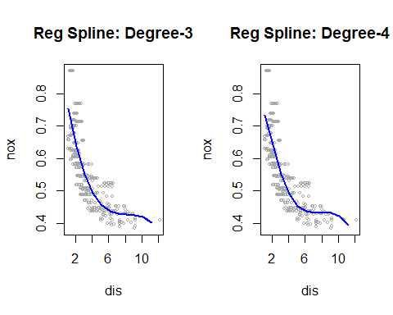 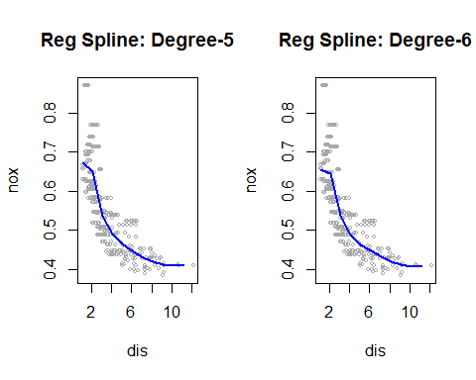 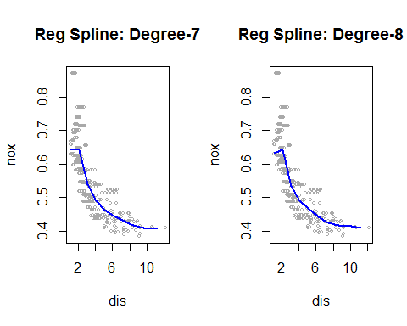 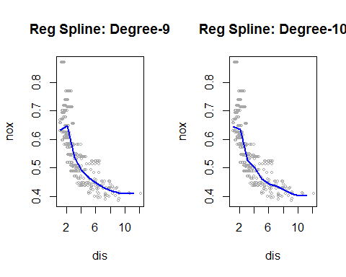
* par(mfrow=c(1,1))  
  plot(rss, xlab="Degree of freedom", ylab="RSS Error", main="Error plot")
* 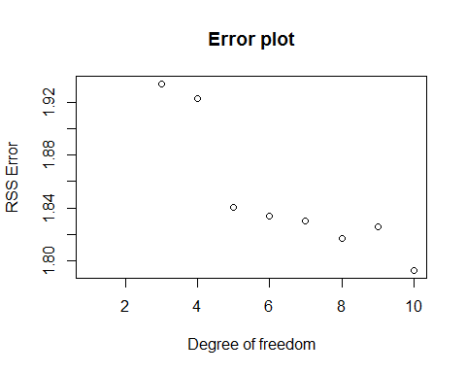
  + The RSS error plot shows that the error decreases with with additional degree of freedom. Reviewing the plots, a cubic or quartic polynomial seem to be the smoothest fits. High order regression splines have sharp boundaries especially at the limits of the data range.
* 2f.
* bs.fit.3=lm(nox~bs(dis,df=3),data=Boston)   
  bs.fit.4=lm(nox~bs(dis,df=4),data=Boston)   
  bs.fit.5=lm(nox~bs(dis,df=5),data=Boston)   
  bs.fit.6=lm(nox~bs(dis,df=6),data=Boston)   
  bs.fit.7=lm(nox~bs(dis,df=7),data=Boston)   
  bs.fit.8=lm(nox~bs(dis,df=8),data=Boston)   
  bs.fit.9=lm(nox~bs(dis,df=9),data=Boston)   
  bs.fit.10=lm(nox~bs(dis,df=10),data=Boston)   
  anova(bs.fit.3,bs.fit.4,bs.fit.5,bs.fit.6,bs.fit.7,bs.fit.8,bs.fit.9,bs.fit.10)
* ## Analysis of Variance Table  
  ##   
  ## Model 1: nox ~ bs(dis, df = 3)  
  ## Model 2: nox ~ bs(dis, df = 4)  
  ## Model 3: nox ~ bs(dis, df = 5)  
  ## Model 4: nox ~ bs(dis, df = 6)  
  ## Model 5: nox ~ bs(dis, df = 7)  
  ## Model 6: nox ~ bs(dis, df = 8)  
  ## Model 7: nox ~ bs(dis, df = 9)  
  ## Model 8: nox ~ bs(dis, df = 10)  
  ## Res.Df RSS Df Sum of Sq F Pr(>F)   
  ## 1 502 1.9341   
  ## 2 501 1.9228 1 0.011332 3.1292 0.077517 .   
  ## 3 500 1.8402 1 0.082602 22.8102 2.359e-06 \*\*\*  
  ## 4 499 1.8340 1 0.006207 1.7140 0.191074   
  ## 5 498 1.8299 1 0.004081 1.1271 0.288918   
  ## 6 497 1.8170 1 0.012889 3.5593 0.059796 .   
  ## 7 496 1.8256 1 -0.008657   
  ## 8 495 1.7925 1 0.033118 9.1453 0.002623 \*\*   
  ## ---  
  ## Signif. codes: 0 '\*\*\*' 0.001 '\*\*' 0.01 '\*' 0.05 '.' 0.1 ' ' 1
  + A regression spline with df=3 is the best fit. The regression splines function could not fit df=1/2 splines and defaulted to df=3 splines. The ANOVA function shows that a regression spline with df=3 is a good fit. A df=4 spline has a p-value of 0.07 hence not necessary or a much better fit than a df=3 regression spline.

1. Q3

* 3a.
* library(ISLR)  
  library(pls)
* ##   
  ## Attaching package: 'pls'  
  ##   
  ## The following object is masked from 'package:stats':  
  ##   
  ## loadings
* bodyR=load("body.RData")  
  plot(Y$Gender,Y$Weight)
* 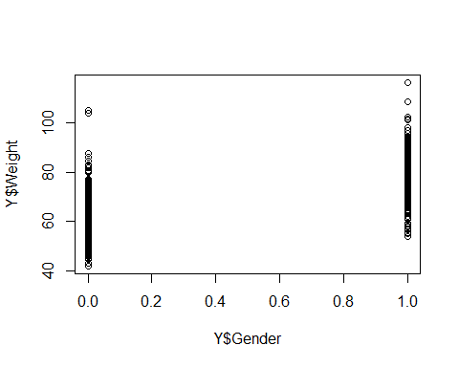
  + Here is a simple visualization showing the distribution of male and female. Assuming that the data is from an average human population, then usually mena are heavier than woman. Given that information, we see that the distribution of weights (also mean and median) of the category with Class=0 has lower wieghts than category with Class=1. From here we can find out that Class=1 are the Males and Class=0 are the females
* 3b.
* set.seed(1)  
  train=sample(507,307)  
  test=-train  
  X.train=X[train,]  
  X.test=X[test,]  
  Y.test=Y[test,"Weight"]  
  Y.train=Y[train,"Weight"]  
    
    
  set.seed(1)  
  #PCR Fit  
  pcr.fit=pcr(Y.train~.,data=X.train, scale=TRUE, validation="CV")  
  #PLS Fit  
  set.seed(1)  
  pls.fit=plsr(Y.train~.,data=X.train, scale=TRUE, validation="CV")
  + The variables measured here have different range of measurements depending on the body port. Some measurements like Wrist diameter or girth are going to inherently smaller than othe measurments like Hip Girth or Diameter. To ensure that magnitude of these measurement do not impact the principal components, we choose to standardize so that measurements are interms of how many sds are the measurement from their mean.
* 3c.
* summary(pcr.fit)
* ## Data: X dimension: 307 21   
  ## Y dimension: 307 1  
  ## Fit method: svdpc  
  ## Number of components considered: 21  
  ##   
  ## VALIDATION: RMSEP  
  ## Cross-validated using 10 random segments.  
  ## (Intercept) 1 comps 2 comps 3 comps 4 comps 5 comps 6 comps  
  ## CV 13.34 3.428 3.266 3.000 2.969 2.963 2.940  
  ## adjCV 13.34 3.426 3.264 2.977 2.966 2.960 2.937  
  ## 7 comps 8 comps 9 comps 10 comps 11 comps 12 comps 13 comps  
  ## CV 2.956 2.922 2.940 2.921 2.930 2.923 2.913  
  ## adjCV 2.953 2.918 2.937 2.916 2.926 2.916 2.908  
  ## 14 comps 15 comps 16 comps 17 comps 18 comps 19 comps  
  ## CV 2.906 2.859 2.792 2.769 2.788 2.804  
  ## adjCV 2.898 2.852 2.782 2.758 2.777 2.793  
  ## 20 comps 21 comps  
  ## CV 2.808 2.808  
  ## adjCV 2.797 2.796  
  ##   
  ## TRAINING: % variance explained  
  ## 1 comps 2 comps 3 comps 4 comps 5 comps 6 comps 7 comps  
  ## X 63.08 75.20 79.96 84.46 86.77 88.89 90.37  
  ## Y.train 93.46 94.12 95.18 95.20 95.27 95.32 95.38  
  ## 8 comps 9 comps 10 comps 11 comps 12 comps 13 comps  
  ## X 91.80 93.08 94.19 95.17 96.05 96.82  
  ## Y.train 95.47 95.47 95.52 95.54 95.60 95.61  
  ## 14 comps 15 comps 16 comps 17 comps 18 comps 19 comps  
  ## X 97.54 98.10 98.57 98.97 99.34 99.60  
  ## Y.train 95.71 95.88 96.08 96.20 96.20 96.21  
  ## 20 comps 21 comps  
  ## X 99.82 100.00  
  ## Y.train 96.21 96.23
* summary(pls.fit)
* ## Data: X dimension: 307 21   
  ## Y dimension: 307 1  
  ## Fit method: kernelpls  
  ## Number of components considered: 21  
  ##   
  ## VALIDATION: RMSEP  
  ## Cross-validated using 10 random segments.  
  ## (Intercept) 1 comps 2 comps 3 comps 4 comps 5 comps 6 comps  
  ## CV 13.34 3.324 2.991 2.863 2.816 2.801 2.792  
  ## adjCV 13.34 3.322 2.989 2.859 2.806 2.789 2.781  
  ## 7 comps 8 comps 9 comps 10 comps 11 comps 12 comps 13 comps  
  ## CV 2.796 2.802 2.807 2.810 2.810 2.809 2.809  
  ## adjCV 2.785 2.790 2.795 2.798 2.798 2.797 2.797  
  ## 14 comps 15 comps 16 comps 17 comps 18 comps 19 comps  
  ## CV 2.808 2.808 2.808 2.808 2.808 2.808  
  ## adjCV 2.796 2.796 2.796 2.796 2.796 2.796  
  ## 20 comps 21 comps  
  ## CV 2.808 2.808  
  ## adjCV 2.796 2.796  
  ##   
  ## TRAINING: % variance explained  
  ## 1 comps 2 comps 3 comps 4 comps 5 comps 6 comps 7 comps  
  ## X 63.06 73.25 79.60 81.27 82.80 85.27 88.37  
  ## Y.train 93.88 95.17 95.67 96.07 96.19 96.21 96.22  
  ## 8 comps 9 comps 10 comps 11 comps 12 comps 13 comps  
  ## X 89.55 91.07 92.05 92.80 93.66 94.67  
  ## Y.train 96.23 96.23 96.23 96.23 96.23 96.23  
  ## 14 comps 15 comps 16 comps 17 comps 18 comps 19 comps  
  ## X 95.56 96.35 97.19 97.77 98.57 99.01  
  ## Y.train 96.23 96.23 96.23 96.23 96.23 96.23  
  ## 20 comps 21 comps  
  ## X 99.66 100.00  
  ## Y.train 96.23 96.23
  + The % of training variance explained by PCR and PLS are very similar. This is not surprising as both the process depend on finding the Principal components first. Principal components generally do capture the maximum variation in the input data. PLS regresses the values of Y on principal components and hence is expected to do have higher % of variance explained than PCR, which it does albiet with the improvement is minor.
* 3d.
  + We can choose the number of components by reviewing the CV error and the % of variance explained and choose the simplest model that has a reasonable fit. In this example, CV error for PCR and PLS reduces significantly adding first few principal components but after that the reduction error is marginal. For e.g N=3 seems be a reasonable fit to have a low CV error (<3.0) and about 95% of the variance of the data explained.
* pcr.pred=predict(pcr.fit,X[test,], ncomp=3)  
  mean((pcr.pred-Y.test)^2)
* ## [1] 8.778749
* pls.pred=predict(pls.fit,X[test,], ncomp=3)  
  mean((pls.pred-Y.test)^2)
* ## [1] 8.370953
* 3e.
  + We show that you can do some variable selection with Lasso and more variable selection with Forward Selection and get comparable error rate to PCR and PLS with a better model interpretability
* #Running Lasso  
  library(glmnet)
* ## Loading required package: Matrix  
  ## Loading required package: foreach  
  ## Loaded glmnet 2.0-3
* body=data.frame(Weight=Y$Weight,X)  
  xl=model.matrix(Weight~.,body)[,-1]  
  yl=body$Weight  
    
  grid=10^seq(10,-2, length=100)  
  lasso.mod=glmnet(xl[train,], yl[train],alpha=1,lambda=grid)  
  plot(lasso.mod)
* 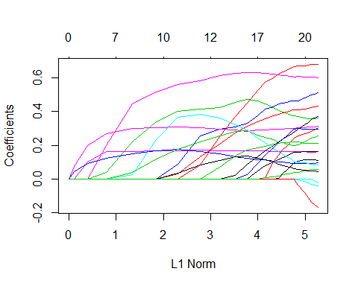
* set.seed(1)  
  cv.out=cv.glmnet(xl[train,],yl[train],alpha=1)  
  plot(cv.out)
* 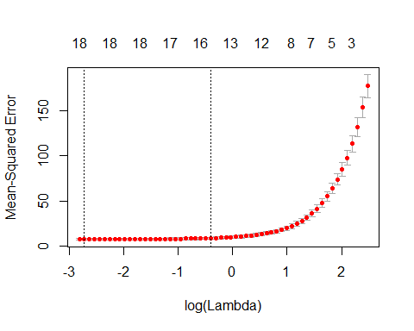
* bestlam=cv.out$lambda.min  
    
  lasso.pred=predict(lasso.mod,s=bestlam, newx=xl[test,])  
  lasso.coef=predict(cv.out,type="coefficients",s=bestlam)  
  lasso.coef
* ## 22 x 1 sparse Matrix of class "dgCMatrix"  
  ## 1  
  ## (Intercept) -100.45764492  
  ## Wrist.Diam 0.09285864  
  ## Wrist.Girth 0.23600867  
  ## Forearm.Girth 0.37524915  
  ## Elbow.Diam 0.46117144  
  ## Bicep.Girth .   
  ## Shoulder.Girth 0.16318198  
  ## Biacromial.Diam 0.15389404  
  ## Chest.Depth 0.40779724  
  ## Chest.Diam 0.21823430  
  ## Chest.Girth 0.09231997  
  ## Navel.Girth .   
  ## Waist.Girth 0.30016716  
  ## Pelvic.Breadth 0.27411671  
  ## Bitrochanteric.Diam .   
  ## Hip.Girth 0.19807114  
  ## Thigh.Girth 0.29043305  
  ## Knee.Diam 0.11038084  
  ## Knee.Girth 0.60539062  
  ## Calf.Girth 0.06393019  
  ## Ankle.Diam 0.65893472  
  ## Ankle.Girth 0.03846260
* print(paste0("Unfortunately with the best value of lambda, most of the variables are selected."))
* ## [1] "Unfortunately with the best value of lambda, most of the variables are selected."
* #Variable Selection  
  library(leaps)  
  regfit.fwd=regsubsets(Y.train~., data=X.train, method="forward", nv=20)  
  summary(regfit.fwd)
* ## Subset selection object  
  ## Call: regsubsets.formula(Y.train ~ ., data = X.train, method = "forward",   
  ## nv = 20)  
  ## 21 Variables (and intercept)  
  ## Forced in Forced out  
  ## Wrist.Diam FALSE FALSE  
  ## Wrist.Girth FALSE FALSE  
  ## Forearm.Girth FALSE FALSE  
  ## Elbow.Diam FALSE FALSE  
  ## Bicep.Girth FALSE FALSE  
  ## Shoulder.Girth FALSE FALSE  
  ## Biacromial.Diam FALSE FALSE  
  ## Chest.Depth FALSE FALSE  
  ## Chest.Diam FALSE FALSE  
  ## Chest.Girth FALSE FALSE  
  ## Navel.Girth FALSE FALSE  
  ## Waist.Girth FALSE FALSE  
  ## Pelvic.Breadth FALSE FALSE  
  ## Bitrochanteric.Diam FALSE FALSE  
  ## Hip.Girth FALSE FALSE  
  ## Thigh.Girth FALSE FALSE  
  ## Knee.Diam FALSE FALSE  
  ## Knee.Girth FALSE FALSE  
  ## Calf.Girth FALSE FALSE  
  ## Ankle.Diam FALSE FALSE  
  ## Ankle.Girth FALSE FALSE  
  ## 1 subsets of each size up to 20  
  ## Selection Algorithm: forward  
  ## Wrist.Diam Wrist.Girth Forearm.Girth Elbow.Diam Bicep.Girth  
  ## 1 ( 1 ) " " " " " " " " " "   
  ## 2 ( 1 ) " " " " "\*" " " " "   
  ## 3 ( 1 ) " " " " "\*" " " " "   
  ## 4 ( 1 ) " " " " "\*" " " " "   
  ## 5 ( 1 ) " " " " "\*" " " " "   
  ## 6 ( 1 ) " " " " "\*" " " " "   
  ## 7 ( 1 ) " " " " "\*" " " " "   
  ## 8 ( 1 ) " " " " "\*" " " " "   
  ## 9 ( 1 ) " " " " "\*" " " " "   
  ## 10 ( 1 ) " " " " "\*" " " " "   
  ## 11 ( 1 ) " " " " "\*" "\*" " "   
  ## 12 ( 1 ) " " " " "\*" "\*" " "   
  ## 13 ( 1 ) " " " " "\*" "\*" " "   
  ## 14 ( 1 ) " " "\*" "\*" "\*" " "   
  ## 15 ( 1 ) " " "\*" "\*" "\*" " "   
  ## 16 ( 1 ) " " "\*" "\*" "\*" " "   
  ## 17 ( 1 ) " " "\*" "\*" "\*" "\*"   
  ## 18 ( 1 ) " " "\*" "\*" "\*" "\*"   
  ## 19 ( 1 ) " " "\*" "\*" "\*" "\*"   
  ## 20 ( 1 ) " " "\*" "\*" "\*" "\*"   
  ## Shoulder.Girth Biacromial.Diam Chest.Depth Chest.Diam  
  ## 1 ( 1 ) " " " " " " " "   
  ## 2 ( 1 ) " " " " " " " "   
  ## 3 ( 1 ) " " " " " " " "   
  ## 4 ( 1 ) " " " " " " " "   
  ## 5 ( 1 ) " " " " " " " "   
  ## 6 ( 1 ) "\*" " " " " " "   
  ## 7 ( 1 ) "\*" " " "\*" " "   
  ## 8 ( 1 ) "\*" " " "\*" " "   
  ## 9 ( 1 ) "\*" " " "\*" " "   
  ## 10 ( 1 ) "\*" " " "\*" "\*"   
  ## 11 ( 1 ) "\*" " " "\*" "\*"   
  ## 12 ( 1 ) "\*" "\*" "\*" "\*"   
  ## 13 ( 1 ) "\*" "\*" "\*" "\*"   
  ## 14 ( 1 ) "\*" "\*" "\*" "\*"   
  ## 15 ( 1 ) "\*" "\*" "\*" "\*"   
  ## 16 ( 1 ) "\*" "\*" "\*" "\*"   
  ## 17 ( 1 ) "\*" "\*" "\*" "\*"   
  ## 18 ( 1 ) "\*" "\*" "\*" "\*"   
  ## 19 ( 1 ) "\*" "\*" "\*" "\*"   
  ## 20 ( 1 ) "\*" "\*" "\*" "\*"   
  ## Chest.Girth Navel.Girth Waist.Girth Pelvic.Breadth  
  ## 1 ( 1 ) " " " " "\*" " "   
  ## 2 ( 1 ) " " " " "\*" " "   
  ## 3 ( 1 ) " " " " "\*" " "   
  ## 4 ( 1 ) " " " " "\*" " "   
  ## 5 ( 1 ) " " " " "\*" " "   
  ## 6 ( 1 ) " " " " "\*" " "   
  ## 7 ( 1 ) " " " " "\*" " "   
  ## 8 ( 1 ) " " " " "\*" " "   
  ## 9 ( 1 ) " " " " "\*" "\*"   
  ## 10 ( 1 ) " " " " "\*" "\*"   
  ## 11 ( 1 ) " " " " "\*" "\*"   
  ## 12 ( 1 ) " " " " "\*" "\*"   
  ## 13 ( 1 ) "\*" " " "\*" "\*"   
  ## 14 ( 1 ) "\*" " " "\*" "\*"   
  ## 15 ( 1 ) "\*" "\*" "\*" "\*"   
  ## 16 ( 1 ) "\*" "\*" "\*" "\*"   
  ## 17 ( 1 ) "\*" "\*" "\*" "\*"   
  ## 18 ( 1 ) "\*" "\*" "\*" "\*"   
  ## 19 ( 1 ) "\*" "\*" "\*" "\*"   
  ## 20 ( 1 ) "\*" "\*" "\*" "\*"   
  ## Bitrochanteric.Diam Hip.Girth Thigh.Girth Knee.Diam Knee.Girth  
  ## 1 ( 1 ) " " " " " " " " " "   
  ## 2 ( 1 ) " " " " " " " " " "   
  ## 3 ( 1 ) " " "\*" " " " " " "   
  ## 4 ( 1 ) " " "\*" " " " " "\*"   
  ## 5 ( 1 ) " " "\*" " " " " "\*"   
  ## 6 ( 1 ) " " "\*" " " " " "\*"   
  ## 7 ( 1 ) " " "\*" " " " " "\*"   
  ## 8 ( 1 ) " " "\*" "\*" " " "\*"   
  ## 9 ( 1 ) " " "\*" "\*" " " "\*"   
  ## 10 ( 1 ) " " "\*" "\*" " " "\*"   
  ## 11 ( 1 ) " " "\*" "\*" " " "\*"   
  ## 12 ( 1 ) " " "\*" "\*" " " "\*"   
  ## 13 ( 1 ) " " "\*" "\*" " " "\*"   
  ## 14 ( 1 ) " " "\*" "\*" " " "\*"   
  ## 15 ( 1 ) " " "\*" "\*" " " "\*"   
  ## 16 ( 1 ) "\*" "\*" "\*" " " "\*"   
  ## 17 ( 1 ) "\*" "\*" "\*" " " "\*"   
  ## 18 ( 1 ) "\*" "\*" "\*" " " "\*"   
  ## 19 ( 1 ) "\*" "\*" "\*" "\*" "\*"   
  ## 20 ( 1 ) "\*" "\*" "\*" "\*" "\*"   
  ## Calf.Girth Ankle.Diam Ankle.Girth  
  ## 1 ( 1 ) " " " " " "   
  ## 2 ( 1 ) " " " " " "   
  ## 3 ( 1 ) " " " " " "   
  ## 4 ( 1 ) " " " " " "   
  ## 5 ( 1 ) " " "\*" " "   
  ## 6 ( 1 ) " " "\*" " "   
  ## 7 ( 1 ) " " "\*" " "   
  ## 8 ( 1 ) " " "\*" " "   
  ## 9 ( 1 ) " " "\*" " "   
  ## 10 ( 1 ) " " "\*" " "   
  ## 11 ( 1 ) " " "\*" " "   
  ## 12 ( 1 ) " " "\*" " "   
  ## 13 ( 1 ) " " "\*" " "   
  ## 14 ( 1 ) " " "\*" " "   
  ## 15 ( 1 ) " " "\*" " "   
  ## 16 ( 1 ) " " "\*" " "   
  ## 17 ( 1 ) " " "\*" " "   
  ## 18 ( 1 ) "\*" "\*" " "   
  ## 19 ( 1 ) "\*" "\*" " "   
  ## 20 ( 1 ) "\*" "\*" "\*"
* #apply linear regression with variables selected from forward selection  
  lm.fit=lm(Y.train~Forearm.Girth+Waist.Girth+Hip.Girth, data=X.train)  
  lm.pred=predict(lm.fit,X.train)  
  mean((Y.train-lm.pred)^2)
* ## [1] 12.73465
* lm.testpred=predict(lm.fit,newdata=X.test)  
  summary(lm.fit)
* ##   
  ## Call:  
  ## lm(formula = Y.train ~ Forearm.Girth + Waist.Girth + Hip.Girth,   
  ## data = X.train)  
  ##   
  ## Residuals:  
  ## Min 1Q Median 3Q Max   
  ## -9.8061 -2.4854 -0.2277 2.1819 16.0035   
  ##   
  ## Coefficients:  
  ## Estimate Std. Error t value Pr(>|t|)   
  ## (Intercept) -74.53249 3.36911 -22.12 <2e-16 \*\*\*  
  ## Forearm.Girth 2.01695 0.10868 18.56 <2e-16 \*\*\*  
  ## Waist.Girth 0.48661 0.03325 14.64 <2e-16 \*\*\*  
  ## Hip.Girth 0.55700 0.04161 13.39 <2e-16 \*\*\*  
  ## ---  
  ## Signif. codes: 0 '\*\*\*' 0.001 '\*\*' 0.01 '\*' 0.05 '.' 0.1 ' ' 1  
  ##   
  ## Residual standard error: 3.592 on 303 degrees of freedom  
  ## Multiple R-squared: 0.928, Adjusted R-squared: 0.9273   
  ## F-statistic: 1301 on 3 and 303 DF, p-value: < 2.2e-16
* 3f.
* print(paste0("PCR Error (N=3):",mean((pcr.pred-Y.test)^2)))
* ## [1] "PCR Error (N=3):8.77874910783801"
* print(paste0("PLS Error (N=3):", mean((pls.pred-Y.test)^2)))
* ## [1] "PLS Error (N=3):8.37095343541857"
* print(paste0("LASSO Error:", mean((lasso.pred-yl[test])^2)))
* ## [1] "LASSO Error:7.96214425943955"
* print(paste0("Variable Selection Error:",mean((Y.test-lm.testpred)^2)))
* ## [1] "Variable Selection Error:13.1441842901964"
  + Comparing the results on test data, PCR and PLS with (N=3) have bit better error rate than Variable Selection with 3 variables. But with Variable selection it is very clear which 3 variables are the most critical one. Lasso has a low error rate but the best lamda with lowest CV error ends up choosing most of the variables.