HW4

Anish Mohan

March 9, 2016

1. Q1.

* 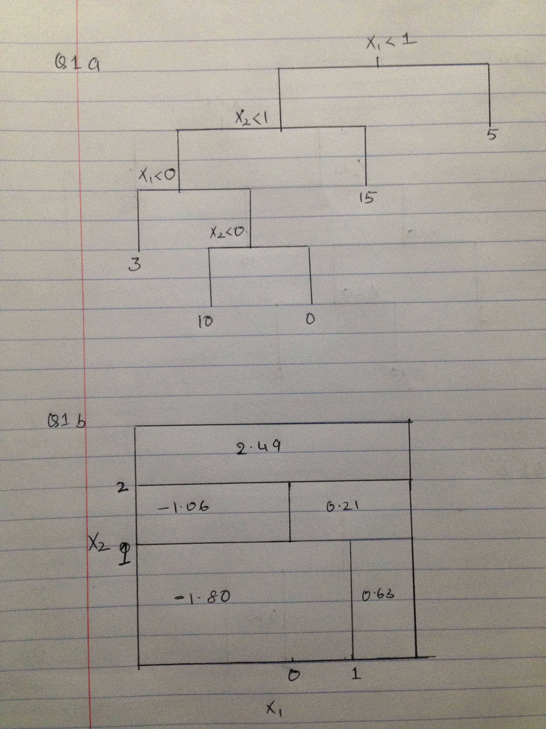

1. Q2.

* 2a.
* X1op=c(3,2,4,1,2,4,4)  
  X2op=c(4,2,4,4,1,3,1)  
  Yop=c("Red","Red", "Red", "Red", "Blue", "Blue","Blue")  
    
  plot(X1op[5:7],X2op[5:7],col="green", xlim=c(0,5), ylim=c(0,5),xlab="X1", ylab="X2", type="p",lwd=6)  
  par(new=T)  
  plot(X1op[1:4],X2op[1:4],col="red", xlim=c(0,5), ylim=c(0,5),xlab="",ylab="",type="p", lwd=6)
* 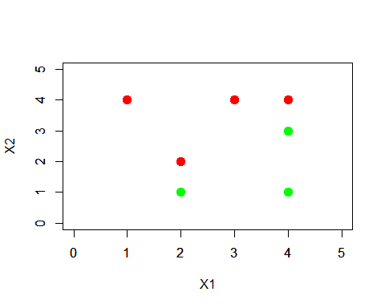
* par(new=F)
* 2b.
* X1op=c(3,2,4,1,2,4,4)  
  X2op=c(4,2,4,4,1,3,1)  
  Yop=c("Red","Red", "Red", "Red", "Blue", "Blue","Blue")  
    
  plot(X1op[5:7],X2op[5:7],col="blue", xlim=c(0,5), ylim=c(0,5),xlab="X1", ylab="X2", type="p",pch=20)  
  par(new=T)  
  plot(X1op[1:4],X2op[1:4],col="red", xlim=c(0,5), ylim=c(0,5),xlab="",ylab="",type="p", pch=20)  
  par(new=F)  
  abline(-0.5,1)
* 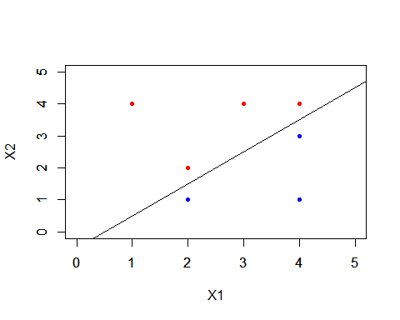
  + Equation of the hyperplane is
* 2c.
  + Eqn of hyperplane is , so subbing values
  + Blue (2,1)= 2(2)-2(1)-1= 4-3=1
  + Red (2,2)=2(2)-2(2)-1=4-4-1=-1
  + -> == Blue
  + -> == Red
* 2d
  + margin is the perpendicular distance from a point to line e.g red point at (2,2) intersects the line at (2.25, 1.75) distance between them is about 0.3
* X1op=c(3,2,4,1,2,4,4)  
  X2op=c(4,2,4,4,1,3,1)  
  Yop=c("Red","Red", "Red", "Red", "Blue", "Blue","Blue")  
    
  plot(X1op[5:7],X2op[5:7],col="blue", xlim=c(0,5), ylim=c(0,5),xlab="X1", ylab="X2", type="p",pch=20)  
  par(new=T)  
  plot(X1op[1:4],X2op[1:4],col="red", xlim=c(0,5), ylim=c(0,5),xlab="",ylab="",type="p", pch=20)  
  par(new=F)  
  abline(-0.5,1)  
  abline(-1,1,lty=2)  
  abline(0,1,lty=2)
* 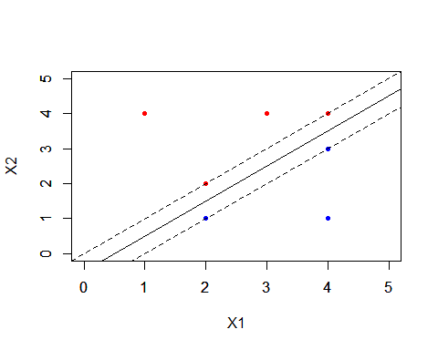
* 2e
* plot(X1op[5:7],X2op[5:7],col="blue", xlim=c(0,5), ylim=c(0,5),xlab="X1", ylab="X2", type="p",pch=20)  
  par(new=T)  
  plot(X1op[1:4],X2op[1:4],col="red", xlim=c(0,5), ylim=c(0,5),xlab="",ylab="",type="p", pch=20)  
  par(new=F)  
  abline(-0.5,1)  
  abline(-1,1,lty=2)  
  abline(0,1,lty=2)  
    
  points(2,2,pch=23, lwd=10, col="red")  
  points(4,4,pch=23, lwd=10, col="red")  
  points(4,3,pch=23, lwd=10, col="blue")  
  points(2,1,pch=23, lwd=10, col="blue")
* 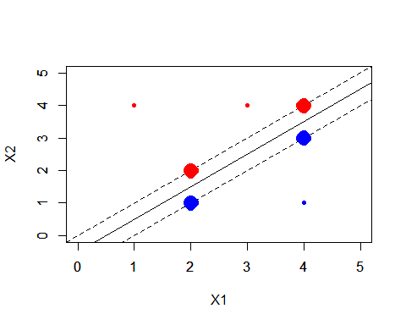
  + Support vectors have been marked with larger points. They are at(2,2),(4,4),(4,3) and (2,1)
* 2f. The 7th point is (4,1) in the blue category. A slight movement of this point will not have an effect on the maximal margin classifer as it would not move within the support vectors of the classifier; However if it moves beyond the margin of the support vectors it will change the hyperplane
* 2g.
* plot(X1op[5:7],X2op[5:7],col="blue", xlim=c(0,5), ylim=c(0,5),xlab="X1", ylab="X2", type="p",pch=20)  
  par(new=T)  
  plot(X1op[1:4],X2op[1:4],col="red", xlim=c(0,5), ylim=c(0,5),xlab="",ylab="",type="p", pch=20)  
  par(new=F)  
  #abline(-0.5,1)  
  abline(-0.25,1)
* 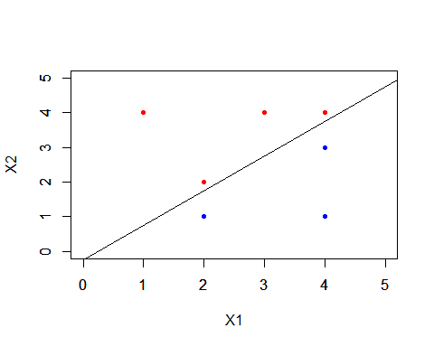
  + The new hyper plane has the same slope as the original hyperplane but the intercept is a bit larger hence it moves this towards the red points
  + Equation of the plane is
* 2h.
* plot(X1op[5:7],X2op[5:7],col="blue", xlim=c(0,5), ylim=c(0,5),xlab="X1", ylab="X2", type="p",pch=20)  
  par(new=T)  
  plot(X1op[1:4],X2op[1:4],col="red", xlim=c(0,5), ylim=c(0,5),xlab="",ylab="",type="p", pch=20)  
  par(new=F)  
    
  points(3.5,2,col="red", pch=20)
* 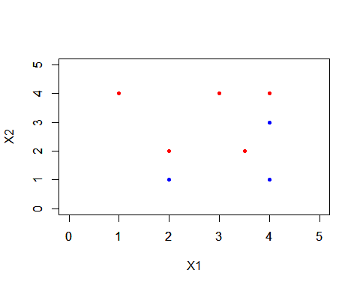

1. Q3.

* 3a.
* set.seed(1)  
  x=matrix(rnorm(20\*3\*50),ncol=50)  
  x[1:20,1]=x[1:20,1]+3  
  x[1:20,2]= x[1:20,2]+3  
  x[21:40,1]=x[21:40,1]-4  
  x[21:40,2]=x[21:40,2]-4  
  x[41:60,2]=x[41:60,2]+3  
  x[41:60,1]=x[41:60,1]-4  
  plot(x)
* 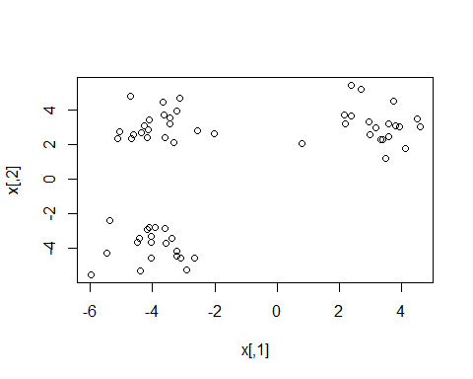
* y=rep(NA,60)  
  y[1:20]=1  
  y[21:40]=2  
  y[41:60]=3
* 3b.
* pr.out=prcomp(x)  
   plot(pr.out$x[,1:2],col=1:3, xlab="z1", ylab="z2", pch=20)
* 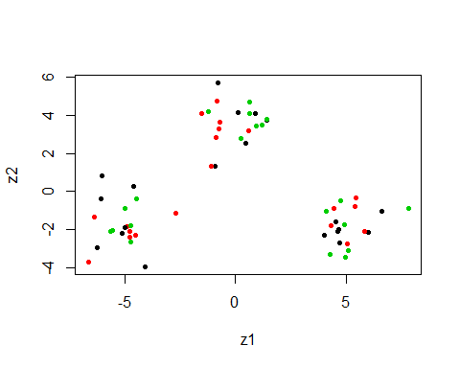
* 3c.
* set.seed(1)  
   km.out=kmeans(x,3,nstart=20)  
   table(y,km.out$cluster)
* ##   
  ## y 1 2 3  
  ## 1 20 0 0  
  ## 2 0 20 0  
  ## 3 0 0 20
  + All the cluster points are correctly classified
* 3d.
* set.seed(1)  
   km.out=kmeans(x,2,nstart=20)  
   table(y,km.out$cluster)
* ##   
  ## y 1 2  
  ## 1 20 0  
  ## 2 0 20  
  ## 3 20 0
  + All the points from class 3 are categorized as points from a class 1.
* 3e.
* set.seed(1)  
   km.out=kmeans(x,4,nstart=20)  
   table(y,km.out$cluster)
* ##   
  ## y 1 2 3 4  
  ## 1 0 10 0 10  
  ## 2 20 0 0 0  
  ## 3 0 0 20 0
  + Points from one of the classes are split into two clusters. Points of the remaining clusters are classified correctly
* 3f.
* set.seed(1)  
   km.out=kmeans(pr.out$x[,1:2],3,nstart=20)  
   table(y,km.out$cluster)
* ##   
  ## y 1 2 3  
  ## 1 20 0 0  
  ## 2 0 20 0  
  ## 3 0 0 20
  + All the points are classified correctly
* 3g.
* set.seed(1)  
   km.out=kmeans(scale(x),3,nstart=20)  
   table(y,km.out$cluster)
* ##   
  ## y 1 2 3  
  ## 1 7 2 11  
  ## 2 3 13 4  
  ## 3 4 10 6
  + There are more missclassifications compared to 3c; By scaling the points the distance between the points changes and hence it impacts the clustering results.

1. Q4

* 4a.
* require(tree)
* ## Loading required package: tree
* ## Warning in library(package, lib.loc = lib.loc, character.only = TRUE,  
  ## logical.return = TRUE, : there is no package called 'tree'
* require(randomForest)
* ## Loading required package: randomForest  
  ## randomForest 4.6-12  
  ## Type rfNews() to see new features/changes/bug fixes.
* bodyR=load("body.RData")  
   plot(Y$Gender,Y$Weight)
* 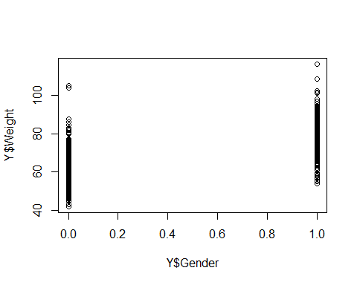
* set.seed(1)  
   train=sample(507,307)  
   test=-train  
   X.train=X[train,]  
   X.test=X[test,]  
   Y.test=Y[test,"Weight"]  
   Y.train=Y[train,"Weight"]  
    
   bag.body=randomForest(Y.train~.,data=X.train,mtry=21,ntree=50)  
   yhat.bag=predict(bag.body, newdata=X[-train,])  
   mean((yhat.bag-Y$Weight[-train])^2)
* ## [1] 10.76931
* rf.body=randomForest(Y$Weight~.,data=X,subset=train,mtry=7,ntree=50)  
   yhat.rf=predict(rf.body, newdata=X[-train,])  
   mean((yhat.rf-Y$Weight[-train])^2)
* ## [1] 10.21739
* plot(c(0,50),c(5,30), type="n", xlab= "# of Trees", ylab="MSE")  
   lines(rf.body$mse, col="blue", lwd=2.5)  
   lines(bag.body$mse, col="red", lwd=2.5)  
   legend(30,30,c("Bagging","Random Forest"))  
   lwd=c(2.5,2,5)  
   col=c("blue","red")  
   legend(30,30,c("Bagging","Random Forest"),lty=c(1,1),lwd=c(2.5,2.5),col=c("red","blue"))
* 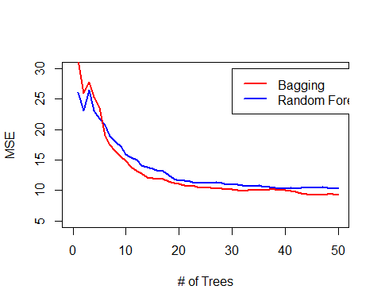
* 4b.
* varImpPlot(rf.body)
* 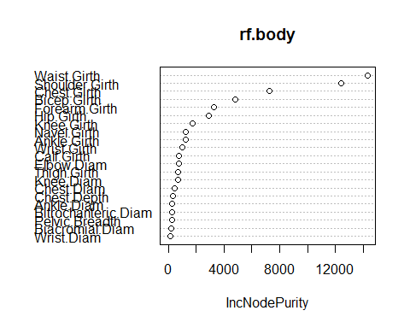
* varImpPlot(bag.body)
* 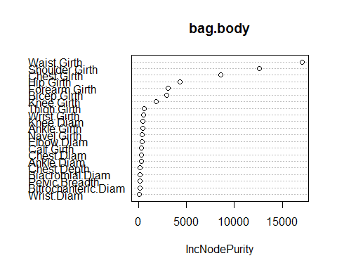
  + Top 3 variables for randomForest: Waist.Girth, Shoulder.Girth, Chest.Girth
  + Top 3 for bagging: Waist.Girth, Shoulder.Girth and Chest.Girth
  + Same variables are chosen by both methods as most important.
* 4c.
* set.seed(1)  
   rf.body=randomForest(Y$Weight~.,data=X,subset=train,mtry=7,ntree=500)  
   yhat.rf=predict(rf.body, newdata=X[-train,])  
   mean((yhat.rf-Y$Weight[-train])^2)
* ## [1] 9.904654
  + In the HW3 Solution, the PLS model had a test error of 8.65, PCR of 9.27, forward stepwise 8.63. The error here is a 9.9, that is bit higher than other methods.
* 4d.
  + The idea of using a smaller subet of 7 from 21 variables is so that we use trees from different variables and that they are uncorrelated, thus helping us to reduce the variance of the averaged trees.
  + Theorectically there are 21C7 ~116280 ways to select 7 variables from 21 variables. So theoretically adding more trees should give a better estimate.
  + Another practical way is to plot the test data error as a function of number of trees and see if the error improves.