Hw2

Anish Mohan

May 17, 2016

1. Q1

* Advantages:
  + Fast: Since only a subset of variables are selected, trees can be built comparitively (compared to full set tree with all variables) quickly
  + Parallizable: Each selection of subset of variables can be independent, hence trees for Random Forests can be calculated independently.
  + Less likely to overfit the data since in each iteration only a smaller set of variables are selected
* Disadvantages:
  + Interpretability becomes difficult as only a subset of variables are selected for each iteration.
  + Addition of a new tunable parameter i.e the number of variables to be chosen. Performance will depend on the value of parameter.
  + Potentially more bias in construction of each tree as we only consider a subset of variables.
* One can introduce additional tree variation in the forest by selecting a subset of training data in each iteration. The results are equivalent to randomly selecting subsets of variables.

1. Q2

If number of predictors are greater than the number of observations in the training sample, then to an extent we have an ill-posed problem. Here are some of the challenges: + High variability in the estimates of risk when evaluated on different random samples + Some of the predictors are guaranteed not to not have any contribution in the sample points.

* Regularization helps here by placing a restriction on the joint solution values. i.e it helps by constraining the number of variables chosen or the coefficients of variables chosen for building the functions.
* Benefits of regularization
  + Regularization also will help when the output response is only dependent on few input parameters, but measurements of many extraneous variables are available.
  + Regularization also helps in minimizing the impact of noise.
* Disadvantages of regularization:
  + Regularization requires prior knowledge e.g # of useful variables, # of variables with zero or near-zero coefficients. These parameters go in choosing the regularizing function. The priors could be easily be wrong. For e.g for best subset selection we have to choose the number of variables at each iteration. If the true number of dependent variables are larger than the subsets we chose, the output will have a high error rate.
* Sparsity is a reasonable assumption in boosting as this method relies on a limited number of weak classifiers.
* There are two possiblities:
  + Actual distribution is not sparse: In this scenario, making the sparsity assumption would impact the results significantly. However, if the actual distribution is not sparse, most methods including Boosting would have problem dealing with the data.
  + Actual distribution is sparse: In this scenario, ground truth matches our assumption and boosting will work well here
* Sparsity might be a reasonable assumption for boosting but might not a reasoble assumption for many other methods. Results are generally poor when sparsity assumptions are made and the distributuon is not sparse.

1. +Q3

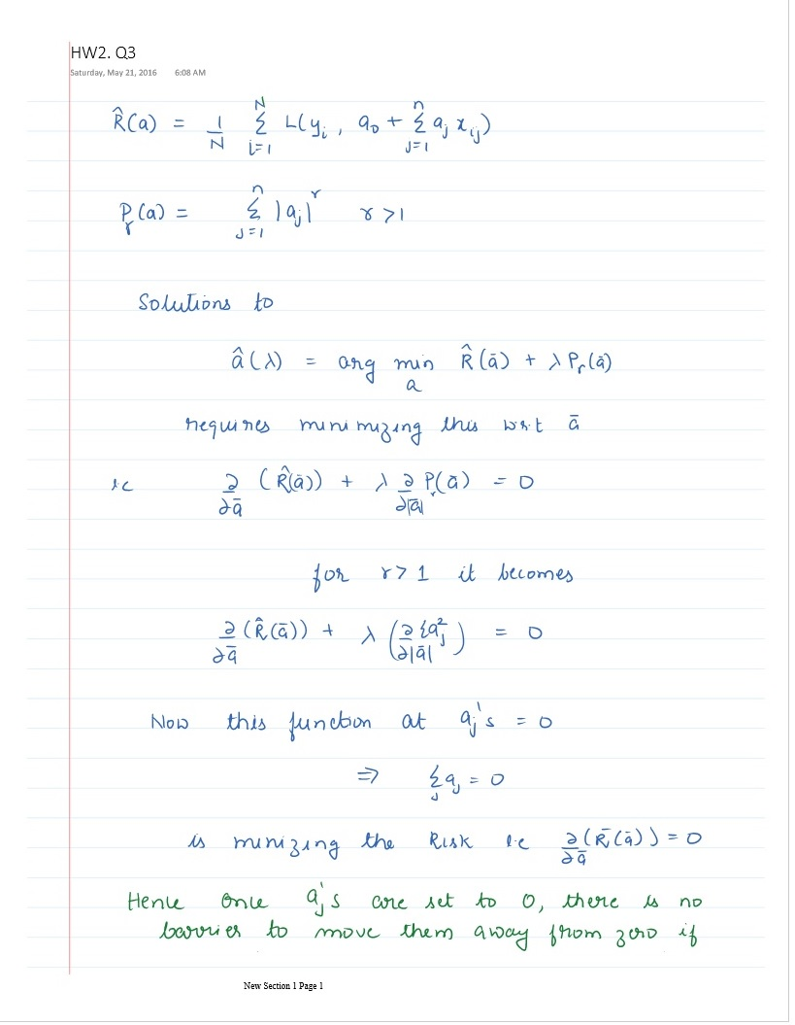

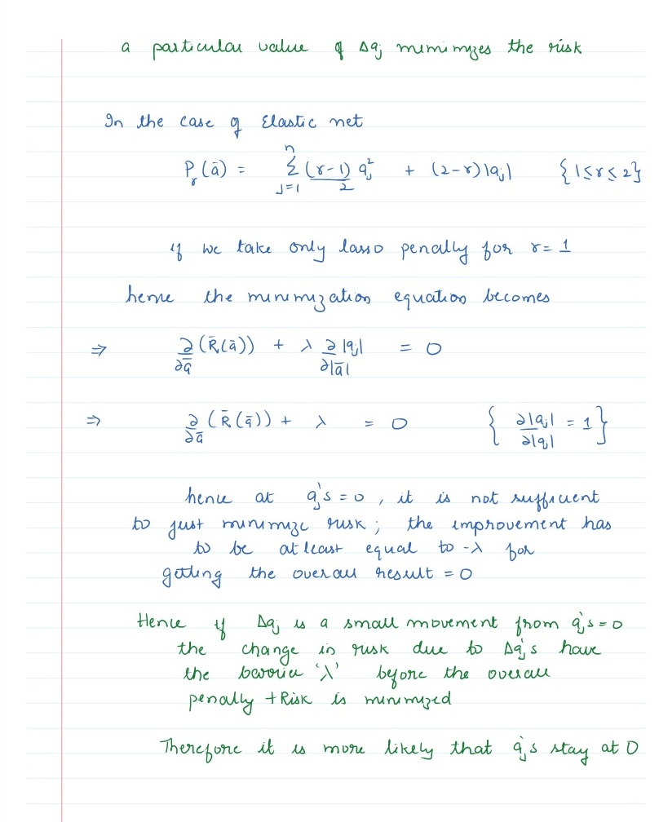

1. Q4

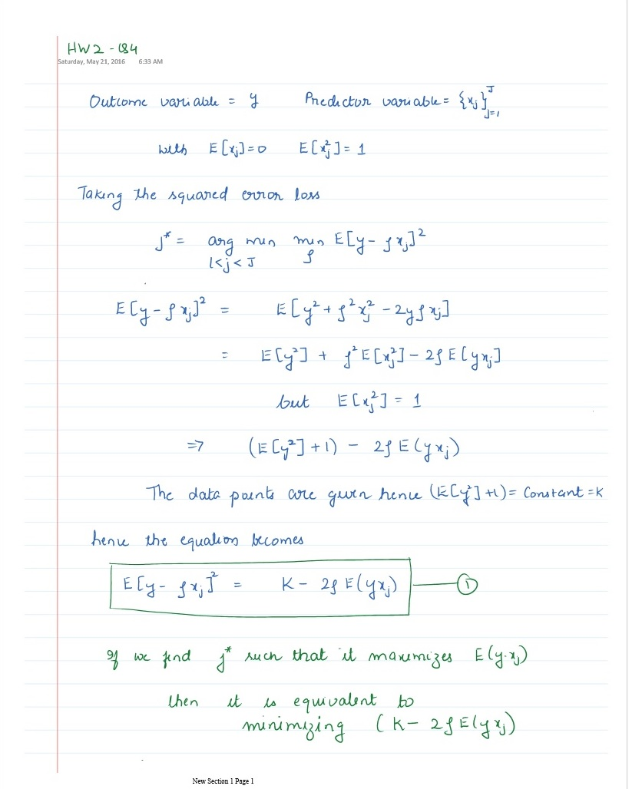

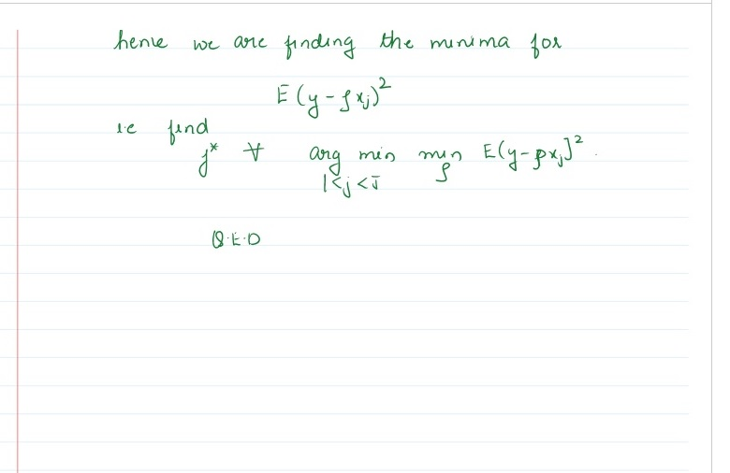

1. Q5

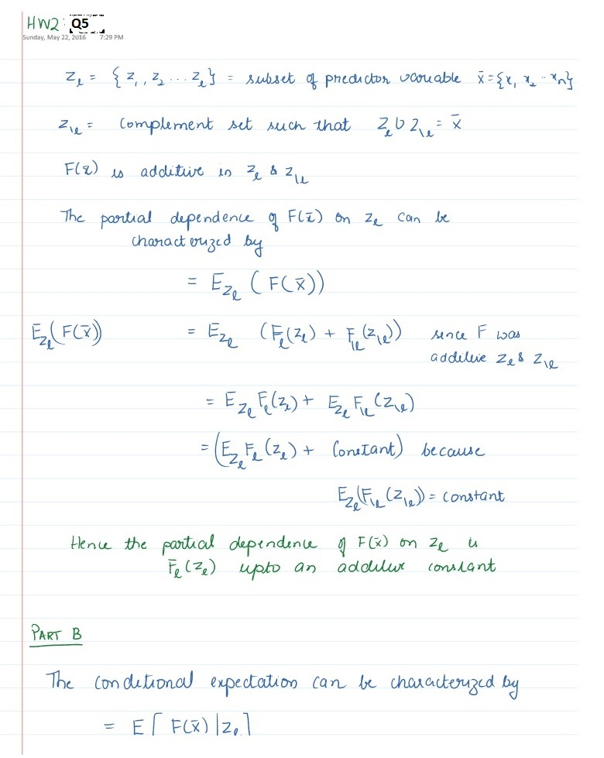

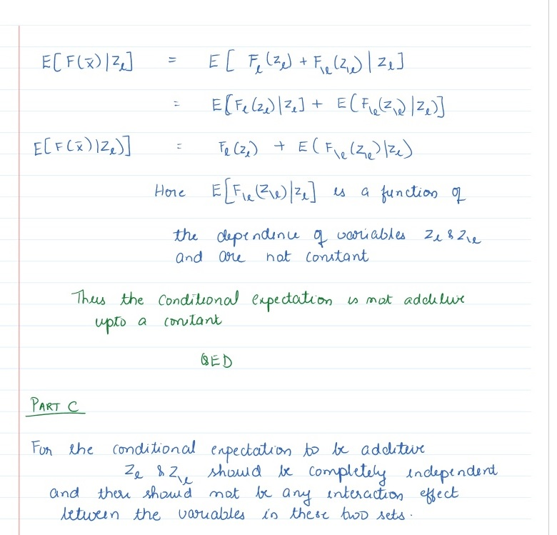

1. Q6

* 6a.
* library(gbm)
* ## Warning: package 'gbm' was built under R version 3.2.5
* ## Loading required package: survival  
  ## Loading required package: lattice  
  ## Loading required package: splines  
  ## Loading required package: parallel  
  ## Loaded gbm 2.1.1
* inspam=read.csv("Spam_Train.txt")  
  spname<-c ("make", "address", "all", "3d", "our", "over", "remove",  
   "internet","order", "mail", "receive", "will",  
   "people", "report", "addresses","free", "business",  
   "email", "you", "credit", "your", "font","000","money",  
   "hp", "hpl", "george", "650", "lab", "labs",  
   "telnet", "857", "data", "415", "85", "technology", "1999",  
   "parts","pm", "direct", "cs", "meeting", "original", "project",  
   "re","edu", "table", "conference", ";", "(", "[", "!", "$", "#",  
   "CAPAVE", "CAPMAX", "CAPTOT","type")  
  colnames(inspam)=spname  
    
    
  set.seed(1)  
  x=inspam[sample(nrow(inspam)),]  
    
  set.seed(1)  
  gbm0=gbm(type~.,data = x,interaction.depth = 4, shrinkage =0.001, n.trees=2500, cv.folds=5, distribution="bernoulli", verbose=F)  
  gbm0.predict=predict(gbm0,x,type="response",n.trees = 300)  
  trainresp=rep(0,length(gbm0.predict))  
  trainresp[gbm0.predict>=0.5]=1  
  conftable=table(trainresp, x$type)  
  best.iter_train=gbm.perf(gbm0,method="cv")
* 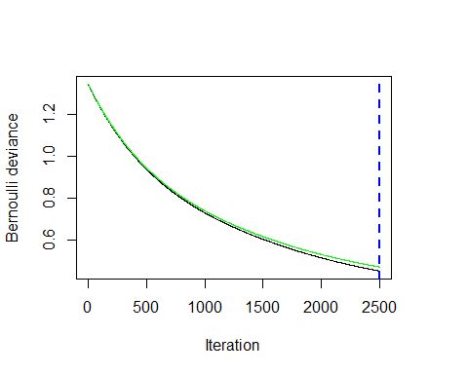
* overallerror=(conftable[1,2]+conftable[1,2])/sum(conftable)  
  nonspam_as_spam=(conftable[2,1])/sum(conftable[,1])  
  spam_as_notspam=(conftable[1,2])/sum(conftable[,2])  
  print(paste0("Overall Error Rate=",overallerror))
* ## [1] "Overall Error Rate=0.263535551206784"
* print(paste0("Non-spam marked as spam=",nonspam_as_spam))
* ## [1] "Non-spam marked as spam=0.012987012987013"
* print(paste0("Spam marked as not-spam=",spam_as_notspam))
* ## [1] "Spam marked as not-spam=0.331691297208539"

set.seed(1)  
 inspamtest=read.csv("Spam.Test.txt")  
 spname<-c ("make", "address", "all", "3d", "our", "over", "remove",  
 "internet","order", "mail", "receive", "will",  
 "people", "report", "addresses","free", "business",  
 "email", "you", "credit", "your", "font","000","money",  
 "hp", "hpl", "george", "650", "lab", "labs",  
 "telnet", "857", "data", "415", "85", "technology", "1999",  
 "parts","pm", "direct", "cs", "meeting", "original", "project",  
 "re","edu", "table", "conference", ";", "(", "[", "!", "$", "#",  
 "CAPAVE", "CAPMAX", "CAPTOT","type")  
 colnames(inspamtest)=spname  
 w=inspamtest[sample(nrow(inspamtest)),]  
  
 #Predicting using gbm from training  
 gbm0.test.predict=predict(gbm0,w,type="response",n.trees = best.iter_train)  
 trainresp1=rep(0,length(gbm0.test.predict))  
 trainresp1[gbm0.test.predict>=0.5]=1  
 conftable2=table(trainresp1, w$type)  
   
 overallerror=(conftable2[1,2]+conftable2[1,2])/sum(conftable2)  
 nonspam_as_spam=(conftable2[2,1])/sum(conftable2[,1])  
 spam_as_notspam=(conftable2[1,2])/sum(conftable2[,2])  
 print(paste0("Overall Error Rate=",overallerror))

## [1] "Overall Error Rate=0.091324200913242"

print(paste0("Non-spam marked as spam=",nonspam_as_spam))

## [1] "Non-spam marked as spam=0.0294759825327511"

print(paste0("Spam marked as not-spam=",spam_as_notspam))

## [1] "Spam marked as not-spam=0.113452188006483"

* 6b. i
* set.seed(1)  
  wghts=rep(1,length(x$type))  
    
  wghts[x$type==0]=25;  
  gbm1=gbm(type~.,data = x,interaction.depth = 4, shrinkage =0.001, weights=wghts, n.trees=2500,cv.folds=5, distribution="bernoulli", verbose=F)  
    
  best.iter_train=gbm.perf(gbm1,method="cv")
* 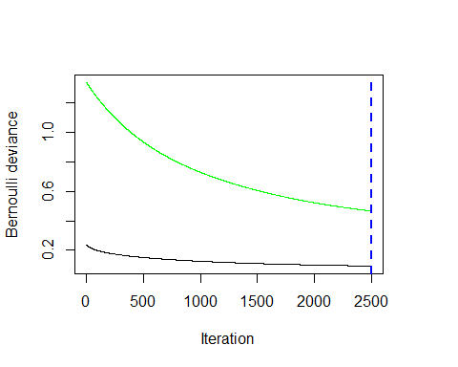
* gbm1.predict=predict(gbm1,w,type="response",n.trees = best.iter_train)  
  trainresp1=rep(0,length(gbm1.predict))  
  trainresp1[gbm1.predict>=0.5]=1  
  conftable2=table(trainresp1, w$type)  
    
  overallerror=(conftable2[1,2]+conftable2[1,2])/sum(conftable2)  
  nonspam_as_spam=(conftable2[2,1])/sum(conftable2[,1])  
  spam_as_notspam=(conftable2[1,2])/sum(conftable2[,2])  
  print(paste0("Overall Error Rate=",overallerror))
* ## [1] "Overall Error Rate=0.377038486627528"
* print(paste0("Non-spam marked as spam=",nonspam_as_spam))
* ## [1] "Non-spam marked as spam=0.00218340611353712"
* print(paste0("Spam marked as not-spam=",spam_as_notspam))
* ## [1] "Spam marked as not-spam=0.46839546191248"
  + By giving more weight to missclassifcation of Non-Spam as a spam mail, the overall accuracy of the model is reduced however, we decreased the missclassification error due to a non-spam mail being marked as a spam mail.
* 6b. ii
* impvar=summary(gbm1)
* 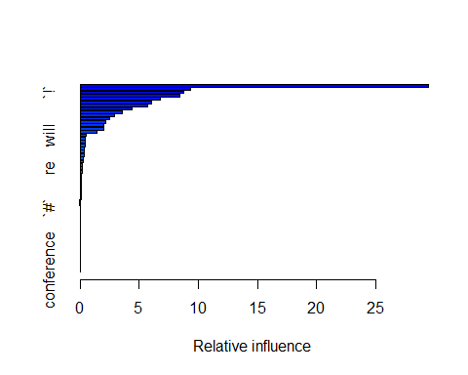
* impvar[1:5,]
* ## var rel.inf  
  ## remove remove 29.481735  
  ## `000` `000` 9.329296  
  ## `!` `!` 8.728980  
  ## money money 8.407674  
  ## CAPTOT CAPTOT 6.758686
  + The 3 most important variables seems to be having following words in the spam email:
    - $ string (#53)
    - phrase: remove (#7)
    - ! exclamation mark. (#52)
* 6b iii
* par(mfrow=c(2,2))  
  plot(x=gbm1, i.var=53, n.trees=best.iter_train, main="Partial Dependence of '$'")  
  plot(x=gbm1, i.var=7, n.trees=best.iter_train, main="Partial Dependence of Phrase 'Remove'")  
  plot(x=gbm1, i.var=52, n.trees=best.iter_train, main="Partial Dependence of '!'")
* 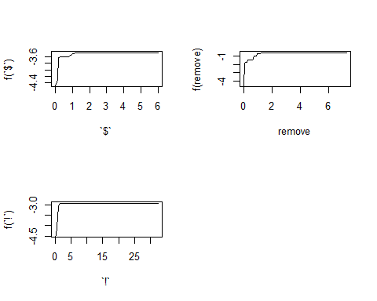
  + There is a significant +ve correlation and mail having $ and probability of it being a spam email. This is also true for other two terms ie presence of "!" and word "Remove" has high correlation with the mail being a spam mail.
* par(mfrow=c(2,2))  
  plot(gbm1, c(52,53),best.iter_train, main="Partial Dependence of '!' and '$'")
* 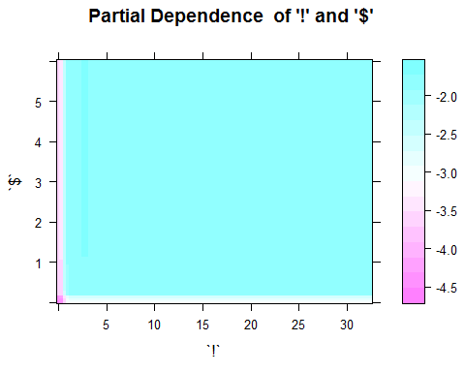
* plot(gbm1, c(7,53),best.iter_train, main="Partial Dependence of 'remove' and '$'")
* 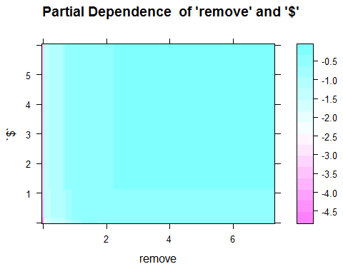
* plot(gbm1, c(7,52),best.iter_train, main="Partial Dependence of 'remove' and '!'")
* 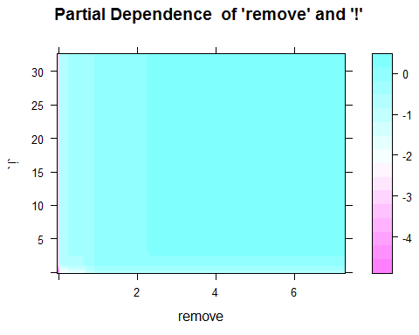
  + The plots with 2 variables indicates that
  + Lower frequency of '!' has high indication of being a spam and seems to be independent of the frequency of occurence of '$' in mails
  + Lower frequency of word 'remove' has high indication of being a spam and seems to be independent of the frequency of occurence of '$' in mails
  + Lower frequency of word 'remove' has high indication of being a spam and seems to be independent of the frequency of occurence of '!' in mails

1. Q7

* 7a.
* inpcal=read.csv("California_Data.txt")  
  calname=c("hval","inc","hage","#rooms","#bed","pop","occu","lat","long")  
  colnames(inpcal)=calname  
  set.seed(1)  
  inpcal=inpcal[sample(nrow(inpcal)),]  
    
  set.seed(1)  
  gbmcal0=gbm(hval~.,data=inpcal, train.fraction=0.8, interaction.depth = 4, shrinkage = 0.001, n.trees=2500, cv.folds=5, distribution = "gaussian", verbose=F)  
    
  best.iter=gbm.perf(gbmcal0,method="test")
* 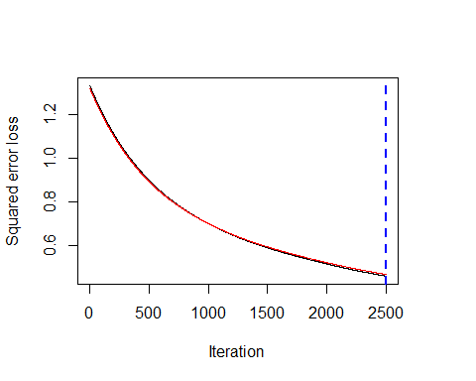
* gbmcal0.predict=predict(gbmcal0,inpcal,n.trees = best.iter)  
    
  # Error:  
  mean((gbmcal0.predict-inpcal$hval)^2)
* ## [1] 0.4593195
* print(paste0("Traning Error=",mean((gbmcal0.predict-inpcal$hval)^2)))
* ## [1] "Traning Error=0.459319450169259"
  + For this exercise, I have divided the data in to Test and training set. The gbm model is trained on the training set.
  + Training set Error is 0.459
* 7b.

par(mfrow=(c(1,1)))  
 impvar=summary(gbmcal0)

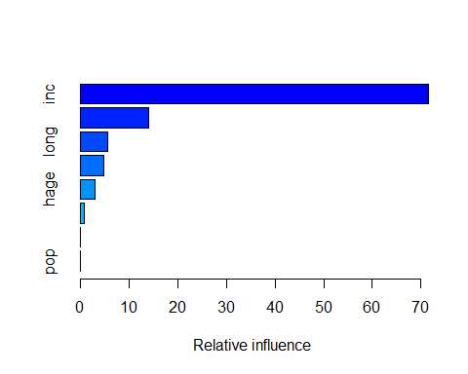

impvar[1:5,]

## var rel.inf  
## inc inc 71.557500  
## occu occu 14.089388  
## long long 5.686636  
## lat lat 4.866760  
## hage hage 2.993203

+ Most important factors of influence on housing prices are:  
 + Median Income of the block/neighborhood  
 + Average occupancy  
 + Longitude of the house location.

* 7c.

par(mfrow=c(2,2))  
 plot(x=gbmcal0, i.var=1, n.trees=best.iter, main="Partial Dependence of 'Income'")  
 plot(x=gbmcal0, i.var=6, n.trees=best.iter, main="Partial Dependence of 'Number of Occupants")  
 plot(x=gbmcal0, i.var=8, n.trees=best.iter, main="Partial Dependence of 'Longitude'")

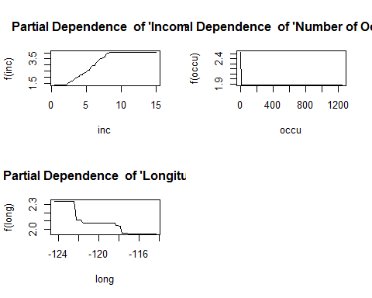

+ Housing value is influenced by Median income of the block. Higher median income indicates that house values are lower.  
+ Average occupancy is negatively correlated with house value. Higher average occupance indicates lower house values are lower.  
+ California's location is around 124'W to 114'W. As we go move east, the housing prices decreases. This effect may be because, houses are more expensive near the California coast and cheaper in the inlands.

par(mfrow=c(2,2))  
 plot(x=gbmcal0,c(1,6), n.trees=best.iter, main="Partial Dependence of Income and Number of Occupants")

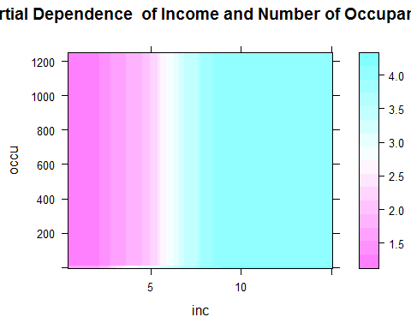

plot(x=gbmcal0, c(1,8), n.trees=best.iter, main="Partial Dependence of Income and Longitude")

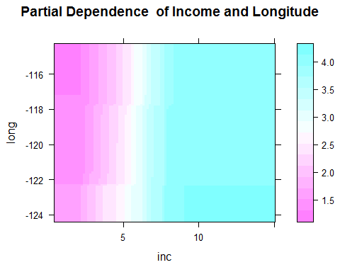

plot(x=gbmcal0, c(8,6), n.trees=best.iter, main="Partial Dependence of Number of occupants and Longitude")

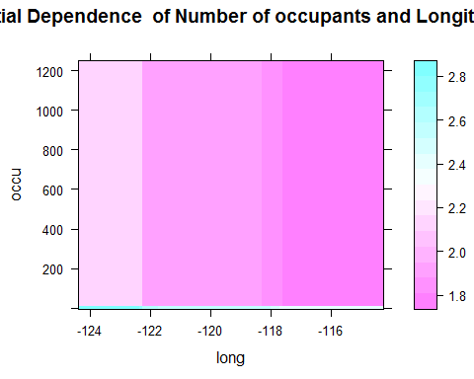

+ Lower Median income is a strong indicator for the Housing value and seems to be indpendent of the average occupancy in the region.  
+ Lower Median income is a strong indicator for the Housing value and seems to be indpendent of longitudinal position in the region.  
+ Eastwards Longitudinal position seems to be a stronger indicator of housing value and seems to be independent of the average occupancy of the house

1. Q8

* 8a.

Income=read.csv("Income_Data.txt")  
 ModIncome=data.frame(Inc=Income$X9,sex=Income$X2,marital=Income$X1,age=Income$X5,edu=Income$X4,occ=Income$X5.1,dwelltime=Income$X5.2,dual=Income$X3,hh=Income$X3.1,hh18=Income$X0,house=Income$X1.1,hometype=Income$X1.2,Ethnic=Income$X7,lang=Income$NA.)  
   
 Inc=ModIncome$Inc  
 sex=factor(ModIncome$sex, levels=1:2, labels=c("Male","Female"))  
 marital=factor(ModIncome$marital, levels=1:5,labels=c("Married","live-in","Divorced","Seperated","Single"))  
 age=factor(ModIncome$age,levels=1:7,labels=c("14-17","18-24","25-34","35-44","45-54","55-64","over 65"))  
 edu=factor(ModIncome$edu,levels=1:6,labels=c("less grade 8","grade 9-11","grad high","1-3 college","College grad","Grad"))  
 occ=factor(ModIncome$occ,levels=1:9,labels=c("Professional","Sales","laborer","Clerk","Home","Student","Military","Retired","Unemployed"))  
 dwelltime=factor(ModIncome$dwelltime,levels=1:5,labels=c("<1year","1-3 years","4-6 years","7-10 years",">10 years"))  
 dual=factor(ModIncome$dual, levels=1:3, labels=c("Not Married","Yes","No"))  
 hh=factor(ModIncome$hh, levels=1:9, labels=c("1","2","3","4","5","6","7","8",">9"))  
 hh18=factor(ModIncome$hh18, levels=1:9, labels=c("1","2","3","4","5","6","7","8",">9"))  
 house=factor(ModIncome$house, levels=1:3, labels=c("Own","Rent","Live with family"))  
 hometype=factor(ModIncome$house,levels=1:5, labels =c("House","Condo","Apa","Mobile","Other"))  
 ethnic=factor(ModIncome$Ethnic, levels=1:8, labels=c("American Ind","Asian","Black","East indian","Hispanic","Pacific Island","White","Other"))  
 lang=factor(ModIncome$lang,levels=1:3, labels=c("English","Spanish","Other"))  
   
 FinalInc=data.frame(Inc=Inc,sex=sex,marital=marital,age=age,edu=edu,occ=occ, dwelltime=dwelltime, dual=dual, hh=hh, hh18=hh18,house=house, hometype=hometype,ethnic=ethnic, lang=lang)  
   
 FinalInc=FinalInc[sample(nrow(FinalInc)),]  
   
 set.seed(1)  
 gbminc0=gbm(Inc~.,data=FinalInc, train.fraction=0.8, bag.fraction=0.5, interaction.depth = 4, shrinkage = 0.01, n.trees=2500, cv.folds=5, distribution = "gaussian", verbose=F)  
  
 best.iter=gbm.perf(gbminc0,method="test")

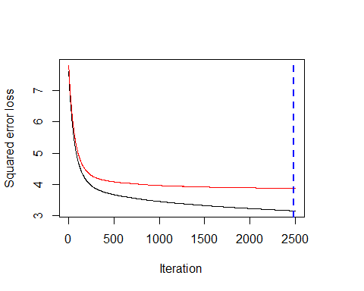

gbminc0.predict=predict(gbminc0,FinalInc,type="response", n.trees =best.iter)  
   
 gbminc0.round=round(gbminc0.predict)  
   
 # Error:  
 mean((gbminc0.predict-FinalInc$Inc)^2)

## [1] 3.306516

print(paste0("Boosting Error=",mean((gbminc0.predict-FinalInc$Inc)^2)))

## [1] "Boosting Error=3.30651559815897"

#RPart tree error  
 library(rpart)  
 #Optimal tree was a tree with 18 nodes with cp=0.00199  
 incfit=rpart(Inc~.,FinalInc, cp=0.00199)  
 #summary(incfit)  
   
 print(paste0("Error using trees:",7.69*0.5236 ))

## [1] "Error using trees:4.026484"

+ MSE Error with Boosting: 3.363  
+ MSE Error with Trees: 4.02  
+ Boosting is doing beter than Trees in in this instance

* 8b.

summary(gbminc0)

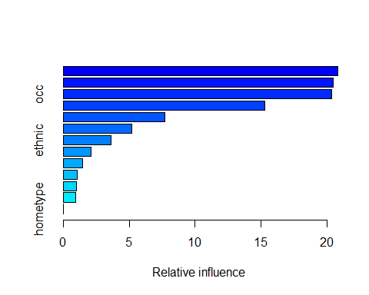

## var rel.inf  
## age age 20.8187441  
## house house 20.4714322  
## occ occ 20.3370780  
## marital marital 15.2938822  
## edu edu 7.6890757  
## hh hh 5.2018256  
## ethnic ethnic 3.6137493  
## dwelltime dwelltime 2.0942961  
## hh18 hh18 1.4720530  
## dual dual 1.0740118  
## lang lang 0.9885550  
## sex sex 0.9452969  
## hometype hometype 0.0000000

+ The most important variables to predict income seems to be:  
 + If the person owns the house or rents it or live with family.  
 + Age of the person  
 + Occupation  
   
+ It is not inconsistent with national average results. Couple of possible reasons:  
 + It could be very well that after adjustment to the critical factors mentioned here, women get paid less than men. i.e if a man and a woman have the same home ownership, age, occupation etc, men might still get paid higher.   
 + Other possible reason could be that data from San-Francisco might not be representative of the national average data. San-Francisco is primarily tech based industry where the disparity between men/women salaries are less disparate than in other fields.

1. Q9a.

Income=read.csv("Occupation_Data.txt")  
 incnames<-c ("occ", "hometype", "sex", "marital", "age", "edu", "Inc",  
 "dwelltime","dual", "hh", "hh18", "house",  
 "ethnic", "lang")  
  
 ModIncome=Income  
 colnames(ModIncome)=incnames  
   
 Inc=factor(ModIncome$Inc, levels=1:9, labels=c("<10K","10-15K","15-20K","20-25K","25-30K","30-40K","40-50K","50K-75K",">75K"))  
 sex=factor(ModIncome$sex, levels=1:2, labels=c("Male","Female"))  
 marital=factor(ModIncome$marital, levels=1:5,labels=c("Married","live-in","Divorced","Seperated","Single"))  
 age=factor(ModIncome$age,levels=1:7,labels=c("14-17","18-24","25-34","35-44","45-54","55-64","over 65"))  
 edu=factor(ModIncome$edu,levels=1:6,labels=c("less grade 8","grade 9-11","grad high","1-3 college","College grad","Grad"))  
 occ=factor(ModIncome$occ,levels=1:9,labels=c("Professional","Sales","laborer","Clerk","Home","Student","Military","Retired","Unemployed"))  
 dwelltime=factor(ModIncome$dwelltime,levels=1:5,labels=c("<1year","1-3 years","4-6 years","7-10 years",">10 years"))  
 dual=factor(ModIncome$dual, levels=1:3, labels=c("Not Married","Yes","No"))  
 hh=factor(ModIncome$hh, levels=1:9, labels=c("1","2","3","4","5","6","7","8",">9"))  
 hh18=factor(ModIncome$hh18, levels=1:9, labels=c("1","2","3","4","5","6","7","8",">9"))  
 house=factor(ModIncome$house, levels=1:3, labels=c("Own","Rent","Live with family"))  
 hometype=factor(ModIncome$house,levels=1:5, labels =c("House","Condo","Apa","Mobile","Other"))  
 ethnic=factor(ModIncome$Ethnic, levels=1:8, labels=c("American Ind","Asian","Black","East indian","Hispanic","Pacific Island","White","Other"))  
 lang=factor(ModIncome$lang,levels=1:3, labels=c("English","Spanish","Other"))  
   
 FinalInc=ModIncome  
   
 train=sample(1:nrow(FinalInc),7000)  
 test=-train  
   
 Finalocc.train=FinalInc[train,]  
 Finalocc.test=FinalInc[test,]  
   
 set.seed(1)  
 gbmocc0=gbm(occ~.,data=Finalocc.train, bag.fraction=0.5, interaction.depth = 4, shrinkage = 0.01, n.trees=2500, cv.folds=5, distribution = "multinomial", verbose=F)  
  
 best.iter=gbm.perf(gbmocc0,method="cv")

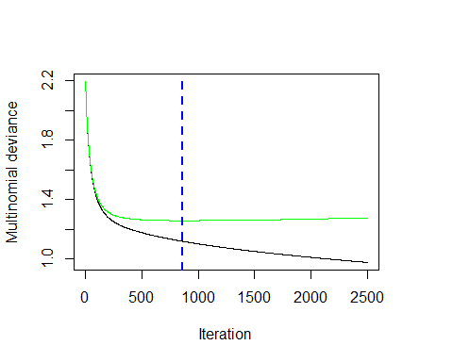

#Predict on the test data  
 gbmocc0.predict=predict(gbmocc0,Finalocc.test,type="response", n.trees =best.iter)  
  
 #Assign the class with maximum probability:  
 pred.occ=apply(gbmocc0.predict,1,which.max)  
   
 # Error:  
 actual.occ=Finalocc.test$occ  
 occ.table=table(actual.occ, pred.occ)  
   
 #Classficiation Error  
 print(paste0("Overall Misclassification rate",1-sum(diag(occ.table))/sum(occ.table)))

## [1] "Overall Misclassification rate0.430495689655172"

#Misclassification for each class  
 print(paste0("Misclassification rate for Professional/Managerial",1-occ.table[1,1]/sum(occ.table[1,]) ))

## [1] "Misclassification rate for Professional/Managerial0.222984562607204"

print(paste0("Misclassification rate for Sales Worker",1-occ.table[2,2]/sum(occ.table[2,]) ))

## [1] "Misclassification rate for Sales Worker0.953020134228188"

print(paste0("Misclassification rate for Factory worker/Laborer/Driver",1-occ.table[3,3]/sum(occ.table[3,]) ))

## [1] "Misclassification rate for Factory worker/Laborer/Driver0.716867469879518"

print(paste0("Misclassification rate for Clerical/Service Worker",1-occ.table[4,4]/sum(occ.table[4,]) ))

## [1] "Misclassification rate for Clerical/Service Worker0.710900473933649"

print(paste0("Misclassification rate for Homemaker",1-occ.table[5,5]/sum(occ.table[5,]) ))

## [1] "Misclassification rate for Homemaker0.391608391608392"

print(paste0("Misclassification rate for Student/HS or College",1-occ.table[6,6]/sum(occ.table[6,]) ))

## [1] "Misclassification rate for Student/HS or College0.250764525993884"

print(paste0("Misclassification rate for Military",1-occ.table[7,7]/sum(occ.table[7,]) ))

## [1] "Misclassification rate for Military0.674418604651163"

print(paste0("Misclassification rate for retired",1-occ.table[8,8]/sum(occ.table[8,]) ))

## [1] "Misclassification rate for retired0.16025641025641"

print(paste0("Misclassification rate for Unemployed",1-occ.table[9,9]/sum(occ.table[9,]) ))

## [1] "Misclassification rate for Unemployed0.846153846153846"

* 9b.

summary(gbmocc0)

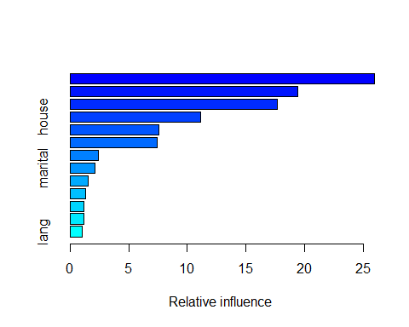

## var rel.inf  
## age age 25.963151  
## Inc Inc 19.378973  
## edu edu 17.702209  
## house house 11.146211  
## sex sex 7.550540  
## dual dual 7.455251  
## hh hh 2.409436  
## marital marital 2.105662  
## dwelltime dwelltime 1.538799  
## ethnic ethnic 1.312185  
## hh18 hh18 1.212070  
## hometype hometype 1.211225  
## lang lang 1.014290

* Most important variables as an indicator for Occupation
  + Age:
  + Education:
  + Income