HW3

1. Q1

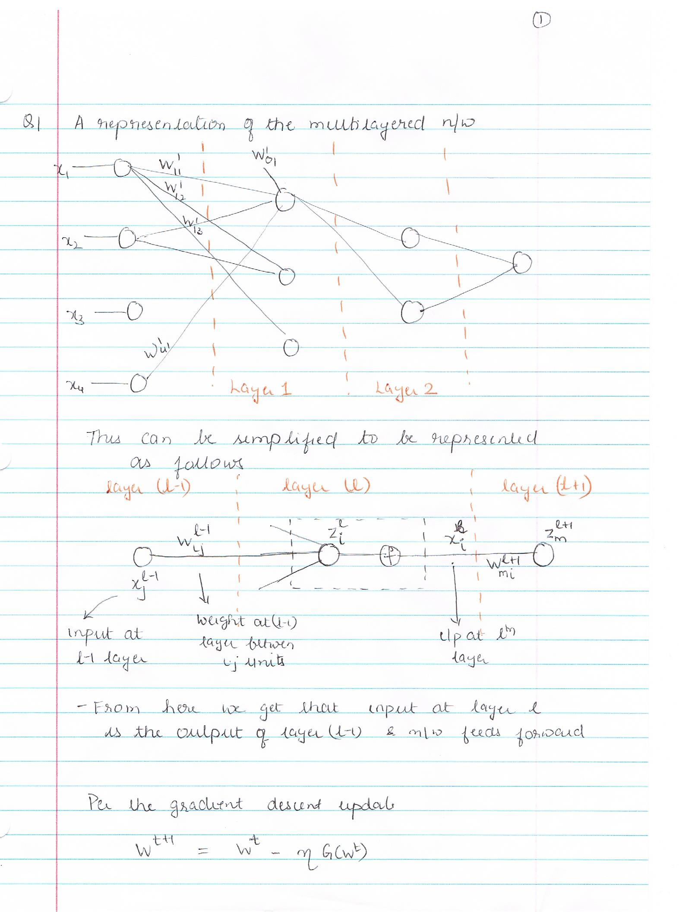

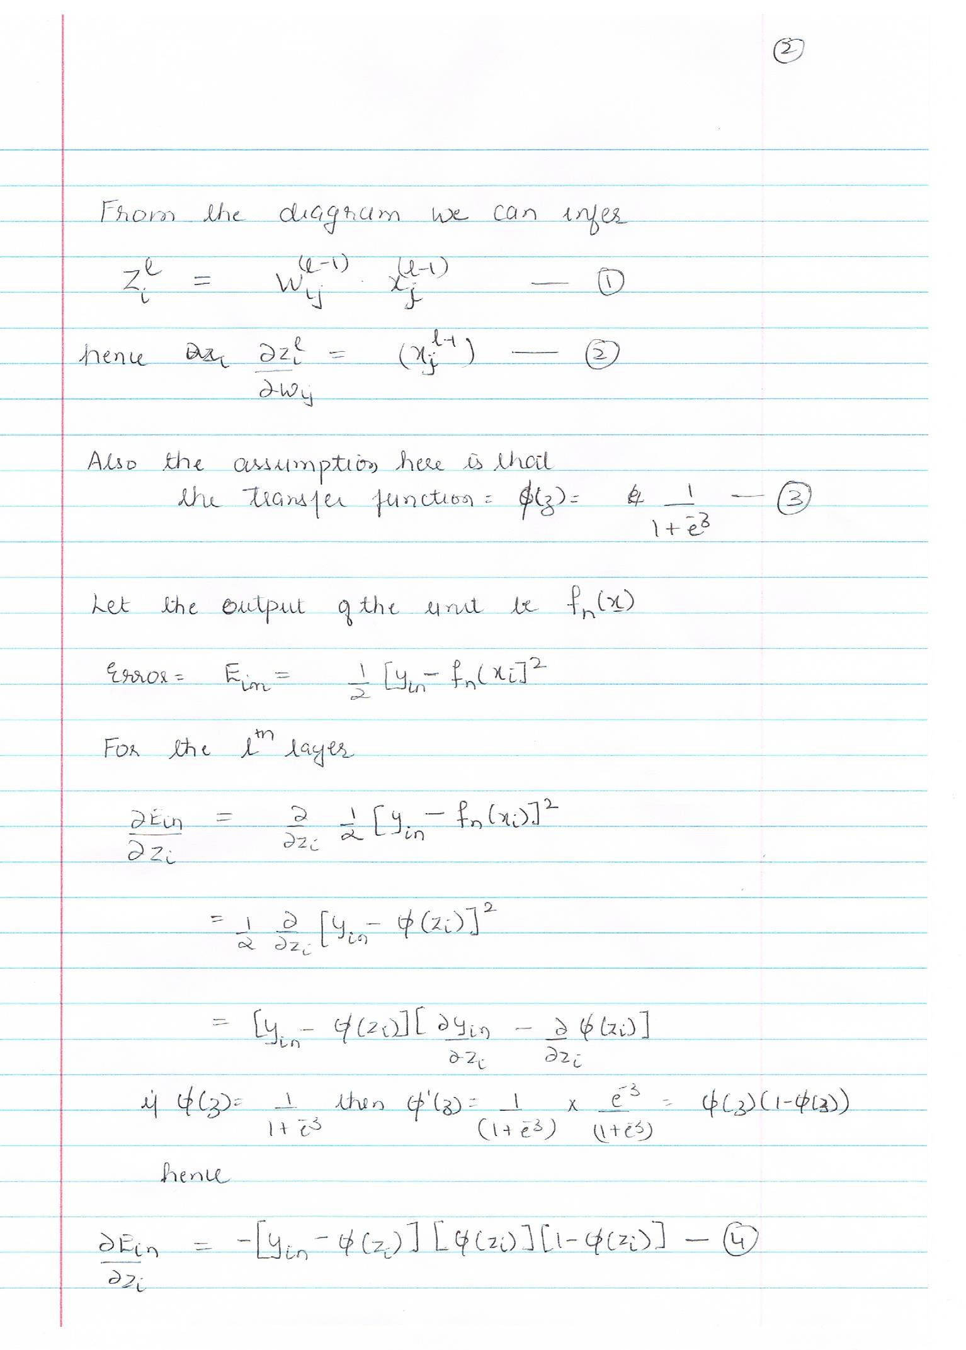 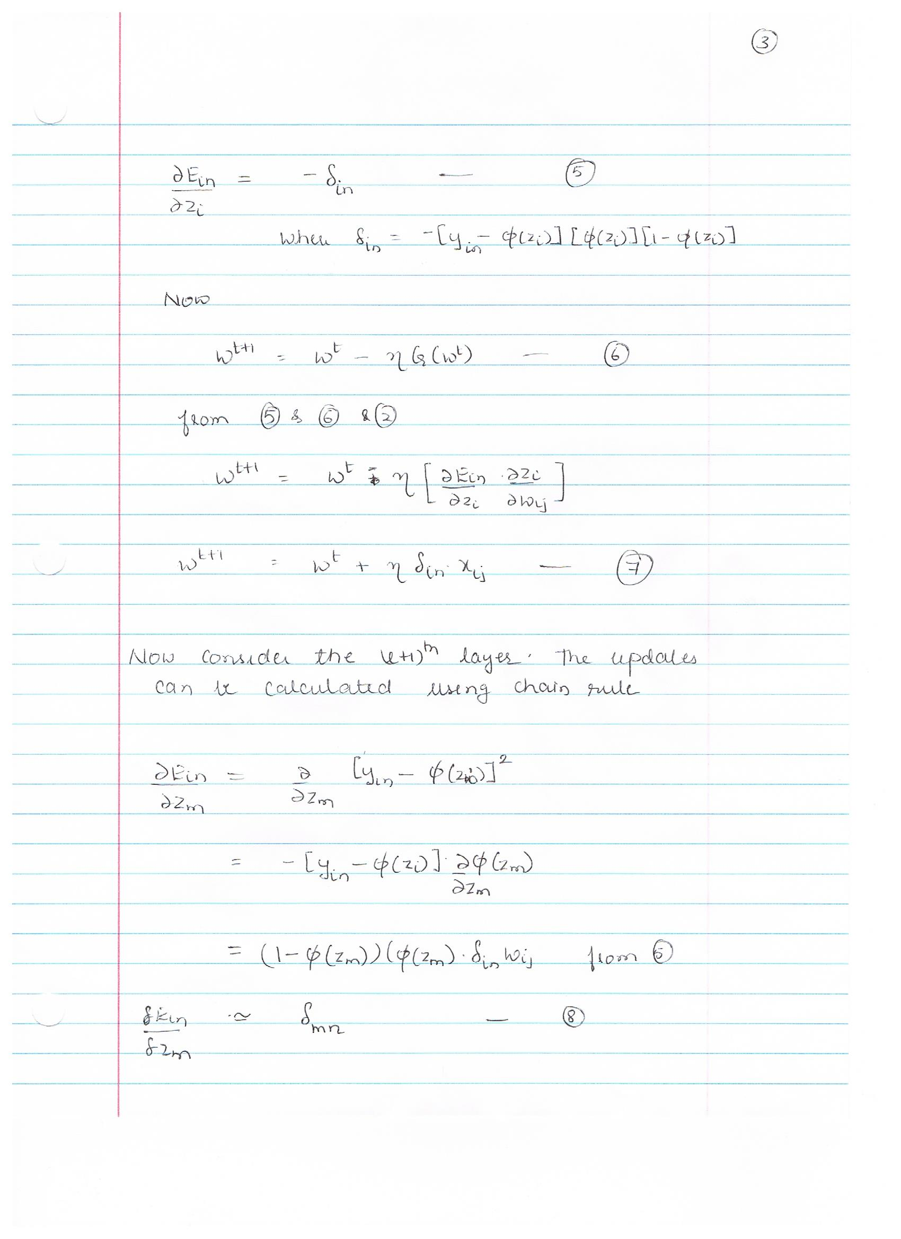 

1. Q2

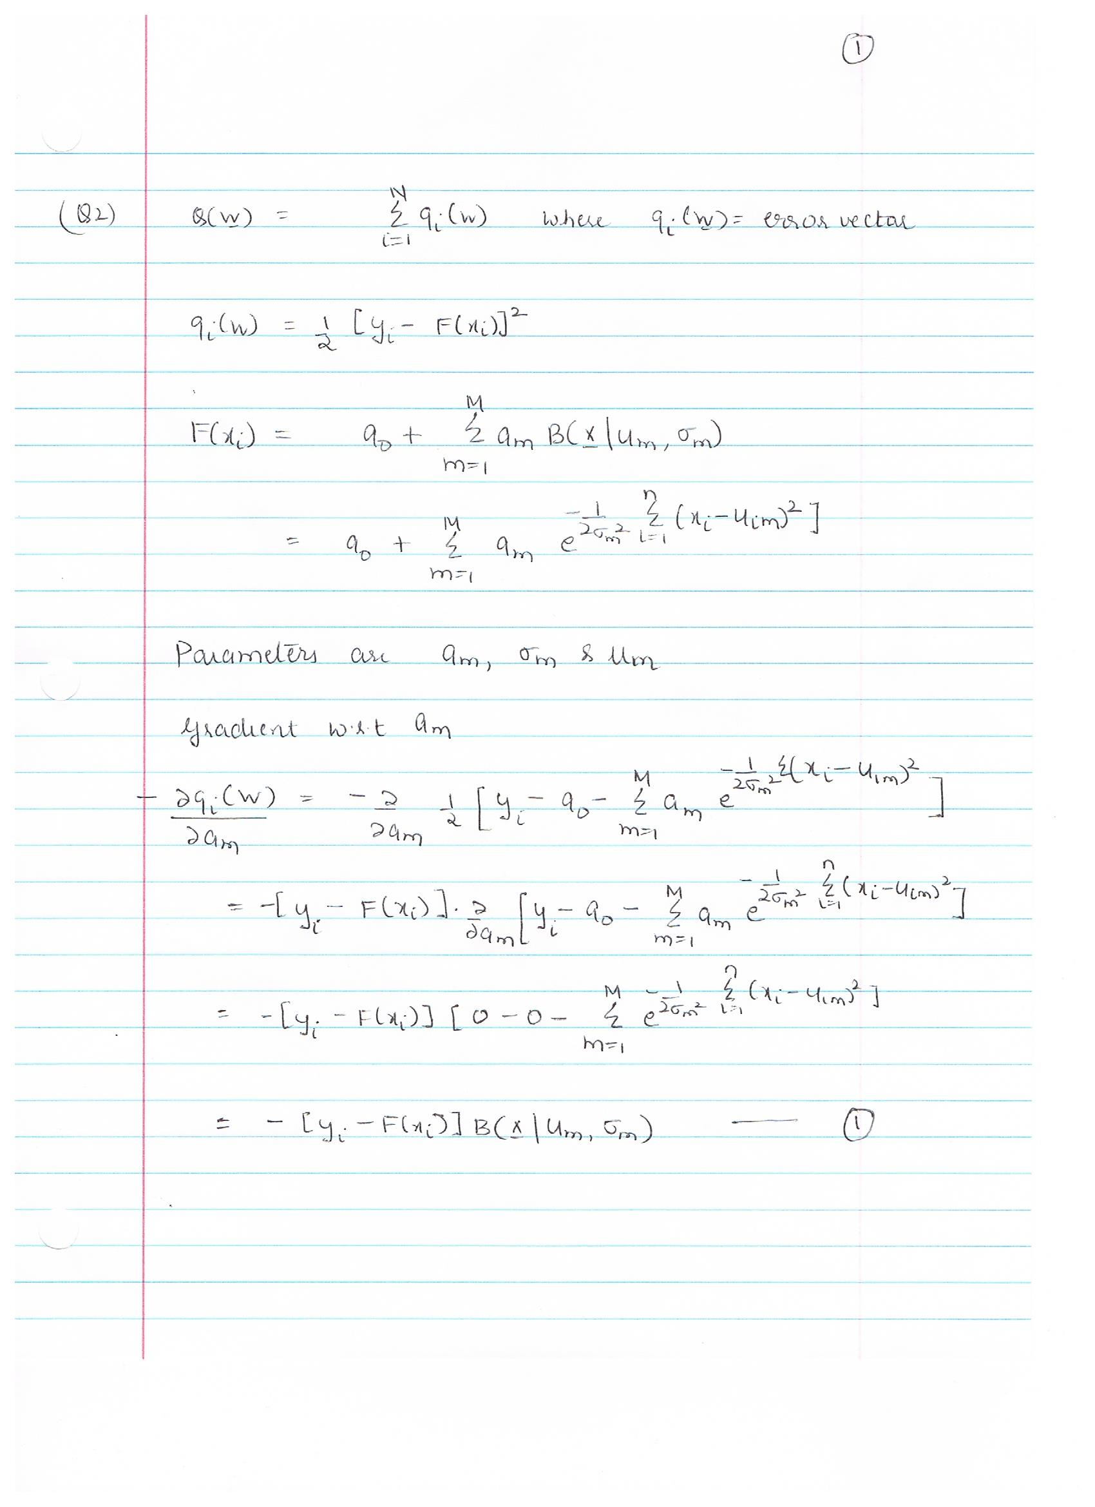

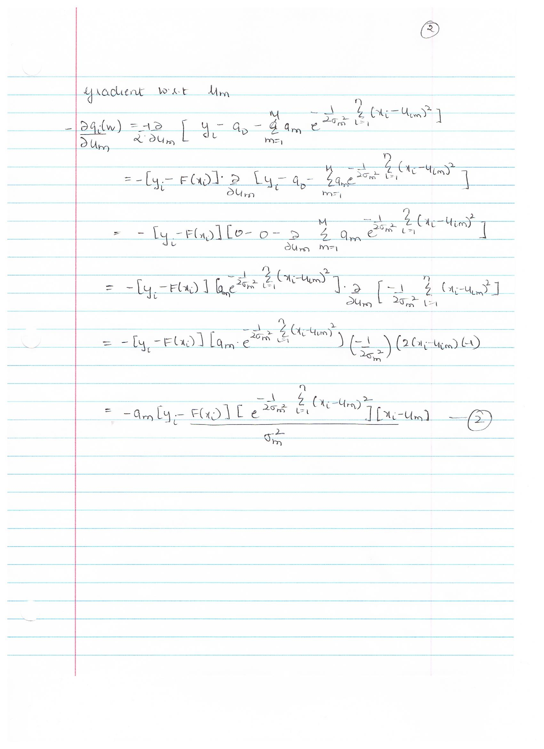 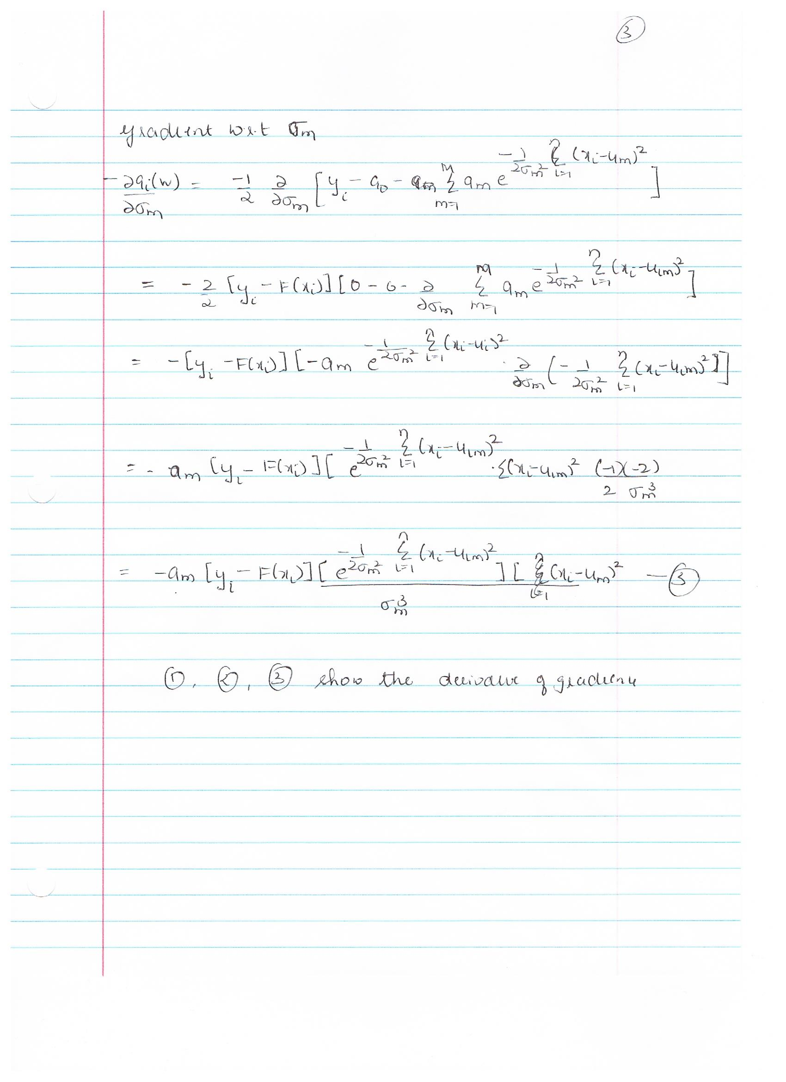

1. Q3

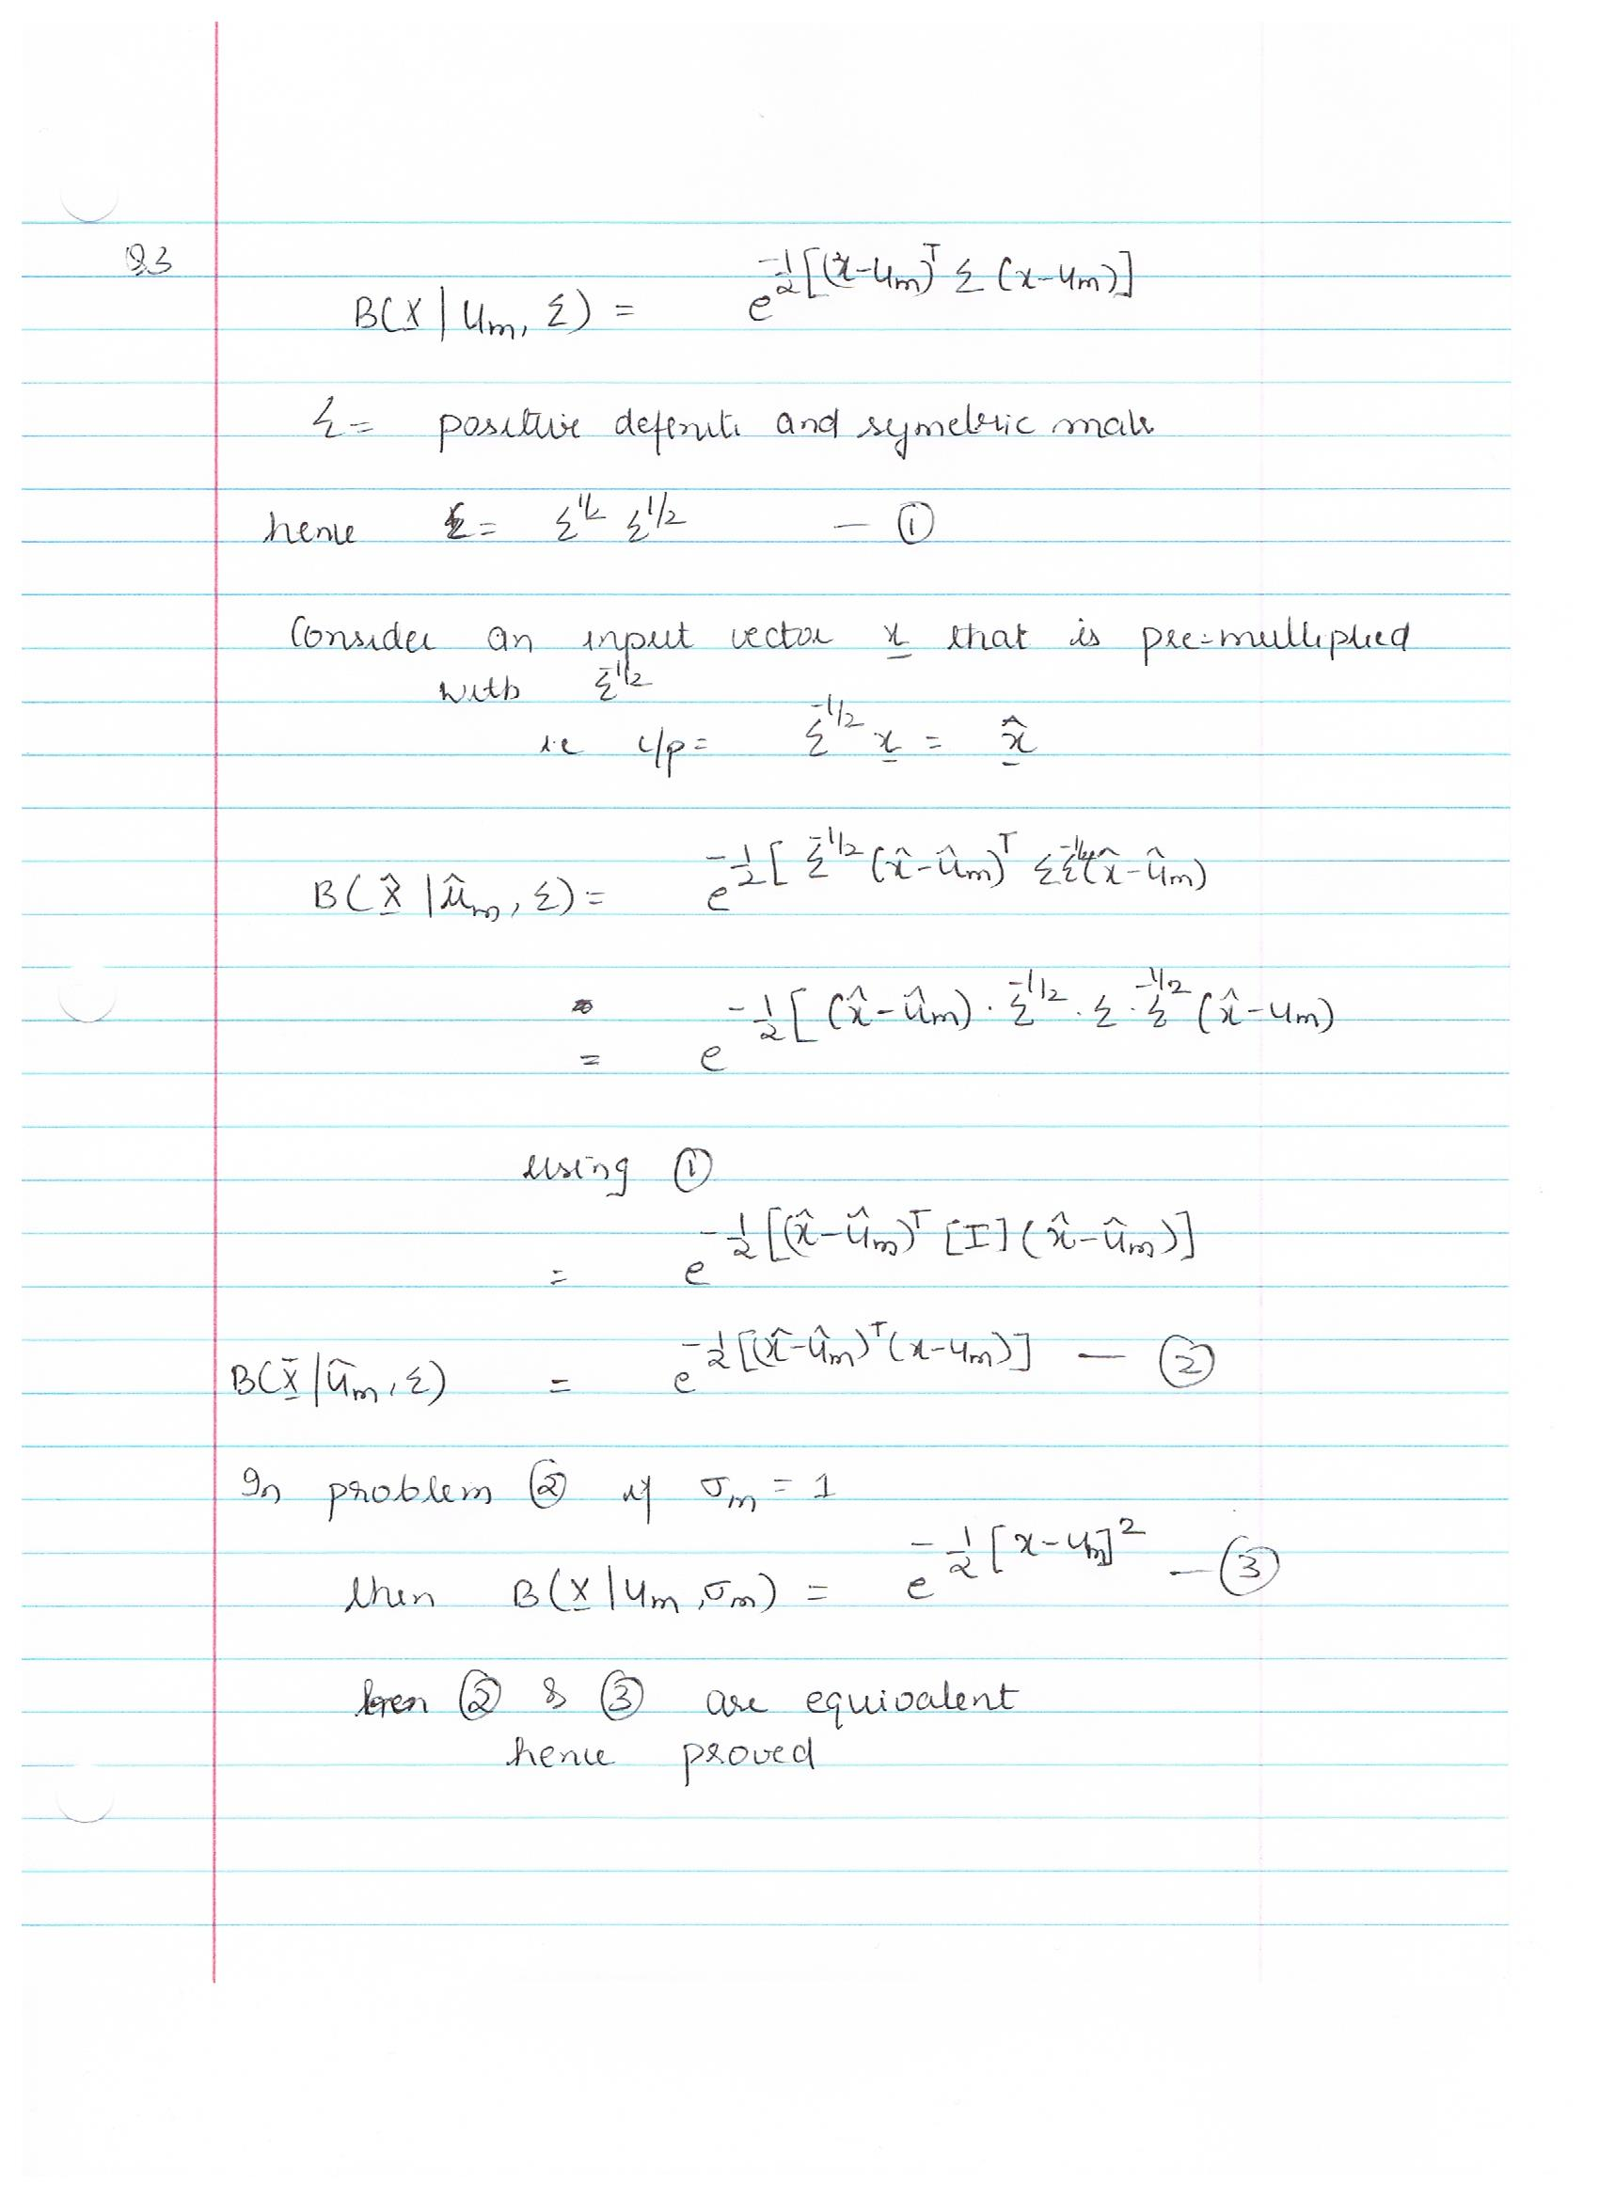

1. Q4



1. Q5.
   * 5a.

library(nnet)  
  
inspam=read.csv("Spam_Train.txt")  
spname<-c ("make", "address", "all", "3d", "our", "over", "remove",  
 "internet","order", "mail", "receive", "will",  
 "people", "report", "addresses","free", "business",  
 "email", "you", "credit", "your", "font","000","money",  
 "hp", "hpl", "george", "650", "lab", "labs",  
 "telnet", "857", "data", "415", "85", "technology", "1999",  
 "parts","pm", "direct", "cs", "meeting", "original", "project",  
 "re","edu", "table", "conference", ";", "(", "[", "!", "$", "#",  
 "CAPAVE", "CAPMAX", "CAPTOT","type")  
colnames(inspam)=spname  
x=inspam  
colnames(x)=spname  
x$type=as.factor(inspam$type)  
x[,1:57]=scale(x[,1:57], center=TRUE, scale=TRUE)  
x=data.frame(x)  
colnames(x)=spname  
  
  
inspamtest=read.csv("Spam.Test.txt")  
colnames(inspamtest)=spname  
w=inspamtest  
colnames(w)=spname  
w$type=as.factor(as.factor(inspamtest$type))  
w[,1:57]=scale(w[,1:57],center=TRUE, scale=TRUE)  
w=data.frame(w)  
colnames(w)=spname  
w.type=w$type  
  
#Find the size with minimum error  
set.seed(1)  
for(i in 1:10){   
 nn1=nnet(type~.,data=x, size=i, maxit=5000, decay=0.0, rang=0.5, trace=F)  
 nn1.predict=predict(nn1, newdata = w,type="class")   
 nn1.out=nn1.predict  
 u=matrix(data=0,2,2)  
 u=table(nn1.out, w.type)  
 err=sum(nn1.out!=w.type)/(length(nn1.out))  
 print(paste0("# of hidden nodes = ",i," and error = ", err))  
}

## [1] "# of hidden nodes = 1 and error = 0.0730593607305936"  
## [1] "# of hidden nodes = 2 and error = 0.0743639921722113"  
## [1] "# of hidden nodes = 3 and error = 0.0652315720808871"  
## [1] "# of hidden nodes = 4 and error = 0.060665362035225"  
## [1] "# of hidden nodes = 5 and error = 0.0639269406392694"  
## [1] "# of hidden nodes = 6 and error = 0.0574037834311807"  
## [1] "# of hidden nodes = 7 and error = 0.0600130463144162"  
## [1] "# of hidden nodes = 8 and error = 0.0547945205479452"  
## [1] "# of hidden nodes = 9 and error = 0.0678408349641226"  
## [1] "# of hidden nodes = 10 and error = 0.108936725375082"

print(paste0("Minimum Error is with # of hidden nodes = ", 8))

## [1] "Minimum Error is with # of hidden nodes = 8"

+ By using a # of hidden nodes as 8, we get overall error rate ~4-5%

* 5b.

set.seed(1)  
res=matrix(NA, length(nn1.out),11)  
ii=1;  
for(j in seq(0,1,0.1)){   
 nn1=nnet(type~.,data=x, size=8, maxit=5000, decay=j, rang=-0.5, trace=F)  
 nn1.predict=predict(nn1, newdata = w[,1:57],type="class")   
 nn1.out=nn1.predict  
 res[,ii]=nn1.out  
 ii=ii+1;  
 err=sum(nn1.out!=w.type)/(length(nn1.out))  
 print(paste0("Decay = ",j," and error = ", err))  
}

## [1] "Decay = 0 and error = 0.065883887801696"  
## [1] "Decay = 0.1 and error = 0.0482713633398565"  
## [1] "Decay = 0.2 and error = 0.0547945205479452"  
## [1] "Decay = 0.3 and error = 0.0430528375733855"  
## [1] "Decay = 0.4 and error = 0.0437051532941944"  
## [1] "Decay = 0.5 and error = 0.0476190476190476"  
## [1] "Decay = 0.6 and error = 0.0521852576647097"  
## [1] "Decay = 0.7 and error = 0.0476190476190476"  
## [1] "Decay = 0.8 and error = 0.0528375733855186"  
## [1] "Decay = 0.9 and error = 0.0476190476190476"  
## [1] "Decay = 1 and error = 0.0547945205479452"

print(paste0("Minimum Error is with value of decay as = ", 0.6))

## [1] "Minimum Error is with value of decay as = 0.6"

nn1=nnet(type~.,data=x, size=8, maxit=5000, decay=0.6, rang=-0.5, trace=F)  
nn1.best=predict(nn1, newdata = w[,1:57],type="class")   
  
#Finding the class through majority vote:  
vote=rep(NA,length(nn1.out))  
for (i in 1:length(nn1.out)){  
 if(sum(res[i,]==1)>sum(res[i,]==0))  
 {vote[i]=1}  
 else{  
 vote[i]=0  
 }  
}  
  
#Calcualte error  
err=sum(vote!=w.type)/(length(nn1.out))  
print(paste0("Error using the majority of votes is ", err))

## [1] "Error using the majority of votes is 0.0430528375733855"

+ Best Model:  
 + Decay: 0.6  
 + Number of hidden units: 8  
 + Error:~3-4%  
   
   
 + By using an ensemble, where we find majority of votes for a class, the error is about 4%

* 5c.

set.seed(1)  
for(k in seq(0,1,0.1)){   
 nn1=nnet(type~.,data=x, size=8, maxit=5000, decay=0.6, trace=F)  
 nn1.predict=predict(nn1, newdata = w,type="raw")   
 nn1.out=rep(0,length(nn1.predict))  
 nn1.out[nn1.predict>k]=1  
 u=matrix(data=0,2,2)  
 u=table(w.type,nn1.out)  
   
 print(paste0("Threshold= ", k , " Proportion of good mails misclassified is: ", u[3][1]/(u[1][1]+u[3][1]) ))  
}

## [1] "Threshold= 0 Proportion of good mails misclassified is: 0.998908296943231"  
## [1] "Threshold= 0.1 Proportion of good mails misclassified is: 0.140829694323144"  
## [1] "Threshold= 0.2 Proportion of good mails misclassified is: 0.0927947598253275"  
## [1] "Threshold= 0.3 Proportion of good mails misclassified is: 0.0676855895196507"  
## [1] "Threshold= 0.4 Proportion of good mails misclassified is: 0.0524017467248908"  
## [1] "Threshold= 0.5 Proportion of good mails misclassified is: 0.0305676855895196"  
## [1] "Threshold= 0.6 Proportion of good mails misclassified is: 0.0316593886462882"  
## [1] "Threshold= 0.7 Proportion of good mails misclassified is: 0.0196506550218341"  
## [1] "Threshold= 0.8 Proportion of good mails misclassified is: 0.0163755458515284"  
## [1] "Threshold= 0.9 Proportion of good mails misclassified is: 0.00655021834061135"  
## [1] "Threshold= 1 Proportion of good mails misclassified is: NA"

+ By using a Threshold of 90% of classifiying an email as spam, we can get misclassification of good email as spam down to <1% error rate.