HW 8

Anish Mohan

December 2, 2015

For the ALS project, I did the following steps:

1. Get the training features and replace the missing entries with median values.
2. Use Lasso with Cross validation to get the the lambda that gives the minimum RMSE.
3. Get the data for the leaderboard and replace the missing entries with median values.
4. Predict the ALFRS_Slope value, using the parameters from lasso and the best lambda.

# Code:

#Getting the training features and target  
  
#Get the input target or Y i.e the response variable  
train_targ<-read.csv("training_target.csv")  
print(paste0("Number of patients: ", nrow(train_targ)))

## [1] "Number of patients: 2424"

#get the input features or X  
train_feat<-read.csv("training_features.csv")  
print(paste0("Number of features: ", ncol(train_feat)))

## [1] "Number of features: 858"

#summary of training target  
summary(train_targ["ALSFRS_slope"])

## ALSFRS_slope   
## Min. :-4.3452   
## 1st Qu.:-1.0863   
## Median :-0.6207   
## Mean :-0.7308   
## 3rd Qu.:-0.2742   
## Max. : 1.2070

#function to count the number of empty entries in an inputx  
numnas<-function(x){  
 sum_na<-0  
 for (n in x){  
 if(is.na(n)==T)  
 sum_na=sum_na+1  
 }  
 return(sum_na)  
}  
  
#Running the function on training features gives us the number of entries in a column that are empty.  
num_nas_col=apply(train_feat,2,numnas)  
  
#Function to get columns with a greater number than 'a' empty entries  
for( i in names(num_nas_col)){  
 if(num_nas_col[i]<500){  
 #print(i)  
 }  
}  
  
#Missing data points are problem, creat an alternative data set with all missing values  
# filled with median  
  
feature.names<-names(train_feat)  
temp=train_feat  
  
for(feature.name in feature.names[-1]){  
 dummy_name<-paste0("is.na.",feature.name)  
 is.na.feature <-is.na(temp[,feature.name])  
 temp[,dummy_name]<-as.integer(is.na.feature)  
 temp[is.na.feature,feature.name]<-median(temp[,feature.name], na.rm=TRUE)  
}  
  
train_feat_median=temp[1:2424,1:858]  
df.median=data.frame(ALFRS_slope=train_targ$ALSFRS_slope, train_feat_median)  
  
  
set.seed(1)  
train=sample(1:nrow(df.median),2000)  
test=-train  
  
df.median.test=df.median[test,]  
df.median.train=df.median[train,]  
  
  
library(glmnet)

## Loading required package: Matrix  
## Loading required package: foreach  
## Loaded glmnet 2.0-2

x=model.matrix(df.median.train$ALFRS_slope~.,df.median.train)[,-1]  
y=df.median.train$ALFRS_slope  
  
grid=10^seq(10,-2,length=100)  
lasso.mod=glmnet(x,y, alpha=1, lambda=grid)  
  
plot(lasso.mod)

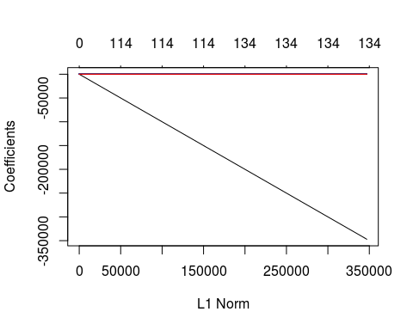

#using cross validation  
set.seed(1)  
cv.out=cv.glmnet(x,y,alpha=1,lambda=grid)  
plot(cv.out)

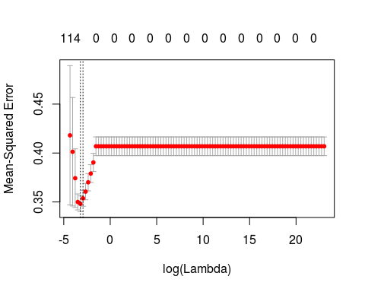

bestlam=cv.out$lambda.min  
  
  
df.test.x=model.matrix(df.median.test$ALFRS_slope~.,df.median.test)[,-1]  
df.test.y=df.median.test$ALFRS_slope  
  
lasso.pred=predict(lasso.mod,s=bestlam,newx=df.test.x)  
mean((lasso.pred-df.test.y)^2)

## [1] 0.273334

#Preparing for leaderboard predictions:  
lb_feat<-read.csv("leaderboard_features.csv")  
leaderboard.predictions <- read.csv("leaderboard_predictions-example.csv")  
  
num_nas_col=apply(lb_feat,2,numnas)  
  
feature.names<-names(lb_feat)  
temp=lb_feat  
  
for(feature.name in feature.names[-1]){  
 dummy_name<-paste0("is.na.",feature.name)  
 is.na.feature <-is.na(temp[,feature.name])  
 temp[,dummy_name]<-as.integer(is.na.feature)  
 ifelse (is.na(median(temp[,feature.name]))==F, temp[is.na.feature,feature.name]<-median(temp[,feature.name], na.rm=TRUE),temp[is.na.feature,feature.name]<-0)  
   
   
}  
  
lb_feat_median=temp[1:187,1:858]  
  
lb.median=data.frame(ALFRS_slope=leaderboard.predictions$ALSFRS_slope, lb_feat_median)  
  
lb.x=model.matrix(lb.median$ALFRS_slope~.,lb.median)[,-1]  
lb.y=lb.median$ALFRS_slope  
  
lasso.pred=predict(lasso.mod,s=bestlam,newx=lb.x)  
leaderboard.predictions$ALSFRS_slope=lasso.pred  
write.csv(leaderboard.predictions, file = "leaderboard_predictions.csv",row.names=FALSE)