HW2

Anish mohan

September 29, 2015

# Q1

* 1a. Proof 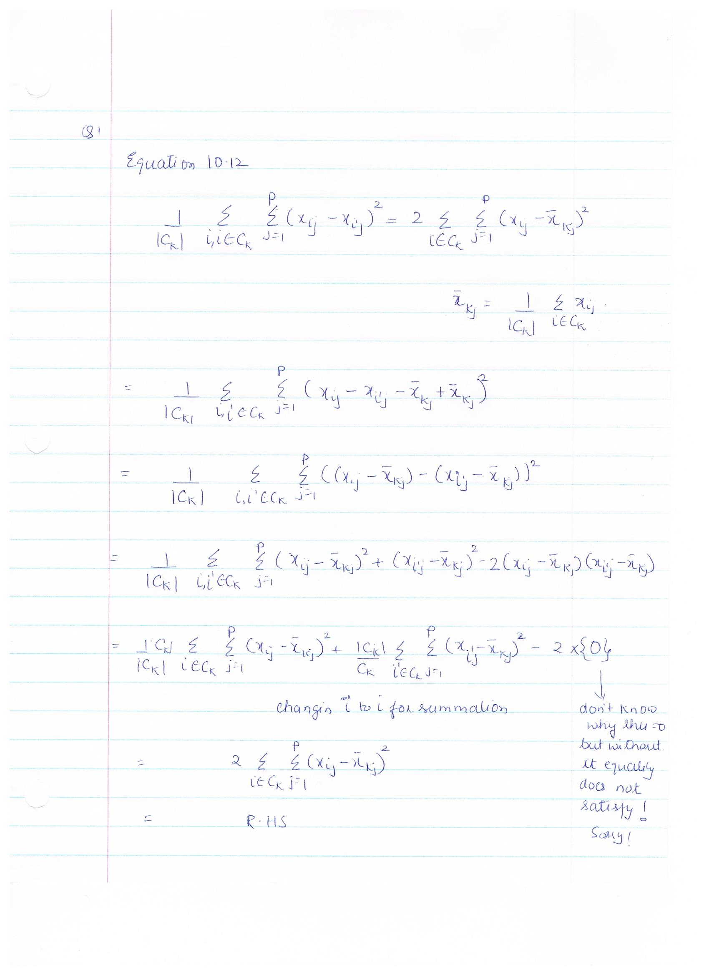
* 1b. As proved, the objective function is equivalent to finding the sum of distances of the point from the centroid of the cluster. Now, during each iteration each point is assigned to the closest centroid, hence in each iteration the cluster of points in a class are getting closer to the centroid of the class (obtained by current set of points of class). The process continues in each iteration and we continue to reduce the distance between points that belong to the same class.

# Q2:

* 2a. 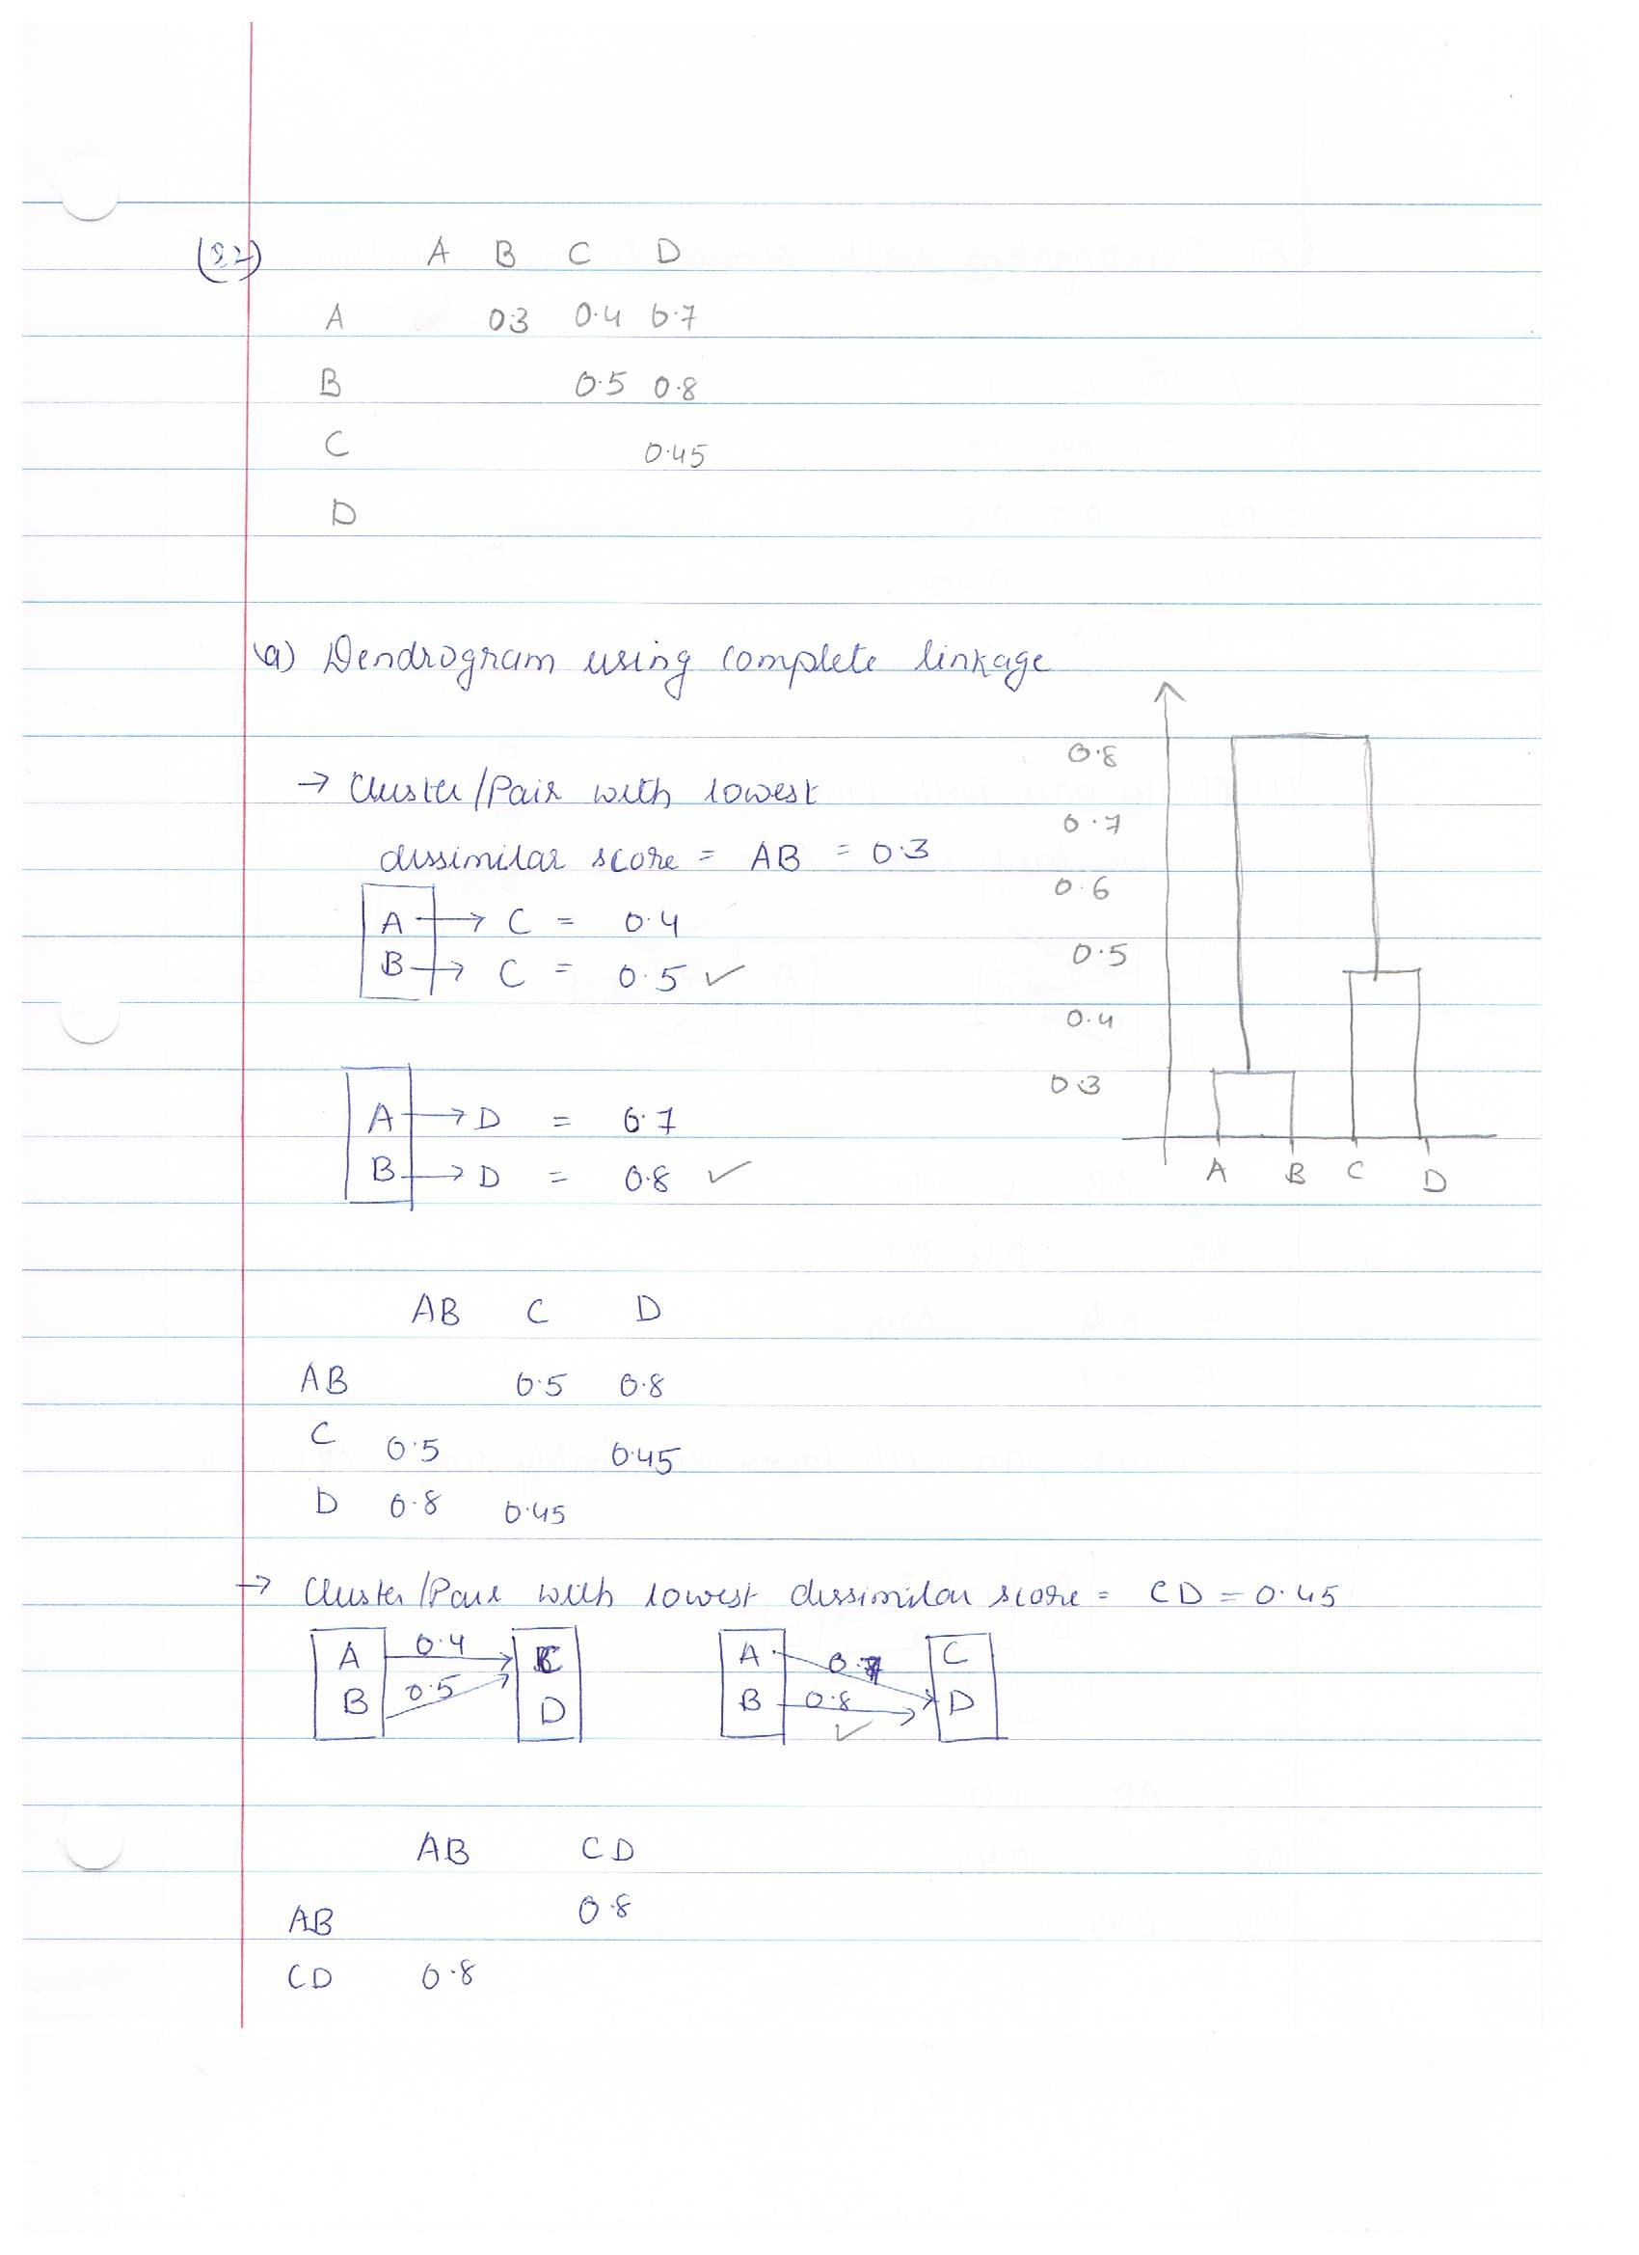
* 2b. 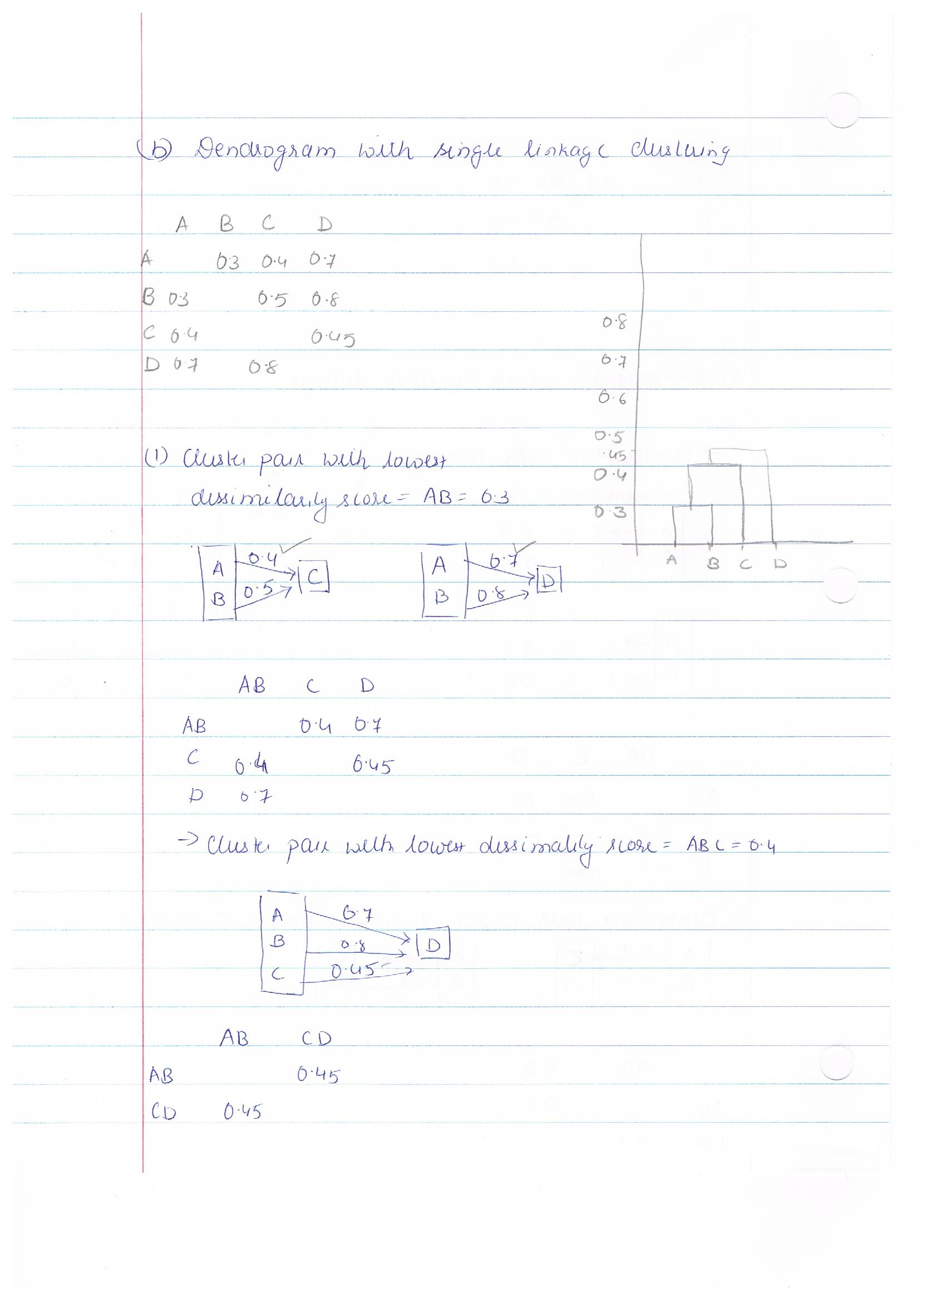
* 2c. AB and CD are the two clusters
* 2d. ABC and D are the two clusters
* 2e. 

# Q3

* 3a.

Arrests_Data=USArrests  
HC_Arrests_Complete=hclust(dist(Arrests_Data),method="complete")  
plot(HC_Arrests_Complete, main ="US Arrests-Complete Linkage",xlab="States", sub=" ",cex=0.9)

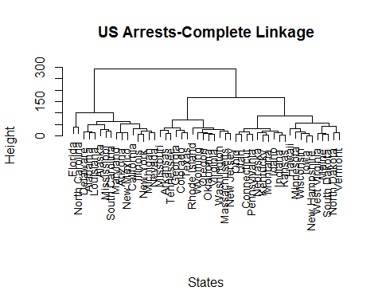

* 3b.

cutree(HC_Arrests_Complete,3)

## Alabama Alaska Arizona Arkansas California   
## 1 1 1 2 1   
## Colorado Connecticut Delaware Florida Georgia   
## 2 3 1 1 2   
## Hawaii Idaho Illinois Indiana Iowa   
## 3 3 1 3 3   
## Kansas Kentucky Louisiana Maine Maryland   
## 3 3 1 3 1   
## Massachusetts Michigan Minnesota Mississippi Missouri   
## 2 1 3 1 2   
## Montana Nebraska Nevada New Hampshire New Jersey   
## 3 3 1 3 2   
## New Mexico New York North Carolina North Dakota Ohio   
## 1 1 1 3 3   
## Oklahoma Oregon Pennsylvania Rhode Island South Carolina   
## 2 2 3 2 1   
## South Dakota Tennessee Texas Utah Vermont   
## 3 2 2 3 3   
## Virginia Washington West Virginia Wisconsin Wyoming   
## 2 2 3 3 2

* 3c.

Arrests_Data_Scaled=scale(Arrests_Data,scale=TRUE)  
HC_ScaledArrests_Complete=hclust(dist(Arrests_Data_Scaled),method="complete")  
plot(HC_ScaledArrests_Complete, main ="US Scaled Arrests-Complete Linkage",xlab="States", sub="",cex=0.9)

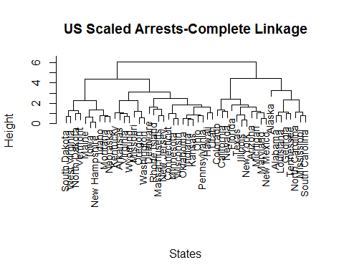

* 3d. Scaling the variables has the clustering of the states and the clustering after states is different before and after scaling. For e.g Arizon and Arkansas have moved to different clusters after scaling.
* Scaling should be done before creating the distance/dissimilarity matrix and some variables/features have higher values e.g Assault, that overwhelms the results from variables/feature with lower values/range e.g Murder in the USArrests Data.

# Q4

* 4a. Theoretically, it is possible to have the linear regression and cubic regression to have the same or similar RSS if the true relationship is linear. The regression model for cubic (when the underlying model is linear) should give us $β_{2}$ and $β_{3}$ == 0. However, since the the training data would contain noise and a cubic model would be more prone to fitting the noise, the RSS value is expected to be lower than that for linear regression model.
* 4b. Test data will contain noise and the cubic model will be more prone to noise. The cubic model being more flexible will fit to the noise in the data and will have higher residual error than linear model with real datasets.
* 4c. If the true relationship is not linear then the accuracy of the model will depend upon the noise in the data and the amount of non-linearity.
* In general, a cubic regression model (flexible) would perform better than a linear regression model when the underlying function is non-linear. RSS error on training data should be lower with the cubic regression model.
* Linear regression model introduces bias when used for non-linear true function hence can result in more errors.
* Noise in the data can impact the results we get from a cubic model. Noisy data can cause the variance to be high and impact the results from a cubic model as the model is flexible and prone to overfitting to noise.
* 4d. Same as above. In general, it is difficult to give an estimation of errors without knowing the true function, however for most scenarios (with low noise) cubic model should perform better with test data if the underlying model is non linear.

# Q5

* 5a.
* library(MASS)  
   library(ISLR)
* ## Warning: package 'ISLR' was built under R version 3.2.2
* autodat=Auto  
  pairs(autodat)
* 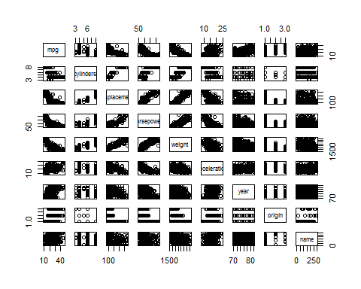
* 5b.
* cor(autodat[,1:8])
* ## mpg cylinders displacement horsepower weight  
  ## mpg 1.0000000 -0.7776175 -0.8051269 -0.7784268 -0.8322442  
  ## cylinders -0.7776175 1.0000000 0.9508233 0.8429834 0.8975273  
  ## displacement -0.8051269 0.9508233 1.0000000 0.8972570 0.9329944  
  ## horsepower -0.7784268 0.8429834 0.8972570 1.0000000 0.8645377  
  ## weight -0.8322442 0.8975273 0.9329944 0.8645377 1.0000000  
  ## acceleration 0.4233285 -0.5046834 -0.5438005 -0.6891955 -0.4168392  
  ## year 0.5805410 -0.3456474 -0.3698552 -0.4163615 -0.3091199  
  ## origin 0.5652088 -0.5689316 -0.6145351 -0.4551715 -0.5850054  
  ## acceleration year origin  
  ## mpg 0.4233285 0.5805410 0.5652088  
  ## cylinders -0.5046834 -0.3456474 -0.5689316  
  ## displacement -0.5438005 -0.3698552 -0.6145351  
  ## horsepower -0.6891955 -0.4163615 -0.4551715  
  ## weight -0.4168392 -0.3091199 -0.5850054  
  ## acceleration 1.0000000 0.2903161 0.2127458  
  ## year 0.2903161 1.0000000 0.1815277  
  ## origin 0.2127458 0.1815277 1.0000000
* 5c.
* attach(autodat)  
  autolm=lm(mpg~cylinders+displacement+horsepower+weight+acceleration+year+origin)  
  summary(autolm)
* ##   
  ## Call:  
  ## lm(formula = mpg ~ cylinders + displacement + horsepower + weight +   
  ## acceleration + year + origin)  
  ##   
  ## Residuals:  
  ## Min 1Q Median 3Q Max   
  ## -9.5903 -2.1565 -0.1169 1.8690 13.0604   
  ##   
  ## Coefficients:  
  ## Estimate Std. Error t value Pr(>|t|)   
  ## (Intercept) -17.218435 4.644294 -3.707 0.00024 ***  
  ## cylinders -0.493376 0.323282 -1.526 0.12780   
  ## displacement 0.019896 0.007515 2.647 0.00844 **   
  ## horsepower -0.016951 0.013787 -1.230 0.21963   
  ## weight -0.006474 0.000652 -9.929 < 2e-16 ***  
  ## acceleration 0.080576 0.098845 0.815 0.41548   
  ## year 0.750773 0.050973 14.729 < 2e-16 ***  
  ## origin 1.426141 0.278136 5.127 4.67e-07 ***  
  ## ---  
  ## Signif. codes: 0 '***' 0.001 '**' 0.01 '*' 0.05 '.' 0.1 ' ' 1  
  ##   
  ## Residual standard error: 3.328 on 384 degrees of freedom  
  ## Multiple R-squared: 0.8215, Adjusted R-squared: 0.8182   
  ## F-statistic: 252.4 on 7 and 384 DF, p-value: < 2.2e-16
  + 1. Yes there is relationship between some of the predictors and the response (mpg) as can be seen from the graph. Example, there is a correlation between mpg and displacement, mpg and horsepower, mpg and weight etc.
    2. From the summary table, Year, Weight,Origin seem to have statistically significant (p<0.001) relationship to MPG.
    3. Coefficient for the year variable is 0.75, hence it suggest that given specific values for other predictors,  
       every year the MPG increases by 0.75 unit
* 5d.
* par(mfrow=c(2,2))  
  plot(autolm)
* 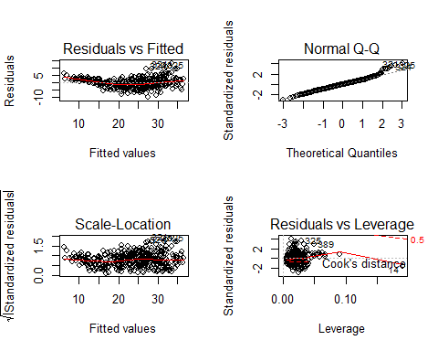
  + The Residuals vs Fitted plot shows a trend line and the shape of the trend line suggests non-linearity in the data.
  + Some points #321,#324 in Residuals vs Fitted graph, have higher residual values and they potentially could be the outliers.
  + Point #14 in Residuals vs Leverage Graph, has high leverage.

# Q6

* 6a. Equation: $y=2+2*x_{1}+0.3*x_{2}$
$β_{0}=2,$ $β_{1}=2,$ $β_{2}=0.3$

* 6b.

set.seed(1)  
 x1=runif(100)  
 x2=0.5*x1+rnorm(100)/10  
 y=2+2*x1+0.3*x2+rnorm(100)  
 cor(x1,x2)

## [1] 0.8351212

plot(x2,x2)

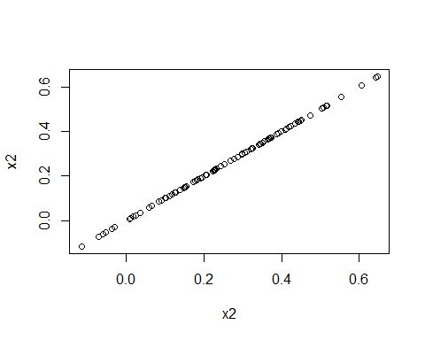

* 6c.

ylm=lm(y~x1+x2)  
 summary(ylm)

##   
## Call:  
## lm(formula = y ~ x1 + x2)  
##   
## Residuals:  
## Min 1Q Median 3Q Max   
## -2.8311 -0.7273 -0.0537 0.6338 2.3359   
##   
## Coefficients:  
## Estimate Std. Error t value Pr(>|t|)   
## (Intercept) 2.1305 0.2319 9.188 7.61e-15 ***  
## x1 1.4396 0.7212 1.996 0.0487 *   
## x2 1.0097 1.1337 0.891 0.3754   
## ---  
## Signif. codes: 0 '***' 0.001 '**' 0.01 '*' 0.05 '.' 0.1 ' ' 1  
##   
## Residual standard error: 1.056 on 97 degrees of freedom  
## Multiple R-squared: 0.2088, Adjusted R-squared: 0.1925   
## F-statistic: 12.8 on 2 and 97 DF, p-value: 1.164e-05

* $\hat{β_{0}}=2.13$ $\hat{β_{0}}$ is a good estimator of $β_{0}$ as the t-value is high and low p-value.
* $\hat{β_{1}}=1.4396$ $\hat{β_{1}}$ provides reasonable estimate of $β_{1}$ and gets close enough. This indicated by comparitively a t-statistic that is not very high and p-value that is near the cut-off of 0.05.
* $\hat{β_{2}}=1.0097$ $\hat{β_{1}}$ is a poor estimator of $β_{1}$. t-statistic is fairly low and p-value is high
* Yes, $H_{0}:β_{1}=0$ can be rejected as p-value =0.04 is below the cut-off of 0.05 or 5%
* No, $H_{0}:β_{2}=0$ cannot be rejected as p-value =0.375 is above the cut-off of 0.05 or 5%
* 6d.

y2lm=lm(y~x1)  
 summary(y2lm)

##   
## Call:  
## lm(formula = y ~ x1)  
##   
## Residuals:  
## Min 1Q Median 3Q Max   
## -2.89495 -0.66874 -0.07785 0.59221 2.45560   
##   
## Coefficients:  
## Estimate Std. Error t value Pr(>|t|)   
## (Intercept) 2.1124 0.2307 9.155 8.27e-15 ***  
## x1 1.9759 0.3963 4.986 2.66e-06 ***  
## ---  
## Signif. codes: 0 '***' 0.001 '**' 0.01 '*' 0.05 '.' 0.1 ' ' 1  
##   
## Residual standard error: 1.055 on 98 degrees of freedom  
## Multiple R-squared: 0.2024, Adjusted R-squared: 0.1942   
## F-statistic: 24.86 on 1 and 98 DF, p-value: 2.661e-06

+ Yes, $H_{0}: \beta_{1} =0$ can be rejected as p-value well below 0.001

* 6e.

y3lm=lm(y~x2)  
 summary(y3lm)

##   
## Call:  
## lm(formula = y ~ x2)  
##   
## Residuals:  
## Min 1Q Median 3Q Max   
## -2.62687 -0.75156 -0.03598 0.72383 2.44890   
##   
## Coefficients:  
## Estimate Std. Error t value Pr(>|t|)   
## (Intercept) 2.3899 0.1949 12.26 < 2e-16 ***  
## x2 2.8996 0.6330 4.58 1.37e-05 ***  
## ---  
## Signif. codes: 0 '***' 0.001 '**' 0.01 '*' 0.05 '.' 0.1 ' ' 1  
##   
## Residual standard error: 1.072 on 98 degrees of freedom  
## Multiple R-squared: 0.1763, Adjusted R-squared: 0.1679   
## F-statistic: 20.98 on 1 and 98 DF, p-value: 1.366e-05

+ Yes, $H_{0}: \beta_{2} =0$ can be rejected as p-value well below 0.001

* 6f. No, the results do not contradict each other. Both $x_{1}$ and $x_{2}$ individually are good predictors of y. That is shown by 6d and 6e. However, $x_{1}$ and $x_{2}$ are highly correlated. Hence once $β_{1}$ provided appropirate weighting to $x_{1}$, adding $x_{2}$ does not introduce any additional information for better fit of y.
* 6g.

x1=c(x1, 0.1)  
 x2=c(x2, 0.8)  
 y=c(y, 6)  
   
 y5lm=lm(y~x1+x2)  
 summary(y5lm)

##   
## Call:  
## lm(formula = y ~ x1 + x2)  
##   
## Residuals:  
## Min 1Q Median 3Q Max   
## -2.73348 -0.69318 -0.05263 0.66385 2.30619   
##   
## Coefficients:  
## Estimate Std. Error t value Pr(>|t|)   
## (Intercept) 2.2267 0.2314 9.624 7.91e-16 ***  
## x1 0.5394 0.5922 0.911 0.36458   
## x2 2.5146 0.8977 2.801 0.00614 **   
## ---  
## Signif. codes: 0 '***' 0.001 '**' 0.01 '*' 0.05 '.' 0.1 ' ' 1  
##   
## Residual standard error: 1.075 on 98 degrees of freedom  
## Multiple R-squared: 0.2188, Adjusted R-squared: 0.2029   
## F-statistic: 13.72 on 2 and 98 DF, p-value: 5.564e-06

par(mfrow=c(2,2))  
 plot(y5lm)

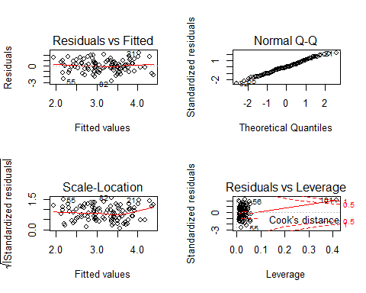

+ $\hat{\beta_{0}}=2.23$   
 $\hat{\beta_{0}}$ is a good estimator of $\beta_{0}$ as the t-value is high and low p-value.  
  
+ $\hat{\beta_{1}}=0.54$   
 $\hat{\beta_{1}}$ s a poor estimator of $\beta_{1}$. t-statistic is fairly low and p-value is high  
  
+ $\hat{\beta_{2}}=2.51$  
 $\hat{\beta_{1}}$ is not a good estimator of $\beta_{1}$. t-statistic is low and p value is just above the threshold   
 of 5%  
  
+ Yes, $H_{0}: \beta_{1} =0$ cannot be rejected as p-value is above the cut-off of 0.05 or 5%  
  
+ No, $H_{0}: \beta_{2} =0$ cannot be rejected as p-value is above the cut-off of 0.05 or 5%  
  
+ The new obeservation caused significant change in the estimates of $\beta_{1}$ and $\beta_{2}$. This is primarily   
 because the new observation in $x_{2}$ is a high leverage point.

y6lm=lm(y~x1)  
 summary(y6lm)

##   
## Call:  
## lm(formula = y ~ x1)  
##   
## Residuals:  
## Min 1Q Median 3Q Max   
## -2.8897 -0.6556 -0.0909 0.5682 3.5665   
##   
## Coefficients:  
## Estimate Std. Error t value Pr(>|t|)   
## (Intercept) 2.2569 0.2390 9.445 1.78e-15 ***  
## x1 1.7657 0.4124 4.282 4.29e-05 ***  
## ---  
## Signif. codes: 0 '***' 0.001 '**' 0.01 '*' 0.05 '.' 0.1 ' ' 1  
##   
## Residual standard error: 1.111 on 99 degrees of freedom  
## Multiple R-squared: 0.1562, Adjusted R-squared: 0.1477   
## F-statistic: 18.33 on 1 and 99 DF, p-value: 4.295e-05

par(mfrow=c(2,2))  
 plot(y6lm)

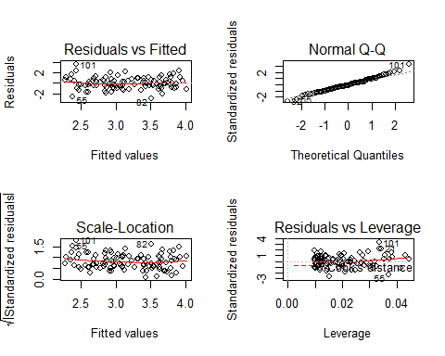

+ Yes, $H_{0}: \beta_{1} =0$ can be rejected as p-value well below 0.001  
  
+ The new observation in $x_{1}$ has not significantly impacted results.

y7lm=lm(y~x2)  
 summary(y7lm)

##   
## Call:  
## lm(formula = y ~ x2)  
##   
## Residuals:  
## Min 1Q Median 3Q Max   
## -2.64729 -0.71021 -0.06899 0.72699 2.38074   
##   
## Coefficients:  
## Estimate Std. Error t value Pr(>|t|)   
## (Intercept) 2.3451 0.1912 12.264 < 2e-16 ***  
## x2 3.1190 0.6040 5.164 1.25e-06 ***  
## ---  
## Signif. codes: 0 '***' 0.001 '**' 0.01 '*' 0.05 '.' 0.1 ' ' 1  
##   
## Residual standard error: 1.074 on 99 degrees of freedom  
## Multiple R-squared: 0.2122, Adjusted R-squared: 0.2042   
## F-statistic: 26.66 on 1 and 99 DF, p-value: 1.253e-06

par(mfrow=c(2,2))  
 plot(y7lm)

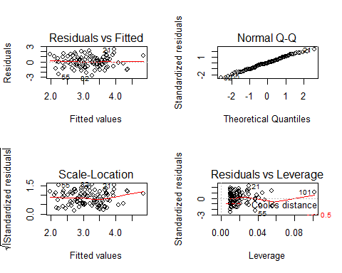

+ Yes, $H_{0}: \beta_{2} =0$ can be rejected as p-value well below 0.001  
+ The new observation in $x_{2}$ has had minor impact on the results but nothing very significant.  
  
  
+ The new obeservation caused significant change in the estimates of $\beta_{1}$ and $\beta_{2}$ only in the case of   
 multiple variable regression. This is primarily because the new observation in $x_{2}$ is a high leverage point.

# Q7

* 7a.
  + Plots show the predictor-response for top 3 t-values. Note that all the following variables have low p-values: Zn,Indus,Nox,Rm,Age,Dis,Rad, Tax, Ptration, Black, Lstat and Medv, but plots have been only included for the lowest 3 p-values

MA=Boston  
 MAName=names(MA)  
 attach(MA)  
 for (i in c(9,10,13)){  
 y=MA$crim  
 x=MA[,i]  
 print(paste0("Predictor=", MAName[i]))  
 print(summary(lm(y~x)))  
 plot(x,y,xlab=MAName[i],ylab="Crim")  
 }

## [1] "Predictor=rad"  
##   
## Call:  
## lm(formula = y ~ x)  
##   
## Residuals:  
## Min 1Q Median 3Q Max   
## -10.164 -1.381 -0.141 0.660 76.433   
##   
## Coefficients:  
## Estimate Std. Error t value Pr(>|t|)   
## (Intercept) -2.28716 0.44348 -5.157 3.61e-07 ***  
## x 0.61791 0.03433 17.998 < 2e-16 ***  
## ---  
## Signif. codes: 0 '***' 0.001 '**' 0.01 '*' 0.05 '.' 0.1 ' ' 1  
##   
## Residual standard error: 6.718 on 504 degrees of freedom  
## Multiple R-squared: 0.3913, Adjusted R-squared: 0.39   
## F-statistic: 323.9 on 1 and 504 DF, p-value: < 2.2e-16

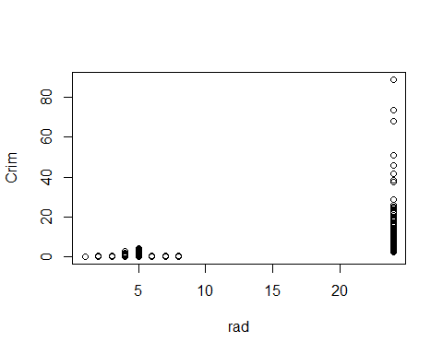

## [1] "Predictor=tax"  
##   
## Call:  
## lm(formula = y ~ x)  
##   
## Residuals:  
## Min 1Q Median 3Q Max   
## -12.513 -2.738 -0.194 1.065 77.696   
##   
## Coefficients:  
## Estimate Std. Error t value Pr(>|t|)   
## (Intercept) -8.528369 0.815809 -10.45 <2e-16 ***  
## x 0.029742 0.001847 16.10 <2e-16 ***  
## ---  
## Signif. codes: 0 '***' 0.001 '**' 0.01 '*' 0.05 '.' 0.1 ' ' 1  
##   
## Residual standard error: 6.997 on 504 degrees of freedom  
## Multiple R-squared: 0.3396, Adjusted R-squared: 0.3383   
## F-statistic: 259.2 on 1 and 504 DF, p-value: < 2.2e-16

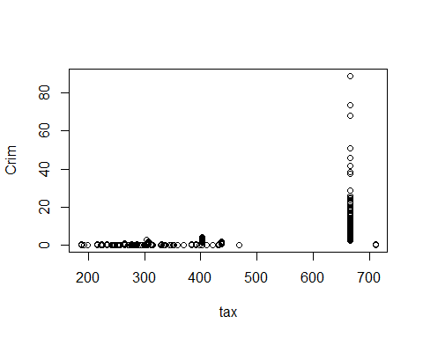

## [1] "Predictor=lstat"  
##   
## Call:  
## lm(formula = y ~ x)  
##   
## Residuals:  
## Min 1Q Median 3Q Max   
## -13.925 -2.822 -0.664 1.079 82.862   
##   
## Coefficients:  
## Estimate Std. Error t value Pr(>|t|)   
## (Intercept) -3.33054 0.69376 -4.801 2.09e-06 ***  
## x 0.54880 0.04776 11.491 < 2e-16 ***  
## ---  
## Signif. codes: 0 '***' 0.001 '**' 0.01 '*' 0.05 '.' 0.1 ' ' 1  
##   
## Residual standard error: 7.664 on 504 degrees of freedom  
## Multiple R-squared: 0.2076, Adjusted R-squared: 0.206   
## F-statistic: 132 on 1 and 504 DF, p-value: < 2.2e-16

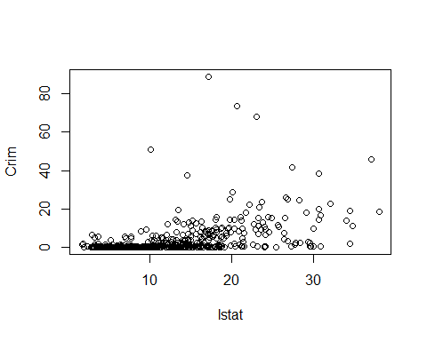

* 7b.

attach(MA)

## The following objects are masked from MA (pos = 3):  
##   
## age, black, chas, crim, dis, indus, lstat, medv, nox, ptratio,  
## rad, rm, tax, zn

MAlm=lm(crim~zn+indus+chas+nox+rm+age+dis+rad+tax+ptratio+black+lstat+medv)  
summary(MAlm)

##   
## Call:  
## lm(formula = crim ~ zn + indus + chas + nox + rm + age + dis +   
## rad + tax + ptratio + black + lstat + medv)  
##   
## Residuals:  
## Min 1Q Median 3Q Max   
## -9.924 -2.120 -0.353 1.019 75.051   
##   
## Coefficients:  
## Estimate Std. Error t value Pr(>|t|)   
## (Intercept) 17.033228 7.234903 2.354 0.018949 *   
## zn 0.044855 0.018734 2.394 0.017025 *   
## indus -0.063855 0.083407 -0.766 0.444294   
## chas -0.749134 1.180147 -0.635 0.525867   
## nox -10.313535 5.275536 -1.955 0.051152 .   
## rm 0.430131 0.612830 0.702 0.483089   
## age 0.001452 0.017925 0.081 0.935488   
## dis -0.987176 0.281817 -3.503 0.000502 ***  
## rad 0.588209 0.088049 6.680 6.46e-11 ***  
## tax -0.003780 0.005156 -0.733 0.463793   
## ptratio -0.271081 0.186450 -1.454 0.146611   
## black -0.007538 0.003673 -2.052 0.040702 *   
## lstat 0.126211 0.075725 1.667 0.096208 .   
## medv -0.198887 0.060516 -3.287 0.001087 **   
## ---  
## Signif. codes: 0 '***' 0.001 '**' 0.01 '*' 0.05 '.' 0.1 ' ' 1  
##   
## Residual standard error: 6.439 on 492 degrees of freedom  
## Multiple R-squared: 0.454, Adjusted R-squared: 0.4396   
## F-statistic: 31.47 on 13 and 492 DF, p-value: < 2.2e-16

* We can reject the Hypothesis $H_{0}:β_{j}=0$ for the following predictors because they have p-value<0.005: Dis, Rad, medv
* 7c.
  + In 7a. there were more variables with p-values<0.005: E.g Zn,Indus,Nox,Rm,Age,Dis,Rad, Tax, Ptration, Black, Lstat and Medv. However in 7b, only 3 variables (Rad, Dis, Medv) have p-values<0.005

MA_coeff=matrix(0,14,3)  
 MA_coeff[,1]=names(MA)  
 for (i in c(2:14)){  
 y=MA$crim  
 x=MA[,i]  
 templm=lm(y~x)  
 temp=summary(templm)  
 MA_coeff[i,2]=temp$coefficients[2,1]  
 }  
   
 S=summary(MAlm)  
 str(S)

## List of 11  
## $ call : language lm(formula = crim ~ zn + indus + chas + nox + rm + age + dis + rad + tax + ptratio + black + lstat + medv)  
## $ terms :Classes 'terms', 'formula' length 3 crim ~ zn + indus + chas + nox + rm + age + dis + rad + tax + ptratio + black + lstat + medv  
## .. ..- attr(*, "variables")= language list(crim, zn, indus, chas, nox, rm, age, dis, rad, tax, ptratio, black, lstat, medv)  
## .. ..- attr(*, "factors")= int [1:14, 1:13] 0 1 0 0 0 0 0 0 0 0 ...  
## .. .. ..- attr(*, "dimnames")=List of 2  
## .. .. .. ..$ : chr [1:14] "crim" "zn" "indus" "chas" ...  
## .. .. .. ..$ : chr [1:13] "zn" "indus" "chas" "nox" ...  
## .. ..- attr(*, "term.labels")= chr [1:13] "zn" "indus" "chas" "nox" ...  
## .. ..- attr(*, "order")= int [1:13] 1 1 1 1 1 1 1 1 1 1 ...  
## .. ..- attr(*, "intercept")= int 1  
## .. ..- attr(*, "response")= int 1  
## .. ..- attr(*, ".Environment")=<environment: R_GlobalEnv>   
## .. ..- attr(*, "predvars")= language list(crim, zn, indus, chas, nox, rm, age, dis, rad, tax, ptratio, black, lstat, medv)  
## .. ..- attr(*, "dataClasses")= Named chr [1:14] "numeric" "numeric" "numeric" "numeric" ...  
## .. .. ..- attr(*, "names")= chr [1:14] "crim" "zn" "indus" "chas" ...  
## $ residuals : Named num [1:506] 0.791 1.007 3.924 4.16 4.393 ...  
## ..- attr(*, "names")= chr [1:506] "1" "2" "3" "4" ...  
## $ coefficients : num [1:14, 1:4] 17.0332 0.0449 -0.0639 -0.7491 -10.3135 ...  
## ..- attr(*, "dimnames")=List of 2  
## .. ..$ : chr [1:14] "(Intercept)" "zn" "indus" "chas" ...  
## .. ..$ : chr [1:4] "Estimate" "Std. Error" "t value" "Pr(>|t|)"  
## $ aliased : Named logi [1:14] FALSE FALSE FALSE FALSE FALSE FALSE ...  
## ..- attr(*, "names")= chr [1:14] "(Intercept)" "zn" "indus" "chas" ...  
## $ sigma : num 6.44  
## $ df : int [1:3] 14 492 14  
## $ r.squared : num 0.454  
## $ adj.r.squared: num 0.44  
## $ fstatistic : Named num [1:3] 31.5 13 492  
## ..- attr(*, "names")= chr [1:3] "value" "numdf" "dendf"  
## $ cov.unscaled : num [1:14, 1:14] 1.26 4.25e-05 9.02e-04 4.16e-03 -5.22e-01 ...  
## ..- attr(*, "dimnames")=List of 2  
## .. ..$ : chr [1:14] "(Intercept)" "zn" "indus" "chas" ...  
## .. ..$ : chr [1:14] "(Intercept)" "zn" "indus" "chas" ...  
## - attr(*, "class")= chr "summary.lm"

MA_coeff[2:14,3]=S$coefficients[2:14,2]  
 plot(MA_coeff[2:14,2],MA_coeff[2:14,3],xlab="Univariate coefficients", ylab="Multivariate coefficients")

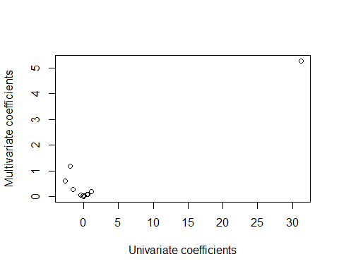

* 7d.

for (i in c(2:14)){  
 y=MA$crim  
 x=MA[,i]  
 print(paste0("Predictor=", MAName[i]))  
 print(summary(lm(y~x+I(x^2)+I(x^3))))  
 }

## [1] "Predictor=zn"  
##   
## Call:  
## lm(formula = y ~ x + I(x^2) + I(x^3))  
##   
## Residuals:  
## Min 1Q Median 3Q Max   
## -4.821 -4.614 -1.294 0.473 84.130   
##   
## Coefficients:  
## Estimate Std. Error t value Pr(>|t|)   
## (Intercept) 4.846e+00 4.330e-01 11.192 < 2e-16 ***  
## x -3.322e-01 1.098e-01 -3.025 0.00261 **   
## I(x^2) 6.483e-03 3.861e-03 1.679 0.09375 .   
## I(x^3) -3.776e-05 3.139e-05 -1.203 0.22954   
## ---  
## Signif. codes: 0 '***' 0.001 '**' 0.01 '*' 0.05 '.' 0.1 ' ' 1  
##   
## Residual standard error: 8.372 on 502 degrees of freedom  
## Multiple R-squared: 0.05824, Adjusted R-squared: 0.05261   
## F-statistic: 10.35 on 3 and 502 DF, p-value: 1.281e-06  
##   
## [1] "Predictor=indus"  
##   
## Call:  
## lm(formula = y ~ x + I(x^2) + I(x^3))  
##   
## Residuals:  
## Min 1Q Median 3Q Max   
## -8.278 -2.514 0.054 0.764 79.713   
##   
## Coefficients:  
## Estimate Std. Error t value Pr(>|t|)   
## (Intercept) 3.6625683 1.5739833 2.327 0.0204 *   
## x -1.9652129 0.4819901 -4.077 5.30e-05 ***  
## I(x^2) 0.2519373 0.0393221 6.407 3.42e-10 ***  
## I(x^3) -0.0069760 0.0009567 -7.292 1.20e-12 ***  
## ---  
## Signif. codes: 0 '***' 0.001 '**' 0.01 '*' 0.05 '.' 0.1 ' ' 1  
##   
## Residual standard error: 7.423 on 502 degrees of freedom  
## Multiple R-squared: 0.2597, Adjusted R-squared: 0.2552   
## F-statistic: 58.69 on 3 and 502 DF, p-value: < 2.2e-16  
##   
## [1] "Predictor=chas"  
##   
## Call:  
## lm(formula = y ~ x + I(x^2) + I(x^3))  
##   
## Residuals:  
## Min 1Q Median 3Q Max   
## -3.738 -3.661 -3.435 0.018 85.232   
##   
## Coefficients: (2 not defined because of singularities)  
## Estimate Std. Error t value Pr(>|t|)   
## (Intercept) 3.7444 0.3961 9.453 <2e-16 ***  
## x -1.8928 1.5061 -1.257 0.209   
## I(x^2) NA NA NA NA   
## I(x^3) NA NA NA NA   
## ---  
## Signif. codes: 0 '***' 0.001 '**' 0.01 '*' 0.05 '.' 0.1 ' ' 1  
##   
## Residual standard error: 8.597 on 504 degrees of freedom  
## Multiple R-squared: 0.003124, Adjusted R-squared: 0.001146   
## F-statistic: 1.579 on 1 and 504 DF, p-value: 0.2094  
##   
## [1] "Predictor=nox"  
##   
## Call:  
## lm(formula = y ~ x + I(x^2) + I(x^3))  
##   
## Residuals:  
## Min 1Q Median 3Q Max   
## -9.110 -2.068 -0.255 0.739 78.302   
##   
## Coefficients:  
## Estimate Std. Error t value Pr(>|t|)   
## (Intercept) 233.09 33.64 6.928 1.31e-11 ***  
## x -1279.37 170.40 -7.508 2.76e-13 ***  
## I(x^2) 2248.54 279.90 8.033 6.81e-15 ***  
## I(x^3) -1245.70 149.28 -8.345 6.96e-16 ***  
## ---  
## Signif. codes: 0 '***' 0.001 '**' 0.01 '*' 0.05 '.' 0.1 ' ' 1  
##   
## Residual standard error: 7.234 on 502 degrees of freedom  
## Multiple R-squared: 0.297, Adjusted R-squared: 0.2928   
## F-statistic: 70.69 on 3 and 502 DF, p-value: < 2.2e-16  
##   
## [1] "Predictor=rm"  
##   
## Call:  
## lm(formula = y ~ x + I(x^2) + I(x^3))  
##   
## Residuals:  
## Min 1Q Median 3Q Max   
## -18.485 -3.468 -2.221 -0.015 87.219   
##   
## Coefficients:  
## Estimate Std. Error t value Pr(>|t|)   
## (Intercept) 112.6246 64.5172 1.746 0.0815 .  
## x -39.1501 31.3115 -1.250 0.2118   
## I(x^2) 4.5509 5.0099 0.908 0.3641   
## I(x^3) -0.1745 0.2637 -0.662 0.5086   
## ---  
## Signif. codes: 0 '***' 0.001 '**' 0.01 '*' 0.05 '.' 0.1 ' ' 1  
##   
## Residual standard error: 8.33 on 502 degrees of freedom  
## Multiple R-squared: 0.06779, Adjusted R-squared: 0.06222   
## F-statistic: 12.17 on 3 and 502 DF, p-value: 1.067e-07  
##   
## [1] "Predictor=age"  
##   
## Call:  
## lm(formula = y ~ x + I(x^2) + I(x^3))  
##   
## Residuals:  
## Min 1Q Median 3Q Max   
## -9.762 -2.673 -0.516 0.019 82.842   
##   
## Coefficients:  
## Estimate Std. Error t value Pr(>|t|)   
## (Intercept) -2.549e+00 2.769e+00 -0.920 0.35780   
## x 2.737e-01 1.864e-01 1.468 0.14266   
## I(x^2) -7.230e-03 3.637e-03 -1.988 0.04738 *   
## I(x^3) 5.745e-05 2.109e-05 2.724 0.00668 **  
## ---  
## Signif. codes: 0 '***' 0.001 '**' 0.01 '*' 0.05 '.' 0.1 ' ' 1  
##   
## Residual standard error: 7.84 on 502 degrees of freedom  
## Multiple R-squared: 0.1742, Adjusted R-squared: 0.1693   
## F-statistic: 35.31 on 3 and 502 DF, p-value: < 2.2e-16  
##   
## [1] "Predictor=dis"  
##   
## Call:  
## lm(formula = y ~ x + I(x^2) + I(x^3))  
##   
## Residuals:  
## Min 1Q Median 3Q Max   
## -10.757 -2.588 0.031 1.267 76.378   
##   
## Coefficients:  
## Estimate Std. Error t value Pr(>|t|)   
## (Intercept) 30.0476 2.4459 12.285 < 2e-16 ***  
## x -15.5543 1.7360 -8.960 < 2e-16 ***  
## I(x^2) 2.4521 0.3464 7.078 4.94e-12 ***  
## I(x^3) -0.1186 0.0204 -5.814 1.09e-08 ***  
## ---  
## Signif. codes: 0 '***' 0.001 '**' 0.01 '*' 0.05 '.' 0.1 ' ' 1  
##   
## Residual standard error: 7.331 on 502 degrees of freedom  
## Multiple R-squared: 0.2778, Adjusted R-squared: 0.2735   
## F-statistic: 64.37 on 3 and 502 DF, p-value: < 2.2e-16  
##   
## [1] "Predictor=rad"  
##   
## Call:  
## lm(formula = y ~ x + I(x^2) + I(x^3))  
##   
## Residuals:  
## Min 1Q Median 3Q Max   
## -10.381 -0.412 -0.269 0.179 76.217   
##   
## Coefficients:  
## Estimate Std. Error t value Pr(>|t|)  
## (Intercept) -0.605545 2.050108 -0.295 0.768  
## x 0.512736 1.043597 0.491 0.623  
## I(x^2) -0.075177 0.148543 -0.506 0.613  
## I(x^3) 0.003209 0.004564 0.703 0.482  
##   
## Residual standard error: 6.682 on 502 degrees of freedom  
## Multiple R-squared: 0.4, Adjusted R-squared: 0.3965   
## F-statistic: 111.6 on 3 and 502 DF, p-value: < 2.2e-16  
##   
## [1] "Predictor=tax"  
##   
## Call:  
## lm(formula = y ~ x + I(x^2) + I(x^3))  
##   
## Residuals:  
## Min 1Q Median 3Q Max   
## -13.273 -1.389 0.046 0.536 76.950   
##   
## Coefficients:  
## Estimate Std. Error t value Pr(>|t|)  
## (Intercept) 1.918e+01 1.180e+01 1.626 0.105  
## x -1.533e-01 9.568e-02 -1.602 0.110  
## I(x^2) 3.608e-04 2.425e-04 1.488 0.137  
## I(x^3) -2.204e-07 1.889e-07 -1.167 0.244  
##   
## Residual standard error: 6.854 on 502 degrees of freedom  
## Multiple R-squared: 0.3689, Adjusted R-squared: 0.3651   
## F-statistic: 97.8 on 3 and 502 DF, p-value: < 2.2e-16  
##   
## [1] "Predictor=ptratio"  
##   
## Call:  
## lm(formula = y ~ x + I(x^2) + I(x^3))  
##   
## Residuals:  
## Min 1Q Median 3Q Max   
## -6.833 -4.146 -1.655 1.408 82.697   
##   
## Coefficients:  
## Estimate Std. Error t value Pr(>|t|)   
## (Intercept) 477.18405 156.79498 3.043 0.00246 **  
## x -82.36054 27.64394 -2.979 0.00303 **  
## I(x^2) 4.63535 1.60832 2.882 0.00412 **  
## I(x^3) -0.08476 0.03090 -2.743 0.00630 **  
## ---  
## Signif. codes: 0 '***' 0.001 '**' 0.01 '*' 0.05 '.' 0.1 ' ' 1  
##   
## Residual standard error: 8.122 on 502 degrees of freedom  
## Multiple R-squared: 0.1138, Adjusted R-squared: 0.1085   
## F-statistic: 21.48 on 3 and 502 DF, p-value: 4.171e-13  
##   
## [1] "Predictor=black"  
##   
## Call:  
## lm(formula = y ~ x + I(x^2) + I(x^3))  
##   
## Residuals:  
## Min 1Q Median 3Q Max   
## -13.096 -2.343 -2.128 -1.439 86.790   
##   
## Coefficients:  
## Estimate Std. Error t value Pr(>|t|)   
## (Intercept) 1.826e+01 2.305e+00 7.924 1.5e-14 ***  
## x -8.356e-02 5.633e-02 -1.483 0.139   
## I(x^2) 2.137e-04 2.984e-04 0.716 0.474   
## I(x^3) -2.652e-07 4.364e-07 -0.608 0.544   
## ---  
## Signif. codes: 0 '***' 0.001 '**' 0.01 '*' 0.05 '.' 0.1 ' ' 1  
##   
## Residual standard error: 7.955 on 502 degrees of freedom  
## Multiple R-squared: 0.1498, Adjusted R-squared: 0.1448   
## F-statistic: 29.49 on 3 and 502 DF, p-value: < 2.2e-16  
##   
## [1] "Predictor=lstat"  
##   
## Call:  
## lm(formula = y ~ x + I(x^2) + I(x^3))  
##   
## Residuals:  
## Min 1Q Median 3Q Max   
## -15.234 -2.151 -0.486 0.066 83.353   
##   
## Coefficients:  
## Estimate Std. Error t value Pr(>|t|)   
## (Intercept) 1.2009656 2.0286452 0.592 0.5541   
## x -0.4490656 0.4648911 -0.966 0.3345   
## I(x^2) 0.0557794 0.0301156 1.852 0.0646 .  
## I(x^3) -0.0008574 0.0005652 -1.517 0.1299   
## ---  
## Signif. codes: 0 '***' 0.001 '**' 0.01 '*' 0.05 '.' 0.1 ' ' 1  
##   
## Residual standard error: 7.629 on 502 degrees of freedom  
## Multiple R-squared: 0.2179, Adjusted R-squared: 0.2133   
## F-statistic: 46.63 on 3 and 502 DF, p-value: < 2.2e-16  
##   
## [1] "Predictor=medv"  
##   
## Call:  
## lm(formula = y ~ x + I(x^2) + I(x^3))  
##   
## Residuals:  
## Min 1Q Median 3Q Max   
## -24.427 -1.976 -0.437 0.439 73.655   
##   
## Coefficients:  
## Estimate Std. Error t value Pr(>|t|)   
## (Intercept) 53.1655381 3.3563105 15.840 < 2e-16 ***  
## x -5.0948305 0.4338321 -11.744 < 2e-16 ***  
## I(x^2) 0.1554965 0.0171904 9.046 < 2e-16 ***  
## I(x^3) -0.0014901 0.0002038 -7.312 1.05e-12 ***  
## ---  
## Signif. codes: 0 '***' 0.001 '**' 0.01 '*' 0.05 '.' 0.1 ' ' 1  
##   
## Residual standard error: 6.569 on 502 degrees of freedom  
## Multiple R-squared: 0.4202, Adjusted R-squared: 0.4167   
## F-statistic: 121.3 on 3 and 502 DF, p-value: < 2.2e-16

+ Analyzing the summary tables, there seems to be non-linear relationship between "Crim" and the following predictors as p-values for $\beta_{0}, \beta_{1}, \beta_{2}$ are <0.005 : Indus, Nox, Dis, Medv

# Q8

* 8_1

in_training_features=read.csv("training_features.csv")  
   
 feature.names<-names(in_training_features)  
 for(feature.name in feature.names[-1]){  
 dummy_name<-paste0("is.na.",feature.name)  
 is.na.feature <-is.na(in_training_features[,feature.name])  
 in_training_features[,dummy_name]<-as.integer(is.na.feature)  
 in_training_features[is.na.feature,feature.name]<-median(in_training_features[,feature.name], na.rm=TRUE)  
 }  
   
 newset=in_training_features[in_training_features$subject.id!=525450,]  
 newset2=newset[,c("q1_speech.slope", "q2_salivation.slope", "q3_swallowing.slope", "q4_handwriting.slope", "q5a_cutting_without_gastrostomy.slope", "q6_dressing_and_hygiene.slope", "q7_turning_in_bed.slope", "q8_walking.slope", "q9_climbing_stairs.slope")]

* 8_2

pca_set2=prcomp(newset2,scale=TRUE)  
 var_set2=pca_set2$sdev^2  
 prop_var_set2=var_set2/sum(var_set2)  
 plot(cumsum(prop_var_set2),xlab="Principal Component",ylab="Cumulative Proportion of Variance Explained", ylim=c(0,1),type='b')

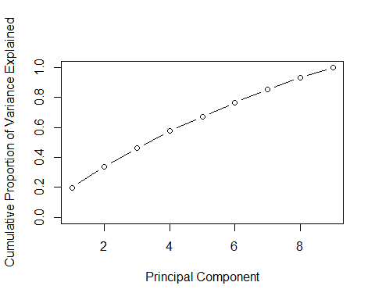

+ About 34% of the cumulative variance is captured by the top 2 Principal   
 Components

* 8_3

biplot(pca_set2, scale=0,cex=0.6)

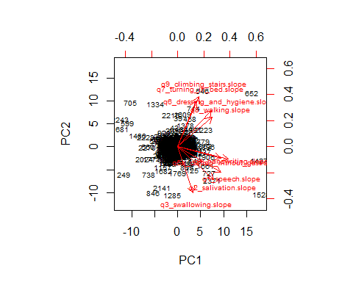

* There seems to be 2 sets of correlated vectors/dimensions:
  + Set 1: q9_climbing_stairs.slope, q7_turning_in_bed.slope, q6_dressing_and_hygiene.slope and q8_walking.slope are 1 set of correlated vectors
  + Set 2: q4_handwriting.slope,q5a_cutting_without_gastrostomy.slope,q1_speech.slope,q3_swallowing.slope and q2_salivation.slope are 2nd set of correlated vectors/dimentions.
* 8_4

newset3=in_training_features[,c("q1_speech.slope", "q2_salivation.slope", "q3_swallowing.slope", "q4_handwriting.slope", "q5a_cutting_without_gastrostomy.slope", "q6_dressing_and_hygiene.slope", "q7_turning_in_bed.slope", "q8_walking.slope", "q9_climbing_stairs.slope")]  
   
 pca_set3=prcomp(newset3,scale=TRUE)  
 var_set3=pca_set3$sdev^2  
 prop_var_set3=var_set3/sum(var_set3)  
 plot(cumsum(prop_var_set3),xlab="Principal Component (with subject ID: 525450 included)",ylab="Cumulative Proportion of Variance Explained", ylim=c(0,1),type='b')

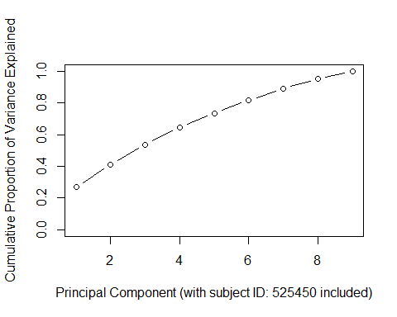

biplot(pca_set3, scale=0,cex=0.6)

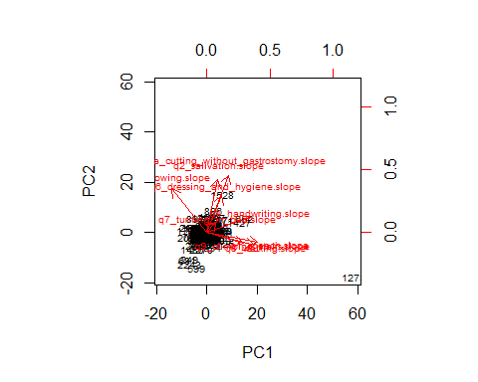

+ There is significant change in the directions or certain dimension vectors e.g q3_swallowing.slope and q_handrwriting.slope. This is because Datapoint with subject ID: 525450 adds new/extreme values to these variables. For example q3_swallowing.slope value for the above subject iD was -10.14556 where as in the previous data set the miniumum value was -3.804583. Hence the new entry significantly changed the value/direction of the vector.  
  
Similarly, the q4_handwriting.slope for subject ID: 525450 is 10.14556. This is 3 times the next maximum value in the dataset which was 3.804583. Hence adding this extreme value change the direction of the q4_handwriting.slope.

This is a good case of detecting outliers/leverage points and removing this from the data set.