HW5

Anish Mohan

November 1, 2015

# Q1

* 1a. Training RSS will start decreasing. $β_{j}$'s start increasing from 0 to s, hence the value of the training RSS will start decreasing as the $β_{j}$'s get to their correct values.
* 1b. Test RSS will decrease initially and then increase. Test RSS will decrease as $β_{j}$'s increase from 0. After a local minima that gives the best value for $β_{j}$'s the Test RSS will start increasing as the the $β_{j}$'s are determined from the training set.
* 1c. variance starts increasing $β_{j}$'s=0 has a constant low variance independent of the data. Variance starts increasing as the s increases from 0.
* 1d. bias starts decreasing $β_{j}$'s=0 has the highest bias as the model predicts a constant value. As s increases from 0, the bias will start decreasing.
* 1e. Irreducible error remains steady Irreducible by error cannot be determined and continues to stay steady.

# Q2

+ 2a. Training RSS will start increasing   
With $\lambda$=0, the solution is what get from oridinary least squares that minimize the training MSE. As $\lambda$ starts increasing from 0, the training error will start increasing as well.

* 2b. Test RSS will decrease initially and then increase. Test RSS will initially decrease as $λ$ increases from 0 as the $β_{j}$'s predicted from training set are able to predict value of the test set with error of margin. However after a certain point that models the best $lambda$ and $beta_{j}$'s for the test set, the test RSS will start going up.
* 2c. variance starts decreasing $λ$ =0 gives the least squares solution. As $λ$ starts increasing the flexibility of the model starts decreasing and the variance of the model starts decreasing as well.
* 2d. bias starts increasing $λ$ =0 gives the least squares solution. As $λ$ starts increasing the flexibility of the model starts decreasing and the bias of the model starts increasing as well.
* 2e. Irreducible error remains steady Irreducible by error cannot be determined and continues to stay steady.

# Q3

* 3a. For k, predictors, the best subset will have the smallest training RSS, because it looks at all k subsets and chooses the subset with lowest RSS.
* 3b. Cannot be reliably predicted and depends on the test data. Best-subset overfits to training data so if it captures the underlying model then the lowest test RSS could be through Best subset. However, forward and backward stepwise selections could also have the least test RSS.
* 3c.
  + 1. True Forward stepwise is incremental and k+1 the iteration contains all variables of kth iterarion and an additonal variable.
    2. True Backward stepwise removes one element in each iteration. So kth iteration will have 1 less variable than in k+1 iteration
    3. False It is not guaranteed to happen.
    4. False It is not guaranteed to happen.
    5. False K+1 iteration could have elements not in kth iteration.

# Q4

* 4a
* set.seed(1)  
   X=rnorm(100)  
   eps=rnorm(100)
* 4b
* X2=X^2  
   X3=X^3  
    
   beta0=1  
   beta1=1  
   beta2=1  
   beta3=1  
   Y=beta0+beta1*X+beta2*X2+beta3*X3+eps
* 4c
* library(leaps)
* ## Warning: package 'leaps' was built under R version 3.2.2
* df=data.frame(y=Y,x=X)  
   regfit.X=regsubsets(y~poly(x,10,raw=T), data=df, nvmax=10)  
   regfitx.summary=summary(regfit.X)  
    
   par(mfrow=c(2,2))  
    
   plot(regfitx.summary$bic, xlab="Number of variables", ylab="bic",type = "l")  
   k=which.min(regfitx.summary$bic)  
   points(k,regfitx.summary$bic[k],col="red",cex=2,pch=20)  
    
   plot(regfitx.summary$adjr2, xlab="Number of variables", ylab="Adjusted RSq",type = "l")  
   k=which.max(regfitx.summary$adjr2)  
   points(k,regfitx.summary$adjr2[k],col="red",cex=2,pch=20)  
    
   plot(regfitx.summary$cp, xlab="Number of variables", ylab="Cp",type="l")  
   k=which.min(regfitx.summary$cp)  
   points(k,regfitx.summary$cp[k],col="red",cex=2,pch=20)  
    
   coefficients(regfit.X,3)
* ## (Intercept) poly(x, 10, raw = T)1 poly(x, 10, raw = T)2   
  ## 1.0615072 0.9752803 0.8762090   
  ## poly(x, 10, raw = T)3   
  ## 1.0176386
* coefficients(regfit.X,4)
* ## (Intercept) poly(x, 10, raw = T)1 poly(x, 10, raw = T)2   
  ## 1.07200775 1.38745596 0.84575641   
  ## poly(x, 10, raw = T)3 poly(x, 10, raw = T)5   
  ## 0.55797426 0.08072292
* 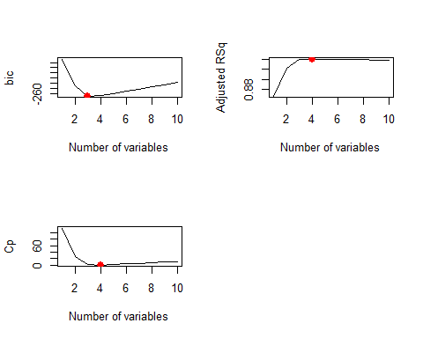
* 3 variable model picks X, X^2 and X^3 4 variable model picks X, X^2, X^3 and X^5
* 4d.
* regfit.fwd=regsubsets(y~poly(x,10,raw=T), data=df, nvmax=10, method="forward")  
   regfitfwd.summary=summary(regfit.X)  
    
   par(mfrow=c(2,2))  
    
   plot(regfitfwd.summary$bic, xlab="Number of variables", ylab="bic",type = "l")  
   k=which.min(regfitfwd.summary$bic)  
   points(k,regfitfwd.summary$bic[k],col="red",cex=2,pch=20)  
    
   plot(regfitfwd.summary$adjr2, xlab="Number of variables", ylab="Adjusted RSq",type = "l")  
   k=which.max(regfitfwd.summary$adjr2)  
   points(k,regfitfwd.summary$adjr2[k],col="red",cex=2,pch=20)  
    
   plot(regfitfwd.summary$cp, xlab="Number of variables", ylab="Cp",type="l")  
   k=which.min(regfitfwd.summary$cp)  
   points(k,regfitfwd.summary$cp[k],col="red",cex=2,pch=20)  
    
   coefficients(regfit.fwd,3)
* ## (Intercept) poly(x, 10, raw = T)1 poly(x, 10, raw = T)2   
  ## 1.0615072 0.9752803 0.8762090   
  ## poly(x, 10, raw = T)3   
  ## 1.0176386
* coefficients(regfit.fwd,4)
* ## (Intercept) poly(x, 10, raw = T)1 poly(x, 10, raw = T)2   
  ## 1.07200775 1.38745596 0.84575641   
  ## poly(x, 10, raw = T)3 poly(x, 10, raw = T)5   
  ## 0.55797426 0.08072292
* 
* #Backward  
   regfit.bwd=regsubsets(y~poly(x,10,raw=T), data=df, nvmax=10, method="backward")  
   regfitbwd.summary=summary(regfit.X)  
    
   par(mfrow=c(2,2))  
   plot(regfitbwd.summary$bic, xlab="Number of variables", ylab="bic",type = "l")  
   k=which.min(regfitbwd.summary$bic)  
   k
* ## [1] 3
* points(k,regfitbwd.summary$bic[k],col="red",cex=2,pch=20)  
    
   plot(regfitbwd.summary$adjr2, xlab="Number of variables", ylab="Adjusted RSq",type = "l")  
   k=which.max(regfitbwd.summary$adjr2)  
   k
* ## [1] 4
* points(k,regfitbwd.summary$adjr2[k],col="red",cex=2,pch=20)  
    
   plot(regfitbwd.summary$cp, xlab="Number of variables", ylab="Cp",type="l")  
   k=which.min(regfitbwd.summary$cp)  
   k
* ## [1] 4
* points(k,regfitbwd.summary$cp[k],col="red",cex=2,pch=20)  
    
   coefficients(regfit.bwd,3)
* ## (Intercept) poly(x, 10, raw = T)1 poly(x, 10, raw = T)2   
  ## 1.0615072 0.9752803 0.8762090   
  ## poly(x, 10, raw = T)3   
  ## 1.0176386
* coefficients(regfit.bwd,4)
* ## (Intercept) poly(x, 10, raw = T)1 poly(x, 10, raw = T)2   
  ## 1.15670295 1.03082564 0.59010182   
  ## poly(x, 10, raw = T)3 poly(x, 10, raw = T)4   
  ## 0.99086710 0.06978542
* 
* Statistics from Forward and Backward models show 3 and 4 variable models are optimal. Additionally,3 variable model picks X, X^2 and X^3 and 4 variable model picks X, X^2, X^3 and X^5. These results are similar to results in 4c.
* 4e
* par(mfrow=c(1,1))  
   library(glmnet)
* ## Warning: package 'glmnet' was built under R version 3.2.2
* ## Loading required package: Matrix  
  ## Loading required package: foreach
* ## Warning: package 'foreach' was built under R version 3.2.2
* ## Loaded glmnet 2.0-2
* xnew=model.matrix(y~poly(x,10,raw=T),data=df)[,-1]  
   grid=10^seq(10,-2,length=100)  
    
   set.seed(1)  
   train=sample(1:nrow(xnew),nrow(xnew)/2)  
   test=(-train)  
   Y.test=Y[test]  
    
   lasso.mod=glmnet(xnew[train,],Y[train], alpha=1,lambda=grid)  
   plot(lasso.mod)
* 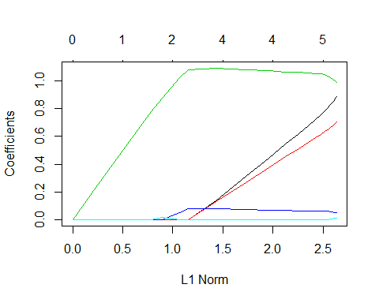
* cv.out=cv.glmnet(xnew[train,], Y[train], alpha=1)  
   plot(cv.out)
* 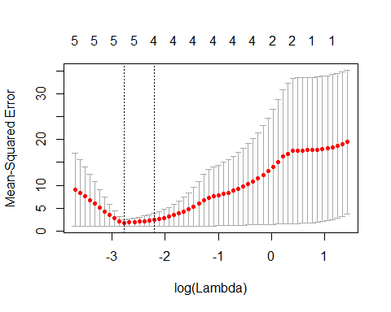
* bestlam=cv.out$lambda.min  
    
   lasso.pred=predict(lasso.mod,s=bestlam,newx=xnew[test,], type="coefficients")  
   lasso.pred
* ## 11 x 1 sparse Matrix of class "dgCMatrix"  
  ## 1  
  ## (Intercept) 1.047519228  
  ## poly(x, 10, raw = T)1 0.791739971  
  ## poly(x, 10, raw = T)2 0.640112595  
  ## poly(x, 10, raw = T)3 1.041070112  
  ## poly(x, 10, raw = T)4 0.060629481  
  ## poly(x, 10, raw = T)5 0.001376594  
  ## poly(x, 10, raw = T)6 .   
  ## poly(x, 10, raw = T)7 .   
  ## poly(x, 10, raw = T)8 .   
  ## poly(x, 10, raw = T)9 .   
  ## poly(x, 10, raw = T)10 .

Lasso predicts a model using $X^{1}$, $X^{2}$, $X^{3}$, $X^{4}$, $X^{5}$. All variables except $X^{4}$ were chosen with backward, forward subselection example above.

* 4f
* set.seed(1)  
  beta7 = 1  
  Y=beta0+beta7*X^7+eps  
  df=data.frame(y=Y,x=X)  
  regfitx7=regsubsets(y~poly(x,10,raw=T), data=df, nvmax=10)  
  regfitx7.summary=summary(regfitx7)  
  k=which.min(regfitx7.summary$bic)  
  coefficients(regfitx7,k)
* ## (Intercept) poly(x, 10, raw = T)7   
  ## 0.9589402 1.0007705
* k=which.min(regfitx7.summary$cp)  
  coefficients(regfitx7,k)
* ## (Intercept) poly(x, 10, raw = T)2 poly(x, 10, raw = T)7   
  ## 1.0704904 -0.1417084 1.0015552
* k=which.max(regfitx7.summary$adjr2)  
  coefficients(regfitx7,k)
* ## (Intercept) poly(x, 10, raw = T)1 poly(x, 10, raw = T)2   
  ## 1.0762524 0.2914016 -0.1617671   
  ## poly(x, 10, raw = T)3 poly(x, 10, raw = T)7   
  ## -0.2526527 1.0091338
* BIC picks the correct 1 variable model with $X^{7}$; Cp picks 2 variable model with $X^{2}$ and $X^{7}$ and Adjusted $R^{2}$ picks a 4 variable model with $X^{1}$, $X^{2}$, $X^{3}$ and $X^{7}$
* xnew=model.matrix(y~poly(x,10,raw=T),data=df)[,-1]  
   cv.out=cv.glmnet(xnew, Y, alpha=1)  
   bestlam=cv.out$lambda.min  
    
   lasso.pred=predict(lasso.mod,s=bestlam,newx=xnew, type="coefficients")  
   lasso.pred
* ## 11 x 1 sparse Matrix of class "dgCMatrix"  
  ## 1  
  ## (Intercept) 1.725094858  
  ## poly(x, 10, raw = T)1 .   
  ## poly(x, 10, raw = T)2 .   
  ## poly(x, 10, raw = T)3 0.826320444  
  ## poly(x, 10, raw = T)4 .   
  ## poly(x, 10, raw = T)5 0.008857532  
  ## poly(x, 10, raw = T)6 .   
  ## poly(x, 10, raw = T)7 .   
  ## poly(x, 10, raw = T)8 .   
  ## poly(x, 10, raw = T)9 .   
  ## poly(x, 10, raw = T)10 .
* Lasso picks the 2 variable model with $X^{3}$ and $X^{5}$. The intercept value is 1.7 as compared to 1.07 in the best subset selection

# Q5.

* 5a.
* library(ISLR)
* ## Warning: package 'ISLR' was built under R version 3.2.2
* set.seed(1)  
  sum(is.na(College))
* ## [1] 0
* train=sample(1:nrow(College),nrow(College)/2)  
  test=(-train)  
  College.train=College[train,]  
  College.test=College[test,]
* 5b.
* lm.fit=lm(Apps~.,data=College.train)  
  lm.pred=predict(lm.fit, College.test)  
  mean((College.test[,"Apps"]-lm.pred)^2)
* ## [1] 1108531
* RSS= 1108531
* 5c.
* library(glmnet)  
  ridge_train=model.matrix(Apps~.,data=College.train)  
  ridge_test=model.matrix(Apps~.,data=College.test)  
  grid=10^seq(4,-2,length=100)  
  ridge.mod=cv.glmnet(ridge_train, College.train[,"Apps"], alpha=0, lambda=grid)  
  bestlam=ridge.mod$lambda.min  
  bestlam
* ## [1] 0.1873817
* ridge.pred=predict(ridge.mod, newx=ridge_test, s=bestlam)  
  mean((College.test[,"Apps"]-ridge.pred)^2)
* ## [1] 1108062

RSS= 1108062. The test RSS is comparable to the result from least squares fit.

* 5d.
* lasso.mod=cv.glmnet(ridge_train, College.train[,"Apps"], alpha=1, lambda=grid)  
  bestlam=lasso.mod$lambda.min  
  lasso.pred=predict(lasso.mod,newx=ridge_test, s=bestlam)  
  mean((College.test[,"Apps"]-lasso.pred)^2)
* ## [1] 1026783
* predict(lasso.mod,newx=ridge_test, s=bestlam, type="coefficients")
* ## 19 x 1 sparse Matrix of class "dgCMatrix"  
  ## 1  
  ## (Intercept) -4.230907e+02  
  ## (Intercept) .   
  ## PrivateYes -4.926762e+02  
  ## Accept 1.542260e+00  
  ## Enroll -4.183196e-01  
  ## Top10perc 4.768619e+01  
  ## Top25perc -7.845864e+00  
  ## F.Undergrad -5.064600e-03  
  ## P.Undergrad .   
  ## Outstate -5.204703e-02  
  ## Room.Board 1.871769e-01  
  ## Books 7.387966e-04  
  ## Personal .   
  ## PhD -4.068964e+00  
  ## Terminal -3.303902e+00  
  ## S.F.Ratio .   
  ## perc.alumni -2.127554e+00  
  ## Expend 3.204866e-02  
  ## Grad.Rate 2.863551e+00

RSS error (1026783) is lower than ridge and least squares

* 5e.
* library(pls)
* ## Warning: package 'pls' was built under R version 3.2.2
* ##   
  ## Attaching package: 'pls'  
  ##   
  ## The following object is masked from 'package:stats':  
  ##   
  ## loadings
* pcr.fit=pcr(Apps~., data=College, subset=train, scale=T, validation="CV")  
  validationplot(pcr.fit, val.type="MSEP")
* 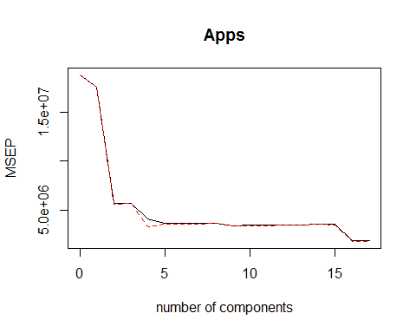
* summary(pcr.fit)
* ## Data: X dimension: 388 17   
  ## Y dimension: 388 1  
  ## Fit method: svdpc  
  ## Number of components considered: 17  
  ##   
  ## VALIDATION: RMSEP  
  ## Cross-validated using 10 random segments.  
  ## (Intercept) 1 comps 2 comps 3 comps 4 comps 5 comps 6 comps  
  ## CV 4335 4184 2372 2376 2009 1896 1896  
  ## adjCV 4335 4184 2368 2374 1811 1883 1887  
  ## 7 comps 8 comps 9 comps 10 comps 11 comps 12 comps 13 comps  
  ## CV 1897 1912 1847 1848 1854 1857 1860  
  ## adjCV 1888 1904 1835 1837 1845 1848 1851  
  ## 14 comps 15 comps 16 comps 17 comps  
  ## CV 1879 1887 1353 1355  
  ## adjCV 1886 1856 1335 1337  
  ##   
  ## TRAINING: % variance explained  
  ## 1 comps 2 comps 3 comps 4 comps 5 comps 6 comps 7 comps  
  ## X 31.216 57.68 64.73 70.55 76.33 81.30 85.01  
  ## Apps 6.976 71.47 71.58 83.32 83.44 83.45 83.46  
  ## 8 comps 9 comps 10 comps 11 comps 12 comps 13 comps 14 comps  
  ## X 88.40 91.16 93.36 95.38 96.94 97.96 98.76  
  ## Apps 83.47 84.53 84.86 84.98 84.98 84.99 85.24  
  ## 15 comps 16 comps 17 comps  
  ## X 99.40 99.87 100.00  
  ## Apps 90.87 93.93 93.97
* pcr.pred=predict(pcr.fit, College.test, ncomp=16)  
  mean((College.test[,"Apps"]- data.frame(pcr.pred))^2)
* ## [1] 1166897

Test RSS using 16 components (1166897) is higher than lasso, ridge and least squares

* 5f
* pls.fit=plsr(Apps~., data=College, subset=train, scale=T, validation="CV")  
  validationplot(pls.fit, val.type="MSEP")
* 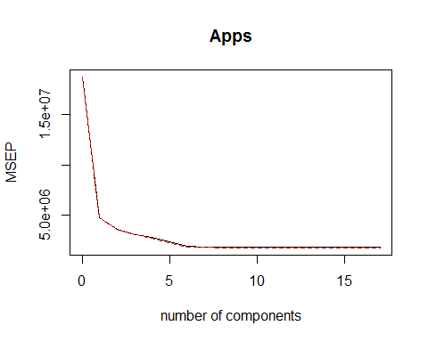
* summary(pls.fit)
* ## Data: X dimension: 388 17   
  ## Y dimension: 388 1  
  ## Fit method: kernelpls  
  ## Number of components considered: 17  
  ##   
  ## VALIDATION: RMSEP  
  ## Cross-validated using 10 random segments.  
  ## (Intercept) 1 comps 2 comps 3 comps 4 comps 5 comps 6 comps  
  ## CV 4335 2176 1889 1748 1663 1517 1364  
  ## adjCV 4335 2171 1884 1738 1631 1483 1345  
  ## 7 comps 8 comps 9 comps 10 comps 11 comps 12 comps 13 comps  
  ## CV 1353 1332 1327 1324 1325 1324 1323  
  ## adjCV 1334 1315 1311 1309 1309 1309 1307  
  ## 14 comps 15 comps 16 comps 17 comps  
  ## CV 1322 1322 1323 1323  
  ## adjCV 1306 1307 1307 1307  
  ##   
  ## TRAINING: % variance explained  
  ## 1 comps 2 comps 3 comps 4 comps 5 comps 6 comps 7 comps  
  ## X 26.91 43.08 63.26 65.16 68.50 73.75 76.10  
  ## Apps 76.64 83.93 87.14 91.90 93.49 93.85 93.91  
  ## 8 comps 9 comps 10 comps 11 comps 12 comps 13 comps 14 comps  
  ## X 79.03 81.76 85.41 89.03 91.38 93.31 95.43  
  ## Apps 93.94 93.96 93.96 93.96 93.97 93.97 93.97  
  ## 15 comps 16 comps 17 comps  
  ## X 97.41 98.78 100.00  
  ## Apps 93.97 93.97 93.97
* pls.pred=predict(pls.fit, College.test, ncomp=14)  
  mean((College.test[,"Apps"]- data.frame(pls.pred))^2)
* ## [1] 1112475
* Test RSS using 14 components (1112475) is higher than lasso, ridge and least squares and smaller than pcr
* 5g. Lasso gave the best results. Fit using Ridge and Least Squares was similar to lasso and the Test RSS was comparable.The Test RSS using Principal components regression and partial least squares were within the range of 10% Test RSS reported by Lasso.

# Q6

* 6a.
* set.seed(1)  
  library(leaps)  
  n=100  
  p=20  
  x=matrix(rnorm(n*p), nrow=n, ncol=p)  
  beta=rnorm(p)  
  eps=rnorm(p)  
    
  beta[5]=0  
  beta[9]=0  
  beta[12]=0  
    
  y=x %*% beta + eps
* 6b.
* test=sample(1:nrow(x),nrow(x)/10)  
  train=(-test)  
  x.train=x[train,]  
  x.test=x[test,]  
  y.train=y[train,]  
  y.test=y[test,]
* 6c.
* df=data.frame(x=x,y=y)  
  regfit =regsubsets(y~.,data=df, nvmax=p)  
  val.errors=rep(NA,p)  
    
  train.mat=model.matrix(y~.,data=df[train,])  
  test.mat=model.matrix(y~.,data=df[test,])  
    
  for(i in 1:p) {  
   coefi=coef(regfit,id=i)  
   pred=train.mat[,names(coefi)]%*%coefi  
   val.errors[i]=mean((df$y[train]-pred)^2)  
  }  
    
  plot(val.errors, xlab="p value", ylab="training MSE")
* 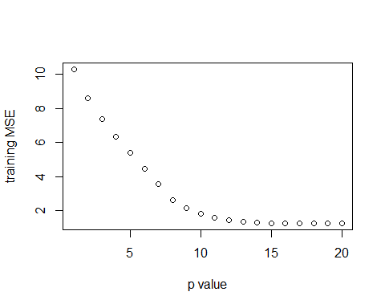
* 6d.
* val.errors=rep(NA,p)  
  for(i in 1:p) {  
   coefi=coef(regfit,id=i)  
   pred=test.mat[,names(coefi)]%*%coefi  
   val.errors[i]=mean((df$y[test]-pred)^2)  
  }  
    
  plot(val.errors, xlab="p value", ylab="test MSE")
* 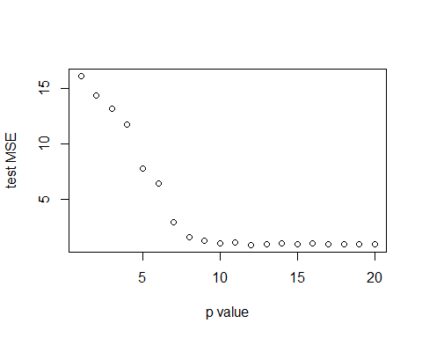
* 6e.
* which.min(val.errors)
* ## [1] 12

12 parameter model has the smallest test mse

* 6f.
* coef(regfit,12)
* ## (Intercept) x.1 x.2 x.3 x.4 x.6   
  ## -0.03109649 -0.88260240 -1.86261823 1.73345042 0.58266354 0.71656900   
  ## x.8 x.13 x.15 x.16 x.17 x.18   
  ## -1.44000805 0.40443299 1.04729141 1.26597138 -0.69084672 -0.83238264   
  ## x.20   
  ## 1.38086014
* 6g.

# Q7.

lambda=5  
 beta=seq(-50,50,0.1)  
 y=5  
 f=(y-beta)^2 + lambda*(beta^2)  
 plot(beta,f, xlab="Beta values", ylab="ridge regression values")  
 beta_r=1/(1+lambda)  
 new_f=(y-beta_r)^2+lambda*(beta_r^2)  
 points(beta_r,new_f,col="red")

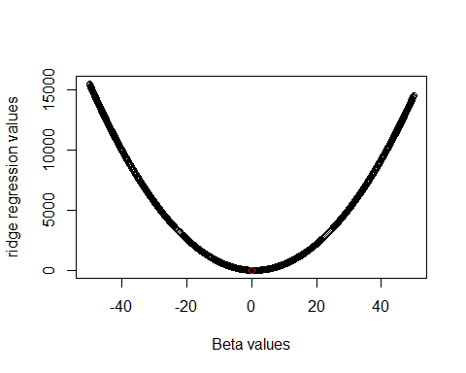

lambda=5  
 beta=seq(-50,50,0.1)  
 y=5  
 f=(y-beta)^2 + lambda*(abs(beta))  
 plot(beta,f, xlab="Beta values", ylab="Lasso values")  
 beta_r=y-lambda/2  
 new_f=(y-beta_r)^2+lambda*abs(beta_r)  
 points(beta_r,new_f,col="red")

