HW6

Anish Mohan

November 9, 2015

# Q1

x=rnorm(100)  
eps=rnorm(100)  
y=5+2*x+7*x*x+3*x*x*x+5*eps  
plot(x,y)

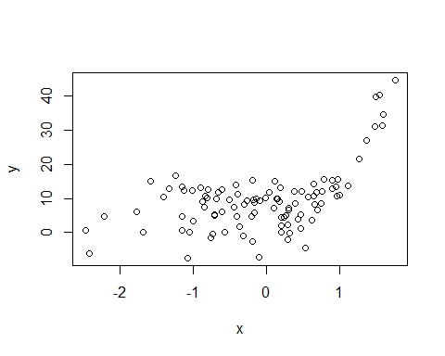

u=lm(y~-1)  
u0=lm(y~1)  
u1=lm(y~poly(x,1))  
u2=lm(y~poly(x,2))  
u3=lm(y~poly(x,3))  
u4=lm(y~poly(x,4))  
u5=lm(y~poly(x,5))  
xlim=range(x)  
xgrid=seq(from=xlim[1],to=xlim[2], length.out = 100)

* 1a. $λ=∞$, m=0
* Since $λ=∞$, to minimize the equation, we need $g^{(0)}$ be zero or tend towards zero. This is possible with a function g(x)=0
* plot(x,y)  
  tempval=rep(0,100)  
  lines(xgrid,tempval)
* 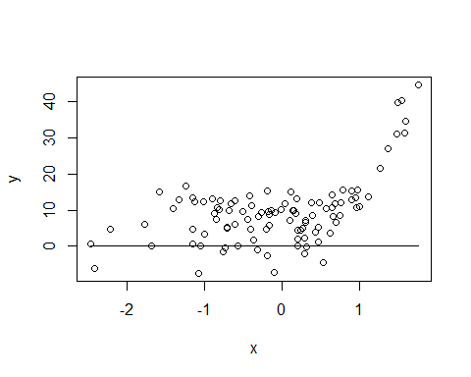
* 1b. $λ=∞$, m=1
* Since $λ=∞$, to minimize the equation, we need $g^{(1)}$ to be lowest or tend towards zero. This is only possible if $g(x)$ is a constant function i.e g(x)= $β_{0}$
* plot(x,y)  
  val=u0$coefficients[1]  
  tempval=rep(val,100)  
  lines(xgrid,tempval)
* 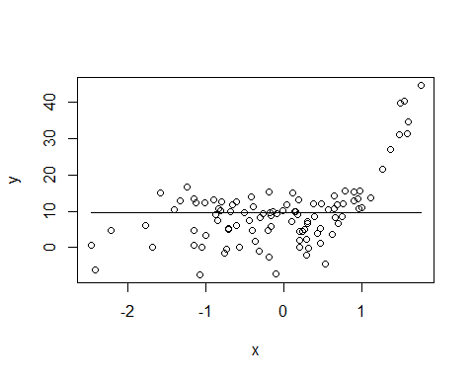
* 1c. $λ=∞$, m=2
* Since $λ=∞$, to minimize the equation, we need $g^{(2)}$ to be lowest or tend towards zero. This is possible if $g^{(1)}$ is constant i.e $g(x)$ is a linear function with constant slope. Hence the function would be g(x)= $β_{0}+β_{1}*x$.
* plot(x,y)  
  xlim=range(x)  
  xgrid=seq(from=xlim[1],to=xlim[2], length.out = 100)  
  pred=predict(u1,newdata=list(x=xgrid),se=T)  
  lines(xgrid, pred$fit, lwd=2)
* 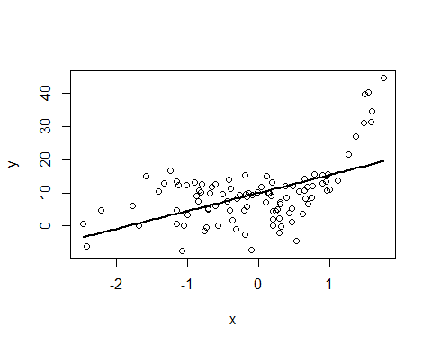
* 1d. $λ=∞$, m=3
* Since $λ=∞$, to minimize the equation, we need $g^{(3)}$ to be lowest or tend towards zero. This is possible if $g^{(2)}$ is constant. This implied $g^{(1)}$ is uniformly increasing or has constant slope i.e the function $g(x)$ would be incresing at a constant rate. This is possible with a function g(x)= $β_{0}+β_{1}*x+β_{2}*x^{2}$
* plot(x,y)  
  xlim=range(x)  
  xgrid=seq(from=xlim[1],to=xlim[2], length.out = 100)  
  pred=predict(u2,newdata=list(x=xgrid),se=T)  
  lines(xgrid, pred$fit, lwd=2)
* 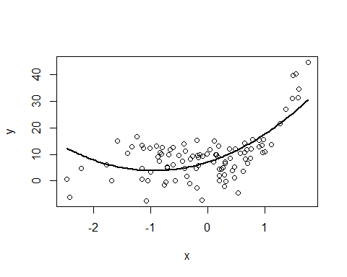
  + 1e. $λ=0$, m=3
* Since $λ=0$, to minimize the equation, we need residual erro to be lowest. This is possible with a function that minimizes the RSS which in this case is g(x)= $β_{0}+β_{1}*x+β_{2}*x^{2}+β_{3}*x^{3}$ a shown by low p value from the summary results.
* plot(x,y)  
  xlim=range(x)  
  xgrid=seq(from=xlim[1],to=xlim[2], length.out = 100)  
  pred=predict(u3,newdata=list(x=xgrid),se=T)  
  lines(xgrid, pred$fit, lwd=2)
* 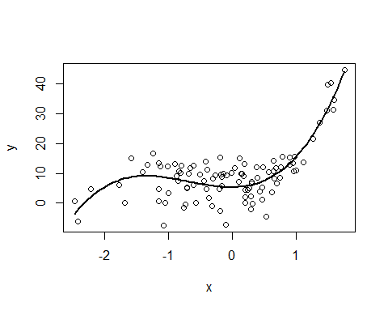
* summary(u4)
* ##   
  ## Call:  
  ## lm(formula = y ~ poly(x, 4))  
  ##   
  ## Residuals:  
  ## Min 1Q Median 3Q Max   
  ## -15.6386 -3.1319 0.6367 3.8068 9.1043   
  ##   
  ## Coefficients:  
  ## Estimate Std. Error t value Pr(>|t|)   
  ## (Intercept) 9.492 0.517 18.362 < 2e-16 ***  
  ## poly(x, 4)1 48.803 5.170 9.440 2.60e-15 ***  
  ## poly(x, 4)2 39.694 5.170 7.678 1.42e-11 ***  
  ## poly(x, 4)3 43.296 5.170 8.375 4.85e-13 ***  
  ## poly(x, 4)4 6.683 5.170 1.293 0.199   
  ## ---  
  ## Signif. codes: 0 '***' 0.001 '**' 0.01 '*' 0.05 '.' 0.1 ' ' 1  
  ##   
  ## Residual standard error: 5.17 on 95 degrees of freedom  
  ## Multiple R-squared: 0.6983, Adjusted R-squared: 0.6856   
  ## F-statistic: 54.97 on 4 and 95 DF, p-value: < 2.2e-16

# Q2

x=-2:2  
 beta0=1  
 beta1=1  
 beta2=-2  
 y=rep(NA,5)  
   
 for(i in 1:5 ) {  
 if(x[i]<1){  
 y[i]=beta0+x[i]*beta1  
 } else {  
 y[i]=beta0+beta1*x[i]+beta2*(x[i]-1)^2  
 }  
 }  
 plot(x,y)

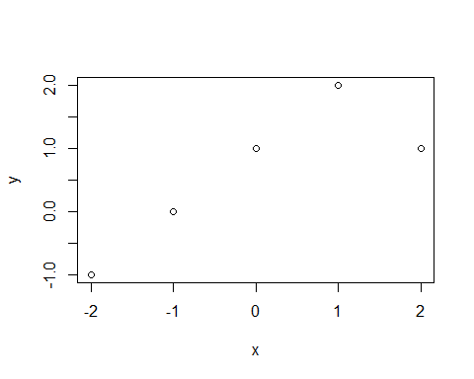

# Q3

* 3a. Functions $\hat{g_{2}}$ will have a smaller training error as it is higher order polynomial and has higher order penalty function. It will fit the training data well
* 3b. Functions $\hat{g_{1}}$ could have a smaller test error as the higher order function $\hat{g_{2}}$ will tend to overfit the noise.
* 3c. Functions $\hat{g_{1}}$ and $\hat{g_{2}}$ are same when $λ=0$, hence they will have same training and test error.

# Q4

library(ISLR)

## Warning: package 'ISLR' was built under R version 3.2.2

library(boot)

## Warning: package 'boot' was built under R version 3.2.2

attach(Auto)  
   
 set.seed(1)  
 #10-Fold validation comparing a linear and cubic model  
   
 fit.lm=glm(mpg~horsepower, data=Auto)  
 cv.error=cv.glm(Auto,fit.lm,K=10)  
 cv.error$delta

## [1] 24.10716 24.09865

hplims=range(Auto$horsepower)  
 hp.grid=seq(from=hplims[1],to=hplims[2])  
   
 plot(horsepower, mpg, xlim=hplims, cex=0.5, col="darkgrey")  
 preds=predict(fit.lm,newdata=list(horsepower=hp.grid), se=T)  
 lines(hp.grid, preds$fit, lwd=2, col="blue")  
 title("Applying linear regression")

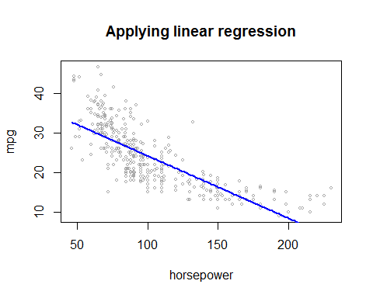

fit.poly=glm(mpg~poly(horsepower,3),data=Auto)  
 cv.error=cv.glm(Auto,fit.poly,K=10)  
 cv.error$delta

## [1] 19.37347 19.35072

print(paste0("Error from polynomial regression is smaller than linear regression" ))

## [1] "Error from polynomial regression is smaller than linear regression"

#Using Polynomial regression  
  
 preds=predict(fit.poly,newdata=list(horsepower=hp.grid), se=T)  
 se.bands=cbind(preds$fit+2*preds$se,preds$fit-2*preds$se.fit)  
   
 plot(horsepower, mpg, xlim=hplims, cex=0.5, col="darkgrey")  
 title("Applying polynomial regression")  
 lines(hp.grid, preds$fit, lwd=2, col="blue")  
 matlines(hp.grid, se.bands, lwd=1, col="blue", lty=3)

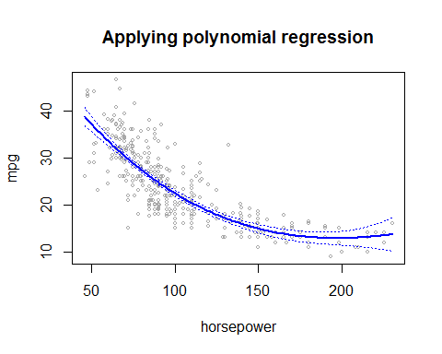

#using ANOVA to analyze variance.  
 fit.1=lm(mpg~horsepower, data=Auto)  
 fit.2=lm(mpg~poly(horsepower,2), data=Auto)  
 fit.3=lm(mpg~poly(horsepower,3), data=Auto)  
 fit.4=lm(mpg~poly(horsepower,4), data=Auto)  
   
 anova(fit.1,fit.2,fit.3,fit.4)

## Analysis of Variance Table  
##   
## Model 1: mpg ~ horsepower  
## Model 2: mpg ~ poly(horsepower, 2)  
## Model 3: mpg ~ poly(horsepower, 3)  
## Model 4: mpg ~ poly(horsepower, 4)  
## Res.Df RSS Df Sum of Sq F Pr(>F)   
## 1 390 9385.9   
## 2 389 7442.0 1 1943.89 101.6666 <2e-16 ***  
## 3 388 7426.4 1 15.59 0.8155 0.3670   
## 4 387 7399.5 1 26.91 1.4076 0.2362   
## ---  
## Signif. codes: 0 '***' 0.001 '**' 0.01 '*' 0.05 '.' 0.1 ' ' 1

print(paste0("Quadratic model seems to be a good fit"))

## [1] "Quadratic model seems to be a good fit"

#Applying spline model  
 library(splines)  
 fit=lm(mpg~bs(horsepower, df=6),data=Auto)  
 pred=predict(fit,newdata=list(horsepower=hp.grid),se=T)  
 plot(horsepower,mpg, col="gray")  
 title('Applying splines')  
 lines(hp.grid, pred$fit,lwd=2)  
 lines(hp.grid, pred$fit+2*pred$se,lty="dashed")  
 lines(hp.grid, pred$fit-2*pred$se,lty="dashed")

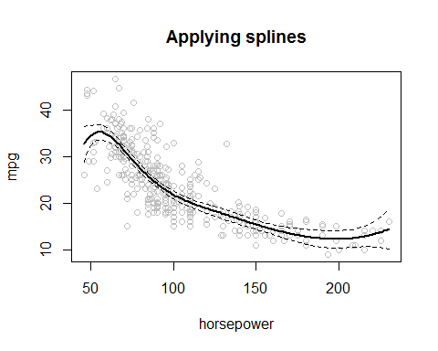

#Applying local regression  
 fit=loess(mpg~horsepower, span=0.2, data=Auto)  
 pred=predict(fit, newdata=data.frame(horsepower=hp.grid))  
 plot(horsepower,mpg, col="gray")  
 title('Applying Local regression')  
 lines(hp.grid, pred,col="blue", lwd=2)

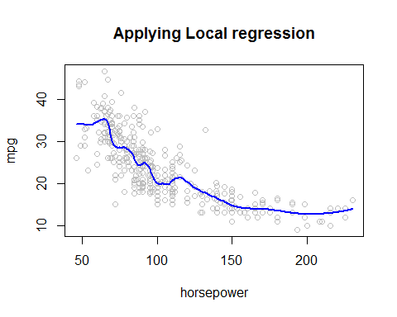

# Q5

* 5a.
* library(MASS)  
   attach(Boston)  
    
   fit.poly=glm(nox~poly(dis,3))  
   print(paste0("Coefficient of the polynomial eqn"))
* ## [1] "Coefficient of the polynomial eqn"
* coef(fit.poly)
* ## (Intercept) poly(dis, 3)1 poly(dis, 3)2 poly(dis, 3)3   
  ## 0.5546951 -2.0030959 0.8563300 -0.3180490
* summary(fit.poly)
* ##   
  ## Call:  
  ## glm(formula = nox ~ poly(dis, 3))  
  ##   
  ## Deviance Residuals:   
  ## Min 1Q Median 3Q Max   
  ## -0.121130 -0.040619 -0.009738 0.023385 0.194904   
  ##   
  ## Coefficients:  
  ## Estimate Std. Error t value Pr(>|t|)   
  ## (Intercept) 0.554695 0.002759 201.021 < 2e-16 ***  
  ## poly(dis, 3)1 -2.003096 0.062071 -32.271 < 2e-16 ***  
  ## poly(dis, 3)2 0.856330 0.062071 13.796 < 2e-16 ***  
  ## poly(dis, 3)3 -0.318049 0.062071 -5.124 4.27e-07 ***  
  ## ---  
  ## Signif. codes: 0 '***' 0.001 '**' 0.01 '*' 0.05 '.' 0.1 ' ' 1  
  ##   
  ## (Dispersion parameter for gaussian family taken to be 0.003852802)  
  ##   
  ## Null deviance: 6.7810 on 505 degrees of freedom  
  ## Residual deviance: 1.9341 on 502 degrees of freedom  
  ## AIC: -1370.9  
  ##   
  ## Number of Fisher Scoring iterations: 2
* dislims=range(Boston$dis)  
   dis.grid=seq(from=dislims[1],to=dislims[2])  
   preds=predict(fit.poly,newdata=list(dis=dis.grid), se=T)  
   se.bands=cbind(preds$fit+2*preds$se,preds$fit-2*preds$se.fit)  
    
   plot(dis,nox, xlim=dislims,xlab="Distance from Employment Ctr", ylab="Notrogen Oxides Conc", cex=0.5, col="darkgrey")  
   title("Polynomial Regression: Boston Dataset")  
   lines(dis.grid, preds$fit, lwd=2, col="blue")  
   matlines(dis.grid, se.bands, lwd=1, col="blue", lty=3)
* 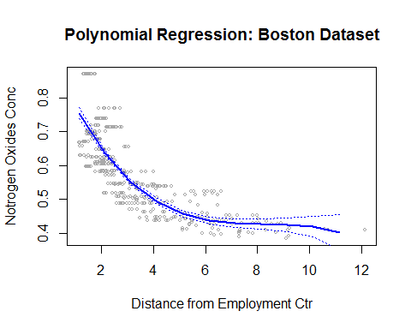
* 5b.
* fit=matrix(0,nrow=10,ncol=1)  
  plot(dis,nox, xlim=dislims,xlab="Distance from Employment Ctr", ylab="Notrogen Oxides Conc", cex=0.5, col="darkgrey")  
  for (i in 1:10){  
   lm.fit=glm(nox~poly(dis,i),data=Boston)  
   fit[i]=sum(lm.fit$residuals^2)  
   preds=predict(lm.fit,newdata=list(dis=dis.grid), se=T)  
   lines(dis.grid, preds$fit, lwd=2, col=i)  
  }
* 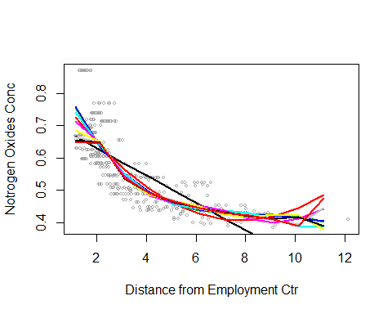
* fit
* ## [,1]  
  ## [1,] 2.768563  
  ## [2,] 2.035262  
  ## [3,] 1.934107  
  ## [4,] 1.932981  
  ## [5,] 1.915290  
  ## [6,] 1.878257  
  ## [7,] 1.849484  
  ## [8,] 1.835630  
  ## [9,] 1.833331  
  ## [10,] 1.832171
* 5c.
* set.seed(1)  
   cv.error.delta=rep(NA,10)  
   for(i in 1:10){  
   fit.poly=glm(nox~poly(dis,i),data=Boston)  
   cv.error=cv.glm(Boston,fit.poly,K=10)  
   cv.error.delta[i]=cv.error$delta[1]  
   }  
   plot(cv.error.delta)
* 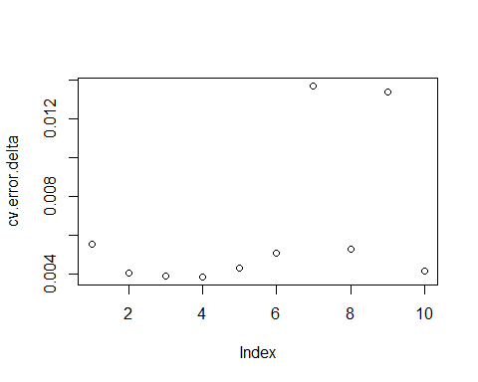
* Degree 4 polynomial is the simplest model with lowest Cross-Validation error.
* A liner model does not fit the data, hence it has higher error. The quadratic and cubic models are comparable as the difference in error between them on a 10 fold CV set is small. Degree 4 polynomial shows the smallest error.
* For polynomials>4, the residual errors are high implying that the model fits to the training data but gives poor results on the CV test data.
* 5d.
* library(splines)  
  fit=lm(nox~bs(dis,df=4),data=Boston)  
  dislims=range(Boston$dis)  
  dis.grid=seq(from=dislims[1],to=dislims[2])  
  summary(fit)
* ##   
  ## Call:  
  ## lm(formula = nox ~ bs(dis, df = 4), data = Boston)  
  ##   
  ## Residuals:  
  ## Min 1Q Median 3Q Max   
  ## -0.124622 -0.039259 -0.008514 0.020850 0.193891   
  ##   
  ## Coefficients:  
  ## Estimate Std. Error t value Pr(>|t|)   
  ## (Intercept) 0.73447 0.01460 50.306 < 2e-16 ***  
  ## bs(dis, df = 4)1 -0.05810 0.02186 -2.658 0.00812 **   
  ## bs(dis, df = 4)2 -0.46356 0.02366 -19.596 < 2e-16 ***  
  ## bs(dis, df = 4)3 -0.19979 0.04311 -4.634 4.58e-06 ***  
  ## bs(dis, df = 4)4 -0.38881 0.04551 -8.544 < 2e-16 ***  
  ## ---  
  ## Signif. codes: 0 '***' 0.001 '**' 0.01 '*' 0.05 '.' 0.1 ' ' 1  
  ##   
  ## Residual standard error: 0.06195 on 501 degrees of freedom  
  ## Multiple R-squared: 0.7164, Adjusted R-squared: 0.7142   
  ## F-statistic: 316.5 on 4 and 501 DF, p-value: < 2.2e-16
* pred=predict(fit,newdata=list(dis=dis.grid), se=T)  
  plot(dis,nox, col="gray")  
  lines(dis.grid, pred$fit, lwd=2)  
  lines(dis.grid, pred$fit+2*pred$se, lty="dashed")  
  lines(dis.grid, pred$fit-2*pred$se, lty="dashed")
* 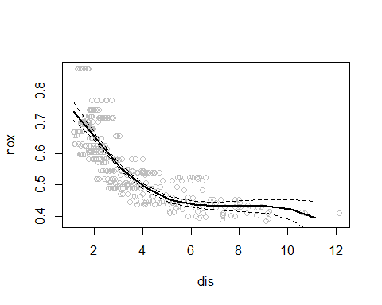
* Knots were chosen by specifying the df attribute that chose the knots at uniform quantile of data. In this case, the knots were at 25th, 50th and 75th quantiles
* 5e.
* plot(dis,nox, col="gray", xlab="Degrees of Freedom")  
  rss=rep(NA,10)  
  for(i in 3:10){  
   lm.fit=lm(nox~bs(dis,df=i),data=Boston)  
   pred=predict(lm.fit,newdata=list(dis=dis.grid), se=T)  
   lines(dis.grid, pred$fit, lwd=2, col=i*10)  
   rss[i]=sum(lm.fit$residuals^2)  
  }
* 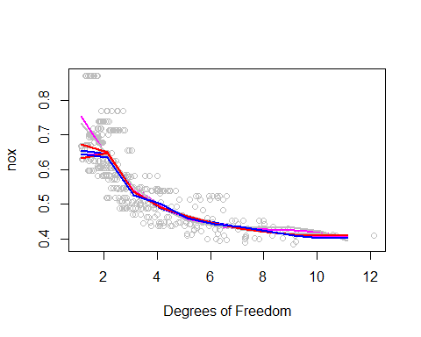
* plot(rss)
* 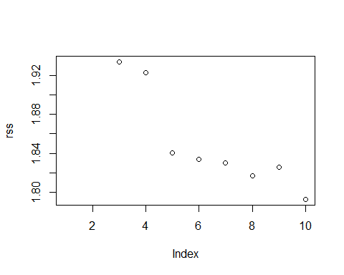
* RSS decreases monotonically as we increase degrees of freedom.Lowest RSS is with df=10
* 5f
* set.seed(1)  
  cv.error.delta=rep(NA,10)  
  for(i in 1:10){  
   fit.spline=glm(nox~bs(dis,df=i),data=Boston)  
   cv.error=cv.glm(Boston,fit.spline,K=10)  
   cv.error.delta[i]=cv.error$delta[1]  
  }  
  plot(cv.error.delta, xlab="Degrees of Freedom")
* 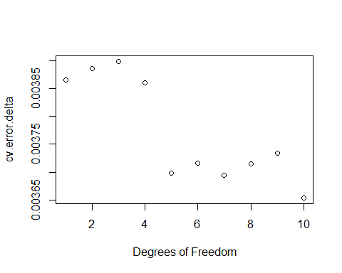
  + Lowest error obtained through cross validation is for df=10.
  + As we increase the degrees of freedome, initially, till we reach df=3, there is increase in the RSS. However, error starts decreasing after that till df=5. Errors fluctuate a bit, before getting the lowest error at df=10.

# Q6

x1=rnorm(100)  
 x2=rnorm(100)  
 eps=rnorm(100)   
 y=5+2*x1+7*x2+eps  
   
 beta0=rep(NA,1000)  
 beta1=rep(NA,1000)  
 beta2=rep(NA,1000)  
   
 beta1[1]=5  
   
 for(i in 1:1000){  
 a=y-beta1[i]*x1  
 beta2[i]=lm(a~x2)$coef[2]  
 beta0[i]=lm(a~x2)$coef[1]  
   
 a=y-beta2[i]*x2  
 beta1[i+1]=lm(a~x1)$coef[2]  
   
 }  
   
 plot(1:1001,beta1, col="green", type='l', ylim=c(0,10), xlab="iteration", ylab="Beta values")  
 lines(1:1000,beta0, col="red")  
 lines(1:1000,beta2, col="blue")  
   
   
 u=lm(y~x1+x2)  
 points(coef(u)[1],col="red", pch=8, cex=2)  
 points(coef(u)[2],col="green", pch=8, cex=2)  
 points(coef(u)[3],col="blue", pch=8, cex=2)  
 legend("topright",c("beta0","beta1","beta2"), lty=4,col = c("red","green","blue"))  
 legend("topleft",c("Multi-Reg beta0","Multi-Reg beta1"," Multi-Reg beta2"), pch=8,col = c("red","green","blue"))

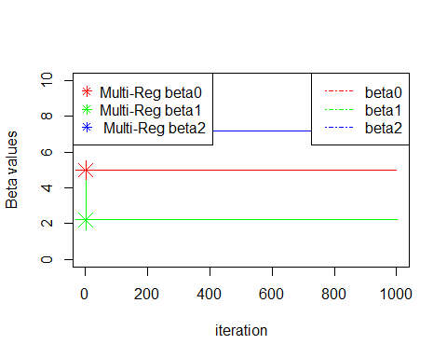

plot(1:1001,beta1, col="green", type='l', ylim=c(0,10), xlab="iteration", ylab="Beta values")  
 title("Showing abline from multiple regression coefficients.")  
 lines(1:1000,beta0, col="red")  
 lines(1:1000,beta2, col="blue")  
 abline(h=beta0, lty="dashed")  
 abline(h=beta1, lty="dashed")  
 abline(h=beta2, lty="dashed")

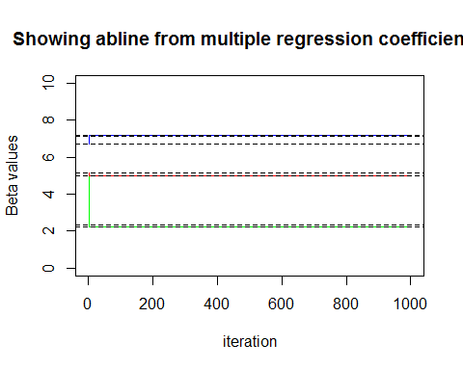

print(paste0("Within 2nd approximations the backfitting answers were good estimates"))

## [1] "Within 2nd approximations the backfitting answers were good estimates"

beta0[1:5]

## [1] 5.149512 5.014518 5.009577 5.009396 5.009389

beta1[1:5]

## [1] 5.000000 2.319657 2.221546 2.217955 2.217824

beta2[1:5]

## [1] 6.693492 7.145315 7.161853 7.162459 7.162481