Learn1

Anish mohan

September 28, 2015

This is an R Markdown document. Markdown is a simple formatting syntax for authoring HTML, PDF, and MS Word documents. For more details on using R Markdown see <http://rmarkdown.rstudio.com>.

When you click the **Knit** button a document will be generated that includes both content as well as the output of any embedded R code chunks within the document. You can embed an R code chunk like this:

summary(cars)

## speed dist   
## Min. : 4.0 Min. : 2.00   
## 1st Qu.:12.0 1st Qu.: 26.00   
## Median :15.0 Median : 36.00   
## Mean :15.4 Mean : 42.98   
## 3rd Qu.:19.0 3rd Qu.: 56.00   
## Max. :25.0 Max. :120.00

You can also embed plots, for example:

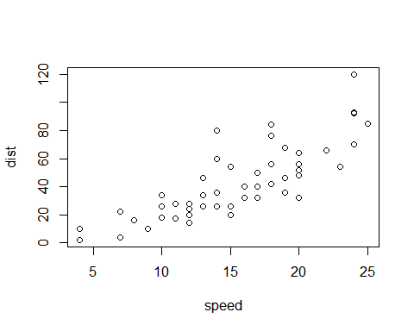

Note that the echo = FALSE parameter was added to the code chunk to prevent printing of the R code that generated the plot. ________________________________________________________________________________________________________________________________

The has results in a title heading. Needs to be fixed #Hello World !

Using the back tick button leads to r computing the value. I counted 2 red trucks on the highway

Embedding Equations: You can embed LaTex or MathMl equations in R Markdown files

The arithmetic mean is equal to $\frac{1}{n}\sum_{i=1}^{n}{x_{i}}$

Emphasis: *italic* *italic*

**bold** **bold**

Headers: #Header 1 ## Header 2 ### Header 3

Unordered List:

* Item 1
* Item 2
* Item 2a
* Item 2b
* Item 3
* Item 4

Ordered list 1. Item 1 2. Item 2 3. Item 3 + Item 3a + Item 3b

Inline R code:

summary(cars$dist)

## Min. 1st Qu. Median Mean 3rd Qu. Max.   
## 2.00 26.00 36.00 42.98 56.00 120.00

summary(cars$speed)

## Min. 1st Qu. Median Mean 3rd Qu. Max.   
## 4.0 12.0 15.0 15.4 19.0 25.0

There were 50 cars studied

links:

[Google](http:/google.com)

Images: 

Blockquotes A friend once said: > Its always better to give > than to recieve.

plain code blocks

This is a plain code block

Inline code We defined add function to compute the sum of two numbers

LateX equation $equation$

Display Equation

$$equation$$

Horizontal Rule/Page break Three or more asterisks or dashes hello **** world you ----- rock

tables: First Header | Second Header ------------ | ------------ content cell | content cell content cell 2| content cell2