**HW:4**

**Anish Mohan**

**a-d) Part_a_d_Video_Store.csv contains the table with requirements specified in the question**

**e) Part_e_Video_Store.csv contains the table with the requirements specified in the question.**

**f) From the Correlation plot we can see the following entries were correlated:**

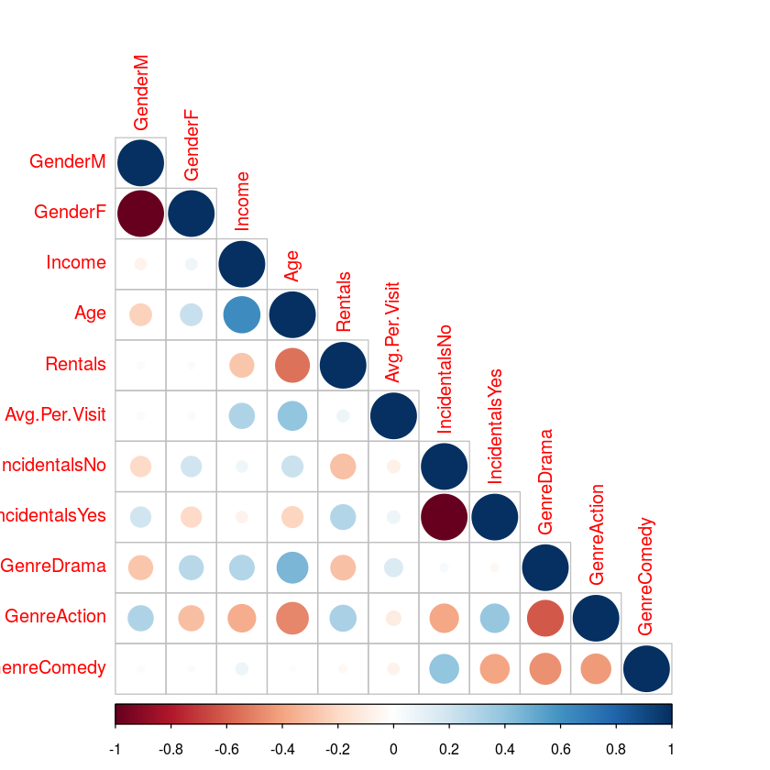

1) Income and Age of the customers were positively correlated. This shows that in the clientèle of the video store the older customers were earning more than the younger customers.

2) Women/Females were more positively correlated with Drama movies and negatively correlated with Action Movies.

3) Women also had negative correlation with Incidental purchases. Hence they were less likely to purchase Incidentals from the store.

4) Men had negative correlation with Drama Movies and positive correlation with Action movies. Also men were more likely to make Incidental purchase in the video store.

5) Higher Income folks were generally older and had positive correlation with Drama Movies and negative correlation with Action movies.

6) Age of the customers had strong negative correlation with frequency of rentals. It also had strong positive correlation with Drama movies and negative correlation with Action movies.

7) Incidental purchases in the store had strong positive correlation with customers renting Action movies and negative correlation with customers renting comedy movies.

8) Drama movies being rented have negative correlation with Male customers, positive correlation with Women customers. It also has negative correlation with Income and Age of the customer.

9) Action movies have strong positive correlation with Male customers, negative correlation with women customers. Also it has negative correlation with Income of the customer, age of the customer.

10) Folks who by Comedy movies have negative correlation with movies of other genre.

**g) Cross Table**

|  |  |  |  |
| --- | --- | --- | --- |
| Category | Comedy | Action | Drama |
| Female | 6 | 5 | 13 |
| Male | 6 | 13 | 7 |

1) Women are more likely to like Drama movies and less likely to like Action Movies.

2) Men are more likely to like Action movies and less likely to like Drama Movies.

3) Comedy movies are equally likely to be liked by Men and Women but they are less preferred than Action and Drama movies by Men and Women respectively.

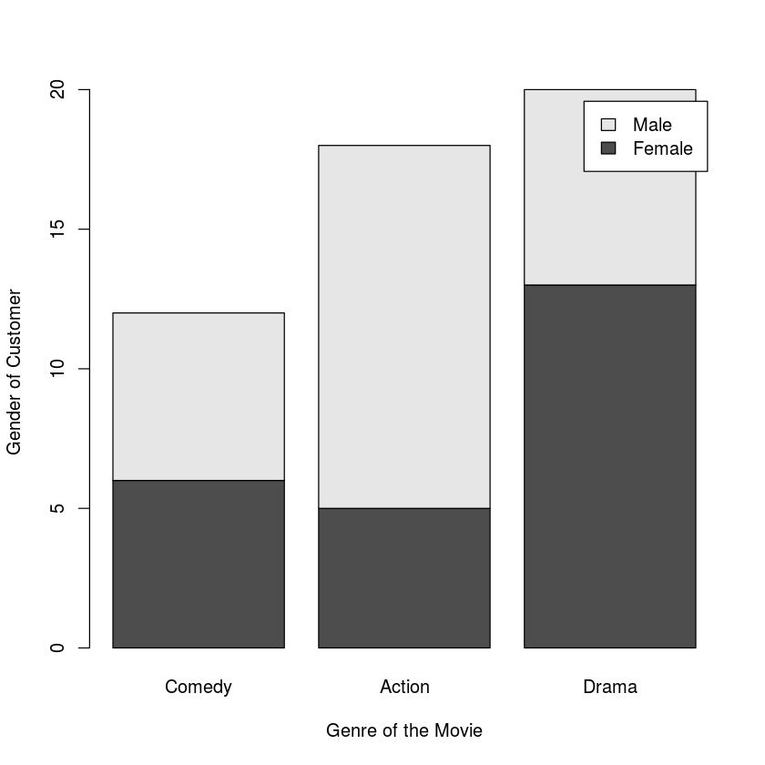

**h) Patterns in customers having high rentals:**

1) Action Movies are much more likely to be rented and are generally rented many times.

2) Average and Median income of folks who rent movies many times are lower than the average and median income of all the customers of video store.

3) Average age of the customers who rent many movies is lower than the average age of all the customers of the video store.

**i) Incidental purchases**

1) Men are more likely to make incidental purchases.

2) Customers who rent Action or Drama movies are more likely to make incidental purchases.

3) Customers who rent Comedy movies are less likely to make incidental purchases.

4) Income and age of the customer do not have significant bearing on their Incidental purchase habit.