1. Go to <https://azure.microsoft.com/en-us/free/students> and click **Start free** button.

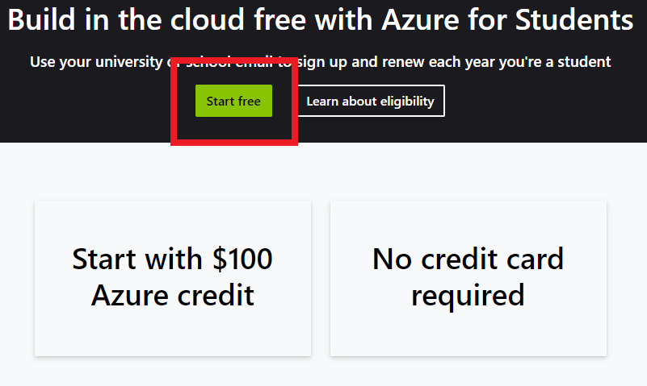

1. Log-in with your ČVUT email and password.
2. Fill in Student Verification and Profile forms:

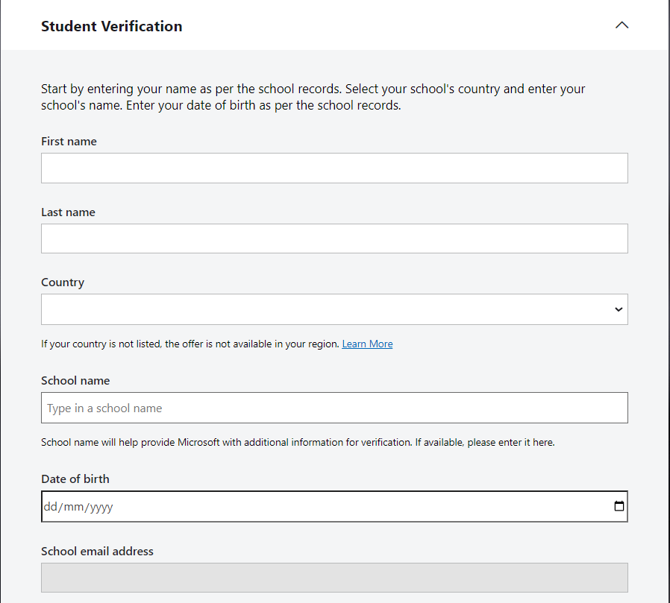

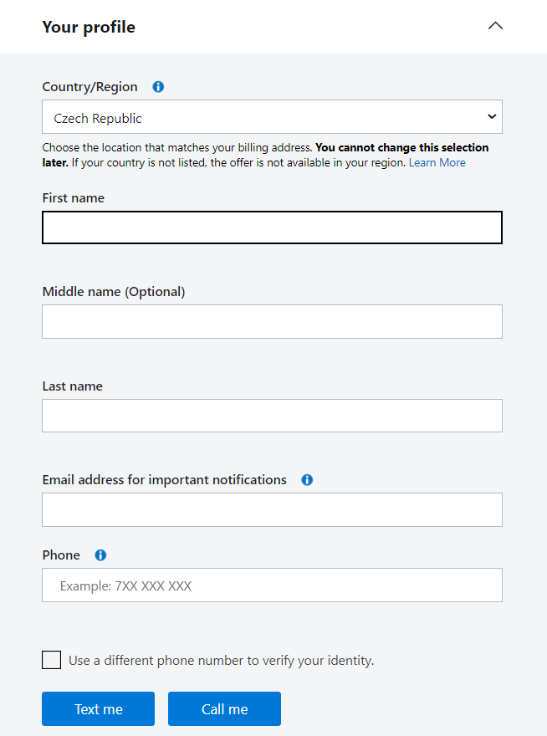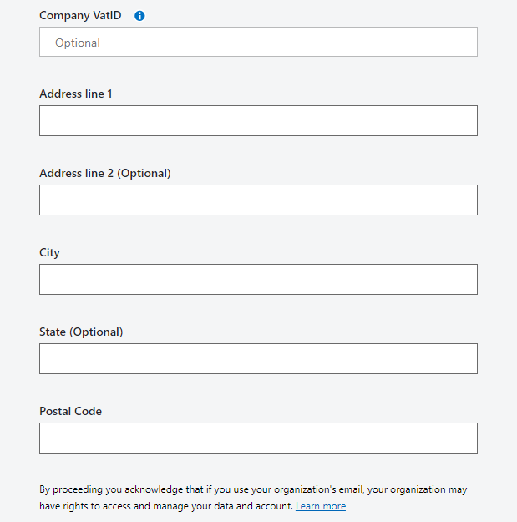

1. Once Azure account is created, click **Create a resource** in a panel of Azure services and search for **Databricks**

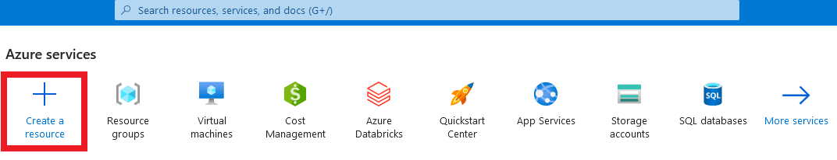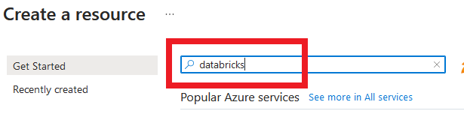

1. Choose Azure **Databricks** resource and click **create**.

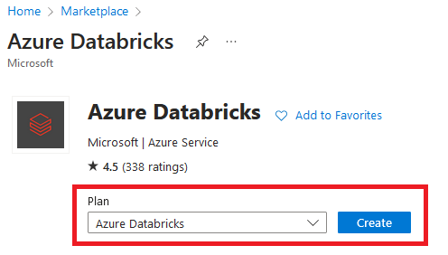

1. Fill out following fields, create a new **Resource group** if needed.   
   Red flagged filed fill as follows:   
   **Subscription:** Azure for Students, **Region:** West Europe, **Pricing Tier:** Standard

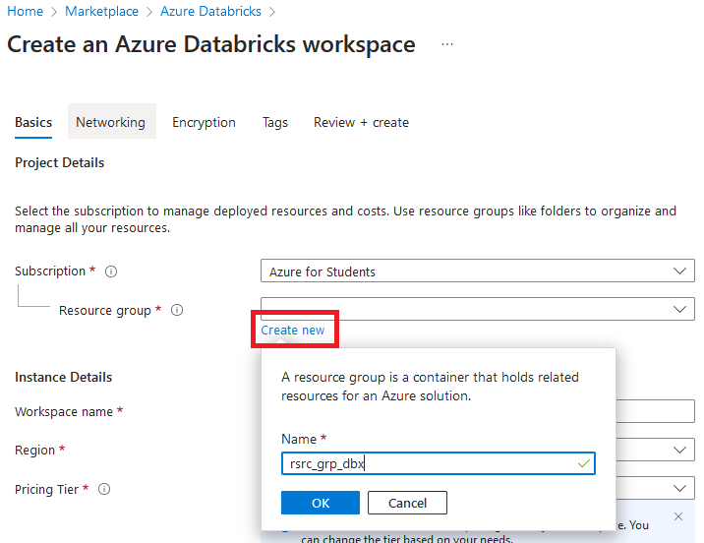

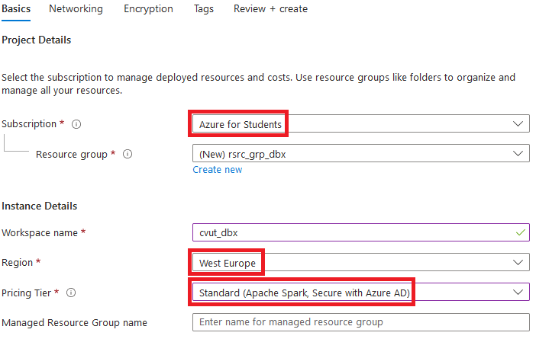

1. Click **Review + Create** and wait till resource is deployed.
2. Once deployed, launch **Databricks Workspace**

