|  |  |  |
| --- | --- | --- |
| Oakville TSA Newsletter | |  |
| January Edition  2018 |
|  | | |
| 2018: A Year Ahead | | |
| INSIDE THIS ISSUE   1. 2017: Year Roundup 2. Executive Spotlight Thomas Gleiforst 3. 2nd Annual TSA STEM Night Pictures 4. Executive Spotlight Thomas Gleiforst   **Events**  **Wednesday 1/24**  **TSA General Meeting 2:20-3:00**  **Saturday 3/17**  **TSA Regional Competition**  **Fri-Saturday 4/6-4/7**  **TSA lock-In** | When you hear the year *2017* what do you think of? What will it be remembered for? Many can still remember a majority of 2017, either if it was good or bad. Oakville TSA had one of its best years in 2017, and by the looks of it, 2018 is only going to get better.  TSA State Conference ~April 23rd-25th  The 2017 TSA State Conference was the first conference Oakville attended, and was a great start for those competing. The following induvial(s) were acknowledged for placing in competitions.  Architectural Design- 2nd  Kate Hoynacki  Engineering Design 2nd  Tom Hibbton, Clayton Brown, Nick Delucia-  On-Demand Video- 2nd and 3rd  Tommy Dong, Kevin Nguyen, Jake Walters, Sheldon Salins, Hannah Jokuti and Nicole Neher 2017: One heck of a Year By Jake Walters; Reporter | |

|  |  |
| --- | --- |
| C:\Users\20waltersj0516\Downloads\FB_IMG_1516735826376.jpg  Below: Pictures from the 2nd Annual TSA STEM Night Out  Question: *Why did you join TSA?*  I joined TSA because technology is the center of my life, and I feel like it is going to be the center of the future. I am going to go to Missouri University of Science and Technology to pursue Computer Science and Engineering, and technology centered competitions are a big deal there, so I wanted to get a head start in high school. I love competing in academic challenges, and TSA is the perfect club for that. It brings together all different sides of academic competitions, so I don't need to be on the quiz bowl team and the robotics club and speech and debate -- I can just be in TSA and do all of those things. To me, that is the beauty of TSA; like the real world, all the facets of technology are brought together instead of being addressed individually. This allowed me to play around with a lot of different challenges that I have equal interest in, which made it easier to decide what I think I want to go into after high school. Executive Spotlight: Thomas Gleiforst By Thomas Gleiforst: President |  |
| C:\Users\20waltersj0516\Downloads\drive-download-20180111T202054Z-001\DSC04309.jpgC:\Users\20waltersj0516\Downloads\drive-download-20180111T202054Z-001\DSC04320.jpg | |
| C:\Users\20waltersj0516\Downloads\drive-download-20180111T202054Z-001\DSC04343.jpg | |

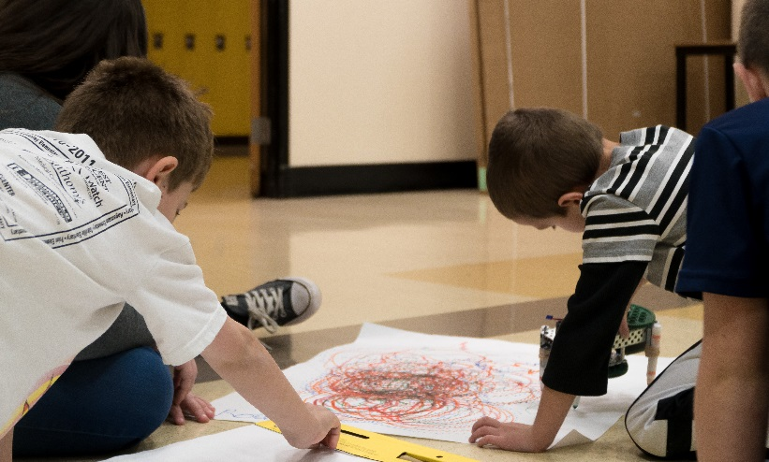

Oakville TSA

Newsletter

## Page 2