Worksheet No. 6

Student Name: ANINDITA DHAR UID: 25MCA20259
Branch: MCA (GENERAL) Section/Group: MCA- 1-A
Semester: II Date of Performance: 27/01/2026
Subject Name: Technical Training Subject Code: 25CAP-652

1.Aim/Overview of the practical:
Learn how to create, query, and manage views in SQL to simplify database queries and provide a layer of abstraction for end-users.

2. Objectives:
- Data Abstraction: To understand how to hide complex table joins and calculations behind a simple virtual table interface.
- Enhanced Security: To learn how to restrict user access to sensitive columns by providing views instead of direct table access.
- Query Simplification: To master the creation of views that pre-join multiple tables, making reporting easier for non-technical users.
- View Management: To understand the syntax for creating, altering, and dropping views, as well as the naming conventions required for efficient data access.

3. Input/Apparatus Used:
    - PostgreSQL
- pgAdmin

4. Practical / Experiment Steps

Step 1: Creating a Simple View for Data Filtering

Implementing a view to provide a quick list of active employees without exposing the entire table structure.

Step 2: Creating a View for Joining Multiple Tables

Simplifying the retrieval of data distributed across the Employees and Departments tables.

Step 3: Advanced Summarisation View

Creating a view to provide department-level statistics automatically

5.Procedure/Algorithm/Code:

- Start the system and log in to the computer.

ii. Open PostgreSQL software.

iii. Create a table using the DDL command.

CREATE TABLE Departments_ (

dept_id INT PRIMARY KEY,

dept_name VARCHAR (50)

);

CREATE TABLE Employees_5(

emp_id INT PRIMARY KEY,

emp_name VARCHAR(50),

salary NUMERIC,

status VARCHAR(10),

dept_id INT,

FOREIGN KEY (dept_id) REFERENCES department(dept_id)

);

iv. Insert records into both tables.

INSERT INTO Departments_ VALUES

(1, 'HR')

INSERT INTO Departments_ VALUES

(2, 'IT')

INSERT INTO Departments_ VALUES

(3, 'Finance')

INSERT INTO Employees_5 VALUES

(1, 'Roshan', 30000, 'Active', 2)

INSERT INTO Employees_5 VALUES

(2, 'Anindita', 40000, 'Active', 2)

INSERT INTO Employees_5 VALUES

(3, 'Shriya', 25000, 'Inactive', 1)

INSERT INTO Employees_5 VALUES

(4, 'Anju', 35000, 'Active', 3)

INSERT INTO Employees_5 VALUES

(5, 'Sanjana', 28000, 'Active', 1);

v.

CREATE VIEW active_employees AS

SELECT emp_id, emp_name, dept_id

FROM Employees_5

WHERE status = 'Active';

SELECT * FROM active_employees;

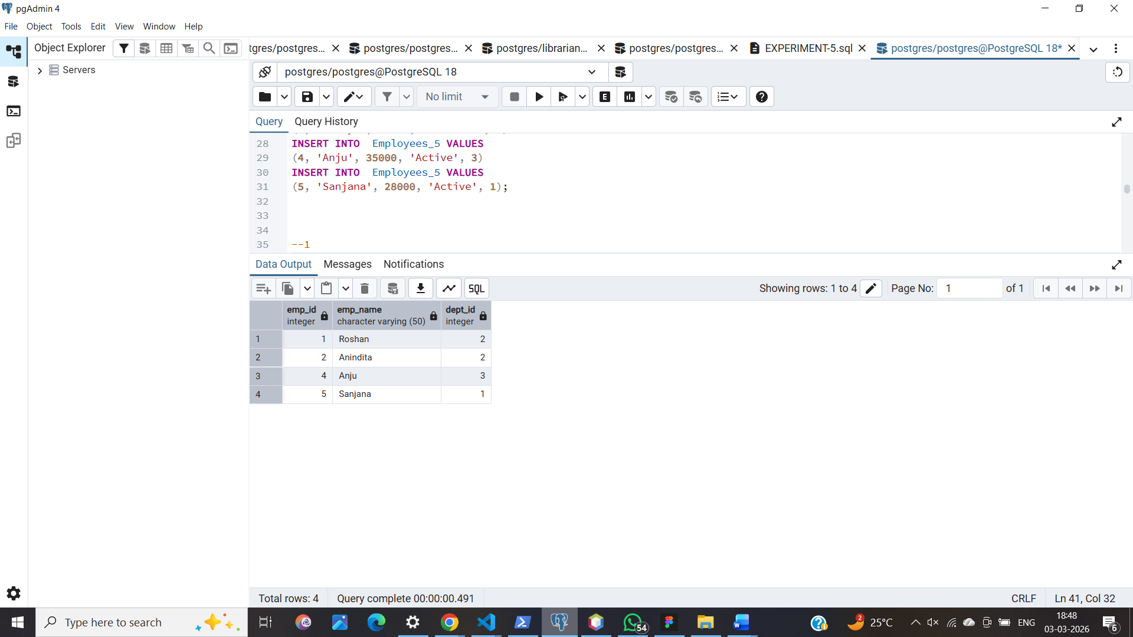

viii.
CREATE VIEW employee_department_view AS
SELECT e.emp_id, e.emp_name, d.dept_name
FROM employee e
JOIN department d ON e.dept_id = d.dept_id;

SELECT * FROM employee_department_view;

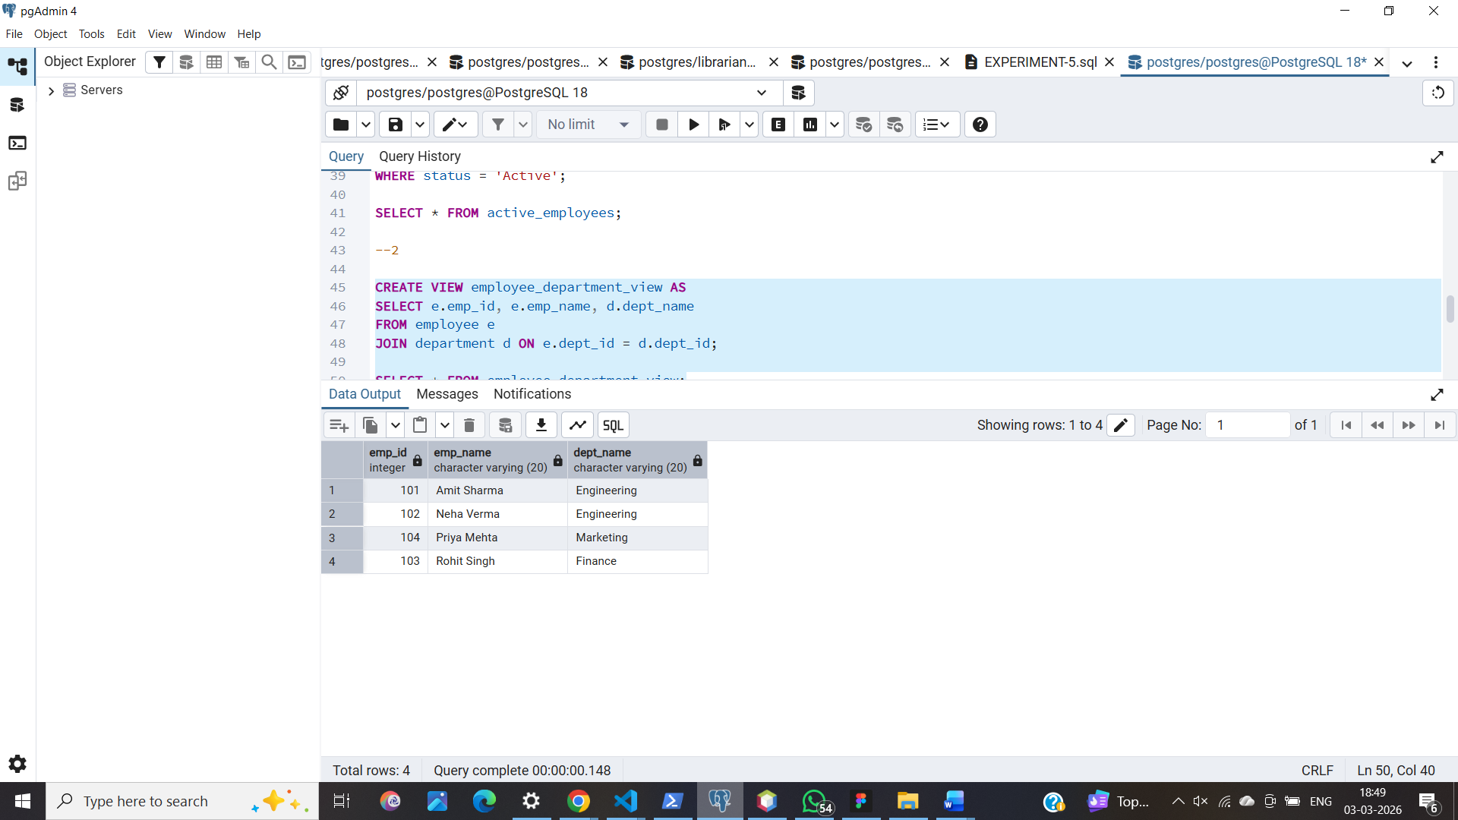

ix.
CREATE VIEW department_summary AS
SELECT d.dept_name,
COUNT(e.emp_id) AS total_employees,
AVG(e.salary) AS average_salary
FROM department d
JOIN employee e ON d.dept_id = e.dept_id
GROUP BY d.dept_name;

SELECT * FROM department_summary;

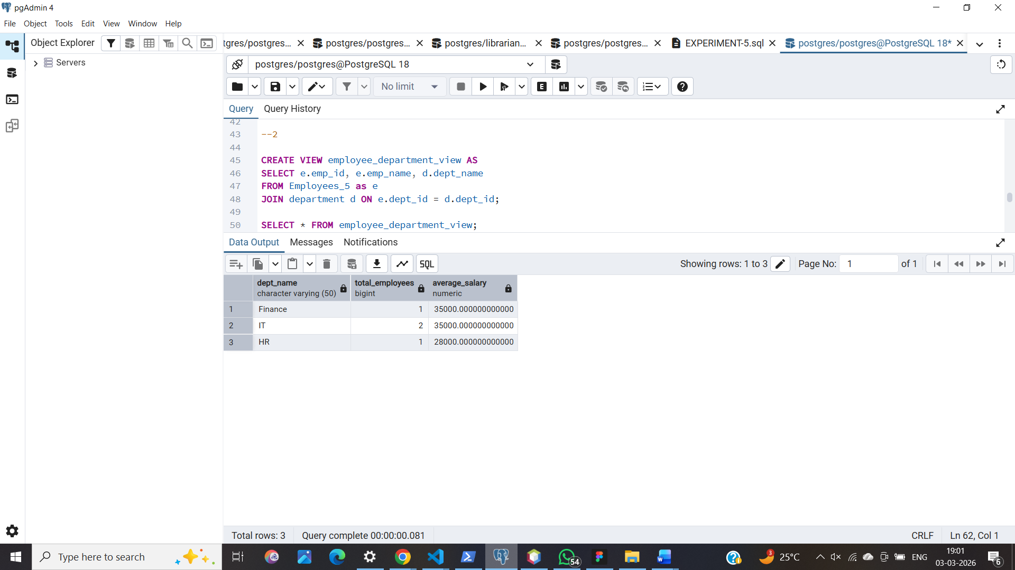

DROP VIEW department_summary;

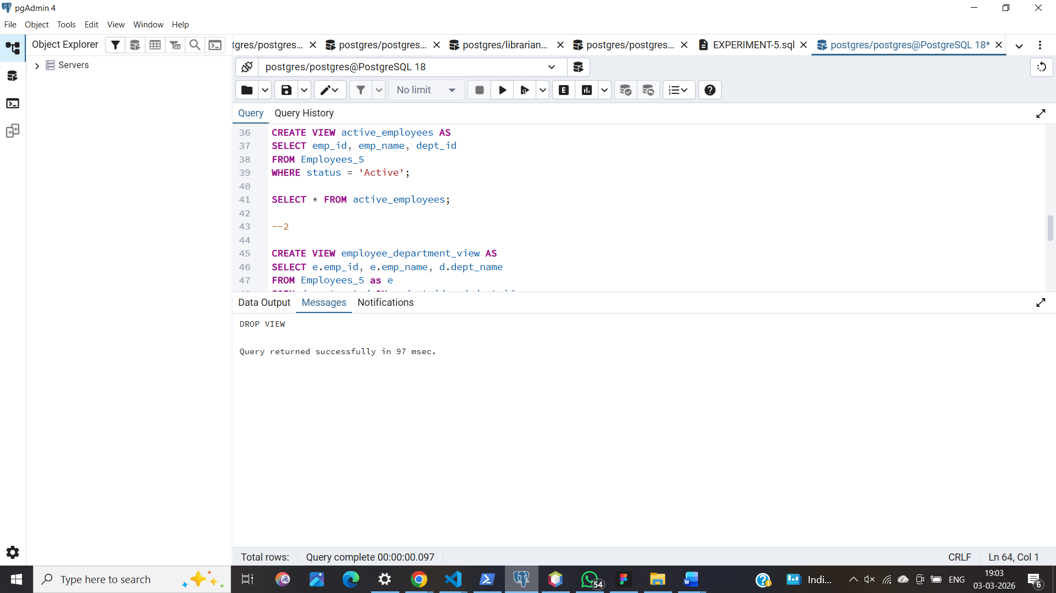

7. Learning Outcomes
- Abstraction Proficiency: Students will be able to create and query views to simplify efficient data access and abstraction.

- Security Implementation: Students will understand how to use views for data masking and providing restricted access to sensitive information.

- Syntactic Accuracy: Students will demonstrate the correct syntax for creating and querying views, ensuring logical clarity in naming conventions.

- Real-world Application: Students will be able to design views for practical domains like Library Management Systems or Payroll Systems to demonstrate functionality.

