Worksheet No. 5

Student Name: ANINDITA DHAR UID: 25MCA20259
Branch: MCA (GENERAL) Section/Group: MCA- 1-A
Semester: II Date of Performance: 23/01/2026
Subject Name: Technical Training Subject Code: 25CAP-652

1.Aim/Overview of the practical:
To gain hands-on experience in creating and using cursors in PostgreSQL for row-by-row data processing, enabling sequential access and manipulation of query results.
2. Objectives:
      - To understand the concept and need of cursors in PostgreSQL
- To learn sequential data access using cursors
- To perform row-level manipulation using cursor logic
- To understand cursor lifecycle management
- To handle cursor termination and exceptions.

3. Input/Apparatus Used:
    - PostgreSQL
- pgAdmin

4. Practical / Experiment Steps
Pre-requisite Understanding
Step 1: Implementing a Simple Forward-Only Cursor
Creating a cursor to loop through an Employee table and print individual records.
Step 2: Complex Row-by-Row Manipulation
Using a cursor to update salaries based on a dynamic "Experience-to-Performance" ratio logic.
Step 3: Exception and Status Handling
Ensuring the cursor handles empty result sets or termination signals gracefully

4.Procedure/Algorithm/Code:

- Start the system and log in to the computer.

ii. Open PostgreSQL software.

iii. Create a table using the DDL command.

CREATE TABLE Employees_1(

emp_id INT PRIMARY KEY,

emp_name VARCHAR(50),

salary INT,

experience INT,

performance VARCHAR(1)

);

iv. Insert records into the table .

INSERT INTO Employees_1 VALUES

(1, 'Aninidta', 25000, 5, 'B');

INSERT INTO Employees_1 VALUES

(2, 'Kunal', 40000, 3, 'A');

INSERT INTO Employees_1 VALUES

(3, 'Atharva', 25000, 2, 'C');

INSERT INTO Employees_1 VALUES

(4, 'Vandana', 30000, 4, 'A');

INSERT INTO Employees_1 VALUES

(5, 'Sakhi', 30000, 3, 'B');

vi.

DO $$

DECLARE

emp_cursor CURSOR FOR

SELECT emp_id, emp_name, salary FROM Employees_1;

rec RECORD;

BEGIN

OPEN emp_cursor;

LOOP

FETCH emp_cursor INTO rec;

EXIT WHEN NOT FOUND;

RAISE NOTICE 'ID: %, Name: %, Salary: %',

rec.emp_id, rec.emp_name, rec.salary;

END LOOP;

CLOSE emp_cursor;

END $$;

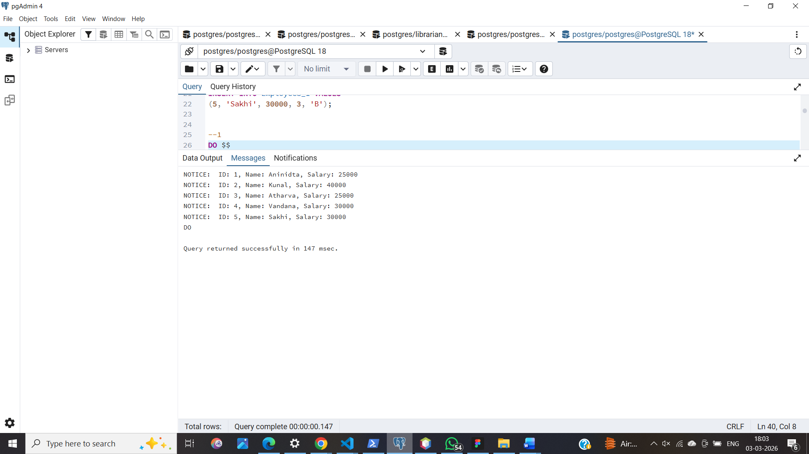

viii.

DO $$

DECLARE

emp_cursor CURSOR FOR

SELECT emp_id, salary, experience, performance FROM Employees_1;

rec RECORD;

new_salary NUMERIC;

BEGIN

OPEN emp_cursor;

LOOP

FETCH emp_cursor INTO rec;

EXIT WHEN NOT FOUND;

IF rec.experience >= 5 AND rec.performance = 'A' THEN

new_salary := rec.salary * 1.20;

ELSIF rec.experience >= 3 AND rec.performance = 'B' THEN

new_salary := rec.salary * 1.10;

ELSE

new_salary := rec.salary * 1.05;

END IF;

UPDATE employee

SET salary = new_salary

WHERE emp_id = rec.emp_id;

END LOOP;

CLOSE emp_cursor;

END $$;

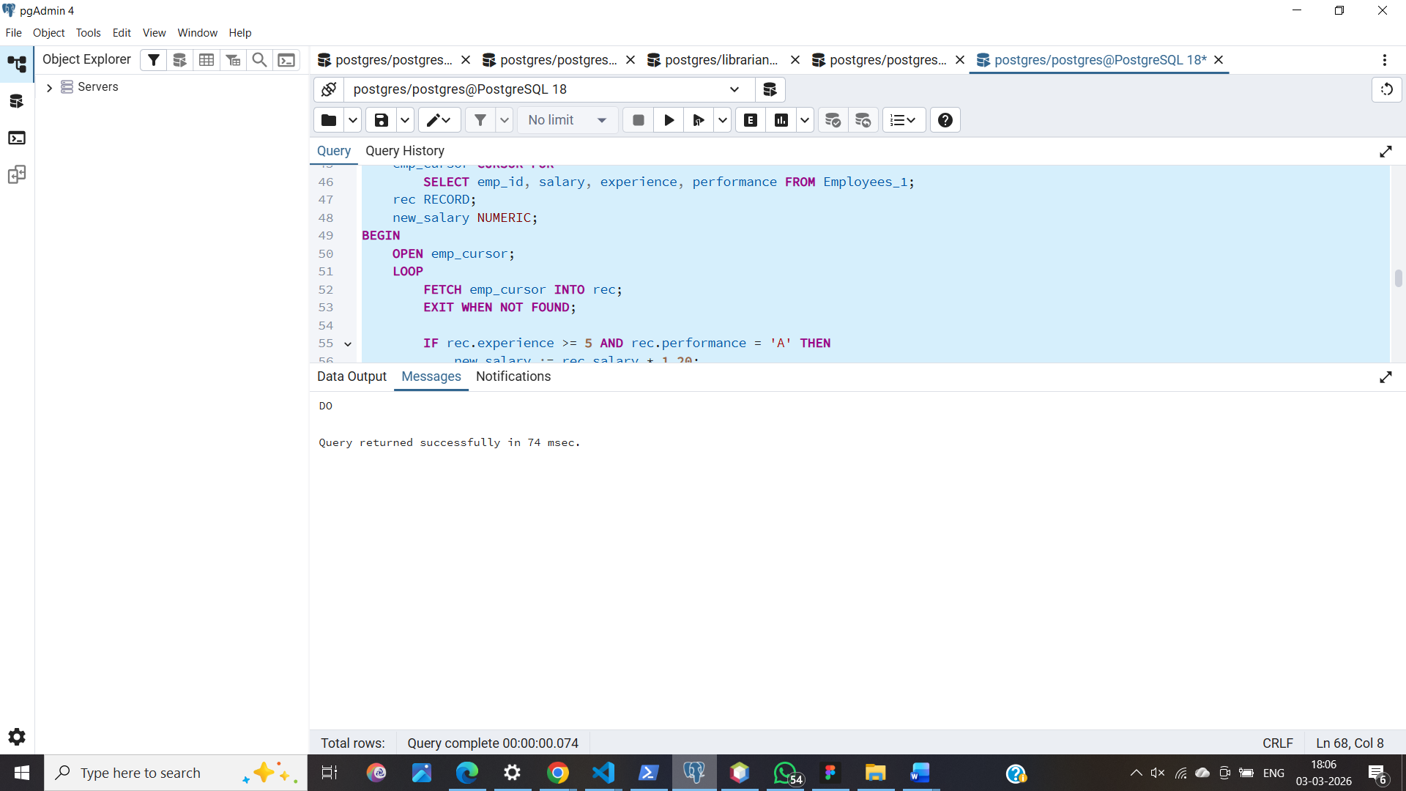

ix.
DO $$
DECLARE
emp_cursor CURSOR FOR SELECT * FROM Employees_1;
rec RECORD;
BEGIN
OPEN emp_cursor;
LOOP
FETCH emp_cursor INTO rec;
EXIT WHEN NOT FOUND;
RAISE NOTICE 'Processing Employee: %', rec.emp_name;
END LOOP;
CLOSE emp_cursor;

EXCEPTION
WHEN OTHERS THEN
RAISE NOTICE 'Error occurred: %', SQLERRM;
END $$;

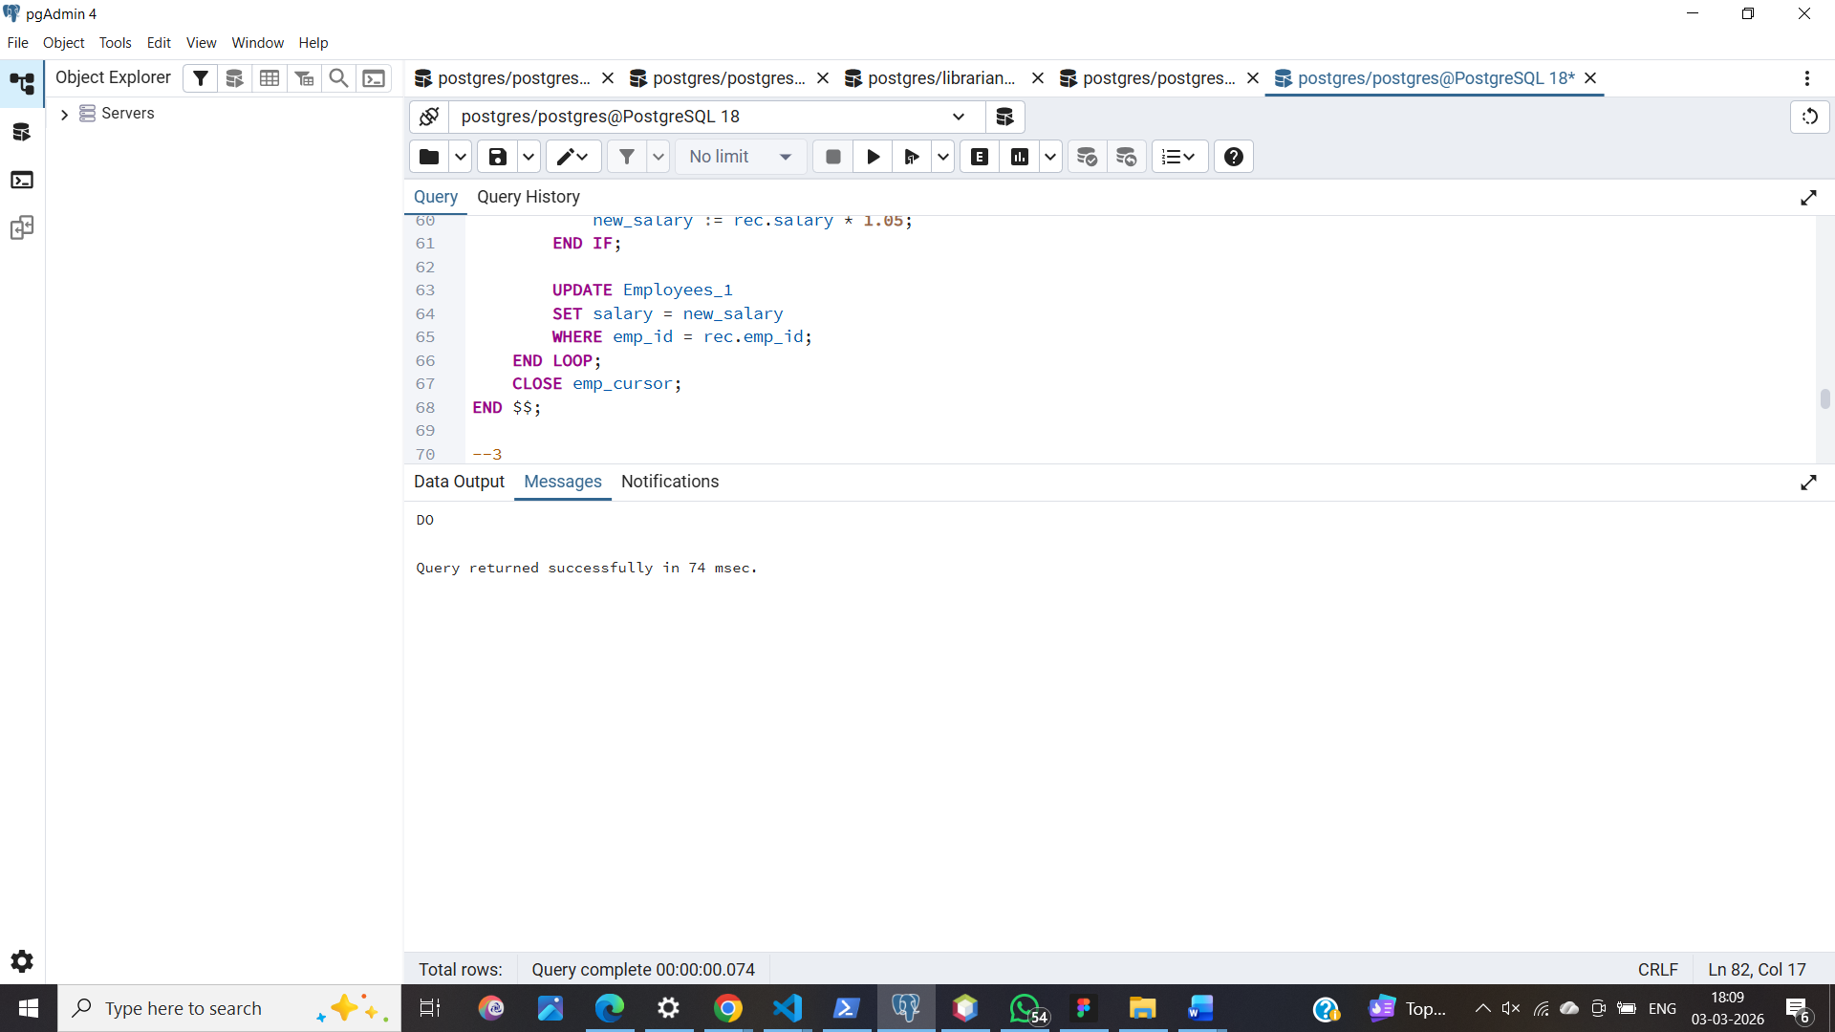

7. Learning Outcomes

- Cursor Implementation: Students will be able to design, implement, and manage cursors to solve row-wise processing problems.
- Lifecycle Mastery: Students will demonstrate the correct syntax for declaring, opening, fetching, and closing cursors.
- Error Prevention: Students will understand how to properly handle row-by-

row processing exceptions and prevent memory leaks via deallocation.

- Analytical Thinking: Students will be able to apply cursor-based logic to solve real-world scenarios like multi-level payroll adjustments or data migrations.

