Worksheet No. 10

Student Name: ANINDITA DHAR UID: 25MCA20259
Branch: MCA (GENERAL) Section/Group: MCA- 1-A
Semester: II Date of Performance: 21/04/2026
Subject Name: Technical Training Subject Code: 25CAP-652

1.Aim/Overview of the practical:
To write a transaction that performs multiple database operations.

2. Objectives:
To write a transaction that performs multiple database operations.

3. Input/Apparatus Used:
    - PostgreSQL
- pgAdmin
4.Procedure/Algorithm/Code:
a. Table Creation
CREATE TABLE Payroll (
emp_id INT PRIMARY KEY,
emp_name VARCHAR(50),
salary DECIMAL (10,2) CHECK(SALARY>0)
);

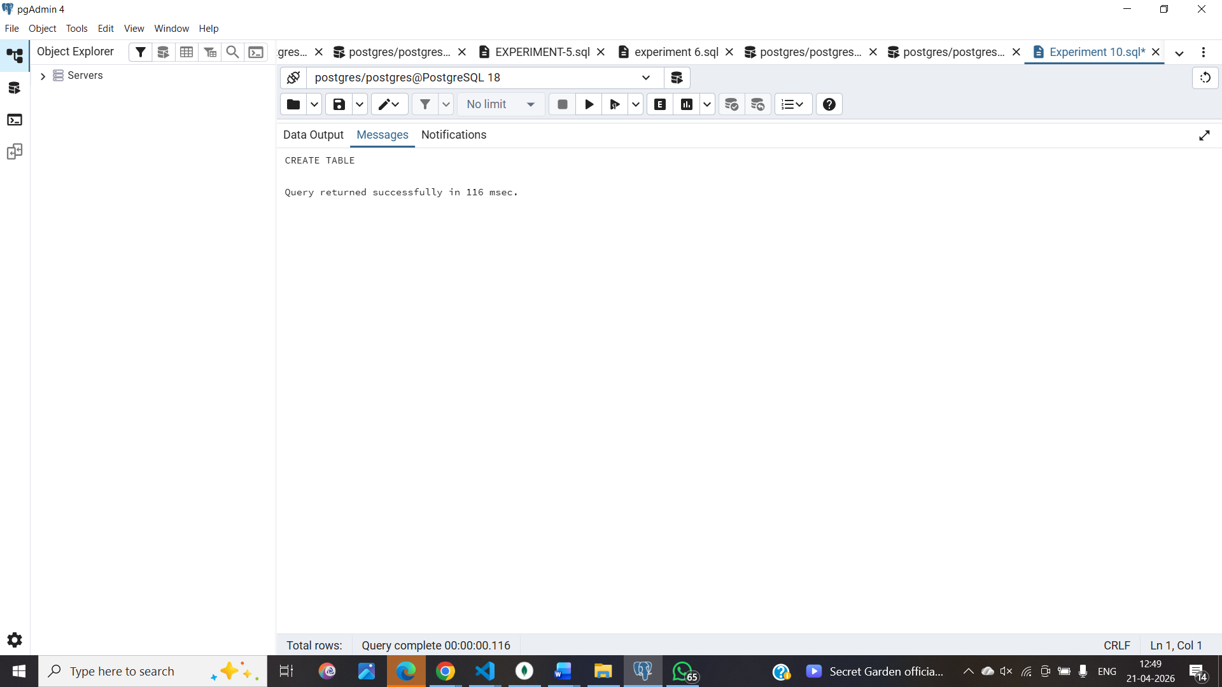
b. Inserting records into the table
INSERT INTO Payroll VALUES
(1, 'Amit', 30000),
(2, 'Neha', 40000),
(3, 'Ravi', 50000);

c.View the records
SELECT * FROM PAYROLL

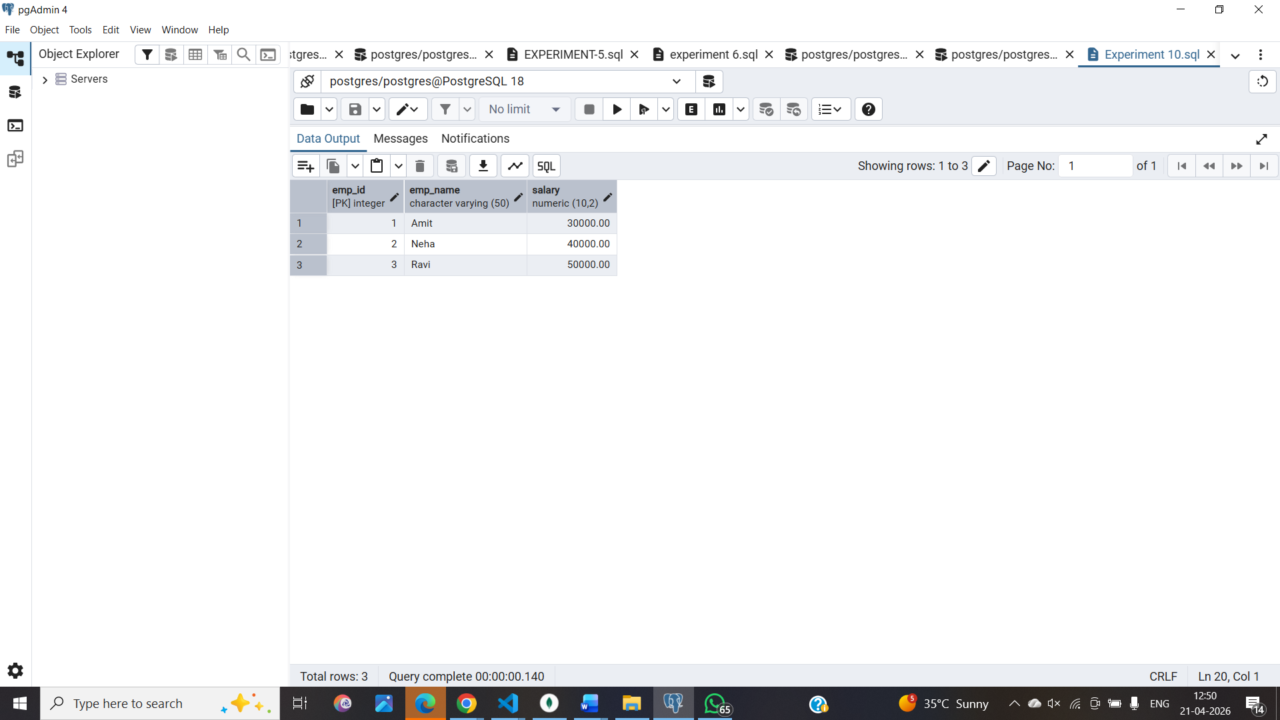

d. Begin the transaction
BEGIN;
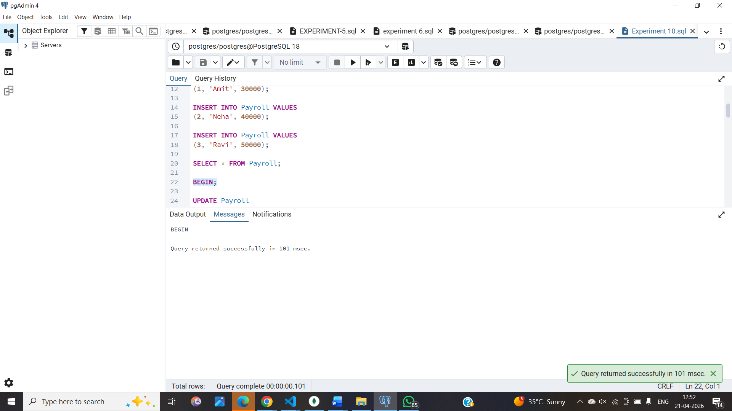

e. First Update
UPDATE Payroll
SET salary = salary + 5000
WHERE emp_id = 1;
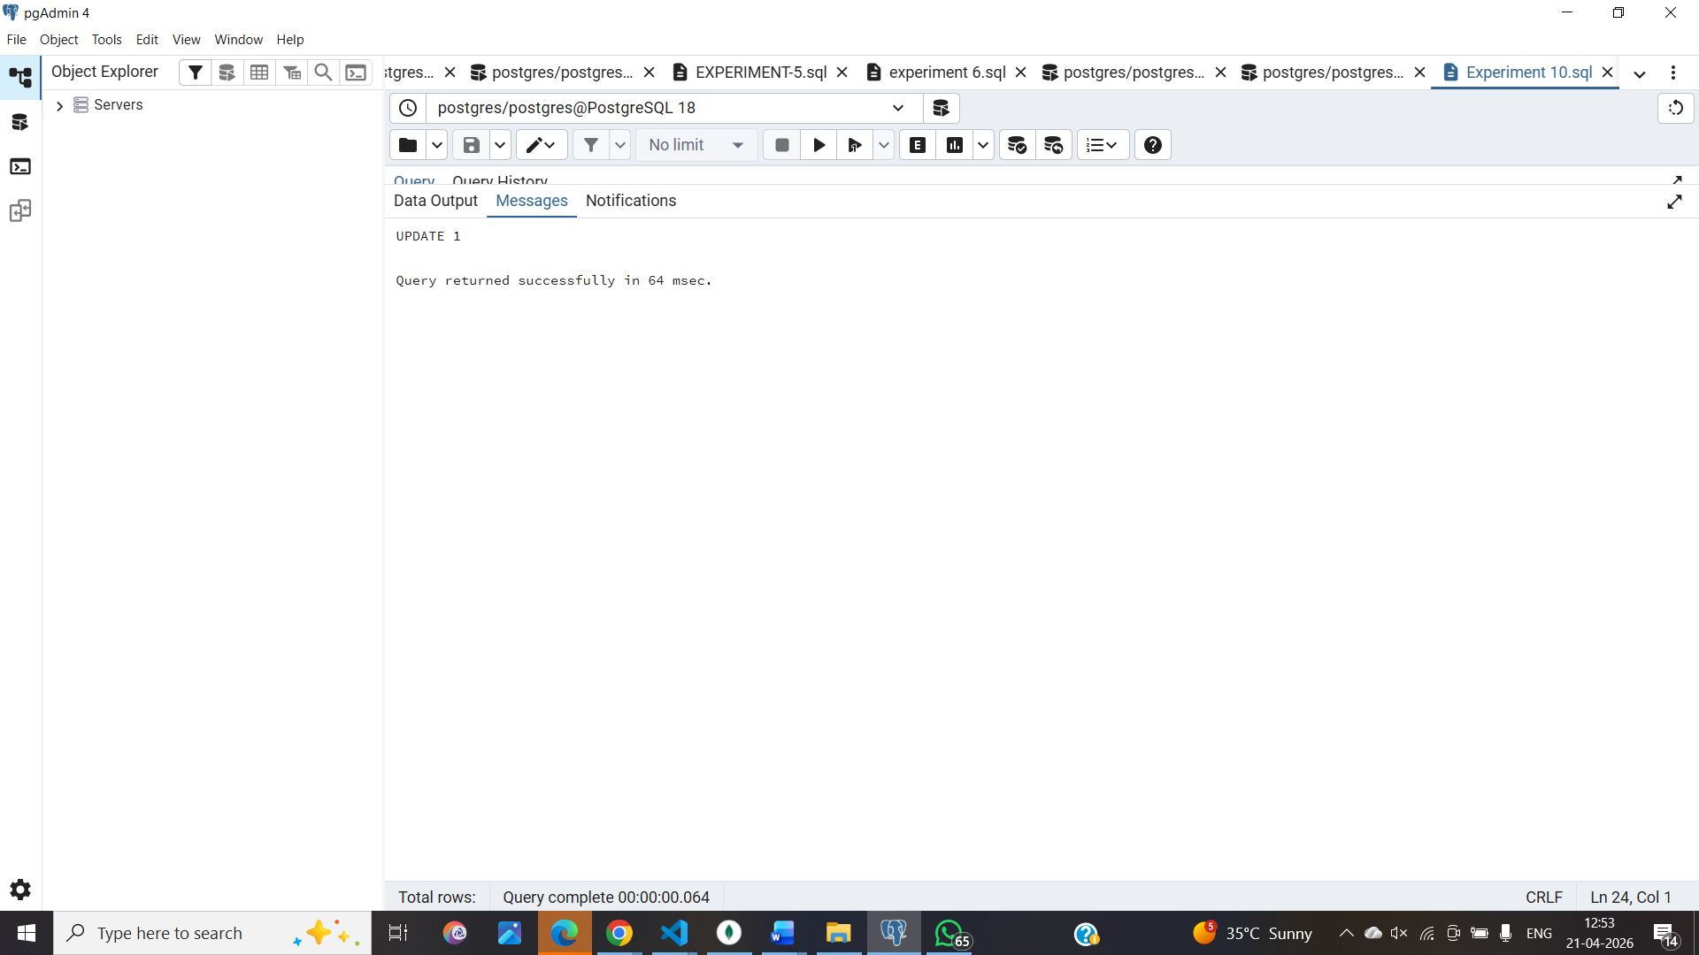
SELECT * FROM Payroll;

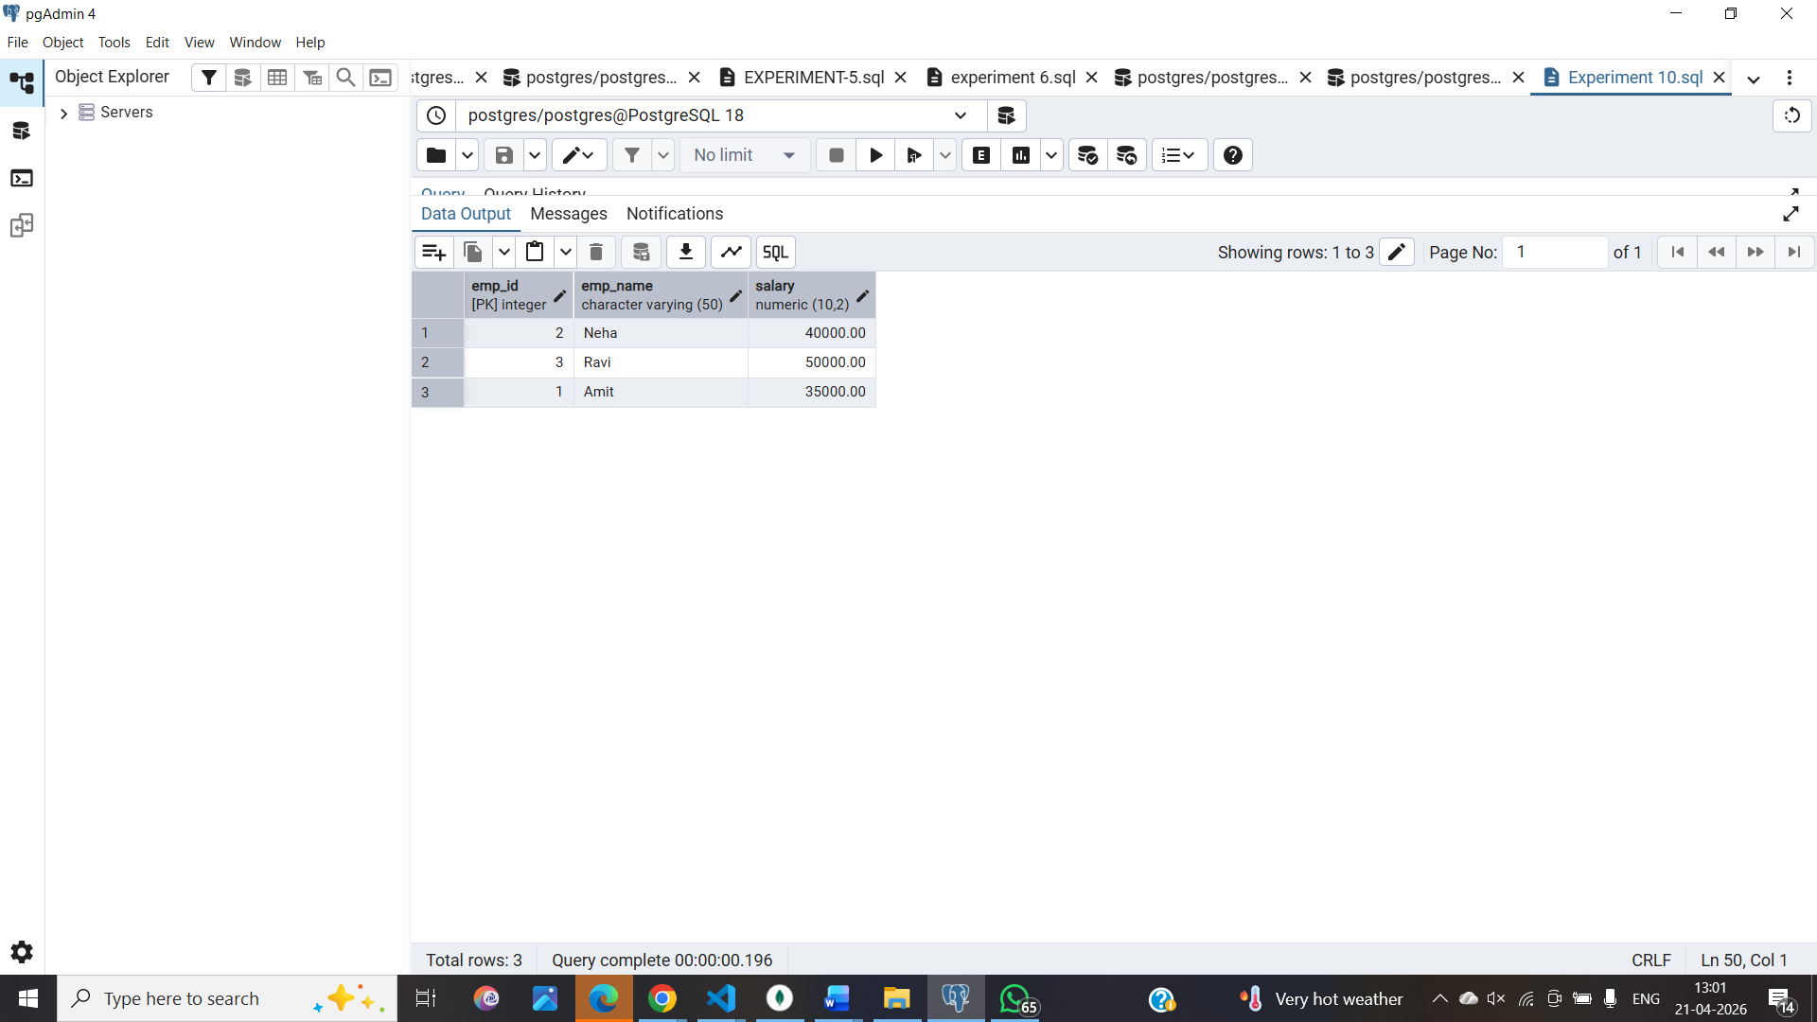
f. Savepoint
SAVEPOINT sp1;

-- Update 2
UPDATE Payroll
SET salary = salary + 7000
WHERE emp_id = 2;

-- Error simulation
UPDATE Payroll
SET salary = -1000
WHERE emp_id = 3;

-- Rollback to savepoint
ROLLBACK TO sp1;

g.Commit valid changes
COMMIT;

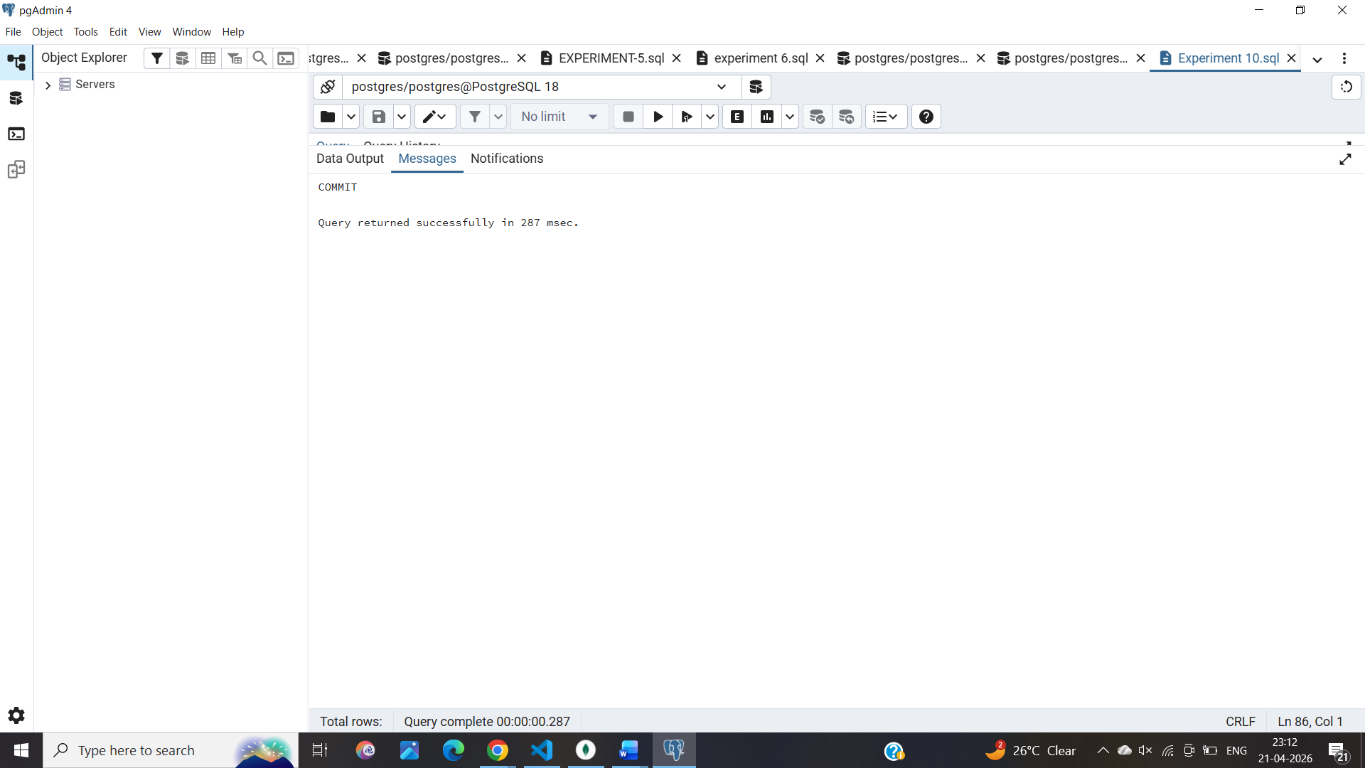

5. Learning Outcomes:
1. Using TCL commands COMMIT, ROLLBACK and SAVEPOINT in PostgreSQL.
2. Transactions in DBMS.

