Worksheet No. 9

Student Name: ANINDITA DHAR UID: 25MCA20259
Branch: MCA (GENERAL) Section/Group: MCA- 1-A
Semester: II Date of Performance: 7/04/2026
Subject Name: Technical Training Subject Code: 25CAP-652

1.Aim/Overview of the practical:
To understand and implement triggers in PostgreSQL.

2. Objectives:
To understand and implement triggers in PostgreSQL.

3. Input/Apparatus Used:
    - PostgreSQL
- pgAdmin

4.Procedure/Algorithm/Code:

- Create the table:
CREATE TABLE employee (
emp_id INT PRIMARY KEY,
emp_name VARCHAR (50),
working_hours INT,
perhour_salary NUMERIC,
total_payable_amount NUMERIC
);

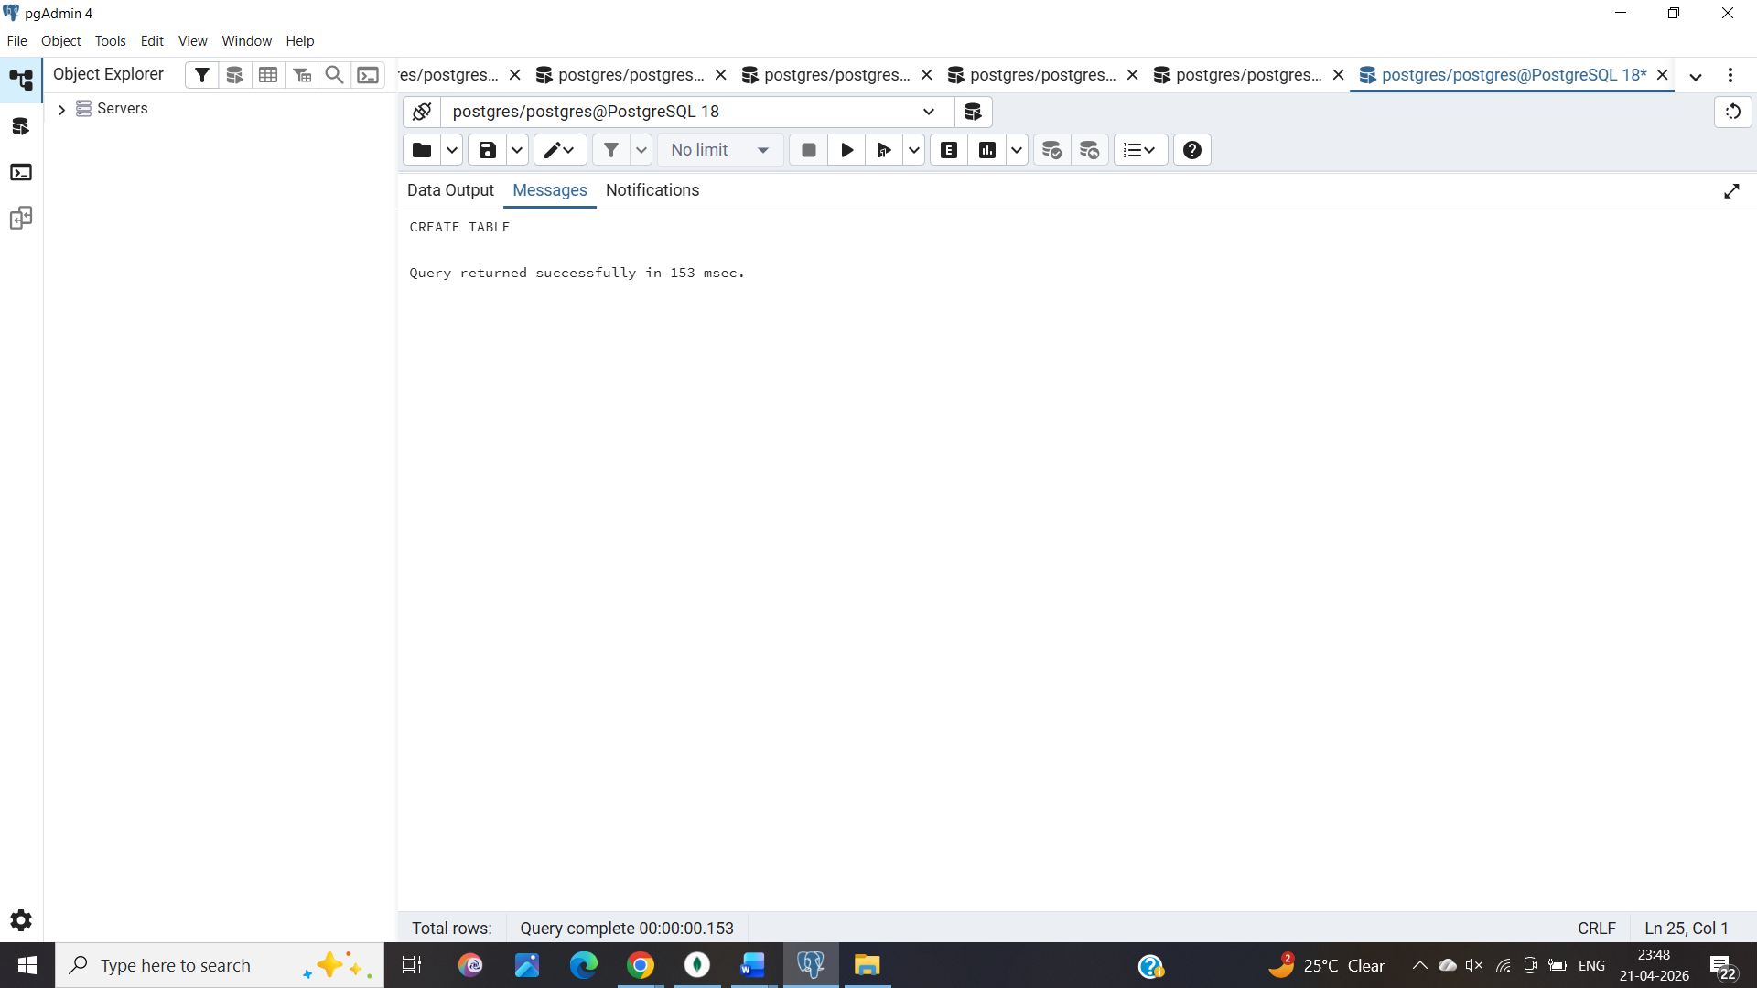

2. Creating a function
CREATE OR REPLACE FUNCTION CACULATE_PAYABLE_AMOUNT () RETURNS TRIGGER
AS
$$
BEGIN
NEW.total_payable_amount:=NEW.perhour_salary*New.working_hours;

IF NEW.total_payable_amount>25000 THEN
RAISE EXCEPTION 'INVALID ENTRY BECAUSE PAYABLE AMOUNT CAN NOT BE GREATER THAN 25000';

END IF;

RETURN NEW;
END;

$$ LANGUAGE PLPGSQL;

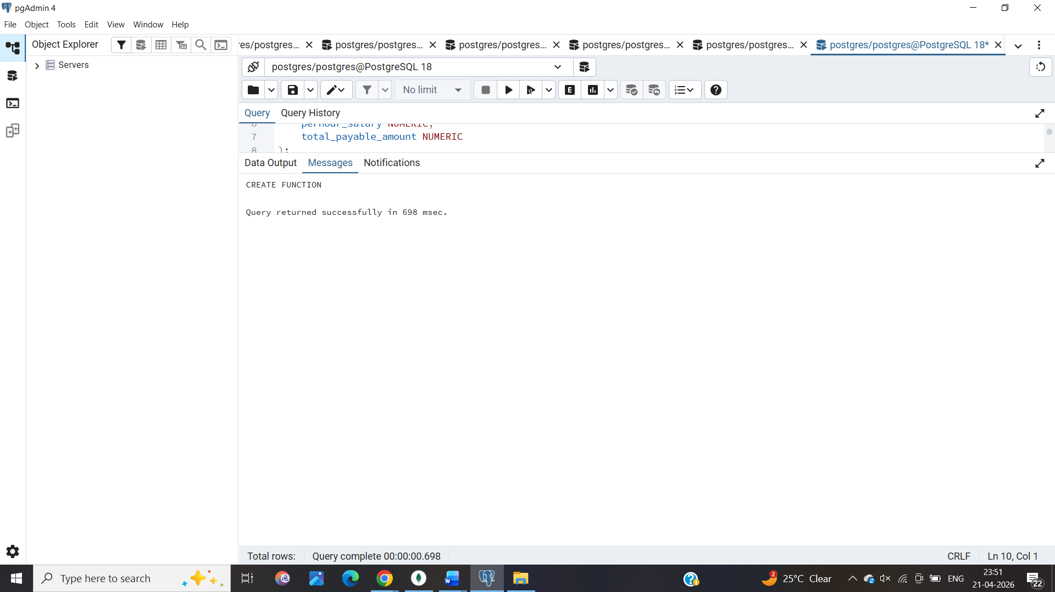
3. Create a trigger
CREATE OR REPLACE TRIGGER AUTOMATED_PAYABLE_AMOUNT_CALCULATION
BEFORE INSERT
ON employee
FOR EACH ROW
EXECUTE FUNCTION CACULATE_PAYABLE_AMOUNT()

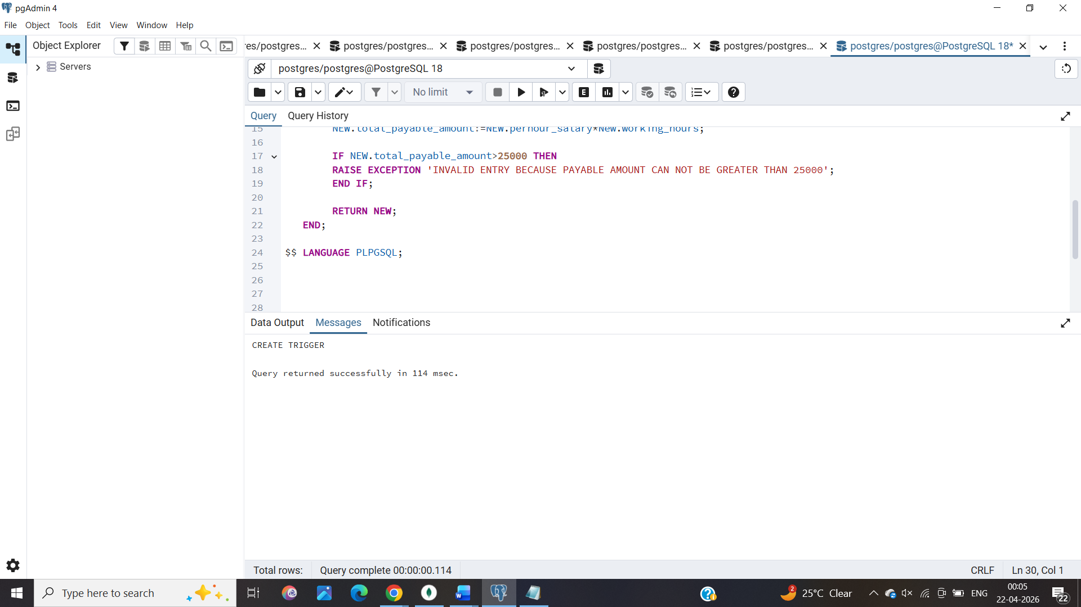

INSERT INTO employee (emp_id, emp_name, working_hours, perhour_salary)
VALUES (1, 'AKASH', 10, 1000);

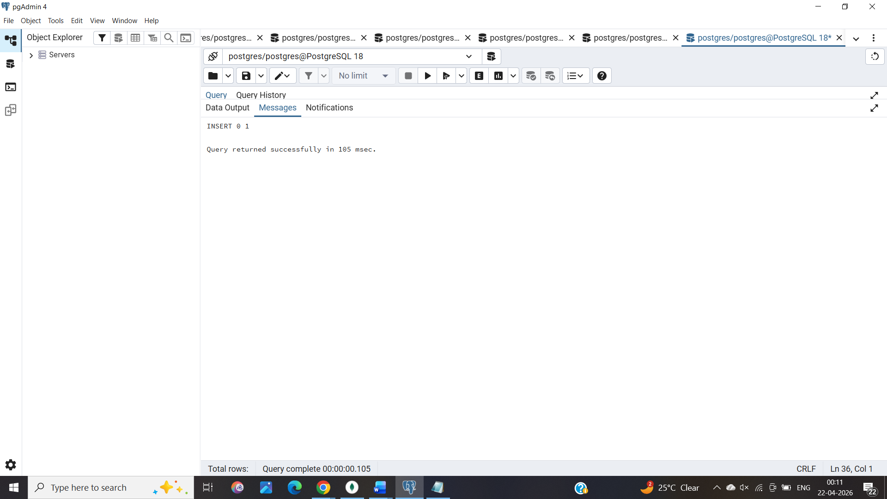

5. Learning Outcomes:
1. Using TCL commands COMMIT, ROLLBACK and SAVEPOINT in PostgreSQL.
2. Transactions in DBMS.

