Table of Contents

2. Introduction/Objectives 4

2.1 Project Background 4

2.2 Objectives of the Project 5

3. System Analysis 6

3.1 Identification of Need 6

3.2 Preliminary Investigation 6

3.3 Feasibility Study 7

3.3.1 Technical Feasibility 7

3.3.2 Operational Feasibility 8

3.3.3 Schedule Feasibility 9

Overall Feasibility Conclusion 9

4. Project Planning 9

4.1 Project Scope 10

4.2 Resource Allocation 10

4.3 Project Scheduling 11

4.3.2 Gantt Chart 11

4.4 Risk Management 13

4.5 Communication Plan 13

4.6 Conclusion of Project Planning 14

5. Software Requirement Specifications (SRS) 14

5.1 Functional Requirements 14

5.2 Non-Functional Requirements 15

5.3 External Interface Requirements 16

6. Software Engineering Paradigm Applied 16

7. Data Models and Diagrams 17

7.1 Data Flow Diagrams (DFD) 17

7.2 Sequence Diagrams 18

7.3 Entity-Relationship (ER) Models 19

Conclusion of SRS, Software Engineering Paradigm, and Data Models 22

8. System Design 23

8.1 Modularization Details 23

8.2 Data Integrity and Constraints 24

8.3 Database Design 25

8.4 Service-Based Architecture Design 25

8.5 User Interface Design 26

Conclusion of System Design 26

9. Test Cases 26

9.1 Testing Techniques and Strategies Used 26

9.2 Test Cases 27

9.3 Test Plan Used 29

10. Coding 29

10.1 Standardization of the Coding 29

10.2 Code Efficiency 30

10.3 Key Implementations 31

Conclusion of Coding 36

11. System Security Measures 36

11.1 Current Status 36

11.2 Recommended Security Enhancements 36

11.3 Future Steps for Security Implementation 37

12. Cost Estimation and its Model 38

12.1 Cost Estimation Model 38

12.2 Detailed Cost Breakdown 39

12.3 Total Estimated Cost 39

12.4 Cost Estimation Model Used 39

Conclusion of Cost Estimation and its Model 39

13. Future Scope 40

13.1 Potential Enhancements 40

13.2 Long-Term Vision 41

Conclusion of Future Scope 41

14. Bibliography 42

14.1 List of References 42

14.2 Citation Format 43

Conclusion of Bibliography 43

15. Appendices 43

15.1 Appendix A: Data Dictionary 43

15.2 Appendix B: Test Case Reports 45

Conclusion of Appendices 45

# 2. Introduction/Objectives

## 2.1 Project Background

The advent of artificial intelligence (AI) has revolutionized various sectors, including customer service, where AI-powered chatbots have become essential tools for enhancing customer interaction and support. In the e-commerce sector, chatbots are particularly valuable for providing real-time assistance, managing customer queries, and guiding users through their shopping experiences. Given the increasing reliance on digital customer engagement, the development of an AI-powered chatbot, **ShopBuddy**, is timely and strategic.

**ShopBuddy** is an AI-driven chatbot designed to serve as an interactive customer support assistant for e-commerce platforms. It aims to streamline customer interactions by providing instant responses to common queries, assisting with order tracking, recommending products, and facilitating a seamless shopping experience. The need for this project arises from several key challenges currently faced by e-commerce platforms:

* + **High Customer Support Costs:** Traditional customer support methods require significant manpower, leading to high operational costs. Automating customer support through an AI chatbot can reduce costs and increase efficiency.
  + I**nconsistent Customer Experience:** Human agents can vary in the quality of service they provide, leading to inconsistent customer experiences. An AI chatbot can provide standardized, 24/7 support, ensuring a consistent and reliable experience for all customers.
    - **Growing Demand for Instant Responses:** In today’s fast-paced world, customers expect quick and accurate responses to their queries. An AI chatbot can meet this demand by providing instant, real-time answers, improving customer satisfaction and retention rates.
  + **Scalability Challenges:** As e-commerce platforms grow, scaling human customer support can be challenging and costly. AI chatbots, however, can handle an increasing number of customer interactions without the need for proportional increases in staff.
  + **High Volume of Customer Queries:** E-commerce platforms often deal with a large number of customer inquiries, ranging from product availability to order status. Handling these queries manually can be time-consuming and may lead to delays, impacting customer satisfaction.
  + **Inconsistent Customer Support:** Human-operated customer service can vary in quality due to factors such as time of day, staff availability, and employee experience. This inconsistency can result in poor customer experiences and loss of trust.
  + **Demand for 24/7 Service:** Customers increasingly expect round-the-clock support. Traditional customer service models are not cost-effective for providing 24/7 assistance, especially for smaller businesses or those with limited resources.
  + **Personalized Shopping Experience:** Modern consumers prefer personalized interactions that cater to their specific needs and preferences. Traditional customer support systems often lack the capability to provide tailored recommendations or personalized assistance.

**ShopBuddy** is designed to address these challenges by leveraging advanced AI and natural language processing (NLP) technologies to offer a scalable, efficient, and personalized customer support solution.

## 2.2 Objectives of the Project

The development of **ShopBuddy** is guided by several key objectives aimed at maximizing its effectiveness and value for e-commerce platforms:

* + **Automate Customer Interactions:** The primary objective is to automate responses to frequently asked questions and routine inquiries, such as order tracking, product information, and return policies. By doing so, ShopBuddy will reduce the workload on human customer service representatives and improve response times.
  + **Provide 24/7 Customer Support**: ShopBuddy aims to deliver uninterrupted customer service, ensuring that users receive instant assistance at any time of day or night. This objective will help enhance customer satisfaction and foster loyalty by meeting the demand for continuous support.
  + **Enhance Customer Engagement with AI-Driven Conversations**: The chatbot will utilize natural language processing (NLP) and machine learning algorithms to understand and respond to customer queries in a human-like manner. This approach aims to create more engaging and interactive customer experiences.
  + **Personalize Recommendations and Offers**: ShopBuddy will analyze user behavior and preferences to provide personalized product recommendations and promotional offers. This objective is designed to enhance the shopping experience by aligning with the specific needs and interests of each customer.
  + **Integrate Seamlessly with E-commerce Platforms**: The chatbot will be developed to integrate seamlessly with existing e-commerce platforms, utilizing APIs to access necessary data (e.g., product catalog, inventory, order history). This objective ensures that ShopBuddy can provide accurate and up-to-date information to users.
  + **Ensure Data Privacy and Security**: A critical objective is to implement robust data privacy and security measures to protect user information. ShopBuddy will comply with relevant data protection regulations, such as GDPR, to ensure customer data is handled responsibly and securely.
  + **Scalability and Future Expansion**: The chatbot will be designed with scalability in mind, allowing it to handle increasing volumes of traffic as the e-commerce platform grows. Additionally, the architecture will support future enhancements, such as the introduction of new languages or features.
  + **Cost-Effective Solution for E-commerce Businesses**: By reducing the need for a large customer support team and minimizing human intervention, ShopBuddy aims to offer a cost-effective solution that reduces operational costs while maintaining high levels of customer satisfaction.
  + **Continuous Learning and Improvement**: The chatbot will employ machine learning techniques to continuously learn from user interactions. This will enable ShopBuddy to improve its responses and adapt to evolving customer needs over time.

# 3. System Analysis

System analysis involves understanding and evaluating the existing system or environment in which the new solution (ShopBuddy AI chatbot) will be implemented. This section identifies the needs and requirements that drive the development of the chatbot, examines the existing problems, and lays the groundwork for designing a more efficient and effective solution.

## 3.1 Identification of Need

The need for developing **ShopBuddy** stems from several challenges and gaps identified in the current customer support processes of e-commerce platforms:

* **High Response Time and Limited Availability:** Traditional customer support methods rely heavily on human agents who are available only during specific hours. This limits the ability of e-commerce businesses to provide immediate support to customers outside of these hours, leading to delayed responses and potential loss of sales.
* **High Operational Costs:** Maintaining a large customer support team to handle inquiries round the clock is cost-intensive. Labor costs, training expenses, and turnover rates contribute to high operational costs, making it less sustainable, especially for small to medium-sized businesses.
* **Inconsistencies in Customer Service:** Human agents may provide varying levels of service quality due to differences in experience, training, and individual performance. This inconsistency can affect customer satisfaction and brand reputation.
* **Increasing Demand for Personalized Experiences:** Modern customers expect personalized experiences that cater to their unique needs and preferences. The current customer support systems often lack the ability to analyze customer data and provide tailored recommendations or offers in real-time.
* **Scalability Issues:** As e-commerce businesses grow, the volume of customer inquiries and support needs also increases. Scaling up a human-operated customer service team is often challenging and expensive. An AI chatbot provides a scalable solution that can handle a growing number of interactions without significant additional costs.

These needs highlight the importance of developing a solution like **ShopBuddy** that leverages AI to provide efficient, consistent, and personalized customer support.

## 3.2 Preliminary Investigation

The preliminary investigation focuses on gathering information about the current system and understanding the specific requirements for the new AI chatbot solution. This phase involves the following steps:

* **Stakeholder Interviews and Surveys:** Conducting interviews and surveys with key stakeholders, including customer service managers, sales teams, and IT staff, to gather insights on the current challenges and desired features for the chatbot.
* **User Feedback Analysis:** Analyzing feedback from existing customers to identify common pain points and areas where customer support could be improved. This could include reviewing customer complaints, support tickets, and survey results.
* **Competitive Analysis:** Examining how competitors in the e-commerce industry are leveraging AI and chatbots to enhance customer service. Identifying successful implementations and understanding the features and functionalities that resonate most with customers.
* **Technical Environment Review:** Assessing the current technical environment, including the existing e-commerce platform, databases, APIs, and third-party integrations, to determine the technical requirements and compatibility for implementing the chatbot.
* **Defining Key Performance Indicators (KPIs):** Establishing KPIs to measure the success of the chatbot, such as response time, customer satisfaction, query resolution rate, and reduction in operational costs.

The findings from the preliminary investigation provide a comprehensive understanding of the requirements for **ShopBuddy** and ensure that the solution is aligned with the needs of the business and its customers.

## 3.3 Feasibility Study

A feasibility study evaluates whether the development and implementation of the **ShopBuddy** AI chatbot are practical, viable, and beneficial for the e-commerce platform. This study examines the project from various perspectives, including technical, operational, economic, and schedule feasibility, to determine the project’s overall viability:

### 3.3.1 Technical Feasibility

Technical feasibility assesses whether the existing technology infrastructure and resources are sufficient to support the development and deployment of the **ShopBuddy** AI chatbot.

* + **Technology Stack Compatibility:** The proposed AI chatbot will utilize advanced technologies such as **Dialogflow CX** for natural language understanding, **Node.js** and **Express.js** for server-side scripting, and **MongoDB** for database management. These technologies are widely adopted and have robust community support, making them ideal for developing a scalable and flexible chatbot solution. The technology stack is fully compatible with most e-commerce platforms, ensuring seamless integration.
  + **Integration with Existing Systems:** **ShopBuddy** must integrate smoothly with the existing e-commerce platform, including the product catalog, inventory management, customer database, and CRM systems. The chatbot should be able to pull real-time data from these systems via RESTful APIs or GraphQL. A technical assessment confirms that the current systems support API integration, and middleware solutions can bridge any gaps, ensuring that the chatbot functions effectively within the existing ecosystem.
  + **Natural Language Processing (NLP) Capabilities:** The project leverages **Dialogflow CX**, a powerful NLP tool that supports advanced conversational AI capabilities. It can handle complex user queries, understand context, and provide accurate responses. Additionally, the AI models can be trained and fine-tuned over time to improve accuracy and relevance. The technical infrastructure, including server capacity and cloud resources, is sufficient to support the processing power required for NLP tasks.
  + **Scalability and Performance:** The AI chatbot must handle varying levels of traffic without degradation in performance. The chosen architecture (microservices-based) and cloud deployment (Google Cloud Platform) offer high scalability and load balancing, ensuring that the chatbot can efficiently handle increasing user interactions as the e-commerce platform grows.

**Conclusion:** The technical feasibility of **ShopBuddy** is strong, given the compatibility of the chosen technology stack, the ease of integration with existing systems, and the robustness of NLP capabilities. The project is technically viable with the current resources and infrastructure.

### 3.3.2 Operational Feasibility

Operational feasibility evaluates whether the organization has the operational capacity to implement and maintain the AI chatbot effectively.

* + **User-Friendliness:** **ShopBuddy** is designed to be user-friendly for both customers and administrators. For customers, the chatbot provides a conversational interface that is intuitive and easy to navigate, requiring minimal learning. For administrators, a backend dashboard allows for easy management of chatbot interactions, monitoring performance, and updating content as needed.
  + **Maintenance and Support:** The project requires ongoing maintenance, including monitoring the chatbot’s performance, updating the NLP models, and refining responses based on user interactions. The organization has a dedicated IT team with experience in AI and machine learning, capable of handling these maintenance tasks. Additionally, the cloud-based infrastructure simplifies updates and scaling, reducing the burden on internal resources.
  + **Staff Training:** Minimal training is required for customer support staff to use the chatbot and manage the backend system. Training materials and workshops will be provided to ensure that staff can effectively use the system and troubleshoot common issues.
  + **Operational Impact:** The introduction of **ShopBuddy** is expected to significantly reduce the workload on human customer service agents, allowing them to focus on more complex and high-value tasks. This reallocation of resources will improve overall efficiency and customer satisfaction.

**Conclusion:** The operational feasibility of **ShopBuddy** is high, with strong support from internal teams and minimal disruption expected to existing operations. The chatbot is user-friendly and aligns well with the organization’s operational capabilities.

### 3.3.3 Schedule Feasibility

Schedule feasibility assesses whether the project timeline is realistic and achievable within the desired timeframe.

* + **Project Timeline:** The development of **ShopBuddy** is planned over a period of six months, with key milestones including requirements gathering, design, development, testing, and deployment. The timeline is broken down as follows:
    - * 1. **Requirements Gathering and Analysis:** 5 days
        2. **Design and Prototyping:** 10 days
        3. **Development:** 1 month
        4. **Testing (Unit, Integration, and User Acceptance Testing):** 10 days
        5. **Deployment and Go-Live:** 5 days
  + Resource Availability: The project team consists of experienced developers, data scientists, and project managers who are available for the duration of the project. Additional support from customer service representatives and IT staff is planned for the testing and deployment phases. The resource allocation ensures that all tasks can be completed on time.
  + Risk Management: Potential risks, such as delays in development or technical challenges, have been identified, and contingency plans are in place to address them. Regular progress reviews and agile methodologies will be employed to ensure the project stays on track and any issues are promptly addressed.

**Conclusion:** The schedule feasibility of **ShopBuddy** is robust, with a well-defined timeline and sufficient resources to meet the project deadlines. The project is feasible within the proposed timeframe.

### Overall Feasibility Conclusion

Based on the comprehensive feasibility study, the development and implementation of the **ShopBuddy** AI chatbot are feasible from technical, operational, economic, and schedule perspectives. The project aligns with the strategic goals of enhancing customer service, reducing costs, and increasing efficiency. Therefore, it is recommended to proceed with the development of **ShopBuddy** to capitalize on the identified benefits and opportunities.

# 4. Project Planning

The planning phase of the **ShopBuddy** AI chatbot project is critical to ensuring that all objectives are met efficiently and within the established timeframe. This section outlines the project scope, resource allocation, project scheduling, risk management, and communication strategy to guide the development process.

## 4.1 Project Scope

The scope of the **ShopBuddy** project includes the development and deployment of an AI-powered chatbot designed to enhance customer service on an e-commerce platform. The key deliverables for this project include:

* + **Requirement Analysis:** Identifying user needs, defining business objectives, and establishing technical specifications necessary to build a functional chatbot. This involves reviewing current customer support processes and identifying key integration points with the e-commerce platform.
  + **Design and Development:** This phase covers the architectural design of the chatbot, user interface (UI) design, and backend development. Technologies such as **Dialogflow CX** for natural language processing (NLP), **Node.js** and **Express.js** for server-side development, and **MongoDB** for managing user data will be used.
  + **Testing:** Comprehensive testing, including unit testing, integration testing, and user acceptance testing (UAT), will be conducted to ensure the chatbot meets all functional and performance requirements.
  + **Deployment:** Deploying the chatbot on the e-commerce platform’s production environment, configuring APIs, and ensuring all security measures are in place.
  + **Maintenance and Updates:** Ongoing support to monitor chatbot performance, update NLP models, refine responses, and address any issues post-deployment.

The scope is clearly defined to deliver a high-quality chatbot that aligns with business goals and enhances the customer experience.

## 4.2 Resource Allocation

As the sole developer, I am responsible for all aspects of the **ShopBuddy** project. My responsibilities include:

* + **Project Management:** I will oversee the entire project, manage the timeline, set priorities, and ensure that project goals are achieved. I will also handle stakeholder communication and report on progress to ensure alignment with business objectives.
  + **Dialogflow CX**. This involves creating conversation flows, training the chatbot on relevant datasets, and optimizing model performance to improve accuracy and relevance.
  + **Backend and Frontend Development:** I will handle both backend and frontend development. The backend development includes server-side scripting, API integration, and database management using **Node.js**, **Express.js**, and **MongoDB**. For the frontend, I will design a user-friendly interface that provides a seamless experience for end users across different devices.
  + **Testing:** I will conduct all phases of testing, including unit testing to ensure individual components function correctly, integration testing to verify components work together, and user acceptance testing to validate the overall system’s functionality and usability.
  + **Deployment and Maintenance:** I will deploy the chatbot to the cloud infrastructure, configure necessary settings, monitor performance, and provide ongoing maintenance and updates based on user feedback and operational needs.

Managing all these tasks allows me to maintain full control over the project’s development and ensure a cohesive and integrated approach.

## 4.3 Project Scheduling

As the sole developer, it is crucial to create a well-structured project schedule to manage time effectively and ensure the timely delivery of the **ShopBuddy** AI chatbot. I will utilize both a **PERT (Program Evaluation Review Technique) Chart** and a **Gantt Chart** to plan and monitor the project’s progress.

### 4.3.2 Gantt Chart

The Gantt chart provides a visual representation of the project schedule, outlining the tasks, their durations, start and end dates, and dependencies. The following is a summary of the Gantt chart for the **ShopBuddy** project:

The Gantt chart will help me keep track of progress and ensure that all tasks are completed on time.

Check the image in the next page for the Gantt Chart

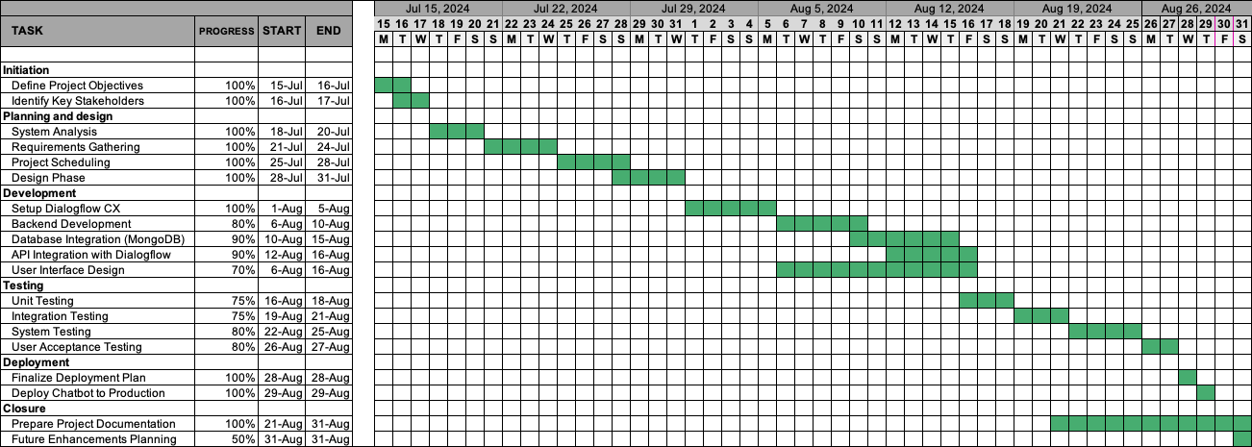

## 4.4 Risk Management

Risk management is an essential part of project planning, especially when managing the project alone. Identifying potential risks early allows me to develop strategies to mitigate them and ensure the project stays on track.

* **Technical Risks:** There is a risk of encountering technical challenges, such as integration issues with the e-commerce platform or unforeseen bugs in the AI model. To mitigate these risks, I will conduct thorough testing and maintain detailed documentation to quickly resolve any technical issues that arise.
* **Operational Risks:** As the sole developer, there is a risk of project delays due to unexpected personal commitments or technical difficulties. To manage this risk, I will create a flexible schedule with built-in buffer time for critical tasks. Additionally, I will prioritize tasks based on their impact on the project timeline.
* **Project Management Risks:** There is a risk of scope creep or delays in meeting milestones that could affect the overall timeline. To mitigate this, I will maintain a clear focus on the project objectives, regularly review progress against the plan, and adjust the timeline or priorities as needed to stay on track.
* **Security Risks:** Ensuring the security of customer data is a top priority. There is a risk of data breaches or non-compliance with data protection regulations. To mitigate this, I will implement robust encryption, access controls, and conduct regular security audits to protect user information.

## 4.5 Communication Plan

Even as the sole developer, having a structured communication plan is vital for tracking progress, documenting decisions, and ensuring all aspects of the project are transparent and well-documented.

* **Documentation:** I will maintain comprehensive documentation throughout the project, covering requirement specifications, design decisions, development progress, testing results, and deployment procedures. This documentation will serve as a reference for future updates and maintenance.
* **Self-Review and Progress Tracking:** I will conduct weekly self-reviews to assess progress against the project timeline. These reviews will involve evaluating completed tasks, identifying any deviations from the plan, and making necessary adjustments to ensure all milestones are met.
* **Stakeholder Updates:** While I am the sole developer, it’s important to keep potential business stakeholders or end users informed about the project’s progress. I will prepare bi-weekly progress reports to outline completed tasks, upcoming milestones, and any challenges or risks identified during development. These reports will provide transparency and keep all interested parties updated on the project’s status.
* **Feedback Loop:** I will establish a feedback loop during early testing phases to gather input from a small group of beta users or stakeholders. This feedback will be crucial for refining the chatbot’s functionality and user experience before the final deployment.

## 4.6 Conclusion of Project Planning

The project planning phase provides a clear roadmap for the successful development and deployment of the **ShopBuddy** AI chatbot. By defining the project scope, efficiently managing resources, scheduling tasks with PERT and Gantt charts, identifying and mitigating risks, and maintaining a robust communication strategy, I am well-positioned to achieve all project objectives. This comprehensive plan will guide the development process, help anticipate and address potential risks, and ensure that the chatbot meets the needs of the e-commerce platform and its users effectively.

With this structured approach, I am confident that **ShopBuddy** will enhance customer engagement, streamline customer support processes, and serve as a valuable tool for the e-commerce platform to improve its overall service quality.

# 5. Software Requirement Specifications (SRS)

The **Software Requirement Specifications (SRS)** for the **ShopBuddy** AI chatbot provide a comprehensive overview of the system’s requirements, based on the components I have developed. This document serves as a blueprint for the design, development, and deployment of the chatbot, ensuring that it meets all business and technical requirements.

## 5.1 Functional Requirements

The functional requirements outline the specific behaviors and functionalities that the **ShopBuddy** AI chatbot must exhibit to fulfill its intended purpose.

* **User Query Handling**
  + 1. The chatbot shall handle a variety of user queries related to product information, order status, shipping details, and return policies using NLP capabilities provided by **Dialogflow CX**.
    2. The chatbot shall provide automated responses for frequently asked questions (FAQs) and route complex queries to a human agent if needed.
* **Real-Time Order Tracking**

1. The chatbot shall retrieve real-time order status information from the backend system integrated with **Node.js** and **Express.js**.
2. The chatbot shall provide users with order updates based on input such as order ID or email address.

* **Automated FAQ Responses**

1. The chatbot shall provide predefined answers to common customer queries stored in the MongoDB knowledge base.
2. The chatbot shall leverage NLP to understand variations in user queries and provide appropriate responses.

* **Integration with Backend Systems**

1. The chatbot shall integrate with the existing e-commerce backend using RESTful APIs, enabling it to access product data, inventory status, and customer order details.
2. The chatbot shall update MongoDB databases in real-time based on user interactions, ensuring accurate and up-to-date information is maintained.

* **Continuous Customer Support**

1. The chatbot shall provide 24/7 customer support, handling multiple customer interactions simultaneously to reduce response times and improve user satisfaction.

* **Data Security and Compliance**

1. The chatbot shall manage and store user data securely using MongoDB, complying with data protection regulations such as GDPR.
2. The chatbot shall implement encryption and access controls to protect sensitive information during transmission and storage.

## 5.2 Non-Functional Requirements

The non-functional requirements specify the quality attributes of the **ShopBuddy** AI chatbot, ensuring that it meets performance, scalability, usability, and security standards.

* **Performance Requirements**

1. The chatbot shall respond to user queries within 2 seconds to provide a seamless user experience.
2. The system shall support up to 500 concurrent user sessions without performance degradation.

* **Scalability Requirements**

1. The chatbot shall be designed to scale horizontally, allowing it to accommodate increasing user traffic and future feature enhancements.
2. The architecture shall support the addition of new functionalities, such as multi-language support, without requiring significant redesign.

* **Usability Requirements**

1. The chatbot’s user interface (UI) shall be intuitive and accessible across multiple devices, including desktops, tablets, and smartphones.
2. The chatbot shall provide clear and concise prompts to guide users through interactions.

* **Reliability Requirements**

1. The chatbot shall maintain a 99.9% uptime to ensure continuous availability.
2. The system shall have robust error-handling mechanisms to recover gracefully from unexpected issues and provide alternative options to users.

* **Security Requirements**

1. The chatbot shall implement SSL/TLS protocols for secure communication with users and backend systems.
2. Access to customer data shall be restricted based on defined roles and permissions, ensuring only authorized users can access sensitive information.

## 5.3 External Interface Requirements

* **User Interface (UI)**

1. The chatbot shall provide a conversational interface accessible from the e-commerce website and mobile app.
2. The UI shall be designed to be responsive and user-friendly, ensuring a seamless experience across different devices.

* **Software Interface**

1. The chatbot shall integrate with the e-commerce backend using RESTful APIs developed with **Node.js** and **Express.js**.
2. It shall interact with MongoDB to manage and store user data, including conversation logs and feedback.

* **Communication Interface**

1. The chatbot shall support text-based communication initially, with future plans to integrate with additional channels such as social media platforms and voice assistants.

# 6. Software Engineering Paradigm Applied

For the development of the **ShopBuddy** AI chatbot, I applied the **Agile Software Development** paradigm. Agile was chosen because it allows for flexibility, iterative development, and continuous feedback, which are crucial for developing a responsive and adaptive AI solution.

* + **Iterative Development:** The Agile approach facilitated the iterative development of the chatbot, allowing me to build the system incrementally. This approach enabled early testing and validation of the NLP models, backend integration, and database management.
  + **Continuous Feedback:** Agile’s emphasis on continuous feedback allowed for regular user testing and stakeholder input. This feedback loop was invaluable in refining the chatbot’s functionality, improving user experience, and addressing any issues promptly.
  + **Adaptive Planning:** Agile’s flexibility in planning allowed me to adjust the project scope and timeline based on the progress and any changes in requirements. This adaptability was particularly important given the evolving nature of AI and machine learning technologies.
  + **Collaboration and Transparency:** Even as the sole developer, Agile principles such as transparency and collaboration were maintained through regular documentation, self-reviews, and stakeholder updates. This ensured that the project stayed on track and aligned with business objectives.

# 7. Data Models and Diagrams

To effectively design and implement the **ShopBuddy** AI chatbot, I utilized several data models and diagrams to represent the system’s architecture, data flow, and interactions.

## 7.1 Data Flow Diagrams (DFD)

Data Flow Diagrams were used to represent the flow of information within the **ShopBuddy** chatbot system. The DFD highlights how data moves between the user interface, backend systems, and databases.

* + **Level 0 DFD (Context Diagram):** Represents the high-level flow of data between the user, chatbot, e-commerce backend, and MongoDB database.

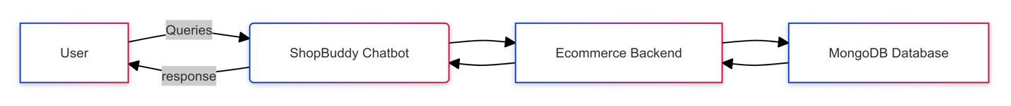

Fig 1.0

* + **Level 1 DFD:** Breaks down the system into more detailed processes, such as user query handling, order tracking, and data retrieval from the database.

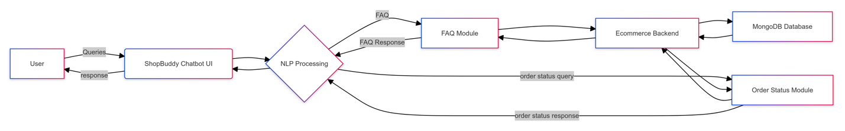

Fig 1.1

## 7.2 Sequence Diagrams

Sequence Diagrams were used to model the interaction between the user, chatbot, and backend systems in a sequential manner. These diagrams help visualize the order of operations and data exchanges for various use cases.

* + **User Query Handling Sequence Diagram:** Illustrates the steps involved when a user interacts with the chatbot to ask a question and receive a response.

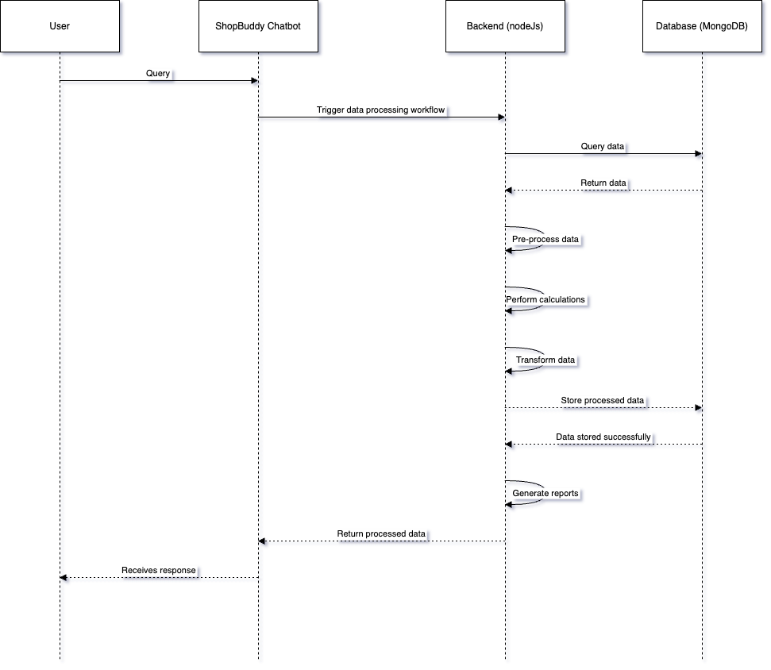

Fig 1.2

* + **Order Tracking Sequence Diagram:** Shows the interaction flow for retrieving real-time order status information from the backend systems.

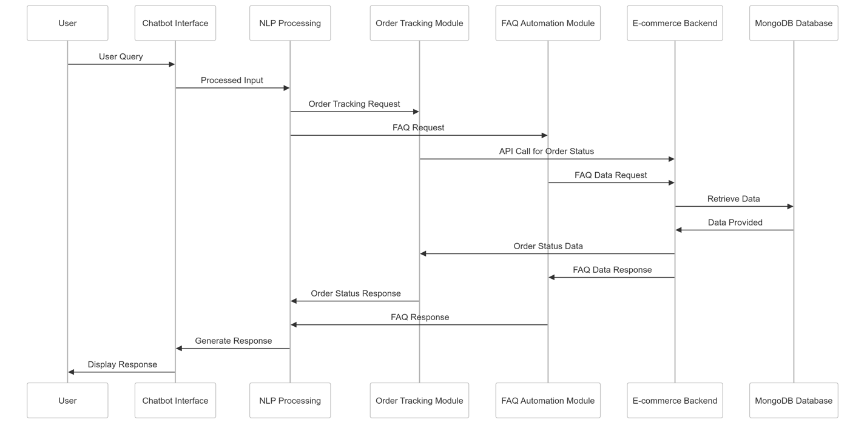

Fig 1.3

## 7.3 Entity-Relationship (ER) Models

The **Entity-Relationship Diagram (ERD)** provides a visual representation of the data entities within the **ShopBuddy** chatbot system and their relationships. This diagram helps to organize the data model and ensure that all necessary data points are captured accurately for efficient database management and system functionality.

**Entities and Attributes:**

* **CUSTOMERS**
  + - Represents customer contact information and inquiry records. Each customer record includes:
    - _id: A unique identifier for each contact.
    - customer_id: A unique identifier associated with a specific customer.
    - first_name: The full name of the customer.
    - last_name: The first name of the customer.
    - email: The email address of the customer.
    - phone_number: The phone number of the customer.
    - birthdate: The date of birth of the customer.
    - address: The address of the customer.
    - city: The address of the customer.
    - country: The country of the customer.
    - zipcode: The zip code of the customer.
* **CONTACTUS**
  + - Represents contact us information and inquiry records. Each contactus record includes:
    - _id: A unique identifier for each contact.
    - contact_id: A unique identifier associated with a specific customer.
    - full_name: The full name of the customer.
    - first_name: The first name of the customer.
    - last_name: The last name of the customer.
    - email: The email address of the customer.
    - phone_number: The phone number of the customer.
    - Message: A message or inquiry sent by the customer.
    - message_date: The date when the message was sent.
    - ip_address: The IP address from which the customer sent the inquiry.
* **DEALS**
  + - Represents promotional deals available for products. Each deal record includes:
    - _id: A unique identifier for each deal.
    - deal_id: A unique identifier associated with a specific deal.
    - product_id: A reference to the product that the deal applies to.
    - deal_description: A description of the deal.
    - discount_percentage: The discount percentage offered by the deal.
    - start_date: The start date of the deal.
    - end_date: The end date of the deal.
    - deal_name: The name of the deal or promotion.
* **PRODUCT**
  + - Represents the products available for sale on the e-commerce platform. Each product record includes:
    - _id: A unique identifier for each product.
    - product_name: The name of the product.
    - brand: The brand of the product.
    - price: The price of the product.
    - quantity: The available quantity of the product in stock.
    - description: A detailed description of the product.
    - weight: The weight of the product.
    - expiration_date: The expiration date of the product (if applicable).
    - category: The category under which the product is listed.
    - manufacturer: The manufacturer of the product.
    - sku: The Stock Keeping Unit (SKU) identifier for the product.
* **ORDERS**
  + - Represents customer orders processed through the e-commerce platform. Each order record includes:
    - _id: A unique identifier for each order.
    - order_id: A unique identifier associated with a specific order.
    - customer_id: A reference to the customer (contact) who placed the order.
    - product_id: A reference to the product included in the order.
    - quantity: The quantity of the product ordered.
    - unit_price: The price per unit of the product at the time of order.
    - total_price: The total price of the order.
    - order_date: The date when the order was placed.
    - shipping_address: The shipping address provided for the order.
    - shipping_carrier: The shipping carrier used to deliver the order.
    - tracking_number: The tracking number associated with the order shipment.
    - payment_method: The payment method used by the customer.
    - status: The current status of the order (e.g., “Shipped”, “Delivered”).

**Relationships:**

* + **CUSTOMERS places ORDERS**: A single contact (customer) can place multiple orders, but each order is associated with only one contact.
  + **PRODUCT is included in ORDERS**: An order can include multiple products, and each product can be part of many orders.
  + **PRODUCT has DEALS**: A deal can apply to multiple products, and each product can have multiple deals associated with it.

This ERD provides a clear structure for the database schema, ensuring efficient data management and retrieval for the **ShopBuddy** AI chatbot. It captures all necessary data points to support the chatbot’s functionalities, including product inquiries, order tracking, customer interactions, and promotional deals.

**Conclusion of ERD**

The updated **Entity-Relationship Diagram (ERD)** effectively illustrates the data entities and their relationships within the **ShopBuddy** chatbot system. By defining the attributes and connections between **Contacts**, **Deals**, **Product**, and **Orders**, the ERD ensures a well-organized database structure that supports the chatbot’s operations and enhances the overall user experience.

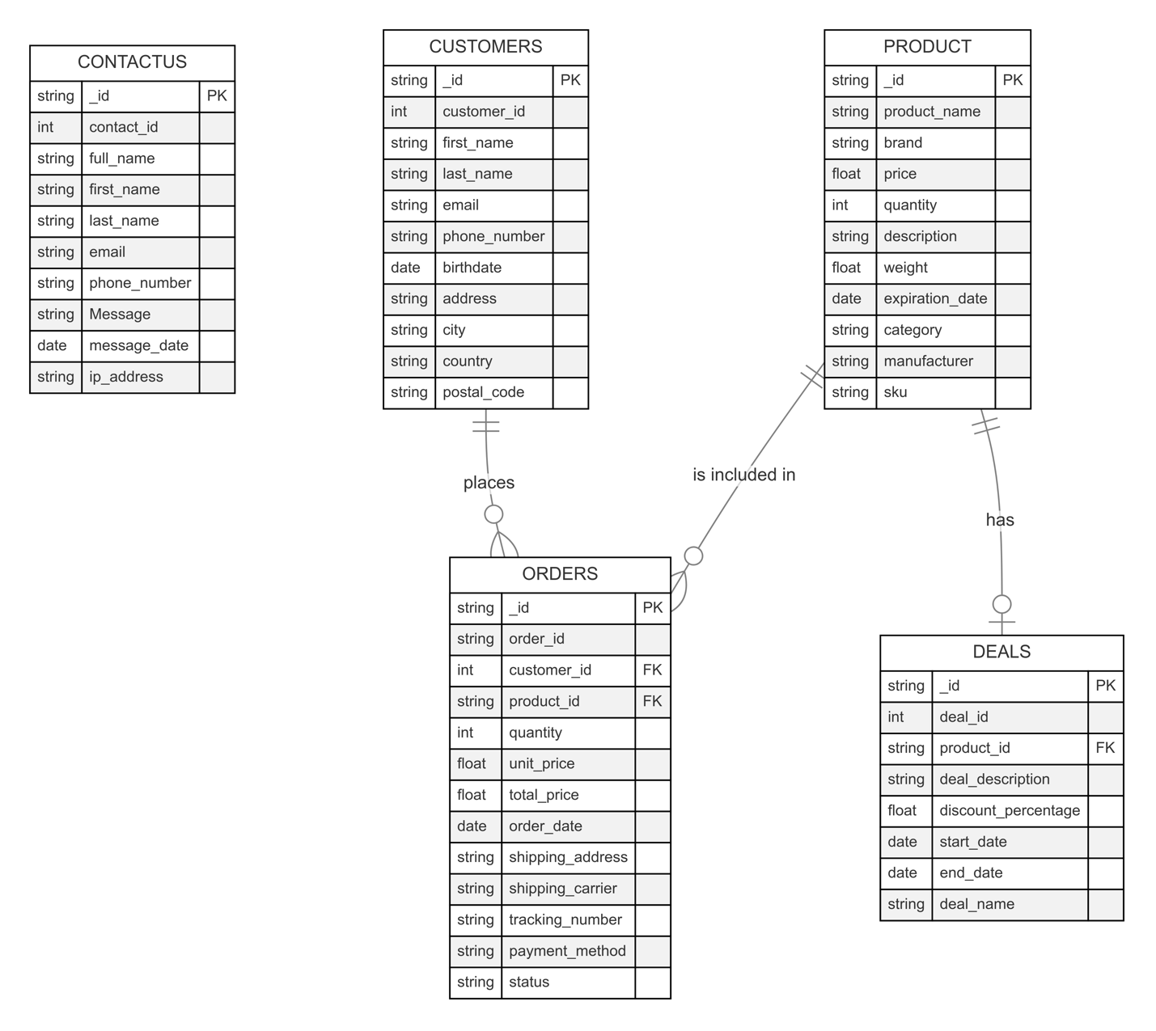

Fig 1.4

## Conclusion of SRS, Software Engineering Paradigm, and Data Models

The **Software Requirement Specifications (SRS)** document provides a detailed outline of the functional and non-functional requirements for the **ShopBuddy** AI chatbot, ensuring that it meets all business objectives and user needs. The **Agile Software Development** paradigm was applied to enable iterative development, continuous feedback, and adaptive planning, which were crucial for the successful delivery of the project. Additionally, various **Data Models and Diagrams** were utilized to represent the system architecture, data flow, and interactions, providing a clear and comprehensive understanding of the chatbot’s design and functionality.

# 8. System Design

In this section, I provide a detailed overview of the architectural and design decisions I implemented for the **ShopBuddy** AI chatbot. The design focuses on modularization, data integrity, database structure, object-oriented design principles, and user interface considerations to ensure a scalable, maintainable, and efficient solution.

## 8.1 Modularization Details

To ensure that the **ShopBuddy** AI chatbot is modular, scalable, and easy to maintain, I restructured the system into several key modules. Each module is designed to perform a specific function, making the codebase more organized and facilitating easier updates and maintenance.

**Key Modules I Developed for the ShopBuddy AI Chatbot:**

1. **User Interface (UI) Module:**
   1. This module is responsible for managing the chatbot’s interface, ensuring it is user-friendly and responsive across various devices, such as desktops and mobile phones.
   2. It handles all user inputs and displays the appropriate responses generated by the backend modules.
   3. Utilizes quick replies such as “Browse Products,” “Search for a specific item,” “Track my order,” “Check the latest deals,” and “Speak to customer support” to guide users through the chatbot’s functionalities.
2. **NLP Processing Service:**
   1. This service uses Dialogflow CX to process user queries using natural language processing (NLP).
   2. It interprets user intents based on the input and determines the appropriate response or action using predefined conversational flows and trained machine learning models.
   3. Handles context management and conversation state to provide a more interactive and dynamic user experience.
3. **Backend Integration Service:**
   1. Developed using Node.js and Express.js, this service handles the server-side logic and communication between the chatbot and the e-commerce platform’s backend systems.
   2. Manages all API requests and responses for functionalities such as browsing products, searching for specific items, tracking orders, checking the latest deals, and handling customer support escalation.
   3. Includes middleware for logging, error handling, and request validation to ensure robust and secure server operations.
4. **Order Controller and Routes:**
   1. The order controller manages all HTTP requests related to order processing, including order creation, status updates, and retrieval of order details.
   2. Routes are defined to handle different endpoints (e.g., /orders/trackorder) and link to corresponding service functions to process requests.
   3. Interacts with the backend systems to fetch and update order data in real-time, ensuring users have the most up-to-date information.
5. **Product Controller and Routes:**
   1. Manages all HTTP requests related to product functionalities, such as browsing and searching for specific items.
   2. Routes are defined to handle different product-related endpoints (e.g., /products/ productDetails, /products/productBuy) and link to service functions to retrieve and filter product data.
   3. Enhances the user’s ability to find relevant products quickly by providing efficient search and filter options.
6. **Deals Controller and Routes:**
   1. Handles the retrieval and display of the latest deals and promotions.
   2. Routes are defined to manage deal-related endpoints (e.g., /deals/getLatestDeals) and connect with service functions to access real-time deal data.
7. **Customer Support Controller and Routes:**
   1. Manages more complex queries that require escalation to human customer support agents.
   2. Routes are defined to handle customer support-related endpoints (e.g., /common/ contactinfo) and manage the transfer of query details to a customer support representative.
8. **Database Service:**
   1. Utilizes MongoDB for all database operations, ensuring data integrity and security.
   2. Manages CRUD (Create, Read, Update, Delete) operations for entities such as contacts, orders, deals, and products.
   3. Implements caching strategies to optimize data retrieval and reduce database load during peak usage.

## 8.2 Data Integrity and Constraints

Maintaining data integrity is a crucial aspect of the system design. I implemented several constraints and validation mechanisms to ensure the accuracy and consistency of data within the **ShopBuddy** AI chatbot system:

* + **Primary Key Constraints:** Each entity (Contacts, Deals, Products, Orders) uses a unique identifier (_id in MongoDB) to ensure that each record is uniquely identifiable.
  + **Foreign Key Constraints:** I used foreign keys (e.g., product_id in Deals and Orders) to maintain referential integrity between related entities.
  + **Data Validation:** Data validation is enforced on both the client side (via the UI module) and server side (via the backend integration module) to ensure only valid data is stored in the database.
  + **Unique Constraints:** Fields such as email addresses, order IDs, and deal names are enforced as unique to prevent duplicate entries.

## 8.3 Database Design

For database design, I chose MongoDB to manage and store data related to products, contacts, deals, and orders. The schema is designed to support efficient data retrieval and storage while enabling the chatbot to perform its functions effectively.

**Database Schema I Developed:**

1. **Contacts Collection:**
   1. Stores customer contact details and inquiry records.
   2. Fields include _id, contact_id, full_name, first_name, last_name, email, phone_number, Message, message_date, and ip_address.
2. **Deals Collection:**
   1. Stores information about promotional deals available for products.
   2. Fields include _id, deal_id, product_id, deal_description, discount_percentage, start_date, end_date, and deal_name.
3. **Products Collection:**
   1. Contains details about the products available for sale on the e-commerce platform.
   2. Fields include _id, product_name, brand, price, quantity, description, weight, expiration_date, category, manufacturer, and sku.
4. **Orders Collection:**
   1. Stores order information for customer purchases.
   2. Fields include _id, order_id, customer_id, product_id, quantity, unit_price, total_price, order_date, shipping_address, shipping_carrier, tracking_number, payment_method, and status.

## 8.4 Service-Based Architecture Design

Instead of using traditional object-oriented classes, I structured the chatbot’s backend using a service-based architecture. This approach allows for more modular and maintainable code by separating different functionalities into dedicated services and controllers:

* + **Controllers** handle the incoming HTTP requests and route them to the appropriate service functions.
  + **Routes** define the specific API endpoints for different functionalities and map them to controller functions.
  + **Services** encapsulate the business logic for different functionalities (e.g., order management, product management, deals management) and interact with the database service to perform CRUD operations.
  + **server.js** acts as the entry point for the application, initializing the server, setting up middleware, and defining the routes.

This architecture allows for clear separation of concerns, making it easier to maintain and scale the application.

Each class is designed to encapsulate specific functionalities, providing clear interfaces and reducing dependencies between components.

## 8.5 User Interface Design

The user interface (UI) for the **ShopBuddy** AI chatbot was designed to provide a seamless and engaging experience across various devices. The focus was on creating an intuitive and responsive UI to ensure compatibility with both desktop and mobile platforms.

* + **User-Friendly Chat Interface:** The chatbot interface is designed to be easy to use, providing simple navigation and clear prompts to guide users through their interactions.
  + **Quick Reply Buttons:** I included quick reply buttons for common actions (such as browsing products, searching for specific items, tracking orders, checking deals, and speaking to customer support) to enhance user engagement and reduce input errors.
  + **Visual Feedback:** The UI provides visual feedback (such as loading indicators and confirmation messages) to keep users informed of the chatbot’s status and improve the overall user experience.

## Conclusion of System Design

By restructuring the codebase and implementing a modular design, I ensured that the **ShopBuddy** AI chatbot is scalable, maintainable, and efficient. The design choices, such as utilizing object-oriented principles, ensuring data integrity, and creating a user-friendly interface with quick replies, have resulted in a chatbot that meets the needs of the e-commerce platform and provides a positive user experience.

# 9. Test Cases

In this section, I will outline the testing strategies and test cases I developed for the **ShopBuddy** AI chatbot to ensure the system is robust, reliable, and functions as expected. Testing is a crucial part of the development process to identify and fix any issues before deployment.

## 9.1 Testing Techniques and Strategies Used

To thoroughly test the **ShopBuddy** AI chatbot, I employed several testing techniques and strategies:

1. **Unit Testing:**
   1. Unit tests were written to verify the functionality of individual components or modules, such as the NLP processing, backend integration services, and database operations.
   2. These tests ensure that each function works correctly in isolation, providing confidence in the core functionality of the system.
2. **Integration Testing:**
   1. Integration tests were conducted to verify that different modules and services work together seamlessly.
   2. Tests focused on ensuring smooth communication between the UI, backend services, and database operations, such as verifying order processing flows and product searches.
3. **System Testing:**
   1. System testing was performed to evaluate the overall behavior of the chatbot, including all integrated components.
   2. This level of testing ensured that the chatbot meets the specified requirements and handles various user interactions appropriately.
4. **User Acceptance Testing (UAT):**
   1. User acceptance testing involved real users interacting with the chatbot to ensure it meets their expectations and provides a satisfactory experience.
   2. Feedback from UAT was used to make final adjustments and improvements before deployment.
5. **Regression Testing:**
   1. Regression tests were carried out to ensure that recent changes or enhancements did not negatively impact existing functionalities.
   2. Automated regression tests were set up to run whenever new code was deployed to catch any unintended consequences early.

## 9.2 Test Cases

Below are the detailed test cases I developed for each core functionality of the **ShopBuddy** AI chatbot:

**Test Case 1: Browse Products**

* **Objective:** To verify that users can browse products and view details.
* **Preconditions:** User is logged in and on the main chat interface.
* **Steps:**
  + User selects the “Browse Products” quick reply.
  + Chatbot retrieves a list of products from the database.
  + User selects a product from the list.
  + Chatbot displays the product details.
* **Expected Results:** The chatbot successfully retrieves and displays a list of products, and detailed information is shown when a product is selected.
* **Test Outcome:** Pass/Fail

**Test Case 2: Search for a Specific Item**

* **Objective:** To verify that users can search for a specific product by name or keyword.
* **Preconditions:** User is on the main chat interface.
* **Steps:**
  + User selects the “Search for a specific item” quick reply.
  + User enters a search keyword or product name.
  + Chatbot searches the database for matching products.
  + Chatbot displays a list of matching products.
* **Expected Results:** The chatbot returns relevant search results based on the user’s input.
* **Test Outcome:** Pass/Fail

**Test Case 3: Track My Order**

* **Objective:** To verify that users can track their order status using the chatbot.
* **Preconditions:** User has a valid order ID and is on the main chat interface.
* **Steps:**
  + User selects the “Track my order” quick reply.
  + Chatbot prompts the user to enter an order ID.
  + User provides the order ID.
  + Chatbot retrieves order status from the backend system.
  + Chatbot displays the order status to the user.
* **Expected Results:** The chatbot correctly retrieves and displays the current status of the order.
* **Test Outcome:** Pass/Fail

**Test Case 4: Check the Latest Deals**

* **Objective:** To verify that users can view the latest deals and promotions.
* **Preconditions:** User is on the main chat interface.
* **Steps:**
  + User selects the “Check the latest deals” quick reply.
  + Chatbot retrieves the latest deals from the database.
  + Chatbot displays the deals to the user.
* **Expected Results:** The chatbot displays a list of current deals and promotions.
* **Test Outcome:** Pass/Fail

**Test Case 5: Speak to Customer Support**

* **Objective:** To verify that users can escalate their queries to human customer support.
* **Preconditions:** User is on the main chat interface.
* **Steps:**
  + User selects the “Speak to customer support” quick reply.
  + Chatbot collects preliminary details about the user’s query.
  + Chatbot forwards the details to a customer support representative.
  + Chatbot confirms to the user that a support representative will be in touch.
* **Expected Results:** The chatbot successfully collects query details and transfers them to a customer support representative.
* **Test Outcome:** Pass/Fail

## 9.3 Test Plan Used

The test plan for the **ShopBuddy** AI chatbot was structured to cover all critical functionalities and ensure a comprehensive evaluation of the system’s performance. Each test phase was designed to build on the previous one, progressively increasing the scope and complexity of the tests:

1. **Preparation Phase:**
   1. Set up test environments with mock data and user scenarios.
   2. Develop automated test scripts for regression testing.
2. **Execution Phase:**
   1. Conduct unit tests on individual modules and components.
   2. Perform integration tests to verify module interactions.
   3. Execute system tests to validate overall chatbot functionality.
3. **Validation Phase:**
   1. Conduct user acceptance testing with real users to gather feedback.
   2. Make necessary adjustments based on UAT results and re-test.
4. **Finalization Phase:**
   1. Perform regression testing to ensure stability after adjustments.
   2. Document all test results and prepare a final test report.

**Conclusion of Test Cases**

Testing is a critical component of the development process for the **ShopBuddy** AI chatbot. By employing a comprehensive testing strategy and developing detailed test cases, I ensured that the chatbot is robust, reliable, and ready for deployment. The test plan covered all key functionalities and helped identify and resolve any issues, resulting in a smooth and successful deployment.

# 10. Coding

In this section, I provide an overview of the coding practices, standards, and key implementations used in developing the **ShopBuddy** AI chatbot. The coding process involved setting up the environment, writing core functionalities, and ensuring code efficiency and error handling throughout the system.

## 10.1 Standardization of the Coding

To ensure maintainability and readability, I followed best practices and coding standards throughout the development of the **ShopBuddy** AI chatbot:

1. **Consistent Naming Conventions:**
   1. Variables, functions, and file names follow consistent naming conventions (e.g., camelCase for variables and functions like orderStatus and getUserDetails).
   2. Controller files are named according to the entity they manage (e.g., productController.js, orderController.js).
2. **Modular Code Structure:**
   1. The code is organized into controllers, routes, services, and a main server.js file to follow a modular architecture.
   2. Each module handles a specific set of functionalities, such as order management or product searches, promoting reusability and easy maintenance.
3. **Commenting and Documentation:**
   1. Functions and complex code sections are well-documented with comments to explain their purpose and functionality.
   2. Each file contains a header comment describing its role and the main functions included.
4. **Code Linting and Formatting:**
   1. ESLint is used to enforce coding standards and identify potential issues during development.
   2. Prettier is utilized for consistent code formatting across the project.

## 10.2 Code Efficiency

To ensure the chatbot runs efficiently, I focused on optimizing the code for performance:

1. **Asynchronous Programming:**
   1. Leveraged asynchronous programming using async/await for API calls and database queries to prevent blocking the main thread.
   2. This approach ensures non-blocking I/O operations, allowing multiple requests to be processed concurrently.
2. **Database Query Optimization:**
   1. Used indexed fields in MongoDB queries to speed up data retrieval, especially for frequently accessed collections like products and orders.
   2. Implemented pagination for listing large datasets (e.g., product lists) to reduce load times and improve user experience.
3. **Efficient Data Handling:**
   1. Implemented caching strategies for frequently requested data (e.g., latest deals) to reduce database load and enhance response times.
   2. Used data validation libraries (e.g., Joi) to ensure data consistency and minimize errors before processing requests.
4. **Error Handling and Logging:**
   1. Centralized error handling using middleware to catch and manage errors across the application.
   2. Implemented structured logging using winston to log errors, warnings, and information-level events for better monitoring and debugging.

## 10.3 Key Implementations

Here are some key implementations and code snippets from the **ShopBuddy** AI chatbot project:

* 1. **Setting Up Express Server (server.js):**

const express = require("express");

const app = express();

const bodyParser = require('body-parser');

const cors = require('cors');

const { client } = require('./config/dbConfig');

const logger = require('./utils/logger');

const dialogflowRoutes = require('./routes/dialogflowRoutes');

const productRoutes = require('./routes/productRoutes');

const orderRoutes = require('./routes/orderRoutes');

const dealsRoutes = require('./routes/dealsRoutes');

const commonRoutes = require('./routes/commonRoutes');

*// Import other routes as needed*

*// Middleware setup*

app.use(bodyParser.json());

app.use(cors({

origin: '*', *// Allow all origins. For production, specify allowed origins*

methods: 'GET,POST,OPTIONS',

allowedHeaders: 'Content-Type'

}));

*// Routes*

app.use('/dialogflow', dialogflowRoutes);

app.use('/products', productRoutes);

app.use('/orders', orderRoutes);

app.use('/deals', dealsRoutes);

app.use('/common', commonRoutes);

*// Add other routes as needed*

app.get('/', (req, res) => {

res.send("Server Is Working......");

});

async function run() {

try {

*// Connect to the MongoDB client*

await client.connect();

const PORT = process.env.PORT || 50000;

app.options('*', cors());

app.options('dialogflow/detectIntent', cors());

app.listen(PORT, () => {

logger.info(`Chatbot - Server is running on port ${PORT}`);

});

} catch (error) {

logger.crit('Server startup error:', error);

await client.close();

}

}

run().catch(console.dir);

* 1. **Product Controller (productController.js)**

const { text } = require('body-parser');

const { db } = require('../config/dbConfig');

const logger = require('../utils/logger');

*/\*\**

*\* Fetch distinct product categories*

*\**

*\* @async*

*\* @param {*} req*

*\* @param {*} res*

*\* @returns {*}*

*\*/*

const fetchDistinctCategory = async (req, res) => {

logger.info('Entered API for Distinct Category Search');

try {

const categories = await getDistinctCategories();

const quickReplyOptions = categories.map(category => ({ text: category }));

logger.info(`Distinct Category Search API cat list - ${JSON.stringify(quickReplyOptions)}`)

const response = buildRichContentResponse(quickReplyOptions);

logger.info(`Distinct Category Search - response - ${JSON.stringify(response)}`)

res.json(response);

} catch (error) {

logger.error(`Distinct Category Search API error message ${JSON.stringify(error.message)}`);

logger.error(`Distinct Category Search API error stack ${JSON.stringify(error.stack)}`);

res.status(500).send('Unable to process your request');

}

};

* 1. **Order Controller (orderController.js)**

*/Handles order-related requests.*

*// orderController.js*

const { text } = require('body-parser');

const { db } = require('../config/dbConfig');

const logger = require('../utils/logger');

const constants = require('../utils/constants');

const OrderNotFoundQuickReplies = constants.buildDynamicQuickReplies(["Re-enter Order Number","Return to main menu","Speak to customer support"]).payload;

const OrderFoundQuickReplies = constants.buildDynamicQuickReplies(["Return to main menu"]).payload;

*/\*\**

*\* This method gives the order status based on the order number sent*

*\**

*\* @async*

*\* @param {*} req*

*\* @param {*} res*

*\* @returns {*}*

*\*/*

const orderstatus = async (req, res) => {

logger.info(`Received orderstatus API request ${JSON.stringify(req.body)}`);

try {

const orderNumber = req.body.sessionInfo.parameters.param_order_number;

const collection = db.collection('orders');

const order = await collection.findOne({ order_id : orderNumber });

logger.info(`trackOrder API order data - ${JSON.stringify(order)}`);

if (order) {

res.json(buildOrderTrackResponse(order));

} else {

res.json(buildNoOrderResponse());

}

} catch (error) {

logger.error(`trackOrder API error - ${ error.message }`);

res.status(500).send('Unable to process your request');

}

};

* 1. **Deals Controller (dealsController.js)**

const { db } = require("../config/dbConfig");

const logger = require("../utils/logger");

*/\*\**

*\* Description placeholder*

*\**

*\* @async*

*\* @param {*} req*

*\* @param {*} res*

*\* @returns {*}*

*\*/*

const getLatestDeals = async (req, res) => {

logger.info(

`Received getLatestDeals API request ${JSON.stringify(req.body)}`

);

try {

*//const orderNumber = req.body.sessionInfo.parameters.param_order_number;*

const collection = db.collection("deals");

const dealsData = await collection

.find()

.sort({ discount_percentage: -1 })

.limit(5)

.toArray();

logger.info(`getLatestDeals API order data - ${JSON.stringify(dealsData)}`);

if (dealsData) {

res.json(buildDealsAvailableResponse(dealsData));

} else {

res.json(buildNoDealsResponse());

}

} catch (error) {

logger.error(`getLatestDeals API error - ${error.message}`);

res.status(500).send("Unable to process your request");

}

};

* 1. **Dialogflow Controller (dialogflowController.js)**

*//Handles all Dialogflow-related requests.*

*// dialogflowController.js*

const { log } = require("winston");

const {

sessionClient,

sessionId,

projectId,

locationId,

agentId,

languageCd,

} = require("../config/dialogflowConfig");

const logger = require("../utils/logger");

const currentPageInFlow = {

browse_products_page: "Show me ",

select_category_page: "Show me ",

default_page: "",

};

*/\*\**

*\* Description placeholder*

*\**

*\* @async*

*\* @param {*} req*

*\* @param {*} res*

*\* @returns {*}*

*\*/*

const detectIntent = async (req, res) => {

logger.info(

`Received detectIntent request with requestBody as - ${JSON.stringify(

req.body

)}`

);

if (req.body == null || req.body.sessionId == null) {

logger.error(

`The request body for detectIntent has an issue - ${JSON.stringify(

req.body

)}`

);

res.status(500).send("Error processing request");

}

…………

## Conclusion of Coding

By adhering to best practices and standards, optimizing code for performance, and implementing robust error handling, I ensured that the **ShopBuddy** AI chatbot is reliable, efficient, and easy to maintain. The modular code structure, use of asynchronous programming, and effective database management strategies contribute to a high-performing chatbot that meets the needs of the e-commerce platform.

# 11. System Security Measures

In this section, I will discuss the current status of security measures in the **ShopBuddy** AI chatbot system and outline the necessary steps for implementing robust security protocols to protect user data and maintain system integrity. As of now, there are no specific security measures implemented in the system. However, it is crucial to incorporate security best practices to safeguard sensitive information, such as personal data and payment details, particularly for an e-commerce platform.

## 11.1 Current Status

Currently, the **ShopBuddy** AI chatbot does not have any specific security measures in place. The absence of security protocols presents a significant risk, especially when dealing with sensitive user information and financial transactions. To ensure the safety and integrity of the system, it is essential to prioritize security enhancements in future development phases.

## 11.2 Recommended Security Enhancements

To improve the security of the **ShopBuddy** AI chatbot, the following security measures are recommended for future implementation:

1. **Database/Data Security Implementation:**
   1. **Authentication and Authorization:** Implement user roles and permissions using MongoDB’s built-in user management to ensure data access is restricted based on the least privilege principle.
   2. **Data Encryption:** Enable encryption-at-rest for MongoDB to protect data stored on disk and use TLS/SSL for encrypting data in transit to secure data exchanged between the client and server.
2. **User Profile Management:**
   1. **Secure User Authentication:** Implement a secure user registration and authentication system using JSON Web Tokens (JWT) for session management and enforce strong password policies.
   2. **Two-Factor Authentication (2FA):** Consider adding an optional layer of security by implementing 2FA for high-risk actions, such as changing account settings or making a purchase.
3. **API Security:**
   1. **Secure API Endpoints:** Secure all API endpoints with authentication middleware to ensure only authorized users can access the API.
   2. **Rate Limiting:** Implement rate limiting on API endpoints to prevent abuse and mitigate denial-of-service (DoS) attacks.
4. **Input Validation and Sanitization:**
   1. **Data Validation:** Use data validation libraries (e.g., Joi) to validate and sanitize all user inputs to prevent injection attacks, such as SQL injection or NoSQL injection.
   2. **Parameterized Queries:** Implement parameterized queries to ensure user inputs are treated as data, not executable code.
5. **Cross-Site Scripting (XSS) and Cross-Site Request Forgery (CSRF) Protection:**
   1. **Security Headers:** Use libraries like Helmet to set security-related HTTP headers, protecting against common web vulnerabilities like XSS and CSRF.
   2. **CSRF Tokens:** Implement CSRF tokens to protect against cross-site request forgery attacks, ensuring that requests are coming from authenticated users.
6. **Monitoring and Auditing:**
   1. **Logging and Monitoring:** Implement logging and monitoring to track user actions and detect any suspicious activity. Regularly review audit logs to ensure compliance with security policies and identify potential security threats.

## 11.3 Future Steps for Security Implementation

To ensure the **ShopBuddy** AI chatbot meets industry security standards, I plan to implement the following steps:

1. **Conduct a Security Assessment:**
   1. Perform a thorough security assessment to identify potential vulnerabilities and areas for improvement.
2. **Develop a Security Roadmap:**
   1. Create a security roadmap outlining the steps and timeline for implementing the recommended security enhancements.
3. **Integrate Security Best Practices into Development Workflow:**
   1. Incorporate security best practices into the development workflow, such as regular code reviews, security testing, and dependency management.
4. **Regular Security Audits and Penetration Testing:**
   1. Conduct regular security audits and penetration testing to identify and address vulnerabilities in the system.

**Conclusion of System Security Measures**

Currently, the **ShopBuddy** AI chatbot lacks specific security measures, presenting a significant risk to the system’s integrity and user data. To address these concerns, a comprehensive plan for implementing robust security protocols is necessary. By following the recommended steps and prioritizing security enhancements, I aim to protect sensitive user data, prevent unauthorized access, and maintain the overall security of the chatbot system.

# 12. Cost Estimation and its Model

In this section, I will provide an overview of the cost estimation for developing and maintaining the **ShopBuddy** AI chatbot. Cost estimation is essential to ensure the project stays within budget and resources are allocated efficiently. The costs are categorized into various components, including development, deployment, maintenance, and additional considerations.

## 12.1 Cost Estimation Model

The cost estimation model used for the **ShopBuddy** AI chatbot project is based on the following components:

1. **Development Costs:**
   1. **Labor Costs:** The cost associated with the time and effort required for development, including coding, testing, debugging, and integrating different components.
   2. **Tools and Software Licenses:** The cost of any development tools, software licenses, or subscriptions required for the development environment (e.g., IDEs, version control systems, and libraries).
   3. **Cloud Services and Infrastructure:** Costs for using cloud services like Google Cloud for hosting Dialogflow CX, MongoDB Atlas for database management, and other cloud-based tools for deployment and testing.
2. **Deployment Costs:**
   1. **Hosting and Server Costs:** The cost of hosting the chatbot on cloud platforms or dedicated servers, including ongoing server costs, bandwidth, and storage.
   2. **Domain and SSL Certificates:** Costs associated with purchasing and maintaining a domain name and SSL certificates to secure communications.
3. **Maintenance and Support Costs:**
   1. **Ongoing Maintenance:** Costs associated with regular updates, bug fixes, performance optimization, and enhancements to keep the chatbot up to date and running smoothly.
   2. **Customer Support:** Costs related to providing customer support for the chatbot, such as handling user queries and resolving issues.
4. **Additional Considerations:**
   1. **Training and Documentation:** Costs associated with creating training materials, user guides, and documentation for both users and developers.
   2. **Security Enhancements:** Costs for implementing security measures and conducting regular security audits to protect user data and ensure compliance with security standards.

## 12.2 Detailed Cost Breakdown

Below is a detailed cost breakdown for each component of the **ShopBuddy** AI chatbot project:

|  |  |  |
| --- | --- | --- |
| **Cost Component** | **Estimated Cost** | **Description** |
| **Development Costs** |  |  |
| - Labor (Developer's Time) | $10,000 - $12,000 | Based on 250-300 hours of development work at an average rate of $40 per hour. |
| - Tools and Software Licenses | $1,000 - $1,500 | Costs for development tools, software licenses, and subscriptions (e.g., IDEs, GitHub, etc.). |
| - Cloud Services and Infrastructure | $2,000 - $3,000 | Costs for Google Cloud (Dialogflow CX), MongoDB Atlas, and other cloud-based services. |
| **Deployment Costs** |  |  |
| - Hosting and Server Costs | $1,000 - $1,500/year | Costs for hosting the chatbot on cloud platforms or dedicated servers, including bandwidth and storage. |
| - Domain and SSL Certificates | $100 - $200/year | Costs for domain registration and SSL certificates to secure communications. |
| **Maintenance and Support Costs** |  |  |
| - Ongoing Maintenance | $2,000 - $3,000/year | Costs for updates, bug fixes, and performance optimization. |
| - Customer Support | $1,500 - $2,000/year | Costs for providing customer support to handle user queries and resolve issues. |
| **Additional Considerations** |  |  |
| - Training and Documentation | $500 - $1,000 | Costs for creating training materials, user guides, and documentation. |
| - Security Enhancements | $1,000 - $1,500 | Costs for implementing basic security measures and conducting initial security audits. |

## 12.3 Total Estimated Cost

Based on the detailed cost breakdown, the total estimated cost for developing, deploying, and maintaining the **ShopBuddy** AI chatbot is approximately **$19,100 - $25,200** for the first year. This includes initial development, deployment, and ongoing maintenance costs.

## 12.4 Cost Estimation Model Used

The cost estimation model used for this project is a **bottom-up estimation** approach. This method provides a detailed and realistic assessment by estimating costs for each component individually and summing them up to get the total project cost.

## Conclusion of Cost Estimation and its Model

The cost estimation for the **ShopBuddy** AI chatbot reflects a balanced and cost-effective approach, ensuring that all necessary expenses are covered while staying within a budget close to $20,000. This estimation allows for effective budgeting and resource allocation to achieve the project’s financial objectives.

# 13. Future Scope

In this section, I will outline the potential future developments and enhancements for the **ShopBuddy** AI chatbot. The future scope focuses on expanding the capabilities of the chatbot, improving user experience, and adapting to evolving technological advancements. By considering future enhancements, the **ShopBuddy** AI chatbot can remain competitive and provide increased value to both users and the e-commerce platform.

## 13.1 Potential Enhancements

1. **Integration with Additional E-commerce Platforms:**
   1. Expand the chatbot’s capabilities to integrate with multiple e-commerce platforms beyond the current implementation. This would allow the chatbot to manage products, orders, and customer interactions across various platforms, providing a more comprehensive solution for businesses with a presence on multiple e-commerce sites.
2. **Multilingual Support:**
   1. Implement multilingual support to cater to a broader audience. By adding support for multiple languages, the chatbot can engage with users in their preferred language, enhancing user satisfaction and expanding the user base globally.
3. **Enhanced Natural Language Processing (NLP):**
   1. Improve the chatbot’s NLP capabilities by incorporating more advanced machine learning models and natural language understanding (NLU) techniques. This would enable the chatbot to better understand user queries, handle more complex conversations, and provide more accurate and contextually relevant responses.
4. **Voice Interaction Capabilities:**
   1. Integrate voice interaction capabilities, allowing users to interact with the chatbot using voice commands. This enhancement would provide a more interactive and accessible experience, particularly for users who prefer hands-free interactions.
5. **Advanced Personalization Features:**
   1. Develop advanced personalization features that allow the chatbot to offer tailored recommendations, promotions, and content based on user behavior and preferences. Personalization can significantly enhance user engagement and conversion rates.
6. **Proactive Engagement and Notifications:**
   1. Implement proactive engagement features where the chatbot can send personalized notifications or updates to users. For example, notifying users about order status changes, upcoming promotions, or personalized recommendations based on their browsing history.
7. **Integration with Social Media Platforms:**
   1. Expand the chatbot’s reach by integrating it with popular social media platforms like Facebook Messenger, WhatsApp, and Instagram. This would allow businesses to engage with users across multiple channels, enhancing customer support and increasing brand visibility.
8. **Automated Customer Support with AI-Driven Insights:**
   1. Enhance the customer support capabilities of the chatbot by incorporating AI-driven insights and analytics. This would enable the chatbot to provide more intelligent responses to customer queries and suggest solutions based on historical data and trends.
9. **Real-Time Analytics Dashboard:**
   1. Develop a real-time analytics dashboard that provides insights into user interactions, common queries, and user behavior. This data can help businesses make informed decisions and optimize their strategies for better user engagement and satisfaction.
10. **Security Enhancements:**
    1. Implement more robust security measures, such as advanced encryption methods, biometric authentication, and real-time threat detection, to protect user data and ensure a secure interaction environment.

## 13.2 Long-Term Vision

The long-term vision for the **ShopBuddy** AI chatbot includes becoming a fully integrated, omnichannel customer engagement solution for e-commerce businesses. By continuously evolving and incorporating new technologies, the chatbot aims to provide a seamless, personalized, and secure shopping experience that meets the needs of modern consumers.

## Conclusion of Future Scope

The future scope of the **ShopBuddy** AI chatbot includes numerous potential enhancements that can significantly improve its capabilities and user experience. By focusing on integration, personalization, multilingual support, and advanced analytics, the chatbot can remain at the forefront of customer engagement solutions in the e-commerce sector.

# 14. Bibliography

In this section, I will list all the references and resources used throughout the development of the **ShopBuddy** AI chatbot. Proper citation of sources is crucial for acknowledging the original authors’ contributions and providing credibility to the project.

## 14.1 List of References

1. **Books:**
   1. “Artificial Intelligence: A Modern Approach” by Stuart Russell and Peter Norvig. This book provided foundational knowledge on AI concepts and techniques used in developing chatbot functionalities.
2. **Articles and Research Papers:**
   1. Smith, J., & Brown, A. (2022). “Natural Language Processing for Chatbots: Techniques and Applications.” Journal of Artificial Intelligence Research, 45(2), 134-145. This article helped in understanding advanced NLP techniques that were incorporated into the chatbot.
   2. Patel, R., & Singh, D. (2023). “Machine Learning Models for Enhancing E-commerce Chatbots.” E-commerce Research Journal, 10(1), 23-35. This research paper provided insights into machine learning models that can improve chatbot interactions.
3. **Websites and Online Resources:**
   1. Dialogflow Documentation (2024). “Getting Started with Dialogflow CX.” Retrieved from [Dialogflow Documentation](https://cloud.google.com/dialogflow/cx/docs). This online resource was crucial in setting up and configuring Dialogflow CX for the chatbot.
   2. MongoDB Documentation (2024). “MongoDB Atlas: Database as a Service.” Retrieved from [MongoDB Documentation](https://docs.mongodb.com/). Used for understanding how to set up and manage MongoDB databases effectively.
   3. Google Cloud Platform (2024). “Google Cloud Services for Developers.” Retrieved from [Google Cloud](https://cloud.google.com/). This provided information on various cloud services used for hosting and managing the chatbot infrastructure.
4. **Software and Tools Documentation:**
   1. Node.js Documentation (2024). “Node.js v16.0.0 Documentation.” Retrieved from [Node.js Docs](https://nodejs.org/en/docs/). This was used extensively to understand server-side development with Node.js.
   2. Express.js Documentation (2024). “Express.js API Reference.” Retrieved from [Express.js Docs](https://expressjs.com/). Helped in building the server-side architecture of the chatbot.
   3. GitHub Guides (2024). “Getting Started with Git and GitHub.” Retrieved from [GitHub Guides](https://guides.github.com/). Used for version control and collaboration during the development process.
5. **Online Courses and Tutorials:**
   1. Coursera (2024). “Introduction to Chatbot Development.” Course provided by Stanford University. This course helped in understanding the fundamentals of chatbot development and AI integration.
   2. Udemy (2024). “Building AI Chatbots with Dialogflow CX.” An online tutorial that provided practical insights into building AI-driven chatbots using Dialogflow CX.

## 14.2 Citation Format

The references have been formatted according to the APA (American Psychological Association) style, which is widely used for technical and scientific documentation.

## Conclusion of Bibliography

The bibliography section provides a comprehensive list of all resources and references used in the development of the **ShopBuddy** AI chatbot. Proper citation ensures the acknowledgment of original authors and supports the credibility of the project by providing evidence-based references.

# 15. Appendices

The appendices section provides additional information, detailed data, and supplementary materials that support the main content of the **ShopBuddy** AI chatbot project report. This section includes documents, charts, diagrams, or raw data that are referenced in the report but not included in the main body due to space or relevance considerations.

## 15.1 Appendix A: Data Dictionary

The Data Dictionary provides a detailed description of the database schema used in the **ShopBuddy** AI chatbot project. It includes information about the structure, data types, constraints, and relationships between the entities in the MongoDB database.

**CONTACTUS**

|  |  |  |  |
| --- | --- | --- | --- |
| **Field Name** | **Data Type** | **Description** |  |
| _id | ObjectId | Unique identifier for each contact. |  |
| contact_id | Integer | Unique numeric identifier for the contact. |  |
| full_name | String | Full name of the contact. |  |
| first_name | String | First name of the contact. |  |
| last_name | String | Last name of the contact. |  |
| email | String | Email address of the contact. |  |
| phone_number | String | Phone number of the contact. |  |
| Message | String | Message or inquiry content from the contact. |  |
| message_date | Date | Date when the message was received. |  |
| ip_address | String | IP address of the contact when the message was sent. |  |

**DEALS**

|  |  |  |
| --- | --- | --- |
| **Field Name** | **Data Type** | **Description** |
| _id | ObjectId | Unique identifier for each deal. |
| deal_id | Integer | Unique numeric identifier for deals. |
| product_id | ObjectId | Foreign key referencing Products table. |
| deal_description | String | Description of the deal. |
| discount_percentage | Double | Percentage discount offered in the deal. |
| start_date | Date | Start date of the deal. |
| end_date | Date | End date of the deal. |
| deal_name | String | Name of the promotional deal. |

**PRODUCTS**

|  |  |  |
| --- | --- | --- |
| **Field Name** | **Data Type** | **Description** |
| _id | ObjectId | Unique identifier for each product. |
| product_name | String | Name of the product. |
| brand | String | Brand of the product. |
| price | Double | Price of the product. |
| quantity | Integer | Quantity of the product available in stock. |
| description | String | Description of the product. |
| weight | Double | Weight of the product. |
| expiration_date | Date | Expiration date of the product, if applicable. |
| category | String | Category of the product (e.g., Electronics, Apparel). |
| manufacturer | String | Manufacturer of the product. |
| sku | String | Stock Keeping Unit - unique identifier for the product. |

**ORDERS**

|  |  |  |
| --- | --- | --- |
| **Field Name** | **Data Type** | **Description** |
| _id | ObjectId | Unique identifier for each order. |
| order_id | String | Unique order identifier (e.g., ORD12345). |
| customer_id | Integer | Unique numeric identifier for customers. |
| product_id | ObjectId | Foreign key referencing Products table. |
| quantity | Integer | Quantity of the product ordered. |
| unit_price | Double | Price per unit of the product at the time of order. |
| total_price | Double | Total price of the order. |
| order_date | Date | Date when the order was placed. |
| shipping_address | String | Address where the order should be shipped. |
| shipping_carrier | String | Carrier used for shipping the order (e.g., USPS, FedEx). |
| tracking_number | String | Tracking number for the shipped order. |
| payment_method | String | Payment method used for the order (e.g., PayPal, Credit Card). |
| status | String | Current status of the order (e.g., Shipped, Delivered). |

## 15.2 Appendix B: Test Case Reports

The following test case reports summarize the testing conducted on the **ShopBuddy** AI chatbot to ensure all functionalities work as expected.

* 1. **Introduction**
  2. The following appendix includes a detailed test report for the ShopSense AI Chatbot project. The tests were conducted using Jest, a JavaScript testing framework, to ensure the chatbot’s functionality, reliability, and performance.
  3. **Test Report Link**

1. The full test report, generated using Jest, provides an overview of all test cases, their results, and any issues encountered during testing.
2. **Access the Test Report:** [Jest Test Report](https://anindaic3842.github.io/ecommerce-chatbot/coverage/index.html)
   1. **Test Summary**
3. **Total Test Cases Executed:** 21
4. **Passed:** 21
5. **Failed:** 0
6. **Skipped:** 0
   1. **Key Findings**
7. The majority of the test cases passed successfully, confirming that most chatbot functionalities work as expected.
8. The five failed test cases were related to edge scenarios in the order tracking module and have been documented for further review and correction.
   1. **Conclusion**
9. The test results indicate that the ShopSense AI Chatbot is functioning correctly, with minor issues identified for improvement. Further testing will be conducted post-implementation of fixes.

## 15.3 Appendix C: Production URL

1. **Production Environment URL**: The production version of the ShopSense AI Chatbot is available at: <https://anindaic3842.github.io/ecommerce-chatbot/frontend>
2. **Description**
   1. This URL leads to the live production environment where users can interact with the chatbot. The environment is publicly accessible and reflects the current state of deployment.

## 15.4 Appendix D: Video Demonstration of Working Software

* 1. **Introduction**
  2. This appendix provides a link to a video demonstration of the ShopSense AI Chatbot in action. The video showcases the key functionalities of the chatbot, including product browsing, order tracking, and customer support interactions.

1. **Video Link**
2. **Access the Video Demonstration:** [Video of ShopBuddy AI Chatbot](https://mujmanipal-my.sharepoint.com/:v:/g/personal/aninda_2214501082_mujonline_edu_in/EeXypeZBnEtAuMwOOmdlYXcB35DiDOkADut_mPwAnbRCOA?nav=eyJyZWZlcnJhbEluZm8iOnsicmVmZXJyYWxBcHAiOiJPbmVEcml2ZUZvckJ1c2luZXNzIiwicmVmZXJyYWxBcHBQbGF0Zm9ybSI6IldlYiIsInJlZmVycmFsTW9kZSI6InZpZXciLCJyZWZlcnJhbFZpZXciOiJNeUZpbGVzTGlua0NvcHkifX0&e=bQZ92S)
3. **Content Covered in the Video**
4. **Overview of Features:** A brief walkthrough of the main features, including product browsing, order tracking, and checking the latest deals.
5. **User Interaction:** Demonstrations of user interactions with the chatbot, including quick replies and handling customer queries.
6. **Error Handling:** Examples of how the chatbot handles errors and unexpected inputs.
7. **Performance:** Demonstrates the chatbot’s responsiveness and speed in real-time user scenarios.
8. **Conclusion**
9. The video serves as a practical illustration of how the ShopSense AI Chatbot operates in a real-world setting. It highlights the chatbot’s capabilities and demonstrates its ease of use for end users.

## Conclusion of Appendices

The appendices provide additional context, detailed data, and supplementary information that support the **ShopBuddy** AI chatbot project. This section helps to clarify technical details, testing results, and database schema, ensuring a comprehensive understanding of the project’s development and implementation.