Smart objects have got maybe sensors and actuators connected. We know sensors, but actuators, since I keep forgetting so here’s an internet knowledge.

An **actuator** is a component of a machine that is responsible for moving and controlling a mechanism or system, for example by opening a valve. In simple terms, it is a "mover". An **actuator** requires a control signal and a source of energy.

So basically, sensors are sensing and actuators are moving. Probably, sensor can sense something and make the actuator move. For example let’s say that the electric bell scenario where bell sensor receives the electricity and it makes the actuator move rapidly hitting something and making that sound.

Let’s consider that the bell comprising of sensor and actuator , which are triggered by electricity and hence it generates some output which is handled by microcontroller.

(I2C, GPIO, SPI UART interfaces)>> to be checked later.

Okay, so now, smart objects because of the existence of micro-controller, is connected to the radio module. This radio module is sending the data generated by the smart object, via short range or long range communication mechanism to the gateway. Once the data reaches the gateway it goes to the cloud via MQTT,COAP,TCP,UDP,HTTP.

In the cloud, we can visualize, analyse data. Eg: Data sent by temperature sensor can be analysed and be then said that this city has a current temperature of …C and later today, the temperature might be ….C..

KamalSingh: Long&Short Range communication.

Many Communication categories classified into 2 classes: short and long range

• If we are talking about short range technologies, you might be familiar with some like “Bluetooth Low Energy” or Zigbee. They allow a communication range of 100 to 200 meters while supporting a rate of 100 kilobits per second at 1 Mbps

Gateway: A gateway is a piece of networking hardware used in telecommunications for telecommunications networks that allows data to flow from one discrete network to another.

Discrete(separate and distinct)

Short range has better dataRate than longRange.

**Mobile networks use licensed radio spectrum**. That means no one else can use that radio spectrum and only the operator can use it.

Unlicensed network is used by wifiNetwork, Bluetooth, LoraWan, zigbee; they work on ISM band which is license free.. let us not mix up the short and long range concept with licensed and unlicensed because as we see here LoraWan is a long range communication technology operating over unlicensed band.

The ISM radio bands are portions of the radio spectrum reserved internationally for industrial, scientific and medical purposes other than telecommunications.

Licensed Band: Within those **bands**, individual stations applied for **licenses**. What specific frequency channels they were allowed to use within a **band** were part of their **license** agreements, along with power output and areas of allowed coverage.

Telecommunication: communication over a distance by cable, telegraph, telephone, or broadcasting.

Telegraph: a system for transmitting messages from a distance along a wire, especially one creating signals by making and breaking an electrical connection.

Broadcasting is the distribution of audio or video content to a dispersed audience via any electronic mass communications medium, but typically one using the electromagnetic spectrum, in a one-to-many model

electromagnetic spectrum: the range of wavelengths or frequencies over which electromagnetic radiation extends.

Electromagnetism is a branch of physics involving the study of the electromagnetic force, a type physical interaction that occurs between electrically charged particles.

**Electromagnetic waves** are produced whenever electric charges are accelerated. This makes it possible to **produce electromagnetic waves** by letting an alternating current flow through a wire, an antenna. The frequency of the **waves created** in this way equals the frequency of the alternating current.

The changing magnetic field, in turn, induces an electric field so that a series of electrical and magnetic oscillations combine to **produce** a formation that **propagates** as an **electromagnetic wave**. ... At the same frequency, the magnetic field oscillates perpendicular to the electric field.

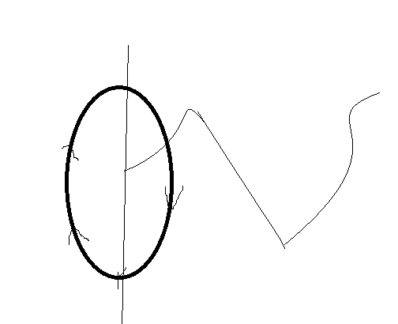magnetic field oscillates perpendicular to the electrical field.

So in my phone, I catch 4g which is a medium range communication technology and it is operating at a licensed band. This band is termed licensed because the band or the range is licensed to the telecommunication service provider. Alright, so I receive the 4g in the phone and now my phone has the mechanism to generate wifi signals. So, I am generating a wifi signal from my phone right now. This wifi signal is operating in a short range. The band it is operating on is not under the control of anybody. So, the corporate people cannot do licensing on this, this is because am broadcasting to the devices in my room’s air. Just FYI, wifi of this phone to the laptop would give lesser speed than the 4g speed in the phone itself.

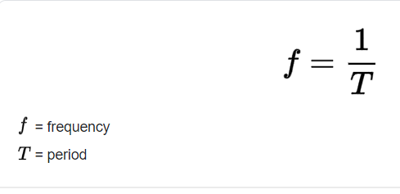

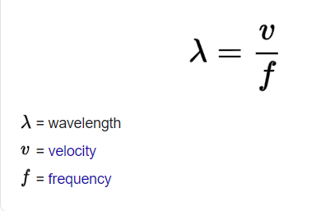

Now, in the phone, we have the option to switch on Bluetooth is 2.4 ghz or 5 ghz.. So we can control the frequency with which the wifi signal would be generated from my phone. It’s just that with high frequency, the wavelength ie range of the wifi decreases but velocity of the wave that is the wifi signal increases(speed of the connection increases)..

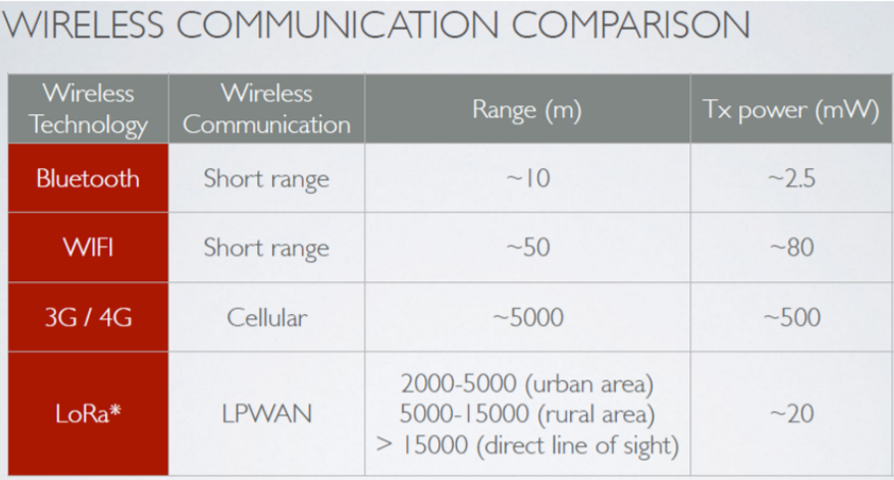

Thus a cellular network tower needs to be present in at-least 5km radius.

Well with this picture, we see that LoRa is better in range and it consumes less power. Again, it operates in unlicensed network.

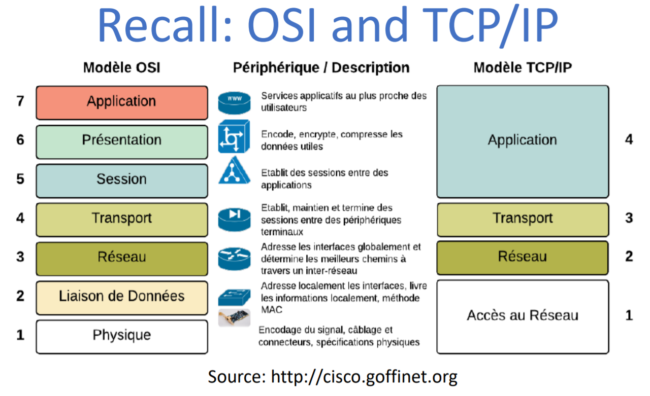

In transport layer we have coap,mqtt,http,udp,tcp etc.. all the communication is happening here.

OSI model: physical, datalink,network, transport,session, presentation, application.

TCP/IP model: physical+datalink=network interface; network;transport;application=session+presentation+application..

EnergyUnit= mW=milliWatt or dBm . this is radio power which is in regards to electronics

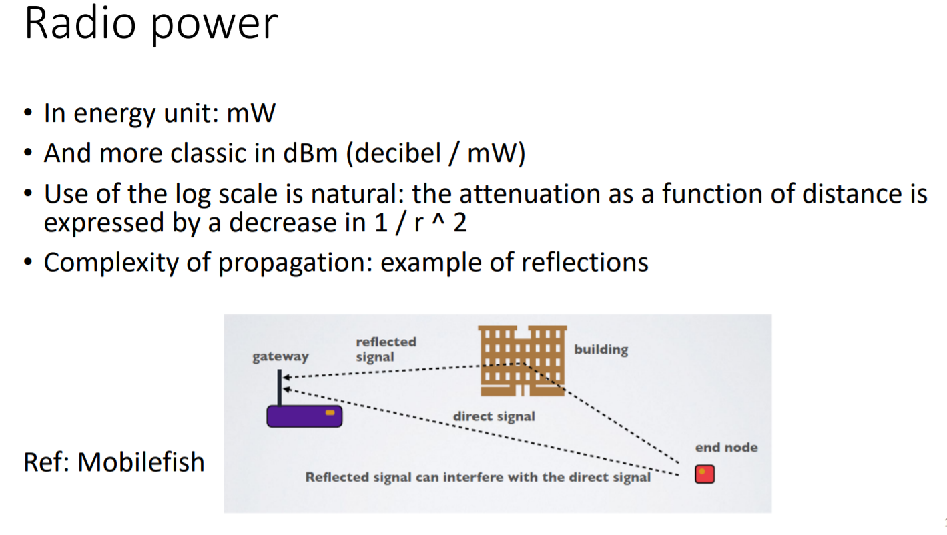

Attenuation= 1/r^2, r=distance

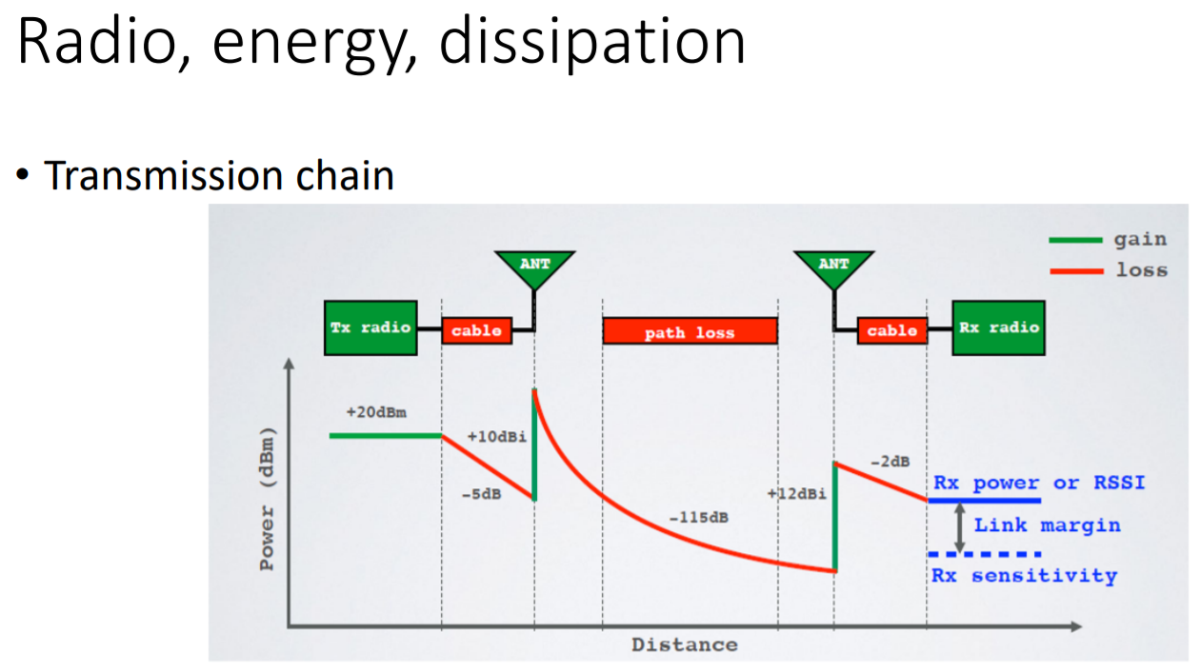

On the left, we have transmitter and on the right we have a receiver

Attunation is calculated in log scale and hence -5dB is mentioned based on the log scale calculation.

Attenae gain comes in

Pathloss is happening due to distance..

Receiver have sensitivity in regards to the fact that the receiver can decode signal for some level of dBm and not below.

Top level dBm received, signal is good and it becomes bad towards the threshold and below the threshold the signal decoding becomes a problem and error starts coming in..

RSSi: received signal strength indication.

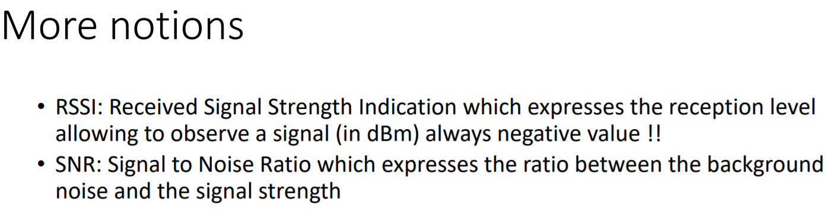

Noise is in regards to other people transmitting or any other disturbance caught.

SINR: signal to interference noise ratio.

Kamal Singh states that the people’s broadcasting impacting the signal quality is an addition to the noise.

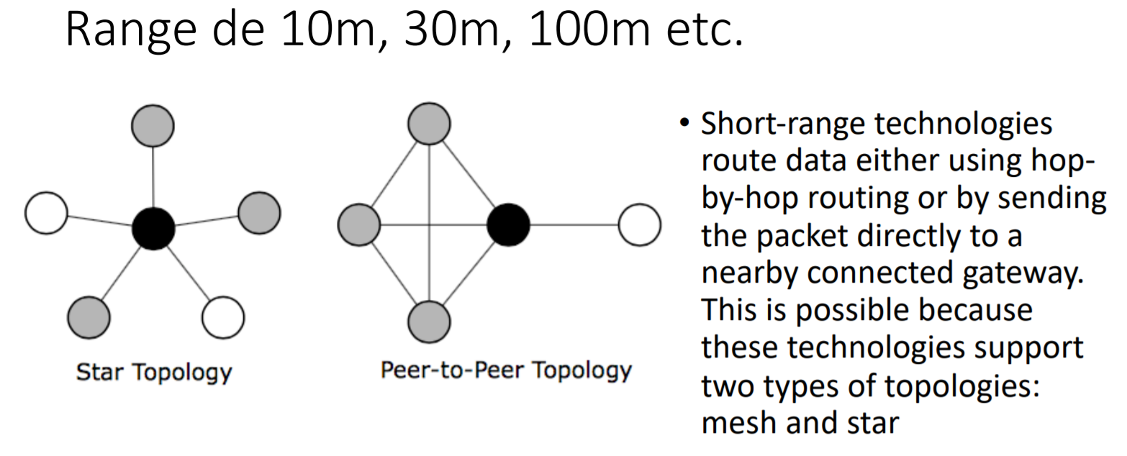

Star topology has one smart object acting as the central gateway of other objects. Other objects send the data to the central object and the central object would use a gateway(recall SOuthIndian guy video) to reach the internet. This gateway uses HTTP,TCP,UDp,MQtt,Coap.

Mesh topology, where everyone is trying to connect to everyone. Maybe everyone is not connected, because it depends on how far these objects are placed away from each other. But these everyone can choose a coordinator transmit the data to the internet. The blackNode in the diagram is acting as the coordinator.

Since we are talking about short range communication technology so mentioning about zigbee , threadBluetooth; would each connected objects can take different paths .

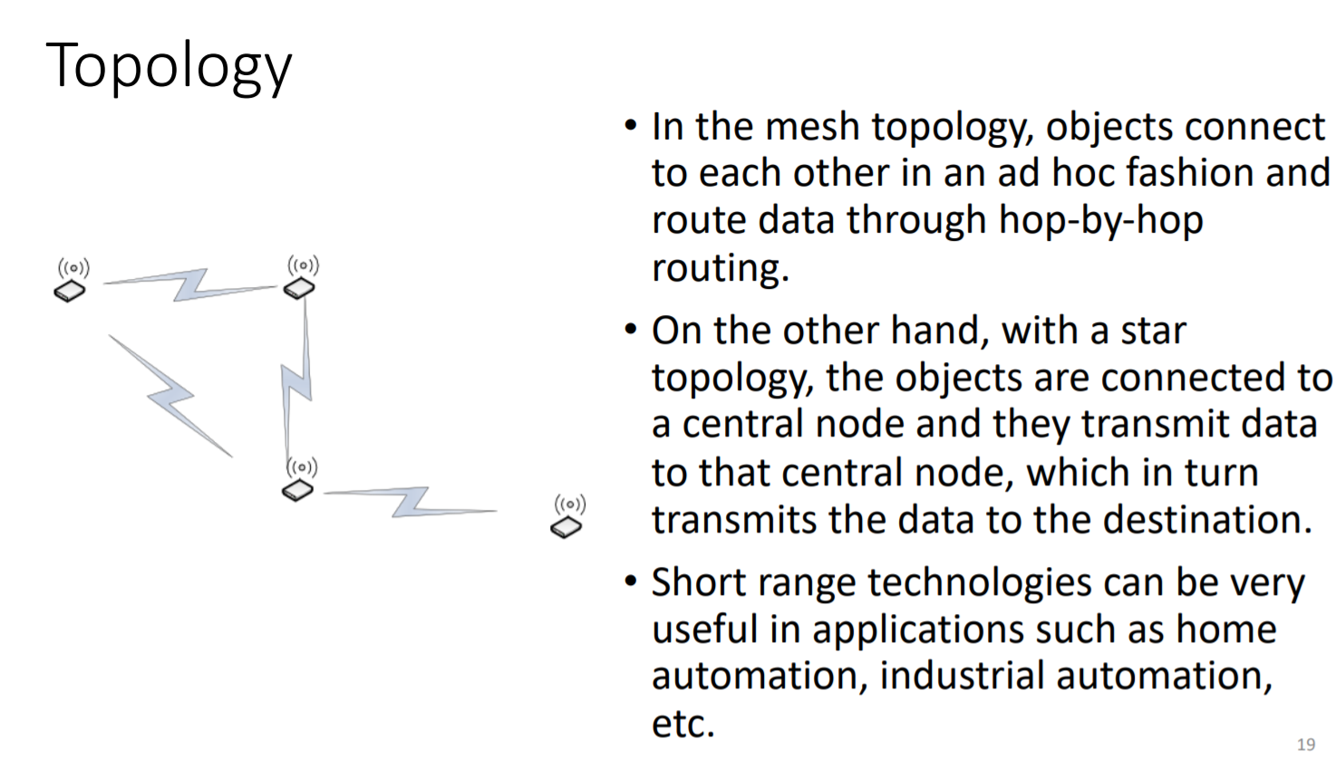

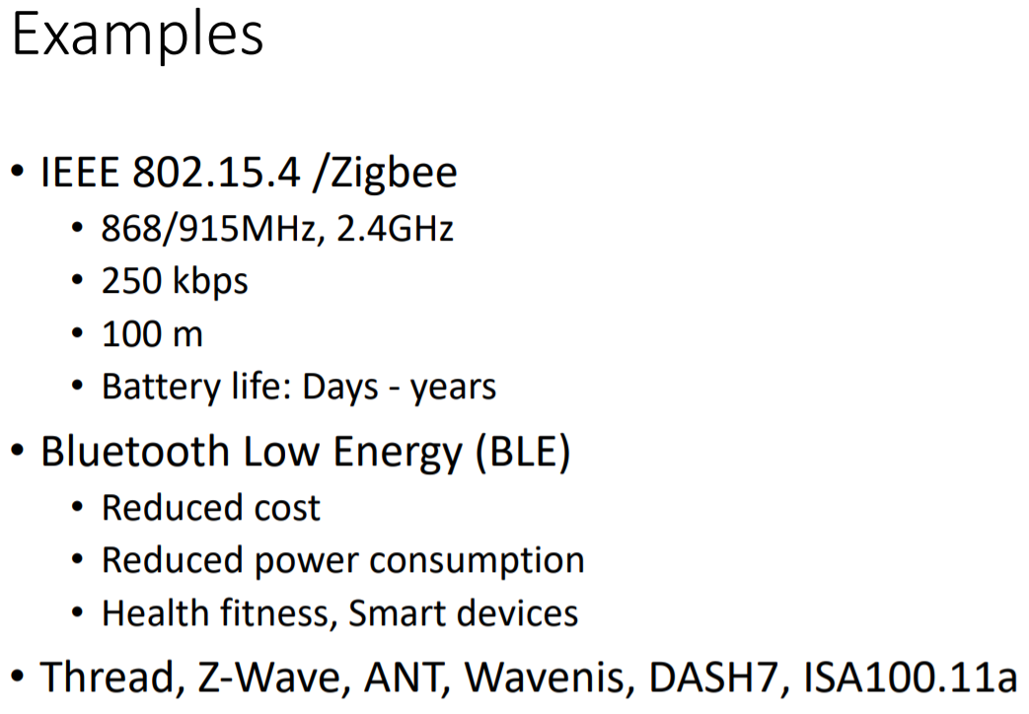

What's the difference between IEEE 802.15 4 and ZigBee wireless?

The 802.15. 4 standard defines the star (a) and peer-to-peer (b) common network topologies. The most widely deployed enhancement to the 802.15. 4 standard is **ZigBee**, which is a standard of the **ZigBee** Alliance.

Zigbee is using this for it’s radio and mac technology. So basically zigbee’s radio and mac technology follows this standard.

Radio is the layer1 , Mac belongs to layer 2 ,and these layer is called network interface layer= physical+datalink

For the next layers which are network, transport, application; other algorithms would come into action.

For zigbee, 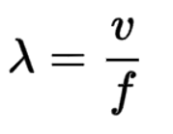all are low, and finally we have a good battery life.

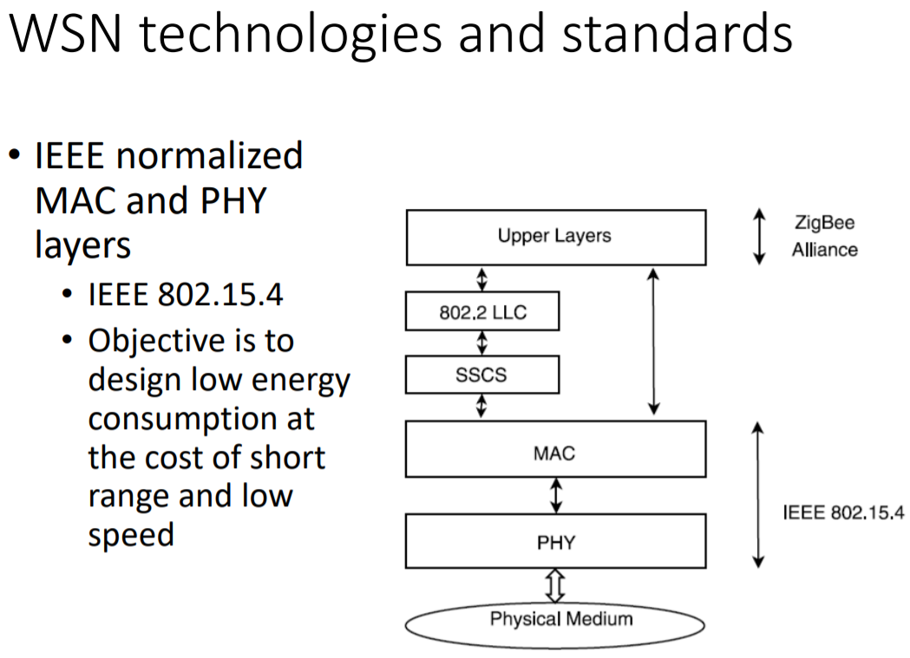

Energy Consumption is based on calculation and communication.

So, energy consumption in regards to communication=220to2290 * calculation’s energy consumption.

Moreover energyConsumption+calculation+listening+communicating..

Okay, now we said for zigbee, which is also followed by thread, is that the above formula’s all parameters are low, so everything is low and now the question is that how is this formula related to energy consumption.