**Image Classification :**

In Image classification, it takes an image as an input and outputs the classification label of that image with some metric (probability, loss, accuracy, etc). For Example: An image of a cat can be classified as a class label “cat” or an image of Dog can be classified as a class label “dog” with some probability.



**Object Localization:**This algorithm locates the presence of an object in the image and represents it with a bounding box. It takes an image as input and outputs the location of the bounding box in the form of (position, height, and width).

**Object Detection:**

Object Detection algorithms act as a combination of image classification and object localization. It takes an image as input and produces one or more bounding boxes with the class label attached to each bounding box. These algorithms are capable enough to deal with multi-class classification and localization as well as to deal with the objects with multiple occurrences.

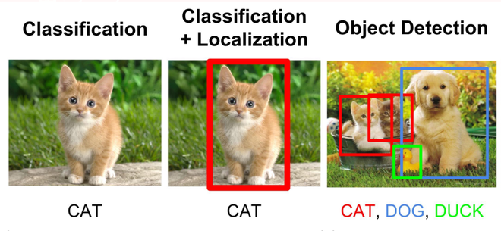

**Applications:**

The above-discussed object recognition techniques can be utilized in many fields such as:

* **Driver-less Cars:** Object Recognition is used for detecting road signs, other vehicles, etc. Google’s driverless car and Microsoft’s Kinect system both use object recognition.
* **Medical Image Processing:** Object Recognition and Image Processing techniques can help detect disease more accurately. For Example, Google AI for breast cancer detection detects more accurately than doctors.
* **Surveillance and Security:** such as Face Recognition, Object Tracking, Activity Recognition, etc.

**Object Recognition :**

Object recognition is the technique of identifying the object present in images and videos. It is one of the most important applications of machine learning and deep learning. The goal of this field is to teach machines to understand (recognize) the content of an image just like humans do.

**Object Recognition Using Deep Learning**

Convolution Neural Network (CNN) is one of the most popular ways of doing object recognition. It is widely used and most state-of-the-art neural networks used this method for various object recognition related tasks such as image classification. This CNN network takes an image as input and outputs the probability of the different classes. If the object present in the image then it’s output probability is high else the output probability of the rest of classes is either negligible or low. The advantage of Deep learning is that we don’t need to do feature extraction from data as compared to machine learning.

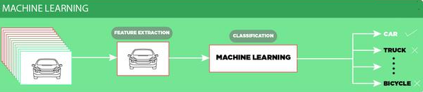

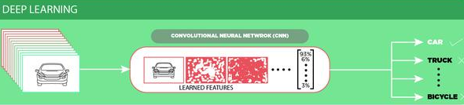

**Challenges of Object Recognition:**

* Since we take the output generated by last (fully connected) layer of the CNN model is a single class label. So, a simple CNN approach will not work if more than one class labels are present in the image.
* If we want to localize the presence of an object in the bounding box, we need to try a different approach that outputs not only outputs the class label but also outputs the bounding box locations.

Google and Bing use image recognition to provide users with the search results. Picsearch is a traditional visual search engine that offers a massive image archive.

# **Google Goggles: Image-Recognition Mobile App**

The **Google Goggles app** is an image-recognition mobile app that uses visual search technology to identify objects through a mobile device’s camera. Users can take a photo of a physical object, and Google searches and retrieves information about the image.

The Google Goggles [mobile app](https://www.wordstream.com/blog/ws/2013/03/06/google-for-mobile) can:

* Recognize and offer information for historical landmarks
* Scan barcodes and QR codes
* Recognize books, CDs, artwork, logos, and other 2D objects
* Add contacts by scanning business cards
* Recognize and conduct a [Google search](https://www.wordstream.com/google-mobile-search-app) for similar products
* Solve Sudoku Puzzles
* Translate foreign language text

The **Google Goggles translate feature** can translate foreign text (like a dinner menu) for travelers visiting foreign-speaking countries. A very handy feature for those with wanderlust.