**Labtainer Practical 1: telnetlab**

**Name: Malshani Prabodha RANCHA GODAGE  
Date: 24/09/2019**

After installing virtual machine and I have imported labtainerVM into it.

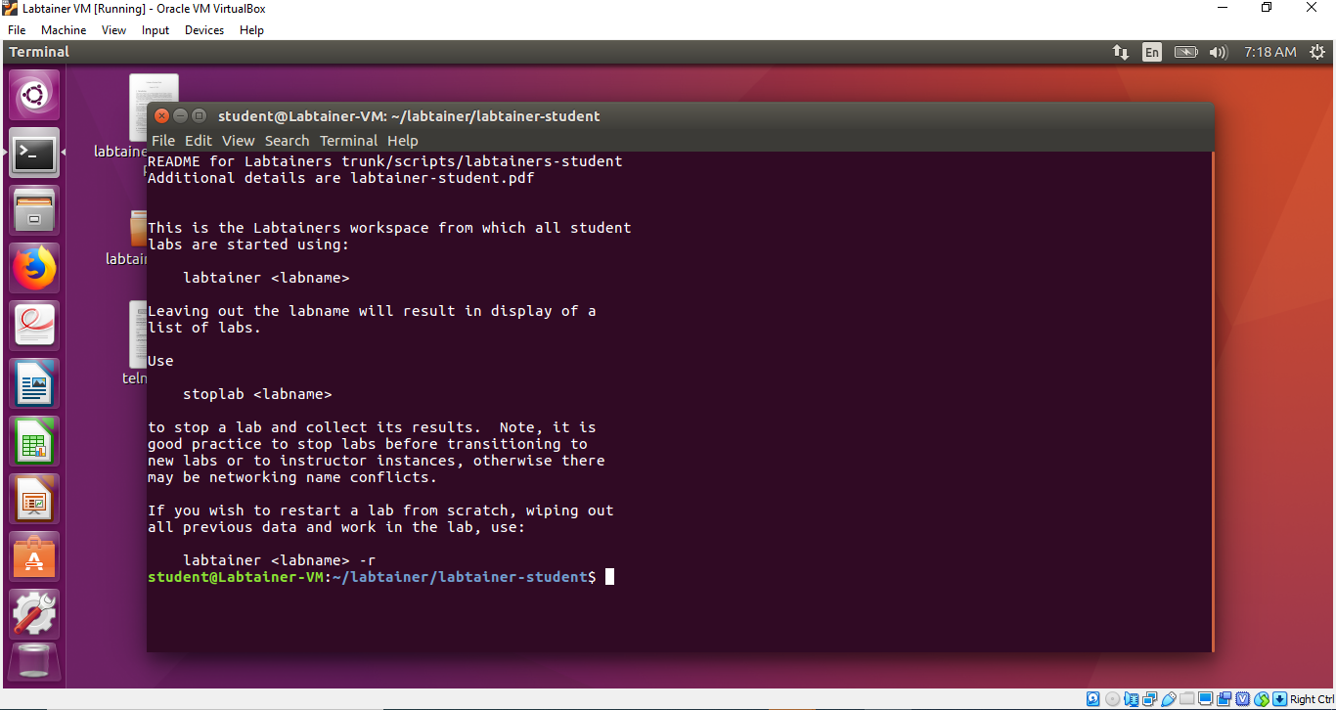

Then I run **telnelab** using command **labtainer telnetlab**. Then I have the **server** and the **client** windows in my virtual ubuntu environment. Then I followed following 4 tasks.

**Task 1:** Command **ifconfig** gives details about network interfaces of the server. It showed the description about Ethernet and loopback (lo) interfaces. ﻿eth0 interface represent the Ethernet network card which is physical interface of the server. lo represents the virtual interface.

**Link encap** shows how packets are encapsulated for transmision. **HWaddre** gives mac address or physical address of Ethernet card. **inet addr** gives IPv4 address of the interface. **Bcast** shows broadcast address of interface. **Mask** gives the netwok mask of interface. **Inet6 addr** shows IPv6 address of interface. And it showed more details like Scope, UP, RX packets, TX packets and etc.

Server’s IP address gives under inet addr: field. In my case it is 172.17.0.3.

**Task 2:** I typed **telnet 172.17.0.3** on client’s window and connect to the server by giving username and password. To make sure I am connected to server listed files (command **ls**) of server and find out the file: filetoview.txt is there. Then I use **cat** command to view the content of text file on the screen. I typed **cat filetoview.txt** and saw the output. Command cat concatenate the file content to the screen. Once typed the **exit** command on client server, connection to server was closed.

**Task 3:** I entered **sudo tcpdump -i eth0 -X tcp** command on server terminal. Then I tried to connect to server from client using telnet. Then I enter a wrong password letter by letter, I noticed the traffic of server. I saw the each letter I entered in the end of header of data packet. Command **sudo** gave me administration access to the system. Command **tcpdump** dumps the network traffic in to the screen, it prints the description of the packets on the network interface. The flag **- i** is for interface. I have given interface as eth0 (Ethernet). The option -**X** is for print the data of packet in addition to headers of packets. By entering the full command I was able to see tcp traffic in the server interface.

Task 4: I entered the command **ssh 172.12.0.3** on clients terminal to connect to the server. Then I saw a message by saying authenticity cannot be established and asking whether I want to continue. I entered yes and server IP address is added to list of known hosts of client automatically. Next time I connect to server it does not ask again. After I connected to the server via client I checked the **filetoview.txt** file using cat command. Meanwhile check the server’s traffic using **tcpdump** command. But this time, the message I entered from the client is not readable on the server terminal, because the connection is secured.

After finishing four tasks, I stopped the labtainer by entering the command **stoplab telnetlab**, it finished the labsession closed client and server terminals. When I open the labtainer again, it starts where I stopped before, because it saved current status in a zip file.