NAME OF THE AWARDING BODY

jk"Vªh; O;kolkf;d f'k{kk ,oa izf'k{k.k ifj"kn }kjk ekU;rk izkIr

Recognised by NCVET

Certificate for Skill Competency

izek.ki= la[;k

Certificate No. :

AWUPB000100000-081214

izekf.kr fd;k tkrk gS fd Jh@lqJh@,e,Dl

This is to certify that Mr./Ms./Mx.

lqiq=@lqiq=h@izfrikfyr

Son/Daughter/Ward of

tUe frfFk

Date of Birth

ukekadu la[;k

Enrolment No

us tkWc jksy@vgrkZ dk vkadyu lQyrkiwoZd

has successfully cleared the assessment in the job role/qualification

vof/k

of duration

vftZr fd;k

having earned

ØsfMV ,ulhvkj,Q@,u,lD;w,Q Lrj

Credits at NCrF/NSQF Level

izf'k{k.k dsUnz

Training Centre

ftyk

District

jkT;

State

izfr'kr@Js.kh ds lkFk mÙkh.kZ fd;kA

with

%/Grade.

tkjh djus dk LFkku

Place of Issue:

Logo of

awarding

body

Logo of

awarding

body

Scheme

logo

tkjh djus dh frfFk

Date of Issue:

gLrk{kj Signature -

ukeName -

in Designation -

gLrk{kj Signature -

ukeName -

in Designation -

bZ&lR;kiu fyad

NCrF - National Credit Framework

e-Verification link

NSQF - National Skills Qualification Framework

Digitally Generated Certificate

(if applicable)

(Incase of joint certification)

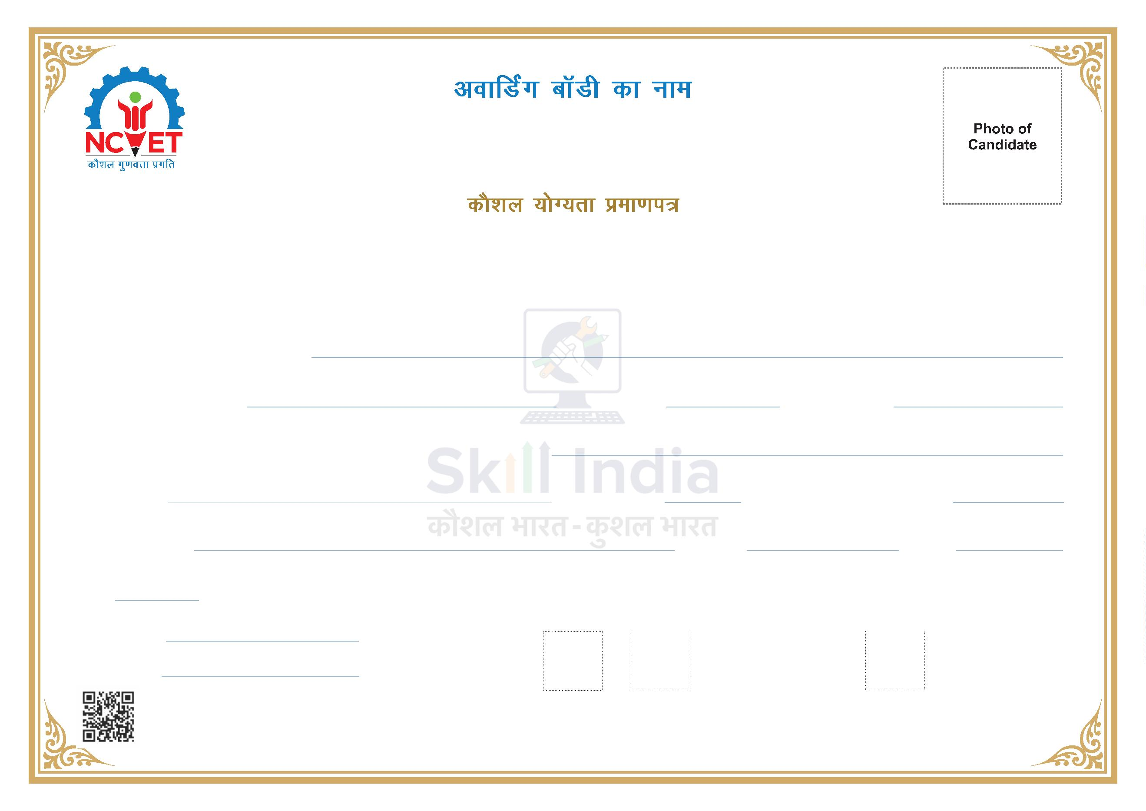

[[Ward]]

[[name]]

[[credits]]

[[date_of_issue]]

[[place_of_issue]]

[[grade]]

[[state]]

[[district]]

[[center_Name]]

[[NSQF_level]]

[[duration]]

[[qualification]]

[[enrolment_No]]

[[dob]]