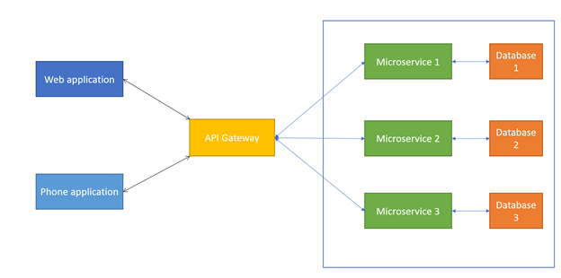

**Ocelot**

Ocelot is a .NET API Gateway.Ocelot is aimed at people using .NET running a micro-services / service orientated architecture who need a unified point of entry into their system.

However it will work with anything that speaks HTTP and run on any platform that ASP.NET Core supports.

## Features

* Routing
* Request Aggregation
* Service Discovery with Consul & Eureka
* Service Fabric
* Kubernetes
* WebSockets
* Authentication
* Authorisation
* Rate Limiting
* Caching
* Retry policies / QoS
* Load Balancing
* Logging / Tracing / Correlation
* Headers / Query String / Claims Transformation
* Custom Middleware / Delegating Handlers
* Configuration / Administration REST API
* Platform / Cloud Agnostic

## How to install

Ocelot is designed to work with ASP.NET Core only and it targets netstandard2.0. This means it can be used anywhere .NET Standard 2.0 is supported, including .NET Core 2.1 and .NET Framework 4.7.2 and up. [This](https://docs.microsoft.com/en-us/dotnet/standard/net-standard) documentation may prove helpful when working out if Ocelot would be suitable for you.

Install Ocelot and it's dependencies using NuGet.

Install-Package Ocelot

Or via the .NET Core CLI:

dotnet add package ocelot