**Q. What is Artifactory?**

**ANS: Artifactory** is a Binary Repository Manager introduced by JFrog gives a DevOps team the tools to efficiently manage an ever-growing matrix of binaries across different environments and geographically distributed sites to ensure a smooth application development workflow.  
A **binary repository manager** is a software tool designed to optimize the download and storage of binary files used and produced in software development. It centralizes the management of all the binary artifacts generated and used by the organization to overcome the complexity arising from the diversity of binary artifact types, their position in the overall workflow and the dependencies between them

**Q. What is the use of Artifactory?**

**ANS:** The uses of Artifactory are as mentioned below- **1. System stability and reliability with Artifactory High Availability**  
Artifactory supports a **High Availability** configuration with a cluster of 2 or more active/ active Artifactory servers on the same Local Area Network.  
This redundant network architecture has several benefits:  
**-No single-point-of-failure**  
Your system can continue to operate as long as any one of the Artifactory nodes is operational. This maximizes your uptime and can take it to levels of up to “five nines” availability.  
**-Accommodate larger load bursts**  
With horizontal server scalability, you can increase your capacity with no compromise to performance and meet any increasing load requirements as your organization grows.  
**-Multiple server architecture**  
Artifactory HA lets you perform most maintenance tasks with no system downtime  
 **2.Managing many binaries across different environments**  
As the number of binaries used by the organization grows, managing those binaries across development, QA, production and possibly more environments can become a maintenance nightmare. Artifactory removes the need to create different copies of the same file. Only a single copy of any binary is ever stored on the file system and Artifactory manages access to the files through repositories. Repositories behave like virtual file systems which we can dedicate to the development groups and their respective environments. Access by the different teams is controlled by defining corresponding repositories and configuring access control on the binary as it goes through the development lifecycle.  
**3. Security, Access Control and Traceability**  
Artifactory can provide security and access control at several levels. From restricting complete repositories down to restricting a single binary.  
Virtual repositories lets us restrict developer access only to reliable 3rd party resources that have been approved.  
**Comprehensive log information** lets you trace virtually any action done on any artifact managed by Artifactory   
**4. Full support for Docker**  
Artifactory offers **fine-grained access control** to our organization’s images with secure “docker push” and “docker pull” effectively providing **secure, private Docker repositories** that exceed the security offered by Docker Trusted Registry   
**5. Quickly replicates repositories to remote sites**  
Artifactory supports replication of your repositories to another instance of Artifactory which is outside of your local network. Replicated repositories are automatically synchronized with their source periodically, so that your artifacts can be made available to different teams wherever they may be located around the world. Artifactory’s **checksum-based storage** optimizes the replication process making it up to 10 times faster  
**6. A Universal, End-to-End Solution for All Binaries**  
Artifactory was designed from the ground up to fit in with any development ecosystem. Uniquely built on checksum-based storage, Artifactory supports any repository layout and can, therefore, provide native-level support for any packaging format. Essentially, regardless of the packaging format we are using, Artifactory can store and manage our binaries, and is transparent to the corresponding packaging client

**Q: What type of components/artifacts are to be kept in the Artifactory?  
ANS:** Artifactory provides full metadata for all major package formats for both artifacts and folders. These include metadata that originates with the package itself, custom metadata added by users such as searchable properties and metadata that is automatically generated by tools such as build information and more. Common Artifact types include:   
• ZIP or tarball files   
• RPM or DEB packages (Linux)   
• JAR, WAR, and EAR packages (Java)   
• Gems (Ruby)   
• Python packages   
• DLLs (Windows)   
• Source packages   
• Documentation packages  
Artifactory offers a universal solution supporting all major package formats including Maven, Gradle, Docker, Vagrant, Debian, YUM, P2, Ivy, NuGet, PHP, NPM, RubyGems, PyPI, Bower, CocoaPods, GitLFS, Opkg, SBT and more.

**Q: What is the industry practice?  
ANS:** The use of JFrog in the DevOps practice in any environment is depicted in the picture below: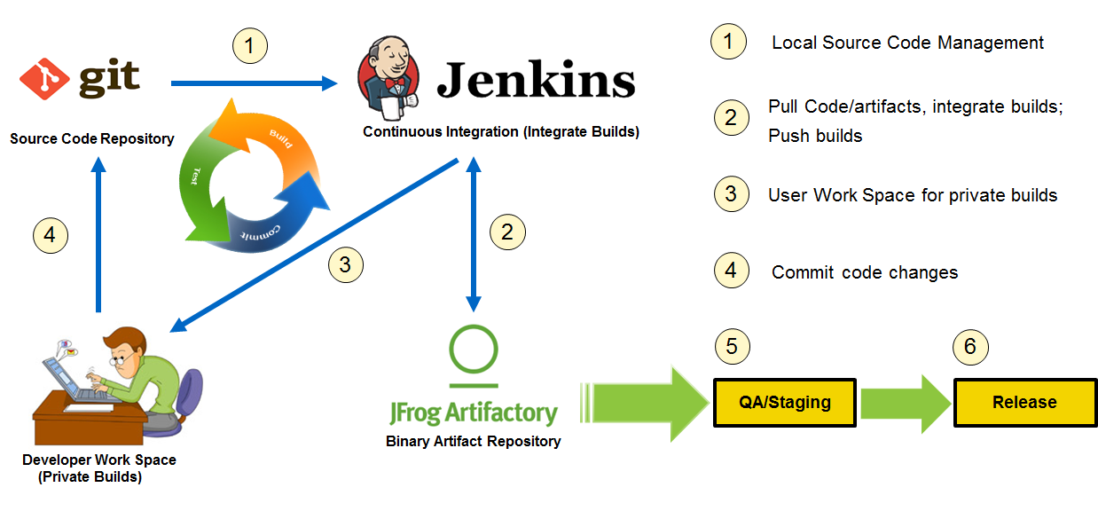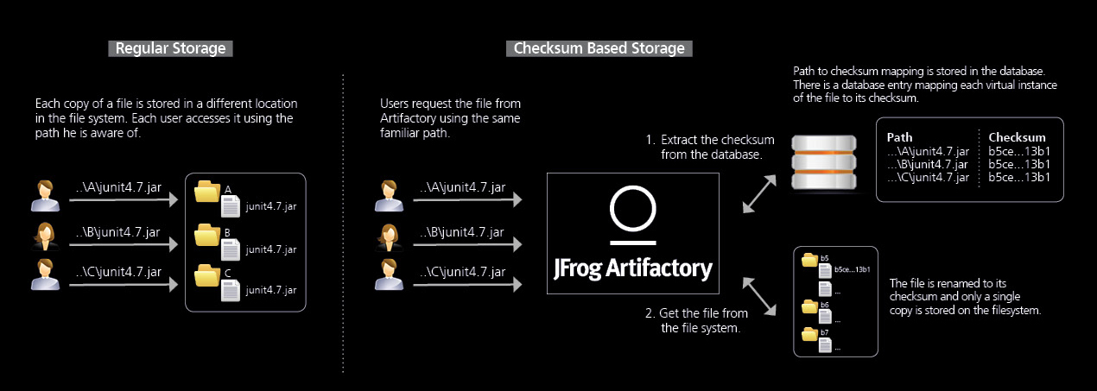

**Q: Show us a demo of how Artifactory is used in conjunction with Jenkins**.   **ANS:**

**Q: JFrog Artifactory  
ANS:** JFrog Artifactory is the only and first Artifact repository manager on the market which fully supports software packages created by any language or technology. It is the only Enterprise-ready repository manager available which supports secure, clustered, High Availability Docker registries. Integrating With all the CI/CD and DevOps tools, it provides an end-to-end, automated and bullet-proof solution for tracking artifacts from development to production.  
To manage the ever-growing matrix of binaries, environments and geographically distributed sites, JFrog Artifactory offers the following benefits:

**System stability and reliability with High Availability (HA) Configuration.**  
Using a redundant cluster of servers on the same LAN means that there is no single-point-of-failure, your system can accommodate larger load bursts, and most maintenance tasks can be performed with zero downtime.

**Managing many binaries across different environments**  
Only a single copy of any binary is ever stored on the file system, and Artifactory manages access to the file through repositories.

**Security and Access Control**  
Artifactory can provide security and access control at several levels. From restricting complete repositories down to restricting a single binary, and from a group of any size down to a single developer.

**Quickly replicate repositories to remote sites**  
To support collaboration between teams that are spread out over remote sites, Artifactory lets you replicate repositories, quickly and easily, to another instance of Artifactory which is outside of your local network  
 **User plugins**User plugins extend the REST API giving you a simple way to add functionality to Artifactory, and implement complex, custom behavior in your binary management workflow

****In case to depict how the JFrog Artifactory works with the complete JFrog Suite,

