Studying different digital logic gates and designing basic logic gates using Universal gates
Group:  Nishat Tasnim Ema  Id:23-55025-3 | Section:
Abstract  This experiment was conducted to study the characteristics and operations of basic digital logic gates, including AND, OR, NOT, NAND, NOR XOR, and XNOR. The digital trainer board and standard logic ICs were used to observe the input-output behavior of each gate. Additionally, universal gates (NAND and NOR) were implemented to construct other logic functions, demonstrating their versatility in digital circuit design. Truth tables were verified through practical connections and output measurements. The experiment also familiarized students with IC pin configurations and proper circuit wiring techniques. Overall, the study successfully enhanced understanding of fundamental logic gate operations and the concept of universal gates in digital electronics.  Theory and Methodology  In analog signals, information is translated into electric pulses of varying amplitude but in case of digital, translation of information is in binary format (zero or one) where each bit is representative of two distinct amplitudes. The main advantage of digital signals over analog signals is that the precise signal level of the digital signal is not vital. This means that digital signals are fairly immune to the imperfections of real electronic systems which tend to spoil analog signals. Codes are often used in the transmission of information. | 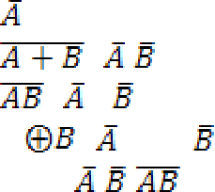  These codes can be used either as a means of keeping the information secret or as a means of breaking the information into pieces that are manageable by the technology used to transmit the code. It can convey information with greater noise immunity, because each information component (byte etc.) is determined by the presence or absence of a data bit (0 or one). Analog signals vary continuously, and their value is affected by all levels of noise. Digital signals can be processed by digital circuit components, which are cheap and easily produced in many components on a single chip. It uses typically less bandwidth with less electromagnetic interference. Moreover, Information storage can be easier in digital systems than in analog ones. The noise-immunity of digital systems permits data to be stored and retrieved without degradation. There are seven basic logic gates: AND, OR, NOT, NOR, NAND, XOR and XNOR. Different logic operations of different IC’s will be introduced which perform the following characteristics:  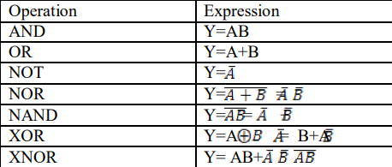
AND operation:  The AND operation produces a high if and only if all the inputs are high. An AND gate can have two or more inputs and performs AND operation or logical multiplication.  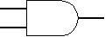  Fig1.1: Symbol of AND gate  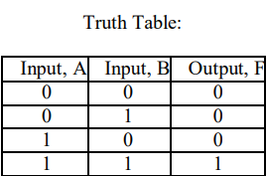  OR operation:  The OR operation produces a high output when any of the inputs are high. It has two or more inputs and one output which performs OR operation or logical addition.  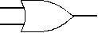  Fig 1.2: Symbol of OR gate  NOR operation:  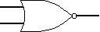  The NOR gate is a combination OR gate followed by an inverter. Its output is high if both inputs are low. Otherwise, the output is low.  Fig 1.5: Symbol of NOR gate  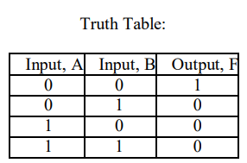  XOR operation:  The XOR (exclusive OR) gate acts in the same way as the logical "either/or". The output is high if either, but both, of the inputs are high. The output is low if both inputs are low or if both inputs are high. Another way of looking at this circuit is to observe that the output is 1 if the inputs are different, but 0 if the inputs are the same.  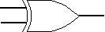  Fig 1.6: Symbol of XOR gate  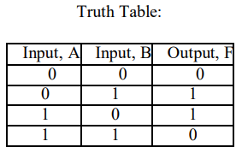 | 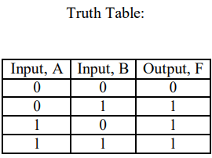  NOT operation:  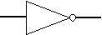  The NOT operation changes one logic level to the opposite logic level. It is implemented by a logic circuit known as an inverter.  Fig1.3: Symbol of NOT gate  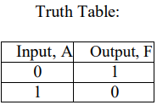  NAND operation:  The NAND gate operates as an AND gate followed by a NOT gate. It acts in the manner of the logical operation "AND" followed by negation. The output will be low if both inputs are high. Otherwise, the output is high.  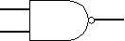  Fig 1.4: Symbol of NAND gate  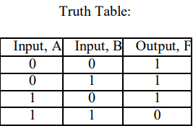  XNOR operation:  The XNOR (exclusive-NOR) gate is a combination XOR gate followed by an inverter. Its output is high if the inputs are the same, and low if the inputs are different.  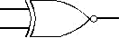  Fig 1.7: Symbol of XNOR gate  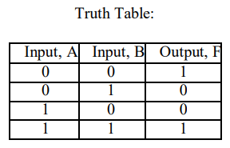

Apparatus  Digital trainer board.  Integrated Circuits (ICs).  Power supply.  Connecting wires  Precautions  Have your instructor check all your connections after you are done setting up the circuit and make sure that you apply only enough voltage to turn on the chip, otherwise it may get damaged.  Experimental Procedure  1.An XOR and XNOR gate were constructed on the trainer board using NAND gates only. The required ICs were used to implement the circuit.  2.The equivalent NOT, OR, and AND gates were obtained using NOR gates only. Then, an XOR and XNOR gate were constructed on the trainer board using NOR gates only, utilizing the required ICs.  XNOR gate using NOR  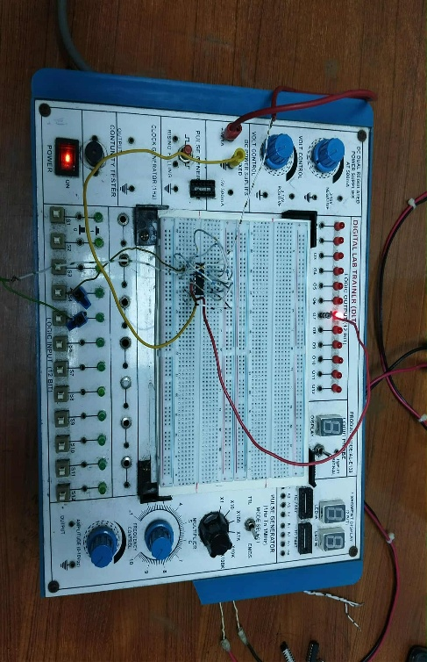  Discussion  During the experiment, the behavior of different logic gates was observed and confirmed through their truth tables. Each IC was connected carefully on the digital trainer board, and the outputs matched the expected theoretical results. The use of universal gates (NAND and NOR) demonstrated that complex logic functions could be implemented without using the basic gates directly. Minor variations in LED brightness and signal stability were noted due to wiring contacts and power supply fluctuations, but these did not affect the overall logical outcomes. The experiment emphasized the importance of correct IC pin configuration and proper circuit grounding. | Simulation and Measurement:  Using NAND gate  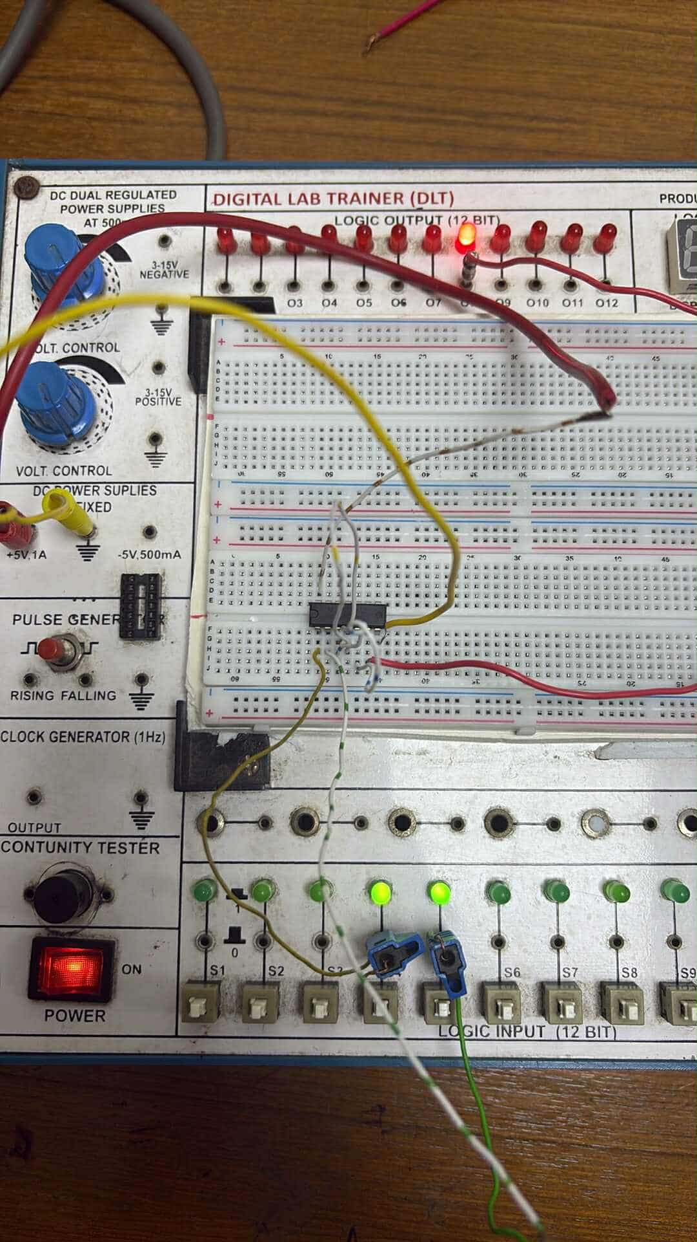  Using NOR gate  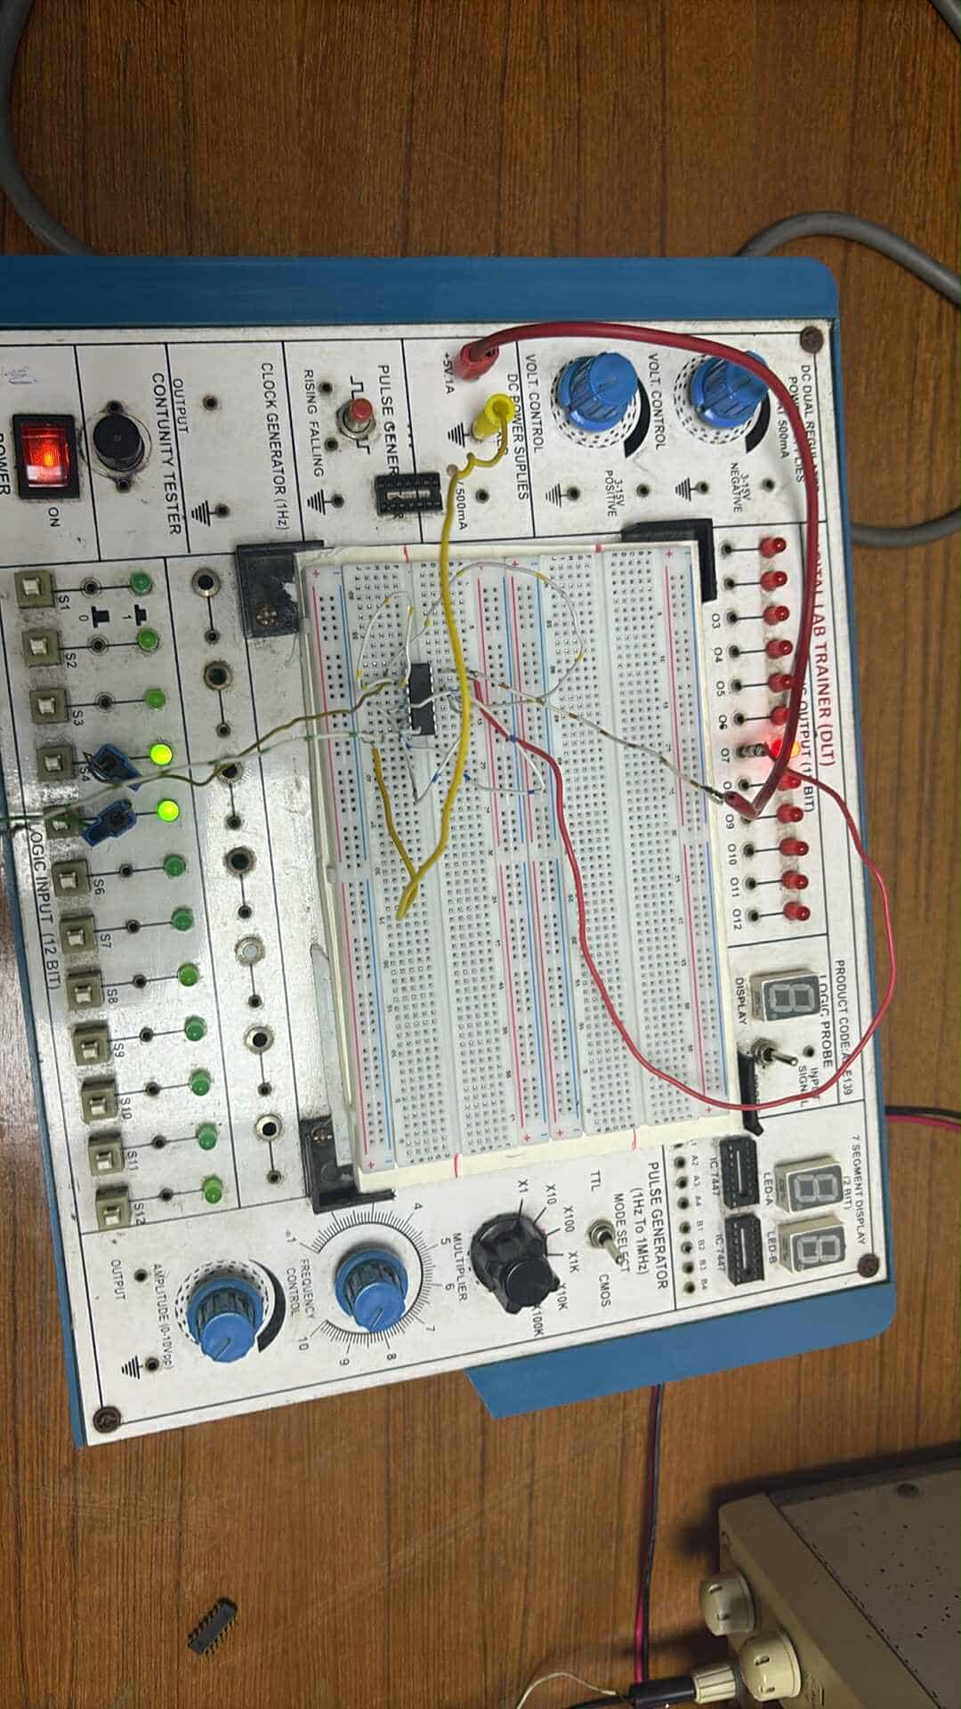  Conclusion  The experiment successfully achieved its objective of studying basic logic gates and constructing logic circuits using universal gates. Students gained hands-on experience in implementing digital logic functions, verifying truth tables, and understanding the advantages of universal gates in circuit design. The results confirmed that NAND and NOR gates could be used to create all other logic gates, demonstrating their versatility in digital electronics. Overall, the experiment enhanced practical skills and strengthened the fundamental understanding of digital logic circuits.  Reference:  - www.tutorialspoint.com  - www.electronics-tutorials.ws  - faculty.kfupm.edu.sa  - “Digital Fundamentals” by Thomas L. Floyd

