Exception Handling
Handling exceptions and errors in APIs and sending the proper response to the client is good for enterprise applications. In this chapter, we will learn how to handle exceptions in Spring Boot.
Before proceeding with exception handling, let us gain an understanding on the following annotations.

Controller Advice
The @ControllerAdvice is an annotation, to handle the exceptions globally.

Exception Handler
The @ExceptionHandler is an annotation used to handle the specific exceptions and sending the custom responses to the client.
You can use the following code to create @ControllerAdvice class to handle the exceptions globally −
package com.tutorialspoint.demo.exception;

import org.springframework.web.bind.annotation.ControllerAdvice;

@ControllerAdvice
public class ProductExceptionController {
}
Define a class that extends the RuntimeException class.
package com.tutorialspoint.demo.exception;

public class ProductNotfoundException extends RuntimeException {
private static final long serialVersionUID = 1L;
}
You can define the @ExceptionHandler method to handle the exceptions as shown. This method should be used for writing the Controller Advice class file.
@ExceptionHandler(value = ProductNotfoundException.class)

public ResponseEntity<Object> exception(ProductNotfoundException exception) {
}
Now, use the code given below to throw the exception from the API.
@RequestMapping(value = "/products/{id}", method = RequestMethod.PUT)
public ResponseEntity<Object> updateProduct() {
throw new ProductNotfoundException();
}
The complete code to handle the exception is given below. In this example, we used the PUT API to update the product. Here, while updating the product, if the product is not found, then return the response error message as “Product not found”. Note that the ProductNotFoundException exception class should extend the RuntimeException.
package com.tutorialspoint.demo.exception;
public class ProductNotfoundException extends RuntimeException {
private static final long serialVersionUID = 1L;
}
The Controller Advice class to handle the exception globally is given below. We can define any Exception Handler methods in this class file.
package com.tutorialspoint.demo.exception;

import org.springframework.http.HttpStatus;
import org.springframework.http.ResponseEntity;
import org.springframework.web.bind.annotation.ControllerAdvice;
import org.springframework.web.bind.annotation.ExceptionHandler;

@ControllerAdvice
public class ProductExceptionController {
@ExceptionHandler(value = ProductNotfoundException.class)
public ResponseEntity<Object> exception(ProductNotfoundException exception) {
return new ResponseEntity<>("Product not found", HttpStatus.NOT_FOUND);
}
}
The Product Service API controller file is given below to update the Product. If the Product is not found, then it throws the ProductNotFoundException class.
package com.tutorialspoint.demo.controller;

import java.util.HashMap;
import java.util.Map;

import org.springframework.http.HttpStatus;
import org.springframework.http.ResponseEntity;
import org.springframework.web.bind.annotation.PathVariable;
import org.springframework.web.bind.annotation.RequestBody;
import org.springframework.web.bind.annotation.RequestMapping;
import org.springframework.web.bind.annotation.RequestMethod;
import org.springframework.web.bind.annotation.RestController;

import com.tutorialspoint.demo.exception.ProductNotfoundException;
import com.tutorialspoint.demo.model.Product;

@RestController
public class ProductServiceController {
private static Map<String, Product> productRepo = new HashMap<>();
static {
Product honey = new Product();
honey.setId("1");
honey.setName("Honey");
productRepo.put(honey.getId(), honey);

Product almond = new Product();
almond.setId("2");
almond.setName("Almond");
productRepo.put(almond.getId(), almond);
}

@RequestMapping(value = "/products/{id}", method = RequestMethod.PUT)
public ResponseEntity<Object> updateProduct(@PathVariable("id") String id, @RequestBody Product product) {
if(!productRepo.containsKey(id))throw new ProductNotfoundException();
productRepo.remove(id);
product.setId(id);
productRepo.put(id, product);
return new ResponseEntity<>("Product is updated successfully", HttpStatus.OK);
}
}
The code for main Spring Boot application class file is given below −
package com.tutorialspoint.demo;

import org.springframework.boot.SpringApplication;
import org.springframework.boot.autoconfigure.SpringBootApplication;

@SpringBootApplication
public class DemoApplication {
public static void main(String[] args) {
SpringApplication.run(DemoApplication.class, args);
}
}
The code for POJO class for Product is given below −
package com.tutorialspoint.demo.model;
public class Product {
private String id;
private String name;

public String getId() {
return id;
}
public void setId(String id) {
this.id = id;
}
public String getName() {
return name;
}
public void setName(String name) {
this.name = name;
}
}
The code for Maven build – pom.xml is shown below −
<?xml version = "1.0" encoding = "UTF-8"?>
<project xmlns = "http://maven.apache.org/POM/4.0.0"
xmlns:xsi = "http://www.w3.org/2001/XMLSchema-instance"
xsi:schemaLocation = "http://maven.apache.org/POM/4.0.0
http://maven.apache.org/xsd/maven-4.0.0.xsd">

<modelVersion>4.0.0</modelVersion>
<groupId>com.tutorialspoint</groupId>
<artifactId>demo</artifactId>
<version>0.0.1-SNAPSHOT</version>
<packaging>jar</packaging>
<name>demo</name>
<description>Demo project for Spring Boot</description>

<parent>
<groupId>org.springframework.boot</groupId>
<artifactId>spring-boot-starter-parent</artifactId>
<version>1.5.8.RELEASE</version>
<relativePath/>
</parent>

<properties>
<project.build.sourceEncoding>UTF-8</project.build.sourceEncoding>
<project.reporting.outputEncoding>UTF-8</project.reporting.outputEncoding>
<java.version>1.8</java.version>
</properties>

<dependencies>
<dependency>
<groupId>org.springframework.boot</groupId>
<artifactId>spring-boot-starter-web</artifactId>
</dependency>
<dependency>
<groupId>org.springframework.boot</groupId>
<artifactId>spring-boot-starter-test</artifactId>
<scope>test</scope>
</dependency>
</dependencies>

<build>
<plugins>
<plugin>
<groupId>org.springframework.boot</groupId>
<artifactId>spring-boot-maven-plugin</artifactId>
</plugin>
</plugins>
</build>

</project>
The code for Gradle Build – build.gradle is given below −
buildscript {
ext {
springBootVersion = '1.5.8.RELEASE'
}
repositories {
mavenCentral()
}
dependencies {
classpath("org.springframework.boot:spring-boot-gradle-plugin:${springBootVersion}")
}
}
apply plugin: 'java'
apply plugin: 'eclipse'
apply plugin: 'org.springframework.boot'

group = 'com.tutorialspoint'
version = '0.0.1-SNAPSHOT'
sourceCompatibility = 1.8

repositories {
mavenCentral()
}
dependencies {
compile('org.springframework.boot:spring-boot-starter-web')
testCompile('org.springframework.boot:spring-boot-starter-test')
}
You can create an executable JAR file, and run the Spring Boot application by using the Maven or Gradle commands −
For Maven, you can use the following command −
mvn clean install
After “BUILD SUCCESS”, you can find the JAR file under the target directory.
For Gradle, you can use the following command −
gradle clean build
After “BUILD SUCCESSFUL”, you can find the JAR file under the build/libs directory.
You can run the JAR file by using the following command −
java –jar <JARFILE>
This will start the application on the Tomcat port 8080 as shown below −
Now hit the below URL in POSTMAN application and you can see the output as shown below −
Update URL: http://localhost:8080/products/3

Interceptor
To work with interceptor, you need to create @Component class that supports it and it should implement the HandlerInterceptor interface.

The following are the three methods you should know about while working on Interceptors −
- preHandle() method − This is used to perform operations before sending the request to the controller. This method should return true to return the response to the client.
- postHandle() method − This is used to perform operations before sending the response to the client.
- afterCompletion() method − This is used to perform operations after completing the request and response.
@Component
public class ProductServiceInterceptor implements HandlerInterceptor {
@Override
public boolean preHandle(
HttpServletRequest request, HttpServletResponse response, Object handler) throws Exception {

return true;
}
@Override
public void postHandle(
HttpServletRequest request, HttpServletResponse response, Object handler,
ModelAndView modelAndView) throws Exception {}

@Override
public void afterCompletion(HttpServletRequest request, HttpServletResponse response,
Object handler, Exception exception) throws Exception {}
}

You will have to register this Interceptor with InterceptorRegistry by using WebMvcConfigurerAdapter as shown below –

@Component
public class ProductServiceInterceptorAppConfig extends WebMvcConfigurerAdapter {
@Autowired
ProductServiceInterceptor productServiceInterceptor;

@Override
public void addInterceptors(InterceptorRegistry registry) {
registry.addInterceptor(productServiceInterceptor);
}
}

@NamedQuery in spring boot?
@NamedQuery is an annotation in Java Persistence API (JPA) that allows you to define named queries in your entity classes. Named queries are predefined queries that you can reuse throughout your application.
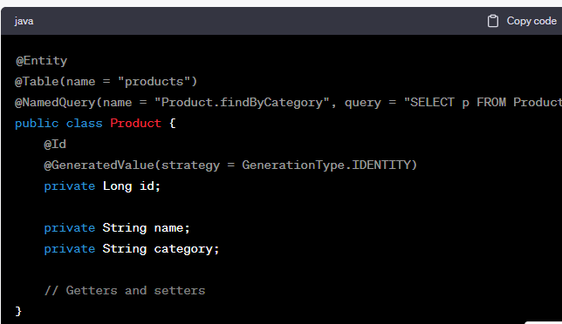
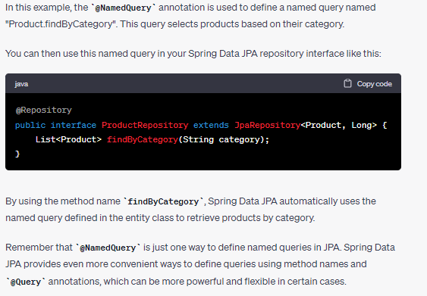

What are the ways to call external apis from spring boot
Spring Boot provides several ways to call external APIs. Here are some commonly used options:

RestTemplate:

https://reflectoring.io/spring-resttemplate/
RestTemplate is a synchronous client for making HTTP requests to remote servers. It's a part of the Spring Web module and offers a simple and convenient way to interact with RESTful services.
RestTemplate restTemplate = new RestTemplate();
String response = restTemplate.getForObject("https://api.example.com/data", String.class);

Some Useful Methods

getForEntity():
Executes a GET request and returns an object of ResponseEntity class that contains both the status code and the resource as an object.

getForObject() :
similar to getForEntity(), but returns the resource directly.

exchange():
executes a specified HTTP method, such as GET, POST, PUT, etc, and returns a ResponseEntity containing both the HTTP status code and the resource as an object.

execute() :
similar to the exchange() method, but takes additional parameters: RequestCallback and ResultSetExtractor.

headForHeaders():
executes a HEAD request and returns all HTTP headers for the specified URL.

optionsForAllow():
Executes an OPTIONS request and uses the Allow header to return the HTTP methods that are allowed under the specified URL.

delete():
deletes the resources at the given URL using the HTTP DELETE method.

put():
Updates a resource for a given URL using the HTTP PUT method.

postForObject() :
Creates a new resource using HTTP POST method and returns an entity.

postForLocation():
creates a new resource using the HTTP POST method and returns the location of the newly created resource.

WebClient
WebClient is a more modern alternative to RestTemplate that provides a non-blocking, reactive way to make HTTP requests. It's a part of the Spring WebFlux module.
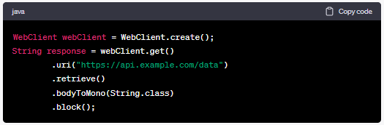

Feign Client
Feign is a declarative HTTP client that simplifies the process of making HTTP requests by allowing you to define an interface with annotated methods, and Spring Boot handles the rest.
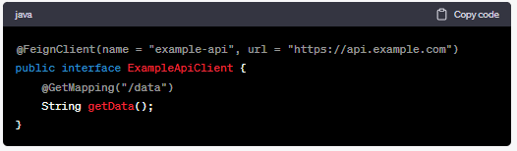

Choosing the Right Approach:
If you're working on a traditional application and prefer synchronous, blocking behavior, RestTemplate can be a good choice.
If you're developing a reactive application and want to leverage non-blocking capabilities, consider using WebClient.
If you're building microservices and need service discovery and load balancing along with API calls, Feign Client could be useful.

Servlet Filter
A filter is an object used to intercept the HTTP requests and responses of your application. By using filter, we can perform two operations at two instances −
- Before sending the request to the controller
- Before sending a response to the client.
In the context of Spring Boot web applications, a "filter" refers to a component that performs filtering tasks on either the request to a resource (like a servlet or JSP) or on the response from a resource. Filters are commonly used for tasks such as logging, authentication, authorization, and more.
To create a filter in a Spring Boot application, you would typically implement the javax.servlet.Filter interface and override the doFilter() method. You can also use Spring's OncePerRequestFilter as a base class to ensure the filter is only applied once per request.

Scheduling
In Spring Boot, scheduling tasks can be accomplished using the @Scheduled annotation, which allows you to execute methods at specific intervals or according to a cron expression. This is useful for automating tasks like data synchronization, sending emails, or performing maintenance tasks.
Here's a basic example of how to use the @Scheduled annotation in a Spring Boot application:
Create a Spring Boot Project: Set up a Spring Boot project using your preferred build tool (Maven or Gradle).
Add Dependencies: Make sure you have the necessary Spring Boot dependencies in your project. You might need the spring-boot-starter and spring-boot-starter-web dependencies at the very least.
Create a Scheduled Task: Define a method in a Spring component (usually a service or a bean) and annotate it with @Scheduled. This method will be executed based on the scheduling configuration you provide.

To enable scheduling

Enable Scheduling:
Need to add the @EnableScheduling annotation to your Spring Boot application class.
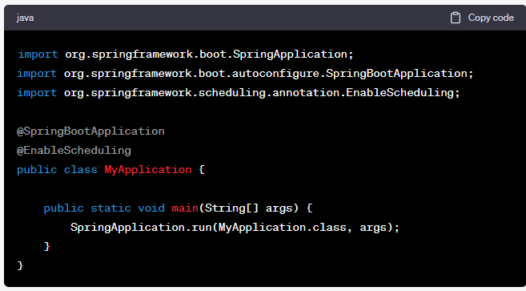

Configure Scheduling
The @Scheduled annotation provides various attributes that allow you to control the scheduling behavior. You can use fixedRate, fixedDelay, or cron attributes to specify the timing.
fixedRate: This attribute specifies the time interval between the start time of consecutive invocations of the method. Regardless of how long the method execution takes, the next invocation will occur after the specified interval.
fixedDelay: This attribute specifies the time interval between the completion of one invocation and the start of the next invocation. It ensures that there's a delay between executions, regardless of how long the method execution takes.
cron: Allows you to define a cron expression for more complex scheduling patterns. A "cron" expression consists of five fields separated by space, representing the minute, hour, day of the month, month, and day of the week. The values within these fields are based on specific ranges or symbols.

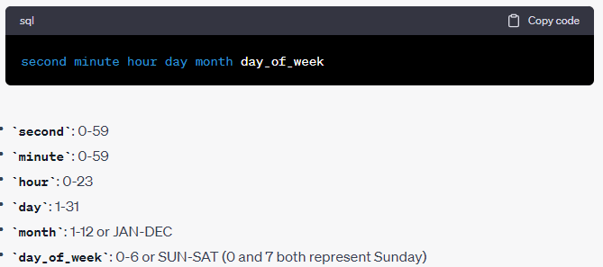

CRON Example
Suppose you want to schedule a task to run every day at 3:30 PM.

The "cron" expression for this would be: 0 30 15 * * ?
0 - Represents the seconds field (starting from 0 seconds).
30 - Represents the minutes field (at the 30th minute).
15 - Represents the hours field (at the 15th hour, which is 3 PM).
* - Represents any value. In the day of the month and month fields, it means "any day" and "any month".
? - This is used in the day of the week field to allow any day of the week.

AOP
