-----------------Spring Security---------------------

Introduction

Security Workflow

Custom Configuration

CSRF

User Registration and Login

HIGH-LEVEL FLOW OVERVIEW
When a request is made to a protected endpoint (like /security/add or /security/get), Spring Security:
- Intercepts the request.
- Invokes the configured AuthenticationProvider.
- That AuthenticationProvider calls your CustomUserDetailService.loadUserByUsername(...).
- You return a UserDetails object (CustomUserDetails) that Spring uses to compare credentials and determine authorities.
- If authentication succeeds, access is granted; otherwise, rejected.

COMPONENT-WISE BREAKDOWN
- WebSecurityConfig — Security Configuration
  - This class sets up the Spring Security context:
  - You allow unauthenticated access to register and login.
  - All other endpoints (e.g., /security/add) require authentication.
  - You're using HTTP Basic Auth (username and password via headers).
  - CSRF is disabled, which is OK for APIs (but be cautious in production for web apps).
- CustomUserDetailService — Load User From DB
  - When a request comes with credentials, this method is triggered.
  - It fetches user data from your DB using JPA (UserRepository).
  - If the user is found, you wrap the entity in your CustomUserDetails class.
- CustomUserDetails — Adapter Between UserEntity and Spring Security
  - 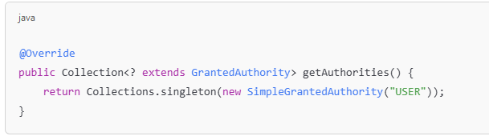
  - This class tells Spring Security what the user's username, password, and authorities (roles) are.
  - You’ve hardcoded the role to "USER" for now — this is okay for starting but can be improved with dynamic role loading.

Why do we need CustomUserDetails?
- It calls UserDetailsService.loadUserByUsername()
- Your CustomUserDetailService fetches the UserEntity from the database.
- It wraps it into a CustomUserDetails object.
- Spring uses this UserDetails object to:
  - Compare credentials (password)
  - Get the username
  - Get roles/authorities
  - Check whether the account is expired/locked/disabled/etc.

For Password Encryption
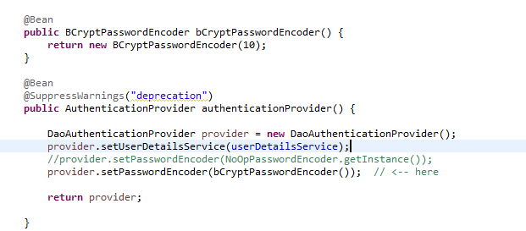

JWT

Implement JWT

JWT for Micro-services

SSO

--------------------------------------------- PLAN--------------------------------------
Phase 1 — Setup Basic Security
Day 1:
Add Spring Security dependency in API-Gateway.
Create a simple in-memory user (hardcoded) with username/password.
Secure all routes — only allow access if authenticated.
Test with Postman or browser login popup.
Goal: Understand how Spring Security is securing your endpoints.
✅ Phase 2 — Disable CSRF and Customize Security
Day 2:
Disable CSRF for APIs (because CSRF is mostly for web UI, not needed for API backend).
Make /login and /register publicly accessible.
Protect /employee/** and /department/** routes (only accessible after login).
Goal: Learn how to customize which endpoints are public/private.
✅ Phase 3 — User Registration and Authentication
Day 3:
Create a simple User model (username, password, roles).
Create a register API to store users temporarily (in-memory list).
Implement /login API to accept username/password and authenticate manually (for now).
Goal: Basic user registration and login setup (without JWT yet).
✅ Phase 4 — Implement JWT Authentication
Day 4:
Add JWT dependency (jjwt or auth0 library).
On successful login, generate JWT token.
Send token back to client.
Day 5:
Add a JWT filter to validate JWT in incoming requests.
Secure /employee/** and /department/** with JWT.
If no token or invalid token → return 401 Unauthorized.
Goal: Basic JWT-based authentication working.
✅ Phase 5 — JWT for Microservices
Day 6:
From API-Gateway → pass JWT token to backend services.
Modify Department and Employee services to validate JWT if needed (optional for now).
Make sure the token flows properly between API Gateway and services.
Goal: JWT across Gateway → Department → Employee service.
✅ Phase 6 — (Optional) Single Sign On (SSO) Idea
Day 7:
Study basics of SSO.
Understand that after logging in once (with one JWT), you can access multiple services.
No need to implement anything big for now.
✅ Phase 7 — (Optional) OAuth2
Day 8–9: (only if you feel confident)
Learn OAuth2 basics (Authorization Code, Client Credentials flows).
Try to connect your service with a simple OAuth2 authorization server (like Keycloak).

✅ Phase 3 :

