CUSTOMER VIEW

1. Create DB: 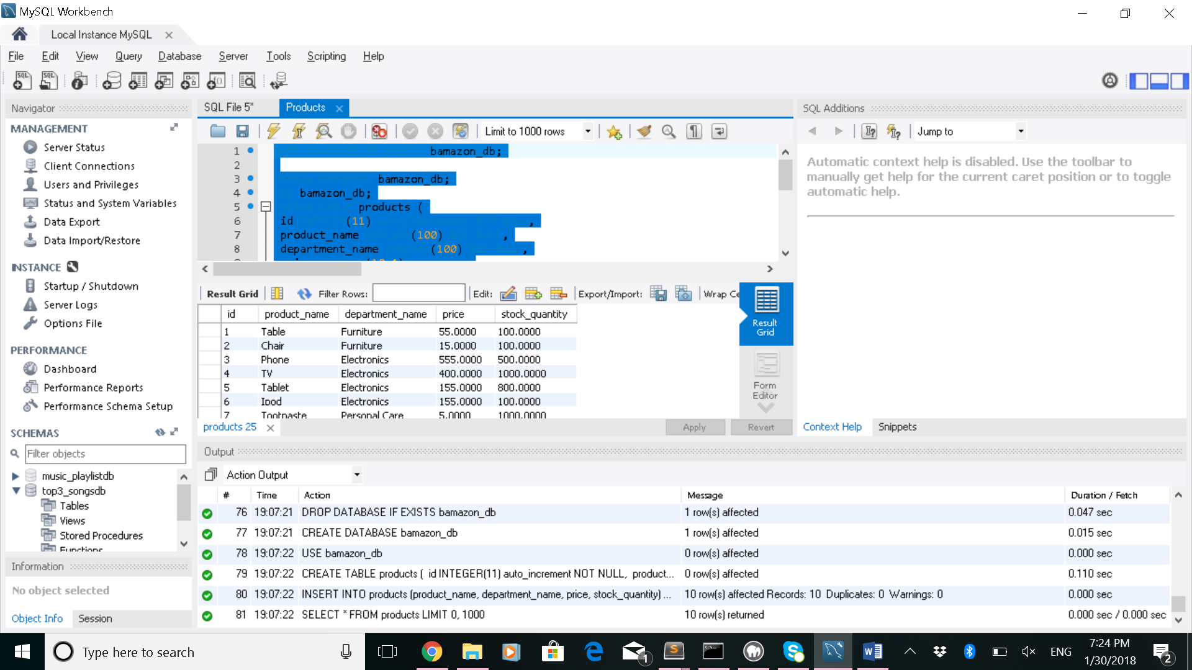
2. BUY a product

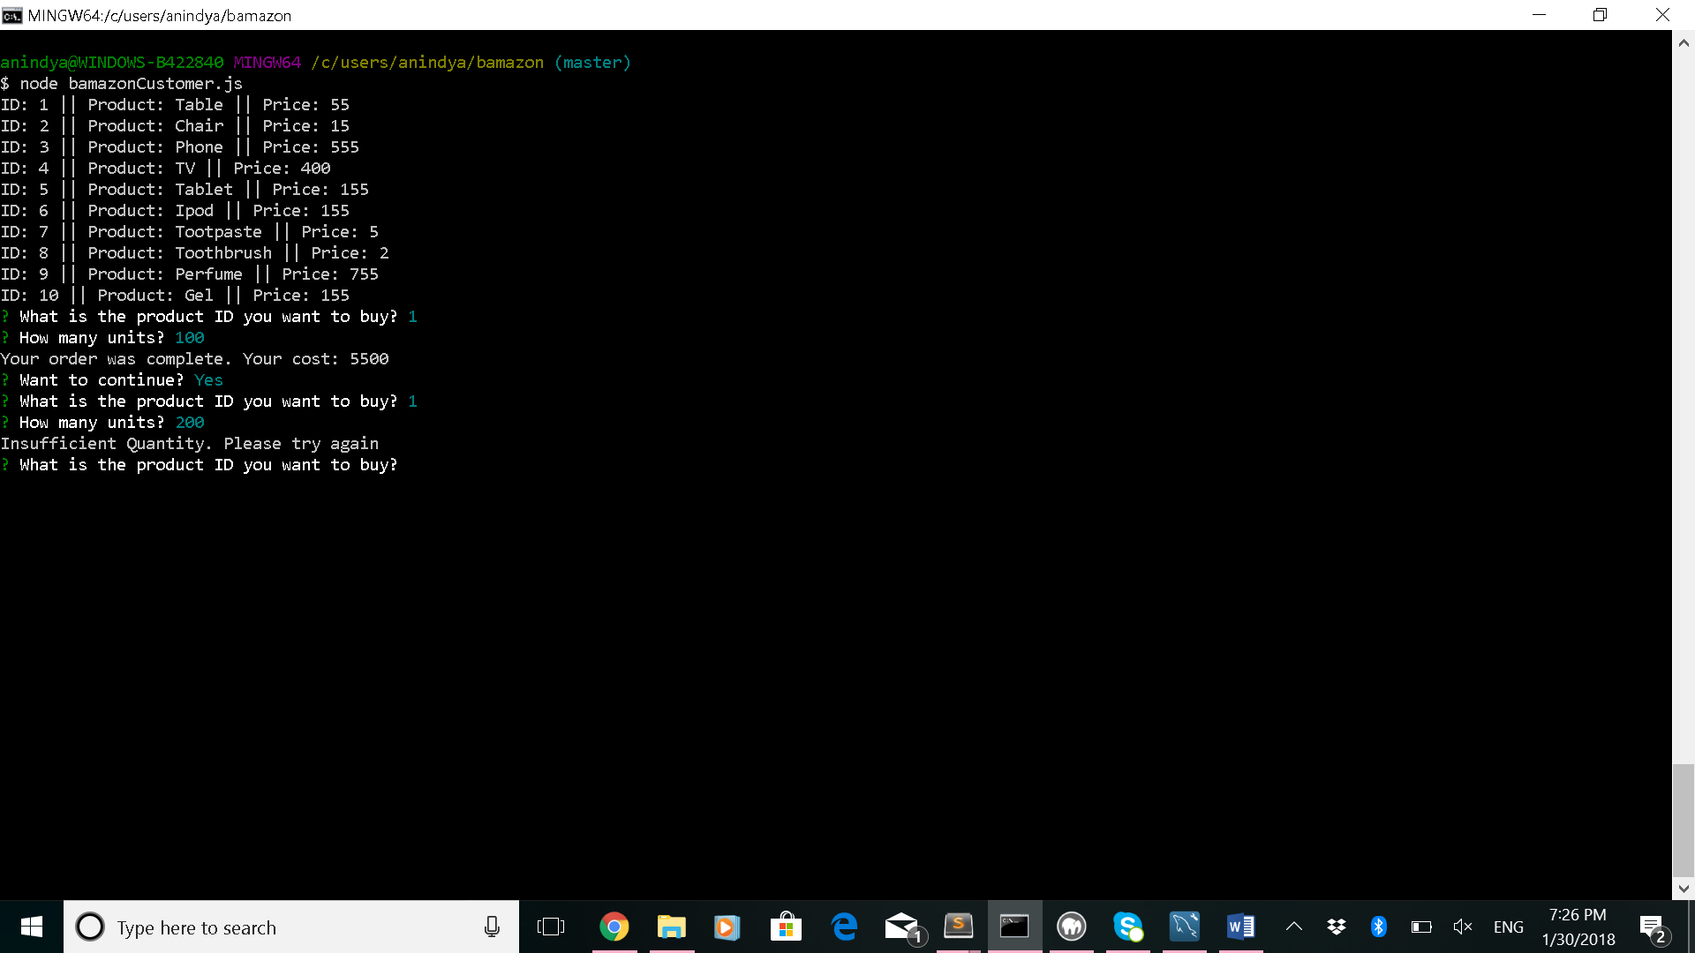

1. Database is updated with the purchase

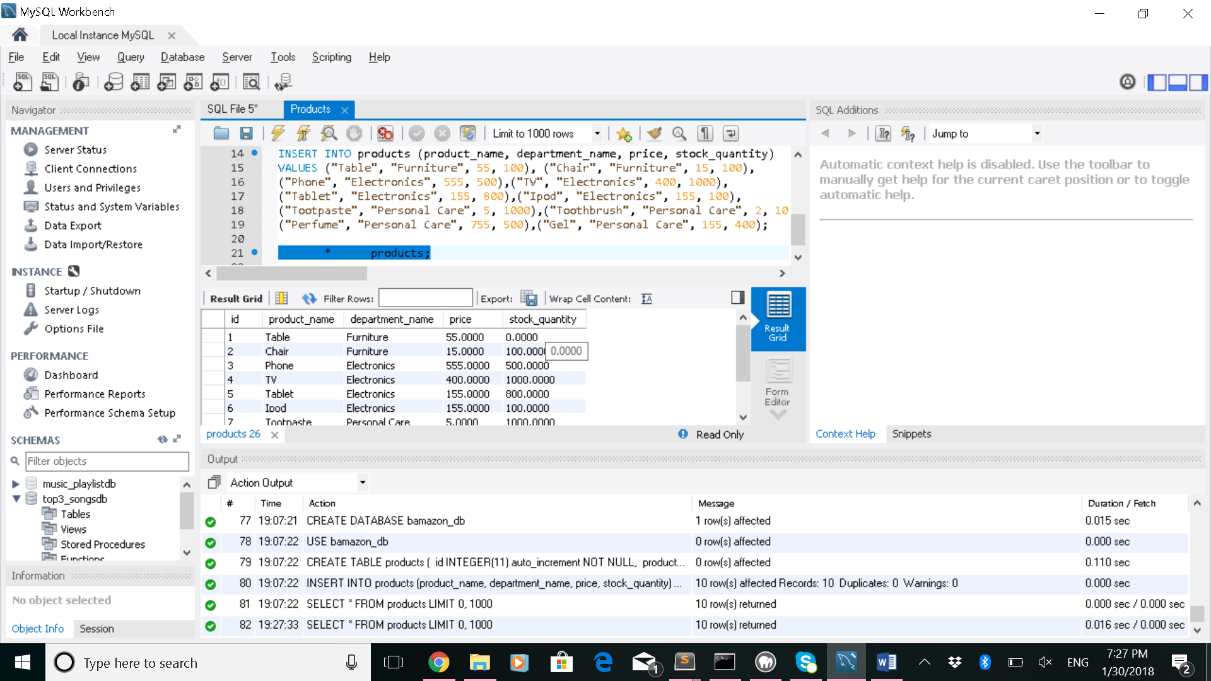

MANAGER VIEW

* Gives options to chose from in the list, example: View low inventory
* 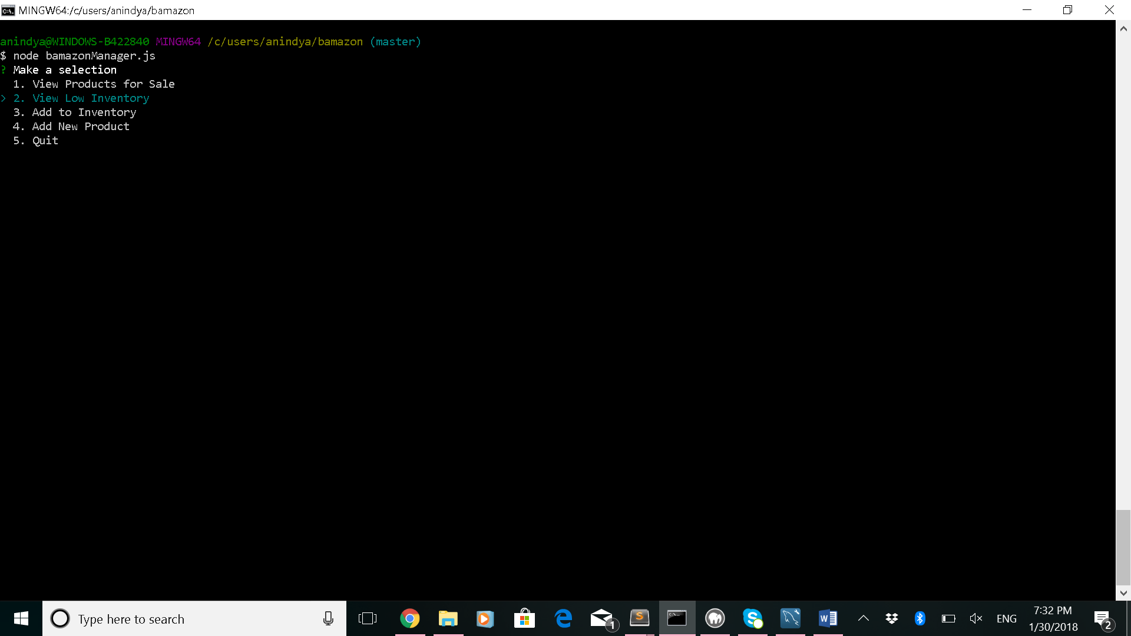
* For inventory less than < 5 displays the actual inventory value else for inventory >5 shows sufficient Quantity

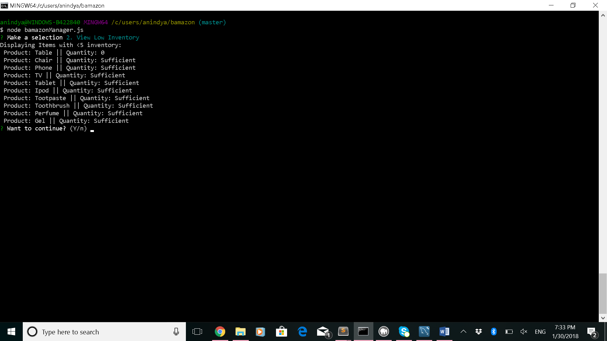

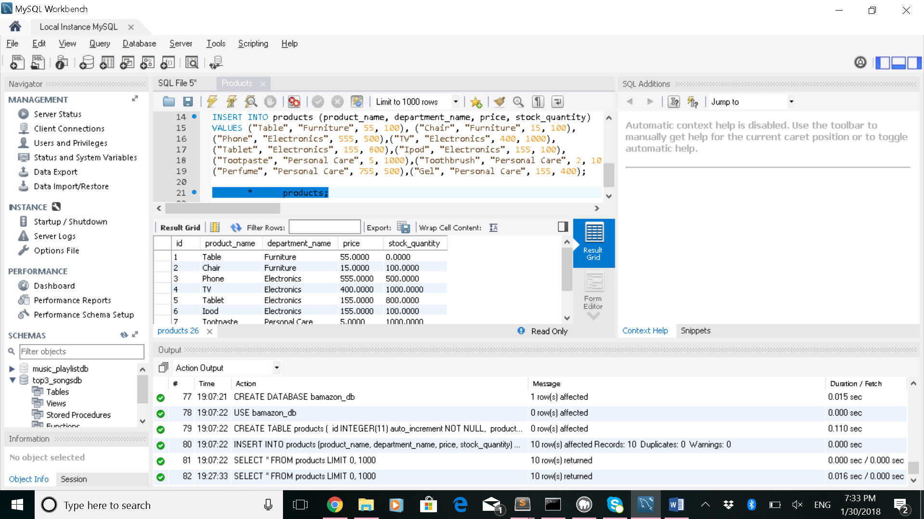

* Update a product

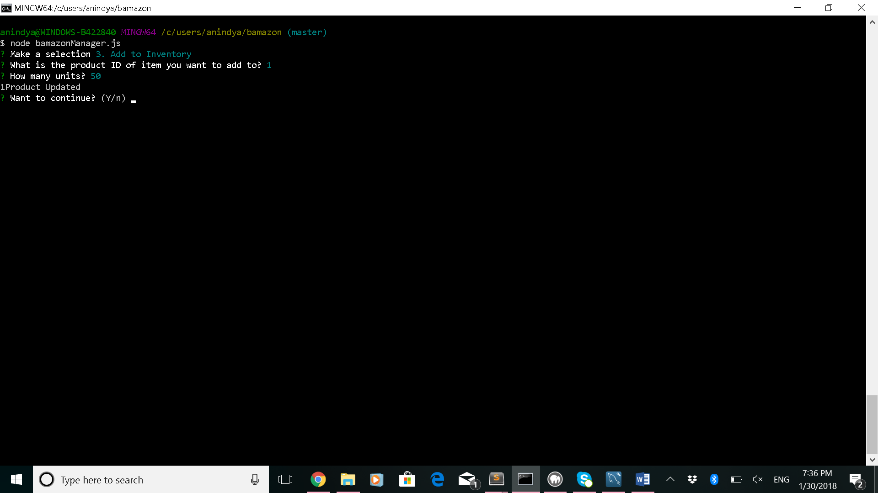

On running Update function inventory for product ID1 increased by 50 from 0

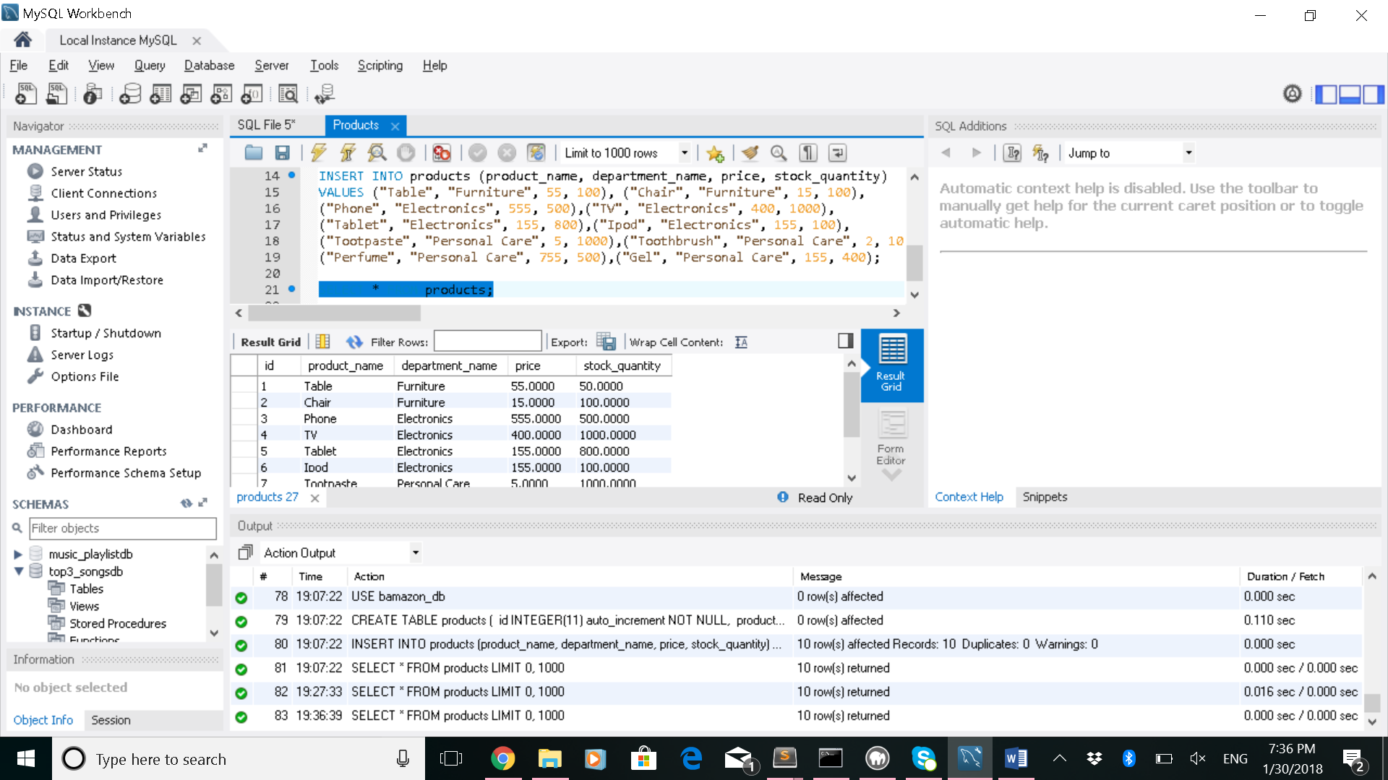

Add new Product:

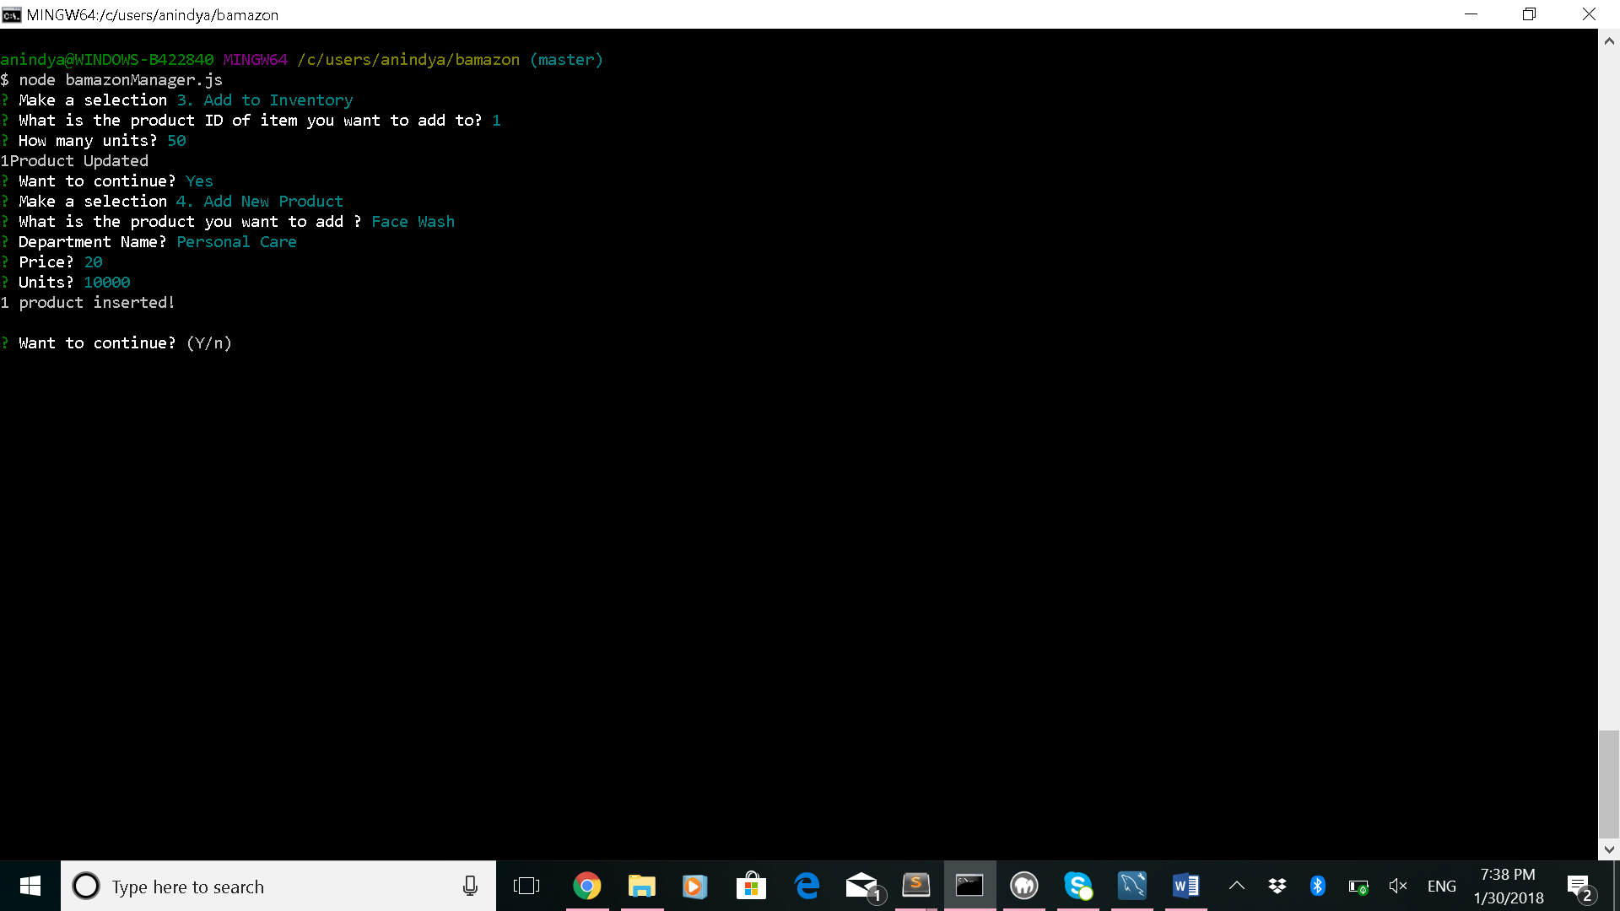

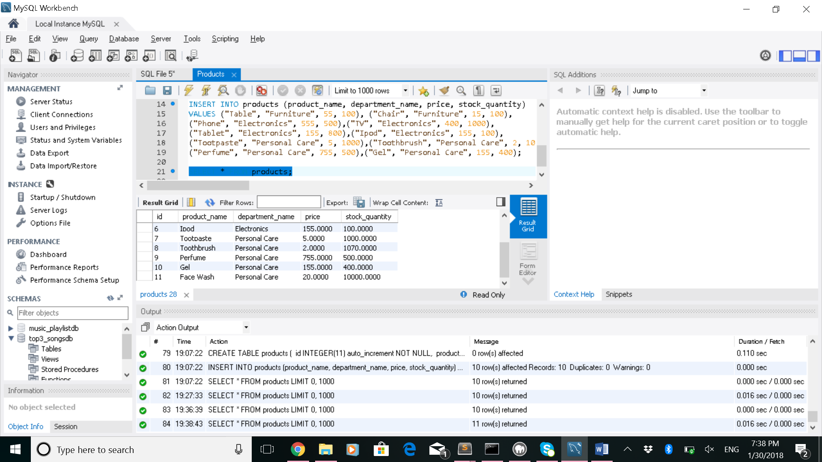

* ### Challenge #3: Modify the products table so that there's a product_sales column and modify the `bamazonCustomer.js` app so that this value is updated with each individual products total revenue from each sale.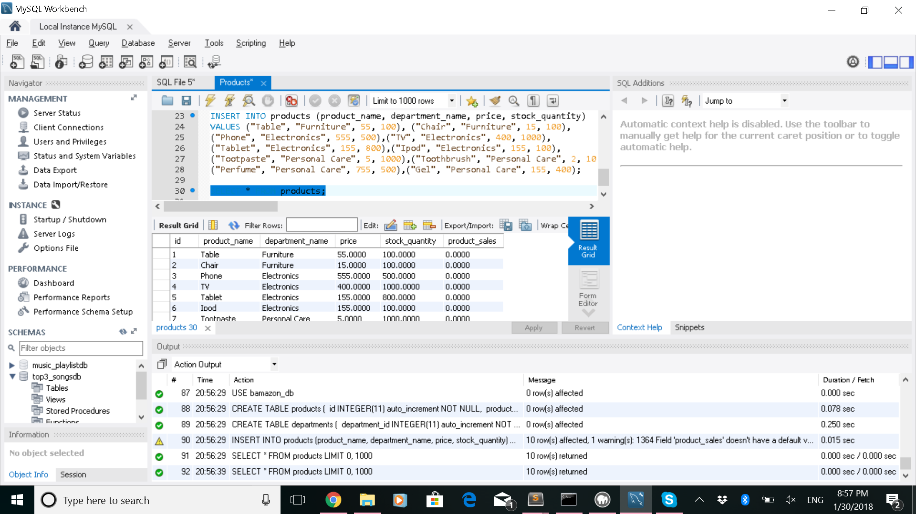

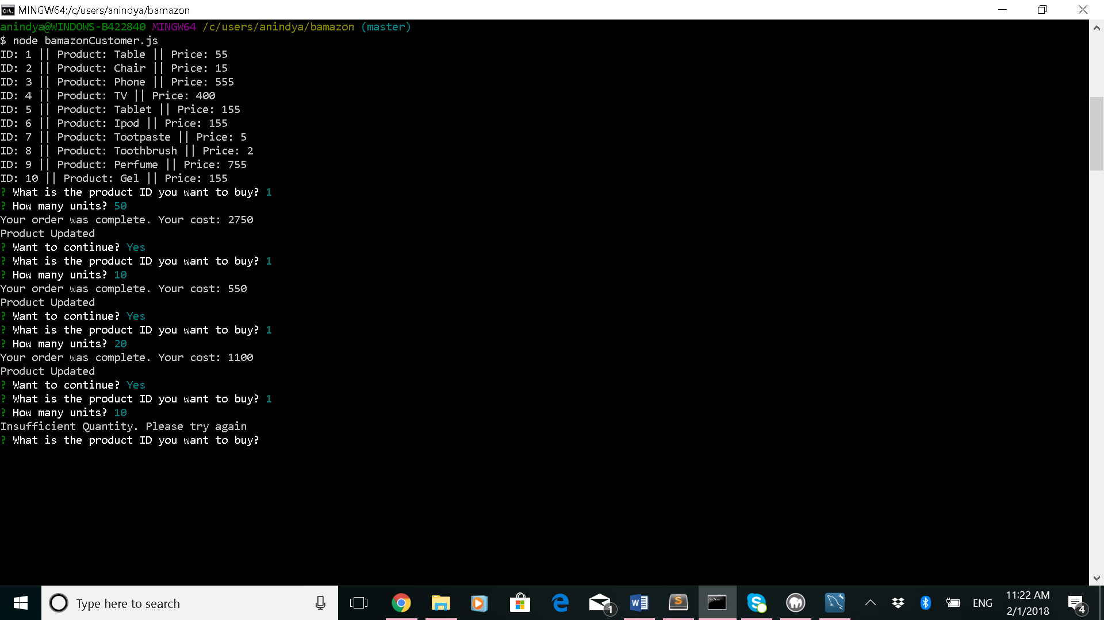

Product sales figure updated as shown below

