TEST CASES:

1. Stopping Client while Uploading the file:

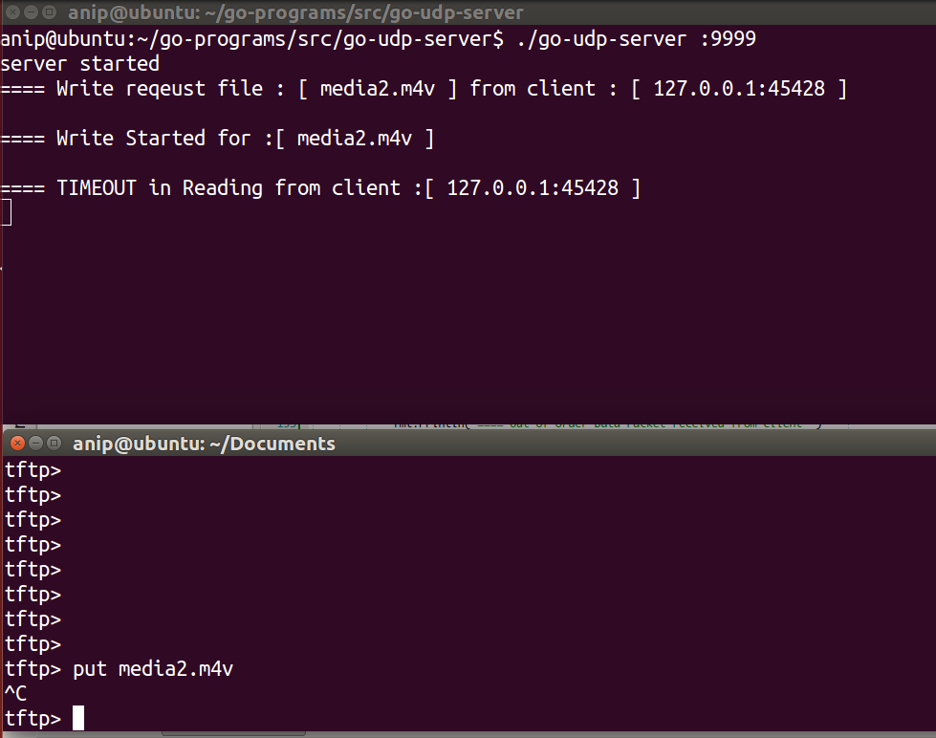

Server got timeout as it’s not receiving Data packets from client.

2) Stopping Client while downloading the File:

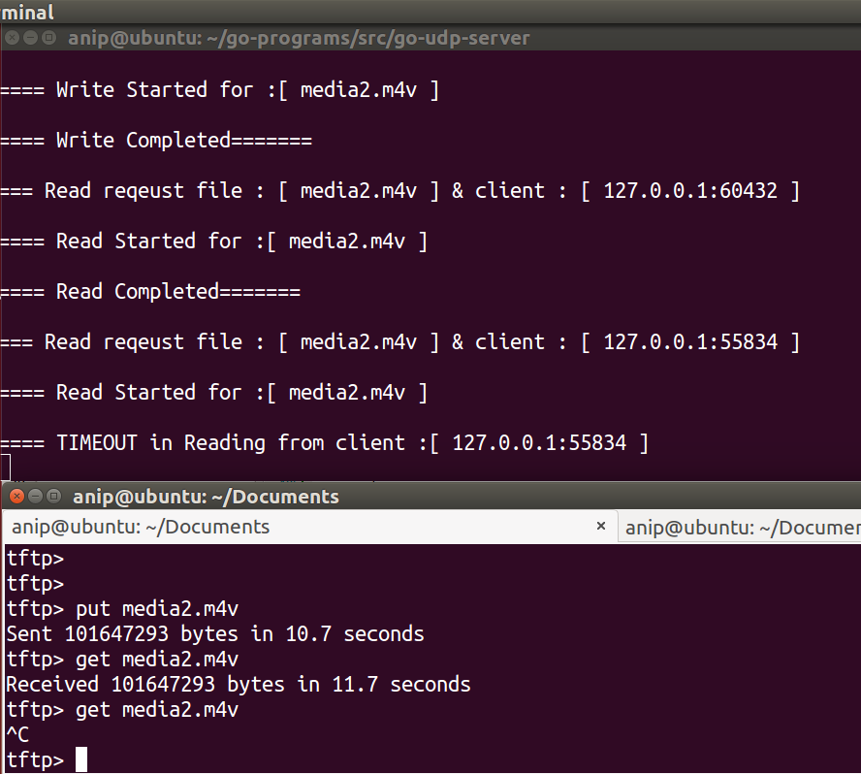

Server got timeout as its not receiving ACK from client

3) Stopping Server while uploading the file:

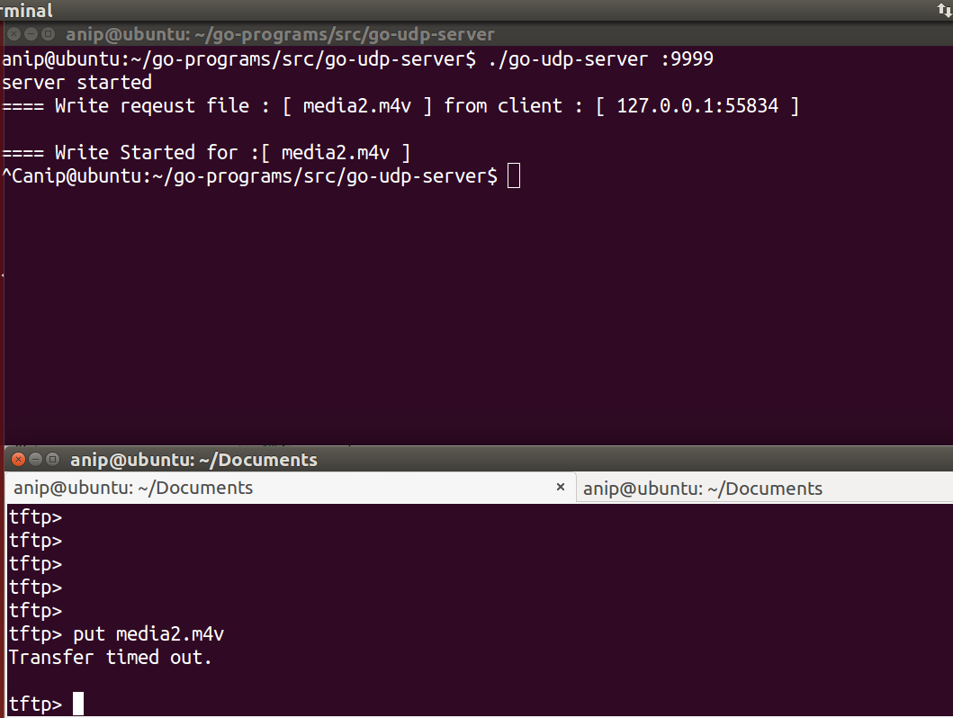

Client is not receiving ACK packets as server crashed. Finally client got timeout.

4) Stopping Server while downloading the file:

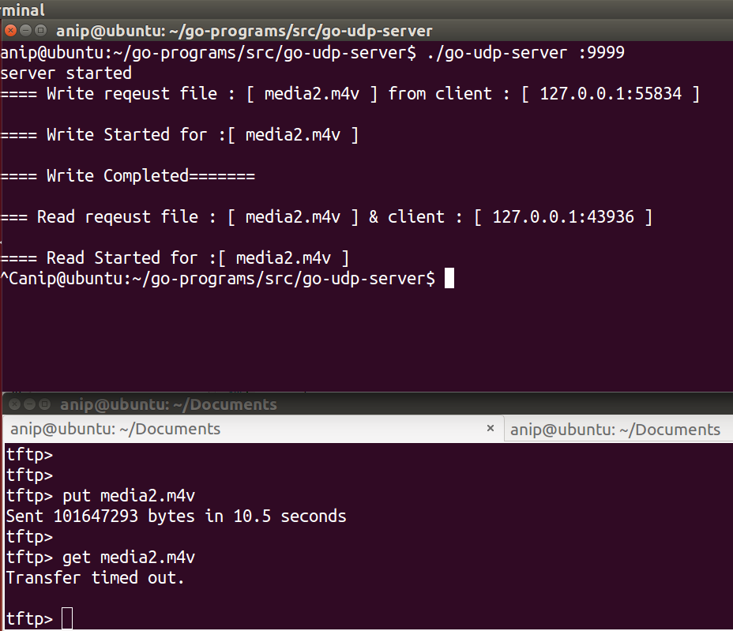

Client is not receiving Data packets as server crashed. Finally client got timeout.

5) Concurrent Uploading of 2 files:

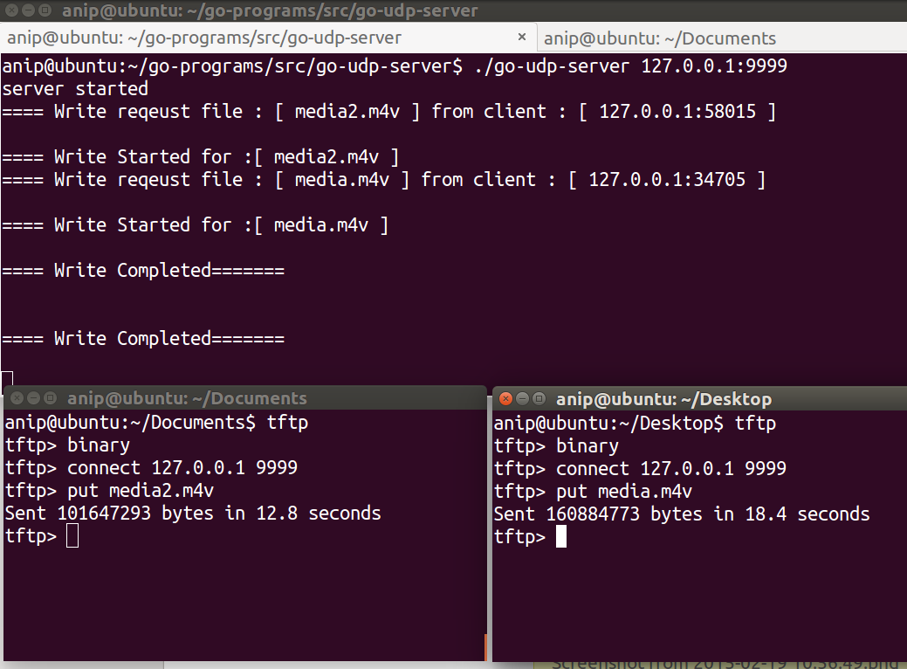

Uploading “media2.m4v” from Document and “media.m4v” from Desktop concurrently.

6) Concurrent downloading of 2 files:

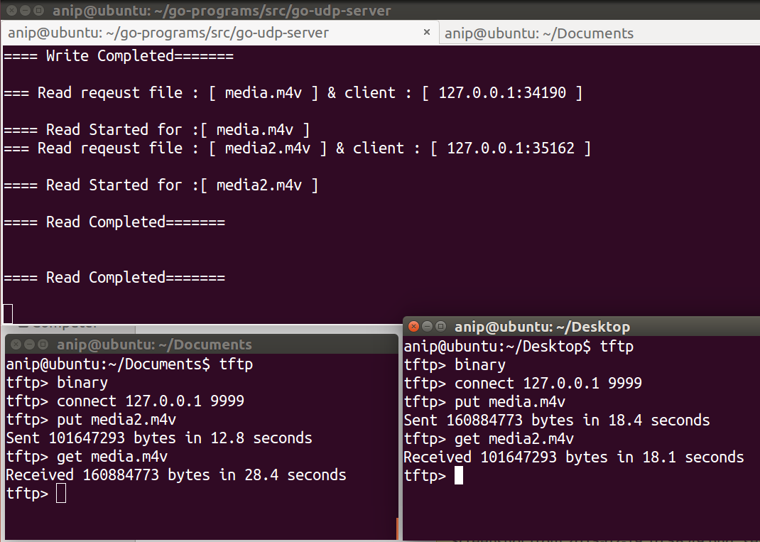

We have media2.m4v & media.m4v on server. Downloading media.m4v on Document and media2.m4v on Desktop concurrently. Swapped file in download compare to upload. We can get as both are on server. We can see that in screenshot above.

7) Testing Uploading Same file Again & downloading not existing file:

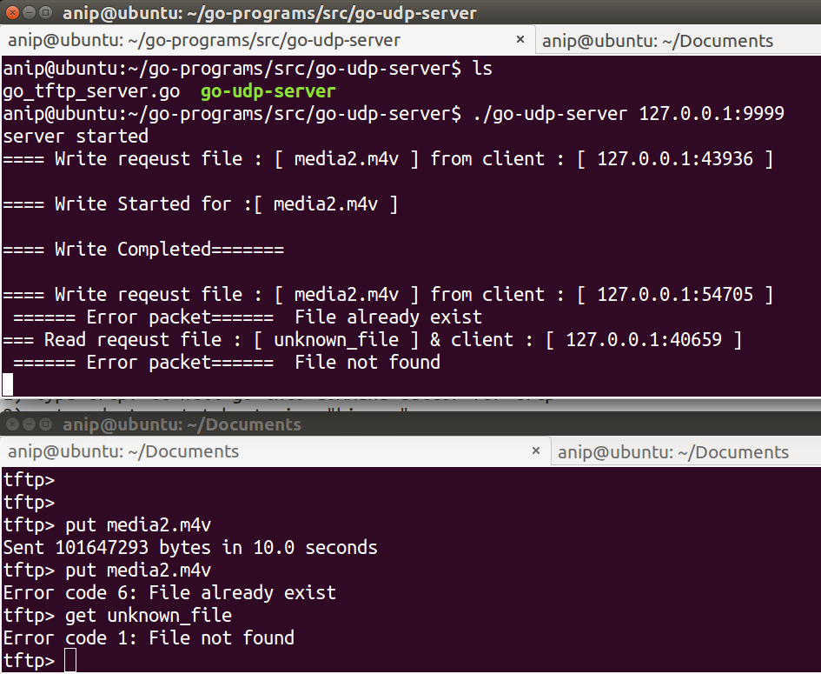

8) Different ip address and port number checking passed at command line.

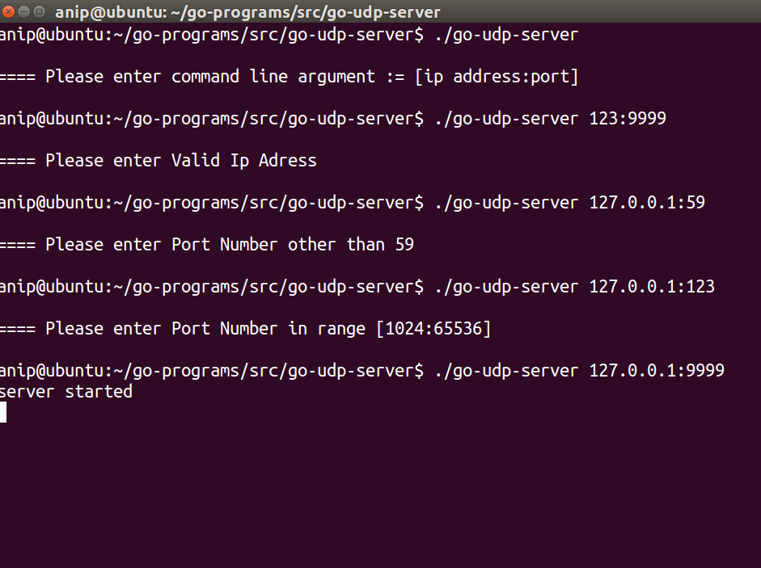

**Anipkumar Patel**

**Aapatel8@asu.edu**