**CE324 ( Mathematical Concepts and Applications in Civil Engineering )**

**Programming Assignment : 1 (10-02-2022)**

Name : Patil Aniruddha Ramesh

Roll No. : 200104072

Steps followed for generating approximate Solution for the following differential equation :

The ***Galerkin's Method*** is a numerical method used to solve differential equations by approximating the solution using a finite number of basis functions. The method involves finding the coefficients of the basis functions that minimize the residual error in the differential equation.

To solve the given differential equation using ***Galerkin's Method***, we followed these steps:

1. We choose a finite number of basis functions to approximate the solution. Here, we are given five polynomial basis functions : $p_{1},p_{2},p_{3} ,p_{4} and p_{5}$
2. Assume that the solution $u\left(x\right)$ can be expressed as a linear combination of the basis functions:

$$u\left(x\right)=c_{1}p_{1}\left(x\right)+c_{2}p_{2}\left(x\right){+ c}_{3}p_{3}\left(x\right)+c_{4}p_{4}\left(x\right)+c_{5}p_{5}\left(x\right)$$

where c1, c2, c3, c4, and c5 are coefficients to be determined.

1. Substitute the assumed solution into the differential equation and multiply by each basis function separately.
$$\frac{d}{dx}\left(\left(1+x\right)\frac{du}{dx}\right)=-x^{2}$$

2. Integrate over the domain $\left(0,1\right)$ and apply integration by parts to eliminate the second derivative term. This results in a system of linear equations for the coefficients c1 , c2 , c3 , c4 , and c5.
3. Solve the system of linear equations to obtain the values of the coefficients.
4. Substitute the values of the coefficients into the assumed solution to obtain the approximate solution $u\left(x\right)$.
5. To calculate the error, substitute the approximate solution $u\left(x\right)$ into the differential equation and calculate the residual. The error is the norm of the residual.
6. The basis were changed from **polynomial** to **trigonometric** and the steps were repeated.

Repeated the above steps for different numbers of basis functions (1 to 5) and observe the change in the error.

1. **With Polynomial Basis :**

The Steps were repeated with Polynomial Basis which are shown in the output.

MATLAB Output :

Code by Patil Aniruddha Ramesh

Roll No. : 200104072

For Trigonometric Basis :

Basis are :

Trigonometric Matrix :

[sin(pi*x), sin(2*pi*x), sin(3*pi*x), sin(4*pi*x), sin(5*pi*x)]

For Number of Basis as 1

K=

7.4022

F=

0.1893

c=

0.0256

The Exact Solution is : ySol(x)=(5*log(x + 1))/(18*log(2)) - x/3 + x^2/6 - x^3/9

symbolic function inputs: x

The Approximate Solution is : P(x)=(7371195900136415*sin(pi*x))/288230376151711744

The Error is : E(x)=(5*log(x + 1))/(18*log(2)) - (7371195900136415*sin(pi*x))/288230376151711744 - x/3 + x^2/6 - x^3/9

The residual is : R(x)=(7371195900136415*pi*cos(pi*x))/288230376151711744 + x^2 - (7371195900136415*pi^2*sin(pi*x)*(x + 1))/288230376151711744

symbolic function inputs: x

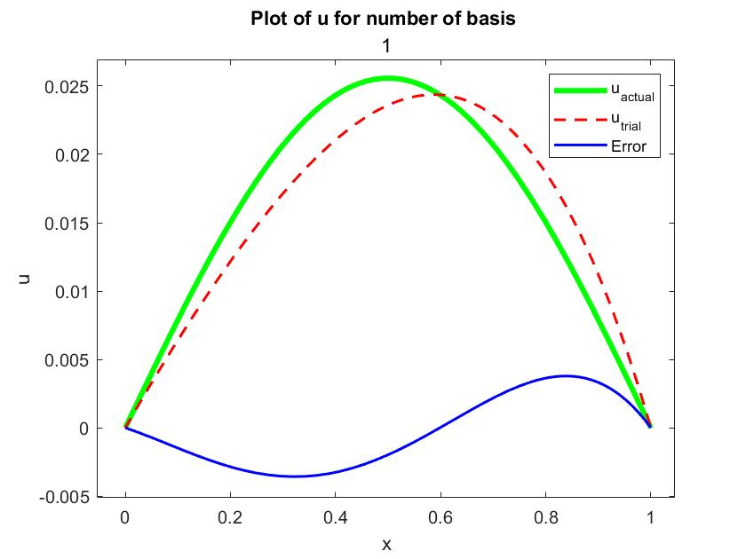

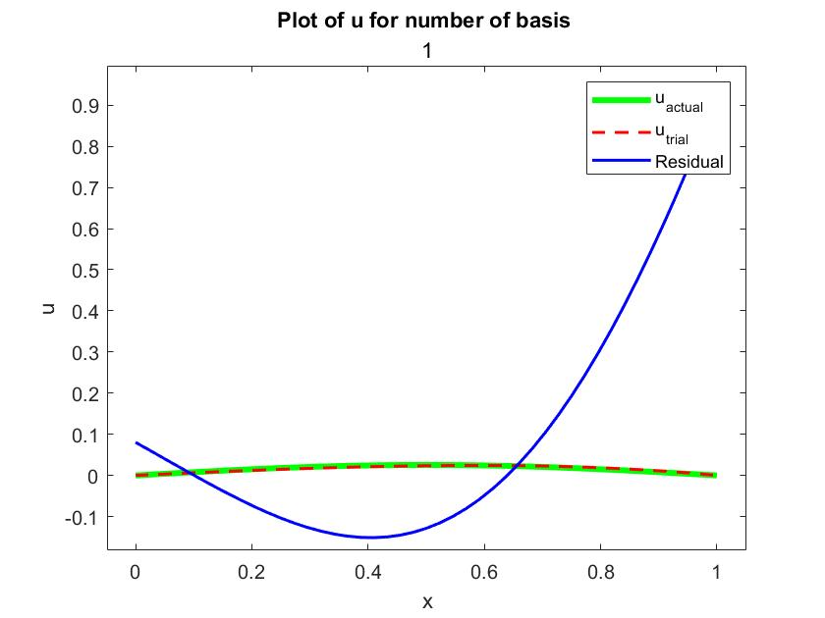

For Number of Basis as 2

K=

7.4022 -2.2222

-2.2222 29.6088

F=

0.1893

-0.1592

c=

0.0245

-0.0035

The Exact Solution is : ySol(x)=(5*log(x + 1))/(18*log(2)) - x/3 + x^2/6 - x^3/9

symbolic function inputs: x

The Approximate Solution is : P(x)=(3532633829361831*sin(pi*x))/144115188075855872 - (1019044367279377*sin(2*pi*x))/288230376151711744

The residual is : R(x)=(3532633829361831*pi*cos(pi*x))/144115188075855872 - (1019044367279377*pi*(2*cos(pi*x)^2 - 1))/144115188075855872 + x^2 - (pi^2*(3532633829361831*sin(pi*x) - 4076177469117508*cos(pi*x)*sin(pi*x))*(x + 1))/144115188075855872

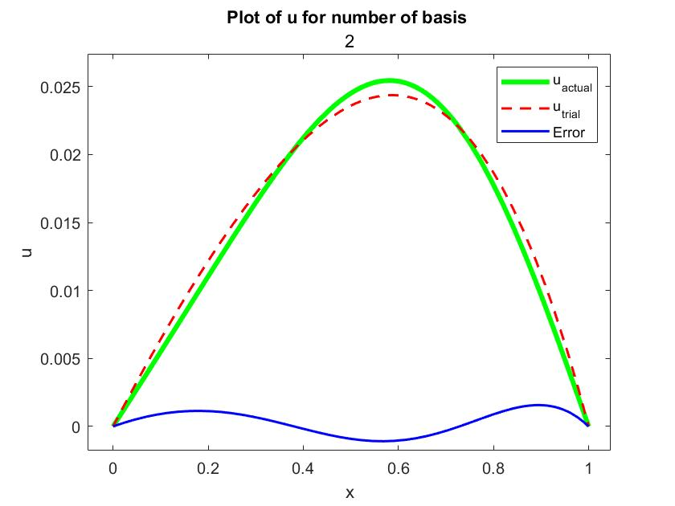

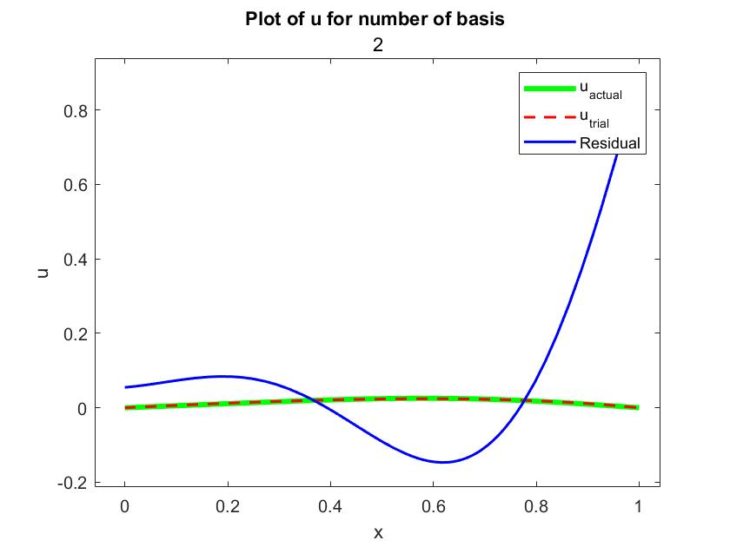

For Number of Basis as 3

K=

7.4022 -2.2222 0

-2.2222 29.6088 -6.2400

0 -6.2400 66.6198

F=

0.1893

-0.1592

0.1013

c=

0.0246

-0.0033

0.0012

The Exact Solution is : ySol(x)=(5*log(x + 1))/(18*log(2)) - x/3 + x^2/6 - x^3/9

symbolic function inputs: x

The Approximate Solution is : P(x)=(7087922338704173*sin(pi*x))/288230376151711744 - (3774327284642259*sin(2*pi*x))/1152921504606846976 + (5600032560474077*sin(3*pi*x))/4611686018427387904

The residual is : R(x)=(7087922338704173*pi*cos(pi*x))/288230376151711744 - (3774327284642259*pi*cos(2*pi*x))/576460752303423488 + (16800097681422231*pi*cos(3*pi*x))/4611686018427387904 + x^2 - (pi^2*(x + 1)*(113406757419266768*sin(pi*x) - 60389236554276144*sin(2*pi*x) + 50400293044266693*sin(3*pi*x)))/4611686018427387904

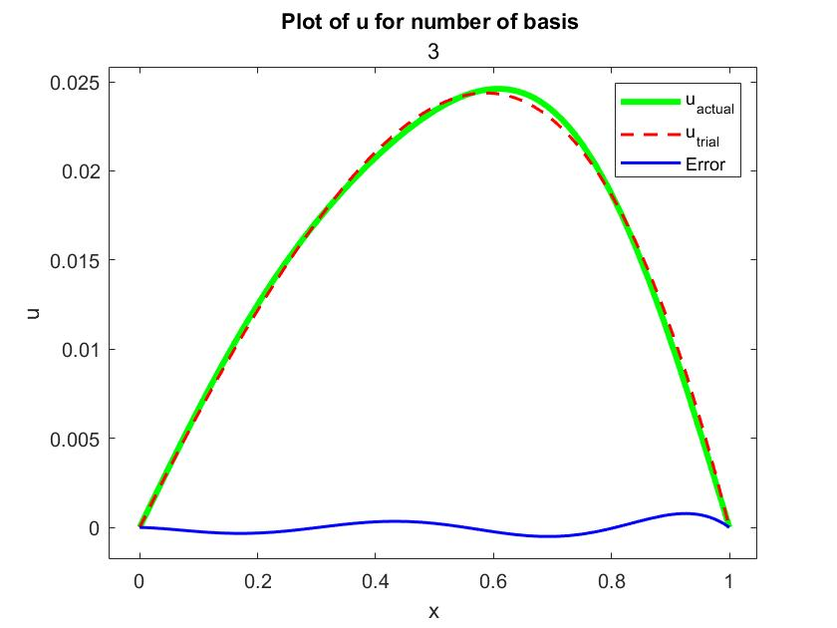

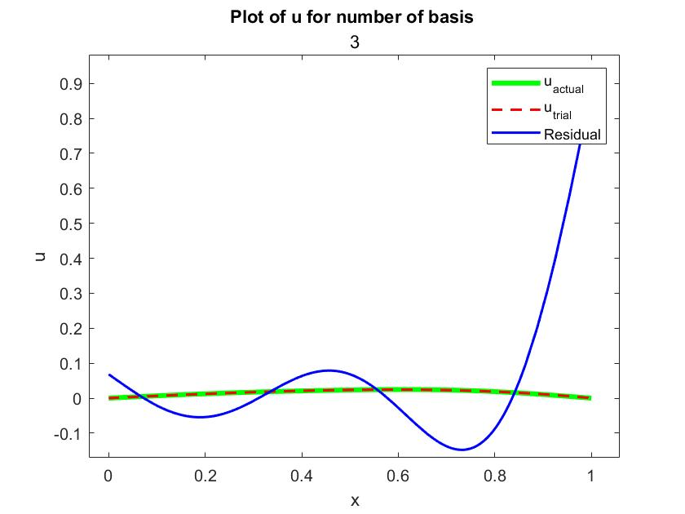

For Number of Basis as 4

K=

7.4022 -2.2222 0 -0.6044

-2.2222 29.6088 -6.2400 0

0 -6.2400 66.6198 -12.2449

-0.6044 0 -12.2449 118.4353

F=

0.1893

-0.1592

0.1013

-0.0796

c=

0.0246

-0.0033

0.0011

-0.0004

The Exact Solution is : ySol(x)=(5*log(x + 1))/(18*log(2)) - x/3 + x^2/6 - x^3/9

symbolic function inputs: x

The Approximate Solution is : P(x)=(3538037373111361*sin(pi*x))/144115188075855872 - (3797519706391963*sin(2*pi*x))/1152921504606846976 + (5227347848839509*sin(3*pi*x))/4611686018427387904 - (3960720498870197*sin(4*pi*x))/9223372036854775808

The residual is : R(x)=(3538037373111361*pi*cos(pi*x))/144115188075855872 - (3797519706391963*pi*cos(2*pi*x))/576460752303423488 + (15682043546518527*pi*cos(3*pi*x))/4611686018427387904 - (3960720498870197*pi*cos(4*pi*x))/2305843009213693952 + x^2 - (pi^2*(x + 1)*(113217195939563552*sin(pi*x) - 60760315302271408*sin(2*pi*x) + 47046130639555581*sin(3*pi*x) - 31685763990961576*sin(4*pi*x)))/4611686018427387904

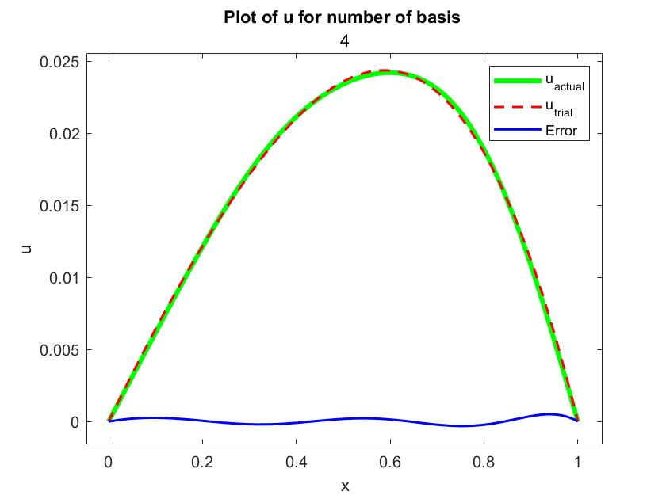

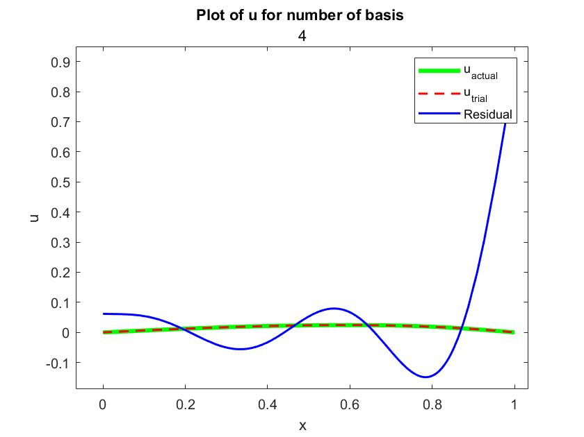

For Number of Basis as 5

K=

7.4022 -2.2222 0 -0.6044 0

-2.2222 29.6088 -6.2400 0 -1.3152

0 -6.2400 66.6198 -12.2449 0

-0.6044 0 -12.2449 118.4353 -20.2469

0 -1.3152 0 -20.2469 185.0551

F=

0.1893

-0.1592

0.1013

-0.0796

0.0626

c=

0.0246

-0.0033

0.0011

-0.0004

0.0003

The Exact Solution is : ySol(x)=(5*log(x + 1))/(18*log(2)) - x/3 + x^2/6 - x^3/9

symbolic function inputs: x

The Approximate Solution is : P(x)=(7078491586319461*sin(pi*x))/288230376151711744 - (7560635706211221*sin(2*pi*x))/2305843009213693952 + (5274337555053271*sin(3*pi*x))/4611686018427387904 - (1759771398720647*sin(4*pi*x))/4611686018427387904 + (5043087384969611*sin(5*pi*x))/18446744073709551616

The residual is : R(x)=(7078491586319461*pi*cos(pi*x))/288230376151711744 - (7560635706211221*pi*cos(2*pi*x))/1152921504606846976 + (15823012665159813*pi*cos(3*pi*x))/4611686018427387904 - (1759771398720647*pi*cos(4*pi*x))/1152921504606846976 + (25215436924848055*pi*cos(5*pi*x))/18446744073709551616 + x^2 - (pi^2*(x + 1)*(453023461524445504*sin(pi*x) - 241940342598759072*sin(2*pi*x) + 189876151981917756*sin(3*pi*x) - 112625369518121408*sin(4*pi*x) + 126077184624240275*sin(5*pi*x)))/18446744073709551616

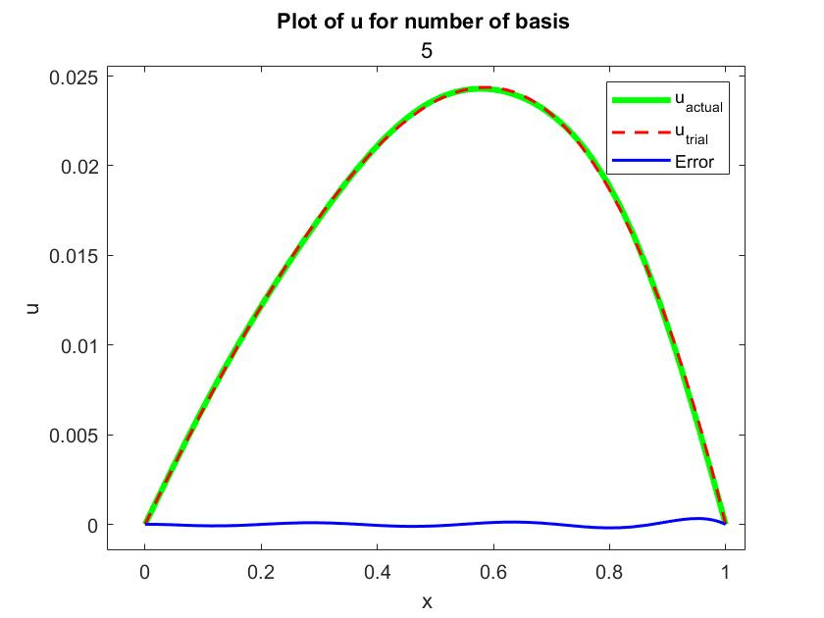

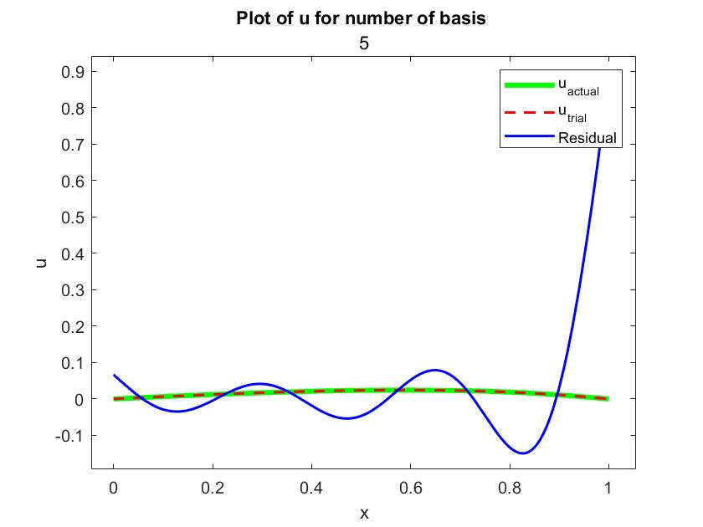

1. **With Polynomial Basis :**

The Steps were repeated with Polynomial Basis which are shown in the output.

MATLAB Output :

Code by Patil Aniruddha Ramesh

Roll No. : 200104072

For Trigonometric Basis :

Basis are :

Trigonometric Matrix :

[-x*(x - 1), x*(x - 1)*(x - 1/2), -x*(x - 1)*(x - 1/3)*(x - 2/3), x*(x - 1)*(x - 1/2)*(x - 1/4)*(x - 3/4), -x*(x - 1)*(x - 1/5)*(x - 2/5)*(x - 3/5)*(x - 4/5)]

For Number of Basis as 1

K=

0.5000

F=

0.0500

c=

0.1000

The Exact Solution is : ySol(x)=(5*log(x + 1))/(18*log(2)) - x/3 + x^2/6 - x^3/9

symbolic function inputs: x

The Approximate Solution is : P(x)=-(x*(x - 1))/10

The residual is : R(x)=x^2 - (2*x)/5 - 1/10

The Error is : Error =(25*log(x + 1) - 39*x*log(2) + 24*x^2*log(2) - 10*x^3*log(2))/(90*log(2))

symbolic function inputs: x

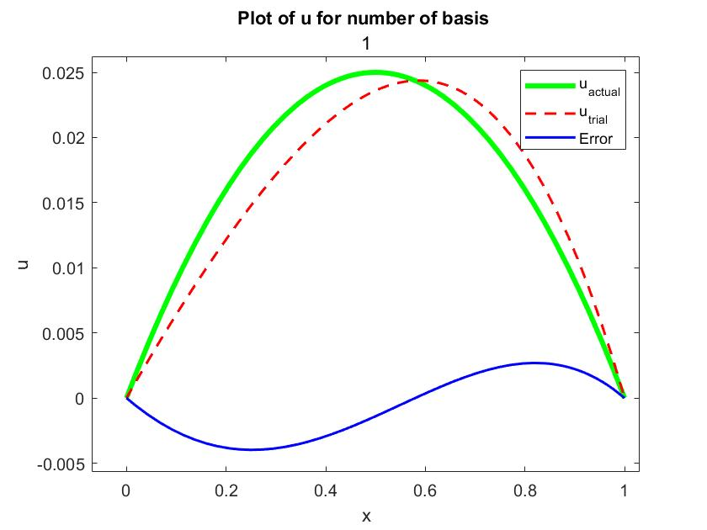

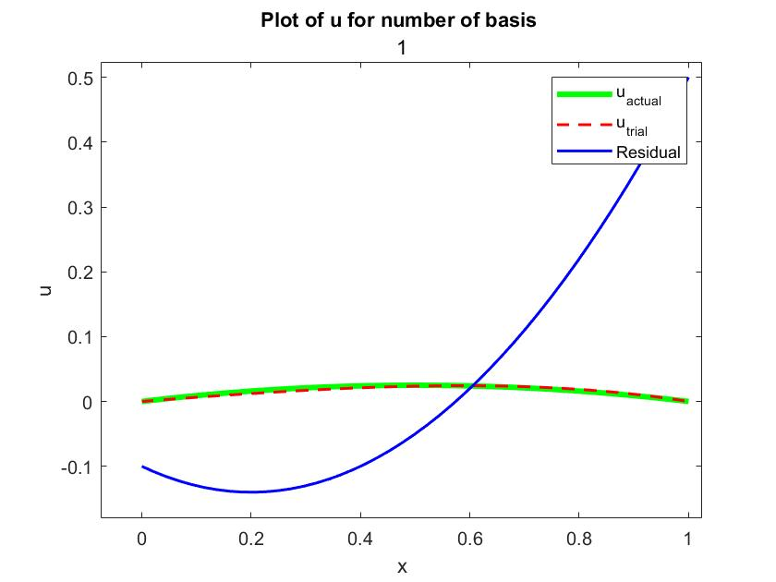

For Number of Basis as 2

K=

0.5000 -0.0333

-0.0333 0.0750

F=

0.0500

-0.0083

c=

0.0954

-0.0687

The Exact Solution is : ySol(x)=(5*log(x + 1))/(18*log(2)) - x/3 + x^2/6 - x^3/9

symbolic function inputs: x

The Approximate Solution is : P(x)=- (25*x*(x - 1))/262 - (9*x*(x - 1)*(x - 1/2))/131

The residual is : R(x)=(50*x^2)/131 - (50*x)/131 + 10/131

The Error is : Error =(5*(131*log(x + 1) - 186*x*log(2) + 75*x^2*log(2) - 20*x^3*log(2)))/(2358*log(2))

symbolic function inputs: x

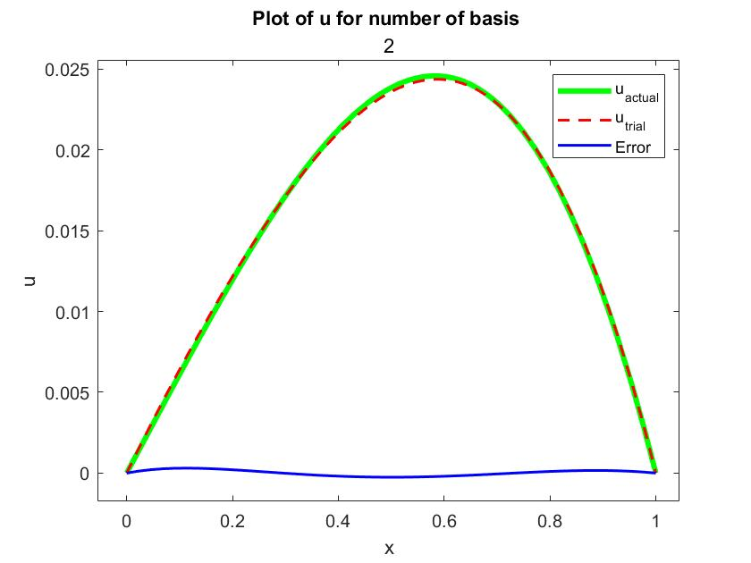

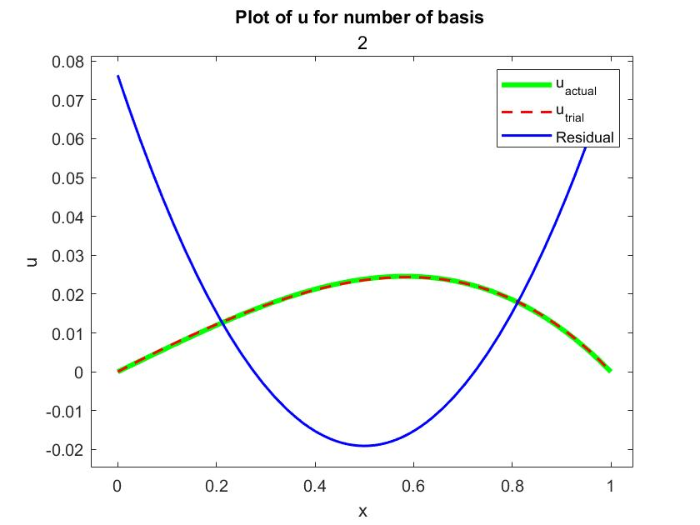

For Number of Basis as 3

K=

0.5000 -0.0333 0.0111

-0.0333 0.0750 -0.0050

0.0111 -0.0050 0.0088

F=

0.0500

-0.0083

0.0016

c=

0.0950

-0.0674

0.0218

The Exact Solution is : ySol(x)=(5*log(x + 1))/(18*log(2)) - x/3 + x^2/6 - x^3/9

symbolic function inputs: x

The Approximate Solution is : P(x)=- (685*x*(x - 1))/7209 - (6*x*(x - 1)*(x - 1/2))/89 - (35*x*(x - 1)*(x - 1/3)*(x - 2/3))/1602

The residual is : R(x)=- (280*x^3)/801 + (140*x^2)/267 - (20*x)/89 + 20/801

The Error is : Error =(5*log(x + 1))/(18*log(2)) - (320*x)/801 + (50*x^2)/267 - (70*x^3)/801 + (35*x^4)/1602

symbolic function inputs: x

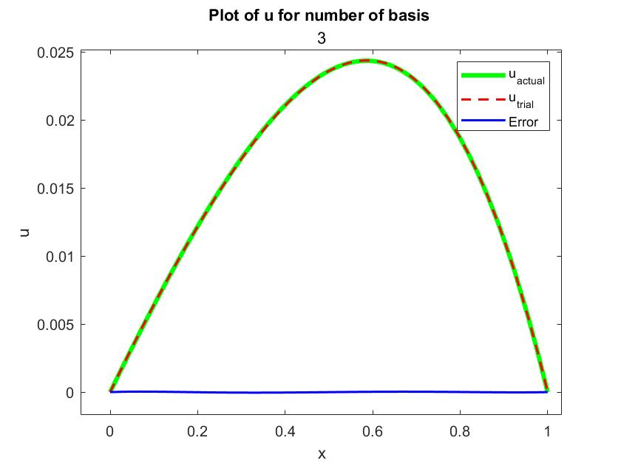

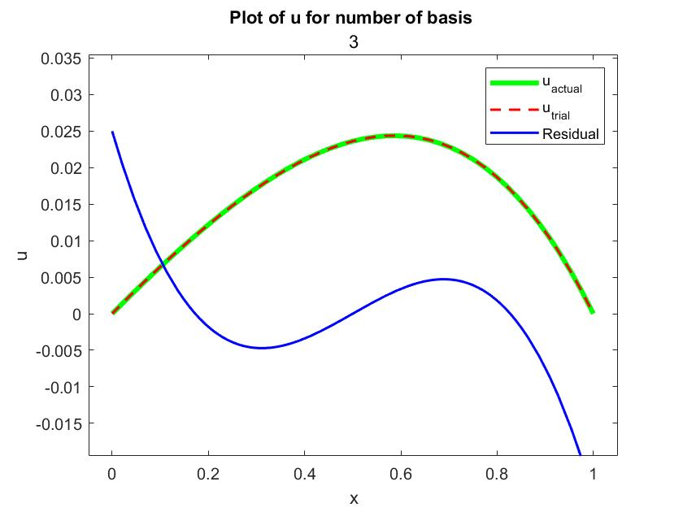

For Number of Basis as 4

K=

0.5000 -0.0333 0.0111 -0.0015

-0.0333 0.0750 -0.0050 0.0033

0.0111 -0.0050 0.0088 -0.0007

-0.0015 0.0033 -0.0007 0.0010

F=

0.0500

-0.0083

0.0016

-0.0004

c=

0.0950

-0.0679

0.0225

0.0120

The Exact Solution is : ySol(x)=(5*log(x + 1))/(18*log(2)) - x/3 + x^2/6 - x^3/9

symbolic function inputs: x

The Approximate Solution is : P(x)=(420*x*(x - 1)*(x - 1/2)*(x - 1/4)*(x - 3/4))/34997 - (2446822393771541*x*(x - 1)*(x - 1/2))/36028797018963968 - (1575*x*(x - 1)*(x - 1/3)*(x - 2/3))/69994 - (3325*x*(x - 1))/34997

The residual is : R(x)=(10500*x^4)/34997 - (21000*x^3)/34997 + (504403158265495467103*x^2)/1260899809272681988096 - (3500*x)/34997 + 18014398509482031165/2521799618545363976192

The Error is : Error =(5*log(x + 1))/(18*log(2)) - (3030021829294869680501*x)/7565398855636091928576 + (1487989316883211793503*x^2)/7565398855636091928576 - (1298838132533650961503*x^3)/11348098283454137892864 + (3675*x^4)/69994 - (420*x^5)/34997

symbolic function inputs: x

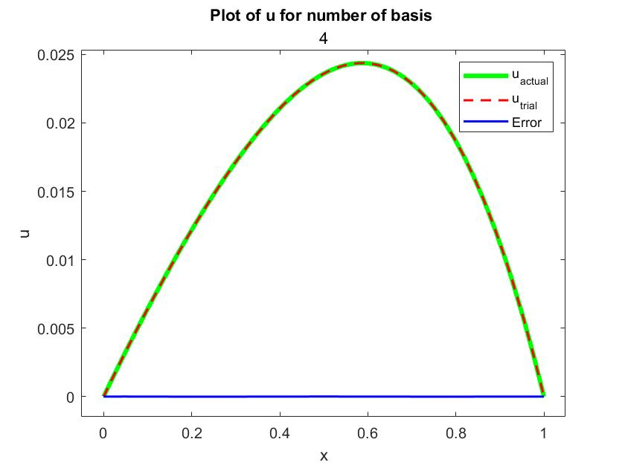

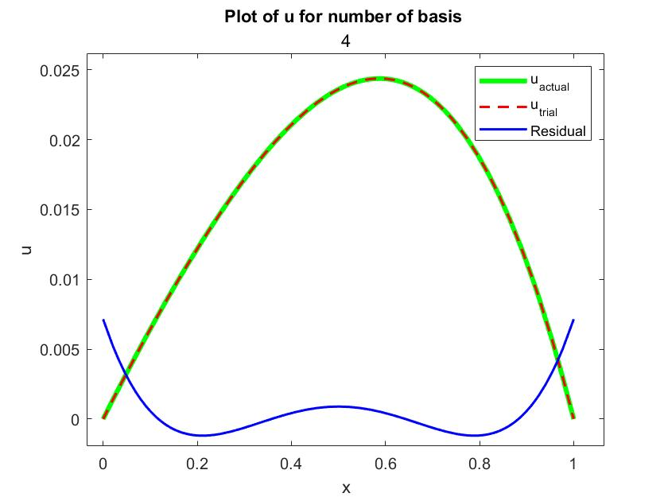

For Number of Basis as 5

K=

0.5000 -0.0333 0.0111 -0.0015 0.0006

-0.0333 0.0750 -0.0050 0.0033 -0.0003

0.0111 -0.0050 0.0088 -0.0007 0.0006

-0.0015 0.0033 -0.0007 0.0010 -0.0001

0.0006 -0.0003 0.0006 -0.0001 0.0001

F=

0.0500

-0.0083

0.0016

-0.0004

0.0001

c=

0.0950

-0.0679

0.0221

0.0124

0.0069

The Exact Solution is : ySol(x)=(5*log(x + 1))/(18*log(2)) - x/3 + x^2/6 - x^3/9

symbolic function inputs: x

The Approximate Solution is : P(x)=(110*x*(x - 1)*(x - 1/2)*(x - 1/4)*(x - 3/4))/8901 - (4837*x*(x - 1)*(x - 1/2))/71208 - (6210376129225*x*(x - 1)*(x - 1/3)*(x - 2/3))/281474976710656 - (3423071777890499*x*(x - 1))/36028797018963968 - (7915550406742569*x*(x - 1)*(x - 1/5)*(x - 2/5)*(x - 3/5)*(x - 4/5))/1152921504606846976

The residual is : R(x)=- (71239953660683121*x^5)/288230376151711744 + (6341068275337531484105*x^4)/10262154312505544933376 - (7205759403792822849317*x^3)/12827692890631931166720 + (3843071682022943614571*x^2)/17103590520842574888960 - (120095990063219927906737*x)/3206923222657982791680000 + 3002399751580561531361/1603461611328991395840000

The Error is : Error =(5*log(x + 1))/(18*log(2)) - (35695197046566151979723*x)/89081200629388410880000 + (639511147086610174103653*x^2)/3206923222657982791680000 - (6501196262088588716021*x^3)/51310771562527724666880 + (3915129276060705633373*x^4)/51310771562527724666880 - (338190308017999987367*x^5)/10262154312505544933376 + (7915550406742569*x^6)/1152921504606846976

symbolic function inputs: x

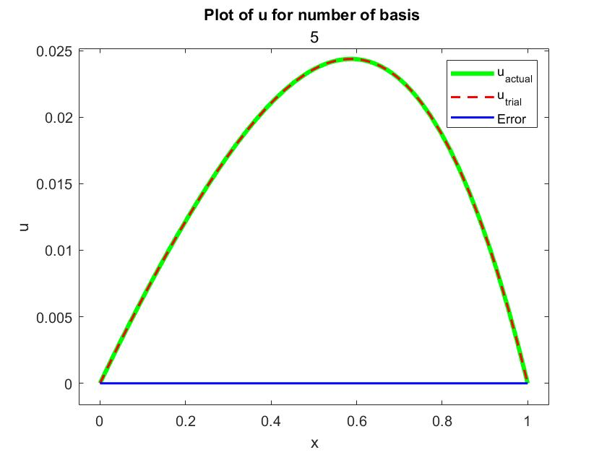

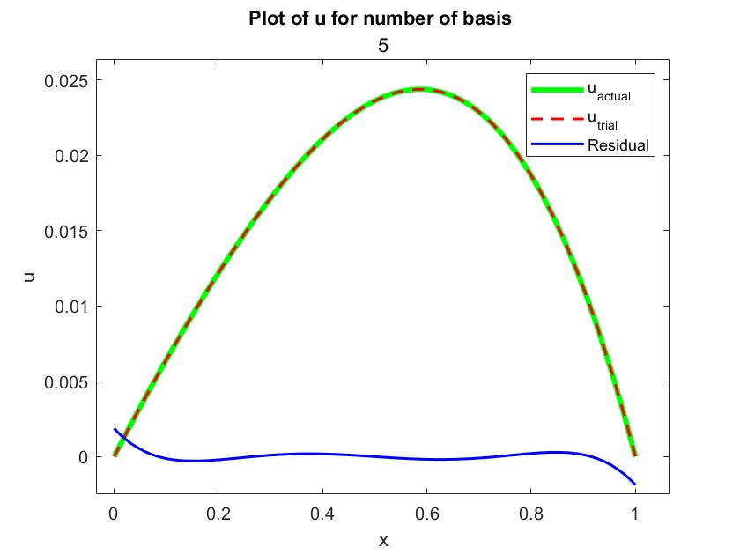

**Some Explainations from the code :**

* On Line 91 function **dsolve( )** was used to get an exact solution of the given differential equation with given boundary conditions.
* On Line 62 ***backslash ‘ \ ’*** operator which is inbuilt in MATLAB is used to calculate ‘K’ matrix directly without computing the inverse of matrix
* The ‘***zeros***’ function is used to crate MATRIX of required size.
* ‘***pMat***’ is the combined matrix of basis functions, formulated for better programming.
* ‘***fplot***’ function is used to plot the results.
* **Residua**l is calculated by substituting the trial solution into the **ODE**.
* **Error** is calculated using (Exact_Solution – Trial_Solution) as a function as x.

**Conclusion :**

The conclusion observed by ***increasing*** the number of basis functions from 1 to 5 is that the error decreases as the number of basis functions ***increases***. This is because a higher number of basis functions provide a more accurate **approximation** of the true solution. However, increasing the number of basis functions beyond a certain point can lead to numerical instability and the error may start to increase again. Therefore, the choice of the number of basis functions is a trade-off between **accuracy** and **computational efficiency**.