SystemC Introduction

Introduction
In series of labs we will introduce SystemC library and understand various features. SystemC provides a C++ based library for modeling or creating a Software executable specification of electronic systems containing Hardware and embedded SW. Below figure shows the architecture of a SystemC application.
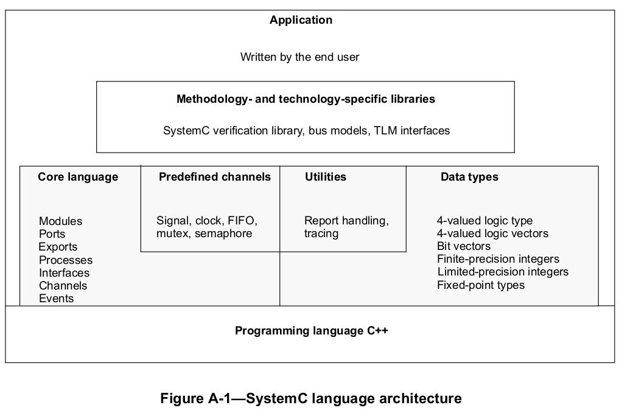
The diagram is referenced for “IEEE Standard of Standard SystemC Language Reference Manual.

In these labs we will try to implement small examples to discuss various features. All the suggestions, coding guidelines discussed in these labs/documents are solely my point of view. These should not be considered has industry standard nor can be quoted has reference. I will try my best to avoid mistakes but some of them may slip. Please do double check. Suggestions, bug fixes and pointing out issues are welcomed.

Prerequisites are prior HW implementation knowledge (design or verification), basic understanding of computer architecture and C++ programming language. Good knowledge of C++ language is must prerequisite to understand SystemC and follow these labs. All the examples will use modern C++ features (C++11, C++14 and C++17).

My preferences are to avoid using Macros (SC_MODULE, etc), prefer C++ primitive data types over SystemC data types and to implement design at much higher levels of abstraction than signal level (sc_in, sc_out, etc). In general, were ever possible, I tend to use core C++ language features rather than equivalent SystemC features.

Lab0 Desciption
In this lab we will mainly focus on installing SystemC, building and running a “Hello World!” program. The design has a clock, reset as inputs and a 4-bit counter as output. Counter is incremented by 1 on every positive edge of clock. On negative edge of reset, counter resets to 0 and holds on to the value until reset is released. Design must display “Hello World!” message when ever counter reaches max value and wraps back to 0. We will discuss about various concepts of SystemC program that are used to build SystemC program.

Installing SystemC
Below installation steps work for Linux Desktop. For various other operating systems refer to SystemC documentation. Also, for Linux it is recommended to refer SystemC installation guidelines on Accellera website.
Steps to install SystemC (version: 2.3.3) on linux machines
- Download SystemC from https://accellera.org/downloads/standards/systemc
- Extract the tar file and cd to systemc-2.3.3
- Using CMake build scripts is easier.
- Below are the steps I followed but please refer to cmake/INSTALL_USING_CMAKE file for details
- For bash shell: export SYSTEMC_HOME=<installation path>
- For csh shell: setenv SYSTEMC_HOME <installation path>

For RELEASE version of shared library
- mkdir build
- cd build
- cmake DCMAKE_BUILD_TYPE=Release -DBUILD_SOURCE_DOCUMENTATION=ON -DCMAKE_CXX_STANDARD=14 -DCMAKE_VERBOSE_MAKEFILE=ON -DINSTALL_TO_LIB_BUILD_TYPE_DIR=ON ..
- make -j
- make -j check
- make -j install

If above cmake command fails dueto missing doxygen installation, Then either install it or get rid of -DBUILD_SOURCE_DOCUMENTATION=ON

For DEBUG version of shared library
- cmake DCMAKE_BUILD_TYPE=Release -DBUILD_SOURCE_DOCUMENTATION=ON -DCMAKE_CXX_STANDARD=14 -DCMAKE_VERBOSE_MAKEFILE=ON -DINSTALL_TO_LIB_BUILD_TYPE_DIR=ON ..
- make -j
- make -j check
- make -j install

Either you can add systemC shared library path to LD_LIBRARY_PATH so that linker is able to locate the shared library or add it to gcc commandline with switch "rpath". It adds an entry to the binary and hints the loader to search additional path. I followed the second approach, please refer to makefile for exact command.

Environment Settings
- Operating System: Distributor ID: Ubuntu, Description: Pop!_OS 18.04 LTS
- Tested GCC versions: (GCC) 9.1.0, g++ (Ubuntu 7.4.0-1ubuntu1~18.04.1) 7.4.0

