INDIAN INSTITUTE OF INFORMATION TECHNOLOGY KALYANI
Department of Computer Science and Engineering
Software Engineering Project Assignment

MediFlow
Hospital Management System
Assignment 1 · Hospital Management System
UML Diagrams
GROUP 11
Sl. | Name of the member | Registration number
1 | Akash Chakraborty | CSE/23011/1059
2 | Anipriyo Mandal | CSE/23017/1065
3 | Arpan Mandal | CSE/23027/1075
4 | Himanshu Patel | CSE/23052/1100
5 | Pranjali Sirari | CSE/23072/1120

Live demo at mediflow-hms-6vw1.onrender.com
Source code at github.com/anipriyo/mediflow-hms
Submitted through Google Classroom · October 2026

Group Details
Table 1. Group and assignment details
Field | Value
Group number | 11
Assignment number and title | Assignment 1, Hospital Management System
Document | UML Diagrams (document 3 of 5)
Project name | MediFlow Hospital Management System
Problem statement (brief) | Develop a system to manage patients, doctors, appointments, prescriptions, billing and medical records.
Companion documents | Software Requirements Specification (SRS), Software Design Document (SDD), Software Test Plan, Software Test Report
Live demo | mediflow-hms-6vw1.onrender.com
Source code | github.com/anipriyo/mediflow-hms
Table 2. Group members (names and registration numbers)
Sl. | Name | Registration number
1 | Akash Chakraborty | CSE/23011/1059
2 | Anipriyo Mandal | CSE/23017/1065
3 | Arpan Mandal | CSE/23027/1075
4 | Himanshu Patel | CSE/23052/1100
5 | Pranjali Sirari | CSE/23072/1120

Document control
Table 3. Revision history
Version | Date | Description
0.1 | 15-Oct-2026 | Project selected (Assignment 1, Hospital Management System)
0.2 | 18-Oct-2026 | Scope, user roles and feature set agreed (core, hospital operations, distinctive features)
0.5 | 21-Oct-2026 | Requirements baselined (50 FR, 10 NFR, 12 BR), architecture and UML diagrams
0.9 | 21-Oct-2026 | Prototype implemented, unit, integration, system and acceptance tests executed
0.95 | 22-Oct-2026 | Robustness / edge-case testing, additional defects fixed and regression-tested
1.0 | 22-Oct-2026 | Final report for submission
1.1 | 22-Oct-2026 | Prototype deployed online (Render), live demo link added
1.2 | 25-Oct-2026 | Issued as a separate document (UML Diagrams), one of five

Summary
MediFlow is a web-based Hospital Management System that manages patients, doctors, appointments, prescriptions, billing and medical records, extended with laboratory, pharmacy and in-patient (bed and admission) management. Beyond the core requirements, it introduces a smart queue with tokens and waiting-time estimates, a live bed board with a discharge workflow tied to billing clearance, and role-based access control with an append-only audit trail for six staff roles.
This document collects the sixteen UML diagrams of the system (use case, class, sequence, state, activity, component and deployment) and the supporting logical data model, each with a short explanation and the requirements it covers.
Live demo. The prototype runs online at mediflow-hms-6vw1.onrender.com and opens in any browser with no installation. Sign in with one of the demo accounts (admin, reception, dr.sharma, lab, pharmacy and billing, all with the password Mediflow@123). It uses a free cloud plan, so the first visit after 15 idle minutes takes about a minute to load, and the demo data is reset to fresh records dated that day whenever the server restarts.
Source code and running it locally. The full source code is at github.com/anipriyo/mediflow-hms. Install Node.js 20 or later, run npm install and then npm run dev in the project folder, and open localhost port 5173 in a browser.

Table of Contents
Group Details 2
Document control 2
Summary 3
Table of Contents 4
UML DIAGRAMS 5
1. Introduction 5
1.1 Notation used 6
2. Use Case Diagrams 6
3. Class Diagrams 10
4. Sequence Diagrams 13
5. State Diagrams 17
6. Activity Diagram 19
7. Component Diagram 20
8. Deployment Diagram 21
9. Logical Data Model 22

UML DIAGRAMS
All diagrams follow UML 2.5 and were drawn as text with PlantUML. The sources are kept with the code in docs/uml/*.puml and rendered to docs/uml/png/, so every diagram can be regenerated and reviewed like source code. The same diagrams are explained in their design context in the Software Design Document.

1. Introduction
This document collects the sixteen UML diagrams of MediFlow, plus the logical data model that supports them. They describe the system from four viewpoints. Use case diagrams show who uses the system and for what, class diagrams show its static structure, sequence, state and activity diagrams show its behaviour, and component and deployment diagrams show how it is built and installed.
Table 4. Diagram catalogue
No. | Diagram | Type | What it shows | Covers | Source (.puml)
1 | System overview | Use case | Six staff actors and the nine major functions of the system (context level) | All modules | 01a-use-case-overview
2 | Outpatient care | Use case | Registration, booking, check-in, smart queue, consultation, laboratory and pharmacy use cases with «include» and «extend» | FR-07 to FR-12, FR-15 to FR-37 | 01b-use-case-outpatient
3 | Inpatient care and billing | Use case | Bed board, admission, transfer, discharge with billing clearance, invoices and payments | FR-38 to FR-47 | 01c-use-case-inpatient-billing
4 | Administration and access control | Use case | Login with lock-out, dashboards, users and roles, reports and audit trail | FR-01 to FR-06, FR-13, FR-14, FR-48 to FR-50 | 01d-use-case-admin
5 | Domain model | Class | Entities with attributes, operations, associations and multiplicities | Data of all FRs | 02-class-domain
6 | Service layer design | Class | React client classes, Express router and middleware, services, rule modules and data access, with dependencies | NFR-06 (maintainability) | 03-class-design
7 | Book an appointment | Sequence | Slot check, conflict detection and transactional booking, with the slot-taken alternative | FR-15 to FR-17 | 04-seq-booking
8 | Check-in, queue and consultation | Sequence | Token and ETA calculation, calling the next patient, consultation, prescription, lab order and charges | FR-21 to FR-29 | 05-seq-queue-consultation
9 | Admission and discharge | Sequence | Bed allocation, discharge request, billing clearance and the administrator override | FR-39 to FR-46 | 06-seq-admission-discharge
10 | Login and access control | Sequence | Password check, lock-out after five failures, token issue and permission check on each request | FR-01 to FR-04 | 07-seq-login
11 | Appointment | State machine | Life cycle of an appointment from booking to completion, cancellation or no-show | BR-04 | 08-state-appointment
12 | Bed | State machine | Available, reserved, occupied, cleaning and maintenance states with their allowed transitions | BR-08 | 09-state-bed
13 | Admission, invoice and lab order | State machine | Three composite life cycles in one diagram | BR-06, BR-09, BR-10 | 10-state-admission-invoice-lab
14 | Outpatient journey | Activity | One patient visit across five swimlanes (reception, doctor, laboratory, pharmacy, billing) | Outpatient FRs | 13-activity-opd
15 | Layered architecture | Component | Client, application and data tiers, and the four server layers | NFR-06, NFR-10 | 11-architecture
16 | Deployment | Deployment | Workstations, application server with Node.js runtime and SQLite file, and printers | NFR-07, NFR-09 | 12-deployment
17 | Logical data model | Entity relationship (supporting) | The 20 database tables, keys and relationships in crow's-foot notation | Data of all FRs | 14-er-diagram

1.1 Notation used
- Use case diagrams. Stick figures are actors (staff roles), ovals are use cases and the rectangle is the system boundary. «include» marks behaviour that always happens as part of the base use case, while «extend» marks optional behaviour.
- Class diagrams. Each class shows its attributes and operations. Lines show associations with multiplicities, a filled diamond marks composition and an arrow marks a dependency. Stereotypes such as «lib/api.js» name the source file that implements a class.
- Sequence diagrams. Lifelines run from left (actor and user interface) to right (database). Messages are numbered, and alt and opt fragments show the error and override paths that are also covered by test cases.
- State and activity diagrams. Rounded boxes are states or actions, the filled circle is the start and the ringed circle is the end. Transitions that are not drawn are rejected by the system with HTTP 409.

2. Use Case Diagrams
The system has six staff actors (Receptionist, Doctor, Lab Technician, Pharmacist, Billing Staff and Administrator). Patients are external to the system, because they do not log in and their data is entered by staff. A single diagram with six actors and about forty use cases would be unreadable, so the model is split into an overview and three detailed diagrams.
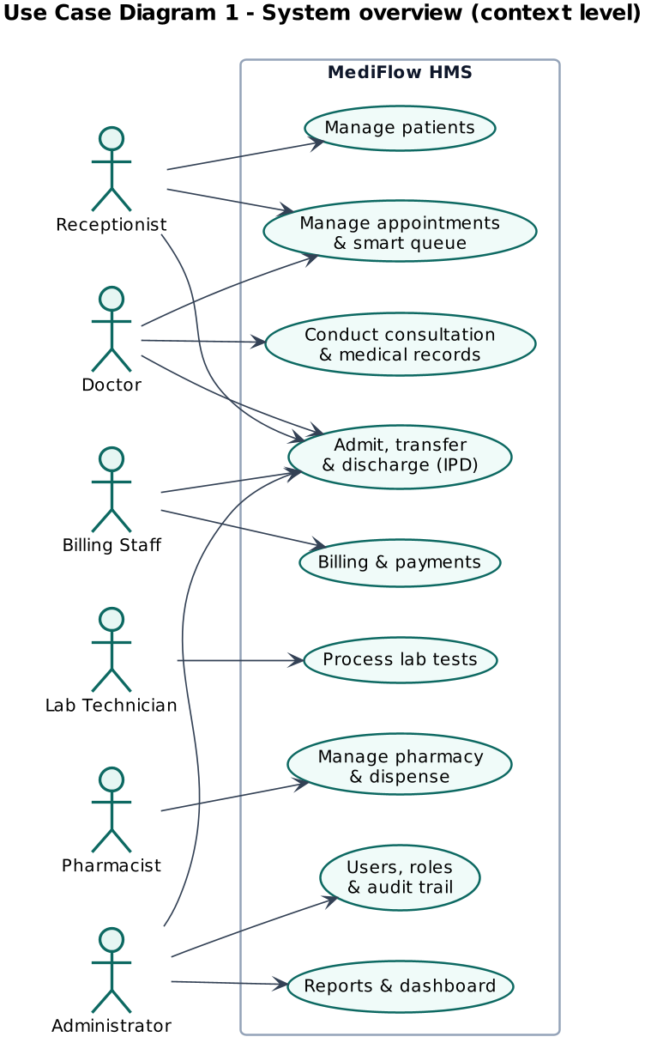
Figure 1. Use case diagram (system overview)
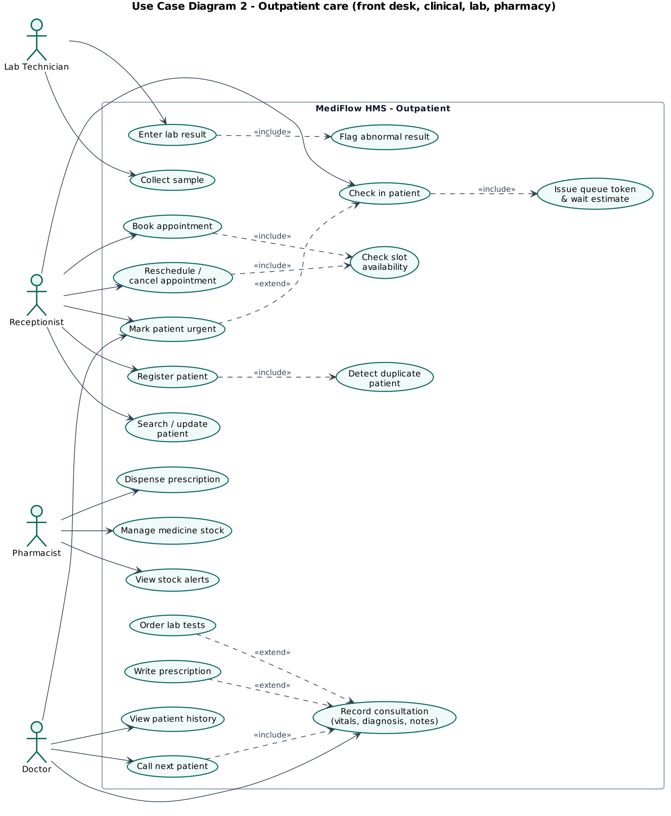
Figure 2. Use case diagram (outpatient care)
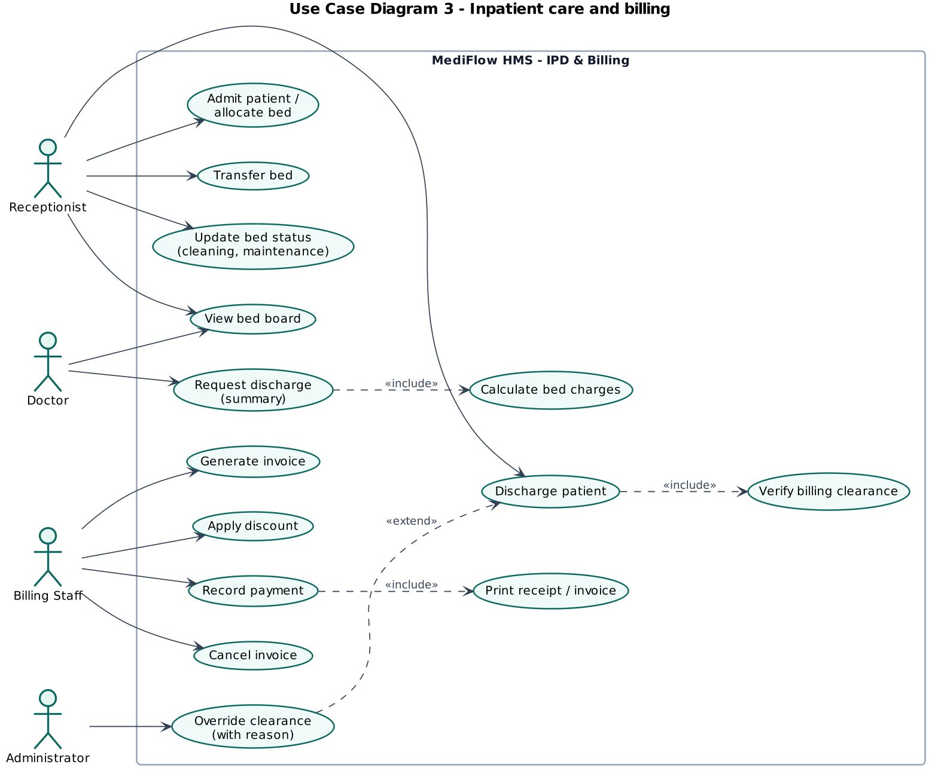
Figure 3. Use case diagram (inpatient care and billing)
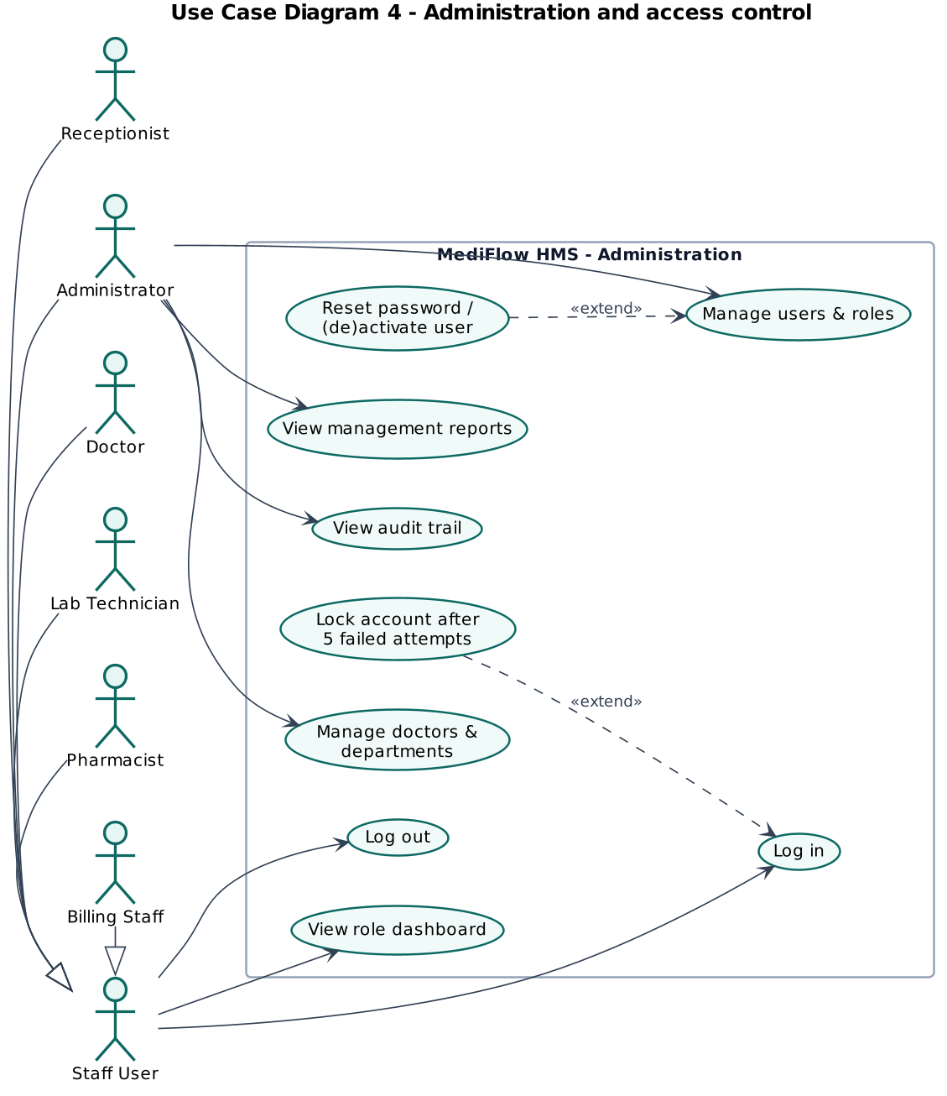
Figure 4. Use case diagram (administration and access control)
Detailed specifications of the five most important use cases (book appointment, check in and manage queue, conduct consultation, discharge patient and record payment) are given in the Software Design Document, Section 5.1.

3. Class Diagrams
The domain class diagram shows the main entities, their attributes, operations and associations with multiplicities. A patient books many appointments, and each appointment has at most one consultation, which may produce one prescription (composed of items referencing medicines) and several lab orders. Wards are composed of beds, and an admission is composed of one or more bed stays (one per bed occupied), which is how transfers and bed-day billing are modelled. Charges aggregate into invoices, which own payments.
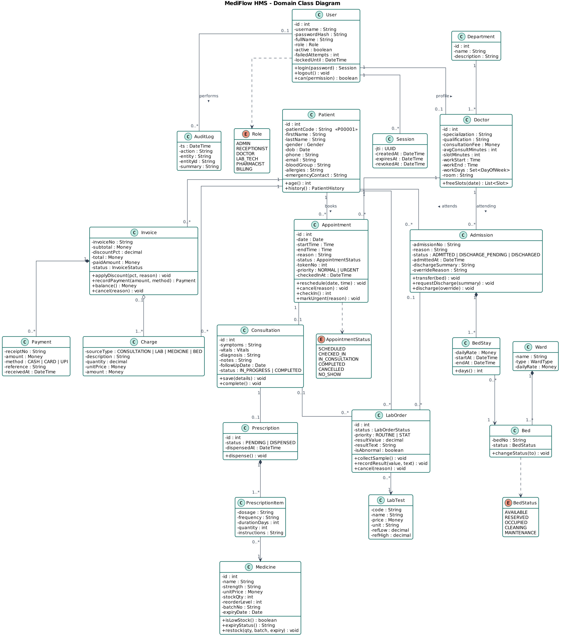
Figure 5. Domain class diagram
The design class diagram shows how the implementation realises the domain. Controllers delegate to services, services use pure rule modules and the data-access layer, and the cross-cutting services (Charge and Audit) are shared by all modules.
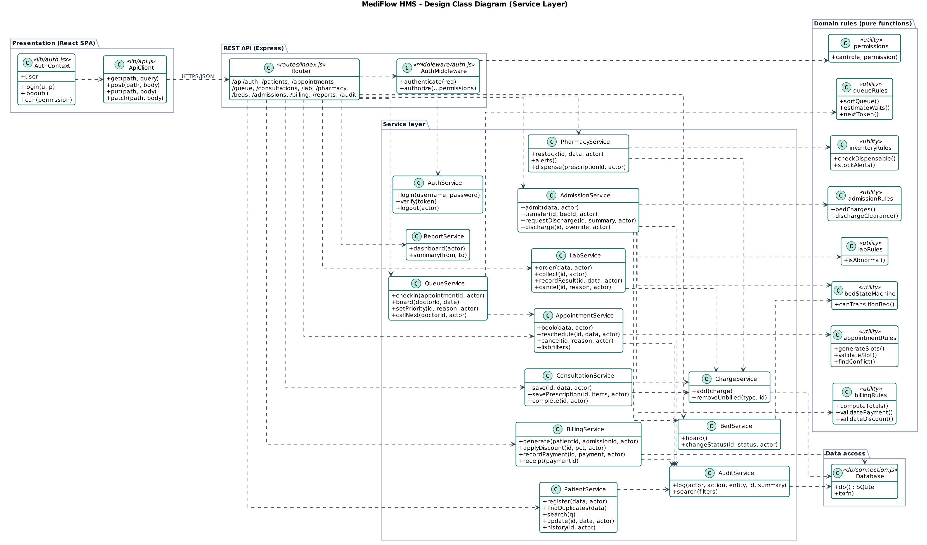
Figure 6. Design class diagram (service layer and dependencies)

4. Sequence Diagrams
The sequence diagrams show the interaction between the actors, the React user interface, the API layer, the services, the rule modules and the database for the four most important scenarios.
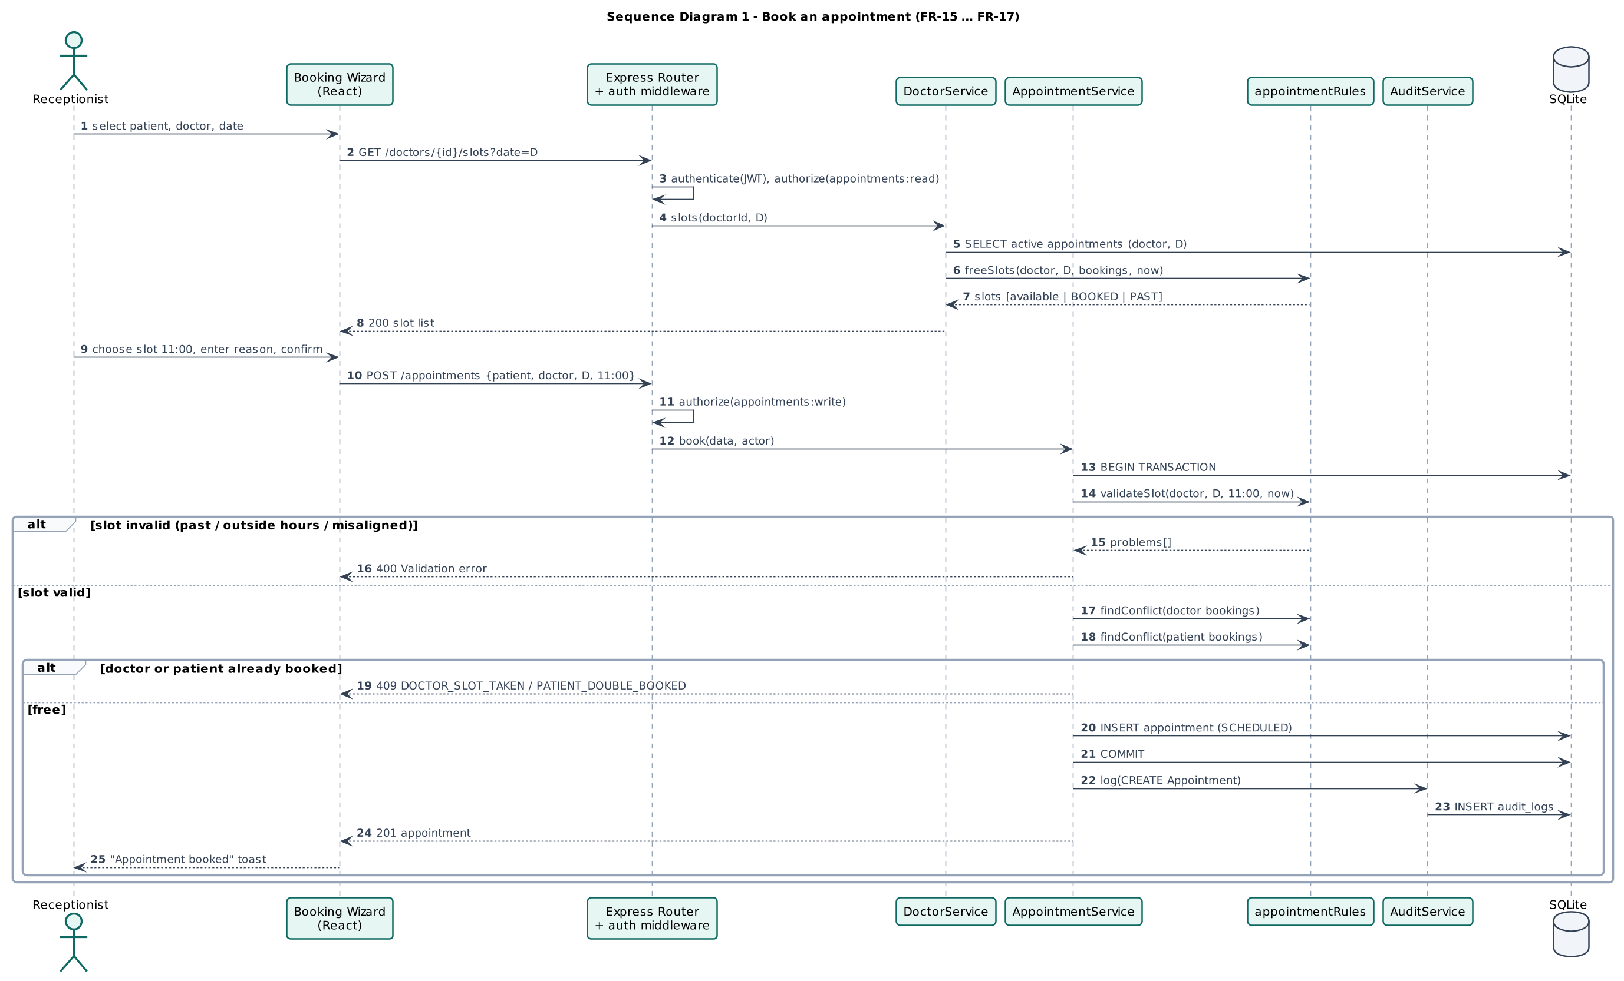
Figure 7. Sequence diagram (book an appointment)
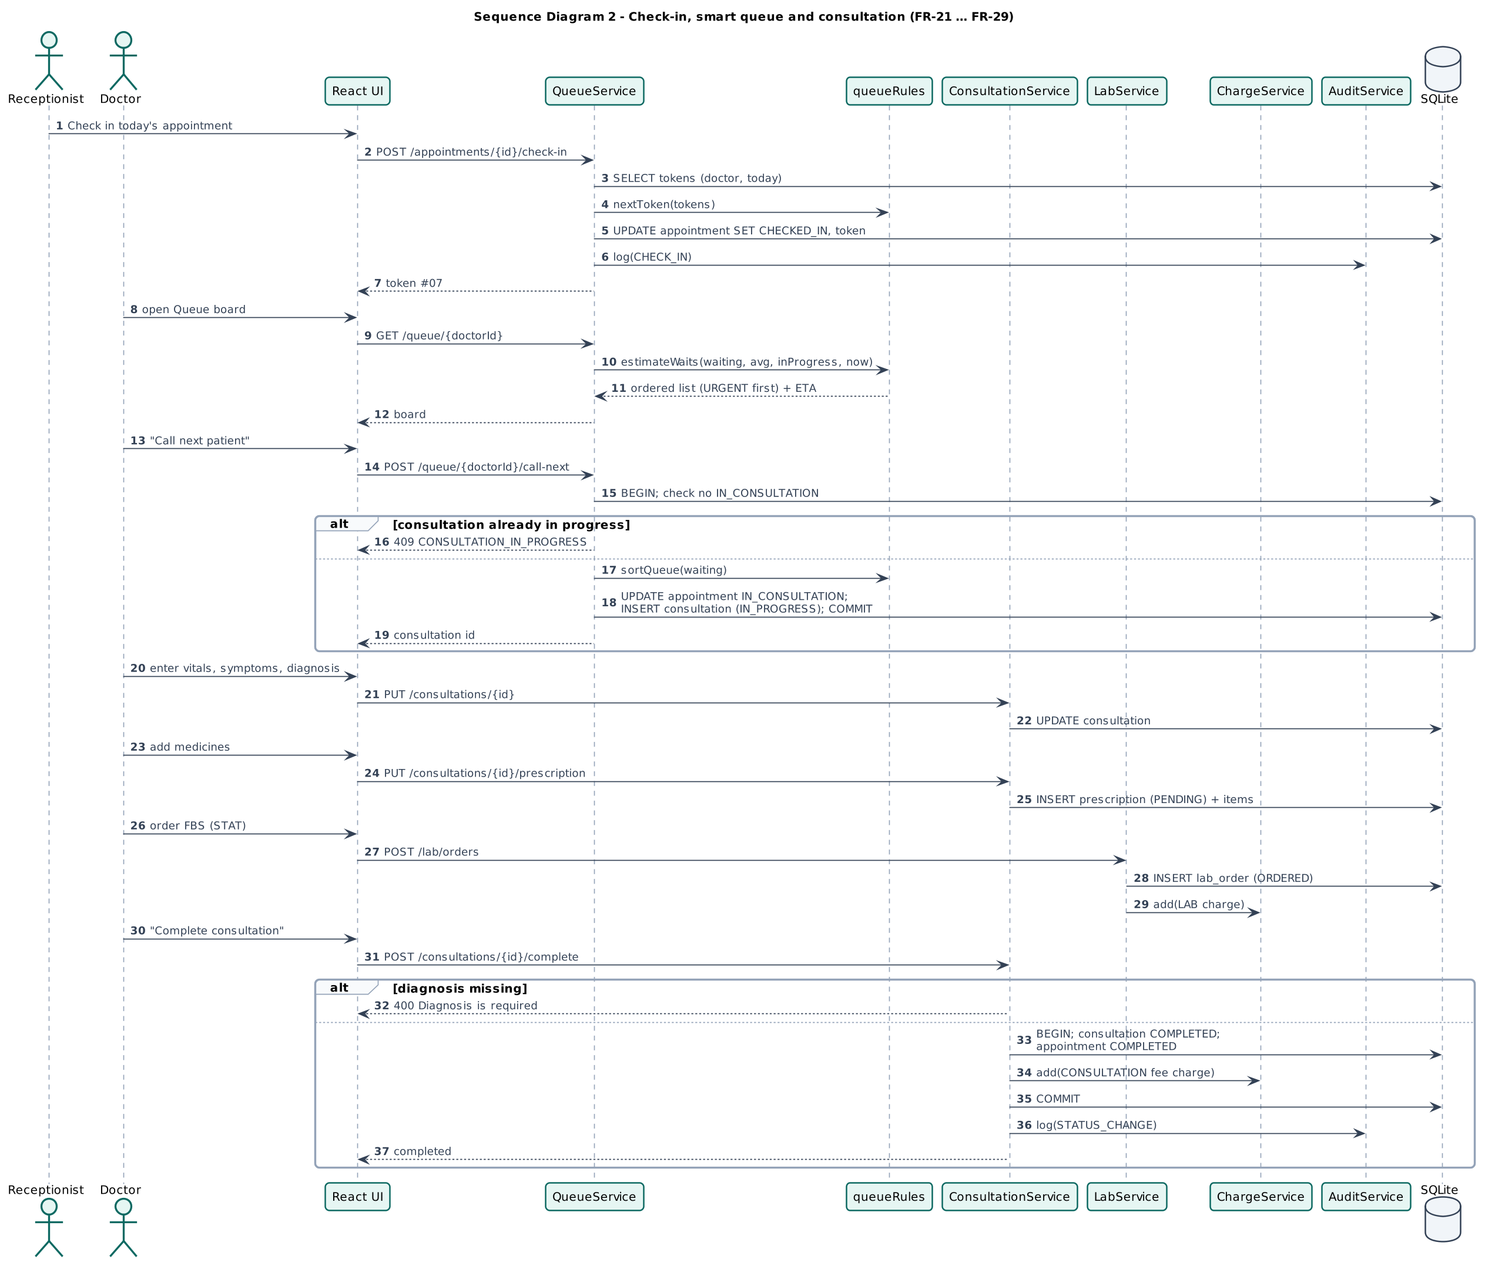
Figure 8. Sequence diagram (check-in, queue and consultation)
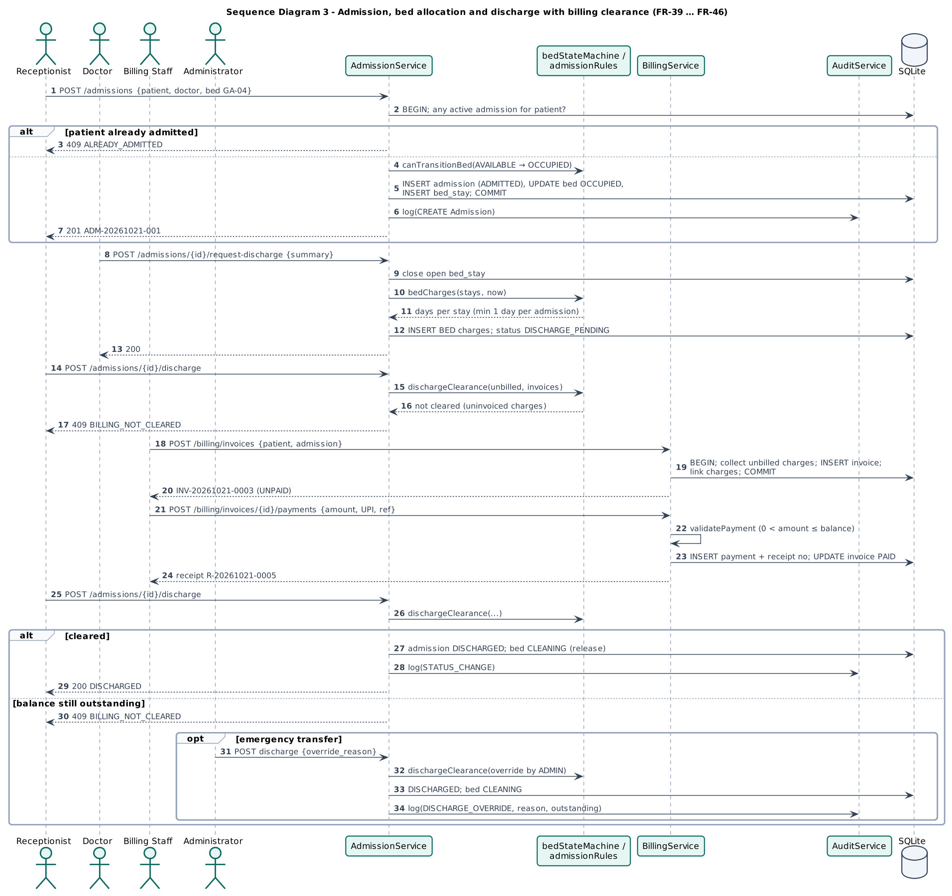
Figure 9. Sequence diagram (admission and discharge with billing clearance)
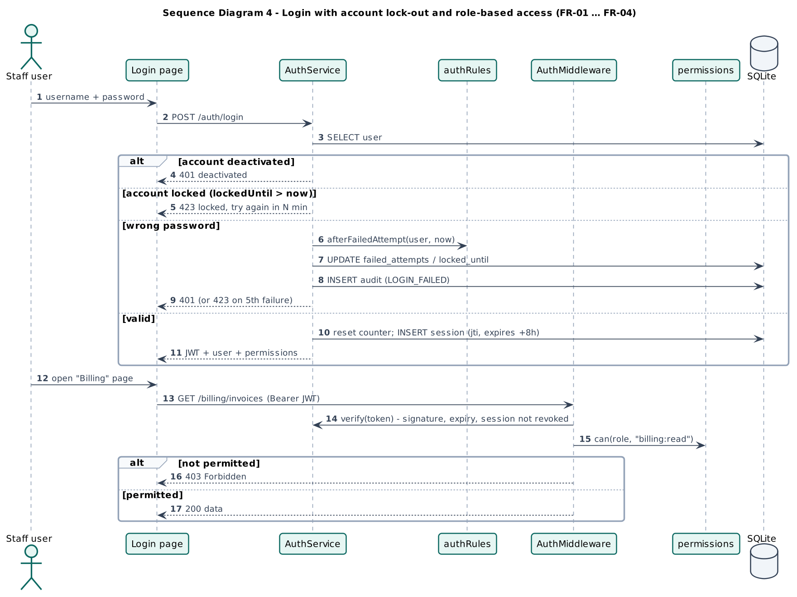
Figure 10. Sequence diagram (login, lock-out and role-based access)

5. State Diagrams
Every entity with a life cycle has a state diagram. The same transition tables are implemented in server/domain/* and verified by the unit tests UT-APT-10, UT-IPD-01, UT-IPD-02, UT-IPD-04, UT-LAB-01 and UT-BIL-06, so the diagrams and the code cannot drift apart unnoticed.
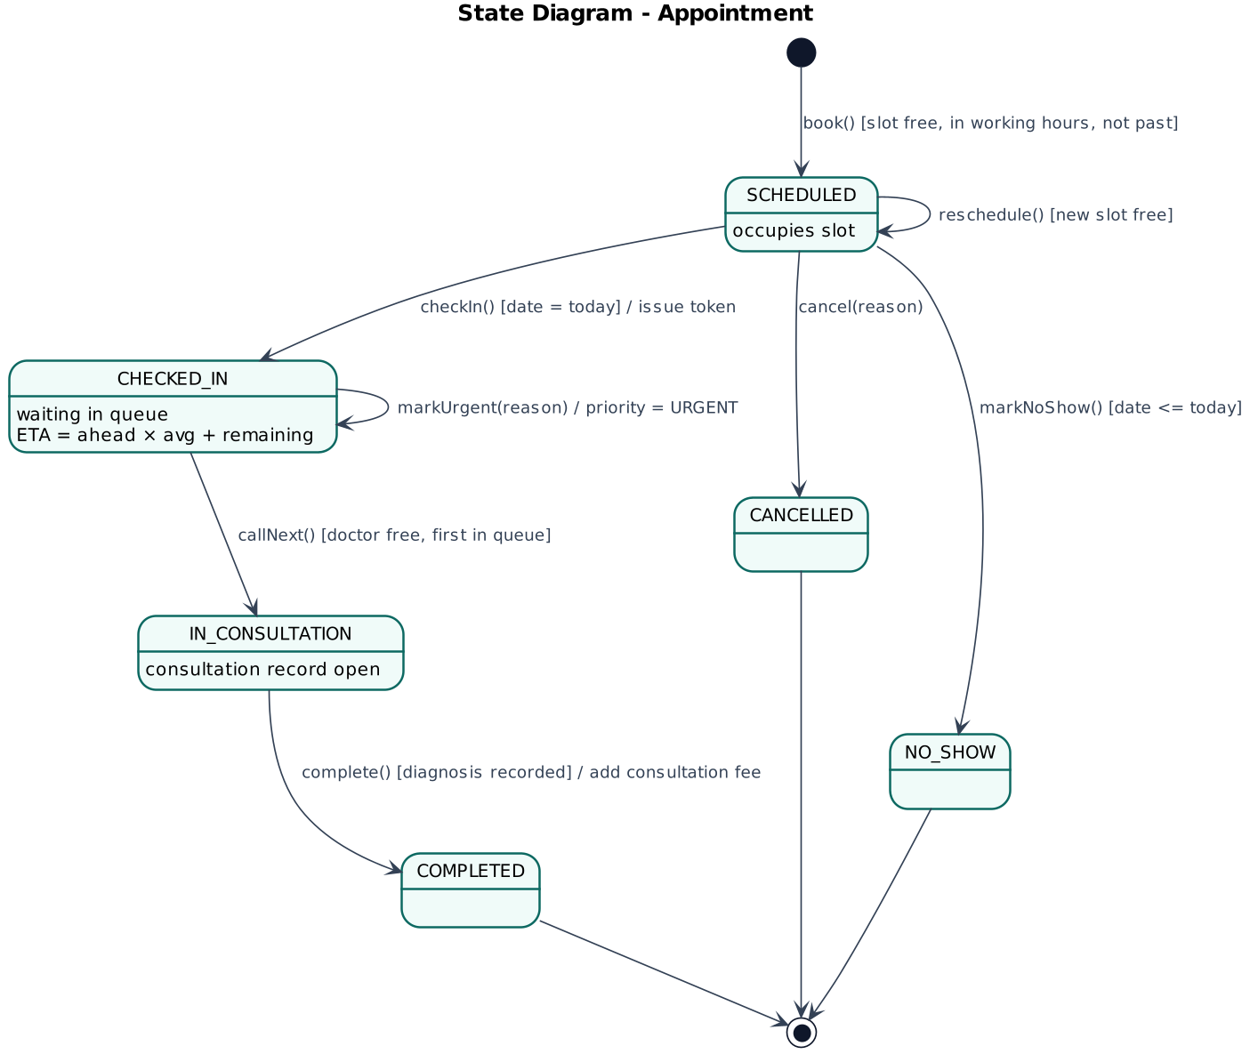
Figure 11. State diagram (Appointment)
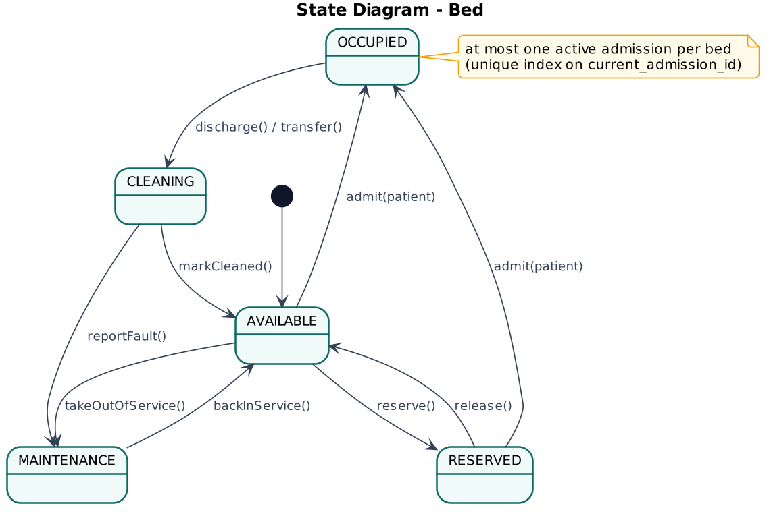
Figure 12. State diagram (Bed)
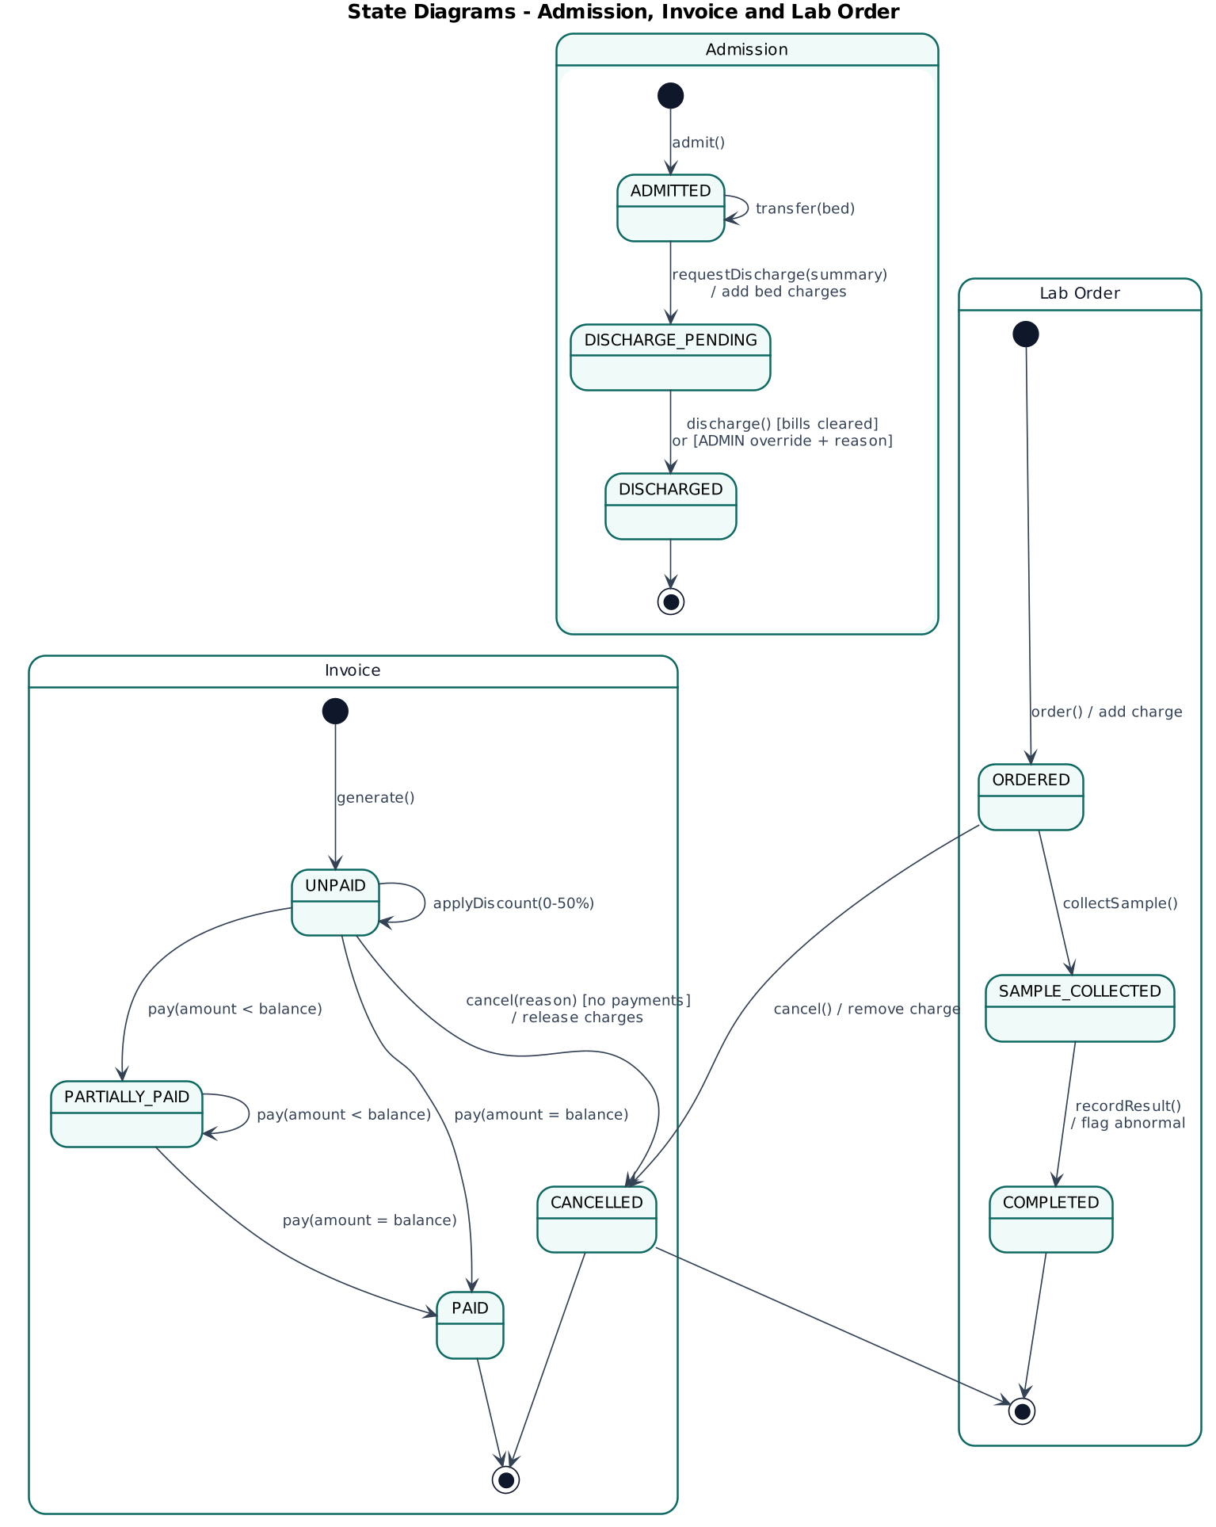
Figure 13. State diagrams (Admission, Invoice and Lab order)

6. Activity Diagram
The activity diagram complements the state diagrams by showing how responsibility for one outpatient visit passes between the roles, from registration and check-in through consultation, laboratory and pharmacy to billing.
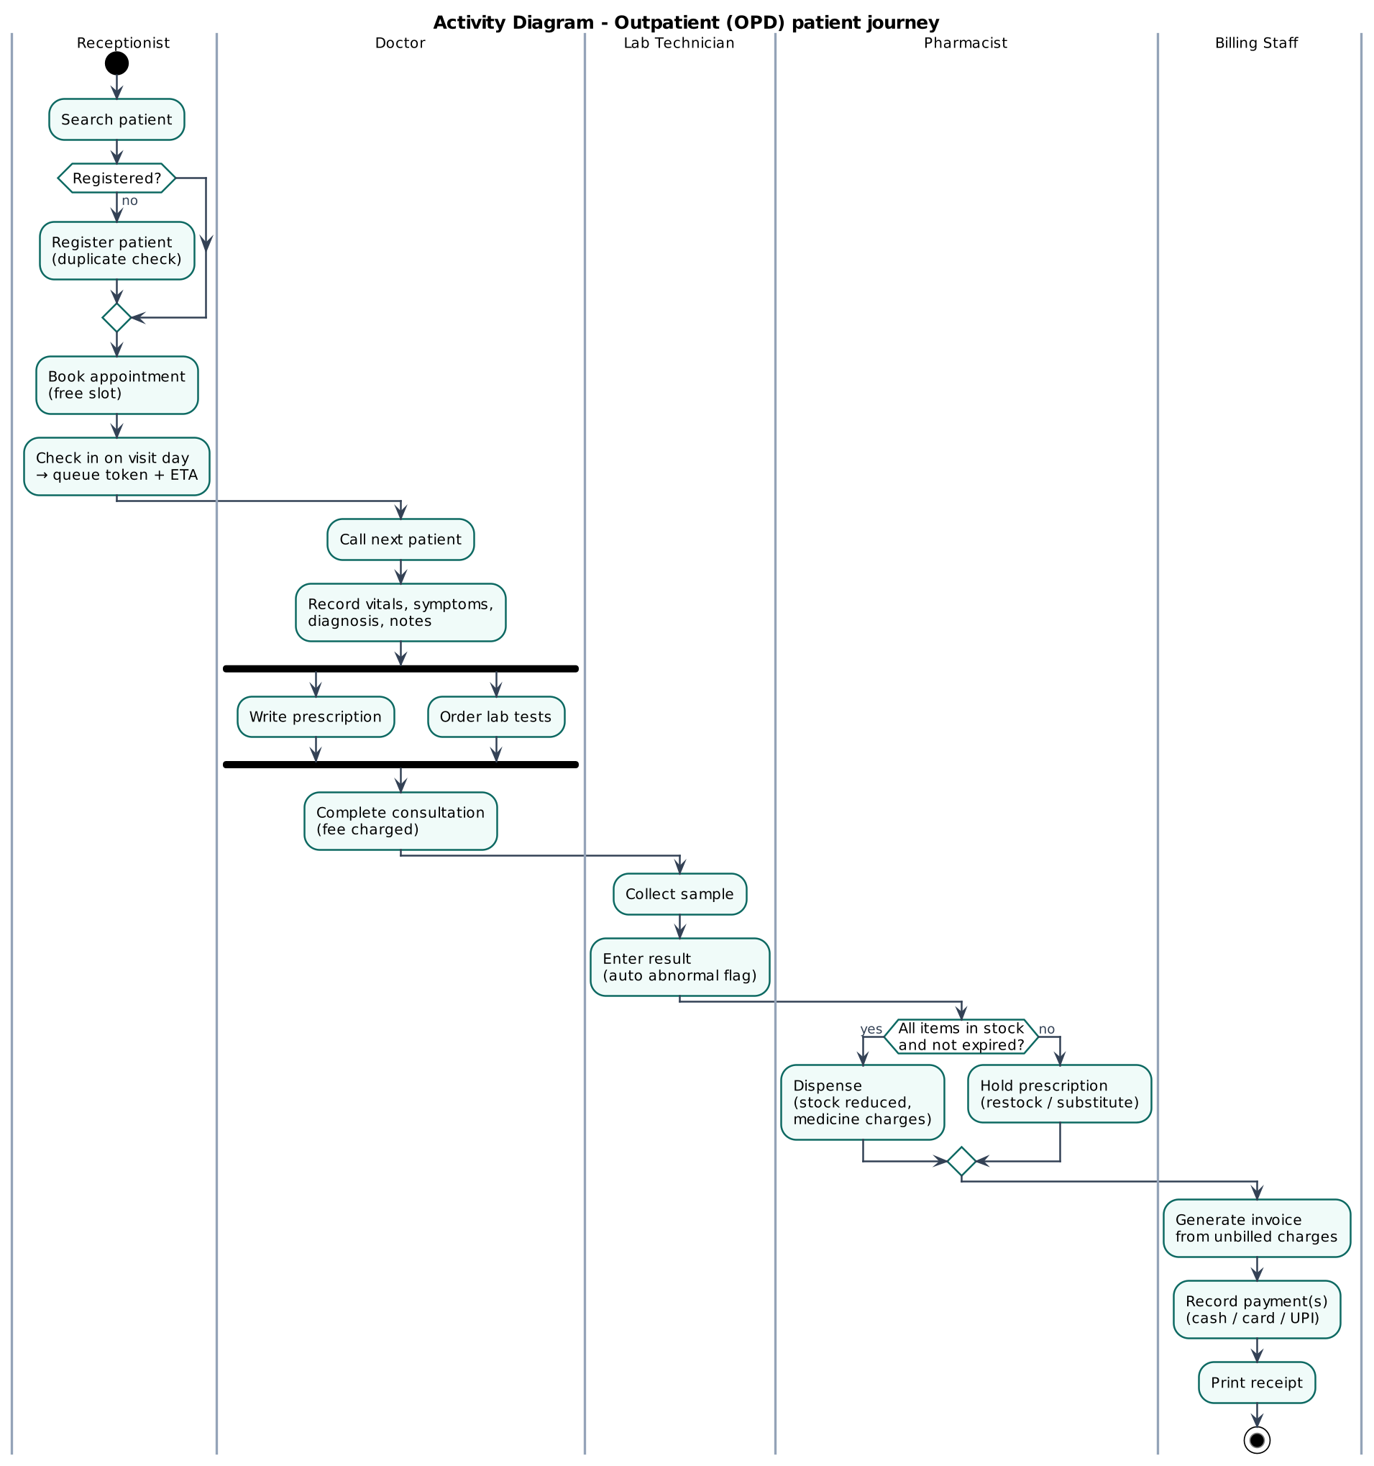
Figure 14. Activity diagram (outpatient journey across roles)

7. Component Diagram
MediFlow uses a three-tier, layered client and server architecture. The presentation tier is a React single-page application in the browser, the application tier is a Node.js and Express server with a REST API, and the data tier is an embedded SQLite database. Inside the server each layer may only call the layer below it.
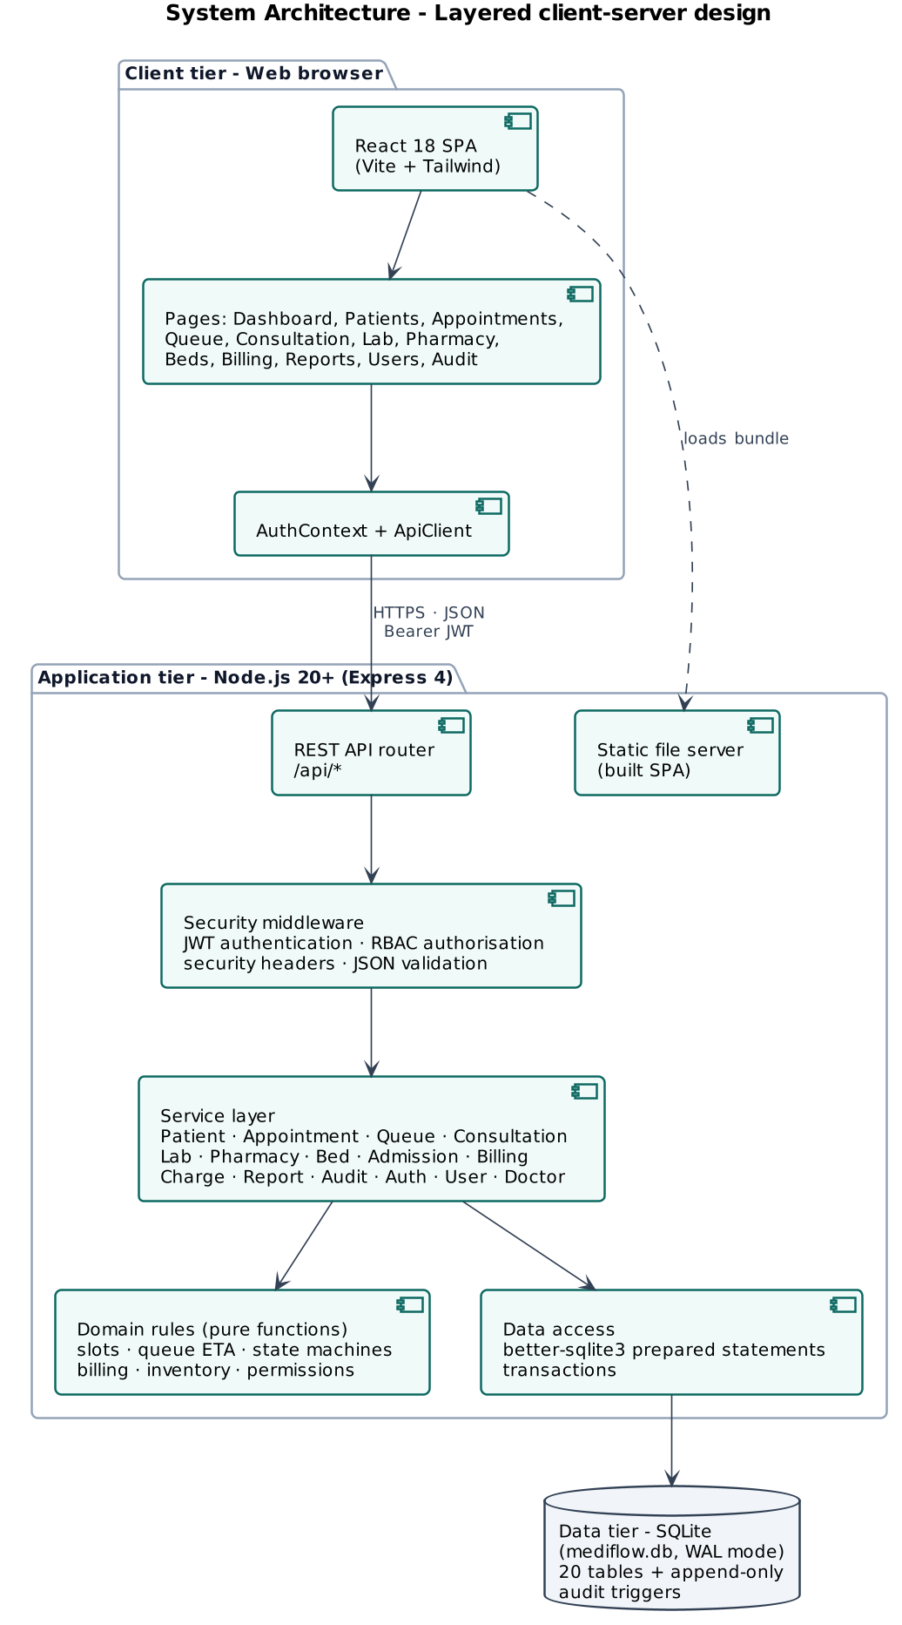
Figure 15. Component diagram (layered system architecture)

8. Deployment Diagram
In a hospital, the server runs on one application machine on the local network and staff use any browser on a workstation or tablet. Invoices and receipts are printed from the browser.
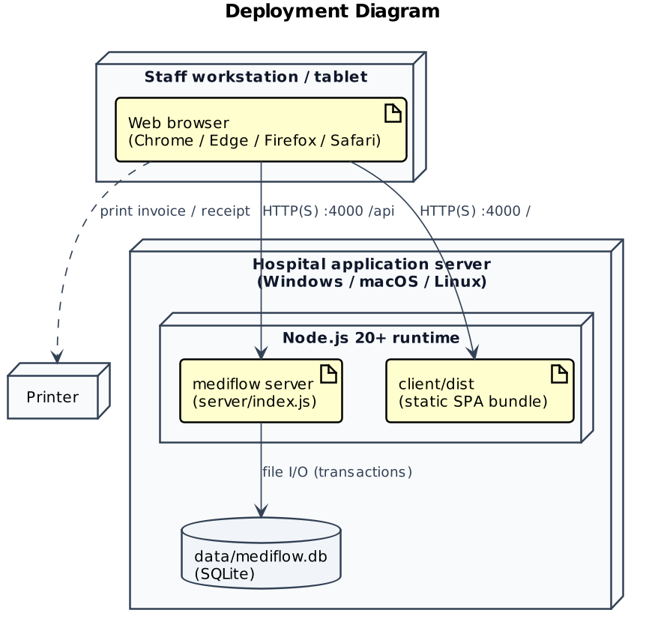
Figure 16. Deployment diagram
The public demonstration uses the same single-server design. One Node.js web service on Render's cloud serves both the built React app and the REST API with the embedded SQLite database, at mediflow-hms-6vw1.onrender.com.

9. Logical Data Model
The logical data model is not a UML diagram, but it is included because the domain class diagram maps directly onto it. It has 20 tables in third normal form, and status columns are constrained by CHECK clauses that mirror the state diagrams in Section 5.
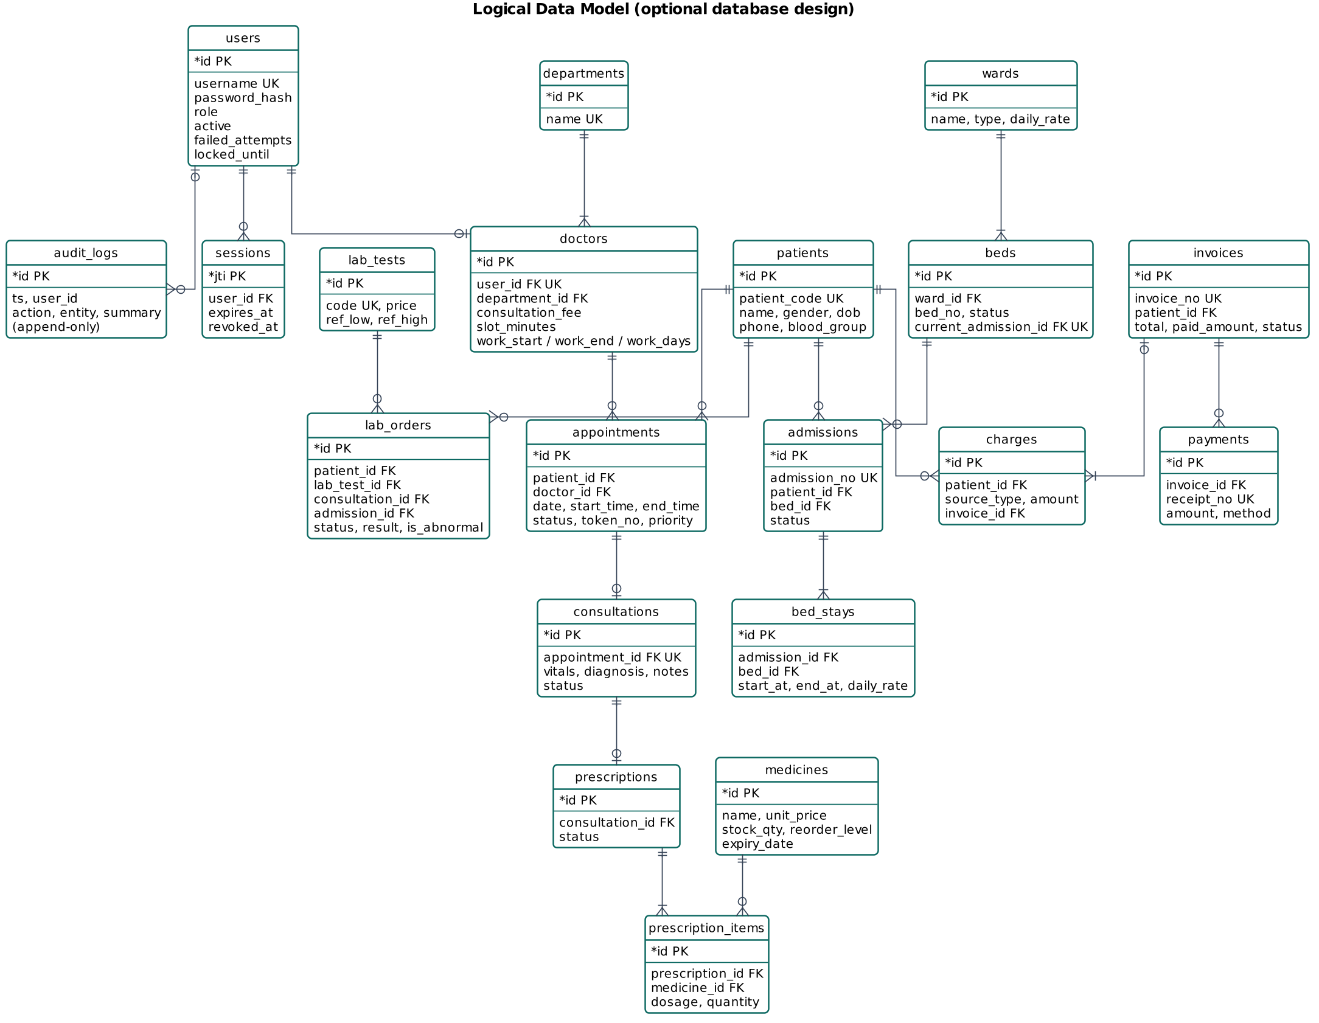
Figure 17. Logical data model (crow's-foot notation)

