INDIAN INSTITUTE OF INFORMATION TECHNOLOGY KALYANI
Department of Computer Science and Engineering
Software Engineering Project Assignment

MediFlow
Hospital Management System
Assignment 1 · Hospital Management System
Software Requirements Specification · Software Design Document (UML) · Software Test Plan · Software Test Report
GROUP 11
Sl. | Name of the member | Registration number
1 | Akash Chakraborty | CSE/23011/1059
2 | Anipriyo Mandal | CSE/23017/1065
3 | Arpan Mandal | CSE/23027/1075
4 | Himanshu Patel | CSE/23052/1100
5 | Pranjali Sirari | CSE/23072/1120

Live demo at mediflow-hms-6vw1.onrender.com
Submitted through Google Classroom · October 2026

Group Details
Table 1. Group and assignment details
Field | Value
Group number | 11
Assignment number and title | Assignment 1, Hospital Management System
Project name | MediFlow Hospital Management System
Problem statement (brief) | Develop a system to manage patients, doctors, appointments, prescriptions, billing and medical records.
Deliverables | SRS, SDD with UML diagrams, Software Test Plan and Test Report (this document) + working prototype (source code)
Live demo | mediflow-hms-6vw1.onrender.com
Table 2. Group members
Sl. | Name | Registration number
1 | Akash Chakraborty | CSE/23011/1059
2 | Anipriyo Mandal | CSE/23017/1065
3 | Arpan Mandal | CSE/23027/1075
4 | Himanshu Patel | CSE/23052/1100
5 | Pranjali Sirari | CSE/23072/1120

Document control
Table 3. Revision history
Version | Date | Description
0.1 | 15-Oct-2026 | Project selected (Assignment 1, Hospital Management System)
0.2 | 18-Oct-2026 | Scope, user roles and feature set agreed (core, hospital operations, distinctive features)
0.5 | 21-Oct-2026 | Requirements baselined (50 FR, 10 NFR, 12 BR), architecture and UML diagrams
0.9 | 21-Oct-2026 | Prototype implemented, unit, integration, system and acceptance tests executed
0.95 | 22-Oct-2026 | Robustness / edge-case testing, additional defects fixed and regression-tested
1.0 | 22-Oct-2026 | Final report for submission
1.1 | 22-Oct-2026 | Prototype deployed online (Render), live demo link added

Summary
MediFlow is a web-based Hospital Management System that manages patients, doctors, appointments, prescriptions, billing and medical records, extended with laboratory, pharmacy and in-patient (bed and admission) management. Beyond the core requirements, it introduces a smart queue with tokens and waiting-time estimates, a live bed board with a discharge workflow tied to billing clearance, and role-based access control with an append-only audit trail for six staff roles.
This report contains the Software Requirements Specification (Part A, with 50 functional and 10 non-functional requirements, 12 business rules and 14 user requirements), the Software Design Document (Part B, with a layered architecture, 13 modules, 16 UML diagrams of the use case, class, sequence, state, activity, component and deployment kinds, and a logical data model), the Software Test Plan (Part C) and the Software Test Report (Part D). A working prototype (React + Node.js + SQLite) was built so that the test report contains real results. In the final run 161 of 161 automated test cases passed, and 33 defects found during testing are documented with their resolution.
Live demo. The prototype runs online at mediflow-hms-6vw1.onrender.com and opens in any browser with no installation. Sign in with one of the demo accounts listed in Appendix B (password Mediflow@123). It uses a free cloud plan, so the first visit after 15 idle minutes takes about a minute to load, and the demo data is reset to fresh records dated that day whenever the server restarts.
Running it locally. Install Node.js 20 or later, run npm install and then npm run dev in the project folder, and open localhost port 5173 in a browser. The demo accounts are admin, reception, dr.sharma, lab, pharmacy and billing, all with the password Mediflow@123. See Appendix B for details.

Table of Contents
Group Details 2
Document control 2
Summary 3
Table of Contents 4
PART A. SOFTWARE REQUIREMENTS SPECIFICATION (SRS) 6
1. Introduction 6
1.1 Purpose 6
1.2 Intended audience 6
1.3 Product overview 6
1.4 Definitions, acronyms and abbreviations 6
1.5 References 7
1.6 Document overview 7
2. Problem Statement 7
3. Objectives 7
4. Scope of the System 8
4.1 In scope 8
4.2 Out of scope (this release) 8
4.3 User classes 8
5. Functional Requirements 9
5.1 Business rules 9
5.2 Authentication & Access Control (AUTH) 10
5.3 User Administration (USR) 10
5.4 Patient Management (PAT) 10
5.5 Doctor & Department Management (DOC) 11
5.6 Appointment Management (APT) 11
5.7 Smart Queue Management (QUE) 11
5.8 Consultation & Medical Records (CON) 12
5.9 Laboratory Management (LAB) 12
5.10 Pharmacy & Inventory (PHA) 12
5.11 Admission, Bed & Discharge Management (IPD) 12
5.12 Billing & Payments (BIL) 13
5.13 Dashboard & Reports (RPT) 13
5.14 Audit Trail (AUD) 13
6. Non-functional Requirements 13
7. User Requirements 14
8. System Requirements 15
8.1 System features (stimulus → response) 15
8.2 External interface requirements 16
8.3 Data requirements 18
9. Hardware and Software Requirements 19
9.1 Hardware requirements 19
9.2 Software requirements 19
10. Assumptions and Constraints 19
10.1 Assumptions 19
10.2 Constraints 20
10.3 Dependencies 20
PART B. SOFTWARE DESIGN DOCUMENT (SDD) 21
1. System Architecture 21
1.1 Design decisions and rationale 22
1.2 Deployment view 23
2. Module / Component Description 23
2.1 Cross-cutting components 24
3. Database Design (optional) 24
4. Class Diagram 25
5. Use Case Diagram 28
5.1 Use case specifications 30
6. Sequence Diagrams 32
7. State Diagrams 36
7.1 Activity view of the outpatient journey 38
8. Security Design 39
9. User Interface Design 40
PART C. SOFTWARE TEST PLAN 48
1. Testing Objectives 48
2. Testing Scope 48
2.1 In scope 48
2.2 Out of scope 48
3. Testing Strategy 48
3.1 Test design techniques 49
3.2 Test environment 49
3.3 Entry and exit criteria 50
3.4 Defect management 50
3.5 Roles, schedule and deliverables 50
3.6 Risks and mitigations 50
4. Unit Testing 51
5. Integration Testing 51
6. System Testing 51
7. Acceptance Testing 52
PART D. SOFTWARE TEST REPORT 53
8. Test Cases 53
8.1 Unit test cases 53
8.2 Integration test cases 57
8.3 System test cases 64
8.4 Acceptance test cases 66
9. Expected Results 68
10. Actual Results 68
10.1 Execution history 68
10.2 Code coverage 69
10.3 Non-functional results 69
11. Pass/Fail Status 69
12. Defect Reporting 70
12.1 Detailed defect reports 72
12.2 Defect summary and analysis 80
13. Conclusion 80
APPENDIX A. REQUIREMENTS TRACEABILITY MATRIX 81
APPENDIX B. RUNNING THE PROTOTYPE 84

PART A. SOFTWARE REQUIREMENTS SPECIFICATION (SRS)
This SRS follows the structure required by the assignment and is informed by IEEE Std 830-1998 / ISO/IEC/IEEE 29148 (2018). Every requirement has a unique identifier (FR-xx, NFR-xx, BR-xx, UR-xx) that is traced to design elements and test cases in Part D and Appendix A.

1. Introduction

1.1 Purpose
This document specifies the requirements of MediFlow, a web-based Hospital Management System (HMS) developed for Assignment 1 of the Software Engineering course. It describes what the system must do (functional requirements), how well it must do it (non-functional requirements), who will use it and under which assumptions and constraints. It is the baseline for the Software Design Document (Part B) and the Software Test Plan and Report (Parts C and D).

1.2 Intended audience
- Course instructor and evaluators, to assess completeness and quality of the specification.
- Development team (Group 11), as the single source of truth for design, implementation and testing.
- Hospital stakeholders (future), administrators, doctors, front-desk, laboratory, pharmacy and billing staff who would validate the requirements.

1.3 Product overview
MediFlow connects the reception desk, doctors, laboratory, pharmacy, wards and billing through one shared patient record. A patient's journey (registration → appointment → check-in and queue token → consultation → prescription / lab tests → billing → payment, and for in-patients admission → bed allocation → transfer → discharge) flows through the system without re-entering data. Three features distinguish the product from a basic HMS. These are a smart queue with tokens and waiting-time estimates, a live bed board with a safe admission/discharge workflow tied to billing clearance, and role-based access control with an append-only audit trail.

1.4 Definitions, acronyms and abbreviations
Table 4. Definitions and acronyms
Term | Meaning
HMS | Hospital Management System
OPD / IPD | Out-patient department (visits without admission) / In-patient department (admitted patients)
RBAC | Role-Based Access Control, permissions are granted to roles, users get one role
Token | Sequential queue number issued to a patient at check-in, unique per doctor per day
ETA | Estimated waiting time until the patient is called
STAT | Urgent laboratory priority (processed before ROUTINE orders)
Charge | A billable event (consultation fee, lab test, medicine, bed-day) waiting to be invoiced
Billing clearance | Condition that all charges of an admission are invoiced and fully paid
JWT | JSON Web Token, signed session token used to authenticate API calls
SPA / REST | Single-Page Application / Representational State Transfer (HTTP + JSON API)
FR / NFR / BR / UR | Functional / Non-functional requirement, Business rule, User requirement

1.5 References
- IEEE Std 830-1998, Recommended Practice for Software Requirements Specifications. ISO/IEC/IEEE 29148 (2018), Requirements engineering.
- IEEE Std 1016-2009, Software Design Descriptions. IEEE Std 829-2008 / ISO/IEC/IEEE 29119-3, Software test documentation.
- OMG Unified Modeling Language (UML) 2.5.1 specification.
- Assignment brief. “Software Development project problems, 1. Hospital Management System”, Software Engineering course, 2026.

1.6 Document overview
Section 2 states the problem, Section 3 the objectives and Section 4 the scope. Sections 5 and 6 list functional and non-functional requirements, Section 7 the user requirements, Section 8 the detailed system requirements (features, interfaces and data), Section 9 the hardware and software requirements, and Section 10 the assumptions and constraints.

2. Problem Statement
Many small and mid-sized hospitals still run their front desk, wards and billing on paper registers and disconnected spreadsheets. This causes recurring problems.
- Duplicate and incomplete patient records, the same patient is registered several times, so history, allergies and previous results are not available to the doctor.
- Double-booked doctors and long, unpredictable waits, appointments are written in diaries, walk-ins and booked patients compete, and nobody can tell a patient how long they will wait.
- Lost or illegible clinical information, prescriptions and lab orders on paper are misread, results arrive late and abnormal values are not highlighted.
- Bed confusion, the front desk does not know which beds are free, being cleaned or under maintenance. Occasionally a bed is promised to two patients.
- Revenue leakage, consultation fees, tests, medicines and bed-days are recorded in different places, invoices are compiled by hand, and patients are sometimes discharged with unpaid bills.
- No accountability, it is impossible to tell who changed a record, cancelled an appointment or authorised a discharge.
The hospital therefore needs a single, secure system that manages patients, doctors, appointments, prescriptions, billing and medical records (as required by the assignment) as one continuous workflow, with the right information available to the right staff member at the right time.

3. Objectives
Table 5. Project objectives
ID | Objective | Measure of success
O1 | Maintain one permanent electronic record per patient with complete visit, clinical, laboratory, admission and billing history. | Unique patient ID, duplicate warning (FR-07 to FR-12).
O2 | Eliminate double-booking and make waiting times predictable. | Zero overlapping bookings, token + ETA for every checked-in patient (FR-15 to FR-25).
O3 | Digitise consultations, prescriptions and lab orders and flag abnormal results automatically. | Diagnosis mandatory, abnormal flag on out-of-range results (FR-26 to FR-34).
O4 | Control medicine stock and prevent dispensing of expired or unavailable drugs. | Dispensing blocked when short/expired, alerts for low/expiring stock (FR-35 to FR-37).
O5 | Give real-time bed visibility and a safe admission → transfer → discharge workflow. | No bed double-allocation, discharge only after billing clearance (FR-38 to FR-43).
O6 | Capture every billable event automatically and produce accurate invoices and receipts. | Invoices built from charges, overpayment refused (FR-44 to FR-47).
O7 | Protect patient data and make every action traceable. | RBAC on every API, lock-out, append-only audit log (FR-01 to FR-06, FR-50).
O8 | Provide managers with live KPIs and period reports. | Role dashboards and admin reports (FR-48, FR-49).

4. Scope of the System

4.1 In scope
- Patient management, registration with unique ID, validation, duplicate detection, search, update and full history.
- Doctor and department management, profiles, fees, working days/hours, slot length and average consultation time.
- Appointments, free-slot calculation, booking, rescheduling, cancellation and no-show handling.
- Smart queue, check-in tokens, live queue board, waiting-time estimates, urgent prioritisation.
- Consultation and medical records, vitals, symptoms, diagnosis, notes, follow-up, e-prescriptions, lab orders.
- Laboratory, worklist, sample collection, result entry and automatic abnormal flagging.
- Pharmacy, inventory with batch/expiry, restocking, low-stock and expiry alerts, dispensing.
- In-patient management, wards and beds, bed board, admission, transfer, discharge request and discharge with billing clearance.
- Billing, automatic charges, invoices, discounts, part payments (cash, card, UPI), receipts and printing.
- Administration, users and roles, dashboards, management reports and audit trail.

4.2 Out of scope (this release)
- Patient self-service portal and online appointment booking by patients.
- Online payment gateway and insurance / TPA claim processing (payments are recorded, not processed).
- Integration with laboratory analysers, PACS / radiology imaging and external pharmacies.
- SMS / e-mail notifications, staff rostering and payroll, operation-theatre scheduling, inventory purchasing.
- AI-based features (e.g. clinical note summarisation), excluded for privacy and reliability reasons.

4.3 User classes
Table 6. User classes (actors)
Actor | Description and main responsibilities
Administrator | Manages users, doctors, departments, wards/beds and system configuration, views reports and the audit trail. May approve discharge overrides.
Receptionist | Registers patients, books/reschedules/cancels appointments, checks patients in (queue tokens), admits patients, allocates/transfers beds and completes discharge.
Doctor | Works through own queue, records consultations, writes prescriptions, orders lab tests, views patient history and lab results, requests admission/discharge.
Lab Technician | Processes lab test orders. Records sample collection and enters results.
Pharmacist | Maintains medicine inventory, receives stock alerts and dispenses prescriptions.
Billing Staff | Generates invoices from unbilled charges, applies discounts, records payments and prints receipts. Clears patients for discharge.
Patients are external to the system. They do not log in. Their data is entered and used by staff.
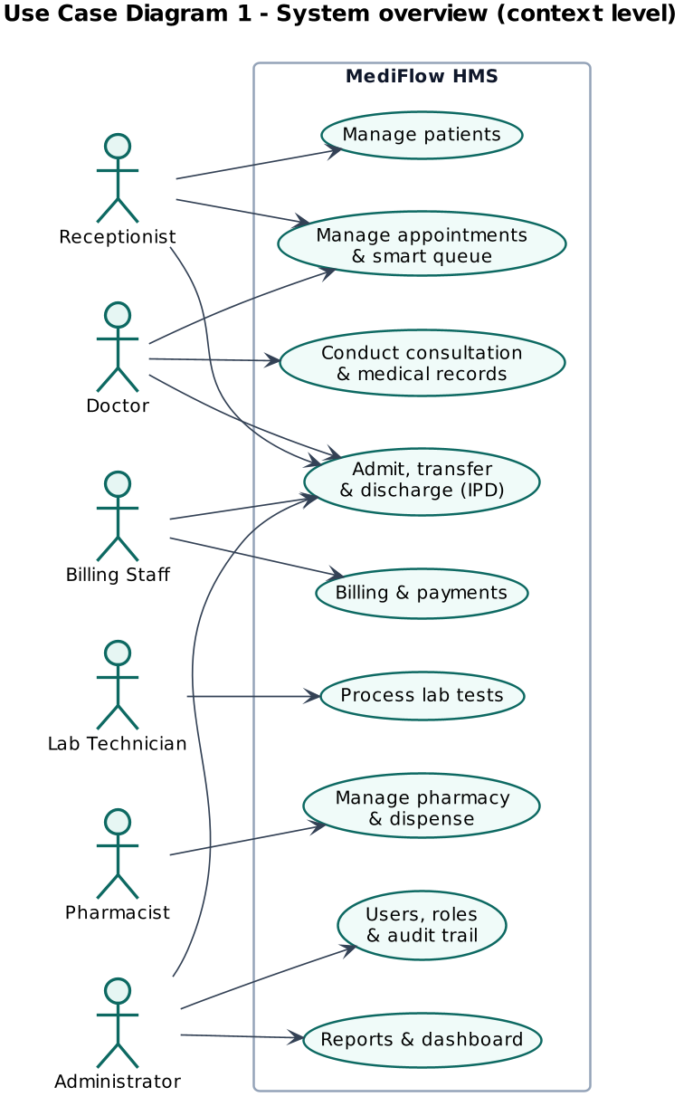
Figure 1. System context (actors and major functions)

5. Functional Requirements
The system shall satisfy the 50 functional requirements below, grouped into 13 modules. Priority follows MoSCoW-style ranking. High = must have for the first release, Medium = should have, Low = could have. All requirements were implemented in the prototype.

5.1 Business rules
Table 7. Business rules referenced by the functional requirements
ID | Business rule
BR-01 | Patient ID format is P followed by 5 digits, assigned sequentially and never reused.
BR-02 | Appointment slots start at the doctor's work start time and repeat every slot length until work end. Bookings must align to a slot boundary.
BR-03 | Active appointment states are SCHEDULED, CHECKED_IN and IN_CONSULTATION, only these block a slot.
BR-04 | Appointment life cycle. SCHEDULED → CHECKED_IN → IN_CONSULTATION → COMPLETED. SCHEDULED → CANCELLED. SCHEDULED → NO_SHOW.
BR-05 | Queue order. URGENT before NORMAL, then earlier check-in first. Wait estimate = ahead × average consultation minutes + max(average − elapsed, 1) when a consultation is in progress.
BR-06 | Lab order life cycle. ORDERED → SAMPLE_COLLECTED → COMPLETED. ORDERED → CANCELLED.
BR-07 | Low stock when quantity ≤ reorder level. Near-expiry when expiry is within 30 days. Expired medicines cannot be dispensed.
BR-08 | Bed state machine. AVAILABLE→RESERVED, AVAILABLE→OCCUPIED, AVAILABLE→MAINTENANCE, RESERVED→OCCUPIED, RESERVED→AVAILABLE, OCCUPIED→CLEANING, CLEANING→AVAILABLE, CLEANING→MAINTENANCE, MAINTENANCE→AVAILABLE.
BR-09 | Admission life cycle. ADMITTED → DISCHARGE_PENDING → DISCHARGED. Bed days = ceil(hours stayed / 24), minimum 1, charged at the ward's daily rate per stay.
BR-10 | Invoice life cycle. UNPAID → PARTIALLY_PAID → PAID. UNPAID → CANCELLED (only when no payment exists). Discount 0 to 50% only while UNPAID.
BR-11 | Payments. Amount > 0 and ≤ outstanding balance. Methods CASH, CARD, UPI, receipt number R-YYYYMMDD-NNNN.
BR-12 | Account lockout. 5 consecutive failures lock the account for 15 minutes. A successful login resets the counter.

5.2 Authentication & Access Control (AUTH)
Table 8. Functional requirements (Authentication & Access Control)
ID | Requirement | Priority
FR-01 | The system shall authenticate users with a username and password and issue a session token valid for 8 hours. | High
FR-02 | The system shall lock an account for 15 minutes after 5 consecutive failed login attempts and shall reject logins for deactivated accounts. | High
FR-03 | The system shall restrict every operation according to the role-permission matrix (Administrator, Receptionist, Doctor, Lab Technician, Pharmacist, Billing Staff) and show each role only its permitted menus. | High
FR-04 | The system shall allow a logged-in user to log out and shall reject requests carrying a missing, invalid or expired token. | Medium

5.3 User Administration (USR)
Table 9. Functional requirements (User Administration)
ID | Requirement | Priority
FR-05 | The Administrator shall be able to create user accounts with a unique username, full name, role and initial password (minimum 8 characters). | High
FR-06 | The Administrator shall be able to activate/deactivate user accounts and reset passwords. An Administrator cannot deactivate their own account. | Medium

5.4 Patient Management (PAT)
Table 10. Functional requirements (Patient Management)
ID | Requirement | Priority
FR-07 | The Receptionist shall be able to register a patient. The system shall generate a unique patient ID in the format P00001. | High
FR-08 | The system shall validate patient data. First and last name required, 10-digit mobile number, date of birth not in the future, valid gender and blood group values. | High
FR-09 | The system shall warn about a possible duplicate registration when a patient with the same mobile number and date of birth, or the same full name and date of birth, already exists, the Receptionist may confirm and proceed. | Medium
FR-10 | Authorised users shall be able to search patients by patient ID, name or mobile number. | High
FR-11 | The Receptionist shall be able to update patient demographic and contact details. The patient ID shall never change. | Medium
FR-12 | The system shall display a patient's history, namely appointments, consultations, prescriptions, lab results, admissions and invoices (clinical items only to clinical roles). | High

5.5 Doctor & Department Management (DOC)
Table 11. Functional requirements (Doctor & Department Management)
ID | Requirement | Priority
FR-13 | The Administrator shall be able to manage doctor profiles (department, specialisation, qualification, consultation fee, working days and hours, slot length and average consultation time). | High
FR-14 | The system shall list departments and the doctors belonging to each department. | Low

5.6 Appointment Management (APT)
Table 12. Functional requirements (Appointment Management)
ID | Requirement | Priority
FR-15 | The system shall show the free appointment slots of a doctor for a selected date, based on working days, working hours, slot length and existing bookings. | High
FR-16 | The Receptionist shall be able to book an appointment for a registered patient with a doctor in a free slot that is not in the past and lies within the doctor's working hours. | High
FR-17 | The system shall reject a booking that overlaps an existing active appointment of the same doctor or of the same patient. | High
FR-18 | The Receptionist shall be able to reschedule an appointment while it is in the SCHEDULED state, subject to the same slot rules. | Medium
FR-19 | The Receptionist shall be able to cancel a SCHEDULED appointment with a mandatory reason. The freed slot becomes bookable again. | Medium
FR-20 | The system shall list appointments filtered by date, doctor and status. | Medium

5.7 Smart Queue Management (QUE)
Table 13. Functional requirements (Smart Queue Management)
ID | Requirement | Priority
FR-21 | On check-in of a SCHEDULED appointment for today, the system shall issue a queue token unique per doctor per day and set the appointment state to CHECKED_IN. | High
FR-22 | The system shall display a live queue board per doctor showing waiting, in-consultation and served patients, ordered by priority (URGENT first) and then check-in time. | High
FR-23 | The system shall estimate each waiting patient's waiting time as (patients ahead × doctor's average consultation time) + remaining time of the consultation in progress. | High
FR-24 | Receptionists, Doctors and Administrators shall be able to mark a waiting patient URGENT with a mandatory reason. The action shall be audited. | Medium
FR-25 | A Doctor shall be able to call the next patient from their queue only when no consultation of theirs is in progress. The appointment moves to IN_CONSULTATION. | High

5.8 Consultation & Medical Records (CON)
Table 14. Functional requirements (Consultation & Medical Records)
ID | Requirement | Priority
FR-26 | A Doctor shall be able to record a consultation for an appointment in IN_CONSULTATION (symptoms, vitals, diagnosis, clinical notes and optional follow-up date). Diagnosis is required to complete it. | High
FR-27 | A Doctor shall be able to issue a prescription of one or more medicines with dosage, frequency, duration and quantity (> 0) during a consultation. | High
FR-28 | A Doctor shall be able to order one or more lab tests for a patient during a consultation or an admission. | High
FR-29 | Completing a consultation shall set the appointment to COMPLETED and add the doctor's consultation fee as an unbilled charge. | High
FR-30 | Only clinical roles (Doctor, Administrator) shall view diagnoses and clinical notes. Receptionist and Billing Staff shall be denied. | High

5.9 Laboratory Management (LAB)
Table 15. Functional requirements (Laboratory Management)
ID | Requirement | Priority
FR-31 | The Lab Technician shall see a worklist of lab orders filtered by status (ORDERED, SAMPLE_COLLECTED, COMPLETED, CANCELLED). | High
FR-32 | The Lab Technician shall record sample collection (ORDERED → SAMPLE_COLLECTED) and then enter the result (SAMPLE_COLLECTED → COMPLETED). Other transitions shall be rejected. | High
FR-33 | The system shall automatically flag a numeric result outside the test's reference range as ABNORMAL. | Medium
FR-34 | Ordering a lab test shall add the test price as an unbilled charge. Cancelling an ORDERED test shall remove the unbilled charge. | Medium

5.10 Pharmacy & Inventory (PHA)
Table 16. Functional requirements (Pharmacy & Inventory)
ID | Requirement | Priority
FR-35 | The Pharmacist shall manage the medicine inventory (add medicines, restock quantities and record batch and expiry date). | High
FR-36 | The system shall raise alerts for medicines at or below their reorder level and for medicines expiring within 30 days or already expired. | Medium
FR-37 | The Pharmacist shall dispense a PENDING prescription only if every item is in stock and not expired. Dispensing reduces stock and adds medicine charges. | High

5.11 Admission, Bed & Discharge Management (IPD)
Table 17. Functional requirements (Admission, Bed & Discharge Management)
ID | Requirement | Priority
FR-38 | The system shall show a ward-wise bed board with each bed's status. AVAILABLE, RESERVED, OCCUPIED, CLEANING or MAINTENANCE. | High
FR-39 | The Receptionist shall admit a patient to an AVAILABLE bed. A patient may have only one active admission and a bed may hold only one patient. | High
FR-40 | The Receptionist shall transfer an admitted patient to another AVAILABLE bed. The previous bed moves to CLEANING and bed charges are kept per stay. | Medium
FR-41 | Bed status changes shall follow the bed state machine (AVAILABLE→RESERVED→OCCUPIED→CLEANING→AVAILABLE, AVAILABLE↔MAINTENANCE, RESERVED→AVAILABLE), invalid transitions shall be rejected. | High
FR-42 | A Doctor shall request discharge with a discharge summary (ADMITTED → DISCHARGE_PENDING). Bed charges (days × daily rate, minimum 1 day) are then added as unbilled charges. | High
FR-43 | Discharge shall be completed only when all charges of the admission are invoiced and fully paid, unless an Administrator overrides with a recorded reason. The bed then moves to CLEANING. | High

5.12 Billing & Payments (BIL)
Table 18. Functional requirements (Billing & Payments)
ID | Requirement | Priority
FR-44 | Billing Staff shall generate an invoice for a patient from all of that patient's unbilled charges (consultation, lab, medicine, bed), with a unique invoice number. | High
FR-45 | Billing Staff shall be able to apply a discount of 0 to 50% with a reason to an UNPAID invoice. | Medium
FR-46 | Billing Staff shall record full or partial payments (Cash, Card, UPI), a payment must be greater than zero and not exceed the outstanding balance. Invoice status moves UNPAID → PARTIALLY_PAID → PAID. | High
FR-47 | The system shall generate a printable receipt with a unique receipt number for every payment and a printable invoice. | Medium

5.13 Dashboard & Reports (RPT)
Table 19. Functional requirements (Dashboard & Reports)
ID | Requirement | Priority
FR-48 | The dashboard shall show today's KPIs. Appointments, patients waiting, bed occupancy, revenue collected, pending lab orders and stock alerts. | Medium
FR-49 | The Administrator shall view reports for a date range (appointments per day and status, revenue per day and payment method, bed occupancy per ward and top diagnoses). | Medium

5.14 Audit Trail (AUD)
Table 20. Functional requirements (Audit Trail)
ID | Requirement | Priority
FR-50 | The system shall record an append-only audit entry (user, role, action, entity, entity id, timestamp, summary) for every create, update and state change, without storing passwords. Administrators can search it. | High

6. Non-functional Requirements
Table 21. Non-functional requirements
ID | Category | Requirement
NFR-01 | Performance | 95% of API requests shall complete within 500 ms on a standard laptop with the demo dataset. Pages shall render within 2 seconds.
NFR-02 | Security | Passwords shall be stored only as bcrypt hashes. All API routes except login shall require a signed JWT. All SQL shall use parameterised statements.
NFR-03 | Security / Privacy | Access to clinical data shall follow the principle of least privilege defined in the role-permission matrix. Audit logs shall not contain passwords or tokens.
NFR-04 | Reliability / Integrity | Multi-step operations (admission + bed update, dispensing + stock update, invoice generation, payment recording) shall execute in a single database transaction.
NFR-05 | Usability | The interface shall be responsive (≥ 360 px width), use consistent colour-coded status badges, show field-level validation messages and allow booking an appointment in at most 4 steps.
NFR-06 | Maintainability | The code shall follow a layered architecture (UI → REST API → Services → Domain rules → Data access). Business rules shall be isolated in pure, unit-tested domain modules.
NFR-07 | Portability | The system shall run on Windows, macOS and Linux with Node.js 20 or later, and on current Chrome, Edge, Firefox and Safari browsers.
NFR-08 | Auditability | Every state-changing operation shall be traceable to an authenticated user and timestamp through the audit trail.
NFR-09 | Availability | The production deployment should target 99.5% availability during hospital operating hours, with daily database backups (out of scope for the prototype).
NFR-10 | Scalability | The design shall support at least 50 concurrent staff users and 100,000 patient records without architectural change.
NFR-01 to NFR-08 are verified by automated tests (see Part D). NFR-09 and NFR-10 are design targets for a production deployment and are addressed by the architecture (Part B) rather than measured on the prototype.

7. User Requirements
User requirements describe, in the language of each user class, what they need to achieve. They are written as user stories with acceptance criteria and are refined into the functional requirements listed in the last column. The acceptance tests (AT-01 … AT-05) in Part D validate them end-to-end.
Table 22. User requirements (user stories)
ID | As a … | I want to … | So that … | Acceptance criteria | FRs
UR-01 | Receptionist | register a new patient in under two minutes and be warned if the patient may already exist | so that every patient has exactly one record and one permanent ID | Unique ID P00001… is shown on save. Invalid mobile/DOB is highlighted on the field. A possible duplicate (same mobile + DOB or same name + DOB) is listed and must be confirmed. | FR-07, FR-08, FR-09
UR-02 | Receptionist / Doctor | find a patient by ID, name or mobile and open the full history | so that no information has to be asked or typed twice | Search returns matches as I type. The history shows visits, admissions and bills, clinical notes are visible to doctors only. | FR-10, FR-11, FR-12, FR-30
UR-03 | Receptionist | book, reschedule and cancel appointments only in free slots | so that doctors are never double-booked | Free / booked / past slots are shown for the chosen date. Booking a taken slot is refused with a clear message. Cancellation asks for a reason. | FR-15 to FR-20
UR-04 | Receptionist | check patients in and give them a token with an expected waiting time | so that the waiting area is orderly and patients know when they will be seen | Token numbers are sequential per doctor per day. The queue board shows position and ETA. Urgent patients can be moved to the front with a recorded reason. | FR-21 to FR-24
UR-05 | Doctor | call the next patient and record vitals, diagnosis, prescription and lab orders on one screen | so that the consultation is fast and complete | Only one consultation can be open at a time. Diagnosis is mandatory to complete. Completing the visit charges the fee automatically. | FR-25 to FR-29
UR-06 | Lab Technician | see a worklist of pending tests and enter results that are flagged when abnormal | so that urgent abnormal results reach the doctor quickly | STAT orders appear first, a result can only be entered after sample collection. Values outside the reference range are marked ABNORMAL. | FR-31 to FR-34
UR-07 | Pharmacist | dispense prescriptions only when stock is sufficient and be alerted about low or expiring stock | so that patients never receive expired medicine and stock-outs are avoided | Dispensing is blocked when any item is short or expired. Low-stock and expiry (≤ 30 days) alerts are listed. Restocking records batch and expiry. | FR-35 to FR-37
UR-08 | Receptionist | see which beds are free and admit or transfer patients safely | so that two patients are never assigned the same bed | The bed board is colour-coded by status. Only AVAILABLE/RESERVED beds can be assigned. A transferred patient's old bed goes to CLEANING. | FR-38 to FR-41
UR-09 | Doctor / Receptionist | discharge a patient only after the bill is settled, with an emergency override for the administrator | so that revenue is not lost and exceptions are accountable | Discharge is refused while charges are uninvoiced or unpaid. An administrator can override with a mandatory reason that is audited. | FR-42, FR-43
UR-10 | Billing Staff | generate an invoice from all pending charges, apply approved discounts and accept part payments | so that billing is accurate and quick | Invoice lines are filled automatically from consultations, tests, medicines and bed days, discount 0 to 50%, overpayment is refused, each payment prints a receipt. | FR-44 to FR-47
UR-11 | Administrator | manage staff accounts, roles and doctor schedules | so that each person can do exactly their job | Usernames are unique, passwords ≥ 8 characters, accounts can be (de)activated, doctor working days, hours and fees are editable. | FR-05, FR-06, FR-13, FR-14
UR-12 | Administrator | see today's key figures and period reports | so that I can monitor workload, occupancy and revenue | Dashboard KPIs per role, reports for a date range with charts and CSV export. | FR-48, FR-49
UR-13 | All staff | log in securely and see only the functions of my role | so that patient data is protected | Account locks for 15 minutes after 5 wrong passwords. Menus and APIs are restricted by role. I can log out. | FR-01 to FR-04
UR-14 | Administrator | trace who did what and when | so that clinical and financial actions are accountable | Every state change is in an append-only audit trail that can be searched by entity, action, user and date. | FR-50

8. System Requirements
System requirements refine the user requirements into precise behaviour of the software system, its interfaces and its data.

8.1 System features (stimulus → response)
Table 23. System features
Feature | Stimulus / input | System response / output
Authentication | Username + password. Bearer token on every API call | Issues an 8-hour JWT bound to a server-side session. Increments failed attempts and locks after 5. Rejects revoked/expired tokens with HTTP 401 and unauthorised roles with HTTP 403.
Patient registration | Demographics, contact, blood group, allergies | Validates fields, searches existing records with the same DOB for phone/name matches. Returns HTTP 409 POSSIBLE_DUPLICATE unless confirmed. Assigns the next ID P#####.
Slot calculation | Doctor + date | Generates slots from work start to end at slot length on working days. Marks slots BOOKED (overlap with an active appointment) or PAST (before current time).
Appointment booking | Patient, doctor, date, start time, reason | Validates working day/hours, slot alignment and future time. Rejects doctor or patient overlap (HTTP 409). Stores SCHEDULED appointment in a transaction.
Check-in & queue | Today's SCHEDULED appointment | Assigns token = max(token)+1 for doctor/day. Sets CHECKED_IN, queue ordered URGENT → check-in time. ETA = ahead × average + remaining time of current consultation.
Consultation | Vitals, symptoms, diagnosis, notes, prescription items, lab tests | Validates vitals ranges and BP format. Stores prescription (PENDING) and lab orders (ORDERED) with charges. On completion requires diagnosis, closes appointment and adds the consultation fee charge.
Laboratory | Sample collected, result value / findings | Enforces ORDERED → SAMPLE_COLLECTED → COMPLETED. Computes ABNORMAL when the value lies outside [ref_low, ref_high], cancelling removes the unbilled charge.
Pharmacy | Restock (qty, batch, expiry), dispense request | Refuses expired batches, checks every item for stock and expiry inside one transaction. Decrements stock and creates medicine charges. Produces low-stock / near-expiry / expired alerts.
Beds & admissions | Patient, attending doctor, bed, transfer bed, discharge | Allows only valid bed transitions. One active admission per patient and one patient per bed (enforced by unique indexes). Bed-day charges = max(1, ⌈hours/24⌉) shared across stays, discharge only when clearance holds or an administrator overrides with a reason.
Billing | Patient (+ admission), discount %, payment amount, method, reference | Builds an invoice from unbilled charges with number INV-YYYYMMDD-NNNN. Discount 0 to 50% only while UNPAID. Payment 0 < amount ≤ balance. Reference required for CARD/UPI, receipt R-YYYYMMDD-NNNN.
Reporting | Date range | Aggregates appointments by day/status, revenue by day/method/source, occupancy by ward, top diagnoses and doctor performance.
Audit | Any create / update / state change | Appends user, role, action, entity, id, timestamp and summary, credentials are scrubbed. UPDATE/DELETE on the log are blocked by database triggers.

8.2 External interface requirements
User interface. A responsive single-page web application (minimum width 360 px) with a sidebar showing only the modules permitted for the logged-in role, colour-coded status badges, modal dialogs for actions, field-level validation messages, toast notifications and print-optimised invoice and receipt layouts.
Software interface (REST API). All functions are exposed as JSON over HTTP under /api. Every route except login and health requires a Bearer token. Each is protected by the permission shown below (generated from the source code).
Table 24. REST API endpoints (78)
Method | Endpoint | Required permission
GET | /api/health | public
POST | /api/auth/login | public
GET | /api/auth/me | any authenticated user
POST | /api/auth/logout | any authenticated user
GET | /api/users | users.manage
POST | /api/users | users.manage
PATCH | /api/users/{id} | users.manage
POST | /api/users/{id}/activate | users.manage
POST | /api/users/{id}/deactivate | users.manage
POST | /api/users/{id}/reset-password | users.manage
GET | /api/departments | doctors.read
POST | /api/departments | doctors.manage
GET | /api/doctors | doctors.read
GET | /api/doctors/{id} | doctors.read
POST | /api/doctors | doctors.manage
PATCH | /api/doctors/{id} | doctors.manage
GET | /api/doctors/{id}/slots | appointments.read
GET | /api/patients | patients.read
POST | /api/patients/check-duplicates | patients.write
POST | /api/patients | patients.write
GET | /api/patients/{id} | patients.read
PATCH | /api/patients/{id} | patients.write
GET | /api/patients/{id}/history | patients.read
GET | /api/appointments | appointments.read
POST | /api/appointments | appointments.write
GET | /api/appointments/{id} | appointments.read
PATCH | /api/appointments/{id}/reschedule | appointments.write
POST | /api/appointments/{id}/cancel | appointments.write
POST | /api/appointments/{id}/no-show | appointments.write
POST | /api/appointments/{id}/check-in | queue.checkin
GET | /api/queue | queue.read
GET | /api/queue/{doctorId} | queue.read
POST | /api/queue/{appointmentId}/priority | queue.priority
POST | /api/queue/{doctorId}/call-next | consultation.write
GET | /api/consultations | clinical.read
GET | /api/consultations/current | consultation.write
GET | /api/consultations/{id} | clinical.read
PUT | /api/consultations/{id} | consultation.write
PUT | /api/consultations/{id}/prescription | consultation.write
POST | /api/consultations/{id}/complete | consultation.write
GET | /api/lab/tests | lab.read or lab.order
GET | /api/lab/orders | lab.read
GET | /api/lab/stats | lab.read
POST | /api/lab/orders | lab.order
GET | /api/lab/orders/{id} | lab.read
POST | /api/lab/orders/{id}/collect | lab.process
POST | /api/lab/orders/{id}/result | lab.process
POST | /api/lab/orders/{id}/cancel | lab.process or lab.order
GET | /api/pharmacy/medicines | pharmacy.read
POST | /api/pharmacy/medicines | pharmacy.manage
PATCH | /api/pharmacy/medicines/{id} | pharmacy.manage
POST | /api/pharmacy/medicines/{id}/restock | pharmacy.manage
GET | /api/pharmacy/alerts | pharmacy.read
GET | /api/pharmacy/prescriptions | prescriptions.read
GET | /api/pharmacy/prescriptions/{id} | prescriptions.read
POST | /api/pharmacy/prescriptions/{id}/dispense | prescriptions.dispense
GET | /api/beds | beds.read or admissions.read
GET | /api/beds/available | admissions.write
POST | /api/beds/{id}/status | beds.manage
GET | /api/admissions | admissions.read
POST | /api/admissions | admissions.write
GET | /api/admissions/{id} | admissions.read
POST | /api/admissions/{id}/transfer | admissions.write
POST | /api/admissions/{id}/request-discharge | admissions.request-discharge
POST | /api/admissions/{id}/discharge | admissions.write
GET | /api/billing/pending | billing.read
GET | /api/billing/unbilled | billing.read
GET | /api/billing/invoices | billing.read
POST | /api/billing/invoices | billing.write
GET | /api/billing/invoices/{id} | billing.read
POST | /api/billing/invoices/{id}/discount | billing.write
POST | /api/billing/invoices/{id}/payments | billing.write
POST | /api/billing/invoices/{id}/cancel | billing.write
GET | /api/billing/receipts/{paymentId} | billing.read
GET | /api/reports/dashboard | dashboard.read
GET | /api/reports/summary | reports.read
GET | /api/audit | audit.read
GET | /api/audit/entities | audit.read
Hardware interfaces. Standard keyboard/mouse or touch screen. Any printer supported by the browser for invoices and receipts. Communication interfaces. HTTP(S) on a hospital LAN. TLS termination by a reverse proxy in production.

8.3 Data requirements
- Persistent data is stored in a relational database (SQLite file) with 20 tables (users, sessions, departments, doctors, patients, appointments, consultations, prescriptions, prescription items, medicines, lab tests, lab orders, wards, beds, bed stays, admissions, charges, invoices, payments and audit logs).
- Integrity rules are enforced in the schema, namely foreign keys, CHECK constraints on every status column, a unique token per doctor per day, at most one active admission per patient and one admission per bed (partial unique indexes), and append-only triggers on the audit log.
- Money is stored in rupees with two decimals and calculated in paise to avoid rounding drift. Dates are ISO-8601, appointment dates/times are local (IST).
- Medical and billing records are never deleted. Cancellations change status and are audited.

9. Hardware and Software Requirements

9.1 Hardware requirements
Table 25. Hardware requirements
Component | Minimum | Recommended
Application server | Dual-core 2 GHz CPU, 4 GB RAM, 2 GB free disk | Quad-core CPU, 8 GB RAM, SSD with 20 GB free, UPS
Client workstation | Any PC, laptop or tablet able to run a current browser, 1366 × 768 display | 1920 × 1080 display at reception and nursing stations. Tablet for doctors
Network | 100 Mbit/s LAN or Wi-Fi | Gigabit LAN, separate VLAN for clinical systems
Peripherals | Any printer for invoices/receipts | Thermal receipt printer at billing. Barcode scanner (future)

9.2 Software requirements
Table 26. Software requirements
Layer | Software (version used) | Purpose
Operating system | Windows 10/11, macOS 12+, Ubuntu 22.04+ | Server and development machines
Runtime | Node.js 20 or later (tested on v24.21.0), npm 10 | Runs the API server and build tools
Web server / API | Express 4.22.3, jsonwebtoken 9.0.3, bcryptjs 2.4.3, zod 3.25.76 | REST API, authentication, password hashing, input validation
Database | SQLite 3 via better-sqlite3 12.11.1 | Embedded relational database (single file, WAL mode)
Front end | React 18.3.1, React Router 6.30.6, Tailwind CSS 3.4.19, Recharts 2.15.4, Vite 5.4.21 | Single-page user interface and build
Browser | Chrome / Edge 120+, Firefox 120+, Safari 16+ | Client access
Testing | Vitest 3.2.4, Supertest 7.3.1, Playwright 1.64.1 | Unit, integration, system and acceptance tests
Design & documentation | PlantUML, docx (document generator), LibreOffice | UML diagrams and this report
Version control | Git, GitHub | Source control and collaboration

10. Assumptions and Constraints

10.1 Assumptions
- The system serves a single hospital site. All staff have individual accounts created by the administrator.
- Patients do not access the system directly. The receptionist registers them and books appointments.
- Doctors work a fixed weekly schedule (days and hours) with a constant slot length. Leave management is out of scope.
- One consultation is recorded per appointment. In-patient lab tests are ordered against the admission.
- Consultation and in-patient services are treated as tax-exempt, so no GST is computed. All amounts are in Indian rupees (₹).
- Payments are taken at the hospital counter (cash, card or UPI) and only recorded in MediFlow. No money is processed online.
- The server clock is correct and set to the hospital time zone (IST).
- All demonstration data (patients, doctors, bills) is synthetic, no real patient data is used.

10.2 Constraints
- Schedule. The project had to be specified, designed, implemented and tested by a group of five students before 31 October 2026.
- Technology. Only free and open-source software is used. The system must run on a standard student laptop without a separate database server.
- Platform. Browser-based only, no native mobile app.
- Regulatory. Patient data is sensitive. Access must follow least privilege, passwords must be hashed and every change must be auditable. Full compliance with the Digital Personal Data Protection Act 2023 and NABH accreditation standards would require further work (consent management, data retention policy, backups) beyond this prototype.
- Scalability. SQLite supports one application server. A multi-branch deployment would move to a client to server DBMS (e.g. PostgreSQL) without changing the service layer.

10.3 Dependencies
- Availability of npm packages listed in Section 9.2 at build time.
- A modern browser with JavaScript enabled on every client.

PART B. SOFTWARE DESIGN DOCUMENT (SDD)
The design follows the IEEE Std 1016-2009 viewpoints, namely context and composition (architecture, modules), logical (class diagrams), interaction (sequence diagrams), state dynamics (state diagrams), information (data model) and interface (UI and API). All diagrams are UML 2.5 and were produced with PlantUML from the source files in docs/uml/.

1. System Architecture
MediFlow uses a three-tier, layered client to server architecture. The presentation tier is a React single-page application running in the browser. The application tier is a Node.js/Express server exposing a REST API. The data tier is an embedded SQLite database. Inside the server, responsibilities are separated into four layers, and each layer may only call the layer below it.
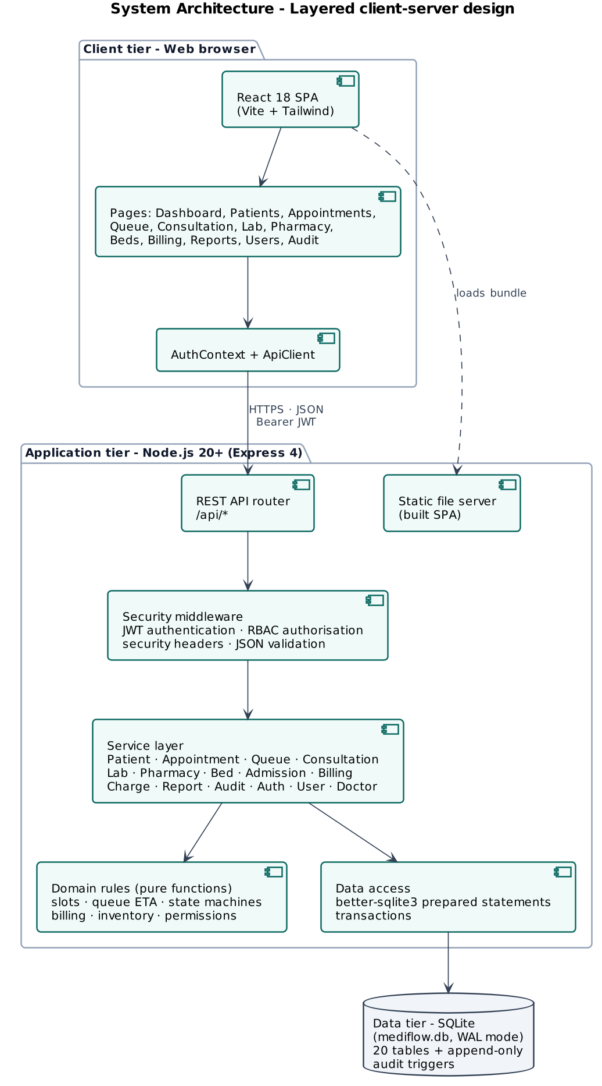
Figure 2. Layered system architecture
Table 27. Architectural layers
Layer | Responsibility | Implementation
Presentation | Screens, navigation by role, forms with client-side validation, charts, printing | client/src, 18 page components, shared UI kit, AuthContext, ApiClient
API / controller | HTTP routing, JSON parsing, authentication, authorisation, error mapping to status codes | server/routes/index.js, server/middleware/auth.js, server/app.js
Service | Use-case logic and transactions, orchestrates rules, data access and audit | server/services/*.js (15 services)
Domain rules | Pure, side-effect-free business rules. Slots, conflicts, queue ETA, state machines, billing, inventory, permissions | server/domain/*.js (unit-tested in isolation)
Data access | Connection, schema, prepared statements, transactions, constraints and triggers | server/db/connection.js, schema.sql, seed.js

1.1 Design decisions and rationale
Table 28. Key design decisions
Decision | Rationale
Web SPA + REST API | Works on any device with a browser, no installation at workstations, the API can later serve a mobile app or integrations.
Business rules as pure functions | Rules such as slot validation, ETA and bed-day allocation are deterministic and testable without a database (NFR-06). A frozen clock makes time-based rules reproducible.
SQLite with WAL and transactions | Zero-administration database suitable for one hospital server and for marking/demonstration. ACID transactions guarantee multi-step operations (NFR-04).
Constraints in the schema as well as in code | Defence in depth. Unique partial indexes stop double bed allocation and double active admissions even under concurrent requests.
JWT + server-side sessions | Stateless verification with the ability to revoke on logout or deactivation (FR-04, FR-06).
Charges as an intermediate ledger | Clinical modules only record billable events. Billing turns them into invoices. This decouples modules and prevents missed charges.
Append-only audit log | Accountability required by O7, enforced by database triggers so even direct SQL cannot alter history.

1.2 Deployment view
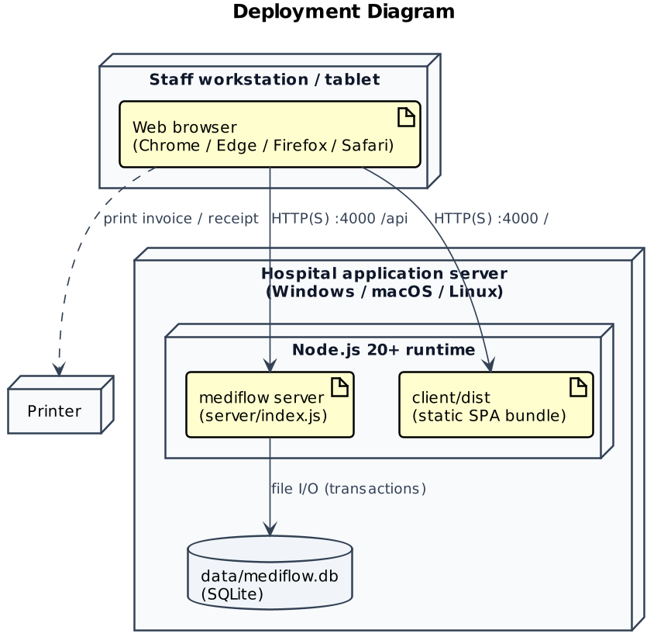
Figure 3. Deployment diagram
The public demonstration uses the same single-server design. One Node.js web service on Render's cloud serves both the built React app and the REST API with an embedded SQLite database, at mediflow-hms-6vw1.onrender.com. Render builds it from the GitHub repository (render.yaml) and redeploys on every push. HTTPS is terminated by Render's proxy, matching the reverse-proxy setup recommended for production.
The prototype consists of about 3,577 lines of server code in 39 files, 5,497 lines of client code in 29 files and 2,582 lines of automated tests.

2. Module / Component Description
The system is decomposed into thirteen functional modules. Each module owns its screens, service, rules and tables, and communicates with other modules only through service calls and shared identifiers (patient, appointment, admission, charge).
Table 29. Module / component description
Module | Responsibility | UI pages | Services / rules | Tables | FRs
Authentication & Access Control | Login/logout, JWT sessions, account lock-out, role permissions, route guards | Login, Layout (role menu) | AuthService, auth middleware, authRules, permissions | users, sessions | FR-01 to FR-04
User Administration | Create users, (de)activate, reset passwords, role-permission matrix view | Users & Roles | UserService | users | FR-05, FR-06
Patient Management | Registration with unique ID, validation, duplicate detection, search, edit, history | Patients, Patient detail | PatientService, patientRules | patients | FR-07 to FR-12
Doctor & Department | Doctor profiles, schedules, fees, departments, free-slot calculation | Doctors | DoctorService, appointmentRules | doctors, departments | FR-13 to FR-15
Appointments | Book, reschedule, cancel, no-show, filters, 4-step booking wizard | Appointments | AppointmentService, appointmentRules | appointments | FR-15 to FR-20
Smart Queue | Check-in tokens, queue board, ETA, urgent priority, call next | Queue Board | QueueService, queueRules | appointments, consultations | FR-21 to FR-25
Consultation & Records | Vitals, diagnosis, notes, follow-up, prescription builder, lab ordering, history | Consultation | ConsultationService, ChargeService | consultations, prescriptions, prescription_items | FR-26 to FR-30
Laboratory | Worklist, sample collection, result entry, abnormal flag, cancellation | Laboratory | LabService, labRules | lab_tests, lab_orders | FR-31 to FR-34
Pharmacy & Inventory | Medicine master, restock, alerts, dispensing | Pharmacy | PharmacyService, inventoryRules | medicines, prescriptions | FR-35 to FR-37
Admission, Bed & Discharge | Bed board, admit, transfer, bed status, discharge request, clearance, override | Beds & Admissions, Admission detail | BedService, AdmissionService, bedStateMachine, admissionRules | wards, beds, admissions, bed_stays | FR-38 to FR-43
Billing & Payments | Pending charges, invoices, discounts, payments, receipts, printing | Billing, Invoice detail, Print views | BillingService, ChargeService, billingRules | charges, invoices, payments | FR-44 to FR-47
Dashboard & Reports | Role-aware KPIs, 7-day trends, management reports, CSV export | Dashboard, Reports | ReportService | (read-only aggregates) | FR-48, FR-49
Audit Trail | Append-only log of every state change. Search & filter | Audit Trail | AuditService | audit_logs (+ triggers) | FR-50

2.1 Cross-cutting components
- Authentication middleware verifies the JWT, checks that the session is not revoked or expired and that the account is active, and attaches the user (with role and doctor id) to the request.
- Authorisation, authorize(permission…) checks the role-permission matrix (Section 8). The UI hides menus the role cannot use, but the server is the authority.
- Validation, zod schemas and domain validators return HTTP 400 with field-level messages that the UI shows next to the inputs.
- Error handling, a central handler maps errors to consistent JSON. 400 validation, 401 unauthenticated, 403 forbidden, 404 not found, 409 business-rule conflict, 423 account locked, 500 unexpected.
- ChargeService, a shared ledger used by Consultation, Laboratory, Pharmacy and Admission modules to create billable events.
- AuditService, called by every service after a successful state change. Scrubs credential-like fields.
- Clock, a single time source that tests can freeze.

3. Database Design (optional)
Database design is not required by the assignment. It is included briefly because the class diagram maps directly to the relational schema. The data model has 20 tables in third normal form. Status columns are constrained by CHECK clauses that mirror the state diagrams in Section 7.
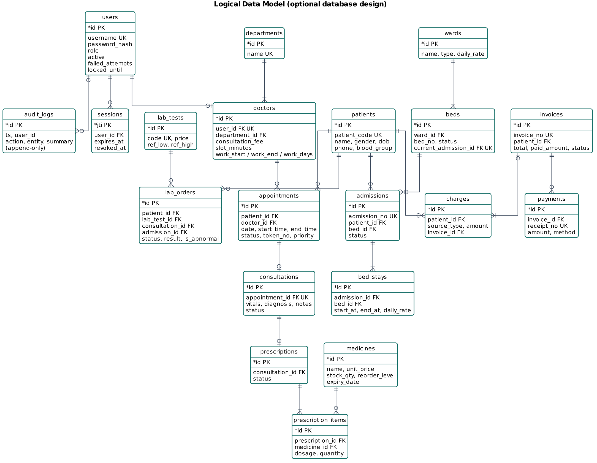
Figure 4. Logical data model (crow's-foot notation)

4. Class Diagram
The domain class diagram (Figure below) shows the main entities, their attributes, operations and associations with multiplicities. A patient books many appointments. Each appointment has at most one consultation, which may produce one prescription (composed of items referencing medicines) and several lab orders. Wards are composed of beds. An admission is composed of one or more bed stays (one per bed occupied), which is how transfers and bed-day billing are modelled. Charges aggregate into invoices, which own payments.
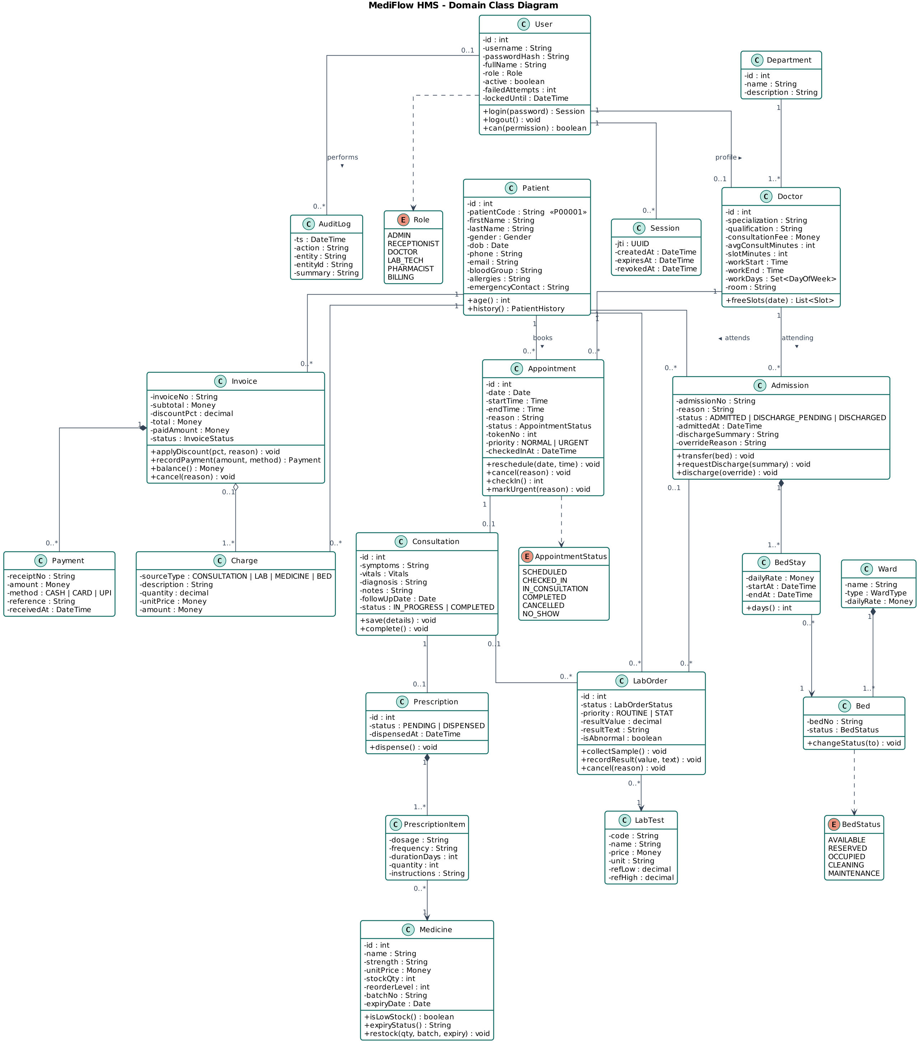
Figure 5. Domain class diagram
The design class diagram shows how the implementation realises the domain. Controllers delegate to services, services use pure rule modules and the data-access layer, and cross-cutting services (Charge, Audit) are shared.
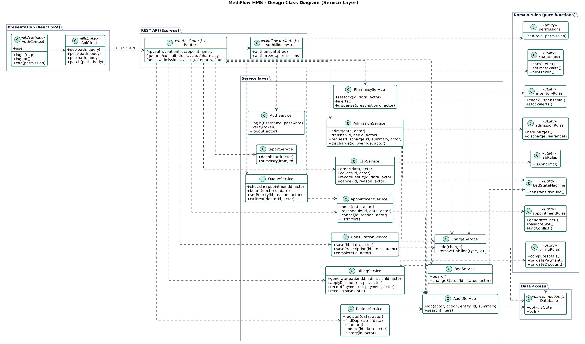
Figure 6. Design class diagram (service layer and dependencies)

5. Use Case Diagram
Because a single diagram with six actors and forty use cases is unreadable, the use-case model is split into four diagrams. These are an overview (Part A, Section 4.3), outpatient care, inpatient care & billing, and administration & access control. «include» marks behaviour that always happens as part of the base use case, while «extend» marks optional behaviour.
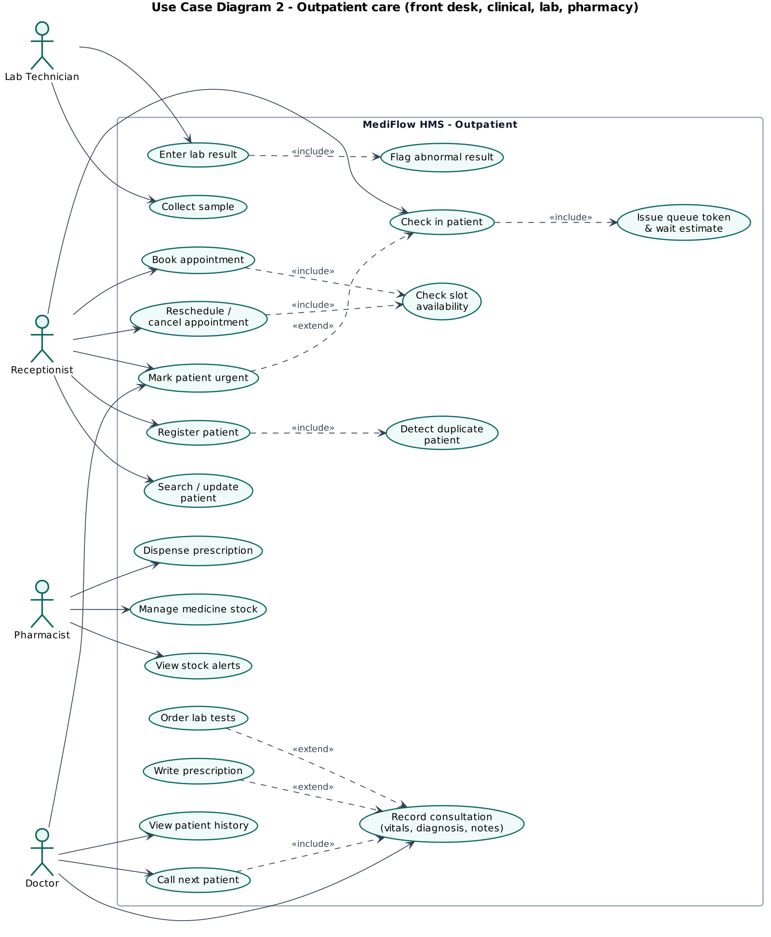
Figure 7. Use case diagram (outpatient care)
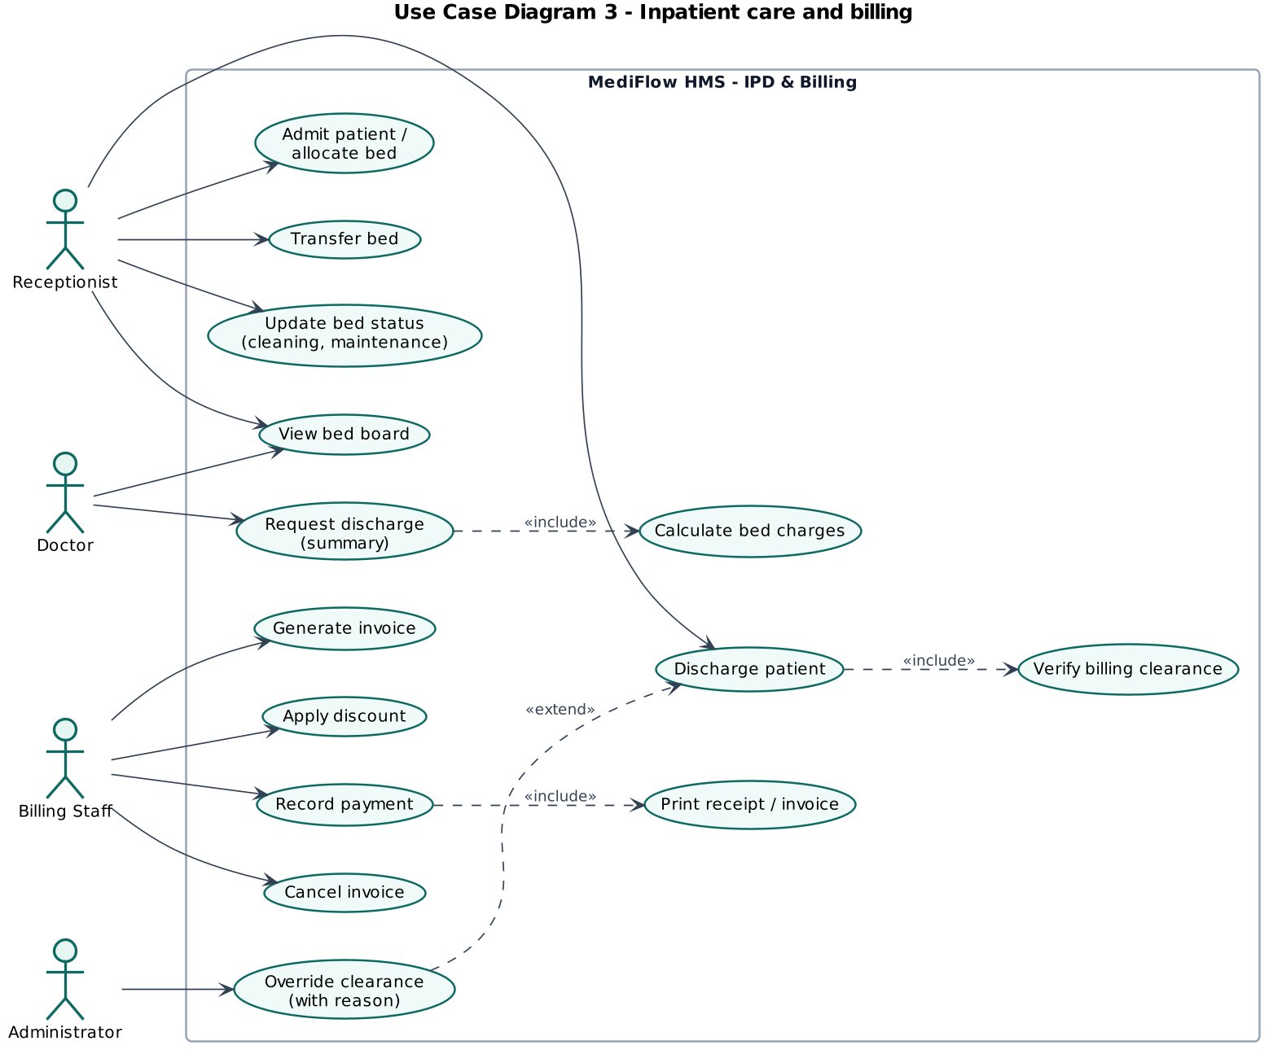
Figure 8. Use case diagram (inpatient care and billing)
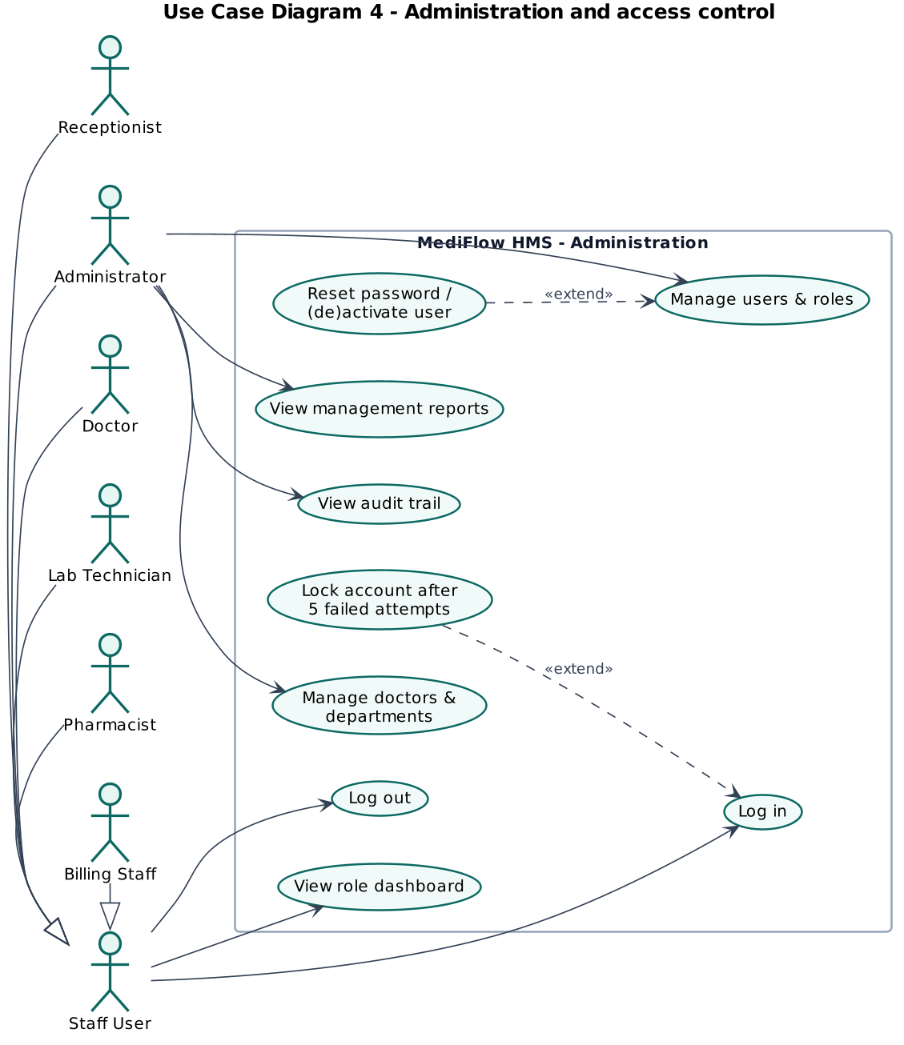
Figure 9. Use case diagram (administration and access control)

5.1 Use case specifications
Table 30. Use case specification UC-01 (Book appointment)
UC-01 | Book appointment
Primary actor(s) | Receptionist
Requirements | FR-15 to FR-17
Pre-condition | Receptionist is logged in, patient is registered, doctor works on the chosen date.
Main success scenario | 1. Receptionist opens Appointments → Book appointment.  2. Selects the patient (search by name / ID / phone).  3. Chooses department and doctor, the system shows fee, room and hours.  4. Chooses a date, the system displays all slots marked free, booked or past.  5. Selects a free slot, enters the reason and confirms.  6. System validates the slot, checks doctor and patient overlaps, saves the appointment as SCHEDULED and writes an audit entry.
Alternative flows | 5a. Slot was taken meanwhile → HTTP 409 DOCTOR_SLOT_TAKEN. The wizard refreshes the slots.  5b. Patient already has an overlapping appointment → HTTP 409 PATIENT_DOUBLE_BOOKED.  4a. Date is a non-working day → no slots are offered.
Post-condition | Appointment exists in SCHEDULED state and blocks the slot.
Table 31. Use case specification UC-02 (Check in patient and manage queue)
UC-02 | Check in patient and manage queue
Primary actor(s) | Receptionist (primary), Doctor
Requirements | FR-21 to FR-25
Pre-condition | Appointment is SCHEDULED for today.
Main success scenario | 1. Receptionist clicks Check in for the appointment.  2. System assigns the next token for the doctor and sets CHECKED_IN.  3. Queue board shows the patient with position and ETA.  4. Doctor clicks Call next patient.  5. System picks the first patient (URGENT first, then by check-in time), sets IN_CONSULTATION and opens a consultation record.
Alternative flows | 2a. Appointment is not for today → HTTP 400.  3a. Patient deteriorates → receptionist/doctor marks URGENT with a mandatory reason (audited). Patient moves to the front.  4a. Doctor already has a consultation in progress → HTTP 409.
Post-condition | Patient is in consultation, others' ETA is recalculated.
Table 32. Use case specification UC-03 (Conduct consultation)
UC-03 | Conduct consultation
Primary actor(s) | Doctor
Requirements | FR-26 to FR-29
Pre-condition | A consultation is IN_PROGRESS for the doctor.
Main success scenario | 1. Doctor records vitals, symptoms, diagnosis, notes and follow-up date and saves.  2. Adds medicines (dosage, frequency, duration, quantity auto-calculated) and saves the prescription.  3. Orders lab tests (ROUTINE or STAT). Charges are created.  4. Clicks Complete consultation.  5. System checks the diagnosis, sets the consultation and appointment COMPLETED and adds the consultation-fee charge.
Alternative flows | 1a. Invalid vitals (e.g. BP “120-80”) → field error.  2a. Quantity ≤ 0 → validation error.  4a. Diagnosis missing → HTTP 400. Consultation stays open.
Post-condition | Visit completed, prescription PENDING at pharmacy, lab orders ORDERED, charges waiting for billing.
Table 33. Use case specification UC-04 (Discharge patient)
UC-04 | Discharge patient
Primary actor(s) | Doctor, Receptionist, Billing Staff, Administrator
Requirements | FR-42, FR-43
Pre-condition | Patient is ADMITTED.
Main success scenario | 1. Doctor requests discharge with a summary (≥ 10 characters).  2. System closes the bed stay, calculates bed-days and adds bed charges. Status DISCHARGE_PENDING.  3. Billing generates the admission invoice and records payment(s) until PAID.  4. Receptionist completes the discharge.  5. System verifies clearance, sets DISCHARGED and moves the bed to CLEANING.
Alternative flows | 4a. Charges not invoiced or balance outstanding → HTTP 409 BILLING_NOT_CLEARED.  4b. Emergency transfer. Administrator overrides with a reason. Discharge proceeds and a DISCHARGE_OVERRIDE audit entry records the outstanding amount.
Post-condition | Admission closed, bed in CLEANING until housekeeping marks it AVAILABLE.
Table 34. Use case specification UC-05 (Record payment)
UC-05 | Record payment
Primary actor(s) | Billing Staff
Requirements | FR-44 to FR-47
Pre-condition | Invoice exists and is UNPAID or PARTIALLY_PAID.
Main success scenario | 1. Billing staff opens the invoice and clicks Record payment.  2. Enters amount (defaults to balance), method and reference (for card/UPI).  3. System validates 0 < amount ≤ balance, stores the payment with a receipt number and updates the status.  4. Receipt is printed.
Alternative flows | 3a. Amount exceeds balance → HTTP 400 with the outstanding balance.  3b. Card/UPI without reference → HTTP 400.  3c. Invoice already PAID or CANCELLED → HTTP 400.
Post-condition | Invoice PARTIALLY_PAID or PAID, receipt available for printing.

6. Sequence Diagrams
The sequence diagrams show the interaction between actors, the React UI, the API layer, services, rule modules and the database for the four most important scenarios. Messages are numbered, alt/opt fragments show the error and override paths that are also covered by test cases.
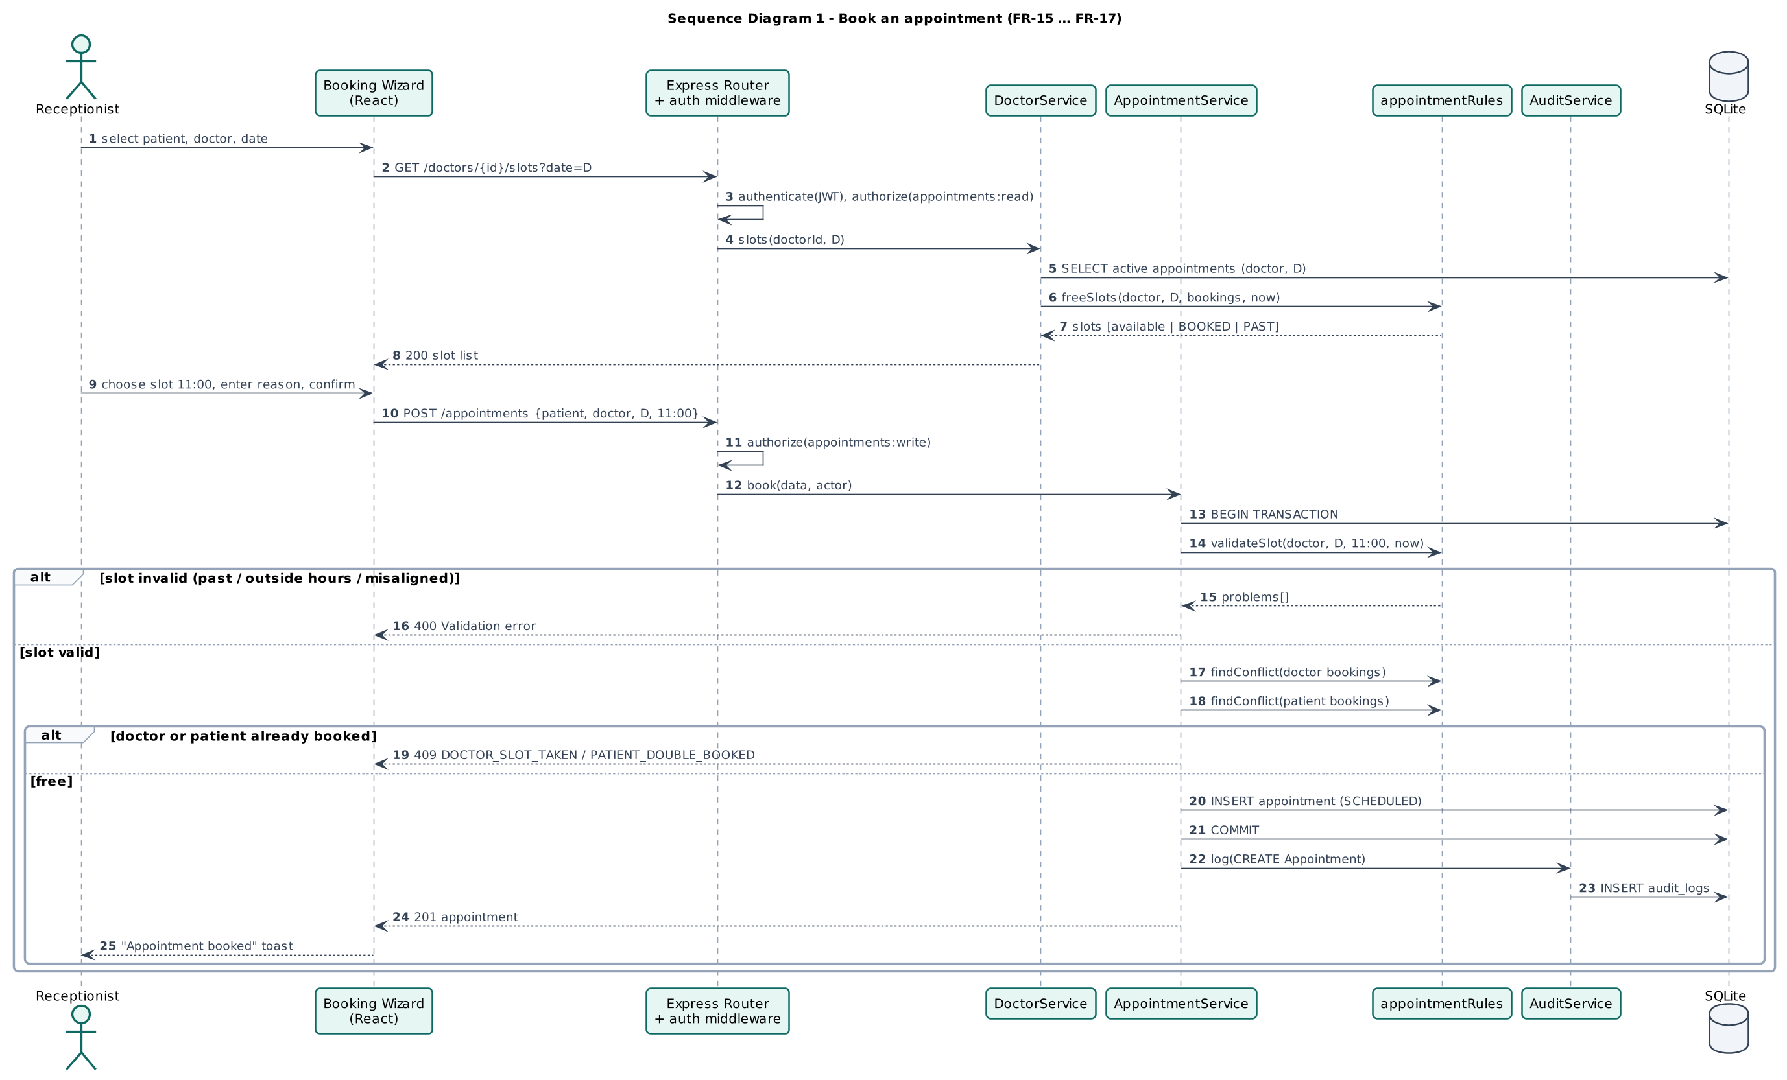
Figure 10. Sequence diagram (book an appointment)
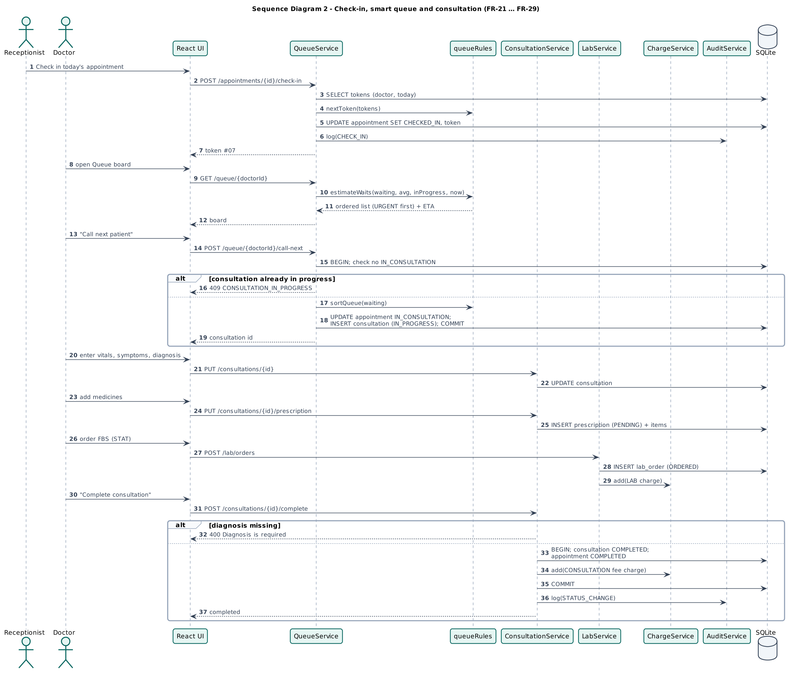
Figure 11. Sequence diagram (check-in, queue and consultation)
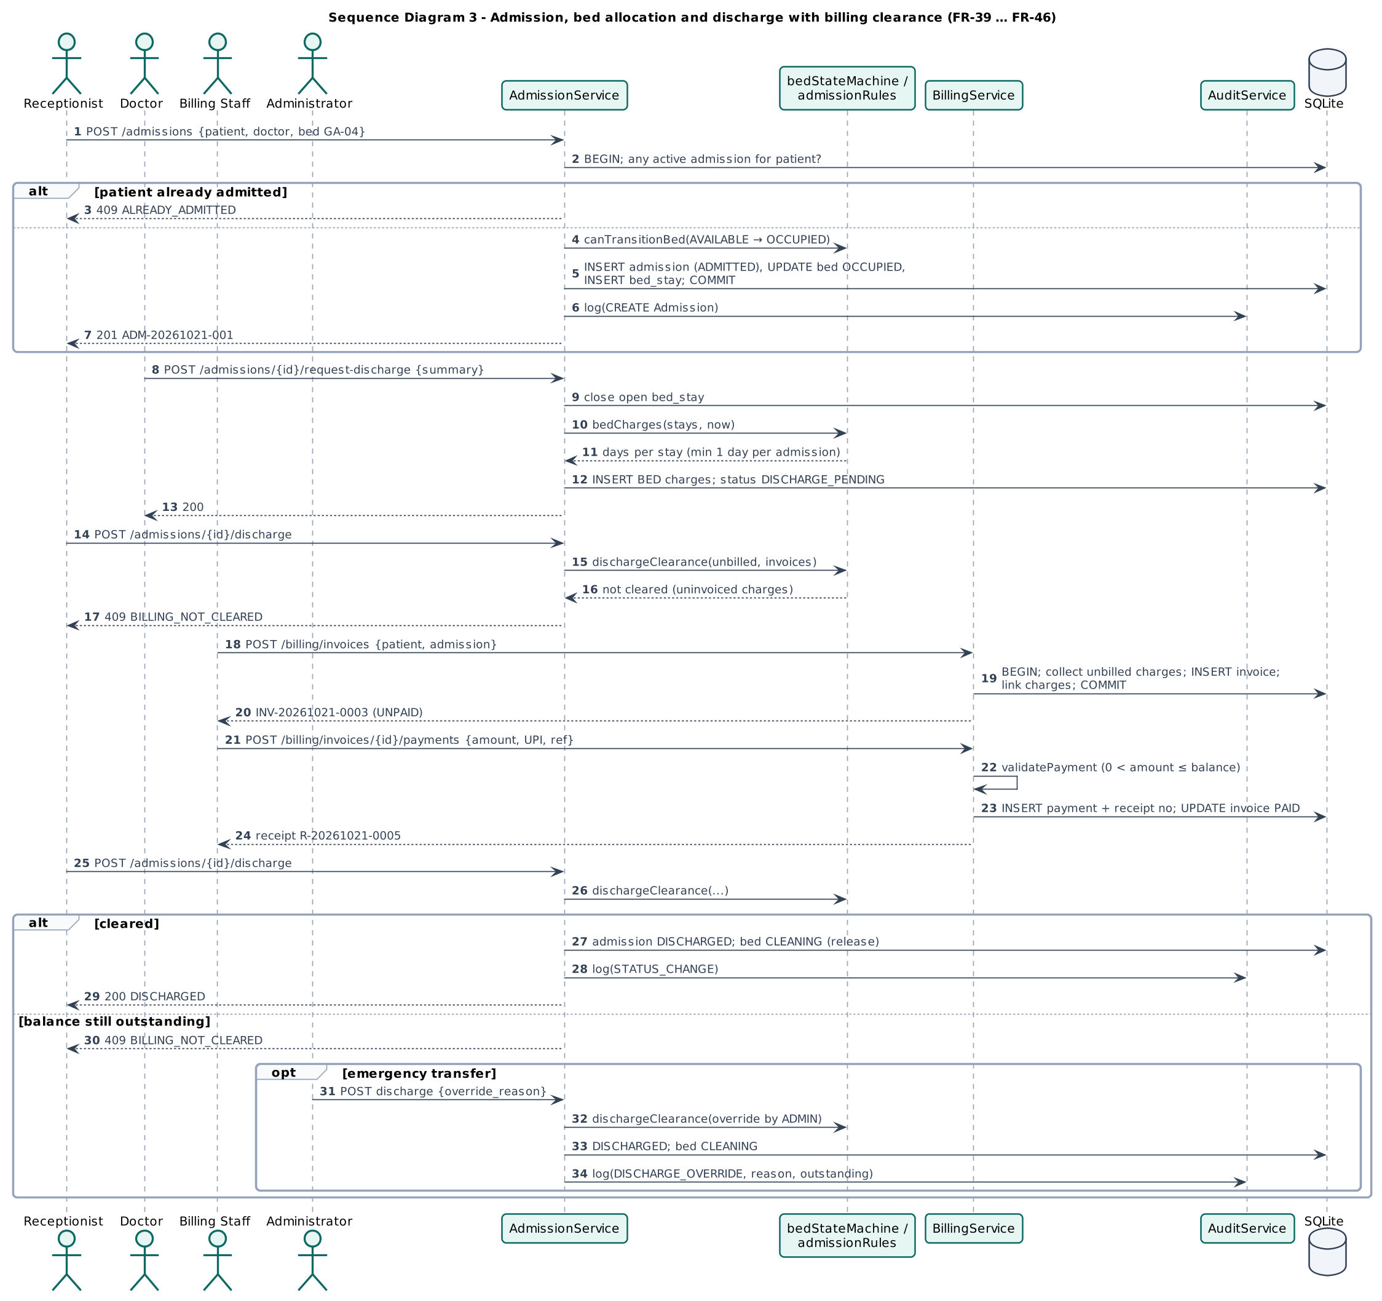
Figure 12. Sequence diagram (admission and discharge with billing clearance)
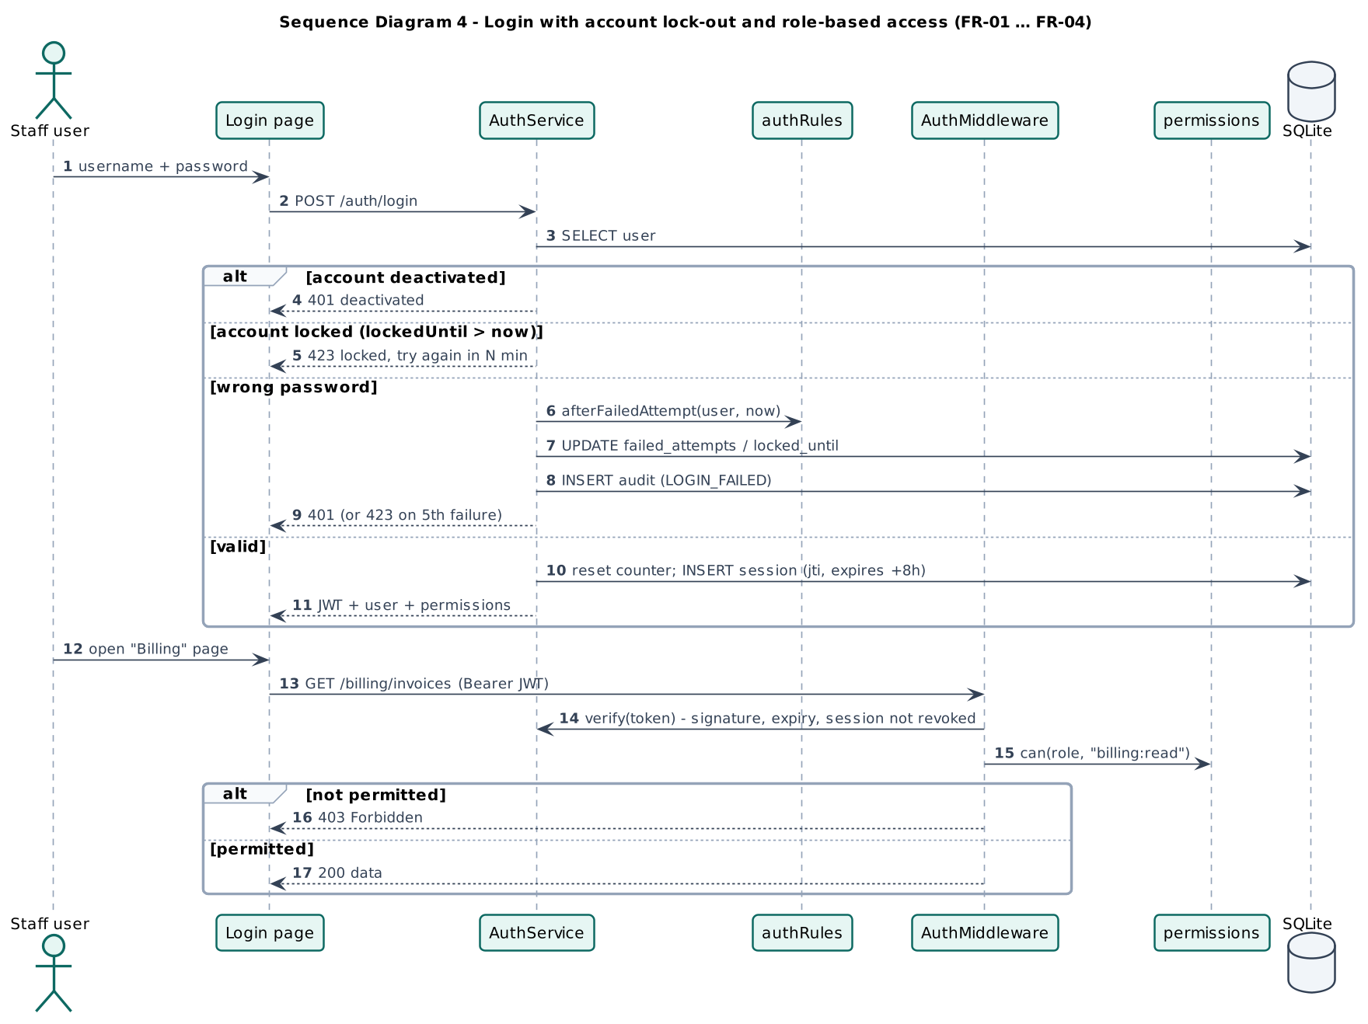
Figure 13. Sequence diagram (login, lock-out and role-based access)

7. State Diagrams
State diagrams are applicable to every entity with a life cycle. Transitions not shown are rejected by the system (HTTP 409), the same transition tables are implemented in server/domain/* and verified by unit tests UT-APT-10, UT-IPD-01/02/04, UT-LAB-01 and UT-BIL-06.
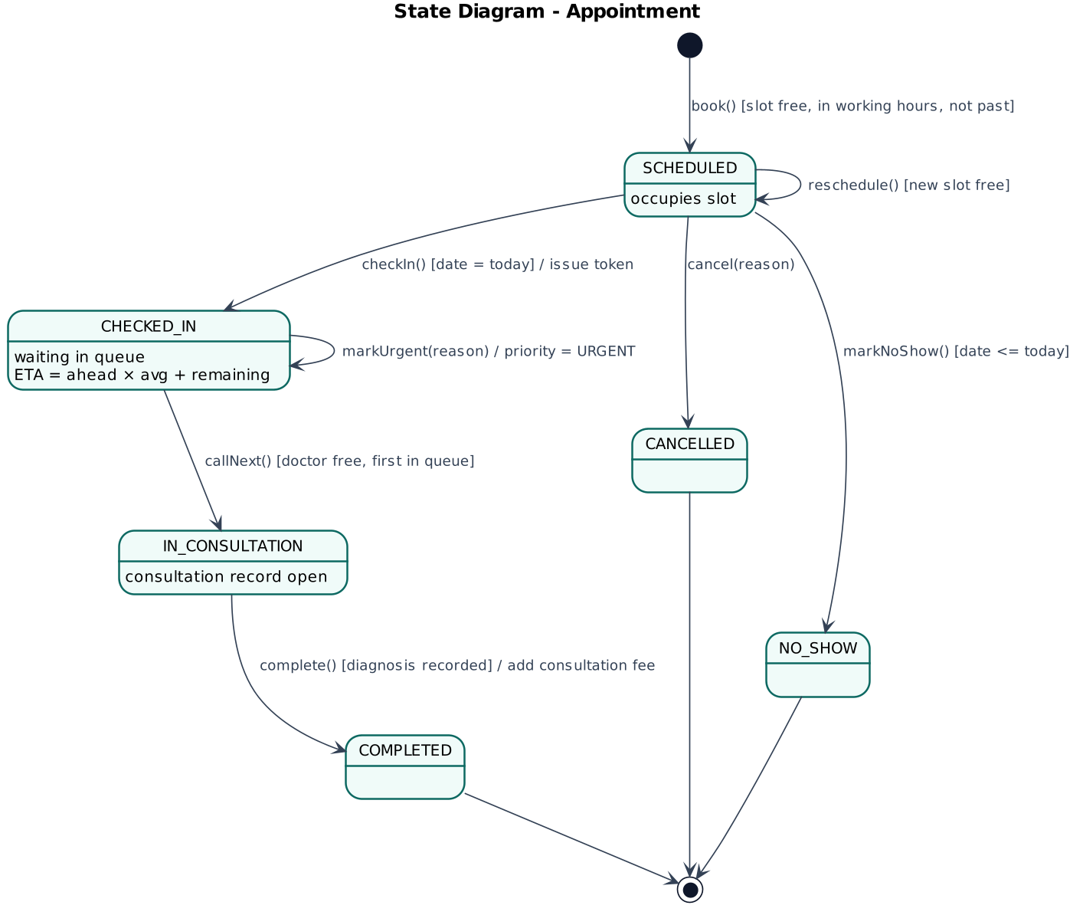
Figure 14. State diagram (Appointment)
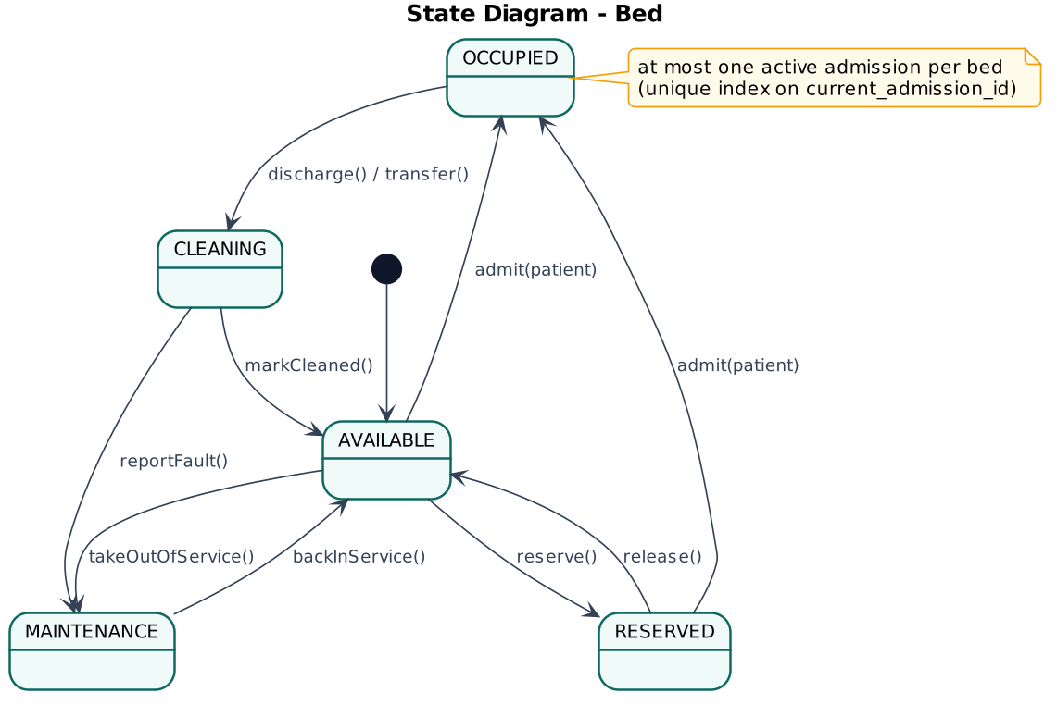
Figure 15. State diagram (Bed)
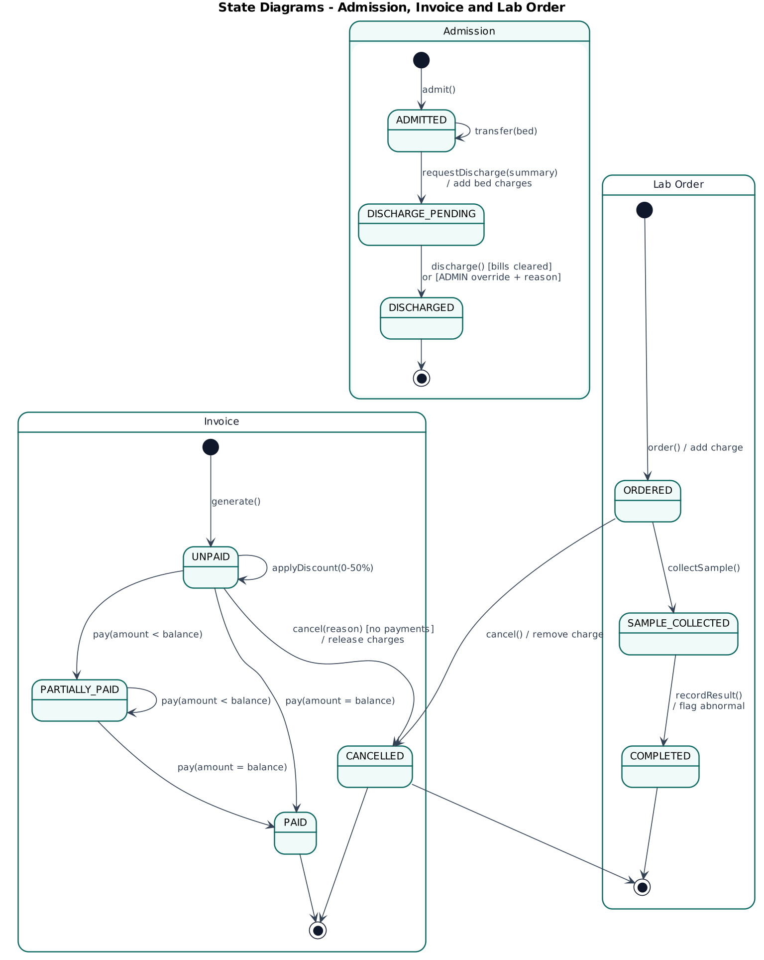
Figure 16. State diagrams (Admission, Invoice and Lab order)

7.1 Activity view of the outpatient journey
The activity diagram complements the state diagrams by showing how the responsibility for one patient visit passes between roles (swimlanes).
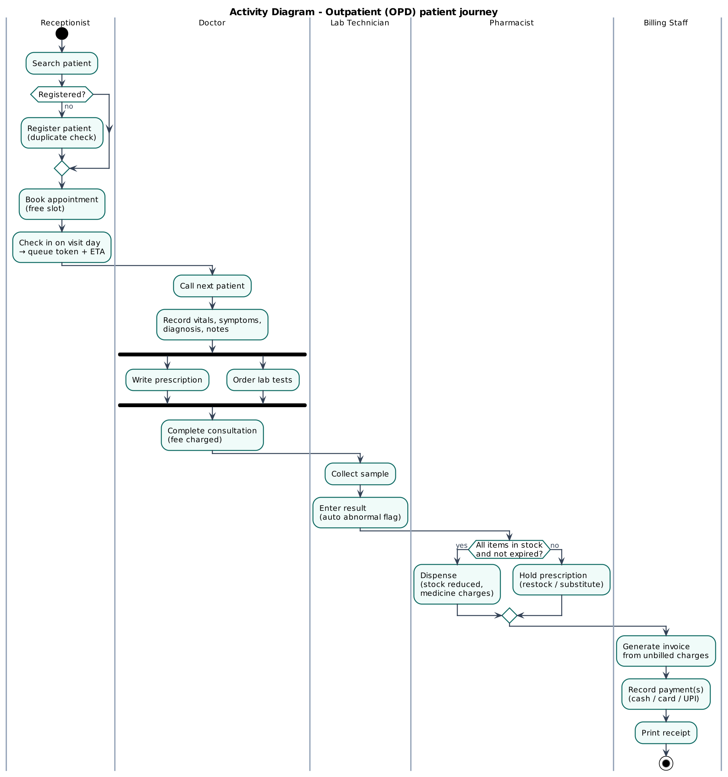
Figure 17. Activity diagram (outpatient journey across roles)

8. Security Design
- Authentication. Bcrypt password hashes (cost 10). JWT signed with HS256 valid 8 h, bound to a server-side session that is revoked on logout or deactivation, 5 failed attempts lock the account for 15 minutes. Generic error messages avoid username enumeration.
- Authorisation. Least-privilege role-permission matrix enforced on every API route. Doctors may act only on their own queue and consultations. Clinical notes are hidden from non-clinical roles.
- Input handling. Schema validation on every write. Parameterised SQL only (no string concatenation). JSON body limit 1 MB. Security headers (nosniff, frame-deny, no-referrer).
- Integrity and accountability. Transactions for multi-step updates. Unique and check constraints, append-only audit log with triggers.
Table 35. Role to permission matrix (generated from server/domain/permissions.js)
Permission | Admin | Recep. | Doctor | Lab | Pharm. | Billing
dashboard.read | ✔ | ✔ | ✔ | ✔ | ✔ | ✔
users.manage | ✔ | n/a | n/a | n/a | n/a | n/a
doctors.read | ✔ | ✔ | ✔ | ✔ | ✔ | ✔
doctors.manage | ✔ | n/a | n/a | n/a | n/a | n/a
patients.read | ✔ | ✔ | ✔ | ✔ | ✔ | ✔
patients.write | ✔ | ✔ | n/a | n/a | n/a | n/a
clinical.read | ✔ | n/a | ✔ | n/a | n/a | n/a
appointments.read | ✔ | ✔ | ✔ | n/a | n/a | n/a
appointments.write | ✔ | ✔ | n/a | n/a | n/a | n/a
queue.read | ✔ | ✔ | ✔ | n/a | n/a | n/a
queue.checkin | ✔ | ✔ | n/a | n/a | n/a | n/a
queue.priority | ✔ | ✔ | ✔ | n/a | n/a | n/a
consultation.write | n/a | n/a | ✔ | n/a | n/a | n/a
lab.read | ✔ | n/a | ✔ | ✔ | n/a | n/a
lab.order | n/a | n/a | ✔ | n/a | n/a | n/a
lab.process | n/a | n/a | n/a | ✔ | n/a | n/a
pharmacy.read | ✔ | n/a | ✔ | n/a | ✔ | n/a
pharmacy.manage | n/a | n/a | n/a | n/a | ✔ | n/a
prescriptions.read | ✔ | n/a | ✔ | n/a | ✔ | n/a
prescriptions.dispense | n/a | n/a | n/a | n/a | ✔ | n/a
beds.read | ✔ | ✔ | ✔ | n/a | n/a | n/a
beds.manage | ✔ | ✔ | n/a | n/a | n/a | n/a
admissions.read | ✔ | ✔ | ✔ | n/a | n/a | ✔
admissions.write | ✔ | ✔ | n/a | n/a | n/a | n/a
admissions.request-discharge | n/a | n/a | ✔ | n/a | n/a | n/a
admissions.override | ✔ | n/a | n/a | n/a | n/a | n/a
billing.read | ✔ | n/a | n/a | n/a | n/a | ✔
billing.write | n/a | n/a | n/a | n/a | n/a | ✔
reports.read | ✔ | n/a | n/a | n/a | n/a | n/a
audit.read | ✔ | n/a | n/a | n/a | n/a | n/a

9. User Interface Design
The interface uses a consistent layout. A role-filtered sidebar, a top bar with global patient search and the user's role, page headers with primary actions, cards, tables and colour-coded status badges (green = available/paid/completed, amber = waiting/pending, red = occupied/unpaid/urgent). Forms validate on the client and show server messages next to the relevant field. The screenshots below were captured automatically by the system tests on the running application.
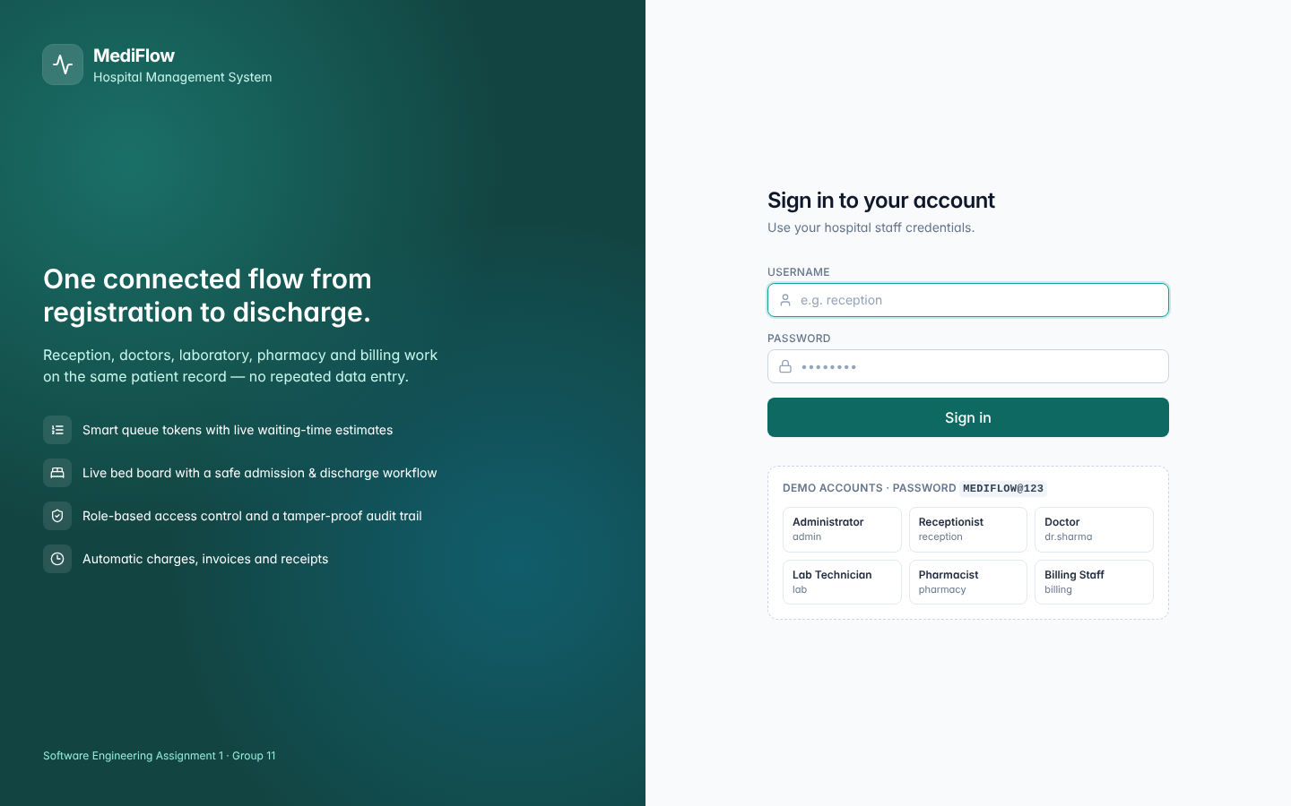
Figure 18. Login screen with demo accounts
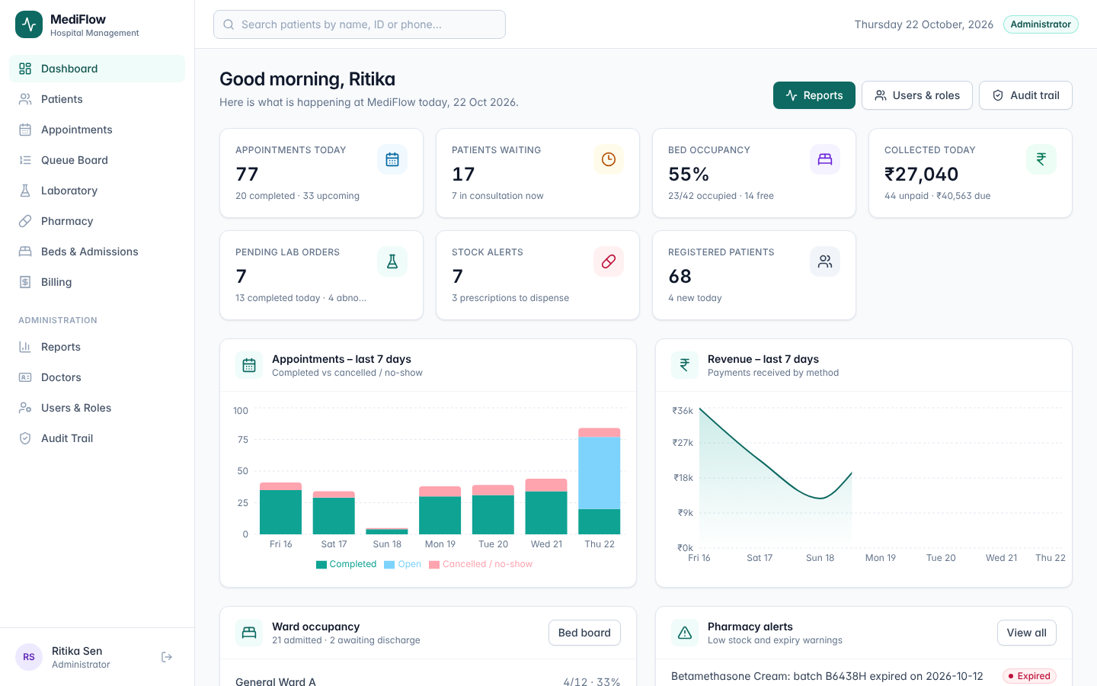
Figure 19. Administrator dashboard (KPIs, 7-day trends, ward occupancy, pharmacy alerts)
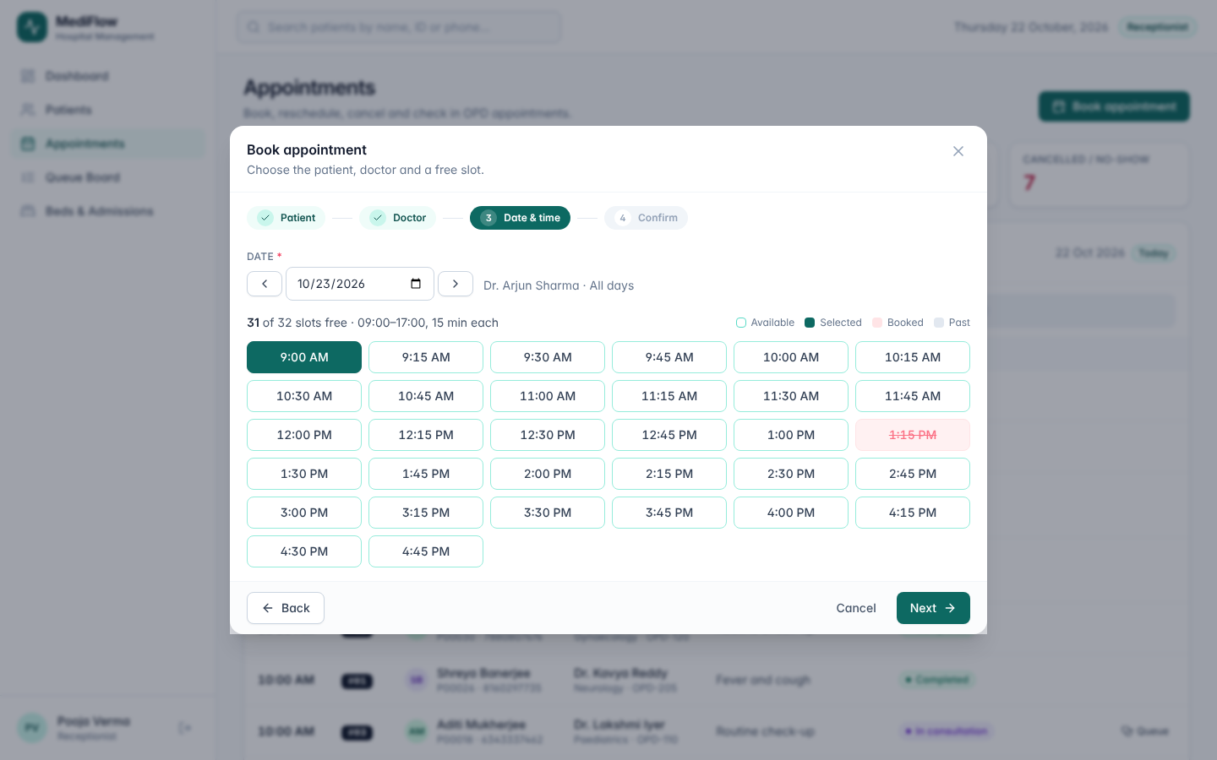
Figure 20. Appointment booking wizard with free / booked / past slots
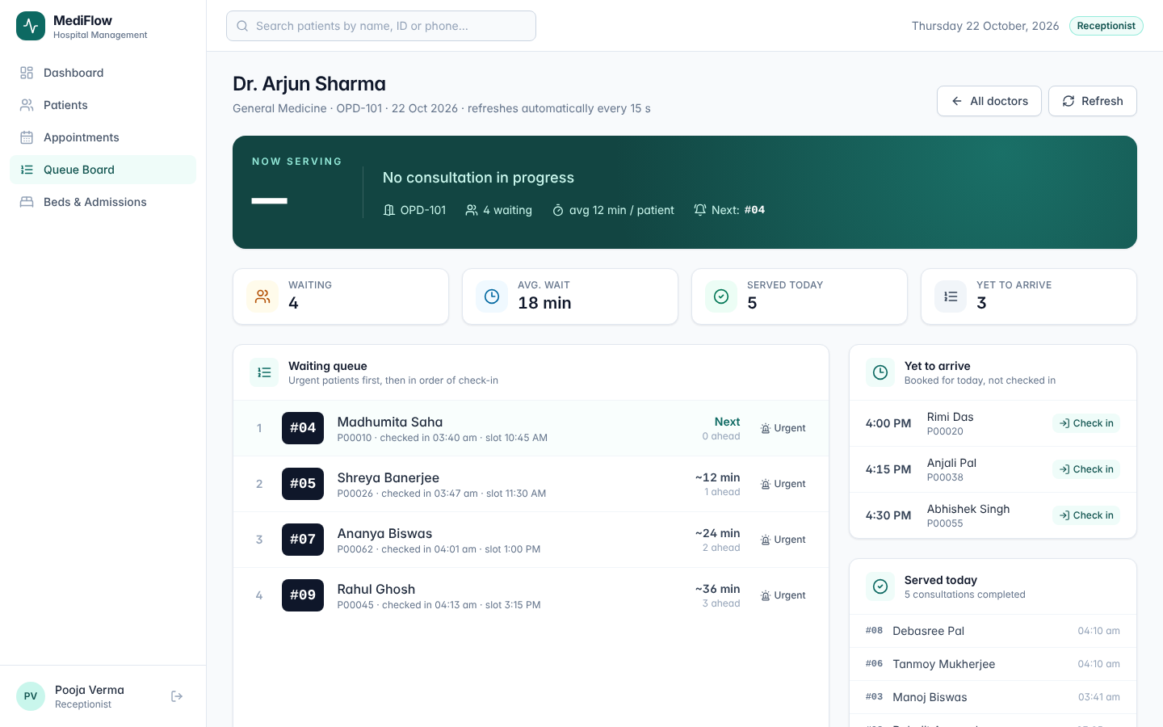
Figure 21. Queue board (now serving, waiting list with tokens, urgent flag and ETA)
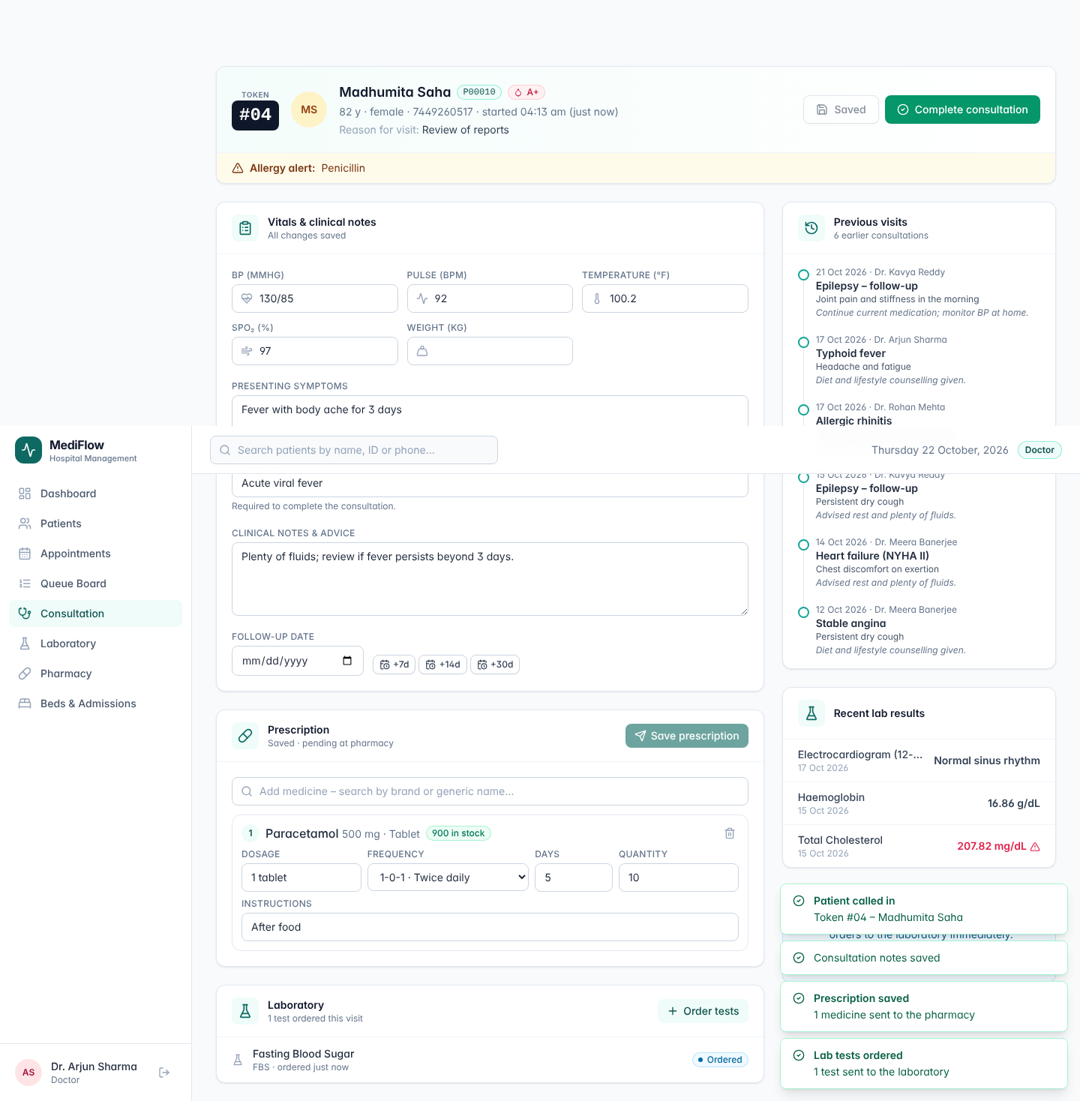
Figure 22. Doctor consultation workspace (vitals, diagnosis, prescription and lab orders)
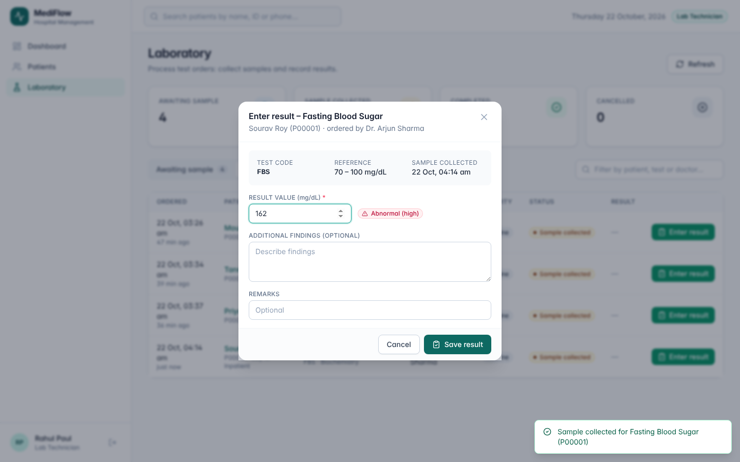
Figure 23. Laboratory result entry with automatic abnormal flag
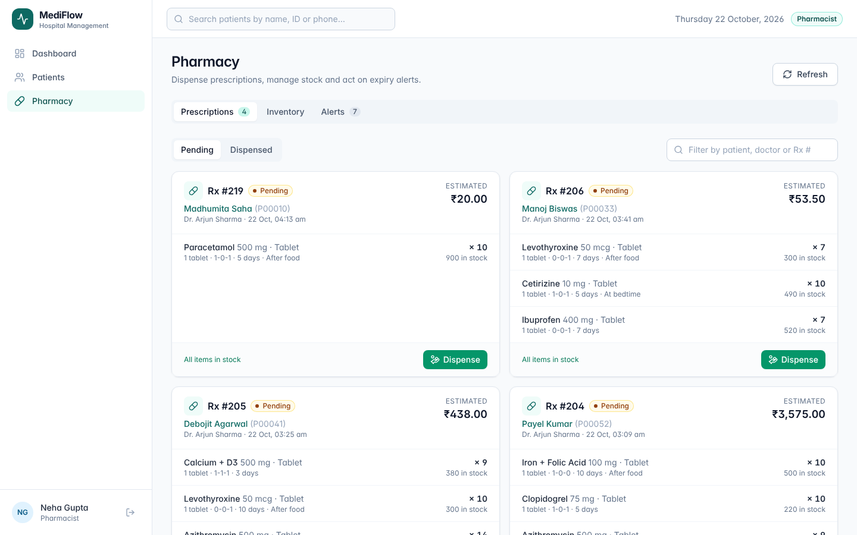
Figure 24. Pharmacy, prescriptions with stock check (undispensable item blocked)
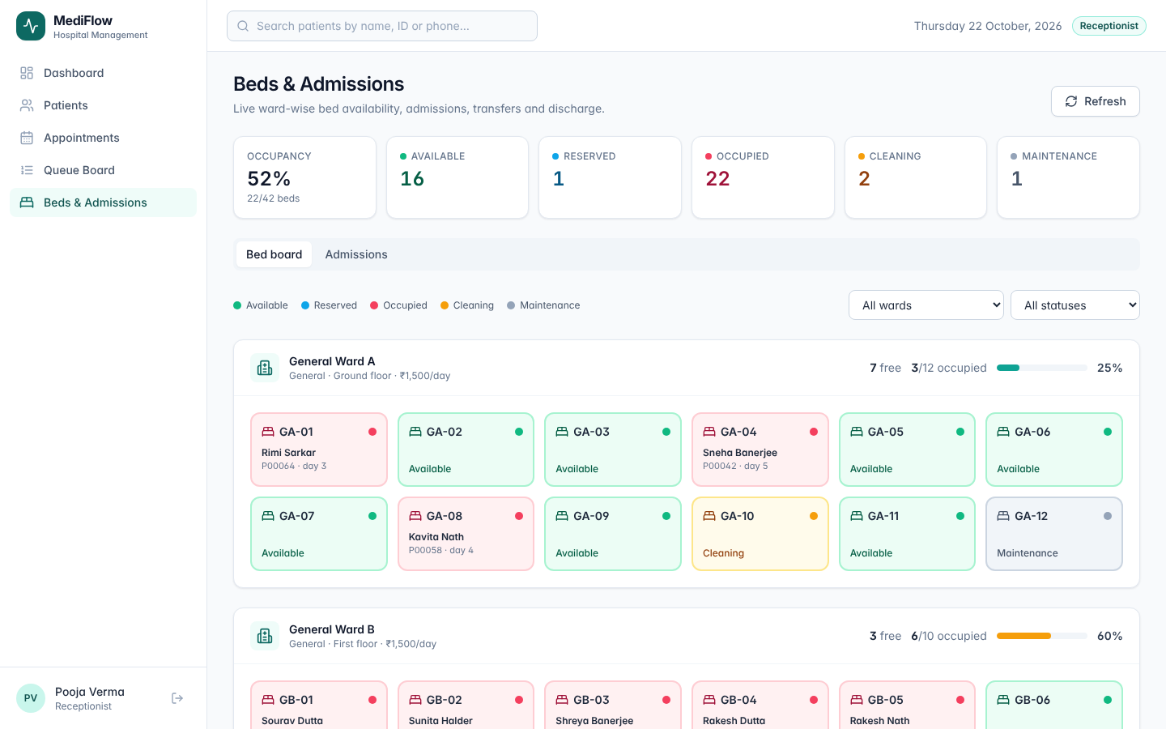
Figure 25. Live bed board colour-coded by status
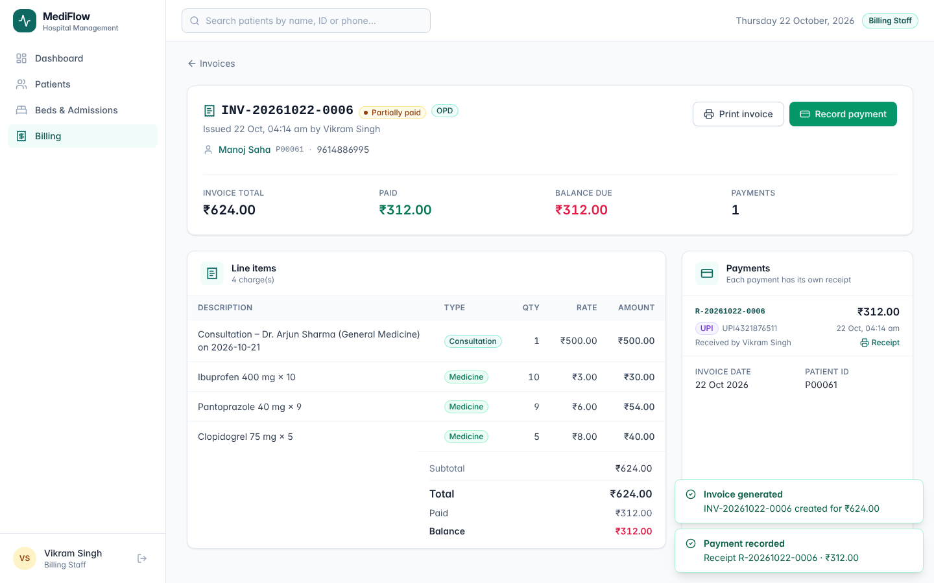
Figure 26. Invoice with line items, discount, payments and balance
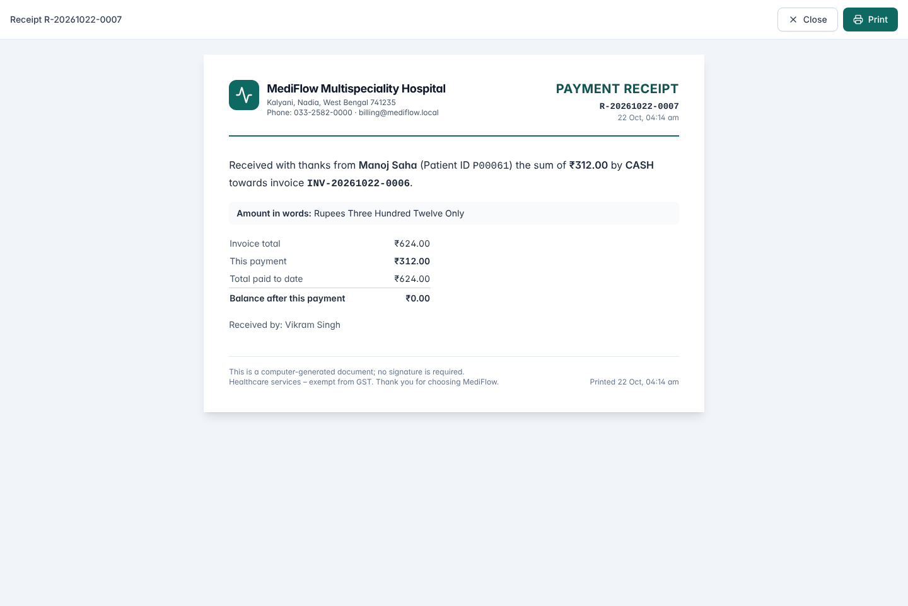
Figure 27. Printable payment receipt
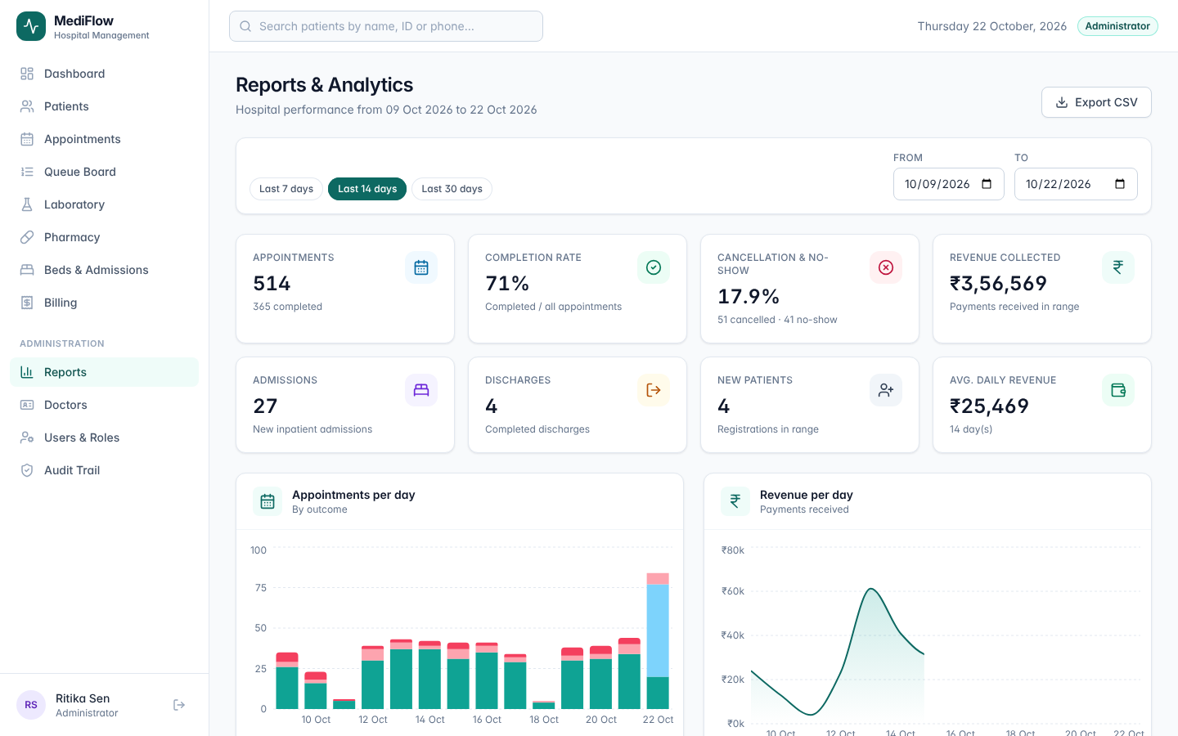
Figure 28. Management reports for a date range
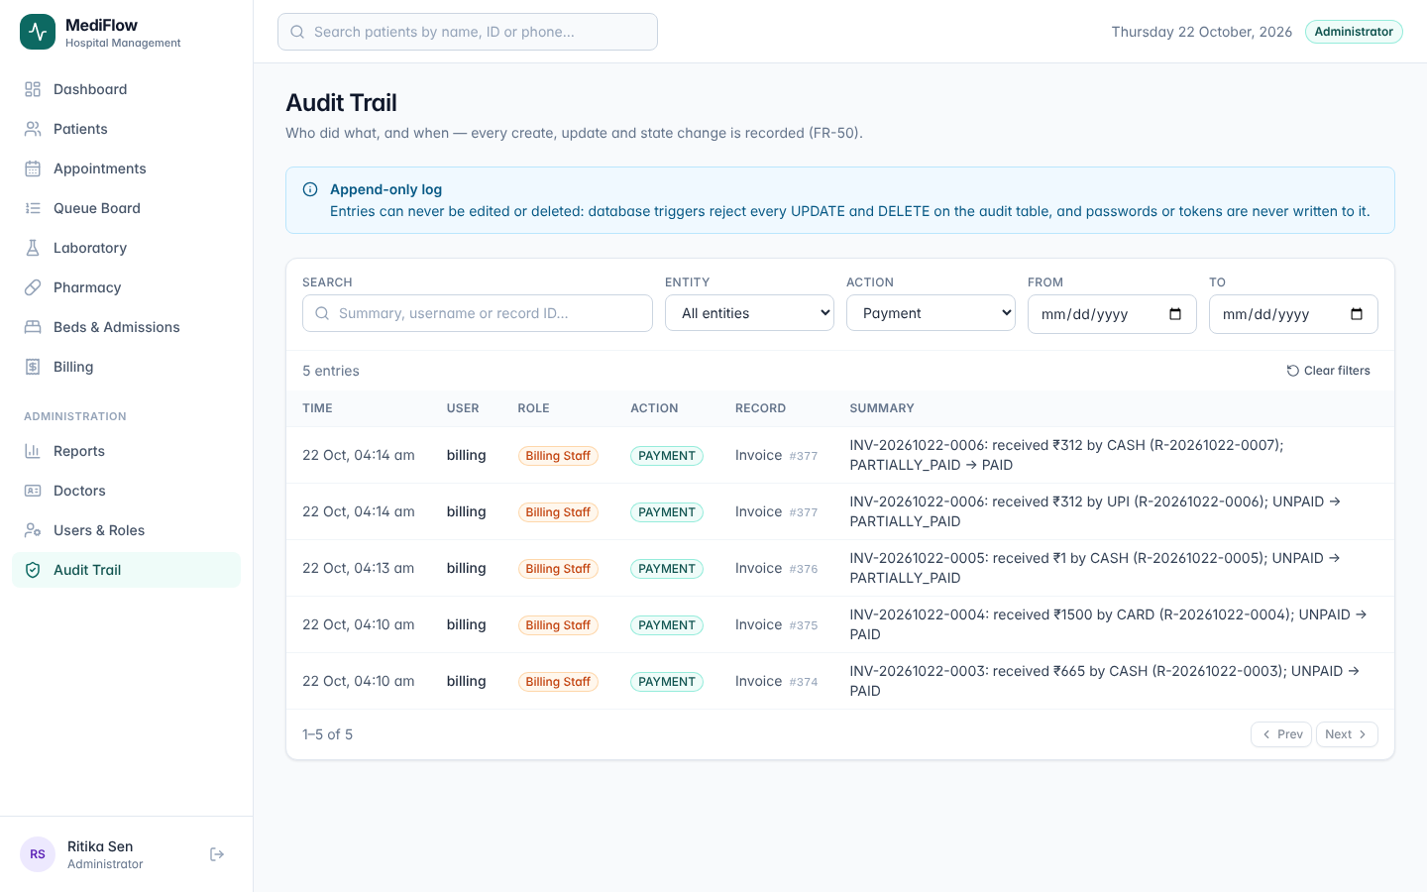
Figure 29. Append-only audit trail
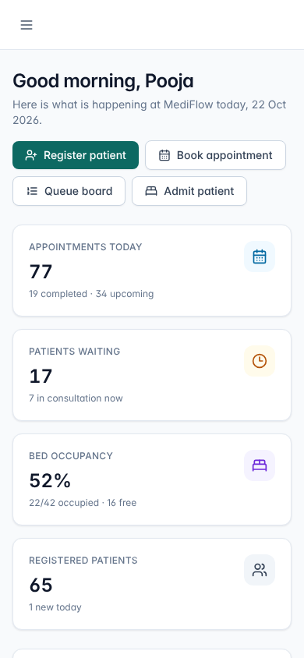
Figure 30. Responsive layout at 390 px (phone)
The module list in this part covers all 50 functional requirements. Appendix A traces each one to its module, screen and test cases.

PART C. SOFTWARE TEST PLAN
This plan follows the structure of IEEE 829 / ISO/IEC/IEEE 29119-3. Test cases are automated and carry the identifier of the requirement they verify, so the plan, the test report and the traceability matrix are generated from the same source.

1. Testing Objectives
- Verify that each of the 50 functional requirements (FR-01 to FR-50) and the measurable non-functional requirements (NFR-01 to NFR-08) are correctly implemented.
- Verify every business rule (BR-01 to BR-12), especially the boundary conditions (slot limits, 5th failed login, 50% discount, 30-day expiry window, payment equal to balance, minimum one bed-day).
- Verify that invalid input and invalid state transitions are rejected with clear messages and without corrupting data (negative testing).
- Verify role-based access control. Every role can perform its tasks and is denied everything else.
- Validate, from the users' point of view, the complete outpatient and inpatient journeys (acceptance).
- Find, record, fix and re-test defects, and provide objective evidence (actual results) for the evaluation of the system.

2. Testing Scope

2.1 In scope
- All thirteen modules listed in Part B, Section 2, through the REST API and through the user interface.
- Business rules and state machines (appointment, bed, admission, lab order, invoice).
- Security. Authentication, lock-out, token tampering/expiry, logout revocation, RBAC, SQL-injection resistance, password storage, audit integrity.
- Performance of typical API requests on the demo dataset (NFR-01) and responsive layout at phone width (NFR-05).
- Data integrity of multi-step operations (transactions) and printing views (invoice, receipt).

2.2 Out of scope
- Load and soak testing at production scale (NFR-09, NFR-10), requires production hardware.
- Automated cross-browser testing on Firefox and Safari (only Chromium is automated, other browsers are a release-candidate activity).
- Penetration testing by an independent party, accessibility audit (WCAG) and usability testing with real hospital staff.
- Third-party integrations, which are out of the product scope (payment gateway, lab analysers, SMS).

3. Testing Strategy
Testing follows the V-model. Each development artefact has a matching test level, and higher levels are executed only when the lower level passes. All tests are automated so that the whole suite can be re-run after every change (regression testing).
Table 36. Test levels (V-model)
Level | Verifies | Scope and approach | Tool | Cases | Exit criterion
Unit | Detailed design (rules) | Pure domain-rule functions in server/domain (slots, conflicts, queue ETA, state machines, billing, inventory, patient validation, lock-out, permissions) | Vitest 3 | 50 | 100% pass
Integration | Architecture & module interfaces | REST API → middleware → services → SQLite (in-memory schema, frozen clock) for every module, NFR security/performance checks and robustness probes with invalid, boundary and malicious input (IT-EDGE-*) | Vitest + Supertest | 92 | 100% pass
System | SRS (FR + NFR) | Complete application in a real browser. Built SPA + API + fresh demo database, one test per module workflow, plus a crawl of every screen for all six roles at desktop and phone width (ST-UI-*) | Playwright (Chromium) | 14 | 100% pass
Acceptance | User requirements | End-to-end business scenarios across several roles, validating the user requirements (UR-01 … UR-14) | Playwright (Chromium) | 5 | 100% pass

3.1 Test design techniques
Table 37. Test design techniques
Technique | Where it is applied (examples)
Equivalence partitioning | Valid / invalid mobile numbers, genders, blood groups, payment methods (UT-PAT-02, UT-BIL-05).
Boundary value analysis | Lab reference limits 69/70/100/145 (UT-LAB-02). Reorder level 21/20/0 (UT-PHA-01), expiry at 30/31 days (UT-PHA-02). Discount 50% vs 60% (UT-BIL-02, IT-BIL-02), payment equal to balance vs +₹0.01 (UT-BIL-04), 4th vs 5th failed login (UT-AUTH-01), 1 h, 24 h, 25 h, 48 h stays (UT-IPD-03).
State-transition testing | Valid and invalid transitions of appointment, bed, admission, lab order and invoice (UT-APT-10, UT-IPD-01/02/04, UT-LAB-01, IT-LAB-02, IT-IPD-05).
Decision tables | Discharge clearance. Uninvoiced charges × outstanding balance × role × override reason (UT-IPD-07, IT-IPD-07/08/09).
Use-case / scenario testing | Booking, queue, consultation, dispensing, admission-to-discharge, billing (ST-*, AT-*).
Error guessing & security | Forged/expired tokens, SQL injection strings, double submission, malformed JSON (IT-AUTH-05, IT-NFR-01, IT-NFR-04, IT-PHA-05).

3.2 Test environment
Table 38. Test environment
Item | Configuration
Hardware | Linux x86-64 container, 2 vCPU, 7 GB RAM (comparable to a mid-range laptop)
Software | Node.js v24.21.0, SQLite 3, Chromium 141 (Playwright), Vitest 3.2, Supertest 7
Unit / integration data | Fresh in-memory SQLite database per test file loaded with reference data (8 doctors, 12 lab tests, 26 medicines, 5 wards / 42 beds, 6 patients), clock frozen at Wed 21-Oct-2026 10.00 IST for deterministic results. Bcrypt cost lowered to 4 for speed
System / acceptance data | Fresh demo database generated at server start. 64 patients, ~600 appointments over 14 days, ~380 invoices, 20 active admissions, real wall-clock time
Performance data | Demo database (IT-NFR-03) to 200 mixed API requests

3.3 Entry and exit criteria
- Entry. Requirements baselined with IDs. Code builds without errors, database schema creates successfully, test data generator runs.
- Exit. 100% of planned test cases executed. All test cases pass, no open defect of severity Critical or High. Every FR covered by at least one passing test. Domain-rule line coverage ≥ 80%.
- Suspension. The build fails or more than 20% of a suite fails because of an environment problem. Resumption. The cause is fixed and the full suite is re-run.

3.4 Defect management
Every failure is analysed first. If the test script or test data was wrong, the test is corrected and the incident is recorded in the run log (it is not a product defect). Product defects are logged with ID, severity, priority, steps to reproduce, expected and actual behaviour, root cause and resolution, and follow the life cycle New → Assigned → Fixed → Re-tested → Closed (or Deferred with justification). Each fixed defect is protected by a regression test referenced in the defect log.
Table 39. Defect severity levels (priority P1 = fix immediately … P4 = next release)
Severity | Definition
Critical | System unusable, data loss or security breach. No workaround.
High | A main function produces wrong results (e.g. wrong bill) or is blocked. Workaround is difficult.
Medium | Function works with a wrong or confusing detail. Workaround exists.
Low | Cosmetic, wording or minor usability issue.

3.5 Roles, schedule and deliverables
Table 40. Test activities and responsibilities
Activity | Responsibility | Output
Test planning and design | Test lead with requirements owner | This test plan, test case catalogue embedded in the test code
Unit & integration test implementation | Developers of each module | tests/unit, tests/integration
System & acceptance test implementation | Test engineer acting as end users of each role | tests/e2e, screenshots
Execution and defect logging | Test engineer | Run log, actual results, defect log
Re-testing and regression | Developers + test engineer | Updated run log
Test summary report | Test lead | Part D of this document

3.6 Risks and mitigations
Table 41. Test risks
Risk | Mitigation
Time-dependent rules (slots in the past, queue ETA, bed-days, session expiry) make tests flaky. | Central clock that tests freeze. E2E tests book only for the next day and use seeded same-day appointments.
Shared database between E2E tests causes order dependence. | Each E2E test creates or looks up its own data through the API before acting in the UI. Fresh database for every run.
Tests written by the same team that wrote the code share its blind spots. | Boundary and negative cases derived from the requirements, not from the code, exploratory walkthroughs by members not involved in the module.
Short project schedule. | Full automation. The complete regression suite runs in about two minutes.

4. Unit Testing
Objective. Verify each business rule in isolation. Approach. White-box tests of the pure functions in server/domain, applying boundary-value and state-transition techniques. No database or network is involved, so each test runs in milliseconds. Coverage. Domain-rule modules 99.2% lines / 85.9% branches. Whole server 95.45% lines / 84.15% branches (unit + integration suites, V8 coverage).
Table 42. Unit test coverage by module
Module under test | Rules verified | Cases
appointmentRules, time | Slot generation, working days, slot validation, overlap detection, free slots, appointment transitions | 11
queueRules | Priority ordering, token sequence, ETA with and without consultation in progress | 5
bedStateMachine, admissionRules | Bed transitions, bed-days, proportional allocation after transfer, discharge clearance | 7
billingRules, money | Totals and discount rounding, discount limits, payment validation, invoice status, number formats | 8
labRules, inventoryRules | Lab transitions, abnormal flag, low stock, expiry window, dispensability, alerts | 7
patientRules, authRules, permissions | ID format, validation, duplicates, age, lock-out, password policy, RBAC matrix | 12

5. Integration Testing
Objective. Verify that the API, middleware, services, rule modules and database work together, including transactions, constraints and the audit log. Approach. Grey-box tests that send real HTTP requests to the Express application (Supertest) backed by a fresh in-memory SQLite database with the production schema. Users log in through the real login endpoint and act with their own tokens. Integration order is bottom-up. Rule modules were unit-tested first, then each service was integrated through its API. Each test checks the HTTP status, the response body and, where relevant, side effects such as charges, stock levels, bed status and audit entries.
Table 43. Integration test areas
Area | Interfaces exercised | Cases
Authentication & users | /auth/*, /users/*, login, lock-out, deactivation, token tampering, logout, RBAC, user admin | 10
Patients, doctors, appointments | /patients/*, /doctors/*, /appointments/* | 15
Smart queue | /appointments/{id}/check-in, /queue/* | 7
Consultation, laboratory, pharmacy | /consultations/*, /lab/*, /pharmacy/* incl. charge creation and atomic dispensing | 17
Admissions, beds, billing | /beds/*, /admissions/*, /billing/* incl. clearance and receipts | 18
Reports, audit, NFRs | /reports/*, /audit, SQL injection, password storage, headers, latency | 9
Robustness / edge cases | Impossible dates, malformed filters, wildcards, paging limits, over-long or wrong-type input, ownership and duplicate checks, sequence-number uniqueness, time-zone day boundaries | 16

6. System Testing
Objective. Verify the complete, integrated system against the SRS from the user interface. Approach. Black-box tests with Playwright driving a real Chromium browser against the production build served by the Node.js server with a freshly generated demo database. Each test logs in through the login form as the relevant role and performs a complete module workflow (e.g. book → check in → queue, generate invoice → partial payment → overpayment rejected → full payment → print receipt). Non-functional system checks include role-based menus and access-denied pages (security), responsive layout at 390 px (usability, NFR-05) and API latency (performance, NFR-01, measured in IT-NFR-03).
Table 44. System test cases
ID | System test
ST-APT-01 | Book an appointment for tomorrow with the 4-step wizard
ST-AUTH-01 | Login per role, role-based menus and blocked direct URLs
ST-BIL-01 | Generate an invoice, take a partial UPI payment, reject an overpayment, settle and print the receipt
ST-CON-01 | Doctor calls the next patient, records the consultation and completes it
ST-IPD-01 | Admit a patient from the bed board and transfer to another bed
ST-LAB-01 | Lab technician collects a sample and records an out-of-range result
ST-PAT-01 | Register a patient through the form with validation feedback
ST-PHA-01 | Pharmacist cannot dispense an out-of-stock prescription but dispenses a valid one
ST-QUE-01 | Check in today's appointment and see the token on the queue board
ST-RPT-01 | Administrator views dashboard, reports, users, doctors and the audit trail
ST-UI-01 | Every screen renders for every role at desktop width without errors
ST-UI-02 | All screens fit a 390 px phone without horizontal page scrolling
ST-UI-03 | Broken or unauthorised deep links show a clear message instead of crashing
ST-UI-04 | Double-clicking “Record payment” records only one payment

7. Acceptance Testing
Objective. Confirm that the system satisfies the user requirements (Part A, Section 7) and is ready for use. Approach. Scenario-based acceptance tests that follow a patient through several roles in one continuous flow, written from the acceptance criteria of the user stories. In this academic project the team acted as the hospital users. The scenarios are scripted and automated (Playwright) so that they are repeatable. A real deployment would add a supervised user-acceptance session with hospital staff and formal sign-off.
Table 45. Acceptance test scenarios
ID | Acceptance scenario | User requirements validated
AT-01 | OPD patient journey. Check-in → consultation → lab → pharmacy → billing | UR-02, UR-04, UR-05, UR-06, UR-07, UR-10
AT-02 | IPD journey. Admission → discharge request → billing clearance → discharge → bed turnaround | UR-08, UR-09, UR-10
AT-03 | Each role sees exactly the menus it is entitled to | UR-13
AT-04 | Usability. Booking in at most 4 steps and no horizontal scrolling on a 390 px phone
AT-05 | Administrator can trace the journeys in the audit trail | UR-14
Acceptance criteria. All acceptance scenarios pass. No open Critical/High defects, every user requirement UR-01 … UR-14 is validated by at least one acceptance or system test.

PART D. SOFTWARE TEST REPORT

8. Test Cases
This section lists every executed test case with its expected and actual result and pass/fail status. The actual result column is not typed by hand. Each automated test records what it observed (HTTP status, message, values) while running, and the report is generated from that log. The final execution took place on 22 Oct 2026, 04.15 am IST.

8.1 Unit test cases
Table 46. Unit test cases (50)
ID | Req. | Test case / input | Expected result | Actual result (recorded during execution) | Status
UT-APT-01 | FR-15 | Generates slots across the working day  Input. Doctor 09.00 to 17.00, 15-min slots, Wednesday | 32 slots, first 09.00 to 09.15, last 16.45 to 17.00 | 32 slots, first 09.00 to 09.15, last 16.45 to 17.00 | PASS
UT-APT-02 | FR-15 | No slots on a non-working day  Input. Doctor works Mon to Sat. Date is Sunday 2026-10-25 | Empty slot list, isWorkingDay = false | slots=0, isWorkingDay=false | PASS
UT-APT-03 | FR-16 | Rejects a time outside working hours  Input. Start 17.00 and 08.45 for a 09.00 to 17.00 doctor | Validation error "outside the doctor's working hours" | 17.00 → "Time is outside the doctor's working hours (09.00 to 17.00)", 08.45 → "Time is outside the doctor's working hours (09.00 to 17.00)" | PASS
UT-APT-04 | FR-16 | Rejects a time that is not on a slot boundary  Input. Start 09.07 with 15-minute slots | Validation error "must align to a 15-minute slot" | Time must align to a 15-minute slot | PASS
UT-APT-05 | FR-16 | Rejects booking a slot in the past  Input. Now = 21 Oct 10.00. Request 21 Oct 09.30 | Validation error "Cannot book a slot in the past" | Cannot book a slot in the past | PASS
UT-APT-06 | FR-16 | Accepts a valid future slot  Input. 21 Oct 11.15, doctor working | No validation problems | problems = [] | PASS
UT-APT-07 | FR-17 | Detects an overlapping active appointment  Input. Existing SCHEDULED 10.00 to 10.15. Request 10.00 to 10.15 | Conflict returned (appointment id 7) | conflict id = 7 | PASS
UT-APT-08 | FR-17, FR-18, FR-19 | Ignores cancelled bookings and the appointment being rescheduled  Input. CANCELLED 10.00 booking. SCHEDULED booking id 9 excluded | No conflict in both cases | cancelled → null, excluded self → null | PASS
UT-APT-09 | FR-17 | Adjacent slots do not overlap (half-open intervals)  Input. [10.00,10.15) vs [10.15,10.30) and [10.10,10.25) | false for adjacent, true for overlapping | adjacent=false, overlapping=true | PASS
UT-APT-10 | FR-19, FR-21, FR-25 | Appointment state machine allows only defined transitions  Input. SCHEDULED→CHECKED_IN, CHECKED_IN→IN_CONSULTATION, COMPLETED→SCHEDULED, CHECKED_IN→CANCELLED | true, true, false, false | true, true, false, false | PASS
UT-APT-11 | FR-15 | Free-slot list marks booked and past slots unavailable  Input. Now 10.00, booking at 10.30 | 09.45 PAST, 10.30 BOOKED, 10.45 available | 09.45=PAST, 10.30=BOOKED, 10.45 available=true | PASS
UT-AUTH-01 | FR-02 | Account locks on the 5th consecutive failed attempt  Input. failed_attempts 3 then 4, then one more failure | 4th failure. Not locked, 5th. Locked for 15 min | 4th → locked_until=null, 5th → locked for 15 min | PASS
UT-AUTH-02 | FR-02 | Lock expires after 15 minutes and the counter restarts  Input. locked_until = now+15 min, check at +14 and +16 min | locked, then unlocked, next failure counts as attempt 1 | +14 min locked=true. +16 min locked=false, next attempt count=1 | PASS
UT-AUTH-03 | FR-03, FR-30 | Role-permission matrix enforces least privilege  Input. clinical.read for RECEPTIONIST/DOCTOR, patients.write for BILLING, billing.write for ADMIN, audit.read for ADMIN | false, true, false, false, true | false, true, false, false, true, LAB_TECH has 5 permissions | PASS
UT-AUTH-04 | FR-05 | Passwords must have at least 8 characters  Input. "short" and "Mediflow@123" | Error, then null | Password must be at least 8 characters | ok | PASS
UT-BIL-01 | FR-44, FR-45 | Invoice totals with discount are rounded to paise  Input. Lines ₹500, ₹450.50, ₹284, discount 10% | Subtotal ₹1234.50, discount ₹123.45, total ₹1111.05 | subtotal 1234.5, discount 123.45, total 1111.05 | PASS
UT-BIL-02 | FR-45 | Discount must be 0 to 50% and only on UNPAID invoices  Input. 60% on UNPAID, −5% on UNPAID, 10% on PARTIALLY_PAID, 50% on UNPAID | error, error, error, ok | Discount must be between 0% and 50% | Discount must be between 0% and 50% | Discount can only be applied to an UNPAID invoice | ok | PASS
UT-BIL-03 | FR-46 | Payment amount must be greater than zero  Input. Amounts 0 and −50 (CASH) | Error "must be greater than zero" | Payment amount must be greater than zero | Payment amount must be greater than zero | PASS
UT-BIL-04 | FR-46 | Overpayment beyond the outstanding balance is rejected  Input. Outstanding ₹800, pay ₹800.01 and ₹800 | Error for ₹800.01. ₹800 accepted | 800.01 → "Payment exceeds the outstanding balance of ₹800.00", 800 → null | PASS
UT-BIL-05 | FR-46 | Rejects unknown methods and payments on PAID or CANCELLED invoices  Input. Method CHEQUE. PAID invoice. CANCELLED invoice | Three distinct errors | Payment method must be one of CASH, CARD, UPI | Invoice is already fully paid | Cannot pay a cancelled invoice | PASS
UT-BIL-06 | FR-46 | Invoice status follows payments  Input. Total ₹900 with paid ₹0, ₹300, ₹900 | UNPAID, PARTIALLY_PAID, PAID | UNPAID, PARTIALLY_PAID, PAID | PASS
UT-BIL-07 | FR-44, FR-47 | Invoice and receipt numbers follow the defined format  Input. Date 20261021, sequence 7 | INV-20261021-0007 and R-20261021-0007 | INV-20261021-0007, R-20261021-0007 | PASS
UT-BIL-08 | FR-44 | Money arithmetic avoids floating-point drift  Input. sum(0.1, 0.2) and round2(1.005) | 0.3 and 1.01 | 0.3, 1.01 | PASS
UT-IPD-01 | FR-41 | Bed state machine accepts every defined transition  Input. AVAILABLE→RESERVED→OCCUPIED→CLEANING→AVAILABLE, AVAILABLE↔MAINTENANCE, RESERVED→AVAILABLE | All transitions allowed | 9/9 allowed | PASS
UT-IPD-02 | FR-41 | Bed state machine rejects undefined transitions  Input. OCCUPIED→AVAILABLE, MAINTENANCE→OCCUPIED, CLEANING→OCCUPIED, manual AVAILABLE→OCCUPIED | All rejected | false, false, false, false | PASS
UT-IPD-03 | FR-42 | Bed days are rounded up with a 1-day minimum  Input. Stays of 1 h, 24 h, 25 h, 48 h | 1, 1, 2, 2 days | 1, 1, 2, 2 | PASS
UT-IPD-04 | FR-42, FR-43 | Admission life cycle allows only ADMITTED → DISCHARGE_PENDING → DISCHARGED  Input. ADMITTED→DISCHARGE_PENDING, DISCHARGE_PENDING→DISCHARGED, ADMITTED→DISCHARGED | true, true, false | true, true, false | PASS
UT-IPD-05 | FR-40, FR-42 | Same-day transfer does not create an extra minimum bed-day (DEF-05 regression)  Input. Ward A ₹1500 for 10 min, then Ward B ₹1500 for 5 h | Total 1 bed-day (₹1,500), not 2 | days = [0, 1], total ₹1500 | PASS
UT-IPD-06 | FR-42 | Bed-days are shared between stays in proportion to time spent  Input. ICU ₹8000 for 30 h then General ₹1500 for 20 h (50 h total) | 3 days total. ICU 2, General 1 → ₹17,500 | days = [2, 1], total ₹17500 | PASS
UT-IPD-07 | FR-43 | Discharge clearance requires settled bills unless an administrator overrides with a reason  Input. (a) ₹500 outstanding (b) all paid (c) admin override "Patient transferred to AIIMS" (d) receptionist override | blocked, allowed, allowed+overridden, blocked | a=false (outstanding ₹500), b=true, c=true/true, d=false | PASS
UT-LAB-01 | FR-32 | Lab order life cycle allows only defined transitions  Input. ORDERED→SAMPLE_COLLECTED, SAMPLE_COLLECTED→COMPLETED, ORDERED→COMPLETED, COMPLETED→CANCELLED | true, true, false, false | true, true, false, false | PASS
UT-LAB-02 | FR-33 | Numeric results outside the reference range are flagged abnormal (bounds inclusive)  Input. FBS 70 to 100 mg/dL with values 69, 70, 100, 145 | true, false, false, true | true, false, false, true | PASS
UT-LAB-03 | FR-33 | Text-only tests and non-numeric values are not auto-flagged  Input. Chest X-ray (no range), value "abc" for FBS | null (not applicable) in both cases | [null,null] | PASS
UT-PAT-01 | FR-07 | Patient IDs use the P + 5 digits format  Input. 1, 42, 12345 | P00001, P00042, P12345 | P00001, P00042, P12345 | PASS
UT-PAT-02 | FR-08 | Required fields and a valid 10-digit mobile number are enforced  Input. Empty names, phone "12345", gender "X" | Errors for first_name, last_name, phone, gender, dob | first_name, last_name, phone, gender, dob | PASS
UT-PAT-03 | FR-08 | Date of birth in the future is rejected  Input. DOB 2026-12-01 when today is 2026-10-21 | Error "Date of birth cannot be in the future" | Date of birth cannot be in the future | PASS
UT-PAT-04 | FR-09 | Duplicate detection matches phone+DOB or name+DOB (case-insensitive)  Input. Existing Riya Ghosh 1990-05-01 9876543210. Candidates with same phone, same name in caps, different DOB | Match, match, no match | 1, 1, 0 | PASS
UT-PAT-05 | FR-12 | Age is computed correctly around the birthday  Input. DOB 2000-10-21 and 2000-10-22 on 2026-10-21 | 26 and 25 | 26, 25 | PASS
UT-PAT-06 | FR-08 | Only real calendar dates are accepted  Input. 2026-02-28, 2028-02-29 (leap), 2026-02-30, 2026-13-01, 0000-00-00 | true, true, false, false, false | true, true, false, false, false | PASS
UT-PAT-07 | FR-08 | Mobile numbers typed in common formats are normalised to 10 digits  Input. "+91 98765 43210", "098765-43210", "(98765) 43210", "12345" | 9876543210 ×3, "12345" unchanged (later rejected) | 9876543210, 9876543210, 9876543210, 12345 | PASS
UT-PAT-08 | FR-10 | Paging values are clamped and search wildcards are escaped  Input. clampInt(-5,50,1,500), clampInt("abc",50,1,500), clampInt(99999,50,1,500), likeTerm("50%_off") | 1, 50, 500, "%50\%\_off%" | 1, 50, 500, %50\%\_off% | PASS
UT-PHA-01 | FR-36 | Low stock when quantity is at or below the reorder level  Input. Reorder level 20 with stock 21, 20, 0 | false, true, true | false, true, true | PASS
UT-PHA-02 | FR-36 | Expiry status uses a 30-day warning window  Input. Expiry 2026-10-20, 2026-11-20 (30 d), 2026-11-21 (31 d) | EXPIRED, NEAR_EXPIRY, OK | EXPIRED, NEAR_EXPIRY, OK | PASS
UT-PHA-03 | FR-37 | Dispensing is refused for insufficient stock, expired batches and invalid quantities  Input. Stock 3 & qty 5. Expired batch, qty 0 | Three errors, valid case returns null | Insufficient stock for Insulin Glargine. 3 available, 5 required | Insulin Glargine is expired and cannot be dispensed | Quantity must be a positive whole number | ok | PASS
UT-PHA-04 | FR-36 | Stock alerts list out-of-stock, low-stock, near-expiry and expired items  Input. 4 medicines in different states | Alert types OUT_OF_STOCK, LOW_STOCK, NEAR_EXPIRY, EXPIRED | EXPIRED, LOW_STOCK, NEAR_EXPIRY, OUT_OF_STOCK | PASS
UT-QUE-01 | FR-22, FR-24 | Queue orders URGENT first, then by check-in time  Input. A normal 09.01, B normal 09.05, C urgent 09.10 | Order C, A, B | C, A, B | PASS
UT-QUE-02 | FR-21 | Token numbers are sequential per doctor per day  Input. Existing tokens [] and [1,2,5] | 1 and 6 | 1 and 6 | PASS
UT-QUE-03 | FR-23 | Wait estimate without a consultation in progress  Input. 3 waiting, average 15 min, nobody in consultation | ETA 0, 15, 30 minutes | 0, 15, 30 | PASS
UT-QUE-04 | FR-23 | Wait estimate includes remaining time of current consultation  Input. 2 waiting, average 15 min, current consultation started 5 min ago | ETA 10 and 25 minutes | 10, 25 | PASS
UT-QUE-05 | FR-23 | Remaining time never drops below 1 minute when a consultation overruns  Input. Average 15 min, consultation running for 40 min | Remaining = 1 | remaining = 1 | PASS

8.2 Integration test cases
Table 47. Integration test cases (92)
ID | Req. | Test case / input | Expected result | Actual result (recorded during execution) | Status
IT-APT-01 | FR-16 | A valid appointment is booked in the SCHEDULED state  Input. Dr. Sharma, 2026-10-22 11.00 | 201, status SCHEDULED, end time 11.15 | 201 SCHEDULED 11.00 to 11.15 | PASS
IT-APT-02 | FR-16 | Bookings in the past or outside working hours are rejected  Input. Today 09.00 (now 10.00), tomorrow 18.00 | 400 "Cannot book a slot in the past", 400 "outside the doctor's working hours" | 400 "Cannot book a slot in the past", 400 "Time is outside the doctor's working hours (09.00 to 17.00)" | PASS
IT-APT-03 | FR-17 | Double-booking a doctor's slot is rejected with a clear message  Input. Another patient books Dr. Sharma 2026-10-22 11.00 | 409 DOCTOR_SLOT_TAKEN "Dr. Arjun Sharma already has an appointment at 11.00…" (no "Dr. Dr.") | 409 DOCTOR_SLOT_TAKEN "Dr. Arjun Sharma already has an appointment at 11.00 on 2026-10-22" | PASS
IT-APT-04 | FR-17 | A patient cannot be booked with two doctors at the same time  Input. Same patient, Dr. Banerjee 2026-10-22 11.00 (overlaps Sharma 11.00 to 11.15) | 409 PATIENT_DOUBLE_BOOKED | 409 PATIENT_DOUBLE_BOOKED "The patient already has an appointment at 11.00 on 2026-10-22" | PASS
IT-APT-05 | FR-18 | Rescheduling moves the booking and frees the old slot  Input. PATCH reschedule to 2026-10-22 12.30 | 200 new time 12.30, slot 11.00 available again | 200 → 12.30, 11.00 available=true | PASS
IT-APT-06 | FR-19 | Cancellation needs a reason and only applies to SCHEDULED appointments  Input. Cancel without reason, cancel with reason "Patient travelling". Cancel again | 400, 200 CANCELLED, 409 INVALID_STATE | 400 "reason. Cancellation reason is required", 200 CANCELLED, 409 INVALID_STATE | PASS
IT-APT-07 | FR-20 | Appointments can be filtered by date, doctor and status  Input. GET /appointments?date=2026-10-22&doctorId=sharma&status=CANCELLED | Only the cancelled appointment is returned | 1 row(s). #1 CANCELLED | PASS
IT-AUD-01 | FR-50, NFR-03 | State changes are audited with user and role, and passwords never appear  Input. Register patient, create user with password "Secret@999", then search the audit log | CREATE Patient by reception (RECEPTIONIST). CREATE User by admin, no entry contains "Secret@999" | patient entry. CREATE by reception (RECEPTIONIST), user entry. "Created LAB_TECH account "audit.user"", password leaked=false | PASS
IT-AUD-02 | FR-50 | The audit log is append-only at database level  Input. Direct SQL UPDATE and DELETE on audit_logs | Both rejected with "audit log is append-only" | UPDATE → "audit log is append-only". DELETE → "audit log is append-only" | PASS
IT-AUD-03 | FR-50, FR-03 | Only administrators can read the audit trail  Input. GET /audit as billing and doctor | 403, 403 | 403, 403 | PASS
IT-AUTH-01 | FR-01 | Valid credentials return a session token and the role permissions  Input. POST /auth/login reception / Mediflow@123 | 200 with JWT, role RECEPTIONIST and permissions list | HTTP 200, role RECEPTIONIST, 13 permissions, token length 228 | PASS
IT-AUTH-02 | FR-01 | Wrong password is rejected with a generic message  Input. POST /auth/login billing / wrongpass | 401 "Invalid username or password" (no hint which part was wrong) | HTTP 401 "Invalid username or password". Unknown user HTTP 401 "Invalid username or password" | PASS
IT-AUTH-03 | FR-02 | Five consecutive failures lock the account, even for the correct password  Input. 5 × wrong password for "reception2", then correct password | 5th attempt → 423 locked. Correct password → 423 locked | attempts → 401, 401, 401, 401, 423, correct password → 423 "Account locked after repeated failed attempts. Try again in 15 minute(s)." | PASS
IT-AUTH-04 | FR-02, FR-06 | Deactivated accounts cannot log in and their sessions end  Input. Admin deactivates "pharmacy", pharmacy uses old token, then logs in | Old token → 401, login → 401 "deactivated" | deactivate 200, old token 401, login 401 "This account has been deactivated. Contact the administrator." | PASS
IT-AUTH-05 | FR-04 | Missing, tampered and expired tokens are rejected  Input. GET /patients with no token, a token signed with another secret, and an expired token | 401 in all three cases | no token 401, forged 401, expired 401 | PASS
IT-AUTH-06 | FR-04 | Logout revokes the session token  Input. Login as lab, POST /auth/logout, reuse token | Logout 200, reused token → 401 | logout 200, reuse 401 "Session has ended. Please log in again." | PASS
IT-AUTH-07 | FR-03 | Role-based access control blocks operations outside each role  Input. Receptionist GET /users. Billing POST /patients. Lab GET /billing/invoices. Pharmacist POST /appointments | 403 for all four | 403, 403, 403, 403 | PASS
IT-BIL-01 | FR-44 | Invoice is generated from all unbilled OPD charges. Nothing left to bill afterwards  Input. POST /billing/invoices for Sohini Pal (consultation ₹500 + cholesterol ₹300). Repeat | 201 total ₹800, 2 lines, UNPAID, repeat → 400 "no unbilled charges" | 201 INV-20261021-0002 ₹800 (2 lines, UNPAID), repeat 400 "There are no unbilled charges for this patient" | PASS
IT-BIL-02 | FR-45 | Discounts above 50% are rejected. A 10% discount recalculates the total  Input. discount_pct 60 then 10 with reason "Senior citizen" | 400, 200 total ₹720, discount ₹80 | 400 "Discount must be between 0% and 50%", 200 total ₹720, discount ₹80 | PASS
IT-BIL-03 | FR-46 | A partial payment moves the invoice to PARTIALLY_PAID  Input. Pay ₹200 CASH | 201 receipt, status PARTIALLY_PAID, balance ₹520 | 201 R-20261021-0001, PARTIALLY_PAID, balance ₹520 | PASS
IT-BIL-04 | FR-46 | Overpayments and card/UPI payments without a reference are rejected  Input. Pay ₹600 (balance ₹520), pay ₹100 UPI without reference | 400 "exceeds the outstanding balance of ₹520.00", 400 "reference is required" | 400 "Payment exceeds the outstanding balance of ₹520.00", 400 "A transaction reference is required for UPI payments" | PASS
IT-BIL-05 | FR-46 | Paying the balance marks the invoice PAID. No further payments or discounts  Input. Pay ₹520 UPI ref UPI881234. Then pay ₹1, then discount 5% | PAID, 400 "already fully paid", 400 discount only on UNPAID | PAID, 400 "Invoice is already fully paid", 400 "Discount can only be applied to an UNPAID invoice" | PASS
IT-BIL-06 | FR-47 | Every payment gets a unique, sequential receipt number  Input. Receipts of the two payments | R-20261021-NNNN numbers, strictly increasing and unique | R-20261021-0001, R-20261021-0002 | PASS
IT-BIL-07 | FR-47 | A receipt shows the balance right after that payment (DEF-02 regression)  Input. GET /billing/receipts/{first payment} | Amount ₹200, balance after ₹520 (not ₹0) | R-20261021-0001. ₹200, balance_after ₹520 | PASS
IT-BIL-08 | FR-44 | Cancelling an unpaid invoice releases its charges. Paid invoices cannot be cancelled  Input. Cancel the paid invoice, create an invoice for another visit and cancel it | 409 for the paid invoice, 200 CANCELLED and charges billable again | paid invoice cancel 409. INV-20261021-0003 → CANCELLED, 1 charge(s) billable again | PASS
IT-BIL-09 | FR-03 | Only billing staff can create invoices or take payments  Input. Receptionist POST /billing/invoices. Admin POST payment | 403, 403 | 403, 403 | PASS
IT-CON-01 | FR-26 | Doctor saves vitals, symptoms and diagnosis, malformed vitals are rejected  Input. PUT /consultations/{id} with BP "120-80". Then BP 128/84, pulse 88, diagnosis "Acute viral fever" | 400 "BP must look like 120/80". Then 200 with saved values | 400 "bp. BP must look like 120/80", 200 BP 128/84, diagnosis "Acute viral fever" | PASS
IT-CON-02 | FR-26 | A consultation cannot be completed without a diagnosis  Input. Second patient. Call next, then complete with empty diagnosis | 400 "Diagnosis is required to complete the consultation" | 400 "Diagnosis is required to complete the consultation" | PASS
IT-CON-03 | FR-27 | Prescriptions need a positive quantity. A valid prescription is saved  Input. Items. Paracetamol qty 0, then Paracetamol 1-0-1 × 5 days qty 10 and Pantoprazole 1-0-0 × 5 qty 5 | 400 "Quantity must be greater than 0". Then 200 with 2 PENDING items | 400 "items.0.quantity. Quantity must be greater than 0", 200 prescription #1 PENDING with 2 items | PASS
IT-CON-04 | FR-28, FR-34 | Ordering lab tests during a consultation creates orders and unbilled charges  Input. POST /lab/orders FBS + HB (STAT) for the open consultation | 201 with 2 ORDERED orders, 2 LAB charges (₹100 + ₹150) unbilled | 201. FBS ORDERED, HB ORDERED, charges 100 + 150 | PASS
IT-CON-05 | FR-29 | Completing a consultation closes the visit and charges the consultation fee  Input. Save diagnosis "Type 2 diabetes mellitus", POST complete | Appointment COMPLETED. CONSULTATION charge ₹500 unbilled, further edits rejected (409) | 200 consultation COMPLETED, appointment COMPLETED, fee ₹500, late edit 409 | PASS
IT-CON-06 | FR-30 | Clinical notes are hidden from non-clinical roles  Input. Receptionist and Billing GET /consultations/{id}. Receptionist GET /patients/{id}/history | 403, 403, history without consultations/prescriptions | 403, 403, receptionist history has consultations=false, doctor sees 1 consultation(s) | PASS
IT-DOC-01 | FR-13 | Administrator adds a doctor with a login. Invalid hours are rejected  Input. POST /doctors (Dermatology, 10.00 to 14.00), again with end 09.00 before start 10.00 | 201 with department name, 400 "Work end time must be after work start time" | 201 Dr. Ishan Paul (Dermatology), 400 "Work end time must be after work start time" | PASS
IT-DOC-02 | FR-15 | Free-slot listing marks the booked slot unavailable  Input. GET /doctors/{sharma}/slots?date=2026-10-22 | 11.00 → BOOKED, 11.15 → available | 11.00 BOOKED, 11.15 available=true, 32 slots | PASS
IT-DOC-03 | FR-14 | Departments are listed with their doctors  Input. GET /departments. GET /doctors?departmentId={Cardiology} | 8+ departments with doctor counts. Only Cardiology doctors returned | 8 departments (Cardiology has 1 doctor(s)). Filter → Dr. Meera Banerjee (Cardiology) | PASS
IT-EDGE-01 | FR-08, FR-15, FR-16, FR-35 | Impossible calendar dates are rejected everywhere  Input. Book on 2027-02-30, slots for 2026-13-01. DOB 1990-02-30, restock expiry 2027-02-31 | 400 "Not a valid calendar date" (or DOB equivalent) in all four cases. Nothing stored | booking 400 "date. Not a valid calendar date". Slots 400. DOB 400 "Date of birth is not a valid calendar date". Restock 400 "expiry_date. Not a valid calendar date" | PASS
IT-EDGE-02 | FR-20, FR-22, FR-49, FR-50 | Malformed date filters return 400 instead of a server error  Input. Reports ?from=abc&to=xyz, invoices ?from=abc, audit ?from=2026-99-99, queue ?date=xyz, appointments ?date=2026-02-31 | 400 with "must be a valid date" for every request (previously the report and list endpoints crashed with 500) | 400, 400, 400, 400, 400 | PASS
IT-EDGE-03 | FR-49 | Report period must be ordered and at most 366 days  Input. from=2026-10-30&to=2026-10-01, from=2024-01-01&to=2026-10-01, from=2026-10-01&to=2026-10-21 | 400 "from … must not be after …", 400 "cannot exceed 366 days", 200 with 21 daily rows | 400 ""from" date must not be after "to" date", 400 "The report period cannot exceed 366 days", 200 21 days | PASS
IT-EDGE-04 | FR-08 | Patient fields must be text and within length limits  Input. first_name as array ["a"], first_name of 5,000 characters | 400 "Must be text", 400 "Must be at most 60 characters" | 400 "Must be text", 400 "Must be at most 60 characters" | PASS
IT-EDGE-05 | FR-08, FR-10 | Mobile numbers typed with +91, spaces or a leading 0 are normalised  Input. Register with phone "+91 98765-43210". Search "9876543210" | 201 with phone stored as 9876543210. Search finds the patient | 201 phone=9876543210, search → P00008 | PASS
IT-EDGE-06 | FR-10, FR-50 | Search terms containing % or _ are matched literally  Input. GET /patients?q=% and /audit?q=% | No rows (wildcards no longer match everything) | patients 0, audit 0 | PASS
IT-EDGE-07 | FR-10, FR-20 | Negative or non-numeric limit / offset values are clamped  Input. /patients?limit=-5, /appointments?limit=-1, /audit?limit=abc&offset=-1 | 200, limit=-5 returns at most 1 row (SQLite treats a negative LIMIT as "no limit") | patients 200 rows=1, appointments 200 rows=0, audit 200 rows=9 | PASS
IT-EDGE-08 | FR-39 | Non-text and over-long free-text values are rejected  Input. Admission reason = 42, reason of 2,000 characters | 400 "must be text", 400 "at most 1000 characters" | 400 "reason. Reason for admission must be text", 400 "reason. Reason for admission must be at most 1000 characters" | PASS
IT-EDGE-09 | FR-19 | A no-show cannot be recorded before the appointment has started  Input. Today 15.00 appointment, clock 10.00. POST no-show | 400 "can only be marked as no-show after its start time". Status stays SCHEDULED | 400 "The appointment starts at 15.00. It can only be marked as no-show after its start time". Status SCHEDULED | PASS
IT-EDGE-10 | FR-13, FR-16 | Appointments cannot be booked with a deactivated doctor  Input. Admin deactivates a newly added doctor. Reception books tomorrow 10.00 | 409 DOCTOR_INACTIVE | 409 DOCTOR_INACTIVE "Dr. On Leave is not currently available for appointments (account inactive)" | PASS
IT-EDGE-11 | FR-28, FR-03 | Lab orders. Only on the doctor's own consultation, duplicates ordered once  Input. Dr. Banerjee orders on Dr. Sharma's consultation. Dr. Sharma orders [FBS, FBS], then FBS again | 403, 201 with one FBS order, 409 DUPLICATE_LAB_ORDER | other doctor 403. [FBS,FBS] → 201 1 order(s). Again 409 DUPLICATE_LAB_ORDER | PASS
IT-EDGE-12 | FR-27 | The same medicine cannot appear twice in one prescription  Input. Prescription with two Paracetamol lines | 400 "Each medicine can appear only once…" | 400 "Each medicine can appear only once in a prescription, adjust the quantity instead" | PASS
IT-EDGE-13 | FR-44, FR-46 | A zero-value invoice is settled automatically instead of staying UNPAID  Input. Free-camp doctor (fee ₹0) completes a consultation. Billing generates the invoice | Invoice total ₹0 with status PAID (a ₹0 invoice could never be paid otherwise) | 201 INV-20261021-0001 total ₹0 status PAID | PASS
IT-EDGE-14 | FR-39, FR-44, FR-47 | Admission, invoice and receipt numbers stay unique when older numbers are out of sequence  Input. Database already holds ADM-20261021-005 (discharged), INV-20261021-0009 and R-20261021-0009 from an earlier import. Create one more of each | New numbers ADM-…-006, INV-…-0010, R-…-0010, continuing after the highest existing number (a COUNT-based counter gives 002/0002 here and collides with an existing number once the count catches up) | 201 ADM-20261021-006, 201 INV-20261021-0010, 201 R-20261021-0010 | PASS
IT-EDGE-15 | FR-43, FR-44 | Cancelling the admission invoice re-blocks discharge  Input. Discharge-pending admission whose invoice is cancelled. Reception tries to discharge | 409 BILLING_NOT_CLEARED because the released charges are unbilled again | 409 BILLING_NOT_CLEARED "Discharge blocked. 1 charge(s) have not been invoiced yet" | PASS
IT-EDGE-16 | FR-31 | Lab worklist date filter uses the local (IST) day, not the UTC day  Input. Clock 22-Oct-2026 01.00 IST (21-Oct 19.30 UTC). Doctor orders TSH, filter date=2026-10-22 and date=2026-10-21 | Order listed for 2026-10-22, not for 2026-10-21 | order 3 created_at 2026-10-21T19.30.00.000Z, in 22-Oct list=true, in 21-Oct list=false | PASS
IT-IPD-01 | FR-38 | Bed board shows every ward with bed status counts  Input. GET /beds on reference data (5 wards, 42 beds) | 5 wards, 42 beds, all AVAILABLE, occupancy 0% | 5 wards, 42 beds, AVAILABLE 42, occupancy 0% | PASS
IT-IPD-02 | FR-39 | Admitting a patient occupies the bed. A second active admission is refused  Input. Admit Kamal Nath to GA-01. Admit again to GA-02 | 201 ADMITTED, GA-01 OCCUPIED, 409 ALREADY_ADMITTED | 201 ADM-20261021-001 ADMITTED. GA-01 OCCUPIED, again 409 ALREADY_ADMITTED | PASS
IT-IPD-03 | FR-39 | A bed that is occupied or under maintenance cannot be assigned  Input. Admit another patient to GA-01 (occupied) and to GA-03 after marking it MAINTENANCE | 409 BED_NOT_AVAILABLE twice | occupied → 409 BED_NOT_AVAILABLE, maintenance → 409 BED_NOT_AVAILABLE | PASS
IT-IPD-04 | FR-40 | Transfer moves the patient and sends the old bed for cleaning  Input. 10 minutes after admission, transfer to GB-01 | Admission bed GB-01. GA-01 CLEANING. GB-01 OCCUPIED, 2 bed stays | 200 now General Ward B GB-01. GA-01 CLEANING. GB-01 OCCUPIED, stays 2 | PASS
IT-IPD-05 | FR-41 | Manual bed status changes follow the state machine  Input. GA-01 CLEANING → OCCUPIED (manual). GA-01 CLEANING → AVAILABLE | 409 INVALID_BED_TRANSITION, 200 AVAILABLE | 409 INVALID_BED_TRANSITION, 200 AVAILABLE | PASS
IT-IPD-06 | FR-42 | Discharge request adds one bed-day after a same-day transfer (DEF-05 regression)  Input. 5 hours later Dr. Sharma requests discharge with summary | DISCHARGE_PENDING. BED charges total ₹1,500 (1 day), no zero-amount lines | short summary 400, 200 DISCHARGE_PENDING, bed lines. Bed charges, General Ward B GB-01 (1 day @ ₹1500). Total ₹1500 | PASS
IT-IPD-07 | FR-43 | Discharge is blocked until all admission charges are invoiced and paid  Input. Reception discharges before invoicing. Billing invoices. Reception discharges with balance due | 409 BILLING_NOT_CLEARED (uninvoiced), then 409 (outstanding ₹1,500) | 409 "Discharge blocked. 1 charge(s) have not been invoiced yet". Invoice INV-20261021-0001 ₹1500, 409 "Discharge blocked (outstanding balance of ₹1500.00 must be paid") | PASS
IT-IPD-08 | FR-43 | Only an administrator can override billing clearance, and must give a reason  Input. Receptionist sends override_reason. Admin overrides with "Transferred to SSKM for surgery" | 403, 200 DISCHARGED with DISCHARGE_OVERRIDE audit entry and bed CLEANING | receptionist 403, admin 200 DISCHARGED, audit "DISCHARGE_PENDING → DISCHARGED (ADM-20261021-001). Override. Transferred to SSKM for surgery. Outstanding ₹1500, bed General Ward B GB-01 → CLEANING". GB-01 CLEANING | PASS
IT-IPD-09 | FR-43 | With bills fully paid, discharge completes without override  Input. New admission → discharge request → invoice → full payment → discharge | 200 DISCHARGED, clearance.allowed = true | invoice ₹9000 (2 days × ₹4500). Discharge 200 DISCHARGED | PASS
IT-LAB-01 | FR-31 | Lab worklist can be filtered by status  Input. Lab tech GET /lab/orders?status=ORDERED | The two new orders, STAT first | 2 order(s). FBS/STAT, HB/STAT | PASS
IT-LAB-02 | FR-32 | Result entry is refused before the sample is collected  Input. POST /lab/orders/{FBS}/result directly from ORDERED | 409 INVALID_STATE | 409 INVALID_STATE "Cannot enter a result for an order that is ORDERED" | PASS
IT-LAB-03 | FR-32, FR-33 | Collect sample then record result. Out-of-range values are flagged abnormal  Input. FBS. Collect, result 162 mg/dL (ref 70 to 100) | SAMPLE_COLLECTED then COMPLETED with is_abnormal = 1 | collect SAMPLE_COLLECTED, result COMPLETED, value 162 mg/dL, abnormal=1 | PASS
IT-LAB-04 | FR-32 | Only lab technicians can process samples  Input. Doctor POST /lab/orders/{HB}/collect | 403 | 403 | PASS
IT-LAB-05 | FR-34 | Cancelling an ORDERED test removes its unbilled charge  Input. Cancel HB order with reason "Duplicate order" | Status CANCELLED. LAB charge for HB no longer unbilled | CANCELLED, remaining LAB charges. Lab test, Fasting Blood Sugar (FBS) | PASS
IT-LAB-06 | FR-31 | Lab status counters can be limited to one doctor (DEF-07 regression)  Input. GET /lab/stats?doctorId={sharma} vs {banerjee} | Sharma. 1 COMPLETED + 1 CANCELLED. Banerjee (no orders) | sharma {"CANCELLED" = 1,"COMPLETED" = 1}. Banerjee {} | PASS
IT-NFR-01 | NFR-02 | SQL injection attempts are treated as plain text  Input. GET /patients?q=' OR 1=1 -- and q=x'. DROP TABLE patients. -- | 200 with 0 matches, patients table intact | 200 0 rows, 200 0 rows, patients in DB 65 | PASS
IT-NFR-02 | NFR-02 | Passwords are stored only as bcrypt hashes and never returned by the API  Input. Inspect users.password_hash. GET /users as admin | Hashes start with $2. API rows have no password field | 15 users, all bcrypt=true. API exposes password_hash=false | PASS
IT-NFR-03 | NFR-01 | 95% of typical API requests finish within 500 ms on the demo dataset  Input. 200 mixed requests (dashboard, queue, bed board, patient search, invoices, reports) on ~600 appointments / ~380 invoices | p95 latency < 500 ms | p50 3.9 ms, p95 5.1 ms, max 8.1 ms over 200 requests | PASS
IT-NFR-04 | NFR-02 | Security headers are sent and malformed JSON is handled  Input. GET /api/health. POST /auth/login with body "{bad json" | X-Content-Type-Options nosniff, X-Frame-Options DENY, 400 BAD_JSON | nosniff=nosniff, frame=DENY, bad JSON → 400 undefined | PASS
IT-PAT-01 | FR-07 | Registering a patient generates the next sequential patient ID  Input. POST /patients with valid details (6 patients already exist) | 201, patient_code P00007, then P00008 | 201 P00007, 201 P00008 | PASS
IT-PAT-02 | FR-08 | Invalid patient data is rejected with field-level messages  Input. Phone "98765", dob 2030-01-01, gender missing | 400 with details for phone, dob and gender | 400, fields. Phone, gender, dob | PASS
IT-PAT-03 | FR-09 | Possible duplicate registration is flagged and can be confirmed  Input. Register Arjun Bose again with same DOB. Then resend with confirmDuplicate=true | 409 POSSIBLE_DUPLICATE listing P00007, confirmed → 201 | 409 POSSIBLE_DUPLICATE → P00007, confirmed 201 P00009 | PASS
IT-PAT-04 | FR-10 | Patients can be searched by ID, name and mobile number  Input. Q = "P00008", "mitali", phone of P00007 | Each search returns the matching patient first | code → P00007, name → P00008, phone → P00007 | PASS
IT-PAT-05 | FR-11 | Patient details can be updated but the patient ID cannot change  Input. PATCH address. PATCH patient_code = P99999 | 200 with new address, 400 "Patient ID cannot be changed" | 200 address="12 Lake Road, Kalyani", 400 "Patient ID cannot be changed" | PASS
IT-PHA-01 | FR-35 | Pharmacist adds a medicine and restocks it. Expired batches are refused  Input. Add "Doxycycline 100 mg" stock 50. Restock +100 batch DX2027 exp 2027-08-31. Restock with expiry 2026-10-01 | 201 stock 50, 200 stock 150, 400 | 201 stock 50, 200 stock 150, 400 "Cannot stock a batch that is already expired" | PASS
IT-PHA-02 | FR-36 | Stock alerts report low-stock, out-of-stock and expiring medicines  Input. GET /pharmacy/alerts on reference data | Includes OUT_OF_STOCK Montelukast, LOW_STOCK Insulin Glargine, EXPIRED Betamethasone, NEAR_EXPIRY Cough Syrup DX | 7 alerts, true, true, true, true | PASS
IT-PHA-03 | FR-37, NFR-04 | Dispensing is all-or-nothing when one item is out of stock  Input. Prescription. Paracetamol 10 + Insulin Glargine 5 (only 3 in stock) | 409 CANNOT_DISPENSE. Paracetamol stock unchanged, prescription still PENDING | 409 CANNOT_DISPENSE "Insufficient stock for Insulin Glargine. 3 available, 5 required", paracetamol 900 → 900, prescription PENDING | PASS
IT-PHA-04 | FR-37 | Dispensing a valid prescription reduces stock and adds medicine charges  Input. Dispense the prescription from IT-CON-03 (Paracetamol 10, Pantoprazole 5) | DISPENSED, stock −10 and −5. MEDICINE charges ₹20 and ₹30 | 200 DISPENSED, paracetamol 900→890, pantoprazole 600→595, charges 20, 30 | PASS
IT-PHA-05 | FR-37, FR-03 | Only pharmacists can dispense, a prescription cannot be dispensed twice  Input. Doctor dispenses, pharmacist dispenses the same prescription again | 403, 409 | 403, 409 "Prescription is already DISPENSED" | PASS
IT-QUE-01 | FR-21 | Check-in issues sequential tokens per doctor per day  Input. Check in three of Dr. Sharma's appointments for today | Tokens 1, 2, 3 and status CHECKED_IN | 1. CHECKED_IN, 2. CHECKED_IN, 3. CHECKED_IN | PASS
IT-QUE-02 | FR-21 | Only today's SCHEDULED appointments can be checked in  Input. Check in a booking for tomorrow. Check in token 1 again | 400 (not today), 409 (already checked in) | 400 "Only today's appointments can be checked in (this one is on 2026-10-22)", 409 "Cannot check in an appointment that is CHECKED_IN" | PASS
IT-QUE-03 | FR-22, FR-23 | Queue board lists waiting patients in order with wait estimates  Input. GET /queue/{sharma} with 3 waiting, average 12 min, no consultation in progress | Tokens 1,2,3 with ETA 0, 12, 24 min | #1 ETA 0, #2 ETA 12, #3 ETA 24 | PASS
IT-QUE-04 | FR-24, FR-50 | Marking a patient URGENT needs a reason, moves them to the front and is audited  Input. Mark token 3 urgent without reason, then with "Chest pain" | 400, then token order 3,1,2 and an audit entry PRIORITY_URGENT | 400, 200 URGENT, order 3,1,2, audit "Marked P00013 (token 3) URGENT. Chest pain" | PASS
IT-QUE-05 | FR-25 | Doctor calls the next patient. A second call while busy is refused  Input. Dr. Sharma POST /queue/{id}/call-next twice | 200 token 3 → IN_CONSULTATION. Then 409 CONSULTATION_IN_PROGRESS | 200 token 3 IN_CONSULTATION, 409 CONSULTATION_IN_PROGRESS | PASS
IT-QUE-06 | FR-25, FR-03 | A doctor cannot call patients from another doctor's queue  Input. Dr. Banerjee POST /queue/{sharma}/call-next | 403 | 403 "Doctors can only call patients from their own queue" | PASS
IT-QUE-07 | FR-23 | Wait estimates account for the consultation in progress  Input. 5 minutes after the call, board for Dr. Sharma (avg 12) | Remaining waiting tokens 1,2 with ETA 7 and 19 min | in progress token 3. #1 ETA 7, #2 ETA 19 | PASS
IT-RPT-01 | FR-48 | Dashboard KPIs are tailored to the role  Input. GET /reports/dashboard as admin, receptionist, doctor, pharmacist | Admin. All sections, receptionist. No billing, doctor (own appointments only), pharmacist (pharmacy only) | admin keys [date,role,appointments,appointmentTrend,newPatientsToday,totalPatients,beds,wards,admissions,lab,pharmacy,billing,revenueTrend,users,recentActivity], reception billing=false, doctor today=12 vs all=78, pharmacist appointments=false, pharmacy=true | PASS
IT-RPT-02 | FR-49 | Management report aggregates a date range. Restricted to administrators  Input. GET /reports/summary?from=2026-10-08&to=2026-10-21 as admin and as billing | 14 daily rows, revenue = sum of daily revenue, top diagnoses present, billing → 403 | 14 days, totals 510 appointments, revenue ₹317130.37 (daily sum ₹317130.37). Top diagnosis "Chronic sinusitis", billing → 403 | PASS
IT-USR-01 | FR-05 | Administrator creates users, duplicate usernames and short passwords are rejected  Input. Create "nurse.anita" (BILLING), repeat, create with password "abc" | 201, 409, 400 | 201, 409 "Username "nurse.anita" is already taken", 400 "password. Password must be at least 8 characters" | PASS
IT-USR-02 | FR-06 | An administrator cannot deactivate their own account  Input. Admin POST /users/{self}/deactivate | 403 "You cannot deactivate your own account" | 403 "You cannot deactivate your own account" | PASS
IT-USR-03 | FR-06 | Password reset lets the user log in with the new password only  Input. Admin resets "nurse.anita" to NewPass@2026 | Old password 401, new password 200 | old 401, new 200 | PASS

8.3 System test cases
Table 48. System test cases (14)
ID | Req. | Test case / input | Expected result | Actual result (recorded during execution) | Status
ST-APT-01 | FR-15, FR-16, FR-20 | Book an appointment for tomorrow with the 4-step wizard  Input. New patient. Dr. Arjun Sharma, tomorrow, first free slot, reason "Persistent cough" | Toast "Appointment booked", appointment listed for tomorrow as Scheduled | booked P00067 with Dr. Arjun Sharma on 2026-10-23 at 09.00. List shows Scheduled | PASS
ST-AUTH-01 | FR-01, FR-03, FR-04 | Login per role, role-based menus and blocked direct URLs  Input. Wrong password for reception, reception and billing log in. Reception opens /users directly | Error on wrong password, receptionist menu has no Billing/Reports/Users. Billing menu has no Queue Board, /users shows "Access denied" | wrong password → "Invalid username or password". Receptionist menu. Dashboard, Patients, Appointments, Queue Board, Beds & Admissions, receptionist → /users shows "Access denied". Billing menu. Dashboard, Patients, Beds & Admissions, Billing, logout returns to /login | PASS
ST-BIL-01 | FR-44, FR-46, FR-47 | Generate an invoice, take a partial UPI payment, reject an overpayment, settle and print the receipt  Input. First OPD patient in "To bill". Pay ~50% by UPI with reference. Then balance + ₹100 in cash. Then the exact balance | Invoice UNPAID → PARTIALLY_PAID, overpayment rejected with the outstanding balance. → PAID, receipt page shows "Payment Receipt" | INV-20261022-0006 ₹624 for P00061. Paid ₹312 UPI (R-20261022-0006) → Partially paid. ₹412 rejected ("Payment not accepted Payment exceeds the outstanding balance of ₹312.00"). Paid ₹312.00 (R-20261022-0007) → Paid. Receipt page rendered | PASS
ST-CON-01 | FR-25, FR-26, FR-27, FR-28, FR-29 | Doctor calls the next patient, records the consultation and completes it  Input. Dr. Sharma. Call next → vitals 130/85, pulse 92, temp 100.2 → diagnosis "Acute viral fever" → Paracetamol → FBS test → Complete | Workspace opens for the called token. Prescription saved, lab order shown, visit completed and queue screen returns | called and treated Madhumita Saha. Notes, prescription (Paracetamol) and FBS order saved. Consultation completed | PASS
ST-IPD-01 | FR-38, FR-39, FR-40, FR-41 | Admit a patient from the bed board and transfer to another bed  Input. New patient, first AVAILABLE bed, attending Dr. Sharma, then Transfer bed to the first bed offered | Admission detail opens with status Admitted. After transfer the new bed is Occupied and the old bed is Cleaning | P00068 admitted to GA-02 (ADM-20261022-002, status ADMITTED), transferred to GA-03. GA-02 → CLEANING, GA-03 → OCCUPIED | PASS
ST-LAB-01 | FR-31, FR-32, FR-33 | Lab technician collects a sample and records an out-of-range result  Input. FBS order for an inpatient. Collect sample, result 162 mg/dL (reference 70 to 100) | Status moves ORDERED → SAMPLE_COLLECTED → COMPLETED. Live preview and saved result show ABNORMAL | order #218 for P00001. Collected → result 162 mg/dL. Preview "Abnormal (high)", saved status COMPLETED, is_abnormal=1 | PASS
ST-PAT-01 | FR-07, FR-08, FR-12 | Register a patient through the form with validation feedback  Input. Register dialog. First with mobile "12345", then with a valid 10-digit mobile | Inline error "Enter a valid 10-digit mobile number". Then patient detail page with a new P-code | invalid mobile → inline error "Enter a valid 10-digit mobile number". Registered Moumita Senipihxw → P00066. Detail page shows allergy alert | PASS
ST-PHA-01 | FR-36, FR-37 | Pharmacist cannot dispense an out-of-stock prescription but dispenses a valid one  Input. Pending prescriptions. One includes Insulin Glargine ×5 (3 in stock). Another fully in stock | Insulin prescription shows the stock problem and a disabled Dispense button. The other is dispensed and stock decreases | Rx #204 blocked ("Insufficient stock for Insulin Glargine, 3 available, 5 required"). Rx #219 → DISPENSED. Paracetamol stock 900 → 890 | PASS
ST-QUE-01 | FR-21, FR-22, FR-23 | Check in today's appointment and see the token on the queue board  Input. A SCHEDULED appointment of Dr. Sharma for today. Check in from the Appointments list | Toast with token number, patient appears in Dr. Sharma's waiting list with token and ETA | checked in P00045 → "Rahul Ghosh checked in · token #09". Queue board (token #09, ETA "~36 min", 3 ahead) | PASS
ST-RPT-01 | FR-48, FR-49, FR-50 | Administrator views dashboard, reports, users, doctors and the audit trail  Input. Admin opens Dashboard, Reports (last 14 days), Users, Doctors, Audit trail filtered by action PAYMENT | KPI cards and charts render. Audit trail lists the payments recorded by billing staff | dashboard KPIs + charts visible. Reports page renders 15 charts. Users permission matrix and doctors list shown. Audit PAYMENT entry. "22 Oct, 04.14 am billing Billing Staff PAYMENT Invoice #377 INV-20261022-0006, namely received ₹312 by CASH (R-20261022-0007), PARTIALLY_PAID → PAI" | PASS
ST-UI-01 | FR-03, FR-48, NFR-05 | Every screen renders for every role at desktop width without errors  Input. 6 roles × 20 routes at 1440 px (allowed pages and access-denied pages) | No uncaught exception or console error. Each page shows content, an access-denied message or a not-found message (never a blank screen) | 120 page visits (64 access-denied pages shown as designed). Problems (none) | PASS
ST-UI-02 | NFR-05 | All screens fit a 390 px phone without horizontal page scrolling  Input. 6 roles × 20 routes at 390 × 844 px | document scroll width ≤ viewport width on every page (wide tables scroll inside their card) | 120 page visits at 390 px. Widest document 390px, problems (none) | PASS
ST-UI-03 | FR-03, FR-12 | Broken or unauthorised deep links show a clear message instead of crashing  Input. Administrator opens /patients/99999, /patients/abc, /admissions/abc, /admissions/99999, /billing/invoices/0, /billing/invoices/99999, /print/receipt/xyz, /print/invoice/99999, /no-such-page, receptionist opens /billing/invoices/1 and /users | “Record not found” / “Page not found” / “Access denied” message with a way back. No page errors | /patients/99999 → Record not found, /patients/abc → Record not found, /admissions/abc → Record not found, /admissions/99999 → Record not found, /billing/invoices/0 → Record not found, /billing/invoices/99999 → Record not found, /print/receipt/xyz → Record not found, /print/invoice/99999 → Record not found, /no-such-page → Page not found. Reception /billing/invoices/1 → Access denied. Reception /users → Access denied. Problems (none) | PASS
ST-UI-04 | FR-46, NFR-04 | Double-clicking “Record payment” records only one payment  Input. Billing staff generates an OPD invoice, enters ₹1 in Record payment and double-clicks the submit button | Exactly one payment of ₹1 and one receipt. The button is disabled while the request is in progress | INV-20261022-0005. 1 payment(s), paid ₹1, receipt R-20261022-0005 | PASS

8.4 Acceptance test cases
Table 49. Acceptance test cases (5)
ID | Req. | Test case / input | Expected result | Actual result (recorded during execution) | Status
AT-01 | FR-12, FR-21, FR-24, FR-25, FR-26, FR-27, FR-28, FR-29, FR-32, FR-37, FR-44, FR-46 | OPD patient journey. Check-in → consultation → lab → pharmacy → billing  Input. Today's scheduled patient of Dr. Sharma, reception marks urgent (fever 103°F). Doctor prescribes Cetirizine and orders Haemoglobin. Lab result 13.5 g/dL, pharmacy dispenses, billing settles in cash | Each role completes its step from its own screen. Patient history shows the visit COMPLETED and the invoice PAID | reception checked in P00028 and marked urgent. Doctor called next (after 1 served ahead) and completed the visit with diagnosis, prescription and HB order, lab recorded HB 13.5 g/dL (within range). Pharmacist dispensed Rx #218, billing raised INV-20261022-0003 with 3 line(s) and settled it in cash. Patient history shows the visit Completed (appointment #543 status COMPLETED) and the invoice Paid | PASS
AT-02 | FR-38, FR-39, FR-41, FR-42, FR-43, FR-44, FR-46 | IPD journey. Admission → discharge request → billing clearance → discharge → bed turnaround  Input. New patient admitted by reception. Dr. Sharma requests discharge, reception tries to discharge, billing invoices and settles, reception discharges, housekeeping marks bed cleaned | Discharge blocked until billing is cleared. Then DISCHARGED, bed goes OCCUPIED → CLEANING → AVAILABLE | reception admitted P00065 to GA-02 (ADM-20261022-001). Doctor requested discharge with summary. Reception discharge blocked. "Discharge blocked by billing Discharge blocked. 1 charge(s) have not been invoiced yet". Billing raised INV-20261022-0004 (bed charges) and settled it by card. Reception completed the discharge, bed GA-02. CLEANING → AVAILABLE after "Mark cleaned" | PASS
AT-03 | FR-03, NFR-03 | Each role sees exactly the menus it is entitled to  Input. Log in as admin, reception, dr.sharma, lab, pharmacy and billing | Sidebar menus match the role-permission matrix for all 6 roles | admin 12 items, reception 5 items, dr.sharma 8 items, lab 3 items, pharmacy 3 items, billing 4 items | PASS
AT-04 | NFR-05 | Usability. Booking in at most 4 steps and no horizontal scrolling on a 390 px phone  Input. Receptionist opens the booking wizard. Then views Dashboard, Queue and Patients at 390×844 | Wizard has ≤ 4 steps. Page scrollWidth ≤ viewport width on all three pages | booking wizard steps = 4. scrollWidth/innerWidth at 390 px. / 390/390px, /queue 390/390px, /patients 390/390px | PASS
AT-05 | FR-50, NFR-08 | Administrator can trace the journeys in the audit trail  Input. Admin filters the audit trail by entity Admission and by the invoice numbers from AT-01/AT-02 | Admission, discharge, payment and dispensing actions are listed with user and role | Admission. "22 Oct, 04.10 am reception Receptionist STATUS_CHANGE Admission #31 DISCHARGE_PENDING → DISCHARGED (ADM-202610", INV-20261022-0003, PAYMENT by billing, INV-20261022-0004, PAYMENT by billing, DISPENSE entries by pharmacy | PASS

9. Expected Results
Expected results were defined before execution from the requirements and business rules (not from the observed behaviour) and are stored with each test case. They specify the exact HTTP status code, error code or message, state transition, calculated amount or UI element that must appear, for example “409 DOCTOR_SLOT_TAKEN”, “ETA 0, 12, 24 min”, “total ₹1,111.05” or “bed GA-01 CLEANING”. The expected result of every case is shown in the tables of Section 8.

10. Actual Results
Actual results were captured automatically at run time. The final regression run executed the complete suite on a clean build.
Table 50. Test execution summary (final run)
Test level | Planned | Executed | Passed | Failed | Pass rate
Unit | 50 | 50 | 50 | 0 | 100%
Integration | 92 | 92 | 92 | 0 | 100%
System | 14 | 14 | 14 | 0 | 100%
Acceptance | 5 | 5 | 5 | 0 | 100%
Total | 161 | 161 | 161 | 0 | 100%

10.1 Execution history
The suite was executed several times during development. Failures in earlier runs and their causes are recorded honestly below. Failures caused by mistakes in test scripts are distinguished from product defects (Section 12).
Table 51. Test run log
Run | Date / time (IST) | Scope | Result | Notes
R1 | 2026-10-21 23.09 | Unit (47) | 47 passed | First execution of unit suite.
R2 | 2026-10-21 23.13 | Integration (75) | 73 passed, 2 failed | IT-IPD-09. Test advanced the simulated clock by 26 h, so the 8-hour sessions had expired (correct product behaviour, FR-01) → test now logs in again after the jump. IT-BIL-08. Test relied on an OPD charge that did not exist in its fixture → test now creates its own visit. Both were test-script errors, not product defects.
R3 | 2026-10-21 23.16 | Unit + Integration (122) | 122 passed | Regression run after correcting the two test scripts.
R4 | 2026-10-21 23.20 | System + Acceptance E2E (15, Playwright/Chromium) | 15 passed | First execution of the browser suite against a freshly seeded demo database (10 system ST-*, 5 acceptance AT-*). No product defects found, report screenshots captured in docs/screenshots/.
R5 | 2026-10-21 23.24 | System + Acceptance E2E (15) | 15 passed | Confirmation run on a new database to check the suite is repeatable (no flaky tests). E2E entries in actuals.jsonl are from this run.
R6 | 2026-10-22 03.00 to 03.35 | Robustness / edge-case probes (API) | 16 issues found | Exploratory boundary and invalid-input probes against every API (impossible dates, wrong types, extreme values, wildcards, ownership, sequence numbers, time-zone boundaries). Product defects DEF-09 … DEF-24 logged and fixed, 16 regression tests IT-EDGE-01 … 16 added.
R7 | 2026-10-22 03.35 to 04.05 | Robustness / edge-case crawl (UI) | 9 issues found | Every screen for all 6 roles at 1440 px, 390 px and 360 px, bad deep links, empty database, double-clicks. Product defects DEF-25 … DEF-33 logged and fixed. Crawl automated as ST-UI-01 … 04.
R9 | 2026-10-22 04.14 | System + Acceptance E2E (19, Playwright/Chromium) | 19 passed | Final regression run on a freshly generated demo database (10 ST functional, 4 ST-UI, 5 AT) in 3.9 min. Report screenshots re-captured in this run.
R10 | 2026-10-22 04.20 | Unit + Integration (142), with coverage | 142 passed | Final regression run after all fixes (includes IT-EDGE-*, UT-PAT-06 … 08). Traceability review showed FR-14 had no test, so IT-DOC-03 was added before this run. Together with R9 this is the final execution reported in Part D.

10.2 Code coverage
Table 52. Code coverage of the server by unit + integration tests (V8)
Scope | Lines | Branches | Functions | Statements
Domain rules (server/domain) | 99.2% | 85.9% | 98.3% | 99.2%
Services (server/services) | 95.2% | 78.6% | 86.8% | 95.2%
Whole server | 95.45% | 84.15% | 90.58% | 95.45%

10.3 Non-functional results
Table 53. Non-functional requirement results
NFR | Measured / observed | Verdict
NFR-01 | p50 3.9 ms, p95 5.1 ms, max 8.1 ms over 200 requests | PASS
NFR-02 | 15 users, all bcrypt=true. API exposes password_hash=false, 200 0 rows, 200 0 rows, patients in DB 65, forged/expired tokens rejected (IT-AUTH-05) | PASS
NFR-03 | Clinical data denied to non-clinical roles (IT-CON-06). Passwords never in audit log (IT-AUD-01) | PASS
NFR-04 | Dispensing with one unavailable item leaves stock and prescription unchanged (IT-PHA-03). Admission + bed update in one transaction | PASS
NFR-05 | booking wizard steps = 4. scrollWidth/innerWidth at 390 px. / 390/390px, /queue 390/390px, /patients 390/390px | PASS
NFR-06 | Layered code, domain rules 99.2% line coverage (target ≥ 80%) | PASS
NFR-07 | Built and fully tested on Linux with Node.js 22 and Chromium. All dependencies are cross-platform (Node.js 20+, prebuilt SQLite binaries for Windows/macOS/Linux). Windows/macOS and Firefox/Safari runs are not yet verified | PASS (partial, see scope)
NFR-08 | patient entry. CREATE by reception (RECEPTIONIST), user entry. "Created LAB_TECH account "audit.user"", password leaked=false | PASS

11. Pass/Fail Status
Overall status. PASS. 161 of 161 test cases passed (100%) in the final run. 50 of 50 functional requirements are covered by at least one passing test (see the traceability matrix in Appendix A). 32 defects were found and fixed during testing and 1 low-severity enhancement was deferred. No Critical or High defect is open.
Table 54. Exit criteria evaluation
Exit criterion (Part C, 3.3) | Result | Met?
100% of planned test cases executed | 161/161 executed | PASS
All test cases pass | 161/161 passed | PASS
No open Critical/High defects | 0 open | PASS
Every FR covered by a passing test | 50/50 | PASS
Domain-rule line coverage ≥ 80% | 99.2% | PASS

12. Defect Reporting
33 defects were reported during system testing and code review. 2 high, 12 medium, 19 low severity. Each fixed defect was re-tested and is protected by the regression test listed in the log.
Table 55. Defect log
ID | Title | Module | Severity / priority | Found in | Status | Verified by
DEF-01 | Doctor name printed as "Dr. Dr. …" in conflict errors and audit entries | APT / QUE | Low / P3 | System testing (UI walkthrough of booking a taken slot) | Fixed | IT-APT-03 (asserts the conflict message)
DEF-02 | Payment receipt shows the invoice's current balance instead of the balance after that payment | BIL | Medium / P2 | System testing (reprinting the first receipt of an invoice paid in two instalments) | Fixed | IT-BIL-07
DEF-03 | Invoice list ordered by internal id rather than invoice date | BIL | Low / P3 | System testing (Billing → Invoices tab) | Fixed | Manual re-test
DEF-04 | Clicking a form label toggles the first payment-method / working-day button | UI (Billing, Doctors) | Medium / P2 | System testing (Record payment dialog) | Fixed | ST-BIL-01 (E2E payment flow)
DEF-05 | Transferring a patient on the day of admission bills two minimum bed-days | IPD / BIL | High / P1 | System testing (admit → transfer after a few minutes → request discharge) | Fixed | UT-IPD-05, UT-IPD-06, IT-IPD-06
DEF-06 | Demo data gives one patient two tokens with the same doctor on the same day | Seed data | Low / P3 | System testing (Queue board shows P00017 with tokens #04 and #05) | Fixed | Manual re-test of queue board
DEF-07 | Laboratory status counters ignore the doctor's "My orders" filter | LAB | Low / P3 | System testing (doctor view of Laboratory page) | Fixed | IT-LAB-06
DEF-08 | Patient picker in the Admit dialog does not flag patients who are already admitted | IPD (UI) | Low / P4 | System testing (admit dialog) | Deferred | IT-IPD-02 (server-side rejection)
DEF-09 | Impossible calendar dates (e.g. 30 February) are accepted | APT / PAT / PHA | Medium / P2 | Robustness / edge-case testing (boundary and invalid-input probes against the API) | Fixed | IT-EDGE-01, UT-PAT-06
DEF-10 | Malformed date filters cause an internal server error | RPT / BIL / AUD / QUE | Medium / P2 | Robustness / edge-case testing (boundary and invalid-input probes against the API) | Fixed | IT-EDGE-02
DEF-11 | Report period is not validated (from after to, multi-year ranges) | RPT | Low / P3 | Robustness / edge-case testing (boundary and invalid-input probes against the API) | Fixed | IT-EDGE-03
DEF-12 | Non-text and over-long patient fields are stored | PAT | Medium / P2 | Robustness / edge-case testing (boundary and invalid-input probes against the API) | Fixed | IT-EDGE-04
DEF-13 | Mobile numbers typed with +91, spaces or a leading 0 are rejected | PAT | Low / P3 | Robustness / edge-case testing (boundary and invalid-input probes against the API) | Fixed | IT-EDGE-05, UT-PAT-07
DEF-14 | Search terms containing % or _ match every record | PAT / AUD / APT / BIL / PHA | Low / P3 | Robustness / edge-case testing (boundary and invalid-input probes against the API) | Fixed | IT-EDGE-06, UT-PAT-08
DEF-15 | Negative limit returns every row | PAT / APT / AUD / BIL / LAB | Low / P3 | Robustness / edge-case testing (boundary and invalid-input probes against the API) | Fixed | IT-EDGE-07, UT-PAT-08
DEF-16 | Free-text reasons accept numbers and unlimited length | IPD / APT / USR | Low / P3 | Robustness / edge-case testing (boundary and invalid-input probes against the API) | Fixed | IT-EDGE-08
DEF-17 | No-show can be recorded before the appointment time | APT | Medium / P2 | Robustness / edge-case testing (boundary and invalid-input probes against the API) | Fixed | IT-EDGE-09
DEF-18 | Appointments can be booked with a deactivated doctor | APT / DOC | Medium / P2 | Robustness / edge-case testing (boundary and invalid-input probes against the API) | Fixed | IT-EDGE-10
DEF-19 | A doctor can order tests on another doctor's consultation. Duplicate tests are ordered twice | LAB | Medium / P2 | Robustness / edge-case testing (boundary and invalid-input probes against the API) | Fixed | IT-EDGE-11
DEF-20 | The same medicine can appear twice in one prescription | CON | Low / P3 | Robustness / edge-case testing (boundary and invalid-input probes against the API) | Fixed | IT-EDGE-12
DEF-21 | A zero-value invoice stays UNPAID and cannot be settled | BIL | Medium / P2 | Robustness / edge-case testing (boundary and invalid-input probes against the API) | Fixed | IT-EDGE-13
DEF-22 | Admission / invoice / receipt numbers can collide with existing numbers | IPD / BIL | High / P1 | Robustness / edge-case testing (boundary and invalid-input probes against the API) | Fixed | IT-EDGE-14
DEF-23 | Lab worklist date filter uses the UTC day instead of the local day | LAB | Medium / P2 | Code review during robustness testing | Fixed | IT-EDGE-16
DEF-24 | Some database constraint errors are reported as HTTP 500 | API | Low / P3 | Code review during robustness testing | Fixed | Code review re-test (no API path triggers it)
DEF-25 | Pages scroll sideways on phones | UI (Dashboard, Queue, Admission, Invoice, Reports) | Medium / P2 | Robustness / edge-case testing of the UI (role × page crawl at 1440 px and 390 px, bad deep links) | Fixed | ST-UI-02
DEF-26 | Long unbroken text overflows the patient header | PAT (UI) | Low / P3 | Robustness / edge-case testing of the UI (role × page crawl at 1440 px and 390 px, bad deep links) | Fixed | Manual re-test
DEF-27 | Create-user dialog keeps the previous user's data, including the password | USR (UI) | Medium / P2 | Code review of dialogs during robustness testing | Fixed | Manual re-test
DEF-28 | Missing or forbidden records show a generic “Could not load data, Retry” message | UI-wide | Low / P3 | Robustness / edge-case testing of the UI (role × page crawl at 1440 px and 390 px, bad deep links) | Fixed | ST-UI-03
DEF-29 | Prescription and medicine forms accept fractional or absurd numbers | CON / PHA (UI) | Low / P3 | Robustness / edge-case testing of the UI (role × page crawl at 1440 px and 390 px, bad deep links) | Fixed | Manual re-test
DEF-30 | Session expiry and server outages show unclear messages | AUTH / API client (UI) | Low / P3 | Robustness / edge-case testing of the UI (role × page crawl at 1440 px and 390 px, bad deep links) | Fixed | Manual re-test
DEF-31 | Disabled “Sign in” button has low contrast | AUTH (UI) | Low / P4 | Robustness / edge-case testing of the UI (role × page crawl at 1440 px and 390 px, bad deep links) | Fixed | Manual re-test
DEF-32 | React Router future-flag warnings on every page in development mode | UI | Low / P4 | Robustness / edge-case testing of the UI (role × page crawl at 1440 px and 390 px, bad deep links) | Fixed | ST-UI-01
DEF-33 | Bed-stay note and lab units display incorrectly | IPD / LAB (UI) | Low / P4 | Robustness / edge-case testing of the UI (role × page crawl at 1440 px and 390 px, bad deep links) | Fixed | Manual re-test

12.1 Detailed defect reports
DEF-01 | Doctor name printed as "Dr. Dr. …" in conflict errors and audit entries
Module / severity | APT / QUE · Low · P3
Detected during | System testing (UI walkthrough of booking a taken slot)
Steps to reproduce | Book an appointment in a slot that is already taken for Dr. Arjun Sharma.
Expected | Message. "Dr. Arjun Sharma already has an appointment at …"
Actual (before fix) | Message. "Dr. Dr. Arjun Sharma already has an appointment at …" (same in audit log summaries).
Root cause | Service prefixed "Dr." to full_name, which already contains the title.
Resolution | Removed the extra prefix in appointmentService and queueService.
Status / verification | Fixed, IT-APT-03 (asserts the conflict message)

DEF-02 | Payment receipt shows the invoice's current balance instead of the balance after that payment
Module / severity | BIL · Medium · P2
Detected during | System testing (reprinting the first receipt of an invoice paid in two instalments)
Steps to reproduce | Pay ₹100 of an ₹900 invoice, then pay the remaining ₹800, then print the first receipt.
Expected | First receipt shows balance after payment ₹800.00.
Actual (before fix) | First receipt shows balance ₹0.00 (uses the invoice's latest paid amount).
Root cause | BillingService.receipt() computed total − invoice.paid_amount.
Resolution | Balance is now total − SUM(payments with id ≤ this payment).
Status / verification | Fixed, IT-BIL-07

DEF-03 | Invoice list ordered by internal id rather than invoice date
Module / severity | BIL · Low · P3
Detected during | System testing (Billing → Invoices tab)
Steps to reproduce | Open Billing → Invoices after loading demo data.
Expected | Newest invoices first.
Actual (before fix) | Older invoices created later in the seed appeared first.
Root cause | ORDER BY i.id DESC.
Resolution | ORDER BY i.created_at DESC, i.id DESC.
Status / verification | Fixed, Manual re-test

DEF-04 | Clicking a form label toggles the first payment-method / working-day button
Module / severity | UI (Billing, Doctors) · Medium · P2
Detected during | System testing (Record payment dialog)
Steps to reproduce | Open Record payment, select UPI, then click on the "Payment method" label text.
Expected | Selection stays on UPI.
Actual (before fix) | Selection jumps to CASH because the buttons were nested inside a <label> element.
Root cause | Button group wrapped by the shared Field component, which renders a <label>.
Resolution | Button groups use a plain caption and role=radio / aria-pressed buttons.
Status / verification | Fixed, ST-BIL-01 (E2E payment flow)

DEF-05 | Transferring a patient on the day of admission bills two minimum bed-days
Module / severity | IPD / BIL · High · P1
Detected during | System testing (admit → transfer after a few minutes → request discharge)
Steps to reproduce | Admit to General Ward A (₹1,500/day), transfer to General Ward B after 10 minutes, request discharge 5 hours later.
Expected | 1 bed-day charged in total (₹1,500).
Actual (before fix) | 2 bed-days charged (₹3,000). Each bed stay applied its own 1-day minimum.
Root cause | bedCharges() applied max(1, ceil(h/24)) per stay instead of per admission.
Resolution | Admission is billed max(1, ceil(totalHours/24)) days, shared across stays by largest-remainder allocation. Zero-day stays are not charged.
Status / verification | Fixed, UT-IPD-05, UT-IPD-06, IT-IPD-06

DEF-06 | Demo data gives one patient two tokens with the same doctor on the same day
Module / severity | Seed data · Low · P3
Detected during | System testing (Queue board shows P00017 with tokens #04 and #05)
Steps to reproduce | Load demo data, open Dr. Sharma's queue board.
Expected | A patient appears at most once per doctor per day.
Actual (before fix) | The same patient appeared twice in the queue.
Root cause | Seeder only prevented identical time slots, not repeat visits to the same doctor.
Resolution | Seeder tracks patient + doctor + date.
Status / verification | Fixed, Manual re-test of queue board

DEF-07 | Laboratory status counters ignore the doctor's "My orders" filter
Module / severity | LAB · Low · P3
Detected during | System testing (doctor view of Laboratory page)
Steps to reproduce | Log in as a doctor, open Laboratory, keep "My orders" selected.
Expected | Tab counts reflect only the doctor's orders.
Actual (before fix) | Tab counts showed hospital-wide totals.
Root cause | /lab/stats had no doctor filter.
Resolution | /lab/stats accepts doctorId, page passes it when "My orders" is selected.
Status / verification | Fixed, IT-LAB-06

DEF-08 | Patient picker in the Admit dialog does not flag patients who are already admitted
Module / severity | IPD (UI) · Low · P4
Detected during | System testing (admit dialog)
Steps to reproduce | Open Admit patient and search for a patient who is currently admitted.
Expected | Picker marks the patient as already admitted.
Actual (before fix) | Patient can be selected, the server then correctly rejects the admission with "already admitted" (FR-39 is still enforced).
Root cause | Picker does not query active admissions (usability enhancement).
Resolution | Deferred to next release, business rule is enforced server-side and covered by IT-IPD-02.
Status / verification | Deferred, IT-IPD-02 (server-side rejection)

DEF-09 | Impossible calendar dates (e.g. 30 February) are accepted
Module / severity | APT / PAT / PHA · Medium · P2
Detected during | Robustness / edge-case testing (boundary and invalid-input probes against the API)
Steps to reproduce | Book an appointment on 2027-02-30. Register a patient with DOB 1990-02-30. Restock with expiry 2027-02-31.
Expected | HTTP 400 "Not a valid calendar date".
Actual (before fix) | Accepted (201/200). JavaScript rolled the date over to March and the invalid value was stored.
Root cause | Date fields were validated only by the YYYY-MM-DD regular expression.
Resolution | isRealDate() added to the domain layer and used by every date validator.
Status / verification | Fixed, IT-EDGE-01, UT-PAT-06

DEF-10 | Malformed date filters cause an internal server error
Module / severity | RPT / BIL / AUD / QUE · Medium · P2
Detected during | Robustness / edge-case testing (boundary and invalid-input probes against the API)
Steps to reproduce | GET /api/reports/summary?from=abc, /api/billing/invoices?from=abc, /api/audit?from=2026-99-99.
Expected | HTTP 400 with a field message.
Actual (before fix) | HTTP 500 Internal server error (RangeError, Invalid time value).
Root cause | new Date('abcT00.00').toISOString() throws, query dates were not validated.
Resolution | optionalDate() validator applied to all date query parameters.
Status / verification | Fixed, IT-EDGE-02

DEF-11 | Report period is not validated (from after to, multi-year ranges)
Module / severity | RPT · Low · P3
Detected during | Robustness / edge-case testing (boundary and invalid-input probes against the API)
Steps to reproduce | GET /api/reports/summary?from=2026-10-30&to=2026-10-01.
Expected | HTTP 400.
Actual (before fix) | HTTP 200 with an empty or very large report.
Root cause | No ordering or range checks.
Resolution | Reject from > to and ranges longer than 366 days. The UI also keeps from ≤ to.
Status / verification | Fixed, IT-EDGE-03

DEF-12 | Non-text and over-long patient fields are stored
Module / severity | PAT · Medium · P2
Detected during | Robustness / edge-case testing (boundary and invalid-input probes against the API)
Steps to reproduce | Register a patient with first_name ["a"] or a 5,000-character name.
Expected | HTTP 400 with field errors.
Actual (before fix) | HTTP 201, the array/huge string was stored.
Root cause | No type or length checks on patient fields.
Resolution | Type checks and maximum lengths (names 60, email 120, address/allergies 300).
Status / verification | Fixed, IT-EDGE-04

DEF-13 | Mobile numbers typed with +91, spaces or a leading 0 are rejected
Module / severity | PAT · Low · P3
Detected during | Robustness / edge-case testing (boundary and invalid-input probes against the API)
Steps to reproduce | Register a patient with phone "+91 98765 43210".
Expected | Number normalised to 9876543210 and accepted.
Actual (before fix) | HTTP 400 "Enter a valid 10-digit mobile number".
Root cause | Strict 10-digit regular expression without normalisation.
Resolution | normalizePhone() on server and client (spaces, dashes, brackets, +91/91/0 prefixes).
Status / verification | Fixed, IT-EDGE-05, UT-PAT-07

DEF-14 | Search terms containing % or _ match every record
Module / severity | PAT / AUD / APT / BIL / PHA · Low · P3
Detected during | Robustness / edge-case testing (boundary and invalid-input probes against the API)
Steps to reproduce | GET /api/patients?q=%
Expected | Only records literally containing "%".
Actual (before fix) | All patients returned.
Root cause | User input inserted into LIKE patterns without escaping wildcards.
Resolution | likeTerm() escapes % and _ (LIKE … ESCAPE '\').
Status / verification | Fixed, IT-EDGE-06, UT-PAT-08

DEF-15 | Negative limit returns every row
Module / severity | PAT / APT / AUD / BIL / LAB · Low · P3
Detected during | Robustness / edge-case testing (boundary and invalid-input probes against the API)
Steps to reproduce | GET /api/appointments?limit=-1
Expected | Bounded page size.
Actual (before fix) | All rows (SQLite treats a negative LIMIT as unlimited). NaN offsets passed through.
Root cause | Math.min(Number(limit) || default, max) keeps negative values.
Resolution | clampInt() clamps limit/offset into a valid range.
Status / verification | Fixed, IT-EDGE-07, UT-PAT-08

DEF-16 | Free-text reasons accept numbers and unlimited length
Module / severity | IPD / APT / USR · Low · P3
Detected during | Robustness / edge-case testing (boundary and invalid-input probes against the API)
Steps to reproduce | Admit a patient with reason 42 or a 2,000-character reason.
Expected | HTTP 400 "must be text" / "at most 1000 characters".
Actual (before fix) | Generic error for a number. Very long text accepted.
Root cause | nonEmpty() validator had no type message or maximum length.
Resolution | nonEmpty(label, max) with type and length checks. Discharge summary ≤ 5,000 characters.
Status / verification | Fixed, IT-EDGE-08

DEF-17 | No-show can be recorded before the appointment time
Module / severity | APT · Medium · P2
Detected during | Robustness / edge-case testing (boundary and invalid-input probes against the API)
Steps to reproduce | At 10.00, mark today's 15.00 appointment as no-show.
Expected | HTTP 400, the appointment has not started yet.
Actual (before fix) | HTTP 200, status NO_SHOW.
Root cause | Only future dates were checked, not the time on the current day.
Resolution | For today's appointments the start time must have passed.
Status / verification | Fixed, IT-EDGE-09

DEF-18 | Appointments can be booked with a deactivated doctor
Module / severity | APT / DOC · Medium · P2
Detected during | Robustness / edge-case testing (boundary and invalid-input probes against the API)
Steps to reproduce | Administrator deactivates a doctor's account. Receptionist books that doctor.
Expected | HTTP 409 DOCTOR_INACTIVE.
Actual (before fix) | HTTP 201, booking created.
Root cause | Doctor's user account status not checked when booking.
Resolution | assertBookable() rejects inactive doctors (booking and rescheduling).
Status / verification | Fixed, IT-EDGE-10

DEF-19 | A doctor can order tests on another doctor's consultation. Duplicate tests are ordered twice
Module / severity | LAB · Medium · P2
Detected during | Robustness / edge-case testing (boundary and invalid-input probes against the API)
Steps to reproduce | Dr. Banerjee orders FBS on Dr. Sharma's open consultation, order test_ids [FBS, FBS].
Expected | HTTP 403, a duplicate test is ordered once.
Actual (before fix) | HTTP 201, two identical orders and two charges.
Root cause | No ownership check and no de-duplication of test ids.
Resolution | Ownership check (403), de-duplication, and 409 DUPLICATE_LAB_ORDER if the same test is still pending for the visit.
Status / verification | Fixed, IT-EDGE-11

DEF-20 | The same medicine can appear twice in one prescription
Module / severity | CON · Low · P3
Detected during | Robustness / edge-case testing (boundary and invalid-input probes against the API)
Steps to reproduce | Save a prescription with two Paracetamol lines.
Expected | HTTP 400 "Each medicine can appear only once".
Actual (before fix) | Accepted, dispensing and billing showed duplicate lines.
Root cause | No duplicate check on prescription items.
Resolution | Duplicate medicines rejected, maximum 30 items.
Status / verification | Fixed, IT-EDGE-12

DEF-21 | A zero-value invoice stays UNPAID and cannot be settled
Module / severity | BIL · Medium · P2
Detected during | Robustness / edge-case testing (boundary and invalid-input probes against the API)
Steps to reproduce | Doctor with a ₹0 (free camp) fee completes a visit. Billing generates the invoice.
Expected | Invoice status PAID (nothing to collect).
Actual (before fix) | Status UNPAID, a ₹0 payment is rejected, so the invoice could never be closed and blocked discharge.
Root cause | Status was always initialised to UNPAID.
Resolution | Invoices with total 0 are created as PAID.
Status / verification | Fixed, IT-EDGE-13

DEF-22 | Admission / invoice / receipt numbers can collide with existing numbers
Module / severity | IPD / BIL · High · P1
Detected during | Robustness / edge-case testing (boundary and invalid-input probes against the API)
Steps to reproduce | With demo data containing ADM-20261021-019, admit about 18 patients on the same day.
Expected | Every new number is unique.
Actual (before fix) | The 18th admission of the day would generate an existing number and fail with a database constraint error.
Root cause | Sequence computed as COUNT(*)+1 for the day, which is wrong when numbers have gaps or come from imported data.
Resolution | nextSequence() uses the highest existing suffix + 1 for admissions, invoices and receipts, seed numbers admissions per day.
Status / verification | Fixed, IT-EDGE-14

DEF-23 | Lab worklist date filter uses the UTC day instead of the local day
Module / severity | LAB · Medium · P2
Detected during | Code review during robustness testing
Steps to reproduce | Order a test at 01.00 IST on 22-Oct. Filter the worklist by 2026-10-22.
Expected | The order is listed under 22-Oct.
Actual (before fix) | Listed under 21-Oct (UTC date of the timestamp).
Root cause | substr(created_at, 1, 10) compares the UTC date part of an ISO timestamp.
Resolution | Filter uses the local day converted to a UTC time range.
Status / verification | Fixed, IT-EDGE-16

DEF-24 | Some database constraint errors are reported as HTTP 500
Module / severity | API · Low · P3
Detected during | Code review during robustness testing
Steps to reproduce | Trigger a NOT NULL / trigger constraint error through an unexpected path.
Expected | HTTP 409 with a clear message.
Actual (before fix) | HTTP 500 Internal server error.
Root cause | Error handler mapped only three SQLite constraint codes.
Resolution | Every SQLITE_CONSTRAINT* code maps to HTTP 409.
Status / verification | Fixed, Code review re-test (no API path triggers it)

DEF-25 | Pages scroll sideways on phones
Module / severity | UI (Dashboard, Queue, Admission, Invoice, Reports) · Medium · P2
Detected during | Robustness / edge-case testing of the UI (role × page crawl at 1440 px and 390 px, bad deep links)
Steps to reproduce | Open /, /queue (doctor), /admissions/1, /billing/invoices/1 or /reports at 390 px width.
Expected | Page fits the screen, wide tables scroll inside their card.
Actual (before fix) | Page became 444 to 641 px wide (horizontal page scroll).
Root cause | Cards inside CSS grid columns kept min-width.auto, so wide tables stretched the column.
Resolution | Cards get min-width 0 so tables scroll inside the card.
Status / verification | Fixed, ST-UI-02

DEF-26 | Long unbroken text overflows the patient header
Module / severity | PAT (UI) · Low · P3
Detected during | Robustness / edge-case testing of the UI (role × page crawl at 1440 px and 390 px, bad deep links)
Steps to reproduce | Register a patient with a 250-character unbroken address. Open the record at 390 px.
Expected | Text wraps.
Actual (before fix) | Page became 1,648 px wide.
Root cause | Inline elements without word wrapping or min-width.
Resolution | Name, e-mail and address wrap anywhere.
Status / verification | Fixed, Manual re-test

DEF-27 | Create-user dialog keeps the previous user's data, including the password
Module / severity | USR (UI) · Medium · P2
Detected during | Code review of dialogs during robustness testing
Steps to reproduce | Create a user, then open “Create user” again.
Expected | Empty form.
Actual (before fix) | Previous username, name and password still filled in.
Root cause | Form state initialised only when the component first mounted.
Resolution | Form resets each time the dialog opens (also Add department).
Status / verification | Fixed, Manual re-test

DEF-28 | Missing or forbidden records show a generic “Could not load data, Retry” message
Module / severity | UI-wide · Low · P3
Detected during | Robustness / edge-case testing of the UI (role × page crawl at 1440 px and 390 px, bad deep links)
Steps to reproduce | Open /patients/99999 or /admissions/abc.
Expected | “Record not found” (or “Access denied”) with a way back.
Actual (before fix) | Generic error with a Retry button that cannot help.
Root cause | ErrorState treated every error the same.
Resolution | 404 → “Record not found”, 403 → “Access denied”, both with “Go back”.
Status / verification | Fixed, ST-UI-03

DEF-29 | Prescription and medicine forms accept fractional or absurd numbers
Module / severity | CON / PHA (UI) · Low · P3
Detected during | Robustness / edge-case testing of the UI (role × page crawl at 1440 px and 390 px, bad deep links)
Steps to reproduce | Enter quantity 2.5, duration 0.5 days, price "abc" or reorder level −3.
Expected | Field-level error before saving.
Actual (before fix) | Client checks passed, the server rejected the request with a less readable error.
Root cause | Checks only tested ≥ 1 / ≥ 0 (NaN comparisons are false).
Resolution | Whole-number and finiteness checks with sensible maxima.
Status / verification | Fixed, Manual re-test

DEF-30 | Session expiry and server outages show unclear messages
Module / severity | AUTH / API client (UI) · Low · P3
Detected during | Robustness / edge-case testing of the UI (role × page crawl at 1440 px and 390 px, bad deep links)
Steps to reproduce | Revoke a session token, then navigate, or stop the API server.
Expected | Login page explains that the session ended. Outage shows a readable message.
Actual (before fix) | Silent redirect, raw “Unexpected token <” / “Failed to fetch”.
Root cause | API client did not map network or non-JSON failures.
Resolution | Readable network/server messages. “Your session has ended” notice after involuntary logout.
Status / verification | Fixed, Manual re-test

DEF-31 | Disabled “Sign in” button has low contrast
Module / severity | AUTH (UI) · Low · P4
Detected during | Robustness / edge-case testing of the UI (role × page crawl at 1440 px and 390 px, bad deep links)
Steps to reproduce | Open the login page with empty fields.
Expected | Normal-contrast button, empty fields reported on submit.
Actual (before fix) | Button faded (60% opacity) until both fields were filled.
Root cause | Disabled state used for input validation.
Resolution | Button always enabled, submit validates the fields.
Status / verification | Fixed, Manual re-test

DEF-32 | React Router future-flag warnings on every page in development mode
Module / severity | UI · Low · P4
Detected during | Robustness / edge-case testing of the UI (role × page crawl at 1440 px and 390 px, bad deep links)
Steps to reproduce | npm run dev, open any page and check the console.
Expected | Clean console.
Actual (before fix) | Two warnings per navigation.
Root cause | Router v7 behaviour flags not opted into.
Resolution | Enabled v7_startTransition and v7_relativeSplatPath.
Status / verification | Fixed, ST-UI-01

DEF-33 | Bed-stay note and lab units display incorrectly
Module / severity | IPD / LAB (UI) · Low · P4
Detected during | Robustness / edge-case testing of the UI (role × page crawl at 1440 px and 390 px, bad deep links)
Steps to reproduce | Open an admission, open the lab result form for a numeric test.
Expected | Bed note describes the per-admission bed-day rule. Units shown as “mg/dL”.
Actual (before fix) | Bed note still said “minimum 1 day” per stay (outdated after DEF-05). Unit shown as “MG/DL”.
Root cause | Text not updated after DEF-05. Unit placed inside an uppercase label style.
Resolution | Updated text, units rendered in their real case.
Status / verification | Fixed, Manual re-test

12.2 Defect summary and analysis
Table 56. Defects by severity and status
Severity | Reported | Fixed | Deferred / open
High | 2 | 2 | 0
Medium | 12 | 12 | 0
Low | 19 | 18 | 1
Analysis. Most defects (25 of 33) were found by the dedicated robustness / edge-case pass, which probed every API with impossible dates, wrong data types, extreme values and malicious strings and crawled every screen for all six roles at desktop and phone width. The two high-severity defects were both data-integrity problems that only appear in longer scenarios. DEF-05 (bed-day billing after a same-day transfer) and DEF-22 (sequence numbers colliding with existing numbers), confirming the value of scenario-based and data-driven testing in addition to unit tests. No defect caused data loss and no security vulnerability was found. The one deferred item (DEF-08) is a usability enhancement whose rule is already enforced by the server.

13. Conclusion
MediFlow implements all 50 functional requirements of the SRS. The final regression run passed 161 of 161 automated test cases across unit, integration, system and acceptance levels, every exit criterion of the test plan is met, and all defects of medium or higher severity are fixed and covered by regression tests. The system is therefore considered ready for demonstration and user acceptance by hospital staff. Recommended next steps before a production pilot are cross-browser and accessibility testing, load testing on the target server, nightly database backups, HTTPS deployment behind a reverse proxy and a supervised user-acceptance session.

APPENDIX A. REQUIREMENTS TRACEABILITY MATRIX
Each requirement is traced forward to the design module (service) and user-interface screen that implement it and to the test cases that verify it. The matrix is generated from the requirement identifiers embedded in the automated tests.
Table 57. Requirements traceability matrix
Requirement | Design module / service | UI screen | Verified by test cases | Status
FR-01 | AUTH, AuthService, permissions | Login, menus | IT-AUTH-01, IT-AUTH-02, ST-AUTH-01 | PASS
FR-02 | AUTH, AuthService, permissions | Login, menus | UT-AUTH-01, UT-AUTH-02, IT-AUTH-03, IT-AUTH-04 | PASS
FR-03 | AUTH, AuthService, permissions | Login, menus | UT-AUTH-03, IT-AUD-03, IT-AUTH-07, IT-BIL-09, IT-EDGE-11, IT-PHA-05, IT-QUE-06, ST-AUTH-01, ST-UI-01, ST-UI-03, AT-03 | PASS
FR-04 | AUTH, AuthService, permissions | Login, menus | IT-AUTH-05, IT-AUTH-06, ST-AUTH-01 | PASS
FR-05 | USR, UserService | Users & Roles | UT-AUTH-04, IT-USR-01 | PASS
FR-06 | USR, UserService | Users & Roles | IT-AUTH-04, IT-USR-02, IT-USR-03 | PASS
FR-07 | PAT, PatientService | Patients | UT-PAT-01, IT-PAT-01, ST-PAT-01 | PASS
FR-08 | PAT, PatientService | Patients | UT-PAT-02, UT-PAT-03, UT-PAT-06, UT-PAT-07, IT-EDGE-01, IT-EDGE-04, IT-EDGE-05, IT-PAT-02, ST-PAT-01 | PASS
FR-09 | PAT, PatientService | Patients | UT-PAT-04, IT-PAT-03 | PASS
FR-10 | PAT, PatientService | Patients | UT-PAT-08, IT-EDGE-05, IT-EDGE-06, IT-EDGE-07, IT-PAT-04 | PASS
FR-11 | PAT, PatientService | Patients | IT-PAT-05 | PASS
FR-12 | PAT, PatientService | Patients | UT-PAT-05, ST-PAT-01, ST-UI-03, AT-01 | PASS
FR-13 | DOC, DoctorService | Doctors | IT-DOC-01, IT-EDGE-10 | PASS
FR-14 | DOC, DoctorService | Doctors | IT-DOC-03 | PASS
FR-15 | APT, AppointmentService | Appointments | UT-APT-01, UT-APT-02, UT-APT-11, IT-DOC-02, IT-EDGE-01, ST-APT-01 | PASS
FR-16 | APT, AppointmentService | Appointments | UT-APT-03, UT-APT-04, UT-APT-05, UT-APT-06, IT-APT-01, IT-APT-02, IT-EDGE-01, IT-EDGE-10, ST-APT-01 | PASS
FR-17 | APT, AppointmentService | Appointments | UT-APT-07, UT-APT-08, UT-APT-09, IT-APT-03, IT-APT-04 | PASS
FR-18 | APT, AppointmentService | Appointments | UT-APT-08, IT-APT-05 | PASS
FR-19 | APT, AppointmentService | Appointments | UT-APT-08, UT-APT-10, IT-APT-06, IT-EDGE-09 | PASS
FR-20 | APT, AppointmentService | Appointments | IT-APT-07, IT-EDGE-02, IT-EDGE-07, ST-APT-01 | PASS
FR-21 | QUE, QueueService | Queue Board | UT-APT-10, UT-QUE-02, IT-QUE-01, IT-QUE-02, ST-QUE-01, AT-01 | PASS
FR-22 | QUE, QueueService | Queue Board | UT-QUE-01, IT-EDGE-02, IT-QUE-03, ST-QUE-01 | PASS
FR-23 | QUE, QueueService | Queue Board | UT-QUE-03, UT-QUE-04, UT-QUE-05, IT-QUE-03, IT-QUE-07, ST-QUE-01 | PASS
FR-24 | QUE, QueueService | Queue Board | UT-QUE-01, IT-QUE-04, AT-01 | PASS
FR-25 | QUE, QueueService | Queue Board | UT-APT-10, IT-QUE-05, IT-QUE-06, ST-CON-01, AT-01 | PASS
FR-26 | CON, ConsultationService | Consultation | IT-CON-01, IT-CON-02, ST-CON-01, AT-01 | PASS
FR-27 | CON, ConsultationService | Consultation | IT-CON-03, IT-EDGE-12, ST-CON-01, AT-01 | PASS
FR-28 | CON, ConsultationService | Consultation | IT-CON-04, IT-EDGE-11, ST-CON-01, AT-01 | PASS
FR-29 | CON, ConsultationService | Consultation | IT-CON-05, ST-CON-01, AT-01 | PASS
FR-30 | CON, ConsultationService | Consultation | UT-AUTH-03, IT-CON-06 | PASS
FR-31 | LAB, LabService | Laboratory | IT-EDGE-16, IT-LAB-01, IT-LAB-06, ST-LAB-01 | PASS
FR-32 | LAB, LabService | Laboratory | UT-LAB-01, IT-LAB-02, IT-LAB-03, IT-LAB-04, ST-LAB-01, AT-01 | PASS
FR-33 | LAB, LabService | Laboratory | UT-LAB-02, UT-LAB-03, IT-LAB-03, ST-LAB-01 | PASS
FR-34 | LAB, LabService | Laboratory | IT-CON-04, IT-LAB-05 | PASS
FR-35 | PHA, PharmacyService | Pharmacy | IT-EDGE-01, IT-PHA-01 | PASS
FR-36 | PHA, PharmacyService | Pharmacy | UT-PHA-01, UT-PHA-02, UT-PHA-04, IT-PHA-02, ST-PHA-01 | PASS
FR-37 | PHA, PharmacyService | Pharmacy | UT-PHA-03, IT-PHA-03, IT-PHA-04, IT-PHA-05, ST-PHA-01, AT-01 | PASS
FR-38 | IPD, AdmissionService, BedService | Beds, Admission | IT-IPD-01, ST-IPD-01, AT-02 | PASS
FR-39 | IPD, AdmissionService, BedService | Beds, Admission | IT-EDGE-08, IT-EDGE-14, IT-IPD-02, IT-IPD-03, ST-IPD-01, AT-02 | PASS
FR-40 | IPD, AdmissionService, BedService | Beds, Admission | UT-IPD-05, IT-IPD-04, ST-IPD-01 | PASS
FR-41 | IPD, AdmissionService, BedService | Beds, Admission | UT-IPD-01, UT-IPD-02, IT-IPD-05, ST-IPD-01, AT-02 | PASS
FR-42 | IPD, AdmissionService, BedService | Beds, Admission | UT-IPD-03, UT-IPD-04, UT-IPD-05, UT-IPD-06, IT-IPD-06, AT-02 | PASS
FR-43 | IPD, AdmissionService, BedService | Beds, Admission | UT-IPD-04, UT-IPD-07, IT-EDGE-15, IT-IPD-07, IT-IPD-08, IT-IPD-09, AT-02 | PASS
FR-44 | BIL, BillingService | Billing, Invoice | UT-BIL-01, UT-BIL-07, UT-BIL-08, IT-BIL-01, IT-BIL-08, IT-EDGE-13, IT-EDGE-14, IT-EDGE-15, ST-BIL-01, AT-01, AT-02 | PASS
FR-45 | BIL, BillingService | Billing, Invoice | UT-BIL-01, UT-BIL-02, IT-BIL-02 | PASS
FR-46 | BIL, BillingService | Billing, Invoice | UT-BIL-03, UT-BIL-04, UT-BIL-05, UT-BIL-06, IT-BIL-03, IT-BIL-04, IT-BIL-05, IT-EDGE-13, ST-BIL-01, ST-UI-04, AT-01, AT-02 | PASS
FR-47 | BIL, BillingService | Billing, Invoice | UT-BIL-07, IT-BIL-06, IT-BIL-07, IT-EDGE-14, ST-BIL-01 | PASS
FR-48 | RPT, ReportService | Dashboard, Reports | IT-RPT-01, ST-RPT-01, ST-UI-01 | PASS
FR-49 | RPT, ReportService | Dashboard, Reports | IT-EDGE-02, IT-EDGE-03, IT-RPT-02, ST-RPT-01 | PASS
FR-50 | AUD, AuditService | Audit Trail | IT-AUD-01, IT-AUD-02, IT-AUD-03, IT-EDGE-02, IT-EDGE-06, IT-QUE-04, ST-RPT-01, AT-05 | PASS
NFR-01 | Performance | n/a | IT-NFR-03 | PASS
NFR-02 | Security | n/a | IT-NFR-01, IT-NFR-02, IT-NFR-04 | PASS
NFR-03 | Security / Privacy | n/a | IT-AUD-01, AT-03 | PASS
NFR-04 | Reliability / Integrity | n/a | IT-PHA-03, ST-UI-04 | PASS
NFR-05 | Usability | n/a | ST-UI-01, ST-UI-02, AT-04 | PASS
NFR-06 | Maintainability | n/a | Verified by measurement. Layered structure + domain-rule line coverage 99.2% (Part D, 10.2) | PASS
NFR-07 | Portability | n/a | Tested on Linux + Chromium only. Other operating systems and browsers not yet verified (Part C, 2.2) | PASS (PARTIAL)
NFR-08 | Auditability | n/a | AT-05 | PASS
NFR-09 | Availability | n/a | Not tested, production design target (Part C, 2.2) | NOT TESTED
NFR-10 | Scalability | n/a | Not tested, production design target (Part C, 2.2) | NOT TESTED
User requirements are traced to functional requirements in Part A, Section 7, and validated by the acceptance tests listed in Part C, Section 7.

APPENDIX B. RUNNING THE PROTOTYPE
Online. The prototype is deployed at mediflow-hms-6vw1.onrender.com as a free Render web service. Render builds it from the GitHub repository using render.yaml and redeploys it on every push. No installation is needed, so simply sign in with any demo account below. The free plan sleeps after 15 idle minutes (the next visit takes about a minute) and recreates the demo database on every restart.
Locally. The commands below run the prototype on your own computer.
Requirements. Node.js 20 or later (includes npm). No database server is needed, because SQLite is embedded and the demo data is generated automatically on first start.
Table 58. Project commands
Command | Purpose
npm install | Install dependencies (once)
npm run dev | Start the API (port 4000) and the web app (localhost port 5173) with live reload
npm start | Build the web app and serve everything from localhost port 4000
npm run seed | Reset the database and regenerate demo data relative to today
npm test | Run unit + integration tests (Vitest)
npx vitest run --coverage | Same, with code coverage
npx playwright install chromium then npx playwright test | Run system and acceptance tests in a real browser
npm run report | Regenerate this report (DOCX + PDF) from the specification, diagrams and latest test results
Table 59. Demo accounts (all use the password Mediflow@123)
Username | Role | Try this
admin | Administrator | Dashboard, Reports, Users & Roles, Audit Trail, discharge override
reception | Receptionist | Register patient, book appointment, check in, queue board, admit patient on the bed board
dr.sharma | Doctor | Queue → Call next patient → consultation, prescription, lab order, complete
lab | Lab Technician | Laboratory worklist → collect sample → enter result
pharmacy | Pharmacist | Dispense prescriptions, stock alerts, restock
billing | Billing Staff | Generate invoice from “To bill”, record payment, print receipt
Project structure. server/ (Express API, routes, middleware, services, domain rules, database), client/ (React app), tests/ (unit, integration, e2e), docs/spec/ (requirements, defects), docs/uml/ (PlantUML sources and images), docs/test-results/ (raw results), docs/report/ (report generator).

