# Objective of this Project

The objectives of this assignments are

1. Drawing plot graph using R
2. Applied t-test using R
3. Examine unpaired t-test using R software

**Answer**

Plot.ts(my_data$Google.Close)

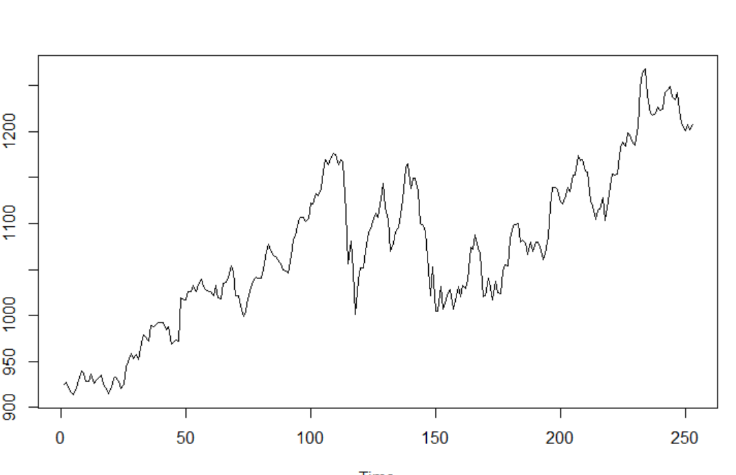  
Here X axis is showing the time part and Y axis showing the closing numbers for Google.If you see the plot graph, you can see the steady slope till a particular time. After that it did not maintain any particular pattern showing some unsteadiness and then it again raised.

plot.ts(my_data$Google.Return)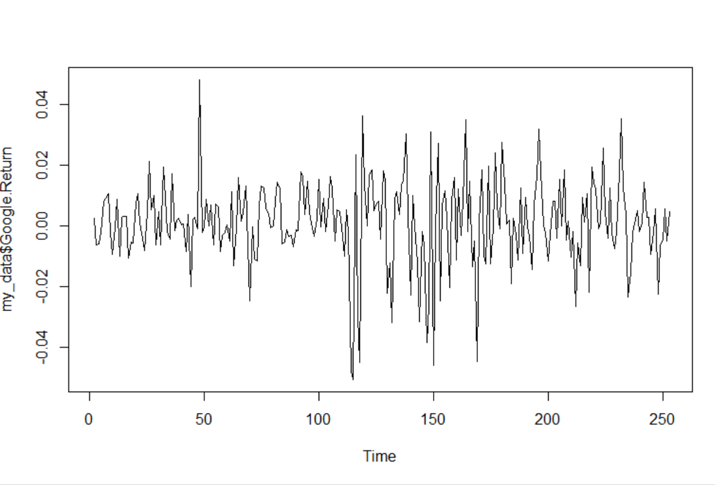

Here X axis is showing the time part and Y axis showing the return numbers for Google.If you see the plot graph, you can see that , most of the time , return ranged between certain number , except at particular time range , it varied more. The propagation is mainly horizontal to X axis.

plot.ts(my_data$Amazon.Close)  
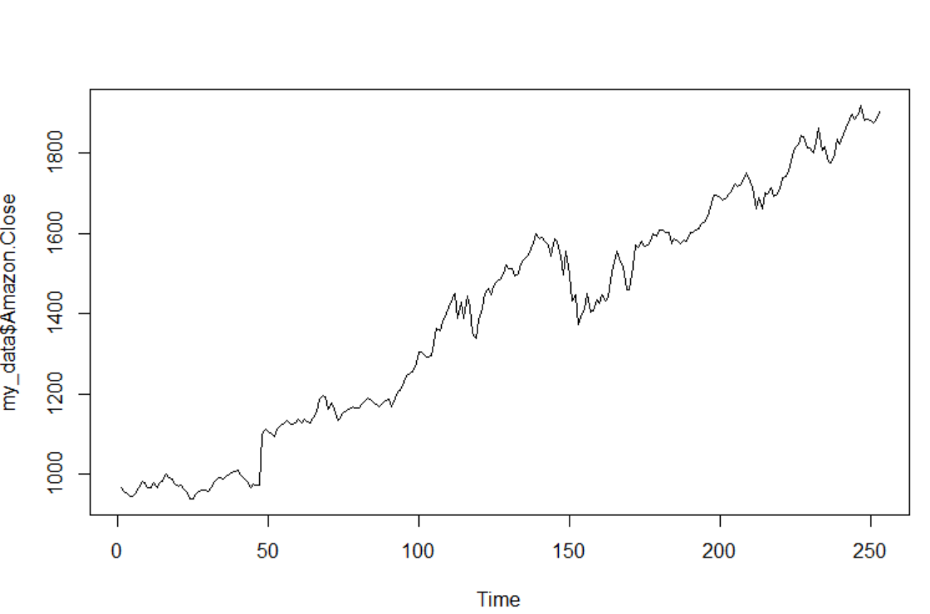

Here X axis is showing the time part and Y axis showing the closing numbers for Amazon. If you see the plot graph, till a particular time , it moves horizontally along x axis and after that it maintains a steady slope and increased.

plot.ts(my_data$Amazon.Return)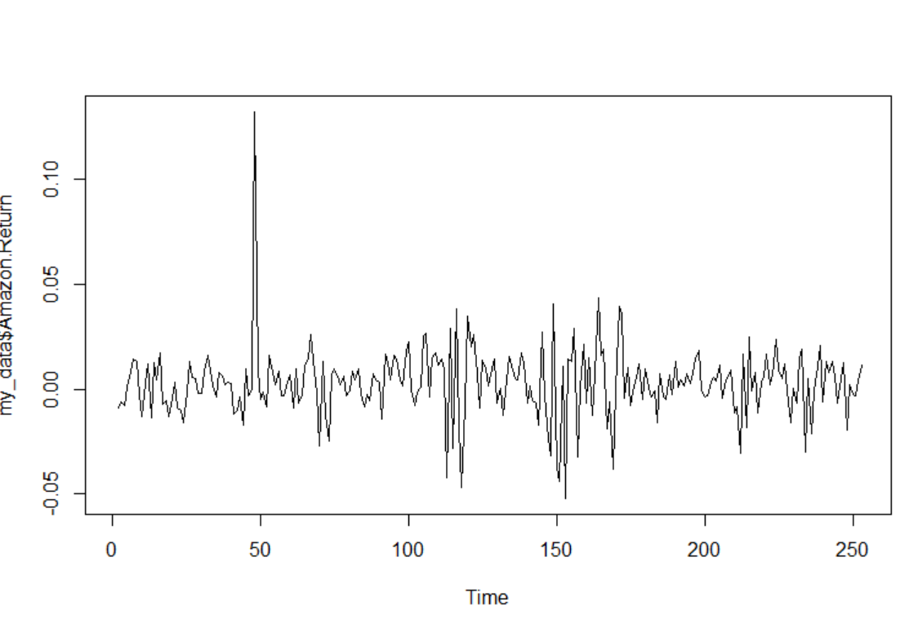

Here X axis is showing the time part and Y axis showing the return numbers for Amazon.If you see the plot graph, you can see that , most of the time , return ranged between certain number , except at particular time range , it varied more. The propagation is mainly horizontal to X axis.

Lets describe the hypothesis:

1. H0 or null hypothesis: mean of the two population are equal
2. Ha or alternative hypothesis: It might be two tailed, left tailed or right tailed.  
   2 tailed: mean of the two population are significantly different

Left tailed: mean of first population is less than mean of second population

Right tailed: mean of first population is higher than second population

Ha or alternative hypothesis

> t.test (my_data$Google.Return,my_data$Amazon.Return)

Welch Two Sample t-test

data: my_data$Google.Return and my_data$Amazon.Return

t = -1.2108, df = 489.05, p-value = 0.2266

alternative hypothesis: true difference in means is not equal to 0

95 percent confidence interval:

-0.004384490 0.001041061

sample estimates:

mean of x mean of y

0.001159563 0.002831277

Here we got p value . And as per thumb rule if we assume that significant level is 0.05 ,then if p value is greater than 0.05, then we will fail to reject null hypothesis. Here we can see that here

p value=0.2266 which is >0.05.  
So we can say that we will fail to reject the null hypothesis and reject the alternative hypothesis.

> t.test(my_data$Google.Close,my_data$Amazon.Close)

Welch Two Sample t-test

data: my_data$Google.Close and my_data$Amazon.Close

t = -16.712, df = 294.47, p-value < 2.2e-16

alternative hypothesis: true difference in means is not equal to 0

95 percent confidence interval:

-360.0003 -284.1421

sample estimates:

mean of x mean of y

1071.855 1393.926

Here p value < < 2.2e-16 which is basically <0.05.  
We can definitely say that we will fail to reject alternative hypothesis or we will reject the null hypothesis. Mean of Google.Close is significantly different from mean of Amazon close

b. Based on the return series, can we claim that the mean Amazon return series is higher than that of Google?

i)Since Amazon and Google are two different company, they are unpaired. Now consequently, if it is unpaired we must do independent t-test.  
  
ii) Now as per problem definition , we need to find out if mean Google return is less than Amazon return. So we can construct it like this whether population 1 will be less than population 2. It will be definitely left tailed independent t-test.  
  
Here Population 1: Google Return

Population 2:Amazon Return

Lets construct the hypothesis one more time:

.

1. H0 or null hypothesis: mean of the two population are equal. Mean of Google Return and Mean of amazon returns are equal
2. Ha or alternative hypothesis:

It might be two tailed, left tailed or right tailed.

Ha: 2 tailed: mean of the two population are significantly different

Ha: Left tailed: mean of first population is less than mean of second population i,e mean of google<mean of amazon

Ha: Right tailed: mean of first population is higher than second population I,e mean of google> mean of amazon

iii)As we already concluded that it will left tailed , independent t-test , I used the following to find the result:

> t.test(my_data$Google.Return, my_data$Amazon.Return, alternative="less", paired=FALSE)

Welch Two Sample t-test

data: my_data$Google.Return and my_data$Amazon.Return

t = -1.2108, df = 489.05, p-value = 0.1133

alternative hypothesis: true difference in means is less than 0

95 percent confidence interval:

-Inf 0.0006035939

sample estimates:

mean of x mean of y

0.001159563 0.002831277

iv)Let’s assume that significance level to be α=0.05.  
So we will comparison p value with respect to 0.05.

If p value> 0.05 , we will fail to reject null hypothesis.  
if p value < 0.05 , we will fail to reject alternative hypothesis.  
  
Based on the fact that the p-value is greater than the significance level (0.1133 > 0.05), we reject the alternative hypothesis..

In non-technical terms: We have sufficient evidence to conclude that the return rate of Google is significantly less than the one of Amazon.

# References:

CTA 5 template provided by professor Mr.Alin

Module 5 Interactive lectures

R software

ZyBook Chapter 2.3 and 2.4