19/10/2026
Agenda
What is mavin?
Assertion and annotation
Test lifecycle
JUnit 5: architecture
Unit test :-it’s a small pieces of code which calls your code and checks the answer of that with what you except
Analogy:- Cooking testing for the right flaours and taste computer checks it every mili sec
Without test u check by running it
With test u press one button and know wheater everthing works ..?
J unit 5 is a lib that gives u the tool to write and run those test
Evey test flow the same three step
1 arrange :- set things up
Calculator calc=new Calculator();
2 act:- do that thing
Int re=cal.add(2,3);
3 assert:- check the ans
assertEqual(5,result);

Mavin ?(project manger and build in tool)
It’s a project management and build tool it does 3 jobs for
1 download lib(like Junit and other)
2 its compiles codes for u
3 run test in one commands
Analogy :- imagin u are chef u write the recipes =java code . mavin it kitchrn manger u hnad over a shopping list (pom.xml) the manager buy it and steps up the kitchen and tells u weather the code is running good or not
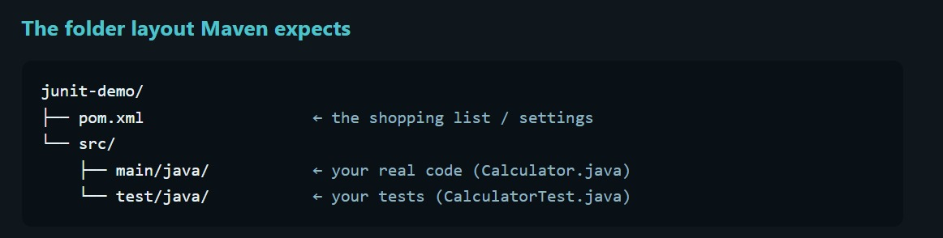
Common words:-
mvn -version =Checks Maven and Java versions
mvn compiles=, mvn test=compiles everything and runs on atest present in folder
mvn clean test=delets the old targets first and then test

Steps for junit testing
1 Design= understand the problem statement and write down the psudocode
2 write code
3 write test
4 run test
They are the 4 filler of junit

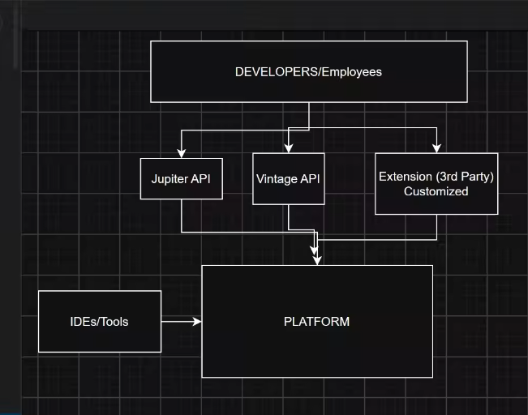
The engine room . starts the test talks to ides and maven, define how test engine plugins (it is used by vs code , mavin surefire,intellige)
Junit Jupiter=The new programming model: @Test, @BeforeEach, assertions. Also contains the engine that runs Jupiter tests.(used by devlopers while writing test)
Junit Vintage:- A compatability engine that old junit 3 and 4 test on a new platform. It is used by old projects that haven’t yet migrated.(analogy cinema and problem of oddyes(vintage or old code ) movies so this thimg will get tacled by junit vintage)
Extension :- its made by user
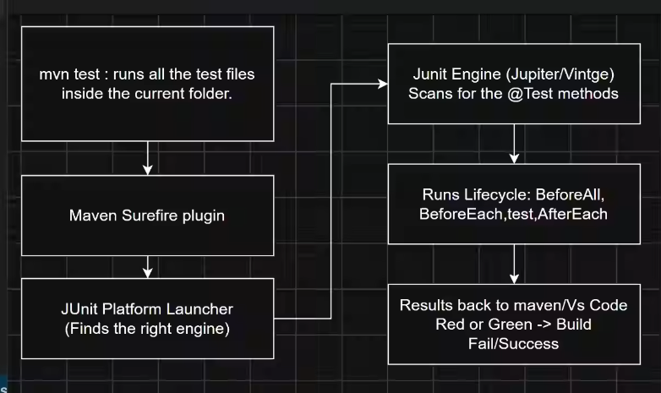

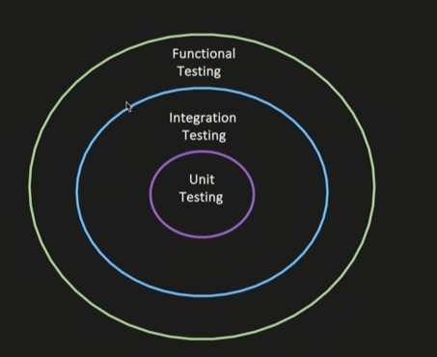
Types of testing :-
1 Unit testing :- testing of an indivual unit or method
2 integration testing :- testing of multipole modules or componyes togther to test there wiring (goal is not to test end to end usere behavous it is just if multipl model wired togrther thus internted behavioud .)
Use case 1: Service ->repository->DB
Wired multiple moule of one component
- U invoke the method in servive layer
- Verify that dependency injection works correctly
- The flow shoud reach DB clear
- Your test can assert that data was persistence properly
Service A->publish to kafka
validate that the message is sussefully published to kafka

Function testing = end to end tesing of a feature or business personality verfifying wheather its work proprerly or not

