**VISHWAKARMA INSTITUTE OF INFORMATION TECHNOLOGY, PUNE**

**COMPUTER ENGINEERING DEPARTMENT**

**APRIL-MAY 2018**

**Synopsis**



**Group number: BE COMP/PRJ/18-19/48**

Group Members :

1. Aniraj Jadhav

2. Akash Udmale

3. Sayali Sonawane

4. Tejashree Kamble

**Title: Chat Service for Mazak, India**

**Objective:**

**A web based chat service acting as a helpdesk interface between Customer Care Executives and Customers of Mazak, India for 1 to 1 direct communication (XMPP based Instant Messaging).**

**Abstract:**

An **XMPP** based web chat service, to be utilized by Mazak, India’s customer care executive branch for attending and resolving the inquiries of their global customers by introducing a **1 to 1** web based communication service following XMPP as the **Application Layer** protocol for setting up a secured, robust and seamless communication between the customer care executives and the customers with **no waiting time** that is to be hosted on [www.Mazak.com](http://www.Mazak.com) with a purpose of directly interacting with the customer care executive branch in order to inquire about Mazak, India’s products and services, thus, with a definitive probability of scheduling an appointment with the company’s sales executives for purchase orders or with the company’s application engineers for services.

**Technical Details:**

|  |  |
| --- | --- |
| **Software** | **Description** |
| Angular 6 | Cross platform support, App like experience, front end development scripting language with a support for Typescript. Best for Animation. |
| NodeJs | A great back end programming scripting language for developing real time applications, that is chat apps or gaming apps. Can run on Mac OS X, Microsoft Windows, Linux and in built libraries provide an extensive list of features. |
| MongoDB | Document oriented storage system, thus, provides support for json file storage, highly scalable and best database for developing user data management system. |
| Ejabberd | An XMPP routing server best used for one to one instant messaging, multi user chatting and a robust architecture for maintaining high security. |
| Apache Tomcat 9.0 | Local debugging server for the product. |
| Microsoft Visual Studio Code | The best source code editor including a powerful tool known as IntelliSense code completion and debugging system. |
| Python | Scripting of offline chat bot, has the best support for machine learning libraries. |
| TensorFlow | Machine Learning framework, in the form of a library which eases the process of acquiring data, training models, serving predictions and refining future results. |

|  |  |
| --- | --- |
| **Protocol** | **Description** |
| Extensible Messaging and Presence Protocol (XMPP) | An robust and powerful standard Application Layer protocol with a decentralized server architecture. Federated connections possible. Numerical priority system supports the purpose of the application. |
| Bi-directional streaming Over Synchronous HTTP (BOSH) | Since XMPP cannot be used over the web directly, BOSH maps the XMPP for it to be used over the browser. That is a transport binder which binds the XMPP to the TCP that is on the transport layer for real time streaming. |

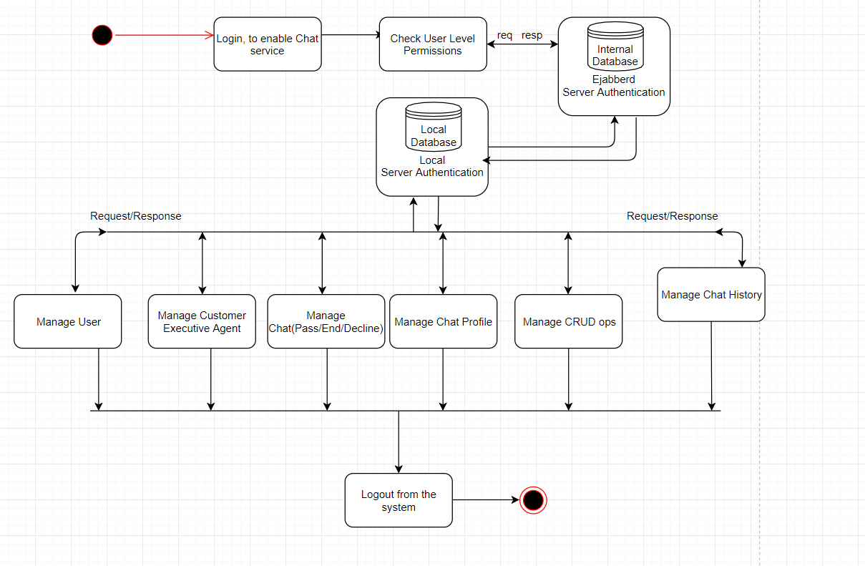**Working:**

**References/Bibliography:**

**IEEE References:**

1. An open standard for instant messaging: extensible Messaging and Presence Protocol (XMPP)  
   Pin Nie  
   Helsinki University of Technology, 2006/4/5
2. Design of an Instant Messaging System Based on the IaaS  
   Cloud Platform  
   Miaofan Sun, Shengsheng Wang, Zhiyi Fang and Mengjiao Zhang  
   College of Computer Science and Technology Jilin University, Changchun, 130012, P.R. China, 2015/9/9
3. A Study of Internet Instant Messaging and Chat Protocols

Raymond B. Jennings III, Erich M. Nahum, David P. Olshefski, Debanjan Saha, Zon-Yin Shae and Chris Waters

IBM T.J. Watson Research Center, 2006/8/5

1. A Lightweight XMPP Publish/Subscribe Scheme for Resource-Constrained IoT Devices  
   Heng Wang, Member, IEEE, Daijin Xiong, Ping Wang and Yuqiang Liu, 2017/4/27

**Product Documentations:**

1. Streaming XML with Jabber/XMPP

Peter Saint Andre, Jabber Foundation, 2005/9/5

**Links of referred web resources:**

1. ********XMPP*******

<https://xmpp.org/about/technology-overview.html#bosh>

1. ********JABBER IDS*******

<https://xmpp.org/extensions/xep-0029.html>

1. ********STROPHE - XMPP Libraries*******

<https://xmpp.org/software/libraries.html>

<http://strophe.im/>

1. ********XMPP Architecture*******

<https://xmpp.org/rfcs/rfc3920.html#stanzas-semantics-iq>

1. ********BOSH*******

<https://xmpp.org/extensions/xep-0124.html#technique>

1. ********XMPP Tutorial*******

<http://xmpp-tutorials.blogspot.com/>

<https://ieeexplore.ieee.org/document/6269411/>

<http://meta-guide.com/videography/100-best-xmpp-videos>

<http://meta-guide.com/bots-agents-assistants/chatbots/jabber-xmpp-chatbots>

<https://medium.com/@thinkwik/web-sockets-vs-xmpp-which-is-better-for-chat-application-113e3520b327>