Meta Title | How Long Do Humidifiers Last? Lifespan by Type and Technology
Meta Description | Learn how long humidifiers last by type and technology. See what affects lifespan, from water quality and cleaning to usage and maintenance.
Excerpt | Humidifier lifespan varies by type, technology, water quality, and upkeep. Learn what affects service life, how long different units last, and how better cleaning and maintenance can help prevent early replacement needs.
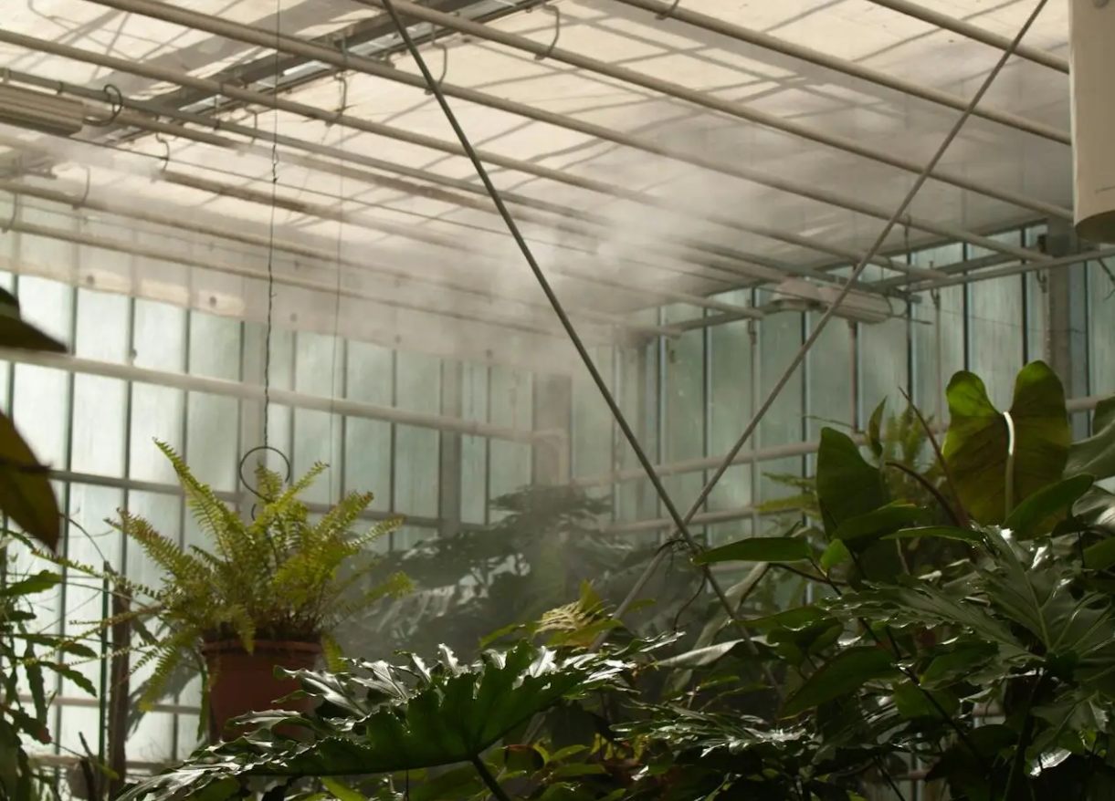

How Long Do Humidifiers Last? Lifespan by Type and Technology
Humidifier lifespan varies by technology type: ultrasonic units typically last 2–3 years, evaporative models around 3–5 years, steam vaporizers around 3 years, and whole-house HVAC-connected systems 10–15 years. Industrial and commercial systems are engineered for significantly longer service. How long any humidifier lasts also depends on water quality, cleaning frequency, and whether it is run continuously or seasonally.
This guide covers lifespan by type, what causes early failure, and how industrial systems compare.
Key Takeaways
- Humidifier lifespan depends on technology type, maintenance, water quality, and frequency of use.
- Most portable units last a few years, while whole-house and commercial systems are built for longer service.
- Mineral buildup, poor cleaning habits, and constant operation can shorten a unit’s working life.
- Performance decline, unusual noise, leaks, or recurring buildup may signal that replacement is near.
- Industrial and commercial systems are engineered for longer service intervals and more durable humidity control than portable residential units.
Average Humidifier Lifespan
Humidifier lifespan varies by system type, build quality, maintenance demands, and operating conditions. Smaller portable units are often built for shorter service life, while larger installed and commercial systems are designed for longer-term performance and more stable operation.
In residential use, portable humidifiers often last a few years with regular cleaning and proper care. Larger whole-house and commercial systems are generally built for longer service because they are designed for more permanent installation, steadier output, and less day-to-day handling.
A simple way to compare general lifespan expectations is this:
- Portable humidifiers: usually built for shorter service life and more frequent cleaning
- Whole-house systems: typically designed for longer-term residential use with seasonal maintenance
- Commercial and industrial systems: engineered for heavier use, stronger durability, and longer service intervals
How long a humidifier lasts also depends on water quality, usage frequency, maintenance habits, and overall system design. Better-built systems with lower maintenance demands and fewer wear points usually perform more reliably over time than units that need constant cleaning, frequent part changes, or closer day-to-day attention.

Lifespan by Humidifier Type
Humidifier lifespan changes depending on the way the unit is built and how it produces moisture. Some designs are quieter and more compact, while others are made for heavier use and longer service life.
That is why humidifier type matters when you are comparing durability.

Ultrasonic Humidifiers
Ultrasonic humidifiers use high-frequency vibration to create moisture. They are often chosen for quiet operation and energy efficiency, but their internal components can be more sensitive to water quality and mineral deposits.
In many cases, these units last around 2 to 3 years with regular care, at the lower end of the broader portable humidifier range. Their lifespan often depends on how well mineral buildup is managed, especially when hard water is used frequently.

Evaporative Humidifiers
Evaporative humidifiers use a fan and a wick or filter to add moisture to the air. This design is common in residential use and is often seen as a practical option for steady everyday humidification.
The main unit can often last around 3 to 5 years, consistent with the ENERGY STAR estimated lifetime for portable humidifiers. However, the wick or filter needs more regular replacement. If those parts are not changed on time, airflow and performance can drop, and the unit may become harder to keep clean.

Steam Vaporizers
Steam vaporizers work by heating water and releasing warm moisture into the room. The design is simple, but the heating element can collect scale over time, especially if the unit is not cleaned regularly.
With proper care, these units typically fall within the 3 to 5 year range for portable humidifiers. Regular descaling is important because scale buildup can reduce efficiency and shorten the life of the heating components.

Whole-House and HVAC Humidifiers
Whole-house humidifiers are connected directly to an HVAC system and are built for longer-term use than most portable units. Because they are part of a larger home system, they are usually designed for more durable performance over time.
These systems often last around 10 to 15 years with seasonal maintenance and proper upkeep, consistent with the ENERGY STAR industry estimate of a 10-year lifetime for whole-house humidification systems. Their longer lifespan makes them a stronger option for households that want more consistent humidity control across the home.
What Shortens Lifespan of a Humidifier
A humidifier can wear out early for a few common reasons, especially poor water quality, inconsistent cleaning, and continuous use without proper care. Even a well-made unit can lose performance quickly if those issues are ignored, which is why regular maintenance matters just as much as the model itself.

Mineral Buildup and Scale Damage
Water quality has a major effect on how long a humidifier lasts. When hard tap water is used regularly, minerals can collect inside the tank and on internal components. Over time, that buildup can reduce moisture output, interfere with performance, and increase wear on the parts that keep your humidifier running.
This is also one of the main reasons some humidifiers start leaving white dust on nearby furniture. In units that rely on more precise internal parts, mineral scale can become especially damaging if it is not removed early. Using better water and staying ahead of buildup can make a noticeable difference in long-term performance.
A few habits help reduce this problem:
- Use distilled water when possible.
- Clean your humidifier before mineral deposits become heavy.
- Watch for white dust as a sign of high mineral content.

Infrequent Cleaning and Mold Growth
A humidifier constantly holds moisture, so regular cleaning is essential. If the tank, wick, or internal surfaces are left dirty for too long, mold, bacteria, and biofilm can begin to build up inside the unit.
That buildup affects more than hygiene. It can also reduce airflow, lower output, create odors, and make the unit work harder than it should. Replacing filters or wicks on time and cleaning damp parts regularly helps the humidifier stay more reliable and last longer.

Continuous Operation Without Maintenance
Running a humidifier all the time without breaks or routine care can also shorten its lifespan. The longer you use the humidifier without cleaning, inspection, or basic upkeep, the more likely it is that residue, wear, and internal strain will build up.
To help the system work more efficiently, it is best to follow the manufacturer's instructions and stick to a few simple habits:
- Check water quality before filling the tank.
- Follow the recommended cleaning schedule.
- Monitor room humidity so the unit is not running harder than necessary.

Signs Your Humidifier Needs Replacing
Even with proper care, every humidifier reaches a point where cleaning and small fixes stop solving the problem. When that happens, the unit may still run, but it may no longer perform well enough to maintain the right humidity level or support better comfort in your space.

Performance and Output Decline
One of the clearest signs is weaker output. If the humidifier no longer adds moisture the way it used to, even after cleaning, the internal parts may be wearing out. That drop in performance can make dry air more noticeable again and may also affect overall indoor air comfort.
Unusual grinding, rattling, or repeated performance drops can also point to internal damage. Persistent mineral buildup is another warning sign. If scale, white dust, or reduced output keep returning no matter how well you maintain the unit, the problem may no longer be routine buildup. It may mean the humidifier is nearing the end of its useful life and no longer helping your indoor air quality the way it should.

When Repairs Cost More Than Replacement
Some problems are worth fixing, but others are not. If the repair cost is close to the price of a newer unit, replacement is usually the better choice. This is especially true for older portable humidifiers with motor, fan, heating element, or tank damage.
A practical way to think about it is this:
- Minor scale buildup is usually worth cleaning.
- Motor or fan failure is often not worth repairing in an older unit.
- A cracked or leaking tank usually points to replacement.
- Outdated performance may make a newer unit the better long-term option.
If you are constantly troubleshooting the same problems, the humidifier is usually telling you it is time for a replacement.

How Industrial Humidification Systems Compare
Industrial humidification systems are built for a very different level of use than standard residential units. While portable home humidifiers are often replaced every few years, commercial systems are designed for long service life, more stable performance, and lower interruption in demanding environments.

Why Commercial Systems Last Significantly Longer
Commercial systems are built for durability, not short seasonal use. They are designed to operate in facilities where humidity control needs to stay reliable over long periods, often in environments where failure can affect equipment, materials, or production conditions.
Their longer lifespan comes from stronger construction, better water handling, and systems engineered for steady performance. Compared with residential units, they are generally better suited for continuous operation and less likely to lose efficiency quickly under heavier use.
A simple way to compare the two is this:
- Residential humidifiers: Often last around 2 to 5 years and usually need more frequent cleaning and hands-on upkeep.
- Commercial systems: Often last 10 years or longer and are built for more durable, long-term operation.
- Maintenance demands: Consumer units often need weekly or monthly attention, while better-engineered commercial systems are designed for much longer service intervals.
- System design: Residential units often depend on multiple wear-prone parts, while industrial systems are usually built for greater durability and reliability.

Smart Fog: No Moving Parts and Longer Service Intervals
Smart Fog is built for long-term industrial performance. While many humidification systems are estimated to last around 15 years, Smart Fog humidification systems are designed for much longer service with no moving parts in the humidification process and maintenance intervals that can extend to every two years.
That makes Smart Fog a stronger fit for facilities that need reliable, low-maintenance humidity control over the long term.

Final Thoughts on Humidifier Lifespan
Humidifier lifespan depends on the type of system, the conditions it operates in, and how well it is maintained over time. Smaller residential units can work well for short-term or seasonal use, but they usually need more frequent cleaning, closer monitoring, and earlier replacement.
For users comparing long-term value, maintenance demands matter just as much as upfront cost. A unit that needs constant cleaning or frequent replacement may be less practical over time than a system designed for longer service and more stable performance.
That is where commercial systems stand apart. For facilities that need a longer-lasting solution, Smart Fog offers a non-wetting precision humidification system with no moving parts, maintenance only every two years, and industrial humidification systems built for long-term facility performance.

FAQ

How long do humidifiers last on average in a typical home?
In most homes, a humidifier can last anywhere from 2 to 5 years with proper care. Whole-house systems typically last longer, often around 10 to 15 years, because they are built for more durable, long-term operation.

What are the primary factors that shorten the life of a humidifier?
The biggest causes are mineral buildup, poor water quality, missed cleaning, and constant use without maintenance. Over time, scale and residue can lead to corrosion, weaker output, and more wear on internal components.

How can I keep my humidifier running efficiently for as long as possible?
Regular cleaning and timely upkeep are the best ways to keep your system running well. Use distilled water when possible, clean the unit often, and change the filter or wick on schedule to reduce buildup and maintain steady performance.

How do I know if my humidifier needs replacement?
A unit may need replacement when output drops, unusual noise becomes frequent, or buildup keeps returning even after cleaning. A cracked water tank, repeated leaks, or odors around the humidifier are also strong warning signs.

What are the health benefits of maintaining proper moisture in indoor environments?
Balanced humidity helps reduce dry skin, throat irritation, nasal dryness, and general respiratory discomfort. When a humidifier adds moisture into the air, it can make indoor spaces feel more comfortable and easier to live in.

Why do industrial systems like Smart Fog last longer than residential models?
Industrial systems are built for heavier use, longer service life, and more durable performance. Smart Fog lasts longer because it has no moving parts in the humidification process and only needs maintenance every two years.

Does the type of humidifier affect its longevity?
Yes. Humidifier type affects lifespan because each design wears differently over time. Performance also depends on how well the unit maintains proper relative humidity, especially during the winter months when it is used more often.

