Meta Title | How Much Does It Cost to Build an RV and Boat Storage Facility?
Meta Description | Discover the full cost of building an RV and boat storage facility. Learn about land, construction, permits, utilities, and operating expenses to plan a profitable project.
Slug | /cost-to-build-rv-boat-storage-facility
Excerpt | This guide explains the true costs of building an RV and boat storage facility, from land and construction to utilities and operating expenses. With clear cost breakdowns and planning tips, you’ll be able to budget smarter, avoid surprises, and build a profitable storage business.

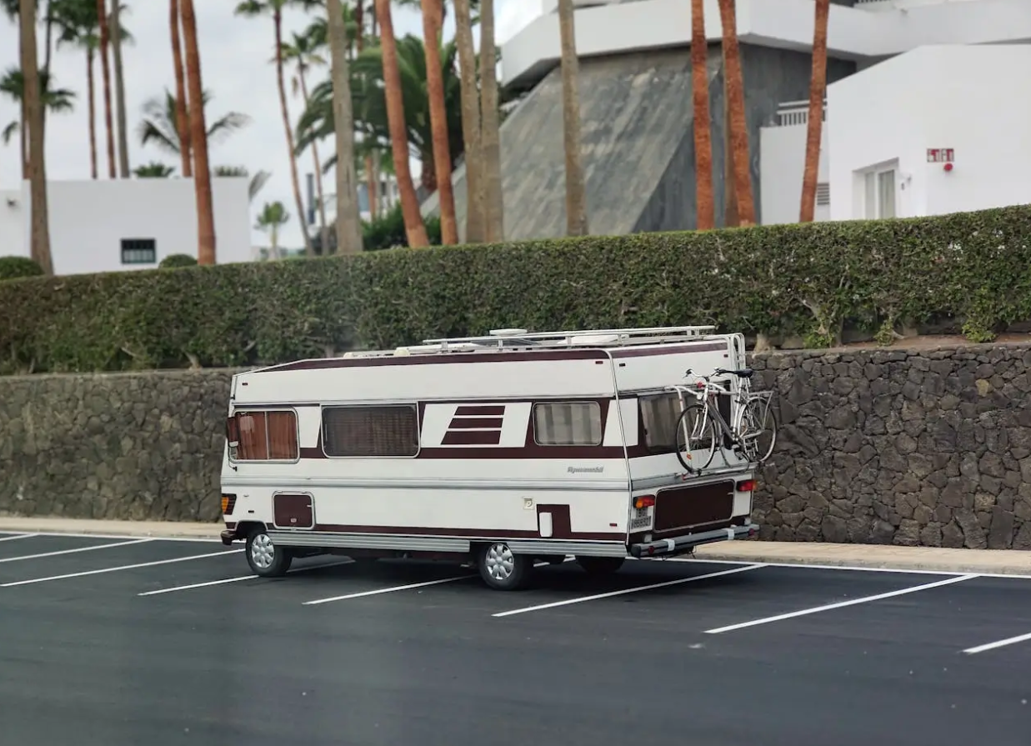

How Much Does It Cost to Build an RV and Boat Storage Facility?
Are you thinking about starting an RV and boat storage facility? You might wonder how much it will cost to build an RV and boat storage facility. Because this project requires significant capital, understanding each cost category upfront is essential to success.
Creating an RV storage facility or a boat and RV storage site involves many variables that shape storage construction costs. The more clearly you understand these expenses, the stronger your plan and financing package will be.
Knowing the costs of RV storage development helps you build a realistic budget, reduce surprises, and keep your project on track from due diligence through opening day. This guide will help you estimate the full cost of developing a high-performing RV and boat storage business, reduce costly surprises, and stay on track from due diligence through launch.

Understanding the Costs of Building an RV and Boat Storage Facility
The total cost of building an RV and boat storage facility is shaped by multiple categories. At a high level, the major cost buckets include:
- Land acquisition and entitlement
- Site preparation (grading, drainage, paving)
- Construction type (outdoor, covered, or enclosed)
- Security systems and fencing
- Utility hookups and access roads
- Professional services (engineering, architecture, permits)
Your storage development strategy should align with both local demand and the type of facility you're offering. For example:
- Outdoor storage is typically the most affordable to build, with fewer materials and faster timelines.
- Covered parking adds mid-tier construction costs but appeals to RV and boat owners who want sun and weather protection.
- Fully enclosed units have the highest upfront costs but allow you to charge premium rental rates for added privacy, climate control, and security.
Security is non-negotiable in RV and boat storage. Cameras, fencing, access control, and lighting are all critical line items, and not just for customer peace of mind. Following Crime Prevention Through Environmental Design principles helps you design a site that deters incidents and can support insurance conversations.
Pro tip: Plan your budget based on a mix of storage types that matches your market’s rig sizes, climate needs, and willingness to pay for premium amenities.

Land Acquisition Costs for RV and Boat Storage Development
Land is the foundation of your RV storage business, and the amount of land you need for the facility will significantly impact both cost and feasibility. The price of land will vary dramatically depending on:
- Location and visibility
- Size and shape of the parcel
- Zoning classification
- Topography and drainage
- Distance to utility mains
For baseline land-value context in rural and fringe markets, use the USDA Land Values Summary, which reports average per-acre values by state and region. Land in urban or fast-growing suburban areas typically comes at a higher price per acre, but also supports stronger demand and higher rental rate potential. Rural sites may be cheaper to purchase but could lack infrastructure or proximity to major roads.
Area Type | Typical Cost Profile | Pros | Cons
Urban | High cost per acre | High demand, great visibility | Zoning complexity, expensive land
Rural | Low cost per acre | Easier permitting, large parcels | Lower traffic, limited utilities
Semi-urban | Balanced cost and access | Good mix of access and affordability | May still need zoning adjustments
Zoning readiness matters. A parcel that’s already approved for self-storage or commercial storage use can be worth significantly more because it reduces entitlement risk and accelerates your timeline. If you’re eyeing a piece of land that needs rezoning, build in both time and budget for planners, public meetings, and legal review.
When planning an RV or camper storage facility, there are several key land cost factors to evaluate:
- Proximity to highways and recreation corridors.
- Access to existing utility lines.
- Parcel width for vehicle turning radii.
- Topography, flat land reduces grading cost.
- Zoning status and approval pathway.

Site Preparation and Infrastructure Development Costs
Once you've acquired a parcel, site preparation transforms it from raw land into a revenue-generating outdoor storage facility. This phase is one of the most critical for your budget, as it lays the foundation for layout, functionality, and long-term performance.
Whether you're developing a full self storage complex or a specialized RV and boat storage facility, infrastructure costs vary significantly based on your site’s terrain, soil, access, and storage product mix.

Grading, Paving, and Drainage
Grading is the first step in shaping your RV storage site. It ensures level surfaces for stalls and pads while establishing flow for stormwater runoff. If your land has steep slopes, rocky conditions, or unstable soils, grading costs can increase quickly.
- Flat, well-drained parcels are the most budget-friendly.
- Uneven or rocky sites often require cut-and-fill work or import of base materials.
Once graded, paving is necessary for aisles, stalls, and drive-up access areas. Asphalt is the most common surface for RV storage because it balances durability with cost. In high-wear areas like entrances or tight turning zones, concrete may be used for added strength.
Drainage systems; such as swales, retention basins, and culverts, prevent water pooling and protect your paving investment. Proper drainage also safeguards RVs from tire rot, mold, or undercarriage corrosion during storage.
Feature | Typical Cost Range | Notes
Grading | Highly site-dependent | Higher on sloped or problematic terrain
Paving (Asphalt) | $2.5–$4.5 per sq. ft. | Varies by thickness, climate, and traffic volume
Drainage | Custom per site plan | Costs depend on code, soil type, and rainfall patterns
Tip: For long-term ROI, invest in durable surfaces that hold up under the weight of heavy Class A RVs and trailers. Preventive drainage is far cheaper than post-flood repairs.

Utility Connections and Access Roads
Functional self storage facilities, especially those with drive-up RV access require utilities such as:
- Electricity for lighting, security systems, and powered gates.
- Water and wastewater if you offer dump stations, washing bays, or staff offices.
- Internet and communication lines to support cloud-based security or payment systems.
The cost of utility hookups will depend on:
- Distance to mains
- Capacity needs
- Local upgrade requirements
In many cases, older or rural parcels need transformer upgrades, additional meters, or trenching, which can quickly escalate costs.
Access roads are equally important. They must accommodate wide rigs, trailers, and boats without bottlenecks. The materials (asphalt, gravel, concrete), length of road, and required traffic improvements (turn lanes, deceleration lanes) all impact the bottom line.
Consider: Local fire departments may require specific turning radii and hydrant spacing for emergency access, so plan early with code officials.

Professional Services and Contractor Fees
Developing an RV or outdoor storage facility isn’t just about materials, it’s about expertise. A team of experienced professionals ensures compliance with local codes and helps streamline your approval timeline.
When planning an RV or camper storage facility, professional services to budget for include:
- Feasibility studies to test market viability and pricing models.
- Due diligence reports on soils, environmental risk, and flood zones.
- Civil and site engineering for grading, paving, stormwater, and utility layout.
- Architectural services for any on-site buildings or climate-controlled units.
- Permitting coordination with local planning, fire, and public works departments.
For feasibility methodology and market research steps, reference the SBA’s market research and competitive analysis guide.
In addition, you’ll need a general contractor to manage site crews, vendors, and timelines. Contingency funds (typically 5–10% of construction budget) should be set aside to manage unforeseen expenses like soil remediation, weather delays, or utility conflicts.

Construction and Building Costs for RV and Boat Storage Facilities
The construction phase is where planning becomes reality. The type of storage product mix; outdoor, covered, or enclosed has the biggest impact on both upfront costs and long-term revenue potential. Each option comes with its own construction demands, durability considerations, and pricing flexibility.

Outdoor Storage Yards
Outdoor yards are the simplest and most cost-effective to build. They primarily require site grading, paving or compacted gravel surfaces, lighting, and perimeter fencing. This setup appeals to budget-conscious customers while keeping development costs low.
- Site preparation and surface work: Generally aligns with the paving benchmarks above. See parking-lot paving cost data for current ranges.
- Fencing: Cost depends on material and perimeter length. Consumer benchmarks put fence installation costs in a wide range per linear foot; chain-link is at the lower end.
Outdoor yards work well in moderate climates but may require frequent maintenance where weather extremes impact pavement and drainage systems.

Covered and Enclosed Storage Options
Covered and enclosed facilities cost more to build but deliver added protection and command higher rents.
- Covered storage: Covered RV and boat storage is typically built with open-sided steel canopies. These structures balance affordability with strong weather protection. According to Estimator Florida, canopy construction usually falls in the $20–$50 per square foot range, depending on span width, materials, and local wind or snow load codes. More custom metal canopy installs, such as heavy-duty or architectural designs, can reach $45–$110 per square foot depending on finishes and complexity. These costs reflect not just the steel framing, but also site prep, foundations, and code compliance.
- Enclosed storage: Enclosed RV and boat storage facilities are essentially pre-engineered steel buildings with taller clear heights and large roll-up doors. They offer maximum protection but at a higher capital cost. BuildingsGuide estimates turnkey enclosed metal buildings at $24–$43 per square foot, while basic kits without erection or slab can be $15–$20 per square foot. Similarly, Worldwide Steel Buildings notes that kits often start around $10–$30 per square foot, with total costs rising when insulation, HVAC, or climate-controlled features are added.
Operators often choose a mix of outdoor, covered, and enclosed storage to appeal to a wider customer base while balancing development costs.

Security, Lighting, and Fencing Costs
Security is a non-negotiable feature for modern RV and boat storage facilities. Owners are entrusting you with high-value assets, often worth $50,000 to $500,000 each, so your facility must project safety and reliability. A layered security system not only deters theft and vandalism but also reassures customers and can reduce insurance premiums.

Lighting
Good lighting is one of the most effective deterrents. Even glare-controlled illumination improves visibility for both customers and security cameras. LED site lighting reduces energy and maintenance.
The DOE’s Energy Saver guidance on LED lighting outlines efficiency benefits that translate into lower operating costs over time. Costs depend on fixture type, pole height, and site coverage:
- Pole spacing: Wider coverage requires taller poles and brighter fixtures.
- Energy efficiency: LED systems cost more upfront but reduce long-term utility bills.
- Automation: Photocells and motion sensors optimize energy use while enhancing security.
Typical costs range from $10,000 to $50,000 for a standard site, with large multi-acre facilities trending toward the higher end.

Fencing
Perimeter fencing forms the first line of defense. Material, height, and perimeter length are the biggest cost drivers:
- Chain-link fencing is common and cost-effective.
- Steel or ornamental fencing provides a stronger physical barrier and better aesthetics near residential areas.
- Height and climb resistance directly affect effectiveness and insurance evaluations.
Expect to spend $20,000 to $100,000 depending on site size and material choice.

Cameras and Access Control
Surveillance and access control provide accountability and evidence in case of incidents. Key factors include:
- Camera coverage density (entrances, aisles, corners).
- Resolution and retention period of recorded footage.
- Gate and keypad systems for tenant access, sometimes app-integrated.
- On-site or remote monitoring adds additional cost but strengthens protection.
Installations typically range from $15,000 to $75,000, with sophisticated systems running much higher.
Note: These cost figures represent broad industry standards and averages. Actual expenses vary by region, site design, vendor selection, and regulatory requirements, so they should be used as reference estimates only.

Permits, Zoning, and Compliance Expenses
Before construction begins, every RV and boat storage facility must navigate a series of permits, including zoning required for storage use and related entitlements. These costs may seem small compared to land and construction, but delays or denials at this stage can derail an entire project. Requirements vary widely depending on the jurisdiction, site conditions, and project scope.

Types of Permits and Typical Costs
- Zoning permits: Confirm that the land is legally approved for storage use. May include hearings or conditions. Typical costs range from $500–$2,000, depending on jurisdiction. For example, Fairfax County, VA lists zoning application fees in the $520–$700 range.
- Building permits: Ensure structures meet life-safety, fire, and accessibility standards. According to ANGI, building permits generally cost $525 to $3,041, with the national average around $1,647
- Environmental permits: Required if wetlands, stormwater, or sensitive habitats are affected. Typical cost: $2,000–$10,000+.
Screen your site using EPA’s NEPAssist to flag wetlands, Superfund, and other constraints, then follow up with consultants as needed. Engaging planning staff early through pre-application meetings reduces rework and clarifies what documents (site plans, traffic studies, environmental reports) will be required.

Insurance and Risk Management Costs
Once built, your facility must be properly insured to safeguard your investment and protect operations. Insurance also plays a role in tenant trust, customers feel more confident when they know the facility owner has taken steps to cover risks.

Types of Insurance
- Liability insurance: Covers accidents, injuries, or claims from customers or visitors.
- Property insurance: Protects buildings, equipment, and site improvements.
- Business interruption insurance: Helps cover income losses after events like fires, floods, or other insured perils.

Typical Premium Ranges
- Liability insurance: ~$500 annually (≈ $42/month) typical for many small businesses. For a $1 million coverage limit, a sample cost is about $824 per year in some cases.
- Property insurance: Typically $1,000 to $3,000 annually (i.e. ~$83 to $250/month) for many small businesses.
- Business interruption insurance: ~$500 to $3,000 annually for many small business policies (often bundled as part of a Business Owners’ Policy).
Strong security measures, regular maintenance, and compliance with fire codes can lower premiums over time. Many operators also require tenants to carry renter’s insurance, further reducing liability exposure.

Operating and Ongoing Maintenance Costs
Owning an RV and boat storage facility means planning for recurring expenses that keep the property functional, safe, and appealing to tenants.
While the upfront development costs are significant, it’s the operating and maintenance budget that determines long-term profitability.

Routine Cleaning and Landscaping
Day-to-day upkeep is vital for customer satisfaction and compliance with municipal codes. Clean, well-kept grounds build trust with RV and boat owners, while neglected sites quickly lose their appeal.
- Typical tasks: mowing grass, trimming trees, pressure washing, litter pickup, sweeping drive aisles.
- Cost ranges: Many operators spend $1,500 to $3,000 per month, depending on acreage, climate, and seasonality.
- Annualized budget: Roughly $18,000 to $36,000, though desert or snow regions may vary due to irrigation or snow removal needs.

Repairs and Preventive Maintenance
Proactive maintenance avoids costly breakdowns and liability risks. Planning ahead ensures facilities remain in top condition.
- Fence repairs: Most fence repair jobs cost $300 to $900 on average, though complex or large-scale repairs can be higher.
- Gate servicing and keypad systems: Automatic gate repairs typically cost $550 to $1,500 depending on system type and parts required.
- Lighting replacements: Varies with fixture count, but LED retrofits reduce costs long-term.
- Drainage upkeep: Annual maintenance for swales and stormwater systems is generally 5–7% of installation costs, which can translate to $1,500–$3,000 per year for clearing swales, culverts, and basins in commercial facilities.
Rule of thumb: Expect 1% to 3% of facility value per year for ongoing maintenance. Larger, more complex sites trend toward the higher end of this range.

Factors That Influence the Total Cost of Building a Storage Facility
The final price reflects a combination of location, design, and product choices.

Location and Market Demand
Where you build has a major impact on both upfront costs and long-term profitability; land prices, local demand, and competitive saturation all shape financial outcomes.
- High-demand areas (near lakes, coasts, or tourist corridors) support higher rental rates but carry higher land costs.
- Rural or suburban markets are more affordable per acre but may generate slower lease-up.
- Competitor analysis is essential, study nearby self-storage and RV storage facilities to avoid overbuilding.

Facility Size, Layout, and Design Complexity
How you configure the site affects everything from construction costs to rental efficiency. Smart design choices can improve ROI even on expensive land.
- Larger facilities require higher capital investment but offer better efficiency and unit mix.
- Smart layouts; using angled stalls, pull-throughs, and right-sized aisles can offset high land prices by fitting more rentable units per acre.
- Complex designs (multi-level storage, enclosed buildings) add costs but also unlock premium pricing.

Type of Storage Offered (Outdoor, Covered, Indoor)
The kind of storage you offer directly impacts construction budgets, tenant appeal, and pricing strategy.
- Outdoor storage: Lowest construction cost, flexible, but exposed to weather.
- Covered storage: Mid-tier cost, attractive in hail- or sun-prone regions.
- Indoor storage: Highest cost but generates premium rental rates and appeals to luxury RV and boat owners.
A balanced product mix helps serve budget-conscious customers and premium renters, boosting overall yield per square foot.

ROI and Profitability: Is Building an RV and Boat Storage Facility Worth It?
Determining whether an RV and boat storage facility is worth the investment depends on how well it performs across three main areas: occupancy, rental income, and operational efficiency. When these elements are carefully managed, the facility can deliver strong and stable returns over time.
Profitability of storage facilities improves when you maintain high occupancy rates, charge market-competitive rents, and keep expenses low through disciplined operations. For a sector-level view of performance within institutional real estate, review NCREIF’s quarterly index returns, which include self-storage alongside other property types.
Monitoring occupancy on a monthly basis allows you to identify trends and make adjustments. For example, you can reconfigure stall lengths to match the sizes of RVs and boats commonly stored in your area. Introducing premium features, such as covered parking, lighting, security, or wash stations, can help increase revenue in markets where renters are willing to pay more for added convenience.
Operationally, right-sizing your staff and using reliable systems for access control and billing will reduce overhead and improve cash flow. Over time, these small adjustments can make a significant impact on your overall return on investment.

Final Thoughts: Budgeting for an RV and Boat Storage Facility
Budgeting accurately is the backbone of a profitable storage business. By carefully estimating land, construction, security, and ongoing operating costs, facility owners can set realistic financial expectations and avoid setbacks.
Success in the self-storage and RV storage industry depends on balancing affordability, usability, and strong security measures. With a well-structured financial plan, operators can build facilities that not only meet customer needs but also generate reliable returns.
RecNation has proven how smart budgeting, efficient layouts, and diversified storage options, from outdoor yards to covered and enclosed units can maximize revenue while keeping operations sustainable. If you want to develop a successful RV storage facility, careful planning and disciplined cost control are the first steps to long-term success.

FAQ

What is the average cost per acre to build an RV and boat storage facility?
Typical projects budget $30K–$100K per acre, including land, grading, and basic site prep. Market, zoning, and terrain influence total cost.

How much does it cost to build outdoor storage units?
Outdoor storage costs $5–$15 per sq ft, depending on grading, paving, fencing, and lighting. It’s the most affordable storage format to develop.

What are the costs associated with security measures for an RV and boat storage facility?
Security costs range from $10K–$50K+ and include fencing, lighting, cameras, and access control. Larger sites or advanced systems cost more.

How long does it take to build an RV and boat storage facility?
Most projects take 12–18 months from permitting to completion, depending on approvals, weather, and construction scope.

What are the ongoing maintenance costs for an RV and boat storage facility?
Annual maintenance typically runs 1–3% of facility value, covering landscaping, gate repair, drainage upkeep, and lighting replacements.

