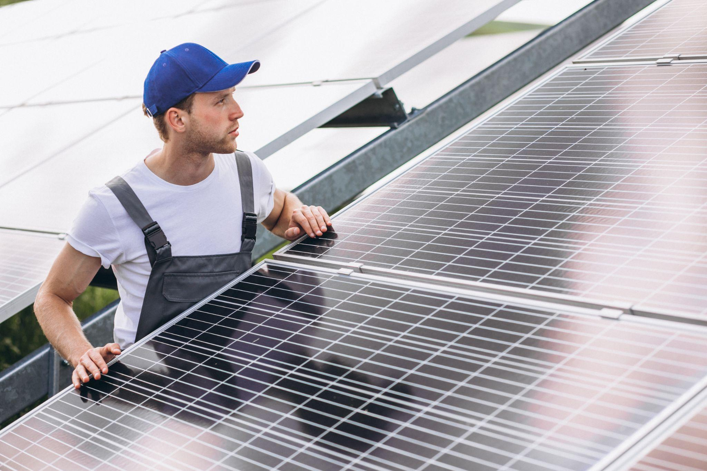

Can You Move Solar Panels?
Moving solar panels might sound like a practical way to keep your investment when relocating or changing your home, but the reality is more complex. While it’s technically possible, relocation isn’t always the most efficient, cost-effective, or high-performing option.
In this article, we explore when moving solar panels is possible, when it isn’t practical, how the process works, and what alternatives may deliver better financial and energy outcomes.
Key Takeaways
- Moving solar panels is possible in certain situations, particularly within the same property, but becomes far more complex when relocating to a different home.
- Relocation involves a structured process, including safe disconnection, transport, and reinstallation, all of which must be handled professionally to protect performance and safety.
- Costs, system compatibility, and roof suitability often reduce the benefits of relocation, making it less practical in many real-world scenarios.
- Alternatives such as installing a new system, upgrading components, or leaving the system in place can often deliver stronger long-term value and better performance.

When Moving Solar Panels Is Possible
Solar panels aren’t always fixed in place for life. In the right circumstances, relocating your system can improve performance, adapt to changes in your home, and help you get more value from your investment.
The key is understanding when relocation is practical, and when it genuinely improves how your system performs.

Relocating Panels Within The Same Property
Moving solar panels within the same property is often the most straightforward and effective option.
Over time, factors like tree growth, nearby construction, or changes to your roof can reduce how much sunlight your panels receive. Even small amounts of shading can significantly impact energy output.
Repositioning your panels to a better location can restore performance and improve long-term efficiency without the need for a full system replacement.

Moving Panels During Home Renovations
If you’re carrying out a loft conversion, extension, or roof replacement, your panels will likely need to be removed anyway. This makes it the ideal time to reposition or optimise your system without additional disruption.
Relocating panels during planned works or roof repairs is typically more cost-effective, as access is already in place and labour overlaps with the wider project.

Situations Where Relocation May Be Feasible
While not every system can or should be moved, there are clear scenarios where relocation makes sense and delivers measurable benefits.
Scenario | Primary Benefit | Complexity Level
Roof replacement | Improved system longevity | Low
Loft extension | Better use of roof space | Medium
Shading mitigation | Increased energy output | Medium
Aesthetic changes | Improved visual appeal | Low
A professional assessment is important to confirm whether relocation will deliver real gains without introducing new limitations.

When Moving Solar Panels May Not Be Practical
While relocation is possible in some cases, it isn’t always the right decision. Technical constraints, system design, and overall cost can quickly outweigh the benefits, especially when moving beyond the original property.

Relocating To A Different Property
Moving solar panels to a new home is far more complex than it first appears.
Solar systems are designed specifically for the property they’re installed on, including roof orientation, structure, and electrical setup. In addition, grid connections and agreements are typically tied to the original address, making relocation legally and administratively challenging.
In many cases, installing a new system designed for the new property delivers better performance and long-term value.

Compatibility And System Design Constraints
Every solar installation is tailored to its environment. Differences in roof angle, direction, shading, and structure can all impact how well an existing system performs in a new location. Mounting systems may not be compatible, and electrical components may require significant reconfiguration to meet safety and efficiency standards.
Without proper alignment, relocated systems often operate below their potential.

Cost And Effort Considerations
Relocation can quickly become a high-cost, labour-intensive process. You’re not just moving panels, you’re paying for removal, transport, redesign, and reinstallation, often with additional costs for new mounting hardware or electrical adjustments.
These combined costs approach, or even exceed, the price of a new, optimised system.
Factor | Relocation | New Installation
Initial Cost | High (labour-intensive) | Moderate (optimised design)
System Fit | Often compromised | Designed for the property
Warranty | Potential risk | Fully protected
Because of this, relocation is rarely recommended for moves between properties. A new installation is typically more efficient, more reliable, and better suited to your long-term energy needs.

How Solar Panel Relocation Works
Relocating a solar PV system is a carefully managed process designed to protect performance, safety, and long-term value. Done correctly, it preserves your investment. Done poorly, it can reduce efficiency or create costly issues.
That’s why relocation should always be handled by a certified professional who understands both the electrical and structural aspects of your system.

Disconnecting And Removing The Existing System
The process begins with safely isolating the system from your home and the grid.
A qualified installer shuts down the inverter, disconnects all electrical components, and ensures there is no active current before any physical work begins. This step is critical for safety and protects sensitive components from damage.
Panels are then carefully removed from the roof, followed by the mounting system. Each component is handled methodically to preserve its condition for reuse. Labelling and documenting the system layout at this stage ensures a smoother and more accurate reinstallation later.

Transporting Panels And Equipment
Solar panels are durable in operation, but fragile during transport. To prevent damage, panels must be properly protected, stored, and handled throughout the move. Inverters and electrical components also require careful handling to avoid faults that may not be immediately visible.
Professional transport typically includes:
- Protective packaging to prevent impact damage
- Secure positioning to avoid movement in transit
- Clear labelling of cables and components for reinstallation
- Careful handling of sensitive electrical equipment
This stage is essential to ensure your system performs as expected once it’s reinstalled.

Reinstalling And Reconnecting The System
Before panels are refitted, the new roof is assessed to ensure it can support the system structurally and is suitable in terms of orientation and exposure to sunlight. The system is then installed, wired, and configured to match the new environment.
Once complete, the entire system is tested for safety, output, and compliance with UK regulations. This ensures your solar setup is operating efficiently, safely, and in line with current standards.
A professionally managed relocation doesn’t just restore your system, it ensures it continues to deliver reliable performance in its new setting.

Key Factors To Consider Before Moving Solar Panels
Relocation isn’t always the most practical or cost-effective option. Before making a decision, it’s important to assess whether moving your system will genuinely deliver long-term value.

System Age And Condition
The condition of your existing system plays a major role in whether relocation makes sense.
Older panels typically produce less energy due to gradual degradation, and components such as inverters or mounting systems may already be nearing the end of their lifespan. In these cases, the cost of removal and reinstallation may outweigh the benefits of keeping the system.
A professional assessment helps determine whether your system is still worth relocating or if upgrading would deliver better returns.

Roof Suitability At The New Location
Your new roof must be able to support both the physical and performance requirements of your system.
Key factors include:
- Orientation and angle, which affect how much sunlight your panels receive
- Shading from nearby structures or trees
- Structural integrity and load-bearing capacity
Even a well-functioning system can underperform significantly if the new roof isn’t suitable.

Regulatory And Certification Requirements In The UK
Solar systems must comply with UK building regulations, electrical standards, and certification requirements.
Relocating your system may affect existing agreements, certifications, or eligibility for certain incentives. Failing to meet these requirements can lead to safety issues, insurance complications, or reduced financial benefits.
Ensuring compliance from the outset protects both your system and your investment.

Alternatives To Moving Solar Panels
Between labour, transport, redesign, and compliance, moving a system can quickly become complex and expensive. That’s why it’s important to consider whether a different approach could deliver better performance, lower risk, and stronger long-term value.

Installing A New System At The New Property
Modern solar technology is significantly more efficient than older systems, meaning you can generate more energy from the same roof space. A new installation is also designed specifically for your new property, ensuring optimal positioning, performance, and long-term reliability.
You also benefit from:
- A full manufacturer warranty on all components
- A system tailored to your current and future energy needs
- Improved compatibility with modern features like battery storage
Rather than adapting an old system to a new environment, a new installation is built to perform from day one.

Upgrading Instead Of Relocating
If your goal is better performance, upgrading often delivers far more value than relocating older equipment.
Older panels and components may not integrate well with newer technologies, limiting efficiency and flexibility. Upgrading allows you to modernise your system with higher-efficiency panels, improved inverters, and smarter energy management, without the constraints of legacy hardware.
This approach ensures your system is aligned with current standards, future-proofed for changing energy needs, and capable of delivering stronger long-term savings.

Leaving The System With The Property
In some cases, the most practical option is to leave your solar system in place. A fully functioning solar installation can increase property appeal, particularly for buyers looking for energy-efficient homes with lower running costs. It can also simplify your move by avoiding the complexity and cost of removal altogether.
Key considerations include:
- Potential to increase property value and buyer interest
- Transfer of schemes such as export tariffs or legacy incentives
- Reduced disruption and cost compared to relocation
- Simpler transition when moving home
While it may feel like leaving value behind, this approach often delivers a better overall financial outcome when all factors are considered.

How Upvolt Helps Homeowners Assess And Manage Solar Panel Relocation
Relocating, upgrading, or removing a solar panel system is a strategic decision, not just a technical one. The right choice depends on your system, your property, and your long-term energy goals.
Upvolt helps you navigate that decision with clarity, ensuring you choose the option that delivers the strongest return.

Evaluating Whether Relocation Is Feasible
The first step is understanding whether relocation actually makes sense. Upvolt assesses your current system, your new property, and the full cost of moving versus alternative options. This includes evaluating system performance, structural suitability, and the financial impact of each approach.
The goal is simple: ensure your decision is based on real value, not assumptions.

Planning Safe Removal And Reinstallation
If relocation is the right choice, Upvolt manages the entire process end-to-end. This includes safe system isolation, careful removal, secure transport, and professional reinstallation. Every stage is handled with precision to protect both your equipment and your property, ensuring your system performs as expected once it’s back in place.

Advising On Better Alternatives Where Needed
Relocation isn’t always the best option, and Upvolt will tell you when that’s the case. By comparing relocation with new installation or system upgrades, you get a clear understanding of which approach delivers the best performance and long-term savings.
Option | Primary Benefit | Best For
Relocation | Retains existing system | Newer, high-efficiency setups
New Installation | Latest technology | Maximising performance and savings
Leave In Place | Increases property appeal | Homeowners planning to sell
This ensures you’re not just preserving your system, but maximising its value.

Ensuring Compliance With UK Standards
All work is carried out in line with UK regulations, including electrical safety, installation standards, and certification requirements.
Upvolt also manages the necessary documentation and compliance checks, ensuring your system remains safe, legally compliant, and eligible for relevant incentives.

Let’s Recap
Solar panel relocation is technically achievable, but it’s not always the smartest move. While repositioning panels within the same property can improve performance, moving them to a new home introduces complexity, cost, and potential performance limitations.
The process itself requires careful handling, from safe electrical disconnection through to transport and reinstallation. Any misstep can affect efficiency, safety, or long-term reliability.
In many cases, alternatives such as installing a new system or upgrading existing components offer a more effective solution. These options ensure your solar setup is optimised for its environment rather than adapted to fit it.
Ultimately, the right decision comes down to value. Assessing your system, your property, and your future energy needs ensures you choose the approach that delivers the strongest return over time.

About Upvolt
Upvolt helps homeowners make confident decisions about whether to move, upgrade, or replace their solar systems. By analysing your current setup, your property, and your long-term energy goals, Upvolt ensures you choose the option that delivers the highest value, not just the most obvious one.
If you’re considering moving your solar panels and want to understand the best option for your situation, fill in our online form or get in touch to get expert advice tailored to your home.

FAQ

What actually happens to your solar panels when you move home?
When you move home, you have three main options: you can relocate the system, leave it in place, or replace it with a new installation at your next property. If you choose to take my solar panels with you, the process involves professional disconnection, careful removal, secure transport, and full reinstallation at the new site. Each step must be handled correctly to protect performance, safety, and compliance.

Will moving my solar panel system affect my Feed-in Tariff or SEG payments?
Yes, it can. Feed-in Tariff (FiT) agreements are typically tied to the original property, meaning you may lose those payments if the system is moved. With the Smart Export Guarantee (SEG), you would usually need to reapply at your new address. Because of this, many homeowners choose to leave the system in place and avoid disrupting existing financial benefits.

Does leaving solar panels in place increase the value of my property?
In many cases, yes. A working solar system can make your property more attractive to buyers, particularly those looking to reduce their electricity bills and improve energy efficiency. Solar panels can also contribute to a better EPC rating, which can further enhance your home’s appeal and perceived value.

What are the main costs involved in moving solar panels to a new location?
Relocation costs go beyond simple transport. They typically include professional removal, scaffolding, safe electrical disconnection, transport, reinstallation, and system testing at the new property. Additional costs may arise if new mounting systems or electrical components are required. When combined, these expenses can approach, or even exceed, the cost of installing a new system.

Will moving my solar panels void my warranty?
In many cases, yes. Solar panel warranties are often linked to the original installation and may not remain valid if the system is removed and reinstalled elsewhere. This can apply to both equipment and workmanship guarantees. Before making any decision, it’s important to review your warranty terms or seek professional advice to understand the potential impact.

Meta Title: Can You Move Solar Panels?
Meta Description: Learn whether you can move solar panels, how relocation works, and when alternatives like upgrading or installing a new system deliver better value.
Excerpt: Moving solar panels is possible, but not always practical. This guide explains when relocation works, the costs involved, and why alternatives may deliver better long-term value.
Sub Title: When moving solar panels makes sense and when other options offer better value.

